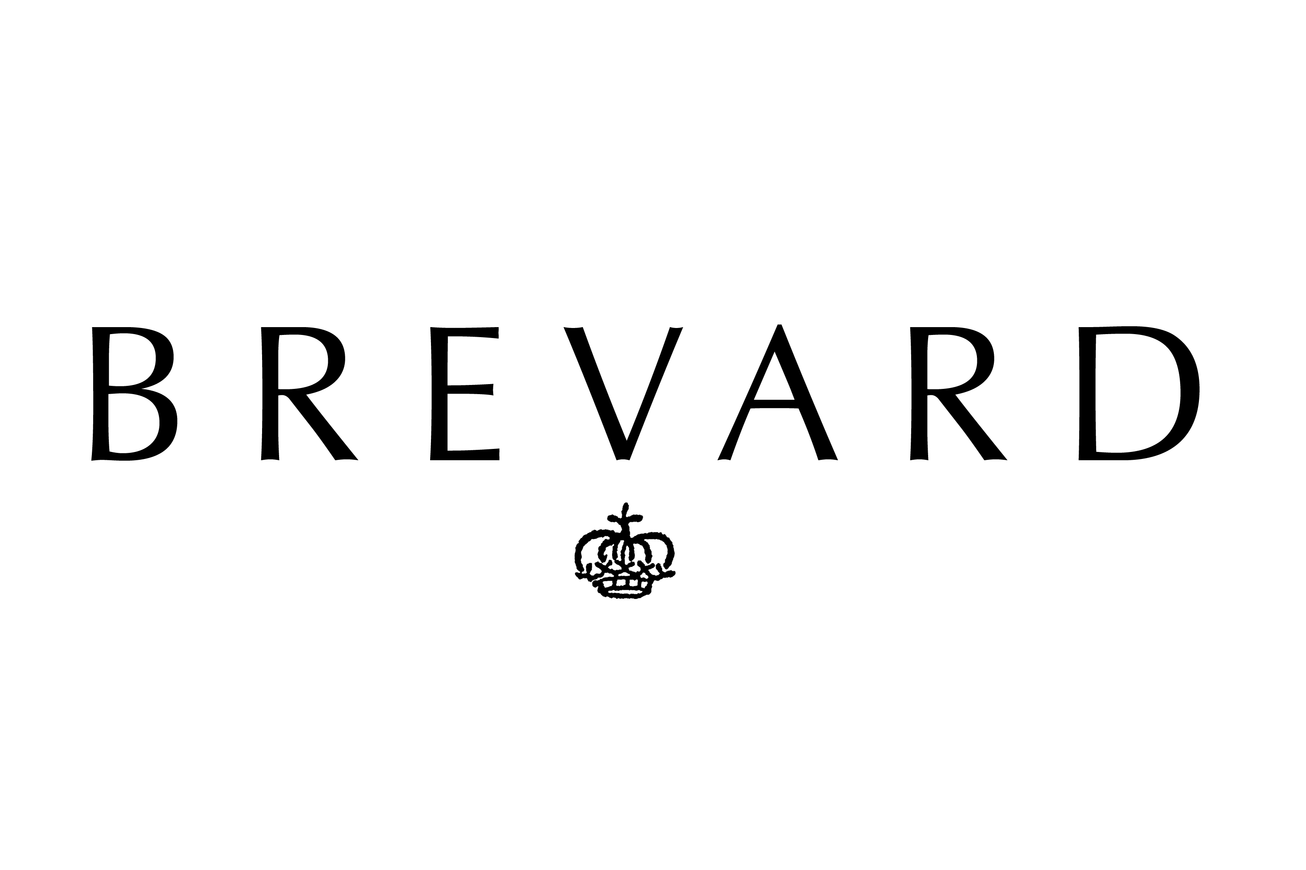
GEORGIA GANJEH CONSULTING
RED CARPET OUTREACH

STYLISTS

- JESSICA PASTEUR
- ELIZABETH STEWART
- ROB ZANGARDI
- MARIEL HAENN
- JEN RADE
- TARA SWEENEN
- MONICA ROSE
- LEE HARRIS
- MARY ALICE STEPHENSON
- KATE ELRICH
- LAUREN SAMPLE
- PHILIP BLOCH
- TIM SNELL
- JUNE AMBROSE
- LINDSAY ALBANESE
- TOD HALLMAN
- ERIC ARCHIBALD
- CHARLENE ROXBOROUGH
- HELLIN KAY
- ANYA SARRE/ENTERTAINMENT TONIGHT
- ADELE HUNT
- ART CONN/AMERICAN IDOL
- GENELLE BROOKS
- GEORGE BLODWELL
- JULIE KOZAK/EXTRA TV
- NICOLE ALLOWITZ/ACCESS HOLLYWOOD
- RAQUEL SMITH
- TY HUNTER
- WENDY AND NICOLE FERRIERA
- LLYOD BOSTON/EXTRA TV
- DANIELA JUNG
- CHRISTINA SCARBO/E!
- LYSA COOPER
- NICOLAS BRU
- HOLLY COPELAND
- LAUREN FRANCIS
- ROBERTA WAGNER
- TINA CHAI

MEDIA/EDITORS – with pitch that we were releasing vintage collection for upcoming red carpet season so targeted celebrity/red carpet driven stories

- PEOPLE MAGAZINE
- US MAGAZINE
- OK! MAGAZINE
- IN TOUCH MAGAZINE
- INSTYLE.COM
- VOGUE.COM
- WSJ
- BUSINESS OF FASHION
- NEWSWEEK
- TODAY SHOW
- FOX NEWS
- CALIFORNIA APPAREL NEWS
- THE DAILY
- NY DAILY NEWS
- REFINERY29.C0M
- WWD
- TV GUIDE
- RACKE.COM
- STYLE.COM
- USA TODAY
- E!
- NYMAG.COM
- FASHIONETC.COM
- MSN.COM
- FASHIONISTA.COM
- NY TIMES
- LA TIMES
- S.F. CHRONICLE
- HOUSTON CHRONICLE
- HUFFPOSTSTYLE.COM
- REDCARPETFASHIONAWARDS.COM
- STYLE NETWORK
- AVENUE MAGAZINE
- JUSTJARED.COM
- HOLLYWOOD WEEKLY MAGAZINE
- C MAGAZINE
- GENLUX MAGAZINE

