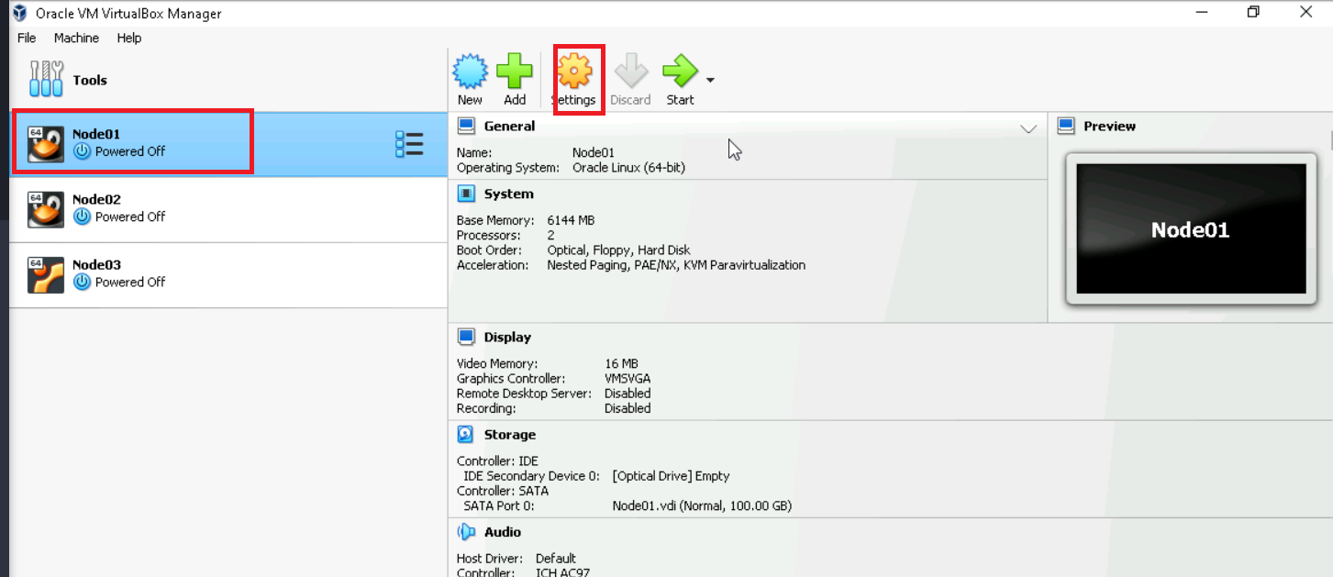

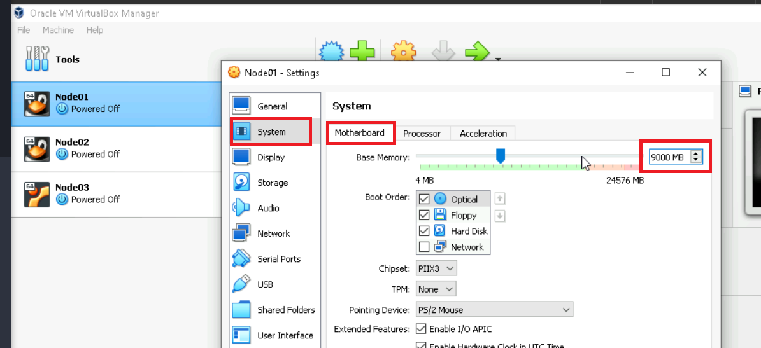

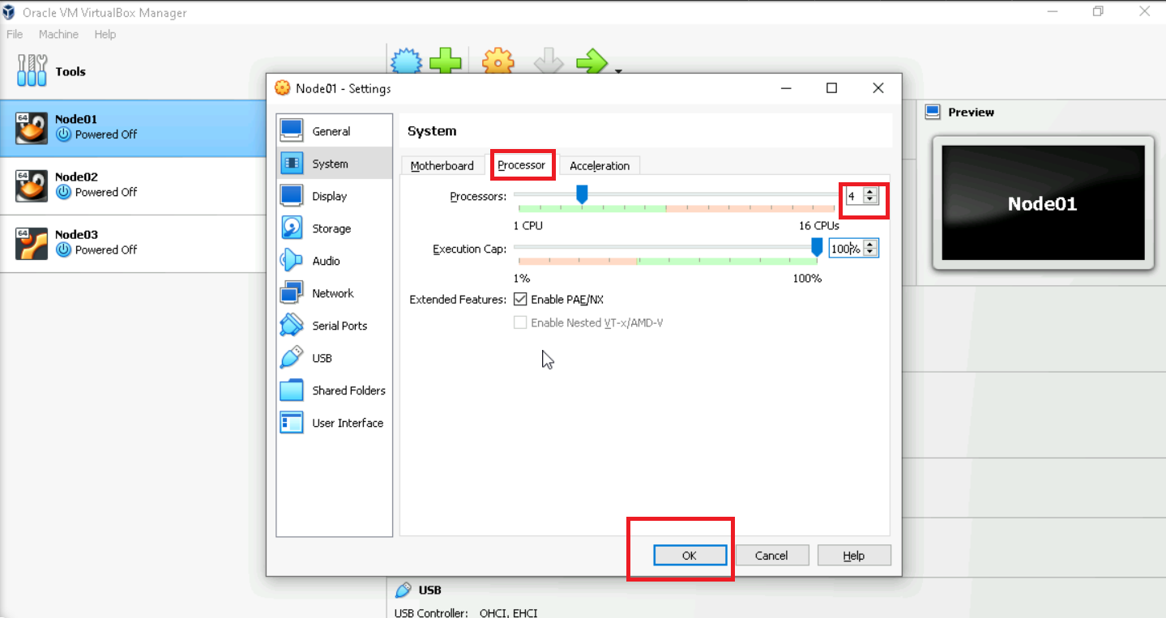

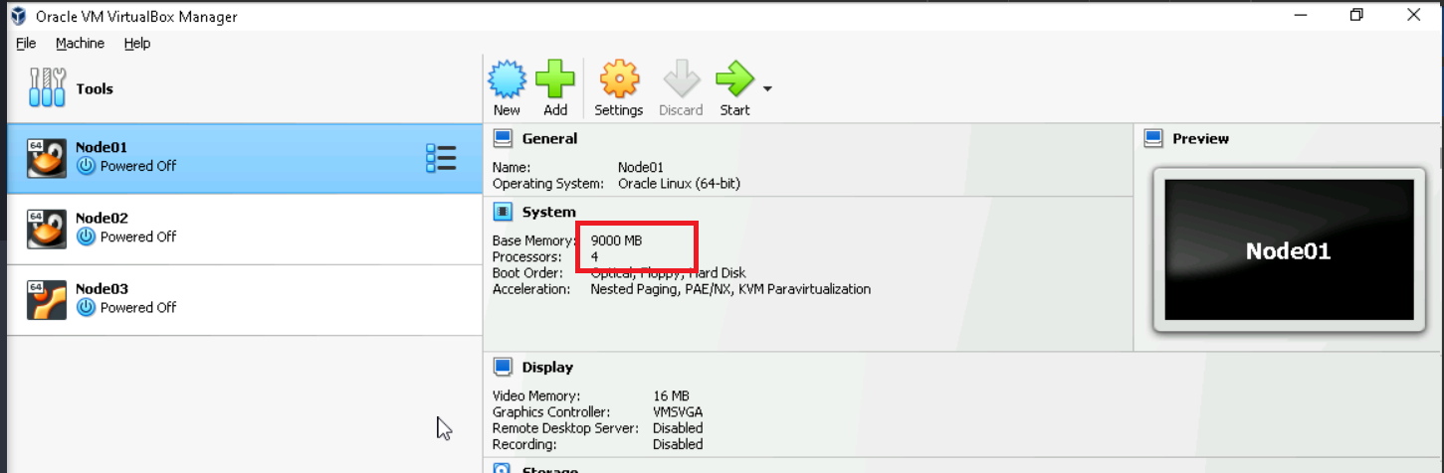

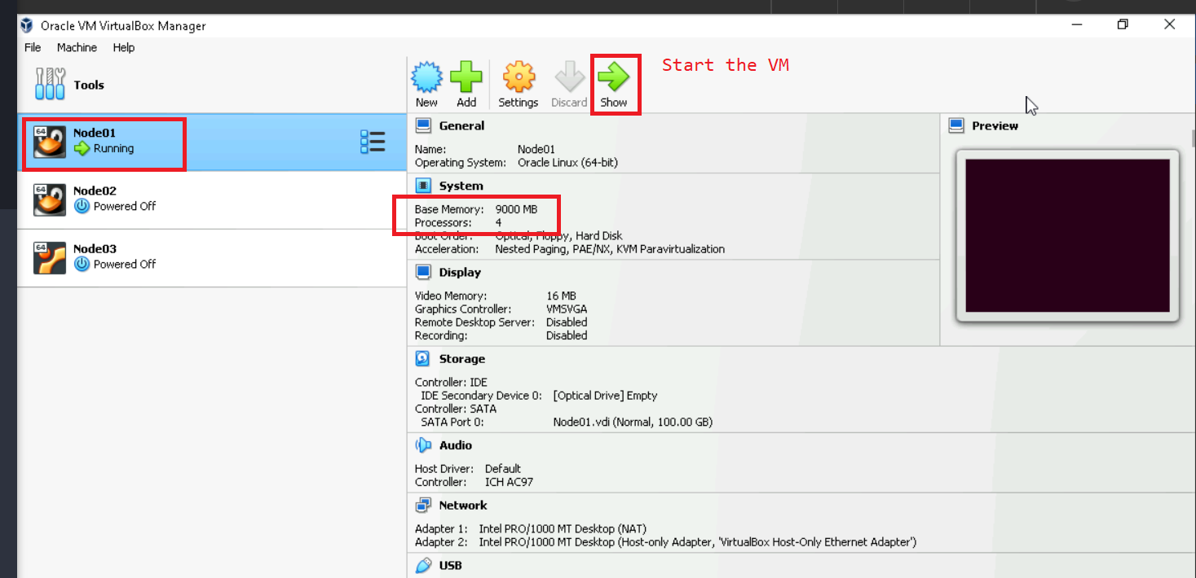

Connect to the VM on Putty

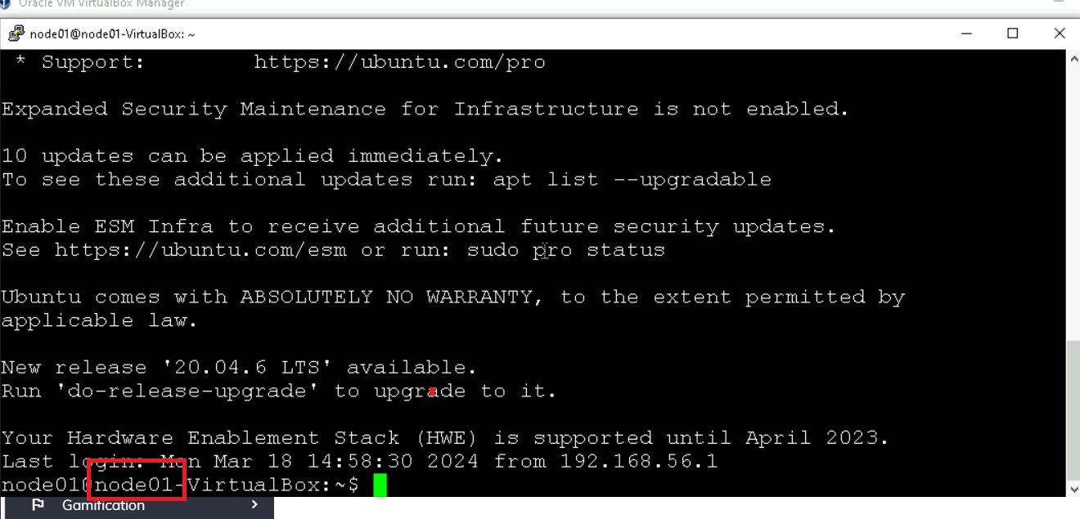

# multinode kafka deployment using docker-compose, exit to host machine if you are inside the container

cd $HOME

mkdir kafkamultinode

cd kafkamultinode

nano docker-compose.yml

version: "3"

services:

zookeeper:

image: 'bitnami/zookeeper:latest'

environment:

- ALLOW_ANONYMOUS_LOGIN=yes

kafka1:

image: 'bitnami/kafka:latest'

environment:

- KAFKA_BROKER_ID=1

- KAFKA_ENABLE_KRAFT=no

- KAFKA_CFG_LISTENERS=PLAINTEXT://:9092

- KAFKA_CFG_ADVERTISED_LISTENERS=PLAINTEXT://kafka1:9092

- KAFKA_CFG_ZOOKEEPER_CONNECT=zookeeper:2181

- ALLOW_PLAINTEXT_LISTENER=yes

depends_on:

- zookeeper

kafka2:

image: 'bitnami/kafka:latest'

environment:

- KAFKA_BROKER_ID=2

- KAFKA_ENABLE_KRAFT=no

- KAFKA_CFG_LISTENERS=PLAINTEXT://:9092

- KAFKA_CFG_ADVERTISED_LISTENERS=PLAINTEXT://kafka2:9092

- KAFKA_CFG_ZOOKEEPER_CONNECT=zookeeper:2181

- ALLOW_PLAINTEXT_LISTENER=yes

depends_on:

- zookeeper

kafka3:

image: 'bitnami/kafka:latest'

environment:

- KAFKA_BROKER_ID=3

- KAFKA_ENABLE_KRAFT=no

- KAFKA_CFG_LISTENERS=PLAINTEXT://:9092

- KAFKA_CFG_ADVERTISED_LISTENERS=PLAINTEXT://kafka3:9092

- KAFKA_CFG_ZOOKEEPER_CONNECT=zookeeper:2181

- ALLOW_PLAINTEXT_LISTENER=yes

depends_on:

- zookeeper

Ctrl+O+Enter

Ctrl+X

docker-compose up -d

docker-compose ps

# one zookeeper & 3 kafka containers should be listed

# wait for a minute

docker-compose up -d

# if the kafka brokers have failed to start, this above command will start them again

docker-compose ps