PRODUCT REQUIREMENTS DOCUMENT
Stock Market Trainer & Wealth Growth LMS
An automated, survey-free platform that teaches investing through real market data and behavior-driven learning.
Document Status | Draft v1.0
Project Duration | 3 Semesters (18 months)
Primary Stack | Java + Spring Boot, React, PostgreSQL
Last Updated | July 2026

Table of Contents
1. Purpose & Problem Statement 3
2. Goals & Success Metrics 3
3. Target Users 3
4. Scope 4
5. Functional Requirements 4
5.1 Data Ingestion Module 4
5.2 Trading Simulator 4
5.3 Behavioral Inference Engine 5
5.4 Learning Management (LMS) 5
5.5 Gamification & Engagement 5
5.6 Auth & Account 6
6. Non-Functional Requirements 7
7. Data Model & ER Diagram 7
8. Milestones 8
9. Risks & Assumptions 8
10. Open Questions 9

1. Purpose & Problem Statement
Most people never learn practical investing because either real trading carries real financial risk, or existing educational content is passive and disconnected from how someone actually behaves as an investor.
THE PROBLEM
There is no platform that combines a realistic, risk-free trading simulator with a learning system that adapts to genuine investor behavior — without relying on subjective, self-reported surveys.

THE SOLUTION
A Stock Market Trainer & Wealth Growth LMS that automatically ingests live market data, lets users paper-trade with real prices, and infers financial behavior and risk profile algorithmically — then serves personalized lessons based on that inferred profile.

2. Goals & Success Metrics
Prove automated data pipeline works at scale | Ingestion uptime & rate-limit compliance | ≥99% successful pulls, zero 429 errors over 30 days
Replace manual surveys with inferred profiling | % of users with computed risk/literacy profile | 100% of active users, auto-generated
Deliver a functioning trading simulator | Trade execution correctness | Portfolio always reconciles with trade history
Adaptive learning works | Lesson relevance | Low-diversification users see relevant lesson within 1 session
Capstone / academic success | Semester deliverables | All 3 milestones demoed & defended on schedule

3. Target Users
  Beginner Investor
  Never traded before, intimidated by real money markets.
  Core need: A safe environment to learn by doing.
  College Student
  Wants to build financial literacy alongside coursework.
  Core need: Gamified, bite-sized learning tied to real outcomes.
  Self-Directed Learner
  Doesn't want rigid courses; learns from their own mistakes.
  Core need: Feedback based on their own behavior, not generic content.

Note: Academic evaluators are a secondary user — the system should clearly demonstrate automated, non-survey-based data flows during a live demo.

4. Scope
✔ IN SCOPE  ● Automated live/delayed market data ingestion (no manual entry)  ● Paper-trading simulator (buy/sell, portfolio tracking, P&L)  ● Algorithmic behavioral/risk profiling engine  ● LMS module: lessons, quizzes, adaptive unlocking  ● Gamification: badges, leaderboards, streaks  ● User auth & account management  ● Real-time price updates (WebSocket)  ● Dashboards & analytics | ✘ OUT OF SCOPE  ● Real money trading or brokerage integration  ● Manual survey-based risk assessment (explicitly excluded)  ● Options / derivatives / futures trading  ● Mobile native apps  ● Multi-currency / international exchanges

5. Functional Requirements

5.1 Data Ingestion Module (Automated Data Loop)
ID | Requirement | Priority
FR-1.1 | System shall poll Finnhub API on a fixed schedule to fetch quote/candle data for a configurable watchlist of tickers | Must
FR-1.2 | System shall respect the API rate limit (≤3,600 requests/hour) with client-side throttling/backoff | Must
FR-1.3 | System shall persist all fetched price data to the database (no data is ever manually entered) | Must
FR-1.4 | System shall log ingestion failures and retry with exponential backoff | Should
FR-1.5 | System shall support adding/removing tracked tickers without code redeployment (config-driven) | Should

5.2 Trading Simulator
ID | Requirement | Priority
FR-2.1 | Users shall be able to buy/sell equities using simulated cash balance at latest available price | Must
FR-2.2 | System shall maintain a full, immutable trade history per user | Must
FR-2.3 | System shall calculate real-time portfolio value, unrealized/realized P&L | Must
FR-2.4 | System shall prevent trades that exceed available simulated balance or holdings | Must
FR-2.5 | System shall support portfolio diversification metrics (e.g., concentration by sector) | Should

5.3 Behavioral Inference Engine (replaces survey)
ID | Requirement | Priority
FR-3.1 | System shall compute a risk_profile score automatically from trade history (frequency, concentration, drawdown reaction) | Must
FR-3.2 | System shall compute a financial_literacy_score from quiz performance + trading discipline signals | Must
FR-3.3 | Scores shall recompute on a schedule (e.g., nightly) as new behavior data accumulates | Must
FR-3.4 | System shall never require the user to manually self-report risk tolerance or preferences | Must

5.4 Learning Management (LMS)
ID | Requirement | Priority
FR-4.1 | System shall present structured lessons/modules on investing concepts | Must
FR-4.2 | System shall unlock or recommend lessons based on the user's computed behavioral profile | Must
FR-4.3 | System shall include quizzes with scored feedback | Must
FR-4.4 | System shall track lesson completion and progress per user | Should

5.5 Gamification & Engagement
ID | Requirement | Priority
FR-5.1 | System shall award badges for milestones (first trade, diversified portfolio, quiz streaks) | Should
FR-5.2 | System shall maintain a leaderboard ranked by simulated portfolio performance | Could
FR-5.3 | System shall automatically track a daily activity streak (current_streak, longest_streak) per user based on login/trading/lesson activity — no manual check-in required | Must
FR-5.4 | System shall support a limited number of “streak freezes” per user to preserve a streak through a missed day | Should

5.6 Auth & Account
ID | Requirement | Priority
FR-6.1 | Users shall sign up/log in securely (Spring Security + JWT) | Must
FR-6.2 | Passwords shall be hashed (bcrypt), never stored in plaintext | Must

6. Non-Functional Requirements
Category | Requirement
Performance | Ingestion service must sustain ≥3,600 requests/hour to the stock API without violating rate limits
Scalability | Backend reads must be served from internal DB/cache, not proxied directly to the external API
Reliability | Ingestion failures must not crash the user-facing app; stale-data fallback required
Security | JWT-based auth, hashed passwords, input validation on all endpoints, HTTPS in production
Data Integrity | All trade and price data immutable once written (audit trail)
Maintainability | Codebase modularized (Spring Boot controller/service/repository layers)
Observability | Ingestion job logs success/failure rate; basic monitoring dashboard by Semester 3

7. Data Model (Core Entities)
User (id, name, email, password_hash, created_at, risk_profile, literacy_score)
Stock (id, ticker, name, sector)
PriceHistory (id, stock_id, price, volume, timestamp) ← automated ingestion only
Portfolio (id, user_id, cash_balance)
Streak (id, user_id, current_streak, longest_streak, last_active_date, freeze_count)
Trade (id, user_id, stock_id, type[buy/sell], quantity, price, timestamp)
Lesson (id, title, content, unlock_condition)
QuizAttempt (id, user_id, lesson_id, score, timestamp)
Badge (id, user_id, badge_type, awarded_at)
The Streak entity is new in this revision — a Duolingo-style daily engagement mechanic that is entirely behavior-derived (login/trade/lesson activity), consistent with the project's no-manual-survey constraint.
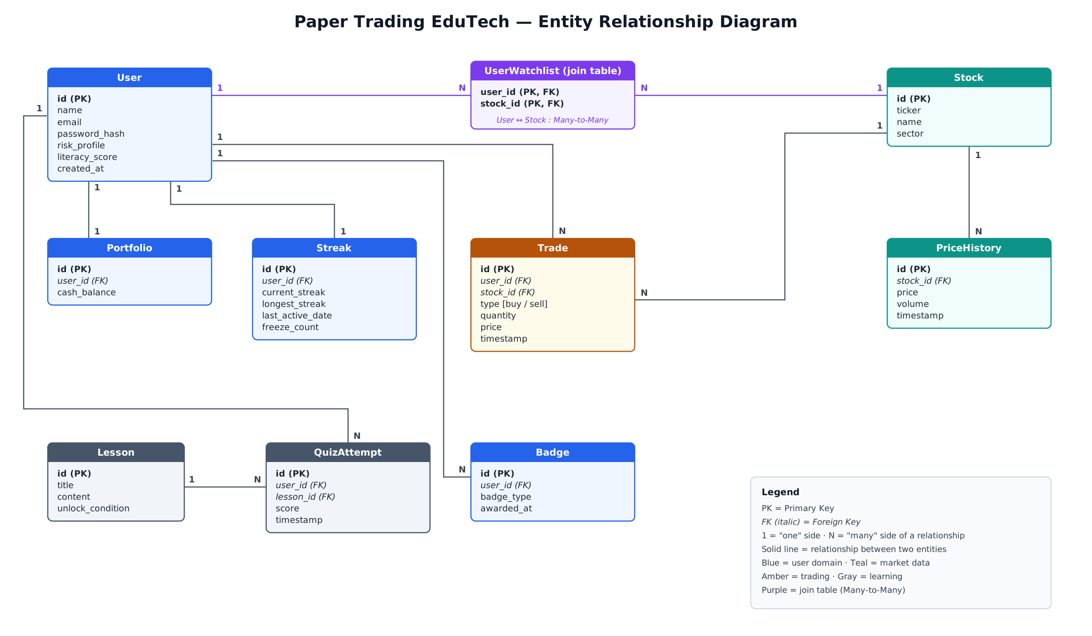
Figure 1: Entity Relationship Diagram — core schema including the Streak engagement entity

8. Milestones
Milestone | Semester | Exit Criteria
M1: Ingestion + Core Trading MVP | 1 | Users can trade with real, auto-ingested prices; core schema live
M2: Behavioral Engine + LMS + Real-time | 2 | Risk/literacy scores computed automatically; lessons adapt; live prices via WebSocket
M3: Scale, Deploy, Prove It | 3 | Dockerized, CI/CD deployed, load-tested at target rate, dashboards live

Detailed sprint-level breakdown lives in the companion Architecture Roadmap document.

9. Risks & Assumptions
Risk | Mitigation
Free-tier API limits change or get revoked | Abstract the data provider behind an interface; keep Twelve Data as fallback
Rate-limit violations if ingestion misconfigured | Client-side throttling + centralized scheduler, never per-user direct calls
Scope creep across 3 semesters | This PRD's Scope section is reviewed before each semester's proposal
Behavioral scoring feels arbitrary without real user volume | Start with a transparent, documented formula (not opaque ML); ML only as Sem 3 stretch goal

ASSUMPTIONS
Simulated money only (no real regulatory exposure). Single currency (USD). US equities only for MVP.

10. Open Questions
- Frontend framework: React or Angular — confirm based on course curriculum?
- Deployment target: Render/Railway (simplest) vs AWS free tier (more resume value, more setup)?
- Should Semester 3 include a stretch ML recommendation engine, or is load-testing/deployment sufficient scope?

