

ETMS_ST7796S TnT Library
User Guide
By Nash Ali

Version 1.00

Dec.,11, 2020.
INTRODUCTION

This library only supports this 3.95" colour tft display.
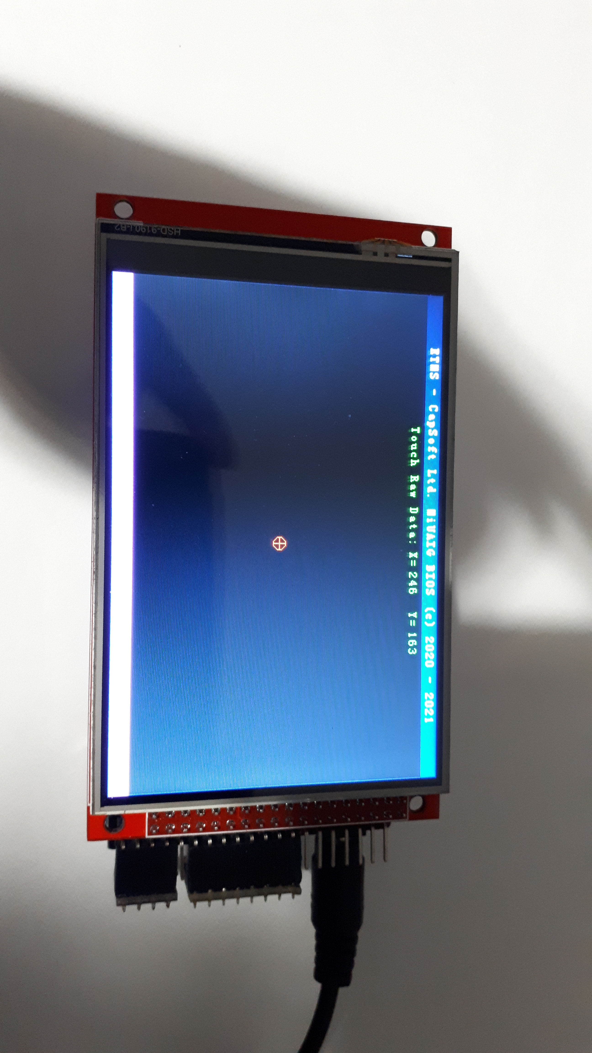
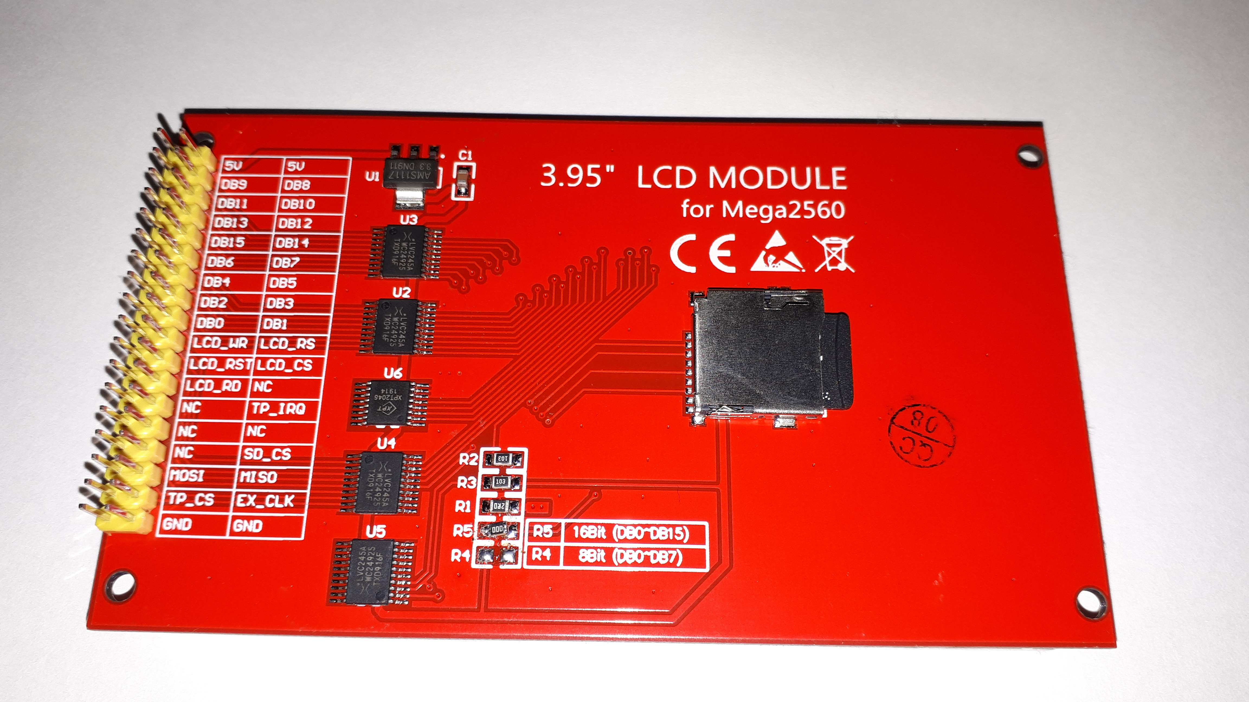

Section 1 Library commands.
Section 2 Software description.
Section 3 Hardware Info.
Section 4 Examples Description.
Section 5 Introduction to Graphics.
Section 6 Misc.

SECTION 1
ETMS_ST7796S TnT Library Commands

Initialize Display – Done once at beginning of program. - see examples folder.
Usage: init();
Prototypes supported:
init();

Display On – Turns on display, takes the display out of displayOff mode.
Usage: displayOn();
Prototypes supported:
displayOn();

Display Off – Turns off display, shuts down HV. Requires displayOn to resume.
Usage: displayOff();
Prototypes supported:
displayOff();

Set Brightness – Set the brightness value of the TFT – ranges from 0x00 to 0xFF.
Usage: setBrightness();
Prototypes supported:
setBrightness(uint8_t br);

Invert Display – Inverts the display.
Usage: invertDisplay();
Prototypes supported:
invertDisplay(uint8_t inv);

Set Address Window – sets the display window (CASET/RASET) for RAMWR operations.
This is the access to the frame buffer 480 x 320 x 18.
Usage: setAddressWindow(x-start,y-start,x-dest,y-dest);
Prototypes supported:
setAddressWindow(int16_t xorg, int16_t yorg,int16_t xdest, int16_t ydest);

Set Fill Window – fills the window with RGB888 colour for the length specified.
Usage: fillWindow(x-start,y-start,x-dest,y-dest);
Prototypes supported:
fillWindow(uint8_t red, uint8_t green, uint8_t blue, int length);
fillWindow(uint16_t colour, int length);
ETMS_ST7796S TnT Library Commands(Contd)

Clear Display – clears the frame buffer. Set all pixels to BLACK (0,0,0).
Usage: clrDisplay(); clrScr();
Prototypes supported:
clrDisplay();
clrScr();

Draw Pixel – draws a pixel of the specified colour and position.
Usage: drawPixel(x-coord, y-coord[,colour565][,red,green,blue]);
Prototypes supported:
drawPixel(uint16_t xp, uint16_t yp);
drawPixel(uint16_t xp, uint16_t yp, uint16_t colour565);
drawPixel(uint16_t xp, uint16_t yp, uint8_t red, uint8_t green, uint8_t blue);

Draw Horizontal Line – draws a line starting at xs,ys and moving to the right for the length in pixels.
Usage: drawHLine(x-start,y-start,length);
Prototypes supported:
drawHLine(uint16_t xs, uint16_t ys, uint16_t length);

Draw Vertical Line – draws a vertical line downwards in length in pixels.
Usage: drawVLine(x-start,y-start,length);
Prototypes supported:
drawVLine(uint16_t xs, uint16_t ys, uint16_t length);

Draw Rectangle – draws a box starting at xs,ys as the top-left corner and the width in pixels across and the height in pixels downward.
Usage: drawRect(x-start,y-start,width,height);
Prototypes supported:
drawRect(uint16_t xs, uint16_t ys, uint16_t width, uint16_t height);

ETMS_ST7796S TnT Library Commands(Contd)

Print Character – print a single character from the selected font file, the x position is automatically incremented and at the end of the line there is roll-over to the next line by incrementing the y position and resetting the x position to the start of the line.
Usage: printChar(CHAR[,x-pos,ypos,[colour565][red,green,blue]]);
Prototypes supported:
printChar(uint8_t c);
printChar(uint8_t c, uint16_t xpos, uint16_t ypos, uint16_t colour);
printChar(uint8_t c, uint16_t xpos, uint16_t ypos, uint8_t red, uint8_t green, uint8_t blue);

Print String – prints an string of characters in the specified colour. Can use 24 bit or 16 bit colour.
Usage: printString(“CHAR”,xpos,ypos);
Prototypes supported:
printString(char x);
printString(char x, uint16_t xpos, uint16_t ypos);
printString(char x, uint16_t xpos, uint16_t ypos, uint16_t colour);
printString(char x, uint16_t xpos, uint16_t ypos, uint8_t red, uint8_t green, uint8_t blue);
printString(char *x);
printString(char *x, uint16_t xpos, uint16_t ypos, uint16_t colour);
printString(char *x, uint16_t xpos, uint16_t ypos, uint8_t red, uint8_t green, uint8_t blue);

Print Number – prints a number in the specified format integer/float at the specified location xpos, ypos..
Usage: printNumI(val,xpos,ypos[,divider='.'][,digits][, spacer=' ']);
printNumF(num, xpos, ypos[, dec][, filler][, length]);
Prototypes supported:
printNumI(long val, uint16_t xpos, uint16_t ypos, [int length, char filler]);
printNumF(double num, uint16_t x, uint16_t y, byte dec=5, char divider='.', int length=0, char filler=' ' );

Set Background Colour – sets the background colour in RGB565 format. The RGB prototype supports RGB888 to RGB565 conversion.
Usage:setBackColour(colour);

Prototypes supported:
setBackColour(uint16_t colour);
setBackColour(uint8_t red, uint8_t green, uint8_t blue);

ETMS_ST7796S TnT Library Commands(Contd)

Set Foreground Colour – set the foreground colour in RGB565 format. The RGB prototype supports RGB888 to RGB565 conversion.
Usage: setColour(colour);

Prototypes supported:
setColour(uint16_t colour);
setColour(uint8_t red, uint8_t green, uint8_t blue);

Set Font – sets the font to use for text operations. Your custom fonts can be installed in the driver's directory and delcared in your program. See example folder LibraryTest programs.
Usage: void setFont(char *font);
Prototypes supported:
setFont(SmallFont);

Get Font – gets the current font in use.
Usage: void setFont(char *font);
Prototypes supported:
uint8_t* getFont();

Get Font X Size – gets the current font x dimension.
Usage: getFontXsize();
Prototypes supported:
uint8_t getFontXsize();

Get Font Y Size – gets the current font y dimension.
Usage: getFontYsize();
Prototypes supported:
uint8_t getFontYsize();

Set Cursor – sets the x,y position for the next screen operation.
Usage: setCursor(xpos,ypos);
Prototypes supported:
setCursor(uint16_t xpos, uint16_t ypos);

Set Guage – set guage.(NEW) – concept stage.
Usage: setGuage(xpos,ypos,value,type);
Prototypes supported:

SECTION 2
Software description.

While the ST7796S controller hardware is configured for16-bit data, the software initialization sets up the colour palette for 565 encoding (65K colour), this allows the pixel transfers to the frame buffer to equal one pixel for each 16-bit word. LSB Data0 – Data4 is the 5 bit blue component, Data5 – Data 10 is the 6 bit green while Data11-Data15 MSB is the 5 bit red component.
Library Header:
/*
Created: 06:23 PM 10/04/2020
Last Updated: 12:05 PM 11/16/2020
MIT License

Copyright (c) 2020 Zulfikar Naushad(Nash) Ali

Permission is hereby granted, free of charge, to any person obtaining a copy
of this software and associated documentation files (the "Software"), to deal
in the Software without restriction, including without limitation the rights
to use, copy, modify, merge, publish, distribute, sublicense, and/or sell
copies of the Software, and to permit persons to whom the Software is
furnished to do so, subject to the following conditions:

The above copyright notice and this permission notice shall be included in all
copies or substantial portions of the Software.

THE SOFTWARE IS PROVIDED "AS IS", WITHOUT WARRANTY OF ANY KIND, EXPRESS OR
IMPLIED, INCLUDING BUT NOT LIMITED TO THE WARRANTIES OF MERCHANTABILITY,
FITNESS FOR A PARTICULAR PURPOSE AND NONINFRINGEMENT. IN NO EVENT SHALL THE
AUTHORS OR COPYRIGHT HOLDERS BE LIABLE FOR ANY CLAIM, DAMAGES OR OTHER
LIABILITY, WHETHER IN AN ACTION OF CONTRACT, TORT OR OTHERWISE, ARISING FROM,
OUT OF OR IN CONNECTION WITH THE SOFTWARE OR THE USE OR OTHER DEALINGS IN THE
SOFTWARE.
Uses the Arduino DUE ONLY!
NOTES:
This program tests the new ETMS library for the generic 3.95 parallel i/f ST7796S
tft colour display controller.

ETMS_ST7796S.h - library setup

The #ifndef statement checks to see if the ETMS_ST7796S.h
file isn't already defined. This is to stop double declarations
of any identifiers within the library. It is paired with a
#endif at the bottom of the header and this setup is known as
an 'Include Guard'.
The following def handles the ARM pcb.

*/

#ifndef __SAM3X8E__
#define __SAM3X8E__
#include "hardware/arm/HW_SAM3X8E.h"
#endif

#ifndef _etms_st7796s_h_
#define _etms_st7796s_h_

// st7796s registers
#define NOP 0x00 // no operation
#define SWRESET 0x01 // software reset
#define RDDID 0x04 // read display ID
#define RDDSI 0x05
#define RDDST 0x09
#define RDDPM 0x0A // read display power mode
#define RDDMADCTL 0x0B
#define RDDCOLMOD 0x0C
#define RDDIM 0x0D // read display image mode
#define RDDSM 0x0E // read display signal mode
#define RDDSDR 0x0F // read display self-diagnostic result

#define SLPIN 0x10 // sleep in
#define SLPOUT 0x11 // sleep out
#define PTLON 0x12 // partial display on
#define NORON 0x13 // normal display on
#define INVOFF 0x20 // display inversion off
#define INVON 0x21 // display inversion on
#define DISPOFF 0X28 // display off
#define DISPON 0x29 // display on

#define CASET 0x2A // column address set
#define RASET 0x2B // row address set
#define RAMWR 0x2C // ram write
#define RAMRD 0x2E // ram read

#define PTLAR 0x30 // partial area
#define VSCRDEF 0x33 // vertical scroll definition
#define MADCTL 0x36 // Memory data access control
#define VSCRSADD 0x37 // vertical scroll start address of RAM
#define IDMOFF 0x38 // idle mode off
#define IDMON 0x39 // idle mode on
#define COLMOD 0x3A // interface pixel format register - colour data input format - RGB888 - RGB565.
#define RAMWRC 0x3C // write memory continue
#define RAMRDC 0x3E // read memory continue

#define WRDISBV 0x51 // write display brightness
#define RDDISBV 0x52 // read display brightness
#define WRCTRLD 0x53 // write ctrl display
#define RDCTRLD 0x54 // read ctrl display
#define WRCABC 0x55 // write adaptive brightness control value
#define RDCABC 0x56 // read adaptive brightness control value
#define WRCABCMB 0x5E // write CABC minimun brightness
#define RDCABCMB 0x5F // read CABC minimun brightness

#define RDFCHKSUM 0xAA // read first checksm
#define RDCFCS 0xAF // read checksum continue

#define IFMODE 0xB0 // interface mode control
#define FRMCTR1 0xB1 // frame rate control - normal mode / full colours
#define FRMCTR2 0xB2 // frame rate control - in idle mode / 8 colours
#define FRMCTR3 0xB3 // frame rate control - partial mode / full colours
#define DIC 0xB4 // display inversion control
#define BPC 0xB5 // blanking porch control
#define DFC 0xB6 // display function control
#define EM 0xB7 // entry mode set
#define PWR1 0xC0 // power control 1
#define PWR2 0xC1 // power control 2
#define PWR3 0xC2 // power control 3
#define VCMPCTL 0xC5 // vcomp control
#define VCMOFFSET 0xC6 // vcomp offset register

#define NVMADW 0xD0 // nvm address/data write
#define NVMBPROG 0xD1 // nvm byte program
#define NVMSTATRD 0xD2 // nvm status read
#define RDID4 0xD3 // read ID4
#define RDID1 0xDA // read ID1
#define RDID2 0xDB // read ID2
#define RDID3 0xDC // read ID3

#define PGC 0xE0 // positive gamma
#define NGC 0xE1 // negative gamma
#define DGC1 0xE2 // digital gamma 1
#define DGC2 0xE3 // digital gamma 2
#define DOCA 0xE8 // display output conrtol adjust
#define CSCON 0xF0 // command set control
#define SPIRDCTRL 0xFB // spi read control
#define PROMACT 0xFE

// masks
#define MADCTL_MY 0x80
#define MADCTL_MX 0x40
#define MADCTL_MV 0x20
#define MADCTL_ML 0x10
#define MADCTL_RGB 0x08
#define MADCTL_DISL 0x04

#define RGB888 0x07 // 24bit - 16M
#define RGB666 0x06 // 18bit - 262K
#define RGB565 0x05 // 16bit - 65K

#define BUS16BIT 0x50 // 16 bit bus
#define BUS18BIT 0x60 // 18 bit bus

#define ON true
#define OFF false
#define PORTRAIT 0
#define LANDSCAPE 1
#define LEFT 0
#define RIGHT 9999
#define CENTER 9998
#define TOP 9997
#define MIDDLE 9996
#define BOTTOM 9995

// standard colour defines ****************************************************
// 565 colour defines
#define LTBLUE 0xB6DF
#define LTTEAL 0xBF5F
#define LTGREEN 0xBFF7
#define LTCYAN 0xC7FF
#define LTRED 0xFD34
#define LTMAGENTA 0xFD5F
#define LTYELLOW 0xFFF8
#define LTORANGE 0xFE73
#define LTPINK 0xFDDF
#define LTPURPLE 0xCCFF
#define LTGREY 0xE71C

#define BLUE 0x001F
#define TEAL 0x0438
#define GREEN 0x07E0
#define CYAN 0x07FF
#define RED 0xF800
#define MAGENTA 0xF81F
#define YELLOW 0xFFE0
#define ORANGE 0xFC00
#define PINK 0xF81F
#define PURPLE 0x8010
#define GREY 0xC618

#define WHITE 0xFFFF
#define BLACK 0x0000

#define DKBLUE 0x000D
#define DKTEAL 0x020C
#define DKGREEN 0x03E0
#define DKCYAN 0x03EF
#define DKRED 0x6000
#define DKMAGENTA 0x8008
#define DKYELLOW 0x8400
#define DKORANGE 0x8200
#define DKPINK 0x9009
#define DKPURPLE 0x4010
#define DKGREY 0x4A49

#define bitmapdatatype unsigned short*

/*
The #include of Arduino.h gives this library access to the standard
Arduino types and constants (HIGH, digitalWrite, etc.). It's
unneccesary for sketches but required for libraries as they're not
.ino (Arduino) files.
*/
#include "Arduino.h"

struct _current_font
{
uint8_t* font;
uint8_t x_size;
uint8_t y_size;
uint8_t offset;
uint8_t numchars;
};

class ETMS_ST7796S{

public:

ETMS_ST7796S();

// Below are the functions for the class. These are the functions available in the library for the user to call.
void init(boolean orientation = LANDSCAPE);
void displayOn();
void displayOff();
void setBrightness(uint8_t br);
uint8_t getID();
uint16_t getHeight();
uint16_t getDisplayYSize();
uint16_t getWidth();
uint16_t getDisplayXSize();
uint16_t to565Colour(uint8_t red, uint8_t green, uint8_t blue); // convert RGB888
void setPixel();
void setPixel(uint16_t colour);
void setPixel(uint8_t red, uint8_t green, uint8_t blue);
void setCursor(uint16_t x, uint16_t y);
void invertDisplay(uint8_t inv);
void setTransparency(bool t);
void setAddressWindow(uint16_t xorg, uint16_t yorg, uint16_t xdest, uint16_t ydest);
void setXY(uint16_t xorg, uint16_t yorg, uint16_t xdest, uint16_t ydest);
void clrXY(); // resets the address window to maximum.
void fillWindow(uint8_t red, uint8_t green, uint8_t blue, int length);
void fillWindow(uint16_t colour, int length);
void fastFill(uint16_t xs, uint16_t ys, uint16_t width, uint16_t height);
void clrDisplay(); // writes 0s to the entire frame buffer.
void clrScr();
void fillScreen();
void fillScreen(uint16_t colour);
void fillScreen(uint8_t red, uint8_t green, uint8_t blue);

void drawLine(uint16_t x1, uint16_t y1, uint16_t x2, uint16_t y2);
void drawLine(uint16_t x1, uint16_t y1, uint16_t x2, uint16_t y2, uint16_t colour);
void drawLine(uint16_t x1, uint16_t y1, uint16_t x2, uint16_t y2, uint8_t red, uint8_t green, uint8_t blue);

void drawPixel(uint16_t xpos, uint16_t ypos);
void drawPixel(uint16_t xpos, uint16_t ypos, uint16_t colour);
void drawPixel(uint16_t xp, uint16_t yp, uint8_t red, uint8_t green, uint8_t blue);

void drawHLine(uint16_t xs,uint16_t ys ,uint16_t length);
void drawHLine(uint16_t xs,uint16_t ys ,uint16_t length, uint16_t colour);
void drawHLine(uint16_t xs,uint16_t ys ,uint16_t length, uint8_t red, uint8_t green, uint8_t blue);

void drawVLine(uint16_t xs,uint16_t ys ,uint16_t length);
void drawVLine(uint16_t xs,uint16_t ys ,uint16_t length, uint16_t colour);
void drawVLine(uint16_t xs,uint16_t ys ,uint16_t length, uint8_t red, uint8_t green, uint8_t blue);

void drawRect(uint16_t xs, uint16_t ys, uint16_t width, uint16_t height);
void drawRect(uint16_t xs, uint16_t ys, uint16_t width, uint16_t height, uint16_t colour);
void drawRect(uint16_t xs, uint16_t ys, uint16_t width, uint16_t height, uint8_t red, uint8_t green, uint8_t blue);

void fillRect(uint16_t xs, uint16_t ys, uint16_t width, uint16_t height);
void fillRect(uint16_t xs, uint16_t ys, uint16_t width, uint16_t height, uint16_t colour);
void fillRect(uint16_t xs, uint16_t ys, uint16_t width, uint16_t height, uint8_t red, uint8_t green, uint8_t blue);

void drawRoundRect(uint16_t xs, uint16_t ys, uint16_t width, uint16_t height);
void drawRoundRect(uint16_t xs, uint16_t ys, uint16_t width, uint16_t height, uint16_t colour);
void drawRoundRect(uint16_t xs, uint16_t ys, uint16_t width, uint16_t height, uint8_t red, uint8_t green, uint8_t blue);

void fillRoundRect(uint16_t xs, uint16_t ys, uint16_t width, uint16_t height);
void fillRoundRect(uint16_t xs, uint16_t ys, uint16_t width, uint16_t height, uint16_t colour);
void fillRoundRect(uint16_t xs, uint16_t ys, uint16_t width, uint16_t height, uint8_t red, uint8_t green, uint8_t blue);

void drawTriangle(uint16_t x0, uint16_t y0, uint16_t x1, uint16_t y1, uint16_t x2, uint16_t y2);
void drawTriangle(uint16_t x0, uint16_t y0, uint16_t x1, uint16_t y1, uint16_t x2, uint16_t y2, uint16_t colour);
void drawTriangle(uint16_t x0, uint16_t y0, uint16_t x1, uint16_t y1,uint16_t x2, uint16_t y2, uint8_t red, uint8_t green, uint8_t blue);

void fillTriangle(uint16_t x0, uint16_t y0, uint16_t x1, uint16_t y1,uint16_t x2, uint16_t y2);
void fillTriangle(uint16_t x0, uint16_t y0, uint16_t x1, uint16_t y1,uint16_t x2, uint16_t y2, uint16_t colour);
void fillTriangle(uint16_t x0, uint16_t y0, uint16_t x1, uint16_t y1,uint16_t x2, uint16_t y2, uint8_t red, uint8_t green, uint8_t blue);

void drawCircle(uint16_t xs, uint16_t ys, uint16_t radius);
void drawCircle(uint16_t xs, uint16_t ys, uint16_t radius, uint16_t colour);
void drawCircle(uint16_t xs, uint16_t ys, uint16_t radius, uint16_t lw, uint16_t colour);
void drawCircle(uint16_t xs, uint16_t ys, uint16_t radius, uint16_t lw, uint8_t red, uint8_t green, uint8_t blue);

void fillCircle(uint16_t xs, uint16_t ys, uint16_t radius);
void fillCircle(uint16_t xs, uint16_t ys, uint16_t radius, uint16_t colour);
void fillCircle(uint16_t xs, uint16_t ys, uint16_t radius, uint8_t red, uint8_t green, uint8_t blue);

void drawArc(uint16_t x, uint16_t y, uint16_t r, uint16_t start, uint16_t stop, uint16_t colour);

void drawChar(byte c, uint16_t xpos, uint16_t ypos);
void drawChar(uint8_t c, uint16_t xpos, uint16_t ypos, uint16_t colour);
void drawChar(uint8_t c, uint16_t xpos, uint16_t ypos, uint8_t red, uint8_t green, uint8_t blue);

void rotateChar(byte c, int x, int y, int pos, int deg);
void print(char *st, int x, int y, int deg=0);
void print(String st, int x, int y, int deg=0);

void printString(String x, uint16_t xpos, uint16_t ypos);
void printString(String x, uint16_t xpos, uint16_t ypos, uint16_t colour);
void printString(String x, uint16_t xpos, uint16_t ypos, uint8_t red, uint8_t green, uint8_t blue);

void printString(String x, String xpos, uint16_t ypos);

void printNumI(long num, uint16_t x, uint16_t y, int length=0, char filler=' ');
void printNumF(double num, uint16_t x, uint16_t y, byte dec=5, char divider='.', int length=0, char filler=' ');

void drawBitMap(int x, int y, int sx, int sy, bitmapdatatype data, int scale=1);
void drawBitMap(int x, int y, int sx, int sy, bitmapdatatype data, int deg, int rox, int roy);

void setColour(uint16_t colour);
void setColour(uint8_t red, uint8_t green, uint8_t blue);

void setBackColour(uint16_t colour);
void setBackColour(uint8_t red, uint8_t green, uint8_t blue);
void setFgBgColour(uint16_t fcolour,uint16_t bcolour);
void setFont(uint8_t* font);

uint8_t* getFont();
uint8_t getFontXsize();
uint8_t getFontYsize();
private:
void SetOutputs();
void Strobe_Write_Pin();
void Strobe_Read_Pin();
void Writ_Bus8(uint8_t val);
void Writ_Bus16(uint16_t val);
uint8_t Read_Bus8();
uint16_t Read_Bus16();
void Lcd_Dummy_Read();
void Lcd_Write_Com(uint8_t com8);
void Lcd_Write_Data8(uint8_t dat8);
void Lcd_Write_Data16(uint16_t dat16);
void Lcd_Write_Com_Data(uint8_t com8,uint8_t dat8);
void Convert_Float(char *buf, double num, int width, byte prec);
byte orient, fch, fcl, bch, bcl;
long disp_x_size, disp_y_size;
_current_font cfont;
boolean _TRANSPARENT = true;
uint16_t _CurrentX, _CurrentY, _CurrentW, _CurrentH, _xStart, _yStart, _colour565, _backcolour565;
};

// The end wrapping of the #ifndef Include Guard
#endif

Library code:

/*
ETMS_ST7796S.cpp
Created: 03:06 PM 10/05/2020
Last Updated: 12:01 PM 11/16/2020
MIT License

Copyright (c) 2020 Zulfikar Naushad(Nash) Ali

Permission is hereby granted, free of charge, to any person obtaining a copy
of this software and the associated documentation files (the "Software"), to deal
in the Software without restriction, including without limitation the rights
to use, copy, modify, merge, publish, distribute, sublicense, and/or sell
copies of the Software, and to permit persons to whom the Software is
furnished to do so, subject to the following conditions:

The above copyright notice and this permission notice shall be included in all
copies or substantial portions of the Software.

THE SOFTWARE IS PROVIDED "AS IS", WITHOUT WARRANTY OF ANY KIND, EXPRESS OR
IMPLIED, INCLUDING BUT NOT LIMITED TO THE WARRANTIES OF MERCHANTABILITY,
FITNESS FOR A PARTICULAR PURPOSE AND NONINFRINGEMENT. IN NO EVENT SHALL THE
AUTHORS OR COPYRIGHT HOLDERS BE LIABLE FOR ANY CLAIM, DAMAGES OR OTHER
LIABILITY, WHETHER IN AN ACTION OF CONTRACT, TORT OR OTHERWISE, ARISING FROM,
OUT OF OR IN CONNECTION WITH THE SOFTWARE OR THE USE OR OTHER DEALINGS IN THE
SOFTWARE.

NOTES:
Uses the Arduino DUE ONLY! (has not been tested with any other product)
This program tests the new ETMS library for the generic 3.95 parallel i/f ST7796S
tft colour display controller in a 16-bit HW config. See docs.

Commercial use of this library requires you to buy a license that
will allow commercial use. This includes using the library,
modified or not, as a tool to sell products.

The license applies to all part of the library including the
examples and tools supplied with the library.

This will include the Header File so that the Source File has access
to the function definitions in the ETMS_ST7796S library.
*/

#include "ETMS_ST7796S.h"
/*
The #include of Arduino.h gives this library access to the standard
Arduino types and constants (HIGH, digitalWrite, etc.). It's
unneccesary for sketches but required for libraries as they're not
.ino (Arduino) files.
*/
#include "Fonts.c"
#include "Arduino.h"
#define libver 100

// Pin shield control macros, this is like digitalWrite

#define PIN_LOW(port, pin) (port)->PIO_CODR = (1<<(pin))
#define PIN_HIGH(port, pin) (port)->PIO_SODR = (1<<(pin))
#define PIN_OUTPUT(port, pin) (port)->PIO_OER = (1<<(pin))

// configure masks for the control pins

#define ReadBitMask 0x100000; // PA20
#define WriteBitMask 0x80; // PC7
#define RegSelBitMask 0x40; // PC6
#define ChipSelBitMask 0x100; // PC8
#define ResetBitMask 0x200; // PC9

// configure macros for the 16 bit data bus @ pins 22 - 37

#define AMASK ((1<<7)|(3<<14)) //PA7, PA14-PA15
#define BMASK (1<<26) //PB26
#define CMASK (31<<1) //PC1-PC5
#define DMASK ((15<<0)|(1<<6)|(3<<9)) //PD0-PD3, PD6, PD9-PD10

#define write16(x) { PIOA->PIO_CODR = AMASK; PIOB->PIO_CODR = BMASK; PIOC->PIO_CODR = CMASK; PIOD->PIO_CODR = DMASK; PIOA->PIO_SODR = (((x)&(1<<6))<<1)|(((x)&(3<<9))<<5); \
PIOB->PIO_SODR = (((x)&(1<<8))<<18); PIOC->PIO_SODR = (((x)&(1<<0))<<5); PIOC->PIO_SODR = (((x)&(1<<1))<<3); PIOC->PIO_SODR = (((x)&(1<<2))<<1); \
PIOC->PIO_SODR = (((x)&(1<<3))>>1); PIOC->PIO_SODR = (((x)&(1<<4))>>3); PIOD->PIO_SODR = (((x)&(1<<7))<<2)|(((x)&(1<<5))<<5)|(((x)&(15<<11))>>11)|(((x)&(1<<15))>>9);}

#define read16(dst) { dst=(0|((PIOC->PIO_PDSR & (1<<5))>>5)|((PIOC->PIO_PDSR & (1<<4))>>3)|((PIOC->PIO_PDSR & (1<<3))>>1)|((PIOC->PIO_PDSR & (1<<2))<<1)|((PIOC->PIO_PDSR & (1<<1))<<3)|((PIOD->PIO_PDSR & (1<<10))>>5)\
|((PIOA->PIO_PDSR & (1<<7))>>1)|((PIOD->PIO_PDSR & (1<<9))>>2)|((PIOB->PIO_PDSR & (1<<26))>>18)|((PIOA->PIO_PDSR & (3<<14))>>5)|((PIOD->PIO_PDSR & (15<<0))<<11)|((PIOD->PIO_PDSR & (1<<6))<<9));}

#define write8(x) write16(x & 0xFF)
#define read8(dst) {read16(dst);uint8_t dst &= 0x0FF;}

#define _tft_width 480
#define _tft_height 320

//#define fontbyte(x) pgm_read_byte(&cfont.font[x])
#define swap(type, i, j) {type t = i; i = j; j = t;}
#define fontbyte(x) cfont.font[x]

#define pgm_read_word(data) *data
#define pgm_read_byte(data) *data

/*
Source Code of the ETMS_ST7796S class for all constructors and functions that are part of this class.
Constructor to set ports configuration.
*/

ETMS_ST7796S::ETMS_ST7796S() {
SetOutputs();
}

void ETMS_ST7796S::SetOutputs(){
PIOA->PIO_PER = 0x14C080;
PIOA->PIO_OER = 0x14C080;
PIOB->PIO_PER = 0x4000000;
PIOB->PIO_OER = 0x4000000;
PIOC->PIO_PER = 0x803FE;
PIOC->PIO_OER = 0x803FE;
PIOD->PIO_PER = 0x064F;
PIOD->PIO_OER = 0x064F;
PIOC->PIO_SODR = 0x3C0; // set the wr,reset,cd,cs pins high - inactive. port pins PC6 - PC9.
PIOA->PIO_SODR = 0x100000; // set the rd pin high - inactive. port pin PA20.
}

void ETMS_ST7796S::Strobe_Write_Pin(){
PIOC->PIO_CODR = WriteBitMask; // - Due port - PC07 mask
PIOC->PIO_SODR = WriteBitMask;
}

void ETMS_ST7796S::Strobe_Read_Pin(){
PIOA->PIO_CODR = ReadBitMask; // - Due port - PA20 mask
PIOA->PIO_SODR = ReadBitMask;
}

void ETMS_ST7796S::Writ_Bus8(uint8_t val) {
write8(val); // put 8-bit data/command on bus.
Strobe_Write_Pin();
}

void ETMS_ST7796S::Writ_Bus16(uint16_t val) {
write16(val); // put 16-bit data on bus.
Strobe_Write_Pin();
}
/*
uint8_t ETMS_ST7796S::Read_Bus8(){
PIOC->PIO_CODR |= ChipSelBitMask; // LCD_CS=0 pin D43 Due port A20
Strobe_Read_Pin();
read8(uint8_t dst);
PIOC->PIO_SODR |= ChipSelBitMask;
}

uint16_t ETMS_ST7796S::Read_Bus16(){
PIOC->PIO_CODR |= ChipSelBitMask; // LCD_CS=0 pin D43 Due port A20
Strobe_Read_Pin();
read16(uint16_t dst);
PIOC->PIO_SODR |= ChipSelBitMask;
}
*/
void ETMS_ST7796S::Lcd_Dummy_Read() {
PIOC->PIO_CODR |= ChipSelBitMask; // LCD_CS=0 pin D43 Due port A20
Strobe_Read_Pin();
PIOC->PIO_SODR |= ChipSelBitMask;
}

void ETMS_ST7796S::Lcd_Write_Com(uint8_t com8) {
PIOC->PIO_CODR |= ChipSelBitMask; // LCD_CS low
PIOC->PIO_CODR |= RegSelBitMask; // LCD_CD=0 pin D38 Due port C6 cd=0 command
Writ_Bus8(com8);
PIOC->PIO_SODR |= ChipSelBitMask; // CS high
}

void ETMS_ST7796S::Lcd_Write_Data8(uint8_t dat8) {
PIOC->PIO_CODR |= ChipSelBitMask; // LCD_CS low
PIOC->PIO_SODR |= RegSelBitMask; // LCD_CD=1 pin D38 Due port PC6 cd=1 data
Writ_Bus8(dat8); // write to bus
PIOC->PIO_SODR |= ChipSelBitMask; // LCD_CS high
}

void ETMS_ST7796S::Lcd_Write_Data16(uint16_t dat16) {
PIOC->PIO_CODR |= ChipSelBitMask; // LCD_CS LOW
PIOC->PIO_SODR |= RegSelBitMask; // LCD_CD=1 pin D38 Due port PC6 cd=1 data
Writ_Bus16(dat16); // write to bus D0-D15
PIOC->PIO_SODR |= ChipSelBitMask; // LCD_CS HIGH

}

void ETMS_ST7796S::Convert_Float(char *buf, double num, int width, byte prec){
char format[10];

sprintf(format, "%%%i.%if", width, prec);
Data access control default values top-left to bottom-right - 0x68 - UTFT 0x48 other
Lcd_Write_Com_Data(COLMOD, RGB565); // 16-bit bus 16-bit 565colour result - 1 transfer per pixel. 153.6 kWORD per screen
Lcd_Write_Com_Data(IFMODE, 0x80); // interface control was 0x00

Lcd_Write_Com_Data(CSCON, 0xC3); // set Command control on
Lcd_Write_Com_Data(CSCON, 0x96);

Lcd_Write_Com_Data(DFC, 0x20);
Lcd_Write_Data8(0x02);

Lcd_Write_Com(BPC); // blanking porch control
Lcd_Write_Data8(0x02);
Lcd_Write_Data8(0x03);
Lcd_Write_Data8(0x00);
Lcd_Write_Data8(0x04);

Lcd_Write_Com_Data(FRMCTR1, 0x80);
Lcd_Write_Data8(0x10);

Lcd_Write_Com_Data(DIC, 0x00); // display inversion control
Lcd_Write_Com_Data(EM, 0xC6); // Entry mode
Lcd_Write_Com_Data(VCMPCTL, 0x24);
//Lcd_Write_Com_Data(0xE4, 0x31); // unknown command ??
sprintf(buf, format, num);
}

void ETMS_ST7796S::Lcd_Write_Com_Data(uint8_t com8,uint8_t dat8) {
Lcd_Write_Com(com8);
Lcd_Write_Data8(dat8);
}

void ETMS_ST7796S::init(boolean orientation) {
PIOC->PIO_CODR |= ResetBitMask; //display RESET low
delay(20);
PIOC->PIO_SODR |= ResetBitMask; //display RESET high
delay(120);
// the chip initialization - sw reset.
Lcd_Write_Com(SWRESET);
delay(50);

Lcd_Write_Data8(0x13);
Lcd_Write_Data8(0x0C);
Lcd_Write_Data8(0x0D);
Lcd_Write_Data8(0x27);
Lcd_Write_Data8(0x3B);
Lcd_Write_Data8(0x44);
Lcd_Write_Data8(0x4D);
Lcd_Write_Data8(0x0B);
Lcd_Write_Data8(0x17);
Lcd_Write_Data8(0x17);
Lcd_Write_Data8(0x1D);
Lcd_Write_Data8(0x21);

Lcd_Write_Com_Data(CSCON, 0x3C); // set command control off
Lcd_Write_Com_Data(CSCON, 0x69);
delay(120); // wait a sec (actually 120mSec)
Lcd_Write_Com(NORON); // normal ON
Lcd_Write_Com(SLPOUT); // sleep off
Lcd_Write_Com(DISPON); // display on
Lcd_Write_Com(SLPOUT); // sleep off
delay(120);

Lcd_Write_Com_Data(MADCTL, MADCTL_MV |MADCTL_MX|MADCTL_MY | MADCTL_RGB); // Memory
Lcd_Write_Com(DOCA);
Lcd_Write_Data8(0x40);
Lcd_Write_Data8(0x8A);
Lcd_Write_Data8(0x00);
Lcd_Write_Data8(0x00);
Lcd_Write_Data8(0x29);
Lcd_Write_Data8(0x19);
Lcd_Write_Data8(0xA5);
Lcd_Write_Data8(0x33);

Lcd_Write_Com(PWR1);
Lcd_Write_Data8(0x80);
Lcd_Write_Data8(0x51);

//Lcd_Write_Com_Data(PWR2, 0x19);

Lcd_Write_Com_Data(PWR3,0xA7);

Lcd_Write_Com(PGC); // positive gamma
Lcd_Write_Data8(0xF0);
Lcd_Write_Data8(0x09);
Lcd_Write_Data8(0x13);
Lcd_Write_Data8(0x12);
Lcd_Write_Data8(0x12);
Lcd_Write_Data8(0x2B);
Lcd_Write_Data8(0x3C);
Lcd_Write_Data8(0x44);
Lcd_Write_Data8(0x4B);
Lcd_Write_Data8(0x1B);
Lcd_Write_Data8(0x18);
Lcd_Write_Data8(0x17);
Lcd_Write_Data8(0x1D);
Lcd_Write_Data8(0x21);

Lcd_Write_Com(NGC); // negative gamma
Lcd_Write_Data8(0xF0);
Lcd_Write_Data8(0x09);
//PIOC->PIO_SODR |= ChipSelBitMask; // CS HIGH
orient = orientation;
cfont.font = 0;
}

void ETMS_ST7796S::displayOn() {
Lcd_Write_Com(SLPOUT);
Lcd_Write_Com(DISPON);
}

void ETMS_ST7796S::displayOff() {
Lcd_Write_Com(SLPIN);
Lcd_Write_Com(DISPOFF);
}

void ETMS_ST7796S::setBrightness(uint8_t br) {
Lcd_Write_Com_Data(WRDISBV, br);
}

uint8_t ETMS_ST7796S::getID(){

}
uint16_t ETMS_ST7796S::getHeight(){
return 320;
}
uint16_t ETMS_ST7796S::getDisplayYSize(){
return 320;
}
uint16_t ETMS_ST7796S::getWidth(){
return 480;
}
uint16_t ETMS_ST7796S::getDisplayXSize(){
return 480;
}
/*
First set colour then write 16 bits
*/
uint16_t ETMS_ST7796S::to565Colour(uint8_t red, uint8_t green, uint8_t blue){
uint16_t b = (blue >> 3) & 0x1f;
uint16_t g = ((green >> 2) & 0x3f) << 5;
uint16_t r = ((red >> 3) & 0x1f) << 11;
_colour565 = (r | g | b);
return _colour565;
}

// write a 16bit 565 colour pixel to frame buffer, if no parameters then uses last colour selected.
void ETMS_ST7796S::setPixel(){
Lcd_Write_Data16(_colour565); // rrrrrggg gggbbbbb
}
void ETMS_ST7796S::setPixel(uint16_t colour){
Lcd_Write_Data16(colour); // rrrrrggg gggbbbbb
}
void ETMS_ST7796S::setPixel(uint8_t red, uint8_t green, uint8_t blue){
//_colour565 = ((red&248)<<8 | (green&252)<<3 | (blue&248)>>3);
uint16_t pcolour565 = to565Colour(red,green,blue);
Lcd_Write_Data16(pcolour565); // rrrrrggg gggbbbbb
}

/*
invert display - needs clarifying.
*/
void ETMS_ST7796S::invertDisplay(uint8_t inv) {
Lcd_Write_Com_Data(DIC,inv);
Lcd_Write_Com_Data(DIC,inv);
}
void ETMS_ST7796S::setTransparency(bool t) {
_TRANSPARENT = t;
}
/*
This is the same as the setxy routine found in most libraries. Sets the display address window boundaries. Normally
portrait or landscape would affect this function, but only landscape is supported by this library (V1.0) for now.
*/
void ETMS_ST7796S::setAddressWindow(uint16_t x1, uint16_t y1, uint16_t w, uint16_t h) {

uint16_t x2 = x1 + w; //garranties x2 > x1
uint16_t y2 = y1 + h;
/*
if (orient==LANDSCAPE)
{
swap(uint16_t, x1, y1);
swap(uint16_t, x2, y2);
y1=_tft_height-y1;
y2=_tft_height-y2;
swap(uint16_t, y1, y2);
}
*/

Lcd_Write_Com(CASET);
Lcd_Write_Data8(x1>>8);
Lcd_Write_Data8(x1);
Lcd_Write_Data8(x2>>8);
Lcd_Write_Data8(x2);
Lcd_Write_Com(RASET);
Lcd_Write_Data8(y1>>8);
Lcd_Write_Data8(y1);
Lcd_Write_Data8(y2>>8);
Lcd_Write_Data8(y2);
Lcd_Write_Com(RAMWR);
}
void ETMS_ST7796S::setXY(uint16_t x1, uint16_t y1, uint16_t w, uint16_t h){
setAddressWindow( x1, y1, w, h);
}
void ETMS_ST7796S::clrXY()
{
if (orient==LANDSCAPE)
setAddressWindow(0,0,_tft_height-1,_tft_width-1);
else
setAddressWindow(0,0,_tft_width-1,_tft_height-1);
}

void ETMS_ST7796S::fillWindow(uint16_t colour, int length) {
_colour565 = colour;
Lcd_Write_Com(RAMWRC);
for (int i = 0; i <= length; i++) {
Lcd_Write_Data16(_colour565);
}
}
void ETMS_ST7796S::fastFill(uint16_t xs, uint16_t ys, uint16_t width, uint16_t height){
int length = width * height;
Lcd_Write_Com(RAMWRC);
for (int i = 0; i <= length; i++) {
Lcd_Write_Data16(_colour565);
}
}
void ETMS_ST7796S::fillScreen(){
int len = _tft_height*_tft_width;
setAddressWindow(0, 0, _tft_width-1, _tft_height-1);
fillWindow(_colour565, len);
}
void ETMS_ST7796S::fillScreen(uint16_t colour){
int len = _tft_height*_tft_width;
setAddressWindow(0, 0, _tft_width-1, _tft_height-1);
fillWindow(colour, len);
}
void ETMS_ST7796S::fillScreen(uint8_t red, uint8_t green, uint8_t blue){
_colour565 = to565Colour(red,green,blue);
fillScreen(_colour565);
}
void ETMS_ST7796S::clrDisplay() {
fillScreen(BLACK);
}
void ETMS_ST7796S::clrScr(){
clrDisplay();
}

void ETMS_ST7796S::drawPixel(uint16_t xpos, uint16_t ypos) {
// out of bounds check
if ((xpos < 0) || (ypos < 0) || (xpos >= _tft_width) || (ypos >= _tft_height))
return;
// all good then draw a pixel with RGB565 here
setAddressWindow(xpos, ypos, xpos, ypos);
setPixel(_colour565);
}
void ETMS_ST7796S::drawPixel(uint16_t xpos, uint16_t ypos, uint16_t fcolour) {
_colour565 = fcolour;
drawPixel(xpos,ypos);
}
void ETMS_ST7796S::drawPixel(uint16_t xpos, uint16_t ypos, uint8_t red, uint8_t green, uint8_t blue) {
_colour565 = to565Colour(red,green,blue); // to565Colour uses private variable - '_colour565'
drawPixel(xpos,ypos);
}

/*
set foreground and background colours
*/
void ETMS_ST7796S::setColour(uint16_t colour){
_colour565 = colour;
}
void ETMS_ST7796S::setColour(uint8_t red, uint8_t green, uint8_t blue){
_colour565 = to565Colour(red, green, blue);
}

void ETMS_ST7796S::setBackColour(uint16_t colour){
_backcolour565 = colour;
_TRANSPARENT = false;
}
void ETMS_ST7796S::setBackColour(uint8_t red, uint8_t green, uint8_t blue){
_backcolour565 = to565Colour(red, green, blue);
_TRANSPARENT = false;
}
void ETMS_ST7796S::setFgBgColour(uint16_t fcolour,uint16_t bcolour){
_colour565 = fcolour;
_backcolour565 = bcolour;
_TRANSPARENT = false;
}
/*
Basic Graphic Primitives **************************************************************
*/
// Draw a line..
void ETMS_ST7796S::drawLine(uint16_t x1, uint16_t y1, uint16_t x2, uint16_t y2){
uint16_t steep = abs(y2 - y1) > abs(x2 - x1);
if (steep)
{
swap(uint16_t, x1, y1);
swap(uint16_t, x2, y2);
}
if (x1 > x2)
{
swap(uint16_t, x1, x2);
swap(uint16_t, y1, y2);
}

int16_t dx, dy;
dx = x2 - x1;
dy = abs(y2 - y1);

int16_t err = dx / 2;
int16_t ystep;

if (y1 < y2)
{
ystep = 1;
}
else
{
ystep = -1;
}

for (; x1<=x2; x1++)
{
if (steep)
{
drawPixel(y1, x1);
}
else
{
drawPixel(x1, y1);
}
err -= dy;
if (err < 0)
{
y1 += ystep;
err += dx;
}
}
}
void ETMS_ST7796S::drawLine(uint16_t x1, uint16_t y1, uint16_t x2, uint16_t y2, uint16_t colour){
_colour565 = colour;
drawLine(x1, y1, x2, y2);
}
void ETMS_ST7796S::drawLine(uint16_t x1, uint16_t y1, uint16_t x2, uint16_t y2, uint8_t red, uint8_t green, uint8_t blue){
_colour565 = to565Colour( red, green, blue);
drawLine(x1, y1, x2, y2);
}
// Horizontal Line (FastLine method)
void ETMS_ST7796S::drawHLine(uint16_t xs,uint16_t ys ,uint16_t length) {
// draw line here, do loop to add pixel to the x line
for (int i = 0; i <= length; i++) {
drawPixel(xs+i, ys, _colour565);
}
}
void ETMS_ST7796S::drawHLine(uint16_t xs,uint16_t ys ,uint16_t length, uint16_t colour) {
_colour565 = colour;
drawHLine(xs,ys,length);
}
void ETMS_ST7796S::drawHLine(uint16_t xs,uint16_t ys ,uint16_t length, uint8_t red, uint8_t green, uint8_t blue) {
_colour565 = to565Colour(red,green,blue);
drawHLine(xs,ys,length);
}
// Vertical Line (FastLine method)
void ETMS_ST7796S::drawVLine(uint16_t xs, uint16_t ys, uint16_t length) {
// draw line here, do loop
for (int i = 0; i <= length; i++) {
drawPixel(xs, ys+i, _colour565);
}
}
void ETMS_ST7796S::drawVLine(uint16_t xs, uint16_t ys, uint16_t length, uint16_t colour) {
_colour565 = colour;
drawVLine(xs,ys,length);

}
void ETMS_ST7796S::drawVLine(uint16_t xs, uint16_t ys, uint16_t length, uint8_t red, uint8_t green, uint8_t blue) {
_colour565 = to565Colour(red,green,blue);
drawVLine(xs,ys,length);
}
/*
Advanced Graphics.
note: world coordinate system used - TOP-LEFT is origin (0,0).
Let's start with the rectangles;open,filled,rounded.
Then the Circles and Triangles.
Asperations on fancy guages elements next...
*/
void ETMS_ST7796S::drawRect(uint16_t xs, uint16_t ys, uint16_t width, uint16_t height){
//xs = _tft_width - xs;
drawHLine( xs, ys, width);
drawHLine( xs, ys+height, width);
drawVLine( xs, ys, height);
drawVLine( xs+width, ys, height);
}
void ETMS_ST7796S::drawRect(uint16_t xs, uint16_t ys, uint16_t width, uint16_t height, uint16_t colour){
_colour565 = colour;
drawRect( xs, ys, width, height);
}
void ETMS_ST7796S::drawRect(uint16_t xs, uint16_t ys, uint16_t width, uint16_t height, uint8_t red, uint8_t green, uint8_t blue){
_colour565 = to565Colour( red, green, blue);
drawRect( xs, ys, width, height);
}

void ETMS_ST7796S::fillRect(uint16_t xs, uint16_t ys, uint16_t width, uint16_t height){
for (int j = 0; j <= height; j++){
for (int i = 0; i <= width; i++) {
drawPixel(xs+i, ys+j, _colour565);
}
}
}
void ETMS_ST7796S::fillRect(uint16_t xs, uint16_t ys, uint16_t width, uint16_t height, uint16_t colour){
_colour565 = colour;
fillRect( xs, ys, width, height);
}
void ETMS_ST7796S::fillRect(uint16_t xs, uint16_t ys, uint16_t width, uint16_t height, uint8_t red, uint8_t green, uint8_t blue){
_colour565 = to565Colour(red,green,blue);
fillRect( xs, ys, width, height);
}

void ETMS_ST7796S::drawRoundRect(uint16_t xs, uint16_t ys, uint16_t width, uint16_t height){
if (xs>width)
{
swap(uint16_t, xs, width);
}
if (ys>height)
{
swap(uint16_t, ys, height);
}
if ((width-xs)>4 && (height-ys)>4)
{
drawPixel(xs+1,ys+1,_colour565);
drawPixel(width-1,ys+1,_colour565);
drawPixel(xs+1,height-1,_colour565);
drawPixel(width-1,height-1,_colour565);
drawHLine(xs+2, ys, width-xs-4,_colour565);
drawHLine(xs+2, height, width-xs-4,_colour565);
drawVLine(xs, ys+2, height-ys-4,_colour565);
drawVLine(width, ys+2, height-ys-4,_colour565);
}
}
void ETMS_ST7796S::drawRoundRect(uint16_t xs, uint16_t ys, uint16_t width, uint16_t height, uint16_t colour){
_colour565 = colour;
drawRoundRect( xs, ys, width, height);
}
void ETMS_ST7796S::drawRoundRect(uint16_t xs, uint16_t ys, uint16_t width, uint16_t height, uint8_t red, uint8_t green, uint8_t blue){
_colour565 = to565Colour(red,green,blue);
drawRoundRect(xs, ys, width, height, _colour565);
}

void ETMS_ST7796S::fillRoundRect(uint16_t x1, uint16_t y1, uint16_t width, uint16_t height){
uint16_t x2 = x1 + width;
uint16_t y2 = y1 + height;

if ((x2-x1)>4 && (y2-y1)>4)
{
for (int i=0; i<((y2-y1)/2)+1; i++)
{
switch(i)
{
case 0:
drawHLine(x1+2, y1+i, x2-x1-4);
drawHLine(x1+2, y2-i, x2-x1-4);
break;
case 1:
drawHLine(x1+1, y1+i, x2-x1-2);
drawHLine(x1+1, y2-i, x2-x1-2);
break;
default:
drawHLine(x1, y1+i, x2-x1);
drawHLine(x1, y2-i, x2-x1);
}
}
}

}
void ETMS_ST7796S::fillRoundRect(uint16_t xs, uint16_t ys, uint16_t width, uint16_t height, uint16_t colour){
_colour565 = colour;
fillRoundRect(xs,ys,width,height);
}
void ETMS_ST7796S::fillRoundRect(uint16_t xs, uint16_t ys, uint16_t width, uint16_t height, uint8_t red, uint8_t green, uint8_t blue){
_colour565 = to565Colour(red,green,blue);
fillRoundRect(xs,ys,width,height);
}

// Circles

void ETMS_ST7796S::drawCircle(uint16_t xs, uint16_t ys, uint16_t radius)
{
//xs = _tft_width - xs;
int f = 1 - radius;
int ddF_x = 1;
int ddF_y = -2 * radius;
int x1 = 0;
int y1 = radius;

setAddressWindow(xs, ys + radius, xs, ys + radius);
Lcd_Write_Data16(_colour565);
setAddressWindow(xs, ys - radius, xs, ys - radius);
Lcd_Write_Data16(_colour565);
setAddressWindow(xs + radius, ys, xs + radius, ys);
Lcd_Write_Data16(_colour565);
setAddressWindow(xs - radius, ys, xs - radius, ys);
Lcd_Write_Data16(_colour565);

while(x1 < y1)
{
if(f >= 0)
{
y1--;
ddF_y += 2;
f += ddF_y;
}
x1++;
ddF_x += 2;
f += ddF_x;
setAddressWindow(xs + x1, ys + y1, xs + x1, ys + y1);
Lcd_Write_Data16(_colour565);
setAddressWindow(xs - x1, ys + y1, xs - x1, ys + y1);
Lcd_Write_Data16(_colour565);
setAddressWindow(xs + x1, ys - y1, xs + x1, ys - y1);
Lcd_Write_Data16(_colour565);
setAddressWindow(xs - x1, ys - y1, xs - x1, ys - y1);
Lcd_Write_Data16(_colour565);
setAddressWindow(xs + y1, ys + x1, xs + y1, ys + x1);
Lcd_Write_Data16(_colour565);
setAddressWindow(xs - y1, ys + x1, xs - y1, ys + x1);
Lcd_Write_Data16(_colour565);
setAddressWindow(xs + y1, ys - x1, xs + y1, ys - x1);
Lcd_Write_Data16(_colour565);
setAddressWindow(xs - y1, ys - x1, xs - y1, ys - x1);
Lcd_Write_Data16(_colour565);
}
clrXY();
}
void ETMS_ST7796S::drawCircle(uint16_t xs, uint16_t ys, uint16_t radius, uint16_t colour){
_colour565 = colour;
drawCircle( xs, ys, radius);
}
void ETMS_ST7796S::drawCircle(uint16_t xs, uint16_t ys, uint16_t radius, uint16_t lw, uint8_t red, uint8_t green, uint8_t blue){
_colour565 = to565Colour(red,green,blue);
drawCircle( xs, ys, radius);
}

void ETMS_ST7796S::fillCircle(uint16_t xs, uint16_t ys, uint16_t radius){

for(long y1=-radius; y1<=0; y1++)
for(long x1=-radius; x1<=0; x1++)
if(x1*x1+y1*y1 <= radius*radius)
{
drawHLine(xs+x1, ys+y1, 2*(-x1));
drawHLine(xs+x1, ys-y1, 2*(-x1));
break;
}
}
void ETMS_ST7796S::fillCircle(uint16_t xs, uint16_t ys, uint16_t radius, uint16_t colour){
_colour565 = colour;
fillCircle(xs, ys, radius);
}
void ETMS_ST7796S::fillCircle(uint16_t xs, uint16_t ys, uint16_t radius, uint8_t red, uint8_t green, uint8_t blue){
_colour565 = to565Colour(red,green,blue);
fillCircle(xs, ys, radius);
}
// Arc
void ETMS_ST7796S::drawArc(uint16_t x, uint16_t y, uint16_t r, uint16_t start, uint16_t stop, uint16_t colour){

}

// Triangles

void ETMS_ST7796S::drawTriangle(uint16_t x0, uint16_t y0, uint16_t x1, uint16_t y1,uint16_t x2, uint16_t y2){
drawLine(x0, y0, x1, y1);
drawLine(x1, y1, x2, y2);
drawLine(x2, y2, x0, y0);
}
void ETMS_ST7796S::drawTriangle(uint16_t x0, uint16_t y0, uint16_t x1, uint16_t y1,uint16_t x2, uint16_t y2, uint16_t colour){
_colour565 = colour;
drawTriangle(x0,y0,x1,y1,x2,y2);
}
void ETMS_ST7796S::drawTriangle(uint16_t x0, uint16_t y0, uint16_t x1, uint16_t y1,uint16_t x2, uint16_t y2, uint8_t red, uint8_t green, uint8_t blue){
_colour565 = to565Colour(red,green,blue);
drawTriangle(x0, y0, x1, y1, x2, y2, _colour565);
}
// tbd
void ETMS_ST7796S::fillTriangle(uint16_t x0, uint16_t y0, uint16_t x1, uint16_t y1, uint16_t x2, uint16_t y2) {

uint16_t a, b, y, last;

// Sort coordinates by Y order (y2 >= y1 >= y0)
if (y0 > y1) {
swap(uint16_t,y0, y1);
swap(uint16_t,x0, x1);
}
if (y1 > y2) {
swap(uint16_t,y2, y1);
swap(uint16_t,x2, x1);
}
if (y0 > y1) {
swap(uint16_t,y0, y1);
swap(uint16_t,x0, x1);
}

//startWrite();
if (y0 == y2) { // Handle awkward all-on-same-line case as its own thing
a = b = x0;
if (x1 < a)
a = x1;
else if (x1 > b)
b = x1;
if (x2 < a)
a = x2;
else if (x2 > b)
b = x2;
drawHLine(a, y0, b - a + 1, _colour565);
//endWrite();
return;
}

int16_t dx01 = x1 - x0, dy01 = y1 - y0, dx02 = x2 - x0, dy02 = y2 - y0,
dx12 = x2 - x1, dy12 = y2 - y1;
int32_t sa = 0, sb = 0;

// For upper part of triangle, find scanline crossings for segments
// 0-1 and 0-2. If y1=y2 (flat-bottomed triangle), the scanline y1
// is included here (and second loop will be skipped, avoiding a /0
// error there), otherwise scanline y1 is skipped here and handled
// in the second loop...which also avoids a /0 error here if y0=y1
// (flat-topped triangle).
if (y1 == y2)
last = y1; // Include y1 scanline
else
last = y1 - 1; // Skip it

for (y = y0; y <= last; y++) {
a = x0 + sa / dy01;
b = x0 + sb / dy02;
sa += dx01;
sb += dx02;
/* longhand:
a = x0 + (x1 - x0) * (y - y0) / (y1 - y0);
b = x0 + (x2 - x0) * (y - y0) / (y2 - y0);
*/
if (a > b)
swap(uint16_t,a, b);
drawHLine(a, y, b - a + 1, _colour565);
}

// For lower part of triangle, find scanline crossings for segments
// 0-2 and 1-2. This loop is skipped if y1=y2.
sa = (uint32_t)dx12 * (y - y1);
sb = (uint32_t)dx02 * (y - y0);
for (; y <= y2; y++) {
a = x1 + sa / dy12;
b = x0 + sb / dy02;
sa += dx12;
sb += dx02;
/* longhand:
a = x1 + (x2 - x1) * (y - y1) / (y2 - y1);
b = x0 + (x2 - x0) * (y - y0) / (y2 - y0);
*/
if (a > b)
swap(uint16_t, a, b);
drawHLine(a, y, b - a + 1, _colour565);
}
clrXY();
}
void ETMS_ST7796S::fillTriangle(uint16_t x0, uint16_t y0, uint16_t x1, uint16_t y1, uint16_t x2, uint16_t y2, uint16_t colour) {
_colour565 = colour;
fillTriangle(x0,y0,x1,y1,x2,y2);
}
void ETMS_ST7796S::fillTriangle(uint16_t x0, uint16_t y0, uint16_t x1, uint16_t y1, uint16_t x2, uint16_t y2, uint8_t red, uint8_t green, uint8_t blue) {
_colour565 = to565Colour(red,green,blue);
fillTriangle(x0,y0,x1,y1,x2,y2);
}

/*
Everything Text...

set cursor - 0,0 is top left!
*/
void ETMS_ST7796S::setCursor(uint16_t xpos, uint16_t ypos){
_CurrentW = cfont.x_size-1; // start with these values for the initial font set.
_CurrentH = cfont.y_size-1;
_CurrentX = xpos;
_CurrentY = ypos;
setAddressWindow(_CurrentX, _CurrentY, _CurrentW, _CurrentH);
}
/*
print a character from the currently selected font array
*/

void ETMS_ST7796S::drawChar(byte c, uint16_t x, uint16_t y){
byte i,ch;
word j;
word temp;
//x = _tft_width - x;
if (!_TRANSPARENT)
{
if (orient==PORTRAIT) // is portrait orientaton
{
setAddressWindow(x,y,cfont.x_size-1,cfont.y_size-1);
temp=((c-cfont.offset)*((cfont.x_size/8)*cfont.y_size))+4;
for(j=0;j<((cfont.x_size/8)*cfont.y_size);j++)
{
ch=pgm_read_byte(&cfont.font[temp]);
for(i=0;i<8;i++)
{
if((ch&(1<<(7-i)))!=0)
{
setPixel(_colour565);
}
else
{
setPixel(_backcolour565);
}
}
temp++;
}
}
else // is landscape orientation and NOT transparent!
{
temp=((c-cfont.offset)*((cfont.x_size/8)*cfont.y_size))+4;
for(j=0;j<cfont.y_size;j++)
{
//setAddressWindow(x,y+(j/(cfont.x_size/8)),x+cfont.x_size-1,y+(j/(cfont.x_size/8)));

for (int zz=0; zz<(cfont.x_size/8); zz++)
{
ch=pgm_read_byte(&cfont.font[temp+zz]);
for(i=0;i<8;i++)
{
setAddressWindow(x+i+(zz*8),y+j,x+i+(zz*8)+1,y+j+1);
if((ch&(1<<(7-i)))!=0)
{
setPixel(_colour565);
}
else
{
//setAddressWindow(x+i+(zz*8),y+j,x+i+(zz*8)+1,y+j+1);
setPixel(_backcolour565);
}
}
}
temp+=(cfont.x_size/8);
}
}
clrXY();
}
else // is transparent and LANDSCAPE
{
temp=((c-cfont.offset)*((cfont.x_size/8)*cfont.y_size))+4;
for(j=0;j<cfont.y_size;j++)
{
for (int zz=0; zz<(cfont.x_size/8); zz++)
{
ch=pgm_read_byte(&cfont.font[temp+zz]);
for(i=0;i<8;i++)
{
if((ch&(1<<(7-i)))!=0)
{
setAddressWindow(x+i+(zz*8),y+j,x+i+(zz*8)+1,y+j+1);
setPixel(_colour565);
}

}
}
temp+=(cfont.x_size/8);
}
}
clrXY();
}
void ETMS_ST7796S::drawChar(uint8_t c, uint16_t xpos, uint16_t ypos, uint16_t colour){
_colour565 = colour;
drawChar(c,xpos,ypos);
}
void ETMS_ST7796S::drawChar(uint8_t c, uint16_t xpos, uint16_t ypos, uint8_t red, uint8_t green, uint8_t blue){
_colour565 = to565Colour(red,green,blue); // converts RGB888 and loads to _colour565
drawChar(c,xpos,ypos);
}

void ETMS_ST7796S::rotateChar(byte c, int x, int y, int pos, int deg){
byte i,j,ch;
word temp;
int newx,newy;
double radian;
radian=deg*0.0175;

temp=((c-cfont.offset)*((cfont.x_size/8)*cfont.y_size))+4;
for(j=0;j<cfont.y_size;j++)
{
for (int zz=0; zz<(cfont.x_size/8); zz++)
{
ch=pgm_read_byte(&cfont.font[temp+zz]);
for(i=0;i<8;i++)
{
newx=x+(((i+(zz*8)+(pos*cfont.x_size))*cos(radian))-((j)*sin(radian)));
newy=y+(((j)*cos(radian))+((i+(zz*8)+(pos*cfont.x_size))*sin(radian)));

setAddressWindow(newx,newy,newx+1,newy+1);

if((ch&(1<<(7-i)))!=0)
{
setPixel(_colour565);
}
else
{
if (!_TRANSPARENT)
setPixel(_backcolour565);
}
}
}
temp+=(cfont.x_size/8);
}
clrXY();
}
// This is to print numbers
void ETMS_ST7796S::print(char *st, int x, int y, int deg){
int stl, i;
stl = strlen(st);

if (orient==PORTRAIT)
{
if (x==RIGHT)
x=(disp_x_size+1)-(stl*cfont.x_size-1);
if (x==CENTER)
x=((disp_x_size+1)-(stl*cfont.x_size-1))/2;
}
else // ***** is landscape orientation
{
if (x==RIGHT)
x=(disp_y_size+1)-(stl*cfont.x_size-1);
if (x==CENTER)
x=((disp_y_size+1)-(stl*cfont.x_size-1))/2;
}

for (i=0; i<stl; i++)
if (deg==0)
drawChar(*st++, x + (i*(cfont.x_size-1)), y);
else
rotateChar(*st++, x, y, i, deg);
}
void ETMS_ST7796S::print(String st, int x, int y, int deg)
{
char buf[st.length()+1];
st.toCharArray(buf, st.length()+1);
print(buf, x, y, deg);
}

void ETMS_ST7796S::printString(String x, uint16_t xpos, uint16_t ypos){
uint16_t csp = cfont.x_size;
// drawChar in a loop for the length of string x
for (int i = 0; i <= x.length()-1; i++) {drawChar( x[i], xpos + (i * csp), ypos);}
}
void ETMS_ST7796S::printString(String x, uint16_t xpos, uint16_t ypos, uint16_t colour){
_colour565 = colour;
printString(x,xpos,ypos);
}
void ETMS_ST7796S::printString(String x, uint16_t xpos, uint16_t ypos, uint8_t red, uint8_t green, uint8_t blue){
_colour565 = to565Colour(red,green,blue);
printString(x,xpos,ypos);
}
// Numbers
void ETMS_ST7796S::printNumI(long num, uint16_t x, uint16_t y, int length, char filler)
{
char buf[25];
char st[27];
boolean neg=false;
int c=0, f=0;

if (num==0)
{
if (length!=0)
{
for (c=0; c<(length-1); c++)
st[c]=filler;
st[c]=48;
st[c+1]=0;
}
else
{
st[0]=48;
st[1]=0;
}
}
else
{
if (num<0)
{
neg=true;
num=-num;
}

while (num>0)
{
buf[c]=48+(num % 10);
c++;
num=(num-(num % 10))/10;
}
buf[c]=0;

if (neg)
{
st[0]=45;
}

if (length>(c+neg))
{
for (int i=0; i<(length-c-neg); i++)
{
st[i+neg]=filler;
f++;
}
}

for (int i=0; i<c; i++)
{
st[i+neg+f]=buf[c-i-1];
}
st[c+neg+f]=0;

}

print(st,x,y);
}

void ETMS_ST7796S::printNumF(double num, uint16_t x, uint16_t y, byte dec, char divider, int length, char filler)
{
char st[27];
boolean neg=false;

if (dec<1)
dec=1;
else if (dec>20)
dec=20;

if (num<0)
neg = true;

Convert_Float(st, num, length, dec);

if (divider != '.')
{
for (int i=0; i<sizeof(st); i++)
if (st[i]=='.')
st[i]=divider;
}

if (filler != ' ')
{
if (neg)
{
st[0]='-';
for (int i=1; i<sizeof(st); i++)
if ((st[i]==' ') || (st[i]=='-'))
st[i]=filler;
}
else
{
for (int i=0; i<sizeof(st); i++)
if (st[i]==' ')
st[i]=filler;
}
}

print(st,x,y);
}
// Images
void ETMS_ST7796S::drawBitMap(int x, int y, int sx, int sy, bitmapdatatype data, int scale)
{
unsigned int col;
int tx, ty, tc, tsx, tsy;

if (scale==1)
{
if (orient==PORTRAIT)
{
setXY(x, y, x+sx-1, y+sy-1);
for (tc=0; tc<(sx*sy); tc++)
{
col=pgm_read_word(&data[tc]);
setPixel(col);
//LCD_Write_DATA(col>>8,col & 0xff);
}
}
else // is landscape
{
for (ty=0; ty<sy; ty++)
{
setXY(x, y+ty, x+sx-1, y+ty);
for (tx=sx-1; tx>=0; tx--)
{
col=pgm_read_word(&data[(ty*sx)+tx]);
setPixel(col);
//LCD_Write_DATA(col>>8,col & 0xff);
}
}
}
}
else
{
if (orient==PORTRAIT)
{
for (ty=0; ty<sy; ty++)
{
setXY(x, y+(ty*scale), x+((sx*scale)-1), y+(ty*scale)+scale);
for (tsy=0; tsy<scale; tsy++)
for (tx=0; tx<sx; tx++)
{
col=pgm_read_word(&data[(ty*sx)+tx]);
for (tsx=0; tsx<scale; tsx++)
setPixel(col);
//LCD_Write_DATA(col>>8,col & 0xff);
}
}
}
else
{
for (ty=0; ty<sy; ty++)
{
for (tsy=0; tsy<scale; tsy++)
{
setXY(x, y+(ty*scale)+tsy, x+((sx*scale)-1), y+(ty*scale)+tsy);
for (tx=sx-1; tx>=0; tx--)
{
col=pgm_read_word(&data[(ty*sx)+tx]);
for (tsx=0; tsx<scale; tsx++)
setPixel(col);
// LCD_Write_DATA(col>>8,col & 0xff);
}
}
}
}
}
clrXY();
}
void ETMS_ST7796S::drawBitMap(int x, int y, int sx, int sy, bitmapdatatype data, int deg, int rox, int roy)
{
unsigned int col;
int tx, ty, newx, newy;
double radian;
radian=deg*0.0175;

if (deg==0)
drawBitMap(x, y, sx, sy, data);
else
{
for (ty=0; ty<sy; ty++)
for (tx=0; tx<sx; tx++)
{
col=pgm_read_word(&data[(ty*sx)+tx]);
newx=x+rox+(((tx-rox)*cos(radian))-((ty-roy)*sin(radian)));
newy=y+roy+(((ty-roy)*cos(radian))+((tx-rox)*sin(radian)));
setXY(newx, newy, newx, newy);
setPixel(col);
//LCD_Write_DATA(col>>8,col & 0xff);
}
}
clrXY();
}

void ETMS_ST7796S::setFont(uint8_t* font){
cfont.font = font;
cfont.x_size=fontbyte(0);
cfont.y_size=fontbyte(1);
cfont.offset=fontbyte(2);
cfont.numchars=fontbyte(3);
}

uint8_t* ETMS_ST7796S::getFont(){
return cfont.font;
}

uint8_t ETMS_ST7796S::getFontXsize(){
return cfont.x_size;
}

uint8_t ETMS_ST7796S::getFontYsize(){
return cfont.y_size;
}

SECTION 3
Hardware Info.

This board uses LS245 octal bus transceivers to isolate and level shift the bus of the Mega2560 which operates at 5 volts from the onboard logic which operates at 3.3V. Now this is convenient because the Arduino Due has a maximum bus voltage of 3.3 volts. So you can safely plug this into a Due, the bus transceivers will level translate correctly.
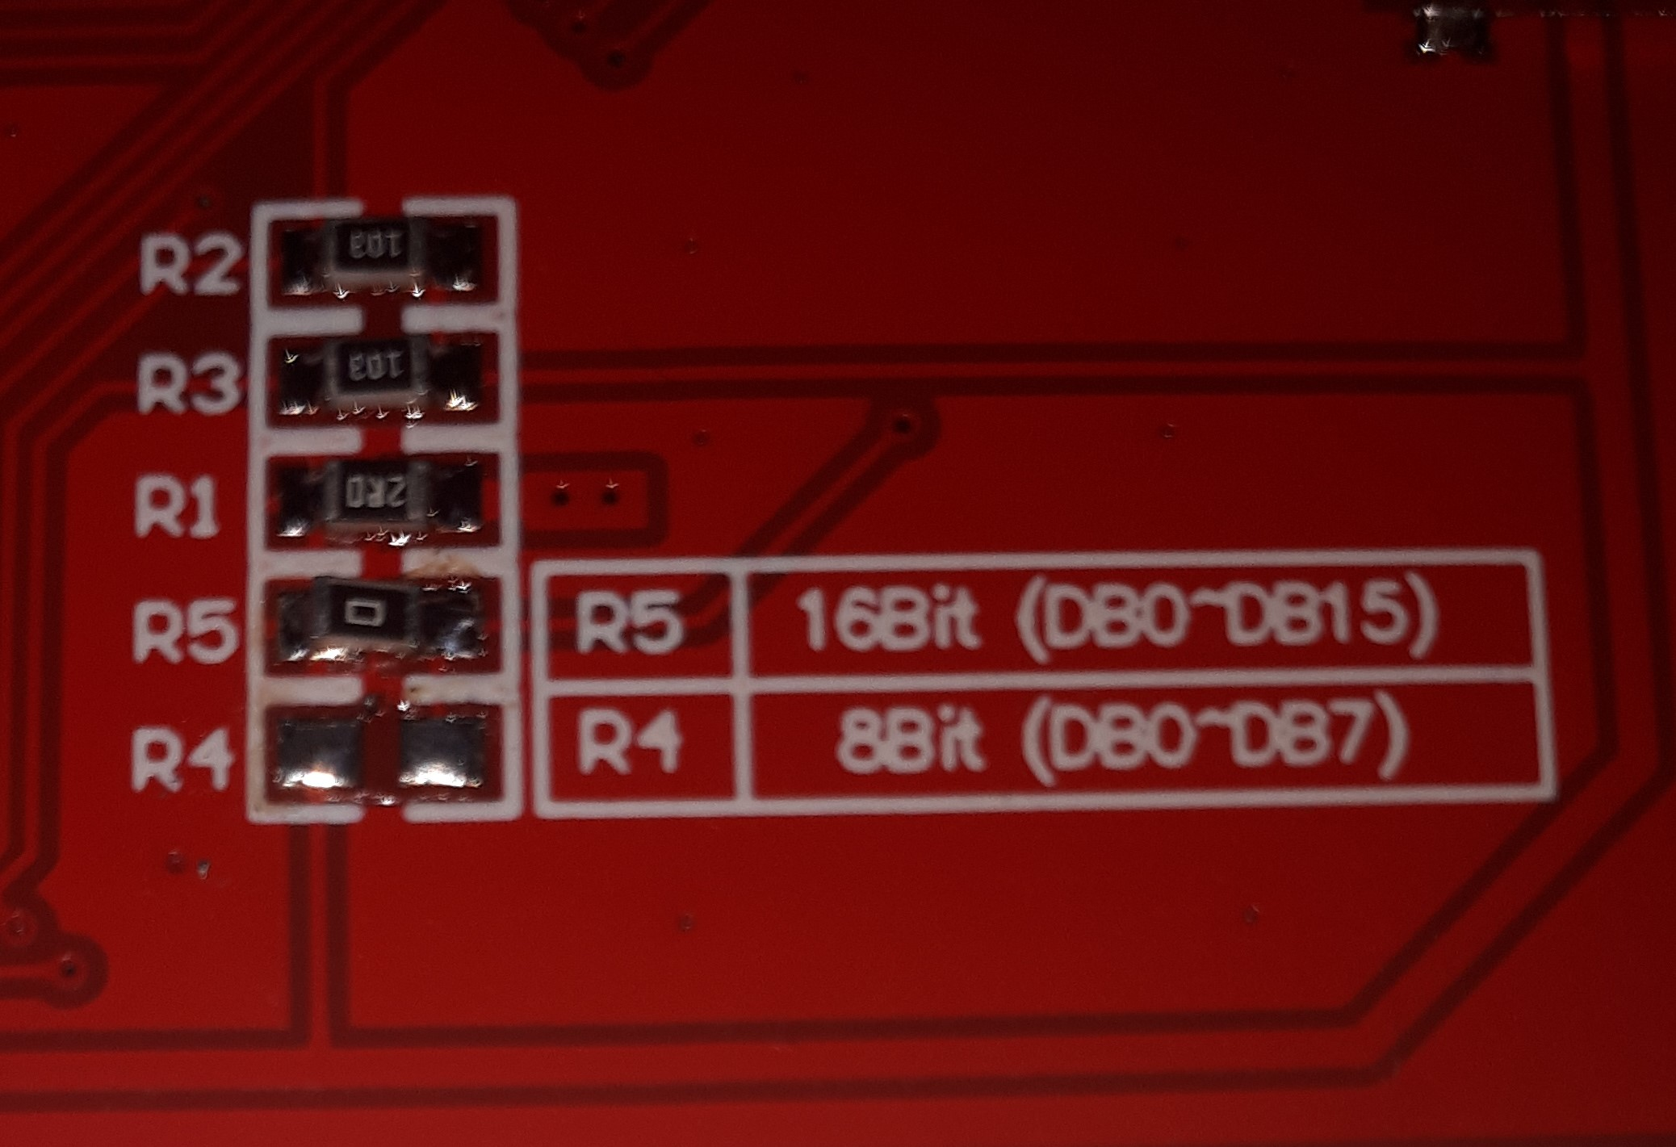
In order for this library to work correctly, this board has to be configured to 16-bit mode. This is accomplished by removing jumper/0 ohm resistor from the R4 position and placing it at the R5 position.

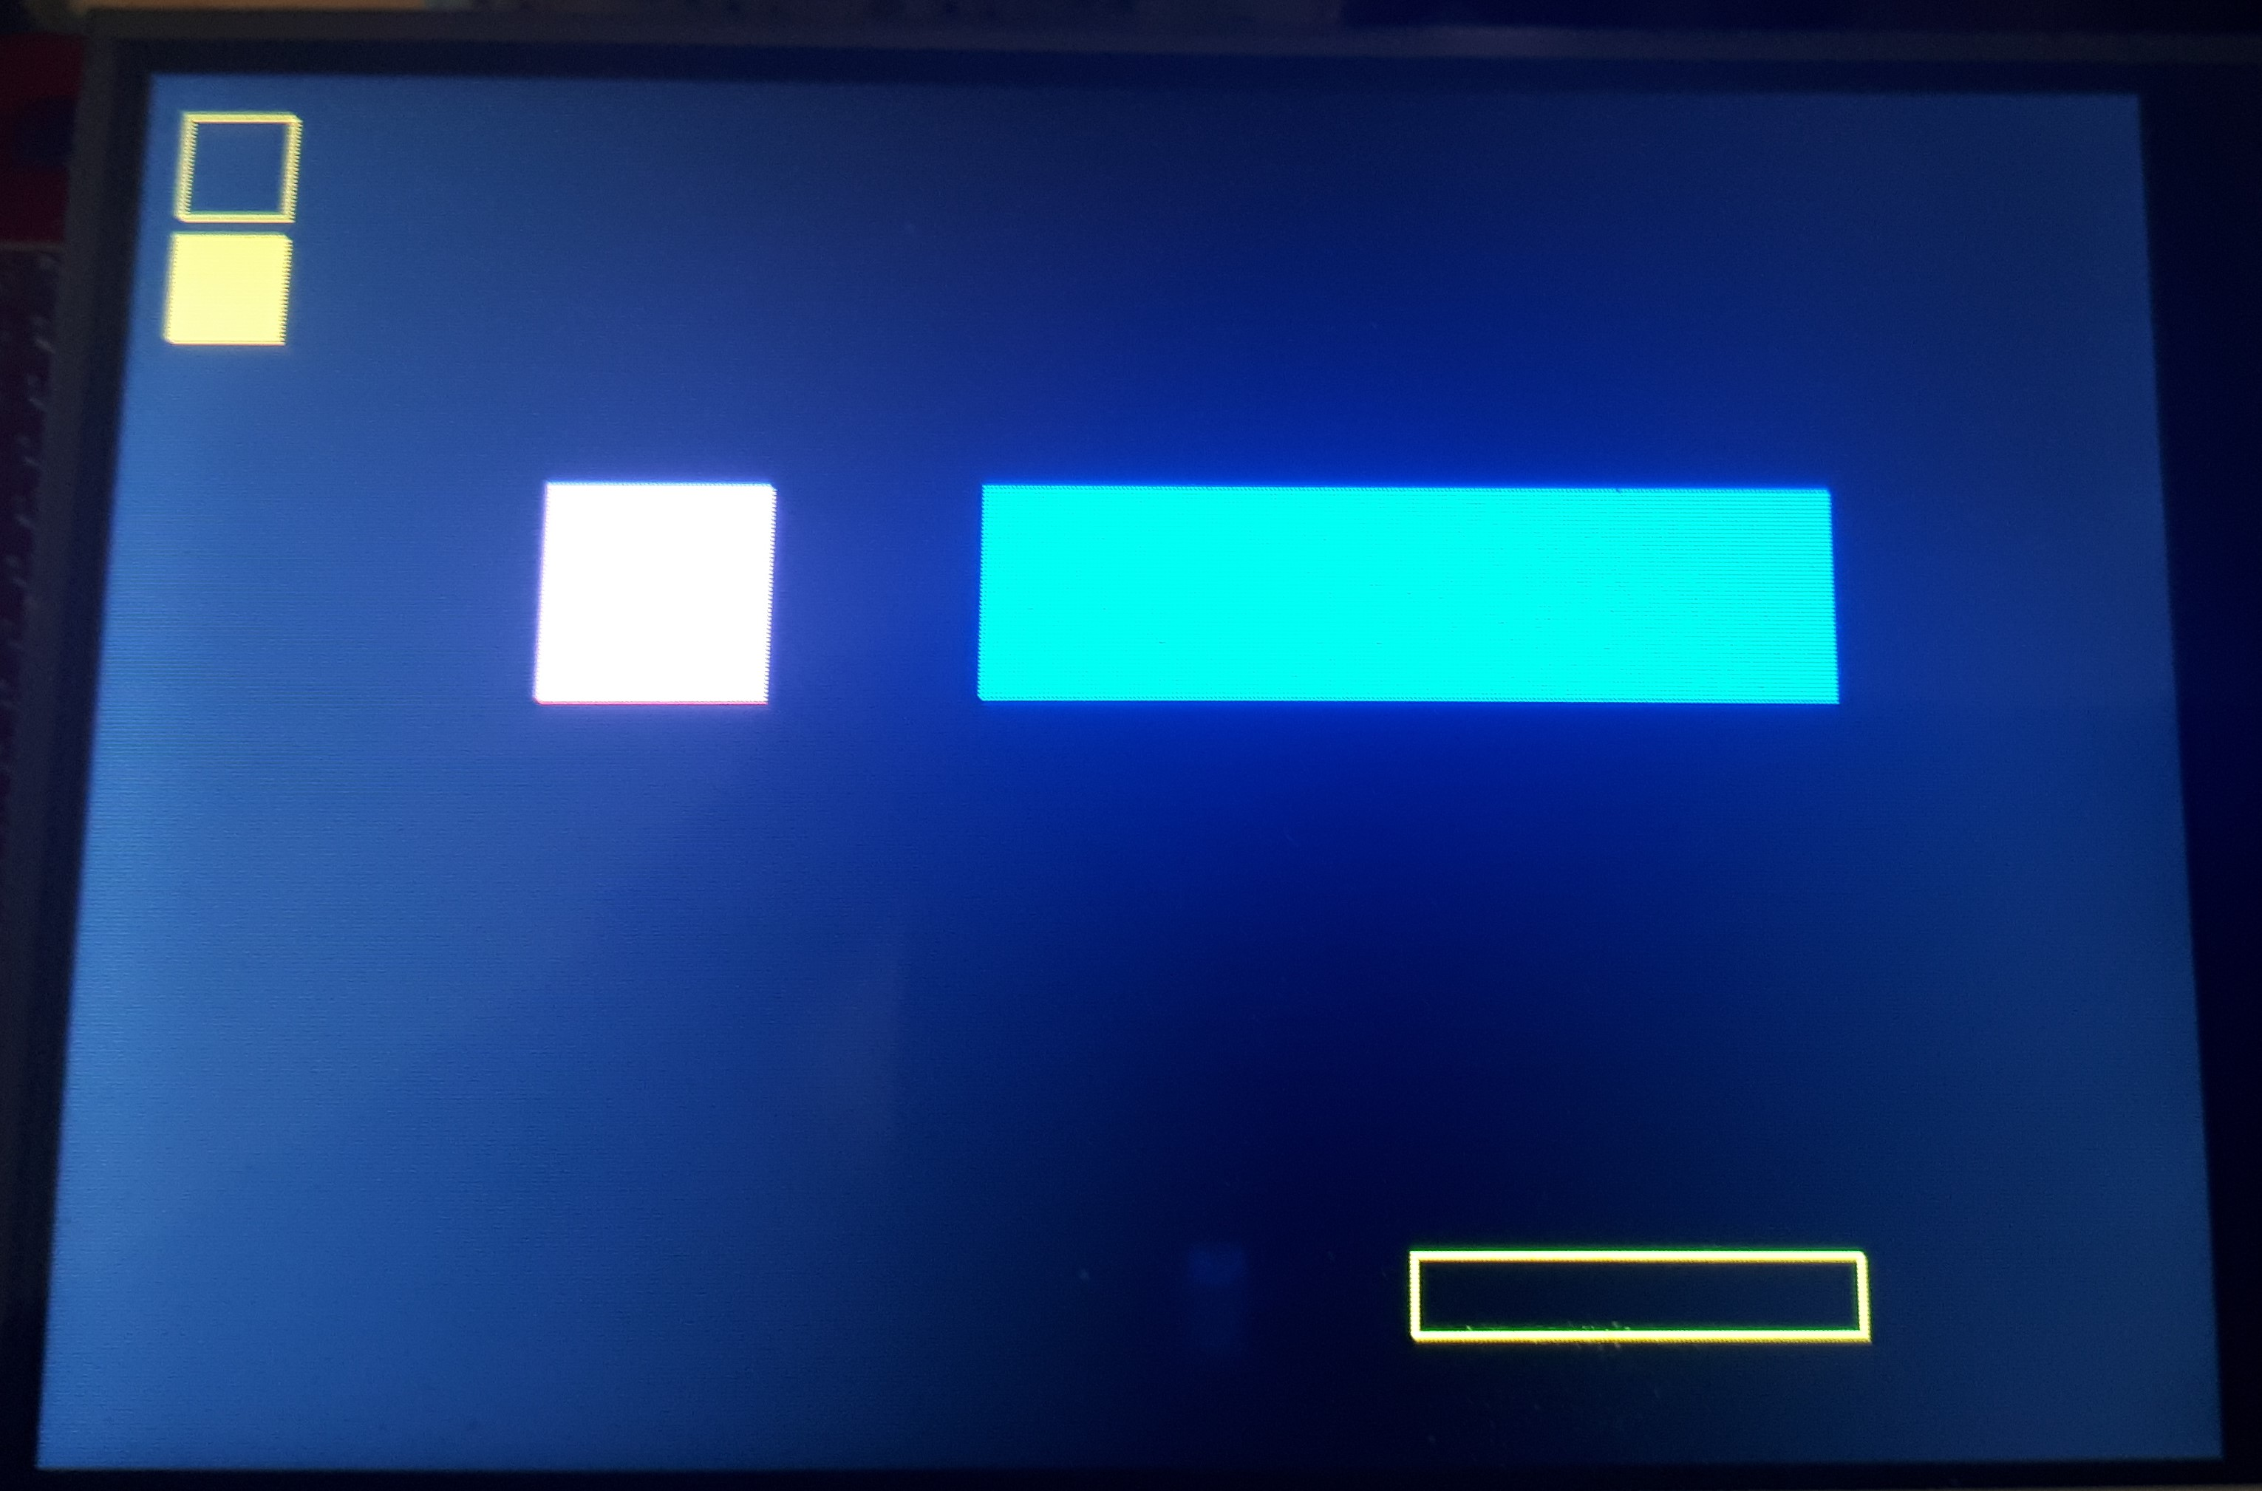

Pin mapping for the Arduino Due and Mega2560.

SECTION 4
Examples Description.

This page is intentionally blank.

SECTION 5
Introduction to Graphics.

This page is intentionally blank.

SECTION 6
Misc.

This page is intentionally blank.

All rights reserved.
This book or parts thereof may not be reproduced in any form, stored in any retrieval system, or transmitted in any form by any means—electronic, mechanical, photocopy, recording, or otherwise—without prior written permission of the publisher, except as provided by Canadian copyright law. For permission requests, write to the publisher, at “Attention: Permissions Coordinator,” at the address below.

DISCLAIMER

The information in this document is designed to provide helpful information on the operations of the above mentioned hardware and software components. Although all attempts to ensure that the information is accurate, it is presented “as is” without warranty of any kind. This is not meant to replace the applicable manufacturers instructions on the operation of the hardware or software in question. This software library has been tested in a limited capacity and will only operate on the tested components, including any modifications mentioned above. Some of the above procedures require a certain level of skill, if you should require assistance in this configuration issue, please contact someone with very good electronic/soldering skills to help. I will not be responsible for tort or damaged property, consequential or otherwise.

Cover Illustration Copyright © 2020 by ETM Studios
Cover design by Nash Ali, ETM Studios.
Book design and production by Yellow Highlighter Productions.
Editing and Photography by Nash Ali.
Chapter opening illustrations/photographs © 2010 Nash Ali
Permissions Coordinator:
email: nash4unow@hotmail.com

