

Group 4
Mohammed Ahmad – 754003903
Mohamed Ahmed - 767000238
Nasheel Nadeem - 764000112
Ryan Benson - 421007591

Web & Mobile II

ISTE240.602

Project Phase 2 Report

Spring 2026
Rubric
FRONTEND (20 pts) – CLOS 2, 3 and 5
├── 18-20: Professional + Bootstrap + responsive + toasts + loading states
├── 14-17: Clean + responsive + basic response messages
├── 10-13: Basic CSS + not responsive
└── 0-9: No CSS or broken

REST API (25 pts) – CLOS 4 and 5
├── 22-25: Each student has own controller + All 6 methods
├── 17-21: Each has controller + 4-5 methods
├── 12-16: Only 1-2 controller + 2-3 methods
└── 0-11: Only one controller + Less than 2 methods

JPA (20 pts) – CLO 4
├── 17-20: Each student has own repository + 5+ methods + entity classes
├── 13-16: Each has repository + 3-4 methods
├── 9-12: Only 1-2 repository + 1-2 methods
└── 0-8: One repository for all → ZERO for section

GIT (10 pts) – CLO 1
├── 9-10: Branches + 5+ commits + good messages + PRs
├── 7-8: Branches + 3-4 commits
├── 5-6: One branch + 1-3 commits
└── 0-4: Single commit

DEMO (15 pts) – CLOS 2, 3 and 5
├── 13-15: 5+ pages + all CRUD + no errors
├── 10-12: 4-5 pages + most CRUD
├── 7-9: 3 pages + basic CRUD
└── 0-6: Less than 3 pages

FINAL REPORT (10 pts) – CLO 1
├── 9-10: Complete documentation + API docs + team contributions + screenshots
├── 7-8: Most sections present + basic API docs
├── 5-6: Basic report + missing key sections
└── 0-4: No report or very incomplete

FINAL PRESENTATION (10 pts) – CLO 1
├── 9-10: Clear explanation + live demo works + answers questions confidently
├── 7-8: Good presentation + minor demo issues
├── 5-6: Basic presentation + demo has problems
└── 0-4: Cannot explain code + demo fails

Critical Deductions (Applied AFTER scoring)
Violation | Deduction
Missing student names/IDs in README | -10 points
Missing student names/IDs (as comments) at the top of their own classes | -10 points
Only one repository for all entities (not per student) | -8 points (ZERO for JPA section)
Using Mustache templates instead of HTML/JS/REST APIs | -10 points
Only one controller/service for all students | -11 points
No proper database seeding (0 records) or missing/incorrect configuration | -10 points
Absence during the presentation | -20 points

Manifesto
Each student contributed to specific modules including backend, frontend, and integration.
Mohammed Ahmad
Contribution:
- Appointment Module, Service, Repository, Controller and HTML page.
- Managing Github merging.
- Reported on Database Design and Features, and the API documentation.
Work Completed:
- Developed Appointment entity, repository, service, and controller.
- Implemented CRUD operations (create, read, update, delete).
- Implemented search functionality by department.
- Designed and developed appointment frontend page (HTML, JavaScript, AJAX).
- Integrated patient and doctor relationships into appointments.

Ryan Benson
Contribution:
- Patient Module, Service, Repository, Controller and HTML page.
- Wrote problem difinition.
Work Completed:
- Developed Patient entity, repository, service, and controller.
- Implemented CRUD operations for patient management.
- Implemented search functionality by patient name.
- Designed and developed patient frontend page.
- Ensured proper API integration with frontend.
Nasheel Nadeem
Contribution:
- Doctor Module, Service, Repository, Controller and HTML page.
- Contributed in the writing of Similar solutions, Technologies used and Technical Architcture.

Work Completed:
- Developed Doctor entity, repository, service, and controller.
- Implemented CRUD operations for doctors.
- Implemented filtering/search by profession and name.
- Developed doctor frontend page.
- Handled backend logic for doctor data management.
Mohamed Ahmed
Contribution:
- Feedback Module, Service, Repository, Controller and HTML page.
- Contributed in writing the abstract.
Work Completed:
- Developed Feedback entity, repository, service, and controller.
- Implemented CRUD operations for feedback.
- Implemented search functionality by patient, doctor, rating, and comment.
- Designed and developed feedback frontend page.
- Integrated feedback with patient and doctor data.

Abstract
This project is a web-based appointment management system designed for a psychology clinic. The system provides a platform where users can perform essential operations such as creating, updating, searching, and deleting records. It is developed using Spring Boot for the backend, MariaDB for the database, and HTML, CSS, and JavaScript for the frontend. REST APIs are used to enable communication between the frontend and backend, while AJAX allows dynamic interaction without page reloads. The system improves data organization, reduces manual errors, and enhances the overall efficiency of clinic operations.

Problem Definition
Most of the time in healthcare especially in psychology or mental health there are so many operational problems caused by outdated, manual processes. In many clinics doctor appointments are managed through systems without real time visibility which causes many scheduling conflicts and a bad experience for both the patients and the employees. This issue happens because of bad management of patient records and user accounts without a secure system with sensitive medical information which are usually difficult to update or access and usually there are no proper ways to get appointment feedback which doesn’t help the medical industry grow. Now with our SpiRIT management system we address all these issues through a web application which uses a MYSQL database and RESTful APIs to make scheduling easier, secure the user data and help get feedback for more improvement.

Similar Solutions
The hospital management system and online appointment platform already existing in the market deliver identical functions which include patient record management and scheduling and feedback handling. The systems require high costs and complex operations because their developers built them for use in extensive hospital networks.
The system we developed aims to provide users with an easy-to-use interface which enables them to complete their tasks. The system delivers essential functions which small clinics need to manage their operations through doctor and patient and appointment and feedback handling. The system achieves its lightweight design through user-friendly elements which make it simple to perform maintenance tasks.

Technologies Used
The system uses Spring Boot for backend development, MariaDB for database storage, and HTML, CSS, JavaScript with jQuery for the frontend. REST APIs are used for communication between the frontend and backend.The front end of the application develops its user interfaces through the combination of HTML and CSS and JavaScript. The system employs jQuery to improve user interaction by using AJAX requests that transmit data to the backend system while users continue to browse the current webpage. The UI framework Semantic UI creates a modern appearance through its styled buttons and forms and layout elements.

Technical Architecture
The application uses a layered architectural design which distributes system tasks across various system components.
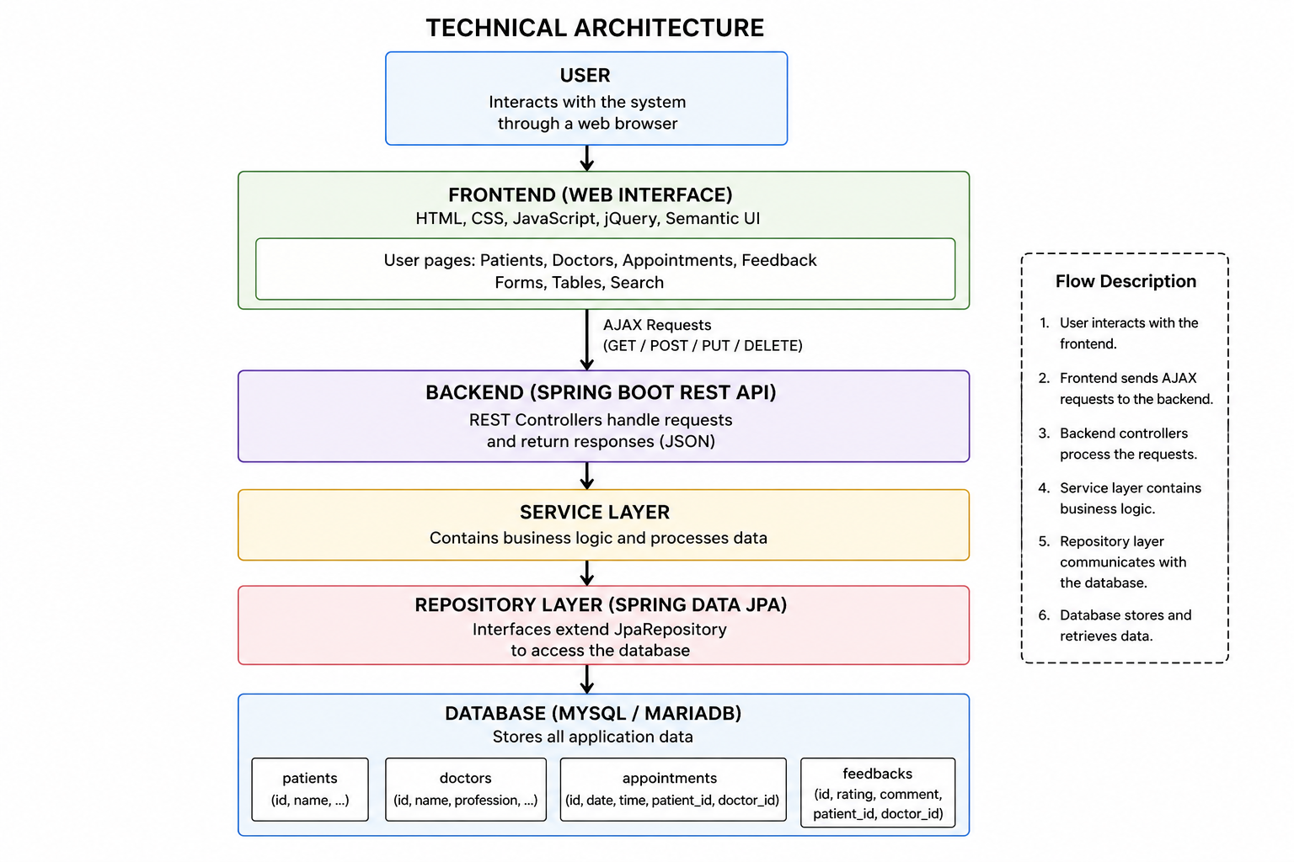
Figure 1: Technical Architecture diagram

The frontend layer exists as the highest system component which developers created using HTML and CSS and JavaScript and jQuery. The system enables users to interact with the application by performing tasks that include adding data and editing data and deleting data and searching data. The system uses AJAX to send HTTP requests from the frontend to the backend system.
Spring Boot REST controllers function as the backend system's main entry point which handles incoming requests. The controllers accept data from the frontend and send it to the service layer for processing of business operations.
The service layer establishes connections with the repository layer which employs Spring Data JPA (Hibernate) for database operations. The repositories perform operations such as saving, updating, deleting, and retrieving data from the MariaDB database.

Database Design
The database is designed around four main entities: Patient, Doctor, Appointment, and Feedback. Each entity represents a table in the database and is connected to the backend using JPA entity classes and repositories. The system stores the data persistently in the configured database so that records are not lost when the application restarts.
The Patient table stores patient information, including the patient ID and name. The Doctor table stores information about doctors, including their ID, name, and profession. The Appointment table stores appointment details, including department, date, and time. Each appointment is linked to one patient and one doctor. This creates a many-to-one relationship where one patient can have many appointments, and one doctor can also have many appointments. The Feedback table stores rating and comment information and is linked to both patient and doctor records.
This design helps reduce duplicate data. For example, instead of storing the full doctor and patient information inside every appointment, the appointment record links to existing doctor and patient records. This makes the database more organised and easier to maintain.

Features
The system includes four main modules: Patient, Doctor, Appointment, and Feedback. Each module includes backend REST API functionality, database integration, and a frontend page that allows users to interact with the data.
The Patient Module allows users to add, view, update, delete, and search patient records. The patient page displays all patients in a table and includes buttons for editing and deleting each record.
The Doctor Module allows users to manage doctor records. Users can add new doctors, update doctor information, delete doctors, and search by doctor name or profession.
The Appointment Module allows users to create and manage appointments. Each appointment includes a patient, doctor, department, date, and time. Users can add new appointments, update existing appointments, delete appointments, and search appointments by department.
The Feedback Module allows users to submit and manage feedback after appointments. Feedback records include patient information, doctor information, rating, and comment. Users can view feedback, add new feedback, edit feedback, delete feedback, and search feedback by patient, doctor, rating, or comment.
All modules use REST API to communicate between the frontend and backend. The frontend pages use JavaScript and AJAX requests to send and receive data without reloading the page.

API Documentation

Patient Endpoints
- GET /api/patients: Retrieve all patients
- GET /api/patients/{id}: Retrieve patient by ID
- GET /api/patients/search?name={name}: Search patients by name
- POST /api/patients: Create a new patient
- PUT /api/patients/{id}: Update a patient
- DELETE /api/patients/{id}: Delete a patient
- GET /api/doctors: Retrieve all doctors
- GET /api/doctors/{id}: Retrieve doctor by ID
- GET /api/doctors/search?name={name}: Search doctors by name
- GET /api/doctors/search?profession={profession}: Search doctors by profession
- POST /api/doctors: Create a new doctor
- PUT /api/doctors/{id}: Update a doctor
- DELETE /api/doctors/{id}: Delete a doctor
- PATCH /api/doctors/{id}/profession: Update only doctor profession
Appointment Endpoints
- GET /api/appointments: Retrieve all appointments
- GET /api/appointments/{id}: Retrieve appointment by ID
- GET /api/appointments/search?department={department}: Search appointments by department
- POST /api/appointments: Create a new appointment
- PUT /api/appointments/{id}: Update an existing appointment
- DELETE /api/appointments/{id}: Delete an appointment
Feedback Endpoints
- GET /api/feedbacks: Retrieve all feedback
- GET /api/feedbacks/{id}: Retrieve feedback by ID
- GET /api/feedbacks/search/doctor?name={name}: Search feedback by doctor name
- GET /api/feedbacks/search/patient?name={name}: Search feedback by patient name
- GET /api/feedbacks/search/rating?rating={rating}:
Search feedback by rating
- GET /api/feedbacks/search/comment?keyword={keyword}: Search feedback by comment
- POST /api/feedbacks:
Create new feedback
- PUT /api/feedbacks/{id}:
Update feedback
- DELETE /api/feedbacks/{id}:
Delete feedback

Screenshots

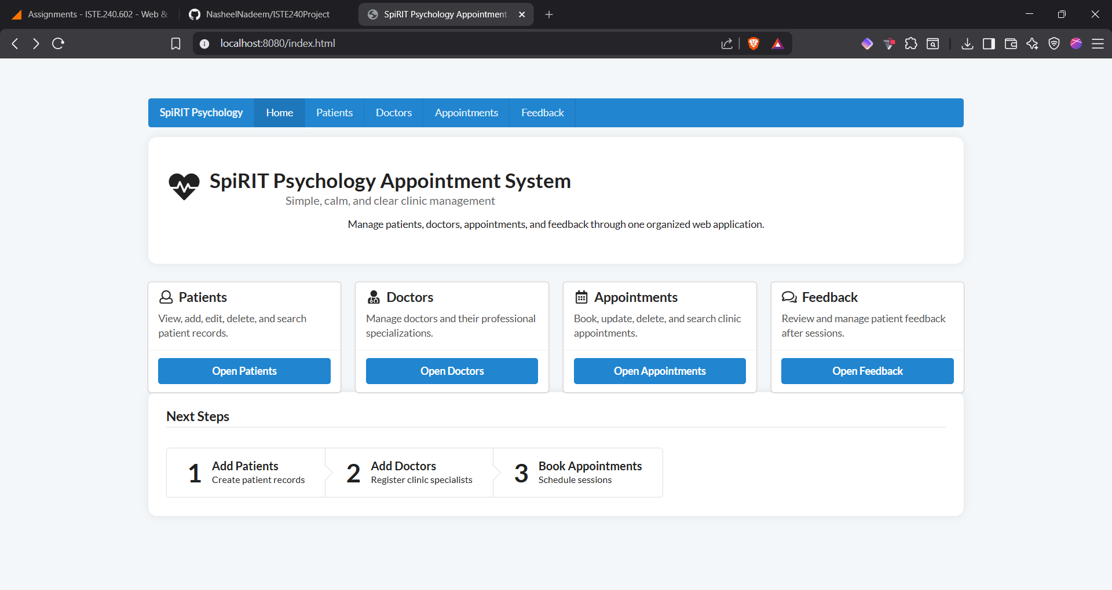
Figure 2: Home page
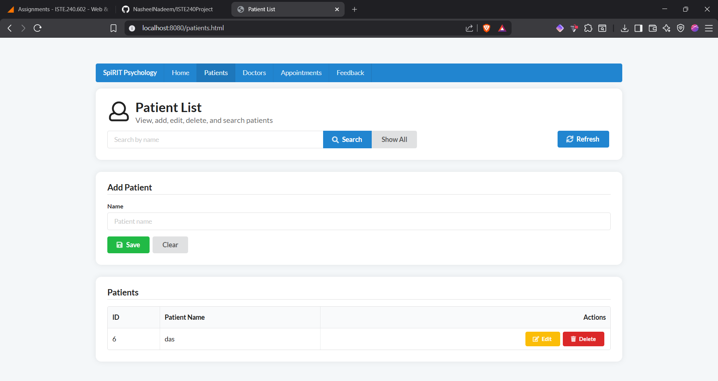
Figure 3: Patients list page
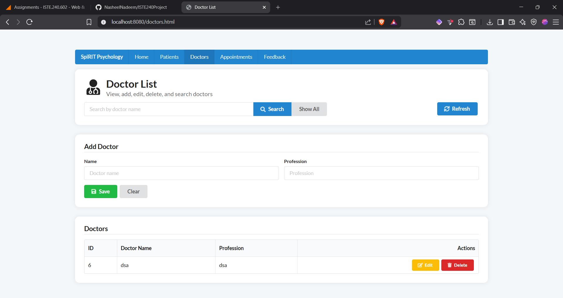
Figure 4: Doctors list page
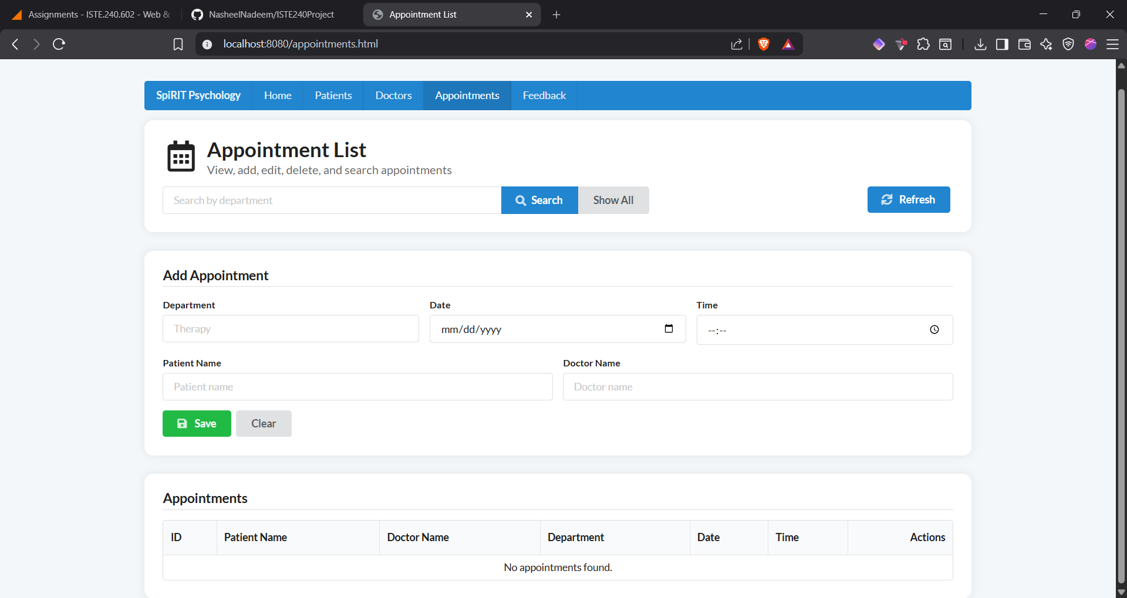
Figure 5: Appointment list page
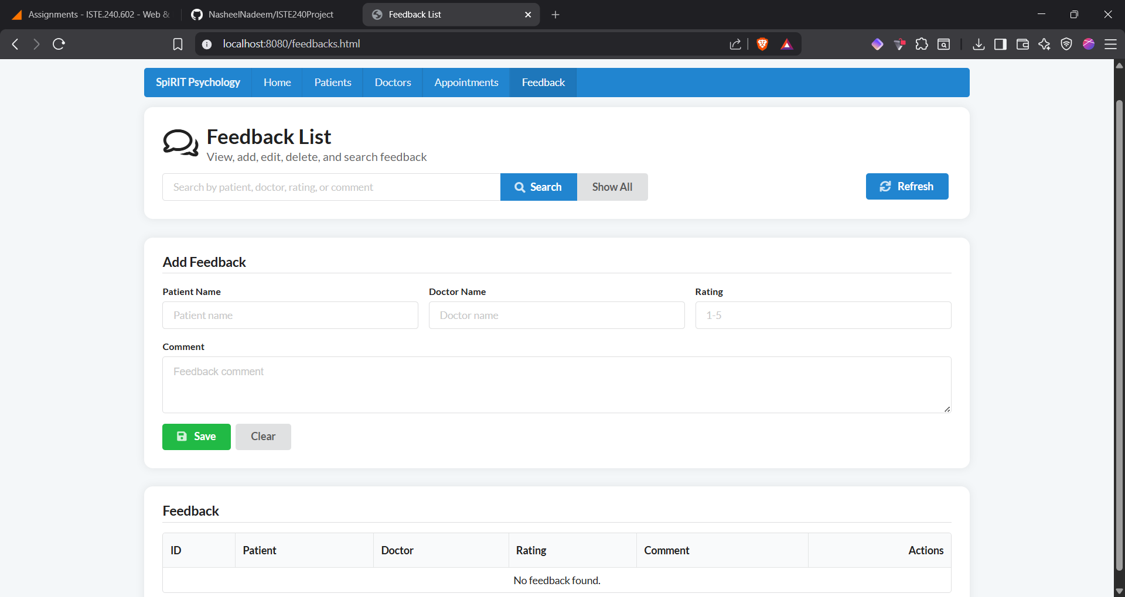

Figure 6: Feedback list page

GitHub & Collaboration
Each student worked on separate branches and used commits and pull requests.
Mohammed Ahmad works has been pushed into MohammedAhmad-appointment branch.
Ryan pushed into Ryan-b branch.
Nasheel pushed into Nasheel-Nadeem branch.
Mohamed Ahmed pushed into MohamedAhmed-feedbacks branch.
Mohammed Ahmad was managing the merging of branches into the main branch.

Github
Github repository link: https://github.com/NasheelNadeem/ISTE240Project

