**Sudoku Solver (Optimization)**

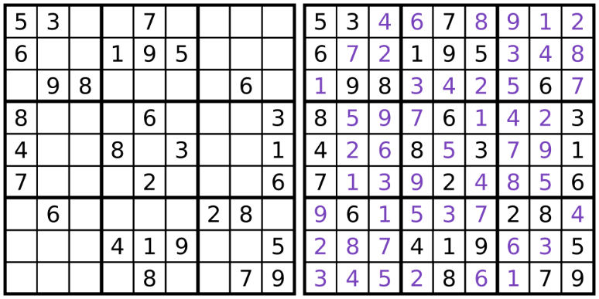Quoting [Wikipedia](http://en.wikipedia.org/wiki/Sudoku): "Sudoku is a logic-based, combinatorial number-placement puzzle. The objective is to fill a 9×9 grid so that each column, each row, and each of the nine 3×3 boxes (also called blocks or regions) contains the digits from 1 to 9 only one time each. The puzzle setter provides a partially completed grid." The rules for an N2 X N2 sudoku are as follows:

1. The board consists of N2 rows and N2 columns.
2. Numbers between 1 and N2(inclusive) are to be filled in each row such that:
   1. All numbers in each row are distinct.
   2. All numbers in each column are distinct.
   3. All numbers in the sub-matrix having rows from (i*N + 1) to (i + 1)*N, and columns from (j*N + 1) to (j + 1)*N both inclusive, should be distinct. 0 <= i,j <= N-1. Rows and columns are 1 indexed. Each such sub-matrix is called a "box" or "region".

For this problem, you are required to solve a general N2X N2 sudoku puzzle. Given a partially filled sudoku board, you have to fill it in as "perfect" a manner as possible.

**Input:**

The first line contains N, K. The following K lines contain 3 numbers: x, y and d. 1 <= x,y,d <= N^2. This means that a number d is present on the board at position (x,y) 2 <= N <= 10 0 <= K <= N4 At most 50% of the board will be covered at the start. All positions (x,y) in the input will be unique.

**Output:**

The output consists of N2 rows having N2 numbers each. Each number should be between 1 and N2 (inclusive) and separated by a space. If the initial grid has a number d at position (x,y), then even the output should have the number d at position (x,y).

**Scoring:**

A solution is “accepted” if:

* It solves a series of sudoku puzzles that have only one possible solution (no mandatory penalty).
* For a sudoku that must incur an obvious small penalty this penalty is as low as possible. The format for penalty calculation is as follows:
  + For each row and every number K in the range 1 to N2 that is missing from the row, incurs a penalty of 1.
  + For each column and every number K in the range 1 to N2 that is missing from the column, incurs a penalty of 1.
  + Similarly, for each box and every number K in the range 1 to N2 that is missing from the box, incurs a penalty of 1.

A box (as explained above) is a N X N square and the grid can be divided into N2 such non-overlapping boxes.

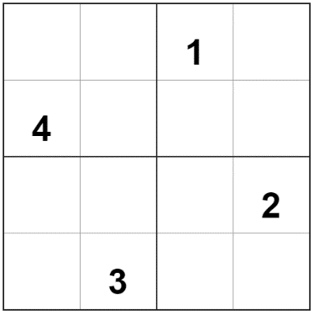**Example 1 (No penalty):**

**Input:**

2 4

1 3 1

2 1 4

3 4 2

4 2 3

**Output:**

3 2 1 4

4 1 2 3

1 4 3 2

2 3 4 1

**Penalty:**

No penalty

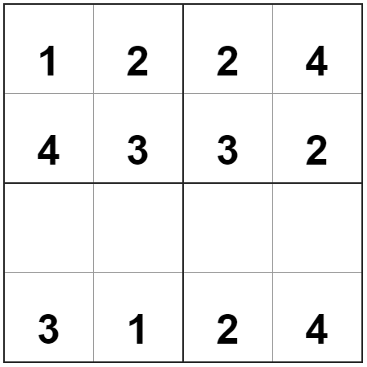**Example 2 (Minimum penalty):**

**Input:**

2 12

1 1 1

1 2 2

1 3 2

1 4 4

2 1 4

2 2 3

2 3 3

2 4 2

4 1 3

4 2 1

4 3 2

4 4 4

**Output:**

1 2 2 4

4 3 3 2

2 4 1 3

3 1 2 4

**Penalty:**

(1 + 1 + 0 + 0) + (0 + 0 + 1 + 1) + (0 + 1 + 0 + 0) = 5 (This penalty is mandatory)