ULTRASONIC THICKNESS MEASUREMENT REPORT
Company/Client: NCOC N.V. |  |  | Project: ESKENE WEST KARABATAN |  |  |  |  | Location: KUT-530
Drawing/Tag No: A1-530-ZN-001B |  |  | Component examined | Material |  | SA 516M Gr485 |  | Probe sensitivity calibration
Procedure No:  QP-11-UTT-Q01 Rev 00 |  |  | Component examined | Día X Nominal Thickness |  | 800mm x 10 mm |  | Probe S/N |  | 677194
 |  |  | Component examined | Operating Temp |  | Ambient |  | Angle |  | 0º
Manufacturing Code/Acceptance Standard: ASME SEC VIII Div. 1/ Client spec. |  |  | Reference Calibration Block Details | Block |  | CS Step wedge |  | Frequency |  | 5 MHz
 |  |  | Reference Calibration Block Details | Range |  | (6.25-25 mm) |  | size |  | 11 mm
Method: Contact |  |  | Reference Calibration Block Details | Accuracy |  | 0.025 mm |  | Crystal |  | Dual
Surface condition: Coated |  |  | Reference Calibration Block Details | Temperature |  | Ambient |  | Reference sensitivity |  | 2nd backwall reflection to 80% FSH
Couplant: Gel |  |  | Correction factors |  |  | N/A |  | Scan Sensitivity |  | Reference dB
S. No | Equipment/  Material Name | Manufacturer |  |  | Serial No |  | Calibration certificate No |  | Calibration Expiry date
 | A-scan UT | OLYMPUS DL-38 |  |  | 171421601 |  | 2113237 |  | 01-04-2018
 | Step wedge calibration block | OLYMPUS |  |  | 145414 |  | - |  | -
Job description:

- UT scanning performed on shell, top and bottom header of the activated carbon filter
- UT spot check performed on 12, 3, 6, 9 O’clock of Nozzles.
- The results were obtained using special probe by eliminating coating thickness.

Legend:
FSH: Full Screen Height, N/A: Not Applicable

DETAILS AND RESULTS
Bottom header (inside view)

North
East
West
South
Vertical weld

Top header (inside view)
West

Nozzle N2
North
South

Nozzle N4

East

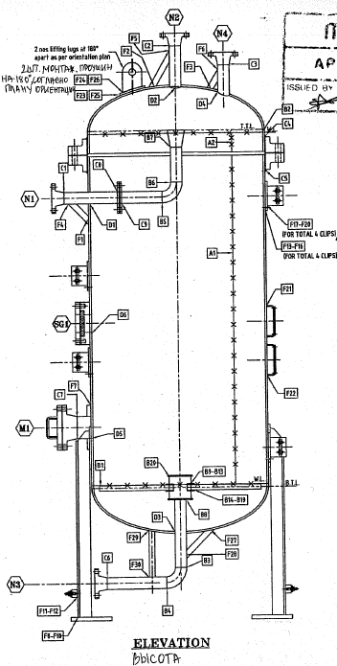

Shell
Middle level
Bottom level
Top level
UT spot check place

 | S/NO | Item description | Spot  Section | Nominal Thickness, mm | North, mm | South, mm | East, mm | West, mm
 | 1 | Shell* | Top | 10 | 10.3 | 10.5 | 10.7 | 11.1
 | 1 | Shell* | Middle | 10 | 10.89 | 10.47 | 10.8 | 10.8
 | 1 | Shell* | Bottom | 10 | 10.3 | 10.84 | 10.57 | 10.8
 | 2 | Top Head* | A | 12 | 11.8 | 11.89 | 11.16 | 11.7
 | 3 | Bottom Head* | A | 12 | 12.7 | 12.9 | 13.0 | 13.1
Notes :
* protection coating thickness is from 0.34 till 0.63 mm. Measurement by UT gauge Olympus DL-38.
S/NO | Item description | Diameter, inch | Nominal Thickness, mm | North, mm | South, mm | East, mm | West, mm | Top | Bottom
 | Nozzle N1* | 2 | 8.74 | 9.3 | 9.23 | - | - | 9.5 | 9.3
 | Nozzle N2* | 2 | 8.74 | 9.26 | 9.5 | 9.3 | 9.2 | - | -
 | Nozzle N3* (internal) | 2 | 8.74 | 9.2 | 9.69 | 9.57 | 9.21 | - | -
 | Nozzle N3* (external) | 2 | 8.74 | 9.0 | 9.67 | 9.63 | 9.3 | - | -
 | Nozzle N4* | 2 | 8.74 | 9.2 | 9.2 | 9.5 | 9.4 | - | -
 | Nozzle M1* | 4 | 11.13 | - | - | 11.52 | 12.7 | 11.34 | 11.62
Notes :
* protection coating thickness is from 0.34 till 0.63 mm. Measurement by UT gaugeOlympus DL-38

APPROVALS:
Operator  UT L-II cert. No 403  expire date 14.05.2018 | Name: Dosbatyrov Damir | Signature:................................................. | Date: 25.02.2018
Supervisor  UT L III cert. No 1A123/15  expire date 29.02.2020 | Name: Shundryk Ihar | Signature:................................................. | Date: 25.02.2018
Client Representative: | Name:…………………………………… | Signature:................................................. | Date: …………………………

