ULTRASONIC TESTING REPORT
Company/Client |  | NCOC N. V. |  | Project |  | ESKENE WEST |  | Location |  | KUT - 570
Line No/Tag No: |  | A1-5700-CS-034-3/4"-NI2.4-HC |  | Material |  | Pipe:B167- N06600;  Elbow: B366; |  | Día × Nominal Thickness |  | 3/4”×2.87mm
Procedure No: |  | QP-11-UTT-Q01 Rev 03  GOST 28702-90 |  | Calibration Block |  | Step wedge |  | Probe  S/N |  | MTD 705  n/a
 |  |  |  | Calibration block Range |  | 2.5-25.0 mm |  | Angle |  | 0º
Manufacturing Code |  | ASME B31.3 |  | Calibration Temp |  | +25º |  | Frequency |  | 5 MHz
 |  |  |  | Object Temp |  | +25º |  | Size |  | 5.1 mm
Acceptance Standard: |  | Acc. to the client specif. |  | Correction factors |  | n/a |  | Crystal |  | Dual
Surface condition |  | Uncoated |  | Couplant |  | UT Gel |  | Accuracy |  | ± 0,1 mm
S. No | Equipment/  Material Name |  | Manufacturer |  | Serial No |  | Calibration certificate No |  | Calibration Expiry date
 | A-scan UT |  | OLYMPUS DL-38 |  | 171421601 |  | BK-01-0674 |  | 20-03-2020
 | Step wedge calibration block |  | NDE-TECH |  | NDE-8363 |  | 7439 |  | 09-05-2020
Job description:

- UT spot check performed on line A1-5700-CS-034-3/4"-NI2.4-HC (drawing KE01-A1-570-MT-P-D1-1001-089)
- P&ID scheme No is KE01-A1-570-MT-R-HP-0024-007.
- Inspection performed on East, West, South, North, Top, Bottom and Extrados from external.
Notes:
N/A – not applicable.
FSH - Full Screen Height

DETAILS AND RESULTS
KE01-A1-570-MT-P-D1-1001-089

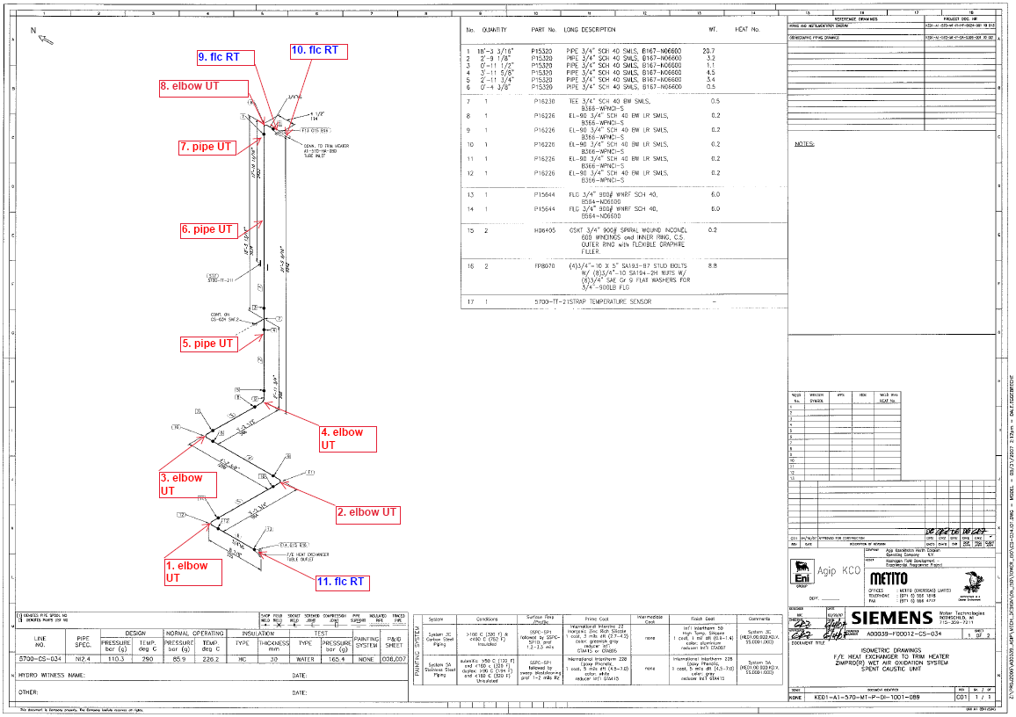

S/NO | P&ID | Isometric No | Line No | Item description | DIA(Ø), inch | Nominal thickness, mm* | East  mm | West  mm | South  mm | North  mm | Top  mm | Bottom  mm | Extrados  mm
1 | KE01-A1-570-MT-R-HP-0024-007 | KE01-A1-570-MT-P-DI-1001-089 | A1-5700-CS-034-3/4"-NI2.4-HC | Elbow-1 | ¾ | 2.87 | - | - | - | - | 2.58 | 2.38 | 1.98
2 | KE01-A1-570-MT-R-HP-0024-007 | KE01-A1-570-MT-P-DI-1001-089 | A1-5700-CS-034-3/4"-NI2.4-HC | Elbow-2 | ¾ | 2.87 | - | - | - | - | 2.53 | 2.58 | 1.99
3 | KE01-A1-570-MT-R-HP-0024-007 | KE01-A1-570-MT-P-DI-1001-089 | A1-5700-CS-034-3/4"-NI2.4-HC | Elbow-3 | ¾ | 2.87 | - | - | - | - | 2.46 | 2.34 | 1.89
4 | KE01-A1-570-MT-R-HP-0024-007 | KE01-A1-570-MT-P-DI-1001-089 | A1-5700-CS-034-3/4"-NI2.4-HC | Elbow-4 | ¾ | 2.87 | - | - | 2.44 | 2.57 | - | - | 1.88
5 | KE01-A1-570-MT-R-HP-0024-007 | KE01-A1-570-MT-P-DI-1001-089 | A1-5700-CS-034-3/4"-NI2.4-HC | Pipe-5 | ¾ | 2.87 | 2.38 | 2.41 | 2.46 | 2.46 | - | - | -
6 | KE01-A1-570-MT-R-HP-0024-007 | KE01-A1-570-MT-P-DI-1001-089 | A1-5700-CS-034-3/4"-NI2.4-HC | Pipe-6 | ¾ | 2.87 | 2.28 | 2.36 | 2.35 | 2.37 | - | - | -
7 | KE01-A1-570-MT-R-HP-0024-007 | KE01-A1-570-MT-P-DI-1001-089 | A1-5700-CS-034-3/4"-NI2.4-HC | Pipe-7 | ¾ | 2.87 | 2.35 | 2.36 | 2.38 | 2.34 | - | - | -
8 | KE01-A1-570-MT-R-HP-0024-007 | KE01-A1-570-MT-P-DI-1001-089 | A1-5700-CS-034-3/4"-NI2.4-HC | Elbow-8 | ¾ | 2.87 | 2.34 | 2.23 | - | - | - | - | 1.85

*according to ASME B36.10-B36.19 schedule 40

Examined by  UT L II cert. No 628  expiry date: 19.12.2022 | Name: Dariskaliyev Nurdaulet | Signature:..................................... | Date: 18 July 2019
Approved by  UT L III cert. No 1A123/15  expiry date 29.02.2020 | Name: Shundryk Ihar | Signature: ............................. | Date: 18 July 2019
Client Representative: | Name: …………………………… | Signature: .................................... | Date: ………………………

