ULTRASONIC TESTING REPORT
Company/Client |  | NCOC N. V. |  | Project |  | ESKENE WEST |  | Location |  | KUT - 570
Line No/Tag No: |  | A1-5700-WW-004-3/4”-NI2.4-HC |  | Material |  | Tee:B366-WPNCI-S; |  | Día × Nominal Thickness |  | ¾”×2.87 mm
Procedure No: |  | QP-11-UTT-Q01 Rev 03  GOST 28702-90 |  | Calibration Block |  | Step wedge |  | Probe  S/N |  | D7908  1214571
 |  |  |  | Calibration block Range |  | 2.0-20.0 mm |  | Angle |  | 0º
Manufacturing Code |  | ASME B31.3 |  | Calibration Temp |  | +3ºC |  | Frequency |  | 5 MHz
 |  |  |  | Object Temp |  | +3ºC |  | Size |  | 5.1 mm
Acceptance Standard: |  | Acc. to the client specif. |  | Correction factors |  | n/a |  | Crystal |  | Dual
Surface condition |  | Uncoated |  | Couplant |  | UT Gel |  | Accuracy |  | ± 0,1 mm
S. No | Equipment/  Material Name |  | Manufacturer |  | Serial No |  | Calibration certificate No |  | Calibration Expiry date
 | DL-38 |  | OLYMPUS |  | 171421601 |  | BK-01-0674 |  | 20-03-2020
 | Step wedge calibration block |  | NDE-TECH |  | NDE-8365 |  | - |  | -
Job description:

- UT spot check performed on line A1-5700-WW-004-3/4"-NI2.4-HC (drawing No KE01-A1-570-MT-P-D1-1001-111).
- P&ID scheme No is KE01-A1-570-MT-R-HP-0024-001.
- Standard UT technique was used.
- Inspection performed on East, West, South, North and Extrados from external.
Notes:
N/A – not applicable.
FSH - Full Screen Height

Inspection drawing
KE01-A1-570-MT-P-D1-1001-111
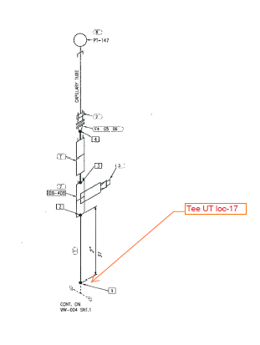

Inspection results
S/NO | P&ID | Isometric No | Line No | Item description | DIA(Ø), inch | Nominal thickness, mm* | East  mm | West  mm | South  mm | North  mm | Top  mm | Bottom  mm | Extrados  mm
1 | KE01-A1-570-MT-R-HP-0024-001 | KE01-A1-570-MT-P-DI-1001-111 | A1-5700-WW-004-3/4-NI2.4-HC | Tee-17 | ¾ | 2.87 | 3.73 | 3.63 | - | - | - | 4.01 | -

*according to ASME B36.10-B36.19 schedule 40

Examined by:  UT L II cert. No 355  expiry date: 16.04.2021 | Name: Dariskaliyev Nurdaulet | Signature: ............................... | Date: 23 Jan 2020
Approved by:  UT L II cert. No 1A 167/17  expiry date 31.01.2022 | Name: Barsukou Raman | Signature: ........................... | Date: 23 Jan 2020
Client Representative: | Name: …………………………… | Signature: .............................. | Date: ……………………

