**“Handlebar” trick…**

**If you have a series of programs (like weekly storytime) put in the first 2 occurrences. NOTE: if you have 2 storytimes per day, start with the early storytime and put the first week of the early storytime and the next week of the early storytime...see below. So, I will put in all of my Tuesday at 9:30 storytimes, before doing my Tuesday at 10:30 storytimes.**

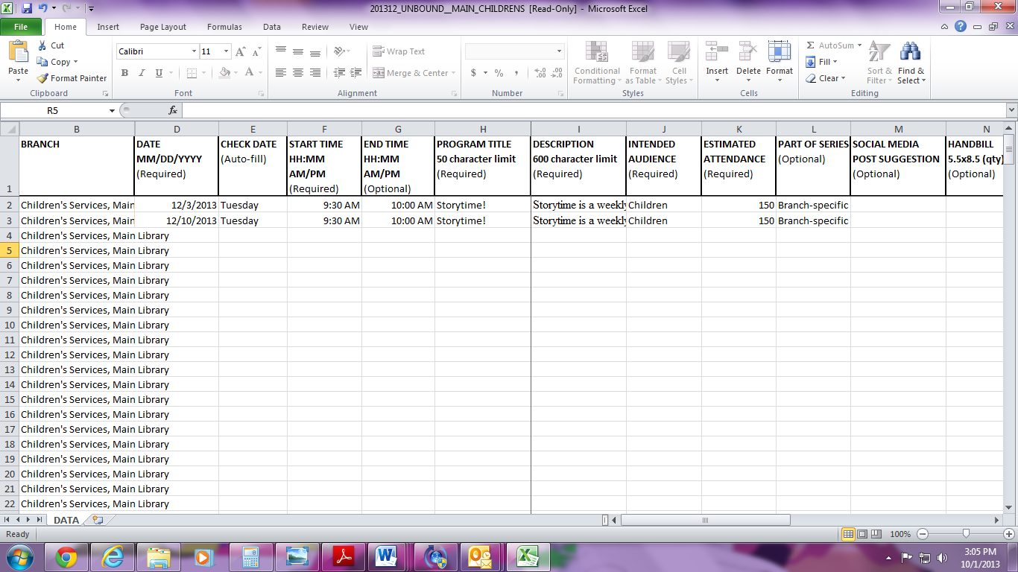

**Next drag and highlight the first two dates…**

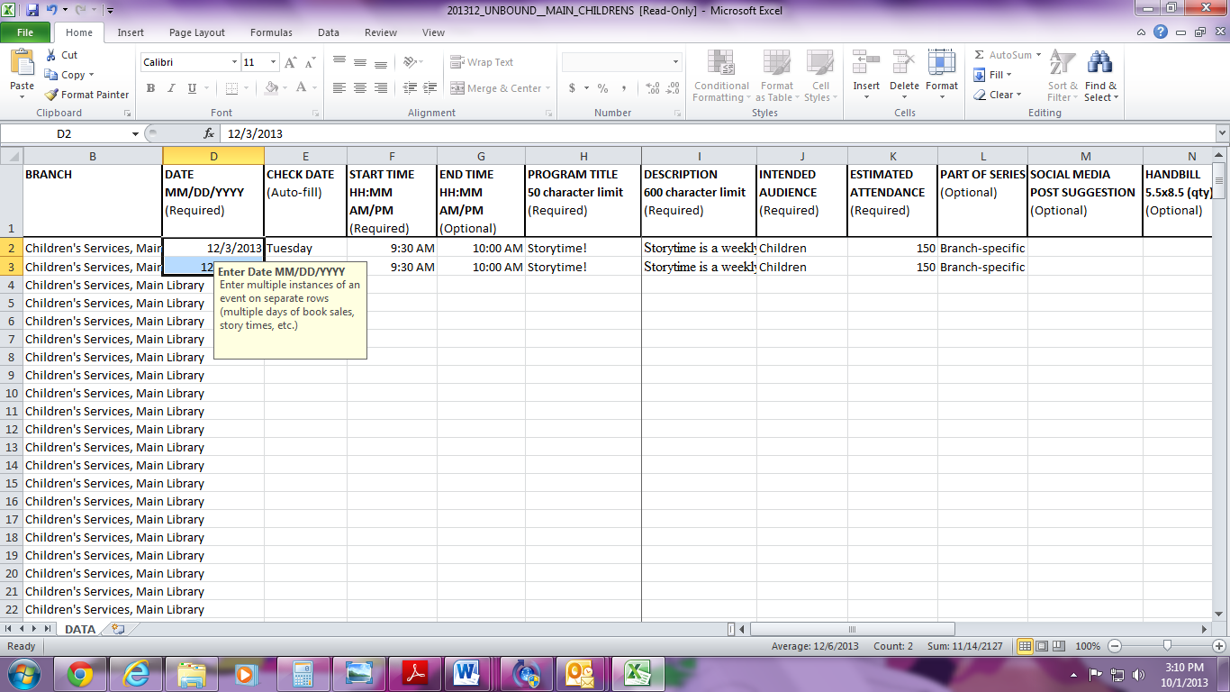

**That pesky yellow box will appear, put your mouse on it and drag it to the middle of the spreadsheet to get it out of your way.**

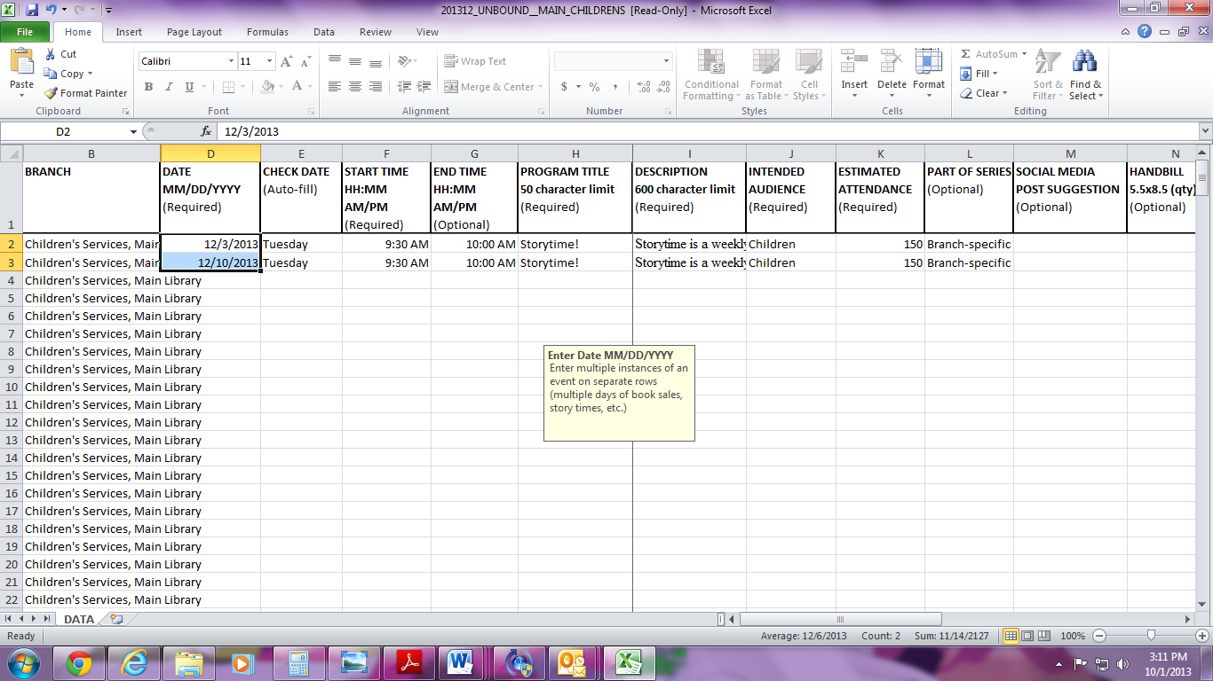

**Now, do you see that tiny black square that appears in the lower right corner of your selected dates?**



**“Hover” your cursor over it and your fat white + sign will turn into a skinny black + sign…we are getting there!!!**

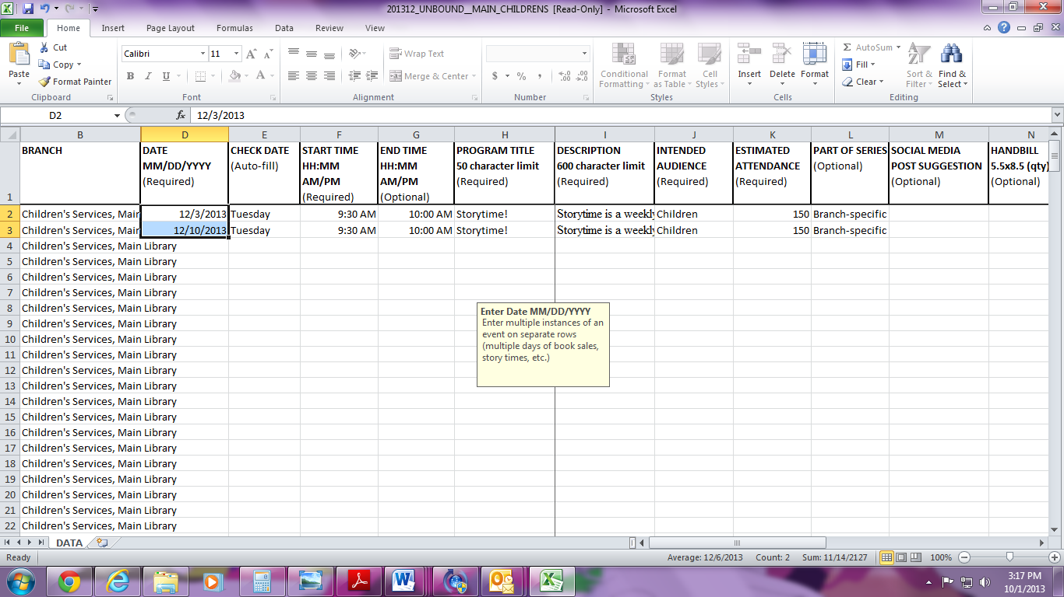

**Once it turns into a skinny black + sign, click and drag down and the fields below will automatically populate with the following weekly dates.**

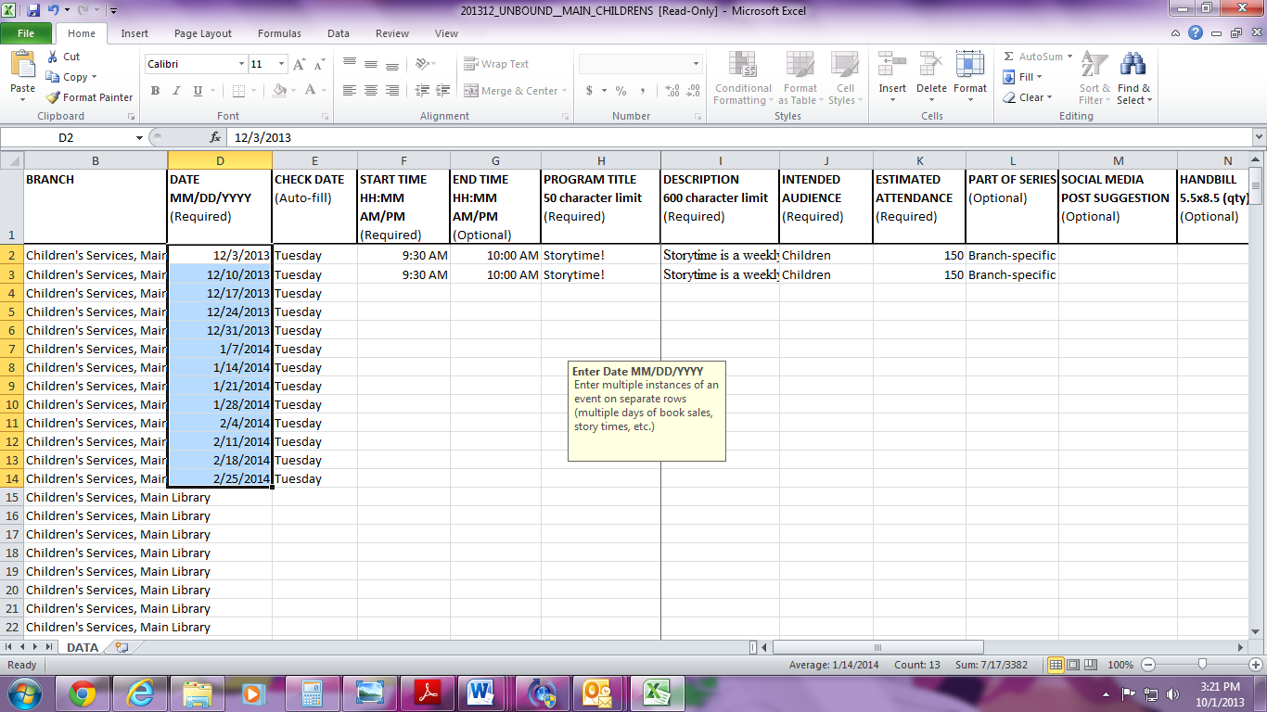

**“But Lindsey, I’m not having a storytime on Christmas Eve!” Not to worry – you can take that out later!**

**“But Lindsey, I have a special guest on January 28!” No worries, there, either – we can change that later. Get them all in the spreadsheet first!**

**Now, you can use the handlebar to populate the other fields.**

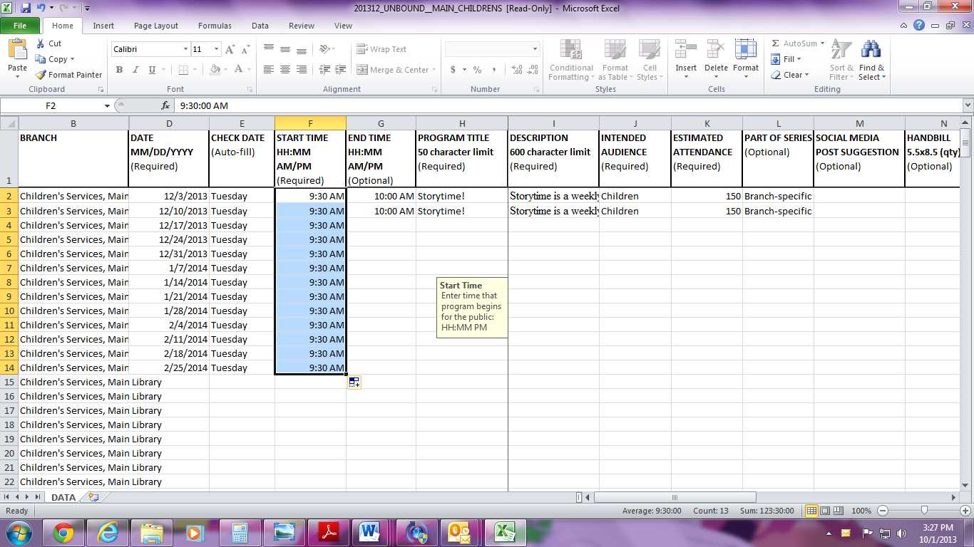**Highlight… Click on the tiny square…. And drag down….**

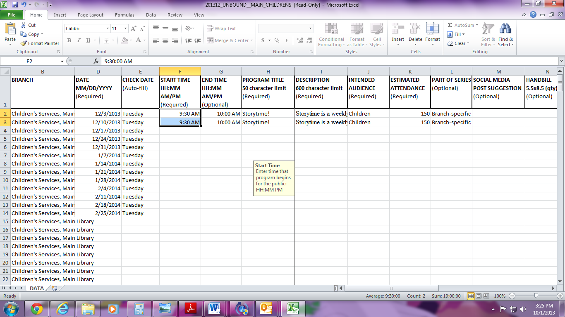

**You can even select multiple columns of information…**

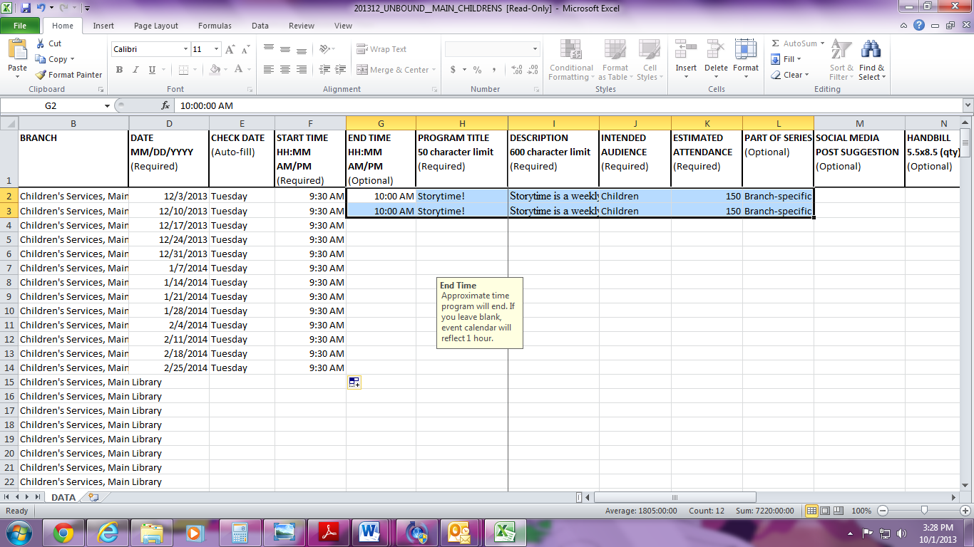

**Click on the little black square and drag down…**



**Voila!!**

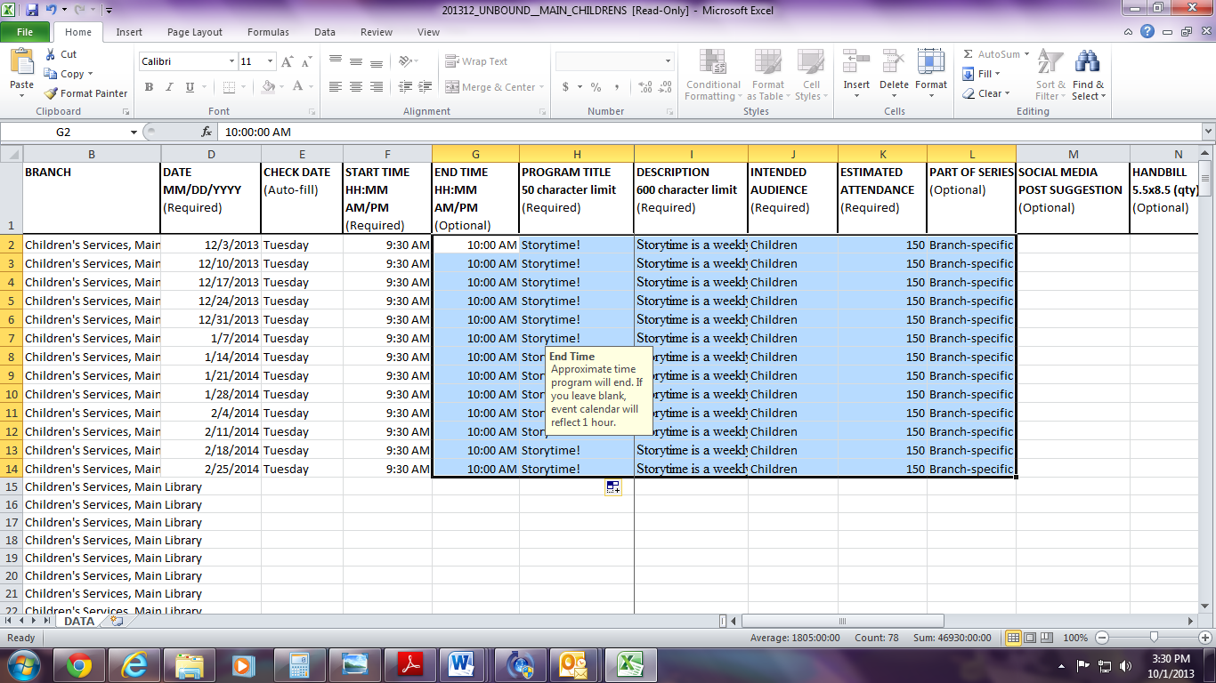

**Rinse and Repeat!**

**What about those dates where you don’t have storytime and you need to delete? Click on the cell that has the date of your storytime and once it is highlighted (has the black box around it) click delete. Then, you can highlight and drag the rest of the contents in the row and click “delete” to empty the contents of the row.**

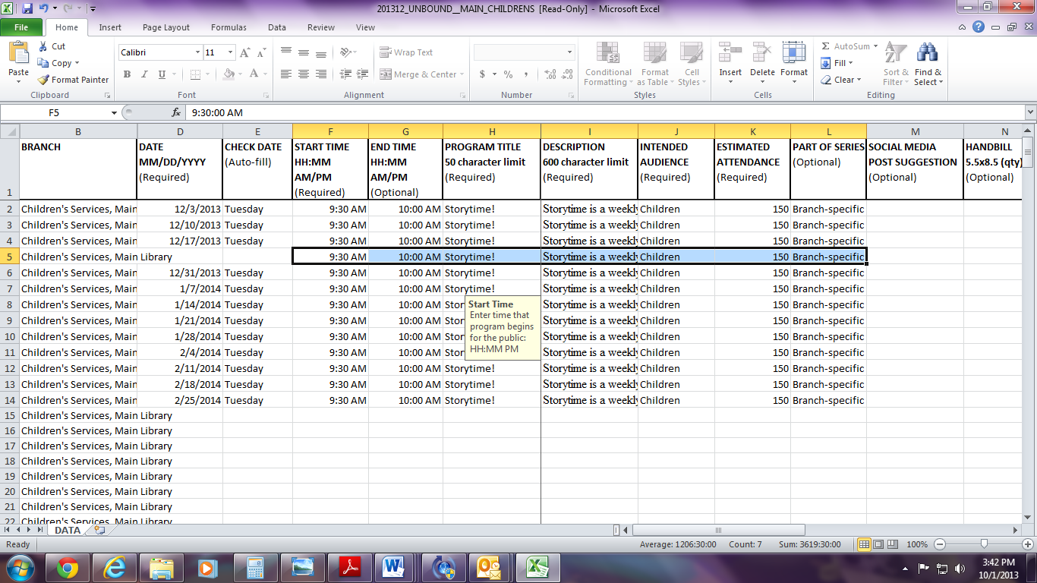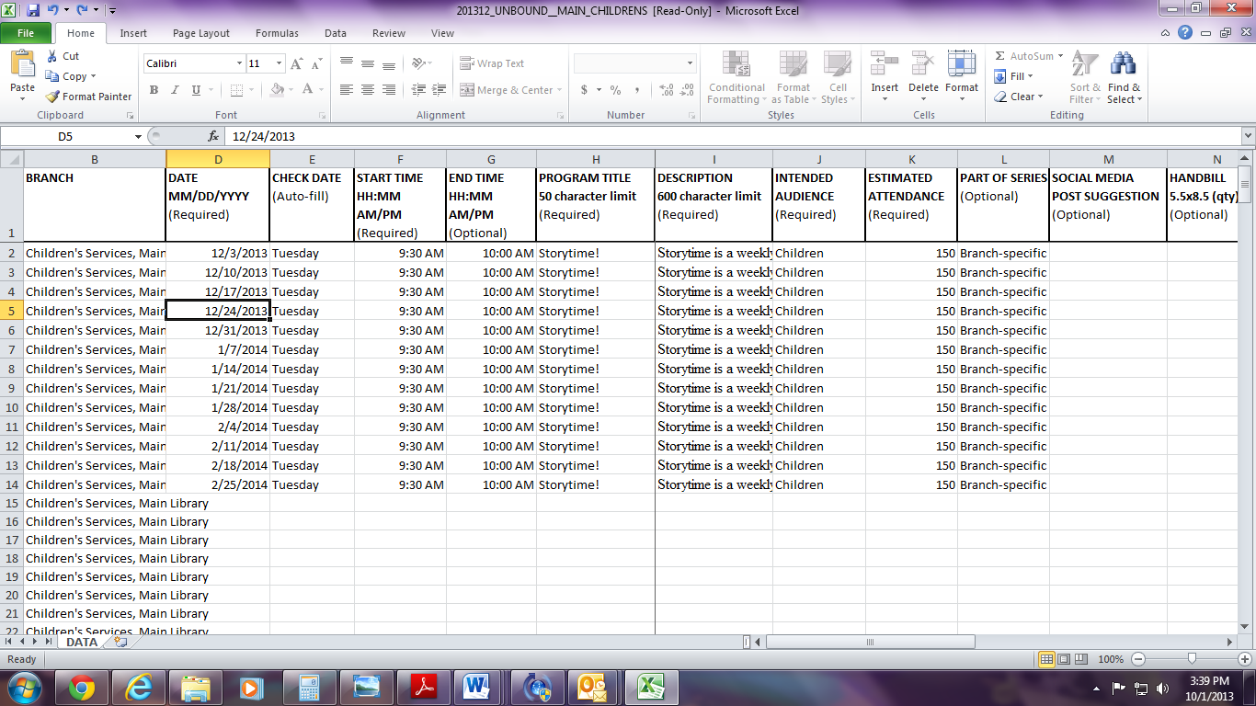

**You will now have an empty row. It is okay. Embrace and love it and name it George.**

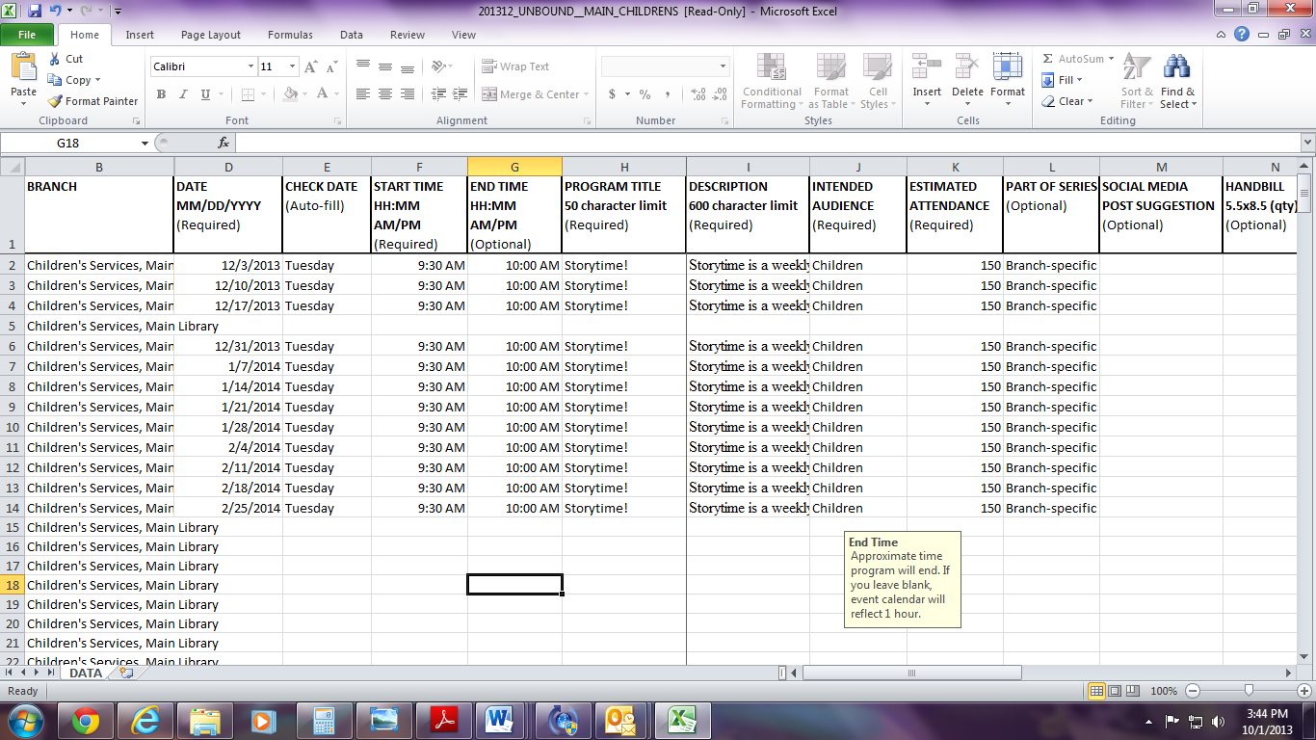

**If you are having a special guest or for your Hunger Awareness program, just go to that date and change the title and/or description and/or “Part of a Series”**

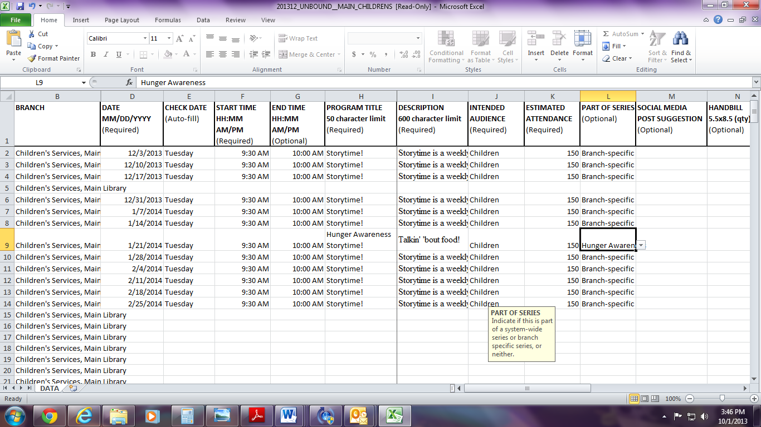

**Please remember to save your document regularly and if you make a mistake – “Edit Undo” or Ctrl+Z is a miracle worker!**