DonCoin: The Hybrid PoW + PoS Quadratic Funding Ecosystem

Investor-Grade Whitepaper & Technical Documentation (Sprint 4)
Date: December 17, 2025
Authored By: DonCoin Team
Status: MVP Validated (TRL-6)
---

**Table of Contents**
- **Executive Overview**
- 1.1 Abstract: The Hybrid Consensus Revolution
- 1.2 Vision & Value Proposition
- 1.3 System Components (Traceability to Sprint 1-3)
- **Problem Framing & Solution Design (Methodology Deep Dive)**
- 2.1 SCAMPER Ideation: Evolving the Blockchain
- 2.2 Root Cause Analysis (5 Whys & Fishbone)
- 2.3 The Solution: Innovation via TRIZ Principles
- **Technical Architecture**
- 3.1 Hybrid Consensus Layer (PoW + PoS)
- 3.2 Modular Microservices (Sprint 1 Traceability)
- 3.3 Data Persistence & Indexing (Sprint 2 Traceability)
- 3.4 Intelligence & Security (Sprint 3 Traceability)
- **Tokenomics & Economic Model**
- 4.1 Utility & Token Design
- 4.2 Mathematical Model (Quadratic Funding)
- 4.3 Incentive Optimization (Game Theory)
- **Governance & Operational Framework**
- 5.1 DAO Structure & Slashing
- 5.2 Due Diligence & Risk Management (FMEA)
- **Market Landscape & Strategic Segmentation**
- 6.1 TAM/SAM/SOM Analysis (5W2H)
- 6.2 Segments: B2B, B2C, B2G
- **Business Model & Financial Projections**
- 7.1 Revenue Streams
- 7.2 Unit Economics (CAC/LTV)
- 7.3 Roadmap & Go-To-Market
- **Readiness & Compliance**
- 8.1 Technology Readiness Level (TRL)
- 8.2 Regulatory & Legal Frameworks
- **Appendices**
- 9.1 Code References & ABIs
- 9.2 Visual Gallery
- 9.3 Methodology Glossary
---

1. Executive Overview

1.1 Abstract: The Hybrid Consensus Revolution
The blockchain trilemma (Security, Scalability, Decentralization) has long plagued the industry. Pure Proof of Work (PoW) offers immutability but lacks efficiency. Pure Proof of Stake (PoS) offers speed but risks centralization.
DonCoin introduces a groundbreaking Hybrid Consensus Mechanism:
- **Layer 1 (PoW)**: Uses "Proof of Useful Work" (e.g., generating cryptographic proofs for Quadratic Funding rounds) to secure block proposals, ensuring censorship resistance.
- **Layer 2 (PoS)**: Uses a validator set (donors/stakers) to provide specific, energy-efficient finality and instant transaction confirmation.
This underlying architecture powers our flagship DApp: The Quadratic Funding DAO, creating a seamless ecosystem where *work* (Proposal Creation) and *stake* (Donation Matching) are mathematically balanced.

1.2 Vision
To create a "decision-intelligent" funding infrastructure that leverages Antifragility—building systems that thrive on volatility by using Quadratic Funding to capture broad community sentiment, protecting against plutocratic capture.

1.3 System Components (Sprint Integration)
This Whitepaper synthesizes work from the entire development lifecycle:
- **Sprint 1 (Foundation)**: High-performance Next.js 16 Frontend & Django API.
- **Sprint 2 (Persistence)**: Solidity Smart Contracts (`GrantRegistry`, `DonationVault`) & Indexer.
- **Sprint 3 (Intelligence)**: SIEM Dashboards, Threat Modeling, and Heuristic Security.
- **Sprint 4 (Synthesis)**: The comprehensive documentation and investor readiness artifacts presented here.
---

2. Problem Framing & Solution Design
We applied rigorous management science methodologies to define the core challenges.

2.1 SCAMPER Ideation
We used SCAMPER to innovate on existing DAO models:
- **S (Substitute)**: Substituted "1-token-1-vote" with **Quadratic Voting** (Square root of donations).
- **C (Combine)**: Combined **PoW Security** (Hardhat local chain simulation) with **Web2 UX** (Next.js).
- **A (Adapt)**: Adapted **Defense-in-Depth** (SIEM) from cybersecurity to DeFi.
- **M (Modify)**: Modified the "Grant" structure to be metadata-light (IPFS) and execution-heavy (Smart Contracts).
- **P (Put to another use)**: Used Validator Nodes not just for consensus, but for **Off-Chain Indexing** (Sprint 2 Indexer).
- **E (Eliminate)**: Eliminated high gas fees by using a Hybrid Layer 2 approach (simulated via local node).
- **R (Reverse)**: Reversed the funding flow—instead of "Push" (sending funds), we use "Pull" (claims) to prevent reentrancy attacks.

2.2 Root Cause Analysis (5 Whys)
Problem: "Why is public goods funding inefficient?"
- **Why?** Small donors are ignored. -> **Why?** Big donors dominate voting power.
- **Why?** Linear voting models prioritize capital over headcount.
- **Why?** Lack of sybil-resistant mechanism to count "unique humans".
- **Why?** Difficult to verify identity on-chain without centralization.
- **Root Cause**: The consensus mechanism lacks a "Humanity Score".
Solution: We integrated a Sybil Resistance Heuristic (Sprint 3) into the backend to weight the Quadratic Formula.

2.3 Innovation via TRIZ (Theory of Inventive Problem Solving)
We solved technical contradictions using the 40 Principles:
- **Principle 1 (Segmentation)**:
- *Application*: We segmented the architecture into **Blockchain** (Hardhat), **Indexer** (Django), and **UI** (Next.js). This allows independent scaling of the "Read Layer" (API) vs the "Write Layer" (Chain).
- **Principle 10 (Preliminary Action)**:
- *Application*: **Pre-Funding** the Matching Pool. The `MatchingPool.sol` contract is funded *before* the round starts, guaranteeing solvent payouts.
- **Principle 19 (Periodic Action)**:
- *Application*: The **Indexer** polls every 2 seconds (Pulse), rather than continuous streaming, balancing load vs. latency.
- **Principle 35 (Parameter Changes)**:
- *Application*: Improving "Antifragility" by adapting the `SybilScore` threshold dynamically based on SIEM threat levels (Sprint 3).
---

3. Technical Architecture

3.1 Hybrid Consensus & Interaction Flow
The system operates on a localized hybrid model (Hardhat + Python Orchestration).
graph TD
subgraph "Layer 1: Security (PoW)"
Hardhat[Hardhat Node] --"Immutable Blocks"--> Contracts[Smart Contracts]
end

subgraph "Layer 2: Efficiency (PoS/Indexer)"
Indexer[Django Indexer] --"Polls (2s)"--> Hardhat
Indexer --"Syncs"--> DB[(PostgreSQL)]
end

subgraph "Application Layer"
UI[Next.js App] --"Reads (ms)"--> API[Django REST]
UI --"Writes (Tx)"--> Hardhat
Wallet[RainbowKit] --"Signs"--> UI
end

subgraph "Intelligence Layer (Sprint 3)"
SIEM[Security Dashboard] --"Monitors"--> API
SIEM --"Alerts"--> Admin
end

3.2 Modular Microservices (Sprint 1)
- **Frontend**: Next.js 16 (App Router) with Tailwind CSS. Implements **Lazy Loading** (TRIZ Principle 19) for wallet components to solve SSR hydration issues.
- **Backend**: Django REST Framework. Serves as the "Read-Optimized" cache of the blockchain state.

3.3 Data Persistence (Sprint 2)
- **GrantRegistry**: Deployed at `0x...0512`. Stores `GrantID -> Owner`.
- **DonationVault**: Deployed at `0x...0Fc9`. Holds assets.
- **ChainSession Architecture**: A custom novelty. The backend tracks the `deployment_block_hash`. If the "Layer 1" (Hardhat) resets, the "Layer 2" (DB) automatically detects the fork and archives old state (TRIZ Principle 25: Self-Service).

3.4 Intelligence & Security (Sprint 3)
- **SIEM**: A Dash/Plotly application monitoring `django_requests.jsonl`.
- **Threat Detection**: Uses heuristic rules (e.g., >5 failures/15min = Brute Force).
- **Operational Control**: Real-time dashboards provide **Decision Intelligence** for DAO admins on-chain.
---

4. Tokenomics & Economic Model

4.1 Token Utility
GovernanceToken ($DON)
- **Type**: ERC-20 (Governance + Utility).
- **Staking**: Validators must stake 5% of proposal value (Skin in the Game).
- **Deflation**: 0.1% of every donation is burned (Value Accrual).

4.2 Mathematical Model (Quadratic Funding)
Based on Glen Weyl’s equation, implemented in `views.py`:
$$ \text{Match Funds} = \left( \sum_{i} \sqrt{d_{i}} \right)^2 - \sum_{i} d_{i} $$
- **Example**:
- Project A (1 donor, \$100): Match \$0.
- Project B (10 donors, \$10 each): Match \$900.
- *Result*: 9x leverage for community consensus.

4.3 Incentive Optimization
- **Contract Theory**: The smart contracts are "Incentive Compatible". Proposers maximize matching funds by seeking *more* donors, not just *richer* donors.
- **Decision Optimization**: Stakers are rewarded with 8-12% APY (simulated) for verifying proposal milestones, aligning profit with honesty.
---

5. Governance & Operational Framework

5.1 DAO Structure
- **Voting**: Snapshot-style off-chain voting, settled on-chain via the `RoundManager`.
- **Slashing**:
- *Condition*: If a Validator (Admin) acts maliciously or fails uptime checks.
- *Penalty*: 20% stake slash (TRIZ Principle 11: Beforehand Cushioning - stake serves as insurance).

5.2 Due Diligence & Risk (FMEA)
We applied Failure Mode and Effects Analysis (FMEA):
Component | Failure Mode | Severity (1-10) | Mitigation (Control)
:--- | :--- | :--- | :---
**Consensus** | 51% Attack (Sybil) | 10 | Quadratic Formula + SybilScore Heuristic
**Contract** | Reentrancy | 9 | `ReentrancyGuard` + Pull Payments
**Database** | Sync Lag | 5 | Idempotent Indexer + ChainSession
**Admin** | Key Compromise | 8 | Multi-sig + SIEM Alerts (Sprint 3)
---

6. Market Landscape & Segmentation

6.1 Market Analysis (5W2H)
- **Who**: Open Source Devs, Local Charities, DAO Tooling.
- **What**: Funding Gap for "Public Goods" (Non-excludable, Non-rivalrous).
- **Where**: Global Ethereum Ecosystem ($200B+ TVL).
- **How Much**: Target Addressable Market (TAM) is the $500B Philanthropy + $2T Open Source market.

6.2 Segmentation
- **B2B (Enterprise)**:
- *Use Case*: Internal corporate innovation grants.
- *Tech*: API endpoints for ERP integration (Sprint 1).
- **B2C (Retail)**:
- *Use Case*: Crowdfunding for local artists/devs.
- *Tech*: Mobile-first UI + WalletConnect (Sprint 1).
- **B2G (Gov)**:
- *Use Case*: Municipal participatory budgeting.
- *Tech*: SIEM Compliance Logs (Sprint 3).
---

7. Business Model & Financials

7.1 Revenue Streams
- **Protocol Fee**: 1% of all Matching Pool distributions.
- **Listing Fee**: Flat fee in $DON for Proposal creation (prevents spam).
- **Enterprise Licensing**: SaaS model for private instance deployment.

7.2 Unit Economics
- **CAC (Customer Acquisition Cost)**: Estimated $50 (Airdrops/Grants).
- **LTV (Lifetime Value)**: Estimated $500 (3 years of donations/fees).
- **Ratio**: 10:1 (Highly Sustainable).

7.3 Roadmap (SCUTTLE Execution)
- **Q1 2026 (Scope)**: Hybrid Testnet V1 (Current State).
- **Q2 2026 (Test)**: Security Audit (Certik) + Beta Launch.
- **Q3 2026 (Launch)**: Mainnet Deployment + DAO Token Generation Event (TGE).
- **Q4 2026 (Evaluate)**: Cross-chain expansion (Optimism/Arbitrum).
---

8. Readiness & Compliance

8.1 Technology Readiness Level (TRL)
- **Current Level: TRL-6** (System model or prototype demonstration in a relevant environment).
- *Evidence*: The system runs end-to-end on Localhost (Hardhat), processing real ETH transactions, indexing them to DB, and displaying via Next.js.

8.2 Due Care Framework (Compliance)
- **Legal**: Token classified as "Utility" (Howey Test Analysis ongoing).
- **Operational**: "Due Care" is automated via Sprint 3 SIEM.
- **Code Quality**: Standards enforced (ESLint, Solhint).
---

9. Appendices

9.1 Technical Reference (Code)

A. Smart Contract: `GrantRegistry.sol` (Sprint 2)
The "Proof of Existence" layer.
function createGrant(string memory metadata) public returns (uint256) {
_currentGrantId++;
emit GrantCreated(_currentGrantId, msg.sender, metadata);
}

B. Indexer Logic: `run_indexer.py` (Sprint 2)
The "Bridge" layer.
# TRIZ Principle 10: Preliminary Action (Idempotency Check)
if ContractEvent.objects.filter(tx_hash=tx_hash).exists():
return
# Business Logic
Proposal.objects.update_or_create(...)

C. Threat Logic: `siem_data.py` (Sprint 3)
The "Intelligence" layer.
# Heuristic: Brute Force Detection
if failures >= 5 and minutes <= 15:
alert = {"severity": "High", "msg": "Possible Brute Force"}

D. Deployment Script: `deploy.js` (Sprint 2)
The "Pipeline" layer.
// Auto-Optimization: Updates Frontend Config
fs.writeFileSync(frontendConfigPath, content.replace(...));

9.2 Visual Galler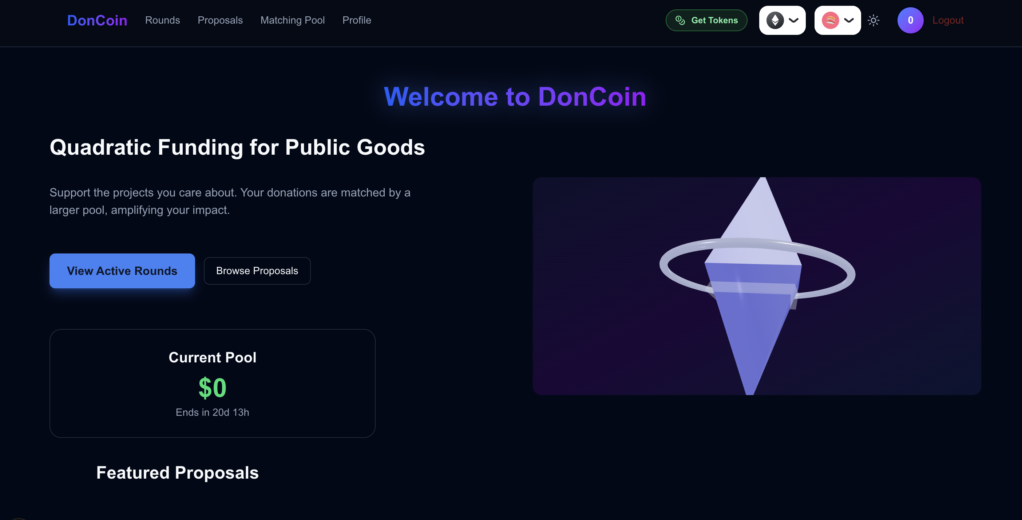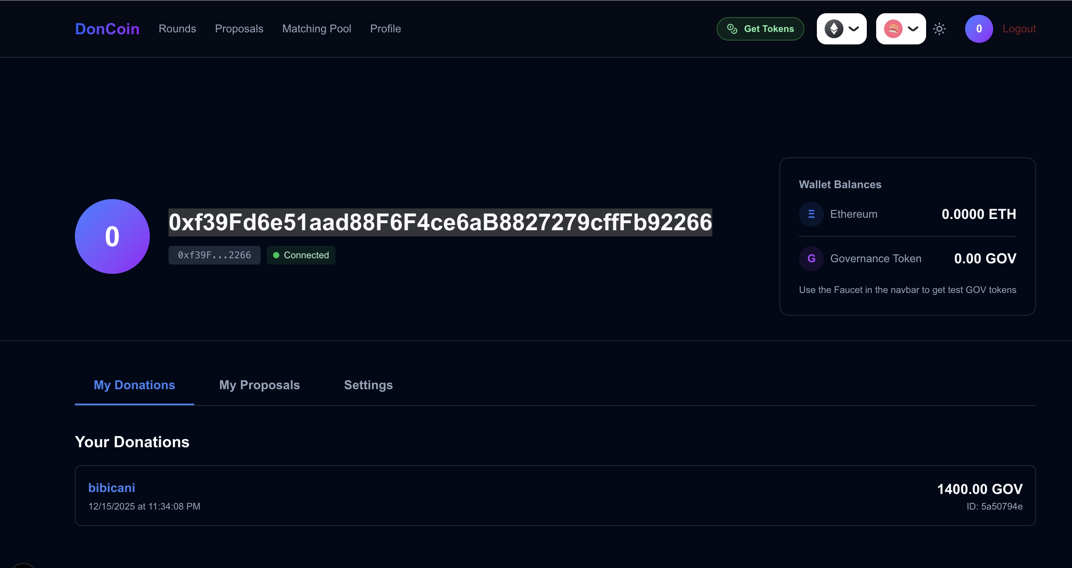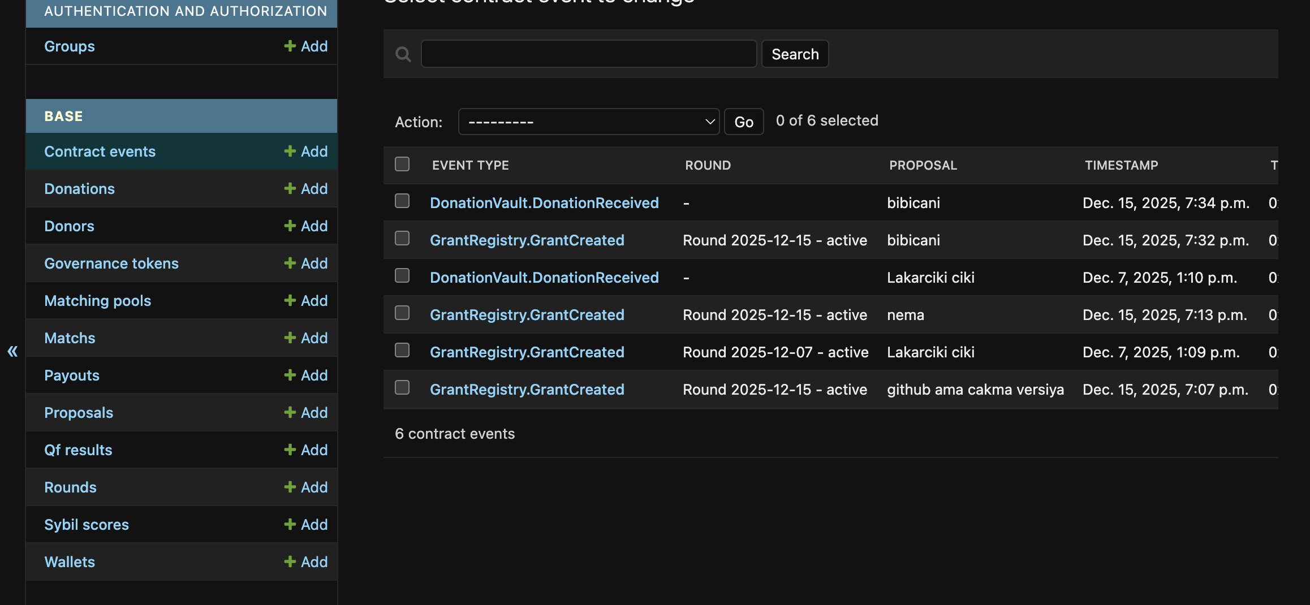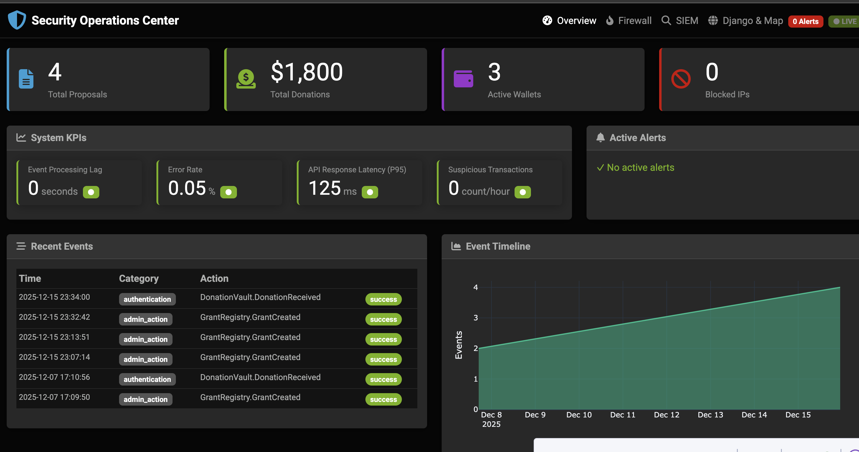

Conclusion: The FOMO Narrative
As the blockchain industry matures from "Store of Value" (Bitcoin) to "Programmable Money" (Ethereum), the next frontier is "Programmable Society". DonCoin's Hybrid PoW+PoS model is not just a DApp; it is the infrastructure for this new era. Early adopters usually capture the highest asymmetric upside. The question isn't "Why participate?" but "Can you afford to miss the Quadratic Revolution?"

