Employee Management System

Submitted in partial fulfilment of the Requirements for the award of the degree of
BACHELOR OF COMPUTER APPLICATION

Submitted By

MOHAMMED NASIK K

Reg.no. 230021079198

Under the guidance of

Mrs. JOXY JOSEPH



DEPARTMENT OF COMPUTER APPLICATIONS PRESENTATION COLLEGE OF APPLIED SCIENCES, PUTHENVELIKARA, ERNAKULAM-683594 NOVEMBER 2025

PRESENTATION COLLEGE OF APPLIED SCIENCES

[Affiliated to Mahatma Gandhi University, Kottayam] Ph: 0484-2485400, email:presentationcollege2002@gmail.com
CERTIFICATE

This is to certify that the project entitled “Employee Management System” is a Bonafide record of the work done by MOHAMMED NASIK K with Reg.no 230021079198 of the Department of Computer Application, Presentation College of Applied Sciences, Puthenvelikara in partial fulfilment of requirements for the award of Bachelor of Computer Applications by Mahatma Gandhi University, Kottayam during the year 2023-2026.
Head of the Department

Project Guide

Submitted for the university examination held on ………………………….

Examiners: 1.
2.

DECLARATION

DECLARATION

I hereby declare that the project entitled “Employee Management System” submitted to Mahatma Gandhi University, Kottayam in partial fulfilment of the requirements for the award of the degree Bachelor of Computer Applications is a record of original work done by me during the period of study (2023-2026) under the guidance of Mrs JOXY JOSEPH Department of computer applications.

Place:

Date: MOHAMMED NASIK K

ACKNOWLEDGEMENT

ACKNOWLEDGEMENT
I use this opportunity to express my sincere thanks and deep sense of gratitude to all those who helped me in various ways for the completion of my project. I give all the glory and honour to GOD ALMIGHTY, who showered his providences and graces on the successful completion of the work.
I sincerely thank my parents for supporting me in completing this project on time. It would have been impossible without their help and support. With great pleasure, I sincerely thank Mr. FEBY F A S, Principal, Presentation College of Applied Sciences, Puthenvelikara for his entire support and encouragement and never-ending support throughout the course in this prestigious institution.
I sincerely thank Mrs. SEEMA M.A., Head of the Department of Computer Application, Presentation College of Applied Sciences, Puthenvelikara for her constant encouragement and never-ending support throughout this project.

I express my deep and sincere gratitude to Mrs. JOXY JOSEPH, Department of Computer Application, Presentation College of Applied Sciences, Puthenvelikara, for her guidance, help, encouragement and never-ending support and guidance throughout the project.

I would like to express my profound thanks to all the faculty members in my department for their valuable suggestions during the period of my project. Last but not least I am indebted to people who have directly or indirectly helped me for the successful completion of the project.

ABSTRACT

ABSTRACT

The Employee Management System (EMS) is a role-based web application that streamlines employee onboarding, project planning, task delegation, file flow, attendance tracking, and leave approvals. Managers supervise projects and performance; Team Leaders plan tasks and coordinate execution; Employees perform assigned tasks and submit deliverables. EMS automates daily timekeeping (Punch-In/Out), enables threaded comments, and provides dashboards and reports for decision-making.

CONTENTS

CONTENTS
- INTRODUCTION 1
- SYSTEM STUDY AND ANALYSIS 3
  - Existing System 4
  - Proposed System 4
  - Feasibility Study 4
    - Operational Feasibility 4
    - Technical Feasibility 5
    - Financial and Economic Feasibility 5
  - Modules and Module Description 5
- SYSTEM REQUIREMENT SPECIFICATION 9
3.1 Hardware Requirements 10
3.2. Software Requirements 10
- COST AND BENEFITS ANALYSIS 12
  - Cost 13
  - Benefits 14
- SYSTEM DESIGN 15
  - Input Design 16
  - Output Design 16
  - Proposed Design 16
    - Data Flow Diagram 17
    - E-R Diagram 22
  - Database Design 23

- SYSTEM TESTING AND IMPLEMENTATION 35
- SYSTEM MAINTENANCE 37
- CONCLUSION 39
- FUTURE SCOPE 41
- APPENDIX 43
  - Screenshots 44
  - Coding 50
- BIBLIOGRAPHY 81

INTRODUCTION

1. INTRODUCTION

The Employee Management System is a web-based application developed using PHP, MySQL, HTML, CSS, and JavaScript. The main purpose of this system is to provide a structured platform for managing employees, assigning work, monitoring project progress, sharing files, and tracking attendance within an organization. In many workplaces, project coordination and employee activity tracking are done manually, which often results in miscommunication, delayed work updates, difficulty in supervision, and inefficient data handling. This project aims to solve these issues by introducing a centralized and automated workflow system.

The system defines three user roles: Manager, Team Leader, and Employee, each with specific permissions based on their responsibilities. The Manager controls employee approvals, project assignment, and performance tracking. Team Leaders manage the tasks given to employees and act as a bridge between management and the workforce. Employees can view assigned work, upload completed tasks, apply for leave, and record attendance through Punch-In and Punch-Out. All interactions are stored in the database, ensuring transparency and accountability.

Since the system is developed in PHP with relational database support, it ensures high compatibility, scalability, and secure data handling. The user-friendly interface allows smooth navigation and real-time workflow management. Thus, this project helps to improve efficiency, communication, and productivity in organizational environments.

SYSTEM STUDY AND ANALYSIS

2. SYSTEM STUDY AND ANALYSIS

Existing System
In many organizations, employee and project management activities are handled manually or through separate, non-integrated software tools. Attendance is often recorded using registers or simple spreadsheets, which can lead to errors and manipulation. Project assignments and task updates are commonly communicated through messaging applications, emails, or verbal instructions, causing miscommunication, loss of information, and difficulty in tracking progress. File sharing is also scattered across different platforms, making it hard for managers and team leaders to monitor work submissions. Overall, the lack of a unified workflow results in poor coordination, delayed task completion, and inefficient supervision.

Proposed System
The Employee Management System is proposed as a unified web-based platform that centralizes employee onboarding, project assignment, task handling, attendance tracking, file sharing, and communication. The system provides three distinct roles: Manager, Team Leader, and Employee, each with specific access permissions. The Manager manages employee approvals, project creation, and performance monitoring. Team Leaders break down projects into smaller tasks and assign them to Employees. Employees can view their assigned tasks, upload completed files, and record work hours. Features such as leave management, comments, and automatic attendance logging help create a structured and transparent workflow. Overall, the system enhances productivity, accountability, and communication across the organization.

Feasibility Study

Operational Feasibility
The system is operationally feasible because it directly addresses the key challenges faced in manual or semi-digital organization workflows. The interface is easy to use, with clear dashboards for each role, making it convenient for Managers, Team Leaders, and Employees to perform their respective activities. The automated task updates, attendance tracking, and structured file management improve coordination and reduce administrative workload.

Technical Feasibility

The system is technically feasible as it is developed using widely supported web technologies such as PHP, MySQL, HTML, CSS, and JavaScript. These tools are well-documented, reliable, and suitable for building scalable web applications. The application can be hosted on standard servers, and no specialized hardware is required. This ensures smooth implementation and future scalability if the organization expands.

Financial and Economic Feasibility
The financial feasibility of the system is high because the development tools used are open-source and free, minimizing initial costs. The organization can deploy the system without investing in expensive software licenses or hardware. Economically, the system has significant benefits as it reduces manual workload, saves time, improves work quality, and supports efficient project completion. Over time, these benefits lead to increased productivity and reduced operational expenses.

Module and Descriptions

The project consists of three main modules, each described below:
- Manager Module
Allows the Manager to approve employee registrations, assign projects, monitor progress, manage files, track attendance, and approve leave requests.
- Team Leader Module
Enables Team Leaders to receive project assignments, create and assign tasks to Employees, review work submissions, upload compiled reports, and manage communication.
- Employee Module
Provides Employees access to their assigned tasks, allows them to upload completed work files, Punch-In/Punch-Out for attendance, request leave, and view feedback.

Manager Module
The Manager Module is designed for the system’s highest-level authority, the Manager. It provides access to all core administrative operations and enables effective supervision across the entire organization. The Manager is responsible for approving new employee registrations, promoting employees to Team Leaders, assigning projects, and monitoring progress. The Manager also has access to all uploaded files, attendance records, and leave requests, ensuring complete control and transparency.

Functions of the Manager Module:
- Login: Manager can securely log in using credentials.
- View Employees: View all registered employees and their details.
- Approve / Reject Registration: Approve new employee registrations or deny them if invalid.
- Promote Employee: Promote selected employees to Team Leader roles.
- Create Projects: Add new projects with descriptions and deadlines.
- Assign Projects: Assign created projects to Team Leaders.
- Monitor Progress: Track project and task progress in real-time.
- Add Comments: Provide feedback or comments on ongoing projects.
- View Uploaded Files: Access work files uploaded by Team Leaders and Employees.
- Approve / Reject Leave: Manage leave requests submitted by employees and team leaders.
- View Attendance: Monitor attendance records of all employees.
- Generate Reports: View overall performance, task completion, and progress statistics.

Team Leader Module

The Team Leader Module contains all the necessary tools for Team Leaders to coordinate work among their team members. After receiving a project from the Manager, the Team Leader can divide it into smaller tasks and assign those tasks to Employees under their supervision. The module also enables structured communication and file sharing to maintain clarity in work execution.

Functions of the Team Leader Module:
- Login: Team Leader logs in using secure credentials.
- View Assigned Projects: View the projects assigned by the Manager.
- Create Tasks: Divide assigned projects into smaller tasks.
- Assign Tasks: Assign specific tasks to employees under their supervision.
- Edit / Delete Tasks: Modify or remove tasks if necessary.
- View Employee Work: Check uploaded files and progress reports from employees.
- Add Comments: Send feedback or additional instructions to employees.
- Upload Reports: Upload compiled project files to the Manager.
- Punch In / Punch Out: Record daily working hours.
- Apply for Leave: Submit leave requests to the Manager.
- View Notifications: See comments, feedback, or task updates from Manager or Employees.
- Update Profile: View and edit personal profile information.

Employee Module

The Employee Module is dedicated to employees performing assigned tasks within the organization. It provides a simplified and user-friendly interface where employees can view tasks, submit completed work, record attendance, and request leaves. This module ensures that employees can manage their daily activities efficiently.

Functions of Employee Module:
- Register: Create a new account by entering personal details.
- Login: Access the system after approval from the Manager.
- View Assigned Tasks: Check details of tasks assigned by the Team Leader.
- Upload Work: Submit completed files or documents for review.
- View Feedback: Read comments or responses from the Team Leader.
- Punch In / Punch Out: Record daily attendance automatically.
- View Attendance History: See previous attendance logs and total hours worked.
- Apply for Leave: Request leave by entering date, reason, and type.
- Check Leave Status: Track leave approval or rejection.
- Edit Profile: Update personal information such as contact, address, and photo.
- Receive Notifications: View system updates, comments, and approvals from higher roles.

SYSTEM REQUIREMENT SPECIFICATIONS

  - SYSTEM REQUIREMENT SPECIFICATIONS

Hardware Requirements:
- Processor / Motherboard: Intel Core i3 / i5 or equivalent
- RAM: Minimum 4GB (8GB recommended for smooth development and database operations)
- Storage: 256GB or above (SSD recommended for faster execution)
- Display: Standard 14”/15.6” HD or Full HD Monitor

Software Requirements:
- Operating System: Windows / Linux
- Frontend Languages: HTML, CSS, JavaScript
- Backend Language: PHP
- Framework Used: Core PHP
- Database: MySQL
- Web Browser: Google Chrome / Mozilla Firefox
- Web Server: Apache (via XAMPP / LAMP stack)

PHP
PHP is an open-source, server-side scripting language commonly used for web application development. It is widely known for its simplicity, flexibility, and strong integration with HTML and database systems. PHP follows a straightforward execution model, making it suitable for dynamic page generation, form handling, and data-driven applications. It supports procedural as well as object-oriented programming, allowing developers to structure code effectively. PHP’s large library ecosystem and community support make it a reliable choice for scalable and maintainable web applications.

MySQL
MySQL is a widely used open-source relational database management system (RDBMS). It stores data in structured tables and supports SQL (Structured Query Language) for data querying and manipulation. MySQL ensures data integrity, supports ACID properties, and handles large datasets efficiently. It integrates seamlessly with PHP through native extensions, making it suitable for applications requiring authentication, transactions, report generation, and data analytics. MySQL is stable, secure, and optimized for high-performance web applications.

HTML
HTML (HyperText Markup Language) is the standard markup language used to structure and display content on the web. It provides the structural layout for web pages, defining elements like headings, paragraphs, forms, images, and tables. HTML serves as the foundational layer upon which CSS and JavaScript add styling and interactivity.

CSS
CSS (Cascading Style Sheets) is used to control the visual appearance and layout of web pages. It allows developers to design responsive, attractive, and user-friendly interfaces. CSS separates content from presentation, making the application easier to style and maintain. It supports animations, themes, and visual customization for better user experience.
JavaScript
JavaScript is a client-side scripting language used to enhance interactivity and dynamic behavior on web pages. It allows for real-time updates, input validation, form handling, and AJAX-based communication with the server without reloading the page. JavaScript plays a crucial role in improving usability and providing a smooth user interface flow in the Employee Management System.
Apache Web Server (XAMPP / LAMP)
Apache is a widely used open-source web server software that delivers web content to users. When combined with PHP and MySQL (in XAMPP for Windows or LAMP for Linux), it creates a complete development environment. Apache efficiently handles HTTP requests, supports virtual hosts, and ensures secure and stable application hosting.

COST AND BENEFITS ANALYSIS

COST AND BENEFIT ANALYSIS

Cost:
    - Development Costs:
      - Costs for hiring or assigning software developers, UI designers, and system testers.
      - Expenses for development tools such as code editors, testing environments, and collaboration platforms.
      - Time investment in planning, designing, coding, testing, and deployment of the system.
    - Operational Costs:
      - Server or web hosting charges for deploying the Employee Management System.
      - Regular maintenance, bug fixes, and updates to keep the system secure and functional.
      - Optional training sessions for employees and administrators to effectively use the system.
      - Network and backup storage costs for storing files, attendance records, and project data.
    - Administrative Costs:
      - Basic office resources such as system equipment, internet connectivity, and utility usage during development.
      - Documentation, reporting, and managerial oversight during system implementation.
      - If deployed in a large organization, additional support staff may be needed for monitoring.

  - Benefits:
4.2.1. Improved Productivity and Workflow Efficiency:
- Automated attendance tracking and leave management reduce manual paperwork and time delays.
- Structured project and task assignment ensures clarity and faster work execution.
- Centralized file sharing and communication minimize misunderstandings and repetitive discussions.
4.2.2. Cost Savings:
- Reduces reliance on physical records, printed documents, and manual tracking systems.
- Minimizes administrative overhead by integrating multiple organizational processes into one platform.
- Eliminates the need for separate attendance machines or task-tracking software.
4.2.3. Organizational Transparency and Performance Improvement:
- Managers can easily monitor employee work status and overall project progress.
- Accurate attendance logs help evaluate working hours and productivity.
- Clear task responsibilities help improve accountability and discipline among employees.
- Enables data-driven decision-making for promotions, workload balancing, and resource allocation.

SYSTEM DESIGN

SYSTEM DESIGN

Input Design:

The input design ensures that the data entered into the system is accurate, complete, and structured for efficient processing. The primary inputs for the Employee Management System include:
    - User Registration Data:
Information provided by new users during signup, such as name, email, password, employee role preference, and contact details. This data is stored and awaits Manager approval.
    - Project and Task Data:
Information entered by the Manager and Team Leaders, including project names, descriptions, deadlines, task assignments, and work progress updates.
    - Attendance Entries (Punch-In / Punch-Out):
Employees and Team Leaders submit their daily work start and end times, which the system records to calculate total working hours.
    - Leave Requests:
Details such as leave type, date range, and reason submitted by users requesting leave approval from the Manager.
    - File Uploads:
Work-related documents uploaded by Employees and Team Leaders for review and progress tracking.

Output Design:

The system provides clear, structured, and user-friendly outputs that support decision-making and workflow tracking. The main outputs include:
    - User Profiles:
Displays the personal details, role, attendance summaries, leave status, and assigned projects or tasks for each user.
    - Project and Task Overviews:
Shows lists of projects and assigned tasks with progress indicators,

deadlines, and submission status, enabling easy tracking and review.
    - Attendance Reports:
Generates daily or monthly attendance summaries showing total working hours and punch records, useful for performance evaluation.
    - Leave Status & Notifications:
Displays approved, rejected, or pending leave requests, and sends alerts for approvals, comments, assignments, or updates.
    - File Access Panels:
Allows users to view, download, or manage uploaded documents related to projects and tasks.

Proposed Design:
The system is designed using a modular and role-based architecture, ensuring separation of responsibilities and secure access control. The modules include:
- User Management Module (handles registration, login, role assignment, promotion, and approvals)
- Project and Task Management Module (manages project creation, task breakdown, assignment, tracking, and status updates)
- File Management Module (stores, retrieves, and organizes work-related files submitted by users)
- Attendance and Leave Module (records work hours and processes leave requests efficiently)
- Communication Module (enables threaded comments and feedback within projects and tasks)
The architecture is scalable and maintainable, capable of supporting additional features such as reports, notifications, and performance analysis. It ensures smooth collaboration between Employees, Team Leaders, and Managers while maintaining data consistency and operational efficiency.

5.4 DATA FLOW DIAGRAM
A Data Flow Diagram is a network that illustrates the flow of data, the processes that act on the data, and the data stores used to hold the data. The DFD uses a set of standard symbols to represent processes, data sources, destinations, and data stores. It is a useful tool for structured analysis and helps to communicate the logical flow of data within a system.
In the Employee Management System, the DFD is used to show how data moves between Manager, Team Leader, Employee, and the system database. The interaction involves actions like employee registration, project assignment, task delegation, attendance recording, file uploads, and leave management.
There are a few symbols used in DFD representation:
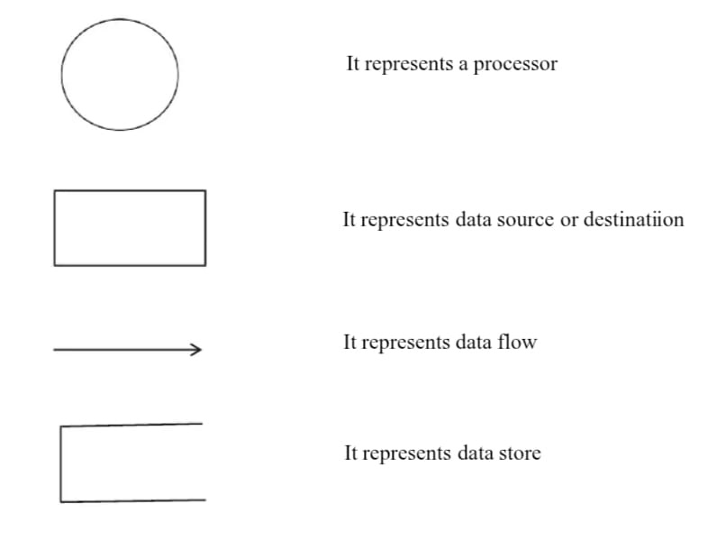

Data Flow Diagram

Level – 0 DFD

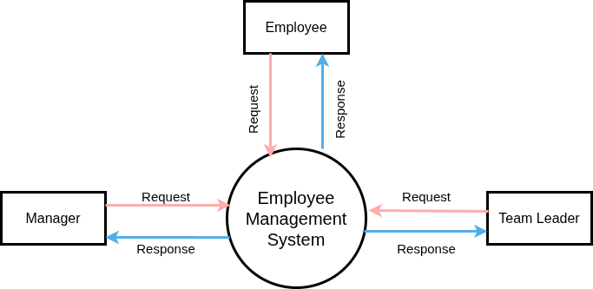

Level - 1 Manager

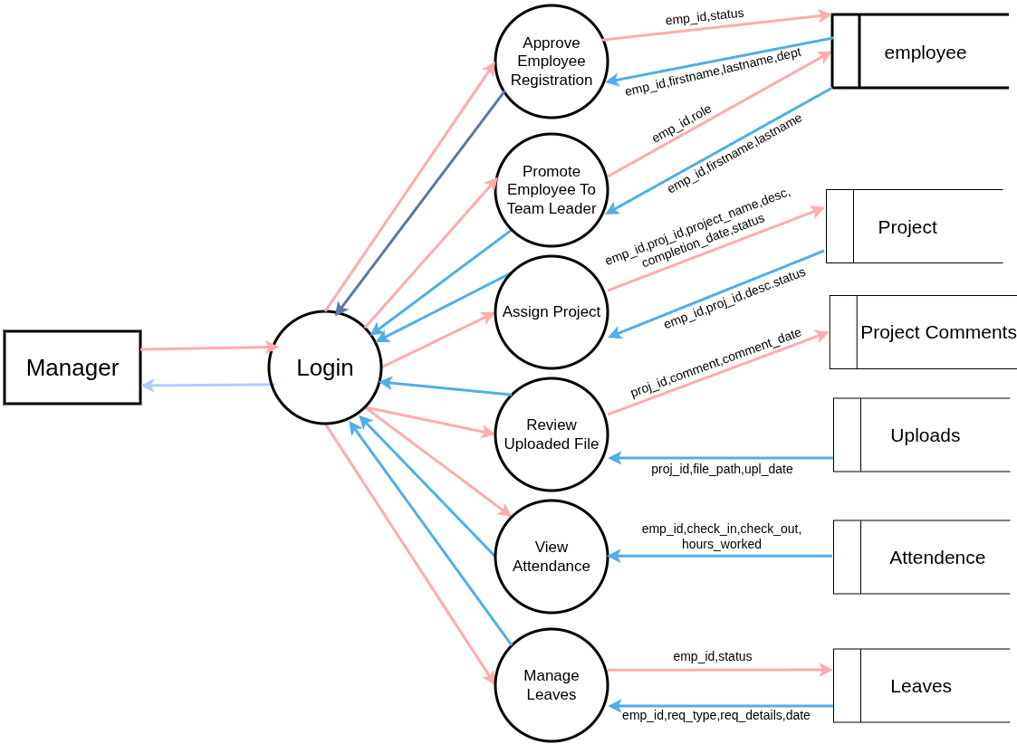

Level-1 Team Leader

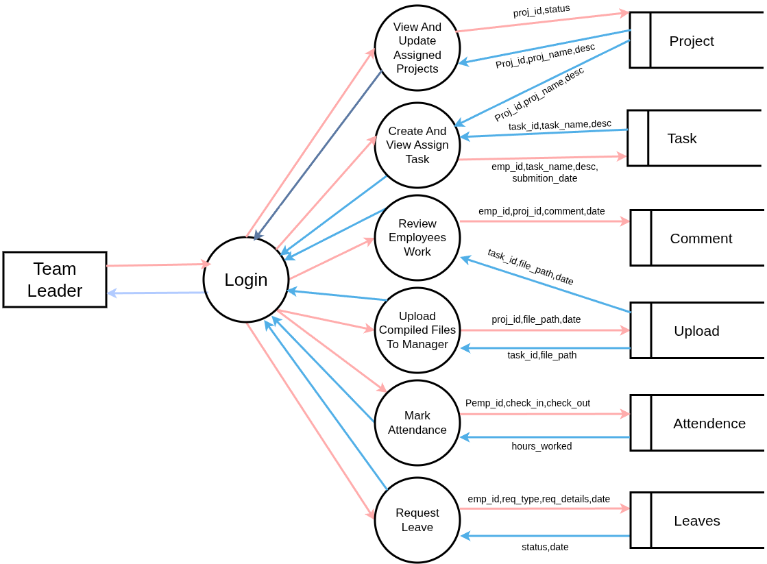

Level-1 Employee

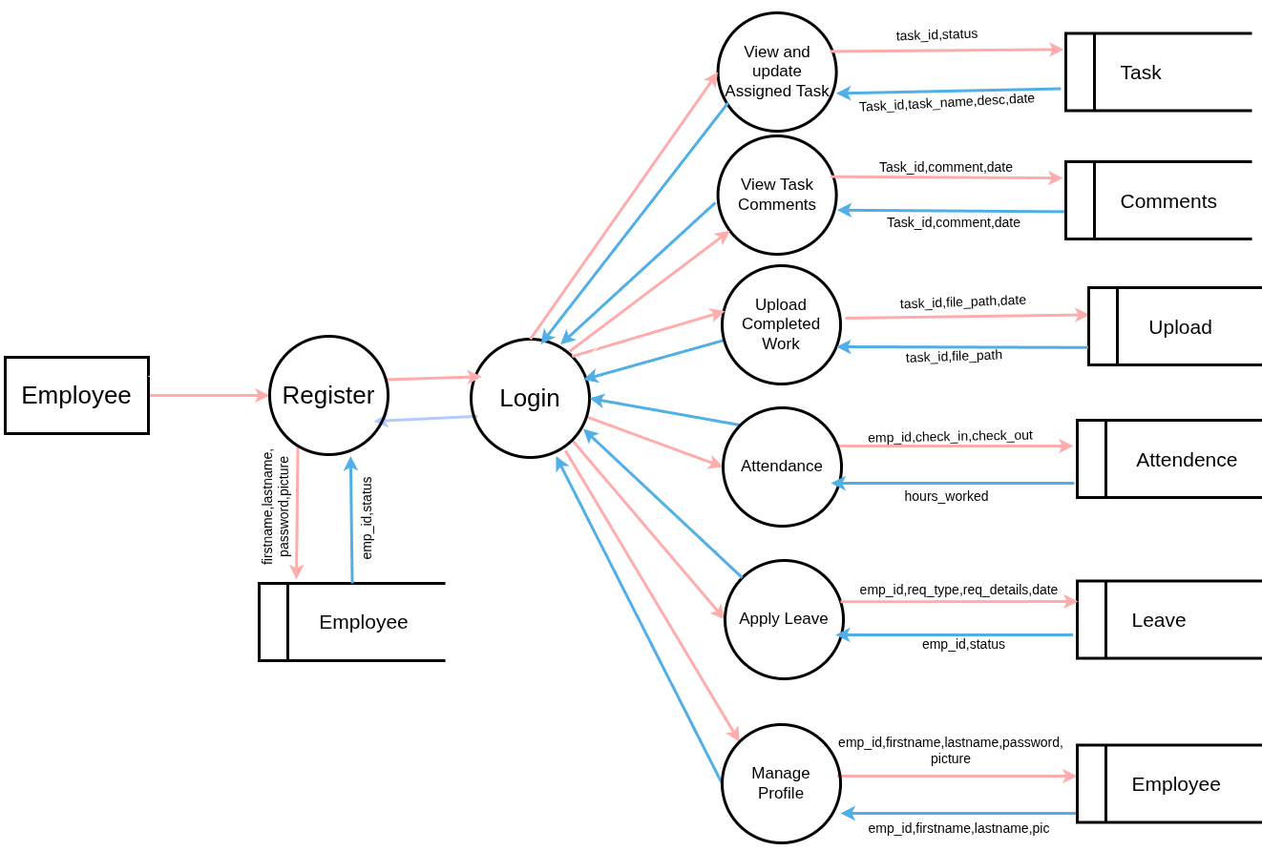

    - Entity Relationship Diagram

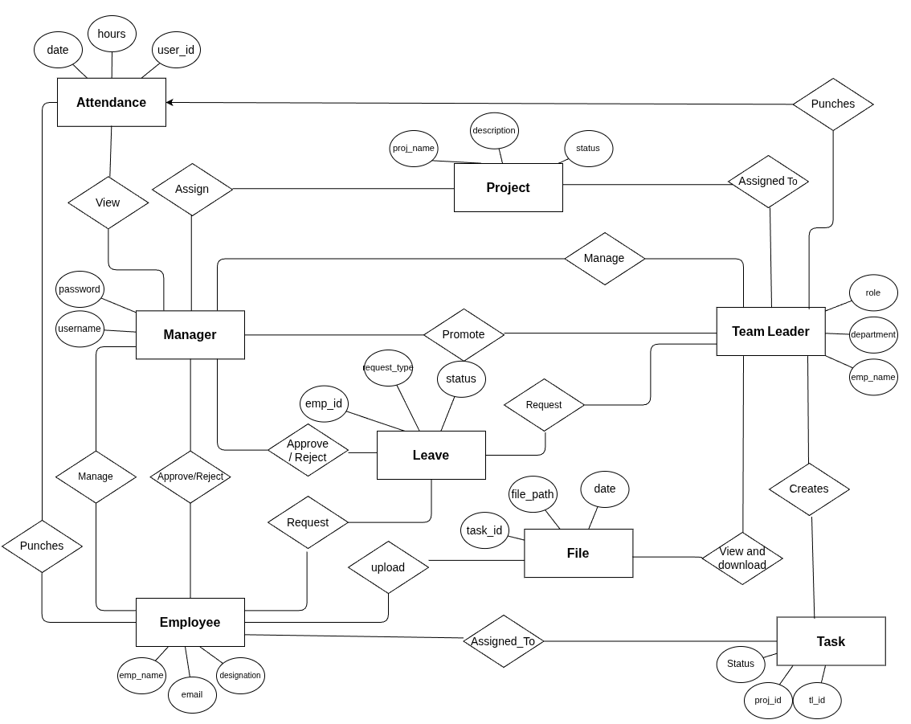

5.4 Database Design
Employee Table
Field Name | Type | Constraints | Description
emp_id | INT (11) | PRIMARY KEY, AUTO INCREMENT | Unique identifier for each employee
firstname | VARCHAR(100) | NOT NULL | Employee’s first name
lastname | VARCHAR(100) | NOT NULL | Employee’s last name
email | VARCHAR(100) | NOT NULL, UNIQUE | Employee’s email address
password | TEXT | NOT NULL | Employee's hashed password
Date_of_birth | DATE | NOT NULL | Employee’s date of birth
gender | VARCHAR(10) | NOT NULL | Employee’s gender
contact | VARCHAR(20) | NOT NULL | Employee’s contact  number
dept | VARCHAR(100) | NOT NULL | Employee’s department name
address | VARCHAR(100) | NOT NULL | Employee’s Residential Address
pic | TEXT | NOT NULL | Profile picture file path or name

Task Table

Field Name | Type | Constraints | Description
task_id | INT (AUTO_INCREMENT) | PRIMARY KEY | Unique identifier for each leave request
proj_id | INT(11) | NOT NULL,Foreign Key | Project ID
assigned_to | INT(11) | NOT NULL,Foreign Key | Employee ID
date | DATE | NULL allowed | Submition date
desc | CHAR(100) | NULL allowed | Description of the task
status | ENUM(“Pending”,”In Progress”,”Submitted”) | DEFAULT ‘Pending’ | Indicates the current progress state of the task

Task Comments Table

Field Name | Type | Constraints | Description
task_id | INT (11) | NOT NULL,Foreign Key | References the task to which the comment belongs
comment | TEXT | NOT NULL | The comment text/content submitted by the user.
commented_by | ENUM(“Team Leader, Employee”) | DEFAULT ‘Team Leader’ | Indicates who made the comment
date | DATETIME | NOT NULL | Date and time of comment

Project Comments Table

Field Name | Type | Constraints | Description
proj_id | INT (11) | NOT NULL,Foreign Key | References the project to which comment belongs
comment | TEXT | NOT NULL | The comment or feedback given on the project
date | DATETIME | DDEFAULT CURRENT_TIMESTAMP | The timestamp when the comment was added

Leave Request Table

Field Name | Type | Constraints | Description
emp_id | INT(10) | NOT NULL,Foreign Key | Refers to the  emp who submitted  the request
request_type | VARCHAR(50) | NOT NULL | Type of request
description | TEXT | NOT NULL | Description given by emp about leave
leave_date | VARCHAR(255) | NOT NULL | Date for leave request
status | ENUM(‘Pending’,’Approved’,’Rejected’) | DEFAULT ’Pending’ | Current request status

File Upload Table

Field Name | Type | Constraints | Description
id | INT (AUTO_INCREMENT) | PRIMARY KEY | Unique identifier for each uploaded file
task_id | INT(10) | NULL allowed, Foreign Key | Refers to the related task if the file belongs to a task
project_id | INT(10) | NULL allowed, Foreign Key | Refers to the related project if the file is uploaded at the project level
emp_id | INT(10) | NOT NULL,Foreign Key | Name or identifier of the employee who uploaded the file
file_path | VARCHAR(255) | NOT NULL | Server file path/location where the file is stored
date | DATETIME | DEFAULT CURRENT_TIMESTAMP | The date and time the file was uploaded

Projects Table

Field Name | Type | Constraints | Description
proj_id | INT (AUTO_INCREMENT) | PRIMARY KEY | Unique identifier for each project
project_name | VARCHAR(250) | NOT NULL | Name/title of the project
description | VARCHAR(250) | NOT NULL | Brief summary or explanation of the project
emp_id | VARCHAR(250) | NOT NULL | Stores which team leader
date | DATE | NOT NULL | Date of project was assigned
status | ENUM(‘Pending’,’In Progress’,’completed’) | DEFAULT ‘Pending’ | current status of the project

Attendance Table

Field Name | Type | Constraints | Description
id | INT (AUTO_INCREMENT) | PRIMARY KEY, AUTO INCREAMENT | Unique identifier for each attendance
emp_id | INT(10) | NOT NULL,Foreign Key | References the employee who recorded attendance
date | DATE | NOT NULL | The date of attendance
check_in | DATETIME | NOT NULL | Timestamp when the employee started work (Punch-In)
check_out | DATETIME | NOT NULL | Timestamp when the employee ended work (Punch-Out)
hours_worked | VARCHAR(20) | NOT NULL | Total hours worked for the day (calculated as check_out - check_in)

SYSTEM TESTING AND IMPLEMENTATION

SYSTEM TESTING AND IMPLEMENTATION
System Testing
System Testing is a crucial phase in the software development lifecycle that involves testing an integrated system to verify that it meets specified requirements. This type of testing assesses the overall behaviour and performance of the system, ensuring that all components work together as intended.
Key aspects of system testing include:
    - Functional Testing: Verifies that the system performs the expected functions correctly based on the requirements.
    - Performance Testing: Assesses how the system performs under various conditions, including load testing, stress testing, and scalability testing.
    - Security Testing: Evaluate the system’s ability to protect data and maintainfunctionality as intended, safeguarding against security threats and vulnerabilities.
    - Usability Testing: Ensures the system is user-friendly and meets user experience standards.
    - Compatibility Testing: Checks that the system works well across different environments, such as various operating systems, browsers, and devices.
    - Regression Testing: Ensures that new changes or additions have not negatively impacted existing functionality.

A specialized testing team typically performs system testing after integration testing and before user acceptance testing (UAT). It helps identify defects and issues at an early stage, ensuring a higher-quality product before it is released to the end users.

Implementation

The Employee Management System is implemented using PHP as the backend scripting language and MySQL as the database. The system follows a modular structure to separate different functionalities such as authentication, user management, project handling, task assignment, and attendance tracking. The project directory contains separate folders for configuration files, server-side scripts, frontend templates, and uploaded files.

The application begins with the configuration of the database connection file, where MySQL credentials are defined to establish communication between PHP and the database. Different PHP pages are created for separate operations such as login, registration, dashboard display, task uploads, and leave requests. These pages interact with the MySQL database using SQL queries for data insertion, retrieval, and updates.

HTML is used to design the structure of the web pages, while CSS ensures layout and styling. JavaScript is used for interactive elements, such as validating form inputs and dynamic interface updates. The pages are linked together through navigation menus allowing smooth transitions across modules for Manager, Team Leader, and Employee roles.

A “uploads” directory is created to store the files submitted by Employees and Team Leaders. The “assets” or “static” folder stores CSS, JavaScript, and images used across the user interface. The role-based access control is implemented by validating the role stored in session variables after login, ensuring that each user accesses only the features permitted to their role.

The database tables and relationships are created based on the system requirements. PHP scripts interact with the database using INSERT, UPDATE, and SELECT operations to perform actions such as project creation, task assignment, attendance tracking, and leave approvals. Every page that requires dynamic data retrieval uses SQL queries to fetch data and populate tables or display content to the user.
Overall, the system ensures smooth workflow management, appropriate access control, proper data storage, and structured file handling to support the organization’s working environment.

SYSTEM MAINTENANCE

7. SYSTEM MAINTENANCE
System Maintenance involves the processes and activities required to keep a software system operational, efficient, and up-to-date after its initial deployment. This phase is crucial for ensuring the system continues to meet user needs and functions correctly over its lifespan.
Key aspects of system maintenance include:
- Corrective Maintenance: This involves fixing any defects or bugs that are discovered in the system after it has been deployed. It ensures that the system remains reliable and operates as expected.
- Adaptive Maintenance: This type of maintenance is necessary when there are changes in the environment where the system operates, such as hardware upgrades, operating system updates, or changes in regulations. Adaptive maintenance ensures that the system continues to function correctly within its new environment.
- Perfective Maintenance: This focuses on improving and enhancing the system to add new features, increase performance, or improve usability. It involves making modifications based on user feedback and changing requirements.
- Preventive Maintenance: This proactive approach aims to anticipate and prevent potential issues before they occur. It includes activities like code optimization, updating documentation, and conducting regular system audits to ensure long-term reliability and performance.
Overall, system maintenance is an ongoing process that helps extend the life of a system, improve its performance, and adapt it to changing requirements and environments. It's essential for sustaining the effectiveness and efficiency of software systems over time.

CONCLUSION

8.Conclusion

The Employee Management System provides substantial organizational benefits that far exceed the initial setup and maintenance costs. By integrating project assignments, task tracking, attendance monitoring, file sharing, and leave management into a single unified platform, the system significantly improves workflow coordination and operational efficiency. It reduces manual workload, prevents communication gaps, and ensures transparency at every level of management. The improved monitoring and structured work distribution help employees perform better, while managers gain clearer insight into performance and productivity. Overall, the Employee Management System is a valuable investment for any organization that aims to enhance productivity, accountability, and collaboration among its employees.

FUTURE SCOPE

FUTURE SCOPE

The Employee Management System has strong potential for further enhancement and expansion in organizational environments. In the future, the system can be improved by integrating advanced features such as automated performance evaluation, AI-based work recommendations, and real-time analytics dashboards to assist managers in decision-making. The system can also be extended to support mobile applications, enabling employees to mark attendance and update task progress conveniently from anywhere. Additional features like biometric or RFID attendance integration, automatic payroll generation, and multi-branch synchronization can further increase accuracy and efficiency. With continuous updates and adoption, this system can evolve into a complete HR and Project Management Suite, widely beneficial for small, medium, and large-scale organizations.

APPENDIX

APPENDIX

  - Screenshots

Landing Page

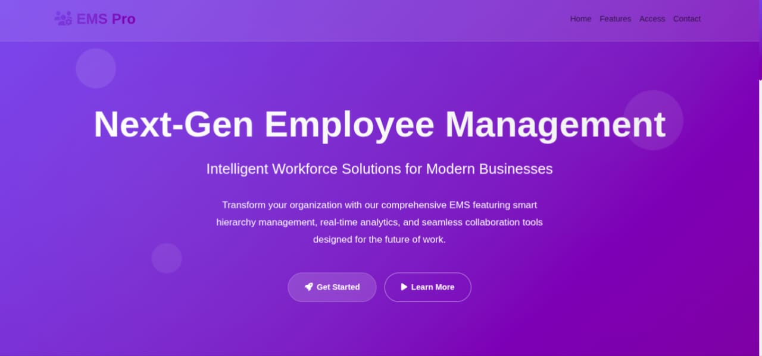

Employee Register Page

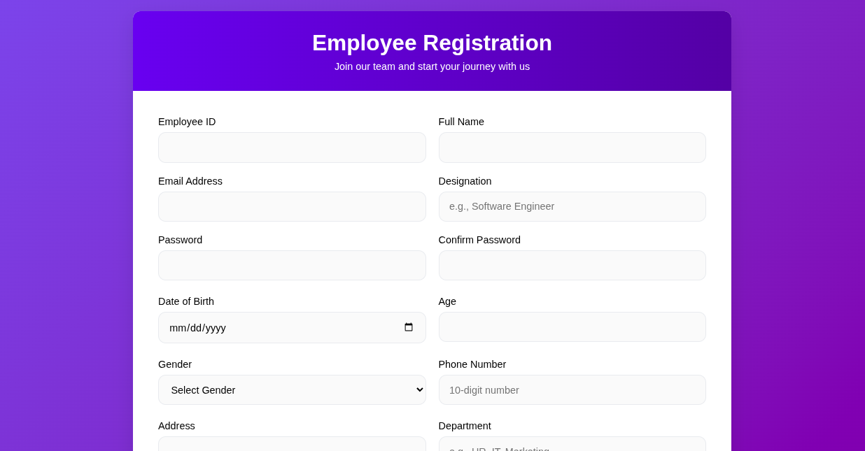

Log-in Page

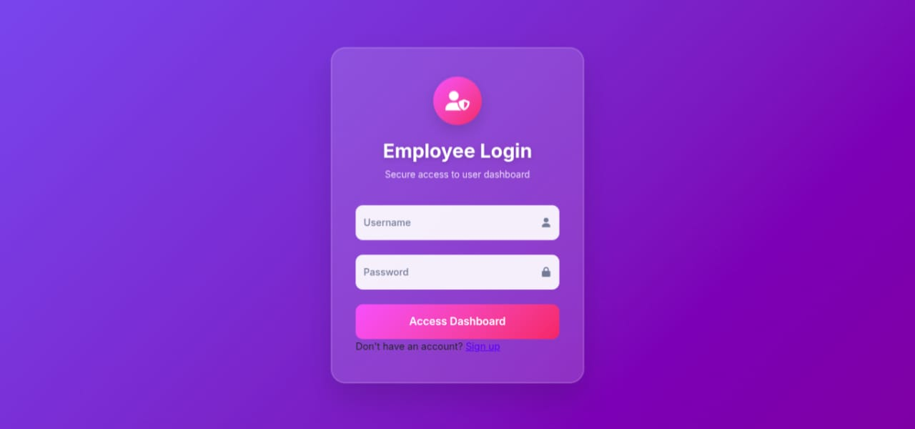
Employee Dashboard

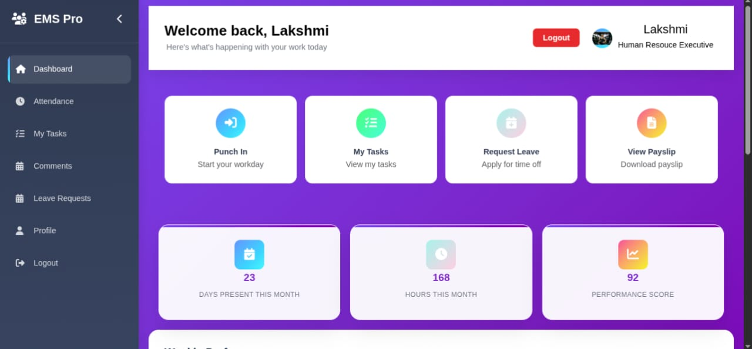

Profile
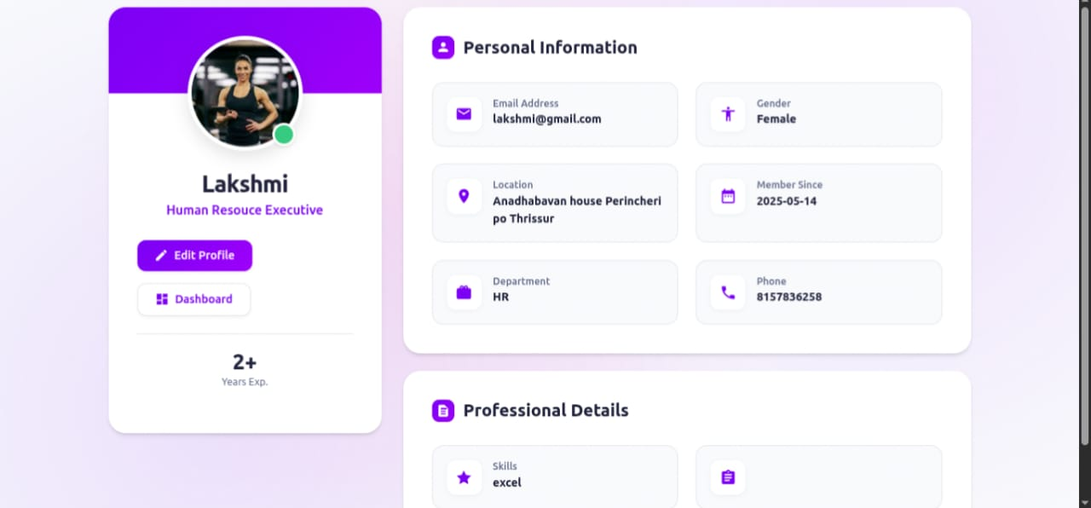
Attendance

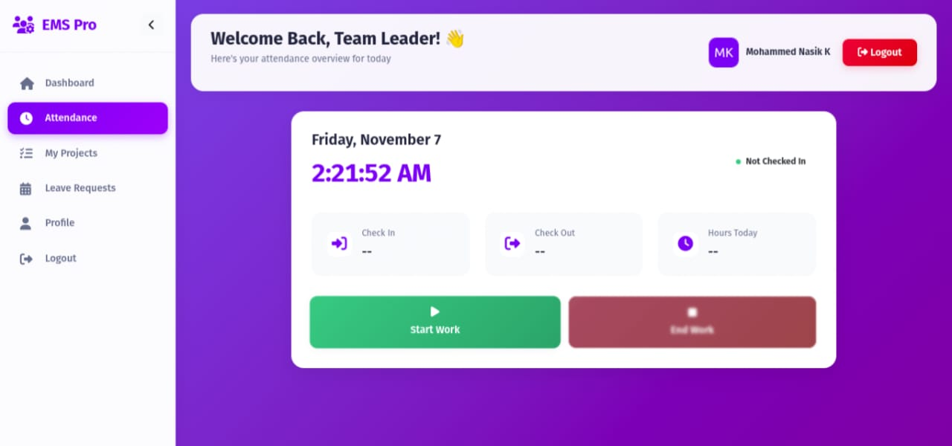

Leave Request

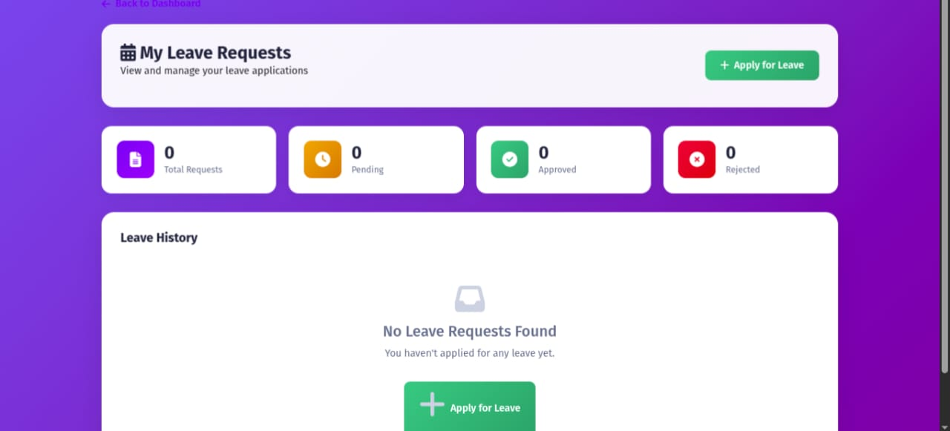

Team Leader Dashboard

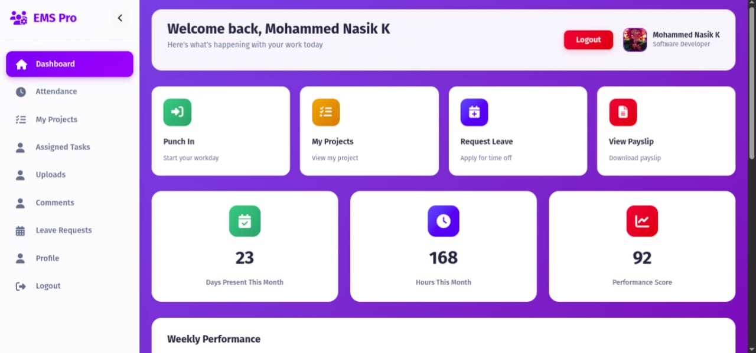

Projects

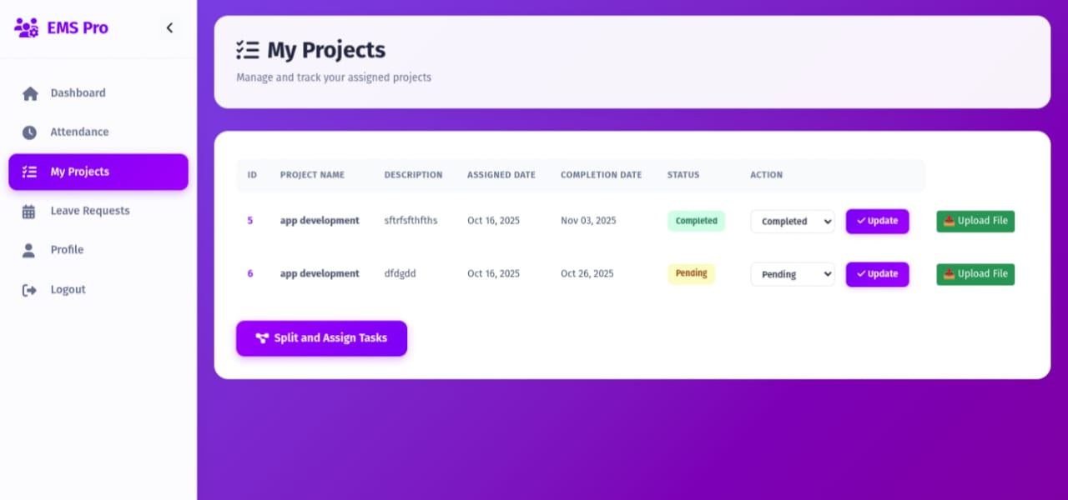

Admin Dashboard

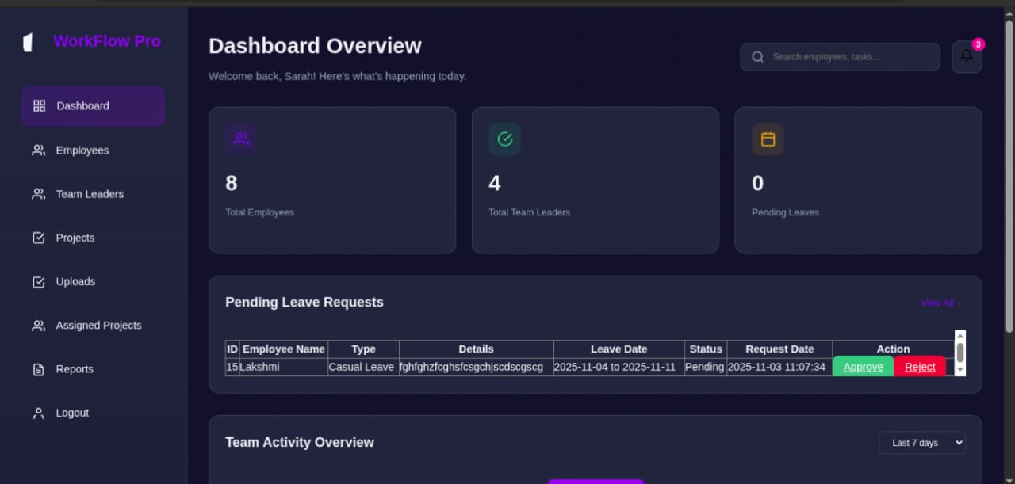

Employees List

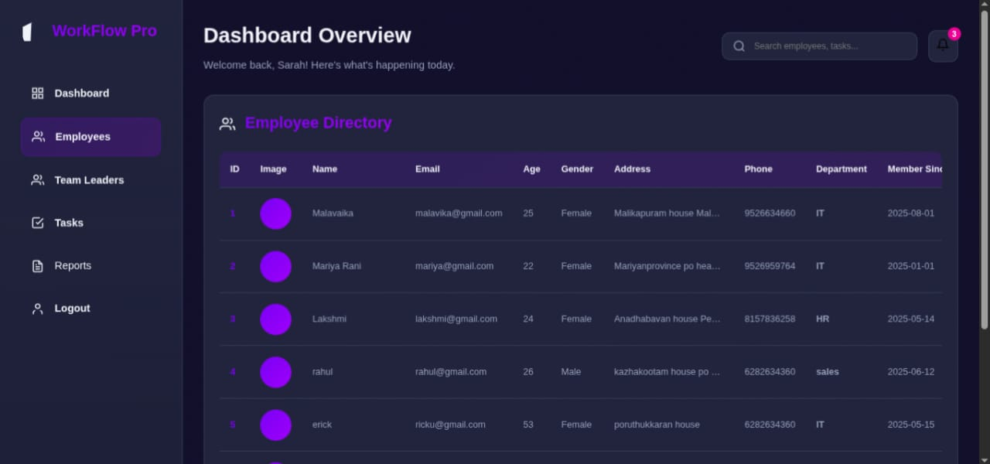

Coding

Employee Registration

<!DOCTYPE html>
<html lang="en">
<head>
<meta charset="UTF-8" />
<meta name="viewport" content="width=device-width, initial-scale=1.0" />
<title>Employee Registration</title>
<link
rel="stylesheet"
href="https://cdnjs.cloudflare.com/ajax/libs/font-awesome/6.4.0/css/all.min.css"
/>
<style>
:root {
--primary-color: #4361ee;
--secondary-color: #3a0ca3;
--accent-color: #4cc9f0;
--light-color: #f8f9fa;
--dark-color: #212529;
--error-color: #f87171;
--border-radius: 12px;
--transition: all 0.3s ease;
}
* {
margin: 0;
padding: 0;
box-sizing: border-box;
font-family: "Segoe UI", Tahoma, Geneva, Verdana, sans-serif;
}
body {
background: linear-gradient(135deg, #667eea 0%, #764ba2 100%);
min-height: 100vh;
display: flex;
align-items: center;
justify-content: center;
padding: 20px;
}
.container {
width: 100%;
max-width: 950px;
background: white;
border-radius: var(--border-radius);
box-shadow: 0 10px 30px rgba(0, 0, 0, 0.1);
animation: fadeInUp 0.6s ease forwards;
overflow: hidden;
}

.header {
background: linear-gradient(to right, var(--primary-color), var(--secondary-color));
color: white;
text-align: center;
padding: 30px 40px;}

.header h2 {
font-size: 2.2rem;
font-weight: 600;
margin-bottom: 8px;
}
.form-container {
padding: 40px;
}
.form-row {
display: flex;
flex-wrap: wrap;
margin: 0 -10px;
}
.form-group {
flex: 1 0 300px;
padding: 0 10px;
margin-bottom: 20px;
}
.form-group label {
display: block;
margin-bottom: 8px;
font-weight: 500;
position: relative;
}
.form-control {
width: 100%;
padding: 14px 16px;
border: 2px solid #e9ecef;
border-radius: var(--border-radius);
font-size: 1rem;
transition: var(--transition);
background-color: #fafafa;
}
.form-control:focus {
outline: none;
border-color: var(--accent-color);
background-color: white;
box-shadow: 0 0 0 3px rgba(76, 201, 240, 0.2);
}
textarea.form-control {
resize: none;
min-height: 80px;
}

.btn-submit {
background: linear-gradient(to right, var(--primary-color), var(--secondary-color));
color: white;
border: none;
padding: 16px 40px;
border-radius: var(--border-radius);
cursor: pointer;
font-size: 1.1rem;
width: 100%;
transition: var(--transition);
margin-top: 15px;
}
</style>
</head>
<body>
<div class="container">
<div class="header">
<h2>Employee Registration</h2>
<p>Join our team and start your journey with us</p>
</div>
<div class="form-container">
<form id="registrationForm" action="empregister.php" method="POST" enctype="multipart/form-data">
<div class="form-row">
<div class="form-group">
<label for="empid">Employee ID</label>
<input type="text" name="empid" id="empid" class="form-control" required />
</div>
<div class="form-group">
<label for="name">Full Name</label>
<input type="text" name="name" id="name" class="form-control" required />
</div>
</div>

<div class="form-row">
<div class="form-group">
<label for="email">Email Address</label>
<input type="email" name="email" id="email" class="form-control" required />
</div>
<div class="form-group">
<label for="designation">Designation</label>
<input type="text" name="designation" id="designation" class="form-control" placeholder="e.g., Software Engineer" required />
</div>
</div>

<div class="form-row">
<div class="form-group">
<label for="password">Password</label>
<input type="password" name="password" id="password" class="form-control" required />

<p class="error-message" id="passwordError"></p>
</div>
<div class="form-group">
<label for="confirm_password">Confirm Password</label>
<input type="password" name="confirm_password" id="confirm_password" class="form-control" required />
<p class="error-message" id="confirmError"></p>
</div>
</div>

<div class="form-row">
<div class="form-group">
<label for="dob">Date of Birth</label>
<input type="date" name="dob" id="dob" class="form-control" required />
<p class="error-message" id="dobError"></p>
</div>
<div class="form-group">
<label for="age">Age</label>
<input type="number" name="age" id="age" class="form-control" readonly />
</div>
</div>

<div class="form-row">
<div class="form-group">
<label for="gender">Gender</label>
<select name="gender" id="gender" class="form-control" required>
<option value="">Select Gender</option>
<option value="Male">Male</option>
<option value="Female">Female</option>
<option value="Other">Other</option>
</select>
</div>
<div class="form-group">
<label for="phone">Phone Number</label>
<input type="tel" name="phone" id="phone" class="form-control" required placeholder="10-digit number" />
<p class="error-message" id="phoneError"></p>
</div>
</div>

<div class="form-row">
<div class="form-group">
<label for="address">Address</label>
<textarea name="address" id="address" class="form-control" required></textarea>
</div>
<div class="form-group">
<label for="department">Department</label>
<input type="text" name="department" id="department" class="form-control" placeholder="e.g., HR, IT, Marketing" required/>
</div>

</div>
<div class="form-row">
<div class="form-group">
<label for="member_since">Member Since</label>
<input type="date" name="member_since" id="member_since" class="form-control" required />
</div>
<div class="form-group">
<label for="years_exp">Years of Experience</label>
<input type="number" name="years_exp" id="years_exp" class="form-control" min="0" required/>
</div>
</div>

<div class="form-row">
<div class="form-group">
<label for="skills">Skills</label>
<input type="text" name="skills" id="skills" class="form-control" placeholder="e.g., JavaScript, Design" required/>
</div>
<div class="form-group">
<label for="image">Profile Image</label>
<input type="file" name="image" id="image" class="form-control" accept="image/*" required />
</div>
</div>

<button type="submit" class="btn-submit"><i class="fas fa-user-plus"></i> Register Now</button>
</form>
</div>
</div>
</body>
</html>

register.php

<?php
include 'connect.php';

$emp_id = $_POST['empid'];
$name = $_POST['name'];
$email = $_POST['email'];
$phone = $_POST['phone'];
$password = $_POST['password'];
$confirm_password = $_POST['confirm_password'];
$dob = $_POST['dob'];
$age = $_POST['age'];
$gender = $_POST['gender'];
$address = $_POST['address'];

$department = $_POST['department'];
$desiginaton = $_POST['designation'];
$member_since = $_POST['member_since'];
$skills = $_POST['skills'];
$years_exp = $_POST['years_exp'];

$image = $_FILES['image']['name'];
$tmp_name = $_FILES['image']['tmp_name'];
$folder = "../uploads/" . $image;

if (move_uploaded_file($tmp_name, $folder)) {
$sql = "INSERT INTO employees
(empid,name, email, phone, password, confirm_password, dob, age, gender, address, department, designation, member_since, skills, years_exp, image)
VALUES
('$emp_id', '$name', '$email', '$phone', '$password', '$confirm_password', '$dob', '$age', '$gender', '$address', '$department', '$desiginaton', '$member_since', '$skills', $years_exp, '$image')";
if (mysqli_query($conn, $sql)) {
echo "Registered successfully! <a href='login.html'>Login</a>";
} else {
echo "Error: " . mysqli_error($conn);
}
} else {
echo "Failed to upload image.";
}

mysqli_close($conn);
?>

Login

<!DOCTYPE html>
<html lang="en">
<head>
<meta charset="UTF-8" />
<meta name="viewport" content="width=device-width, initial-scale=1.0"/>
<title>Login Page</title>
</head>
<body>
<div class="login-container">
<div class="login-card">
<div class="login-header">
<div class="admin-icon">
<i class="fas fa-user-shield"></i>
</div>
<h1 class="login-title"> Employee Login</h1>
<p class="login-subtitle">Secure access to user dashboard</p>
</div>

<form id="loginForm" method="POST" action="login.php">
<div class="form-floating">
<input type="text" class="form-control" id="email" name="email" placeholder="Admin Username" required>
<label for="username"> Username</label>
<i class="fas fa-user input-icon"></i>
</div>

<div class="form-floating">
<input type="password" class="form-control" id="password" name="password" placeholder="Password" required>
<label for="password">Password</label>
<i class="fas fa-lock input-icon"></i>
</div>

<button type="submit" class="btn login-btn">
<span class="btn-text">Access Dashboard</span>
</button>
<div class="login-link">
Don't have an account? <a href="empregister.html">Sign up</a>
</div>
</form>
</div>
</div>
</body>
</html>

Login.php

<?php
include 'connect.php';
session_start();

if ($_SERVER['REQUEST_METHOD'] == 'POST') {
$email = $_POST['email'];
$password = $_POST['password'];
$sql = "SELECT * FROM employees WHERE email='$email' AND password='$password'";
$result = mysqli_query($conn, $sql);
if (mysqli_num_rows($result) > 0) {
$user = mysqli_fetch_assoc($result);
$role = strtolower($user['role']);
$status = strtolower($user['status']);
if ($role !== 'employee') {
echo "<script>alert('Access Denied! You are not an Employee.'); window.history.back();</script>";
exit;
}
if ($status !== 'approved') {

echo "<script>alert('Your account is not yet approved by the manager. Please wait for approval.'); window.history.back();</script>";
exit;
}
// Store user data in session
$_SESSION['user'] = [
'id' => $user['id'], // ADDED THIS LINE
'empid' => $user['empid'],
'name' => $user['name'],
'email' => $user['email'],
'phone' => $user['phone'],
'gender' => $user['gender'],
'age' => $user['age'],
'address' => $user['address'],
'dob' => $user['dob'],
'department' => $user['department'],
'designation' => $user['designation'], // Fixed typo
'member_since' => $user['member_since'],
'skills' => $user['skills'],
'years_exp' => $user['years_exp'],
'image' => $user['image']
];
$_SESSION['emp_id'] = $user['id'];
header("Location: dashboard.php");
exit;
} else {
echo "<script>alert('Invalid Email or Password!'); window.history.back();</script>";
}
}
?>

Dashboard

<?php
session_start();
include 'connect.php';
date_default_timezone_set('Asia/Kolkata');

// Redirect if not logged in
if (!isset($_SESSION['emp_id'])) {
header("Location: login.html");
exit;
}

$user = $_SESSION['user'];
$emp_id = $_SESSION['emp_id'];
$user_id = $emp_id;
$today = date('Y-m-d');

// Default values
$checkInTime = '--';
$hoursToday = '--';
$workStatus = 'Not Checked In';

// Fetch today's attendance
$sql = "SELECT * FROM attendance WHERE user_id='$user_id' AND date='$today'";
$query = mysqli_query($conn, $sql);

if ($query && mysqli_num_rows($query) > 0) {
$data = mysqli_fetch_assoc($query);
if (!empty($data['check_in'])) {
$checkInTime = date("h:i A", strtotime($data['check_in']));
}
if (!empty($data['hours_worked'])) {
$hoursToday = $data['hours_worked'];
}
if (!empty($data['check_out'])) {
$workStatus = 'Inactive';
} elseif (!empty($data['check_in'])) {
$workStatus = 'Active';
}
}
?>
<!DOCTYPE html>
<html lang="en">
<head>
<meta charset="UTF-8">
<meta name="viewport" content="width=device-width, initial-scale=1.0">
<title>Employee Dashboard - EMS Pro</title>
<link href="https://cdnjs.cloudflare.com/ajax/libs/bootstrap/5.3.0/css/bootstrap.min.css" rel="stylesheet">
<link href="https://cdnjs.cloudflare.com/ajax/libs/font-awesome/6.4.0/css/all.min.css" rel="stylesheet">
<link rel="stylesheet" href="../assets/style.css">

</head>
<body>
<!-- Mobile Menu Button -->
<button class="mobile-menu-btn" id="mobileMenuBtn">
<i class="fas fa-bars"></i>
</button>

<!-- Sidebar -->
<nav class="sidebar" id="sidebar">
<div class="sidebar-header">
<a href="#" class="sidebar-brand">
<i class="fas fa-users-cog me-2"></i>
<span>EMS Pro</span>
</a>

<button class="sidebar-toggle" id="sidebarToggle">
<i class="fas fa-chevron-left"></i>
</button>
</div>
<div class="sidebar-nav">
<div class="nav-item">
<a href="#" class="nav-link active">
<i class="fas fa-home"></i>
<span>Dashboard</span>
</a>
</div>
<div class="nav-item">
<a href="attend.php" class="nav-link">
<i class="fas fa-clock"></i>
<span>Attendance</span>
</a>
</div>
<div class="nav-item">
<a href="employee_viewtask.php" class="nav-link">
<i class="fas fa-tasks"></i>
<span>My Tasks</span>
</a>
</div>

<div class="nav-item">
<a href="employee_task_comments.php" class="nav-link">
<i class="fas fa-calendar-alt"></i>
<span>Comments</span>
</a>
</div>

<div class="nav-item">
<a href="view_leave.php" class="nav-link">
<i class="fas fa-calendar-alt"></i>
<span>Leave Requests</span>
</a>
</div>
<div class="nav-item">
<a href="profile.php" class="nav-link">
<i class="fas fa-user"></i>
<span>Profile</span>
</a>
</div>
<div class="nav-item">
<a href="#" class="nav-link">
<i class="fas fa-sign-out-alt"></i>
<span>Logout</span>
</a>
</div>
</div>

</nav>

<!-- Main Content -->
<main class="main-content" id="mainContent">
<!-- Header -->
<header class="header">
<div class="header-left">
<h1 style="color: black">Welcome back, <?php echo htmlspecialchars($user['name']); ?></h1>
<p>Here's what's happening with your work today</p>
</div>
<div class="header-right">
<div class="logout-container">
<a href="logout.php" class="logout-button">Logout</a>
</div>
<div class="user-profile">
<div class="user-avatar">
<a href="profile.php">
<img src="../uploads/<?php echo htmlspecialchars($user['image']); ?>"
alt="Profile Picture"
class="profile-image"></a>
</div>
<div>
<div style="font-weight: 600; font-size: 0.875rem;">
<h4 style="color: black"><?php echo htmlspecialchars($user['name']); ?></h4>
</div>
<div style="font-size: 0.75rem; color: black;">
<h6><?php echo htmlspecialchars($user['designation']); ?></h6>
</div>
</div>
</div>

</div>
</div>
</header>

<!-- Dashboard Content -->

<div class="dashboard-content">
<div class="quick-actions fade-in">
<a href="attend.php" class="action-btn" onclick="showNotification('Punch In functionality would be implemented here')">
<div class="action-icon" style="background: var(--success-gradient);">
<i class="fas fa-sign-in-alt"></i>
</div>
<strong>Punch In</strong>
<p class="mb-0 text-muted">Start your workday</p>
</a>
<a href="#" class="action-btn" onclick="showNotification('New Task functionality would be implemented here')">

<div class="action-icon" style="background: var(--warning-gradient);">
<i class="fa fa-tasks"></i>
</div>
<strong>My Tasks</strong>
<p class="mb-0 text-muted">View my tasks</p>
</a>
<a href="apply_request.php" class="action-btn" onclick="showNotification('Leave Request functionality would be implemented here')">
<div class="action-icon" style="background: var(--info-gradient);">
<i class="fas fa-calendar-plus"></i>
</div>
<strong>Request Leave</strong>
<p class="mb-0 text-muted">Apply for time off</p>
</a>
<a href="#" class="action-btn" onclick="showNotification('Payslip functionality would be implemented here')">
<div class="action-icon" style="background: var(--danger-gradient);">
<i class="fas fa-file-alt"></i>
</div>
<strong>View Payslip</strong>
<p class="mb-0 text-muted">Download payslip</p>
</a>
</div>

</div>

<!-- Task Progress -->
</div>
<!-- Quick Stats -->
<div class="dashboard-grid">
<div class="dashboard-card stat-card fade-in">
<div class="card-icon" style="background: var(--success-gradient); margin: 0 auto;">
<i class="fas fa-calendar-check"></i>
</div>
<div class="stat-value" id="attendanceCount">23</div>
<div class="stat-label">Days Present This Month</div>
</div>
<div class="dashboard-card stat-card fade-in">
<div class="card-icon" style="background: var(--info-gradient); margin: 0 auto;">
<i class="fas fa-clock"></i>
</div>
<div class="stat-value" id="hoursWorked">168</div>
<div class="stat-label">Hours This Month</div>
</div>
<div class="dashboard-card stat-card fade-in">
<div class="card-icon" style="background: var(--danger-gradient); margin: 0 auto;">
<i class="fas fa-chart-line"></i>
</div>
<div class="stat-value" id="performanceScore">92</div>

<div class="stat-label">Performance Score</div>
</div>
</div>

<!-- Performance Chart -->
<div class="performance-chart fade-in">
<div class="card-header">
<h3 class="card-title">Weekly Performance</h3>
</div>
<div class="chart-container">
<div class="chart-bar" style="height: 80%;">
<div class="bar-value">8.5h</div>
<div class="bar-label">Mon</div>
</div>
<div class="chart-bar" style="height: 95%;">
<div class="bar-value">9.2h</div>
<div class="bar-label">Tue</div>
</div>
<div class="chart-bar" style="height: 75%;">
<div class="bar-value">7.8h</div>
<div class="bar-label">Wed</div>
</div>
<div class="chart-bar" style="height: 90%;">
<div class="bar-value">8.9h</div>
<div class="bar-label">Thu</div>
</div>
<div class="chart-bar" style="height: 100%;">
<div class="bar-value">9.5h</div>
<div class="bar-label">Fri</div>
</div>
</div>
</div>

<!-- Recent Attendance Table -->
<div class="table-container fade-in">
<div class="table-header">
<h3>Recent Attendance</h3>
</div>
<table class="table">
<thead>
<tr>
<th>Date</th>
<th>Check In</th>
<th>Check Out</th>
<th>Hours Worked</th>
<th>Status</th>
</tr>
</thead>
<tbody>
<tr>

<td>Today</td>
<td>09:15 AM</td>
<td>-</td>
<td id="currentHours">7h 30m</td>
<td><span class="badge badge-success">Present</span></td>
</tr>
<tr>
<td>Yesterday</td>
<td>09:00 AM</td>
<td>06:00 PM</td>
<td>8h 00m</td>
<td><span class="badge badge-success">Present</span></td>
</tr>
<tr>
<td>Aug 9, 2025</td>
<td>09:30 AM</td>
<td>05:45 PM</td>
<td>7h 15m</td>
<td><span class="badge badge-warning">Late</span></td>
</tr>
<tr>
<td>Aug 8, 2025</td>
<td>08:45 AM</td>
<td>06:15 PM</td>
<td>8h 30m</td>
<td><span class="badge badge-success">Present</span></td>
</tr>
<tr>
<td>Aug 7, 2025</td>
<td>-</td>
<td>-</td>
<td>0h 00m</td>
<td><span class="badge badge-info">Leave</span></td>
</tr>
</tbody>
</table>
</div>
</div>
</main>

<!-- Notification Container -->
<div id="notificationContainer" style="position: fixed; top: 20px; right: 20px; z-index: 9999;"></div>

</body>
</html>

Attendance

<?php
session_start();
include 'connect.php';

if (!isset($_SESSION['emp_id'])) {
header("Location: login.html");
exit;
}

$emp_id = $_SESSION['emp_id'];
$user_id = $_SESSION['emp_id'];
$user = $_SESSION['user'];

$checkInTime = "--";
$checkOutTime = "--";
$hoursToday = "0 hrs 0 mins";
$workStatus = "Not Checked In";
$attendanceStatus = "Absent";
$today = date('Y-m-d');

// Fetch today's attendance
$sql = "SELECT * FROM attendance WHERE user_id = '$user_id' AND DATE(check_in) = '$today' ORDER BY id DESC LIMIT 1";
$result = mysqli_query($conn, $sql);

if ($result && mysqli_num_rows($result) > 0) {
$row = mysqli_fetch_assoc($result);
$checkInTime = date('H:i:s', strtotime($row['check_in']));
if ($row['check_out']) {
$checkOutTime = date('H:i:s', strtotime($row['check_out']));
$workStatus = "Inactive";
$diff = strtotime($row['check_out']) - strtotime($row['check_in']);
$hoursToday = floor($diff / 3600) . " hrs " . floor(($diff % 3600) / 60) . " mins";
// Determine Attendance Status
$hoursWorked = $diff / 3600;
if ($hoursWorked >= 4) {
$attendanceStatus = "Full Day";
} elseif ($hoursWorked > 0) {
$attendanceStatus = "Half Day";
} else {
$attendanceStatus = "Absent";
}
} else {
$workStatus = "Active";
$attendanceStatus = "In Progress";
}
} else {
$attendanceStatus = "Absent";}?>

File Upload

<?php
session_start();
include 'connect.php';

if (!isset($_SESSION['manager_id'])) {
header("Location: manager_login.php");
exit();
}

// 🧹 Handle delete request
if (isset($_GET['delete'])) {
$delete_id = intval($_GET['delete']);

// Get file path before deleting
$file_q = mysqli_query($conn, "SELECT file_path FROM file_uploads WHERE id = $delete_id");
if ($file_q && mysqli_num_rows($file_q) > 0) {
$file = mysqli_fetch_assoc($file_q);
$file_path = '../' . $file['file_path']; // adjust path

// Delete from database
mysqli_query($conn, "DELETE FROM file_uploads WHERE id = $delete_id");

// Delete actual file from folder (optional)
if (file_exists($file_path)) {
unlink($file_path);
}

echo "<script>alert('✅ File deleted successfully'); window.location='uploads.php';</script>";
exit();
} else {
echo "<script>alert('❌ File not found or already deleted'); window.location='uploads.php';</script>";
exit();
}
}

$sql = "
SELECT u.*, tl.name AS team_leader_name
FROM file_uploads u
LEFT JOIN employees tl ON u.uploaded_by = tl.id
ORDER BY u.uploaded_date DESC
";

$result = mysqli_query($conn, $sql);
?>

<!DOCTYPE html>
<html lang="en">
<head>
<meta charset="UTF-8">
<title>Manager - Team Leader Uploads</title>
<link href='https://cdn.jsdelivr.net/npm/bootstrap@5.3.0/dist/css/bootstrap.min.css' rel='stylesheet'>
<style>
body { background: #f9fafb; font-family: 'Poppins', sans-serif; }
.container { margin-top: 40px; }
table { background: white; border-radius: 8px; }
.btn-sm { padding: 4px 10px; font-size: 14px; }
</style>
</head>
<body>
<div class="container">
<h3 class="text-center text-primary mb-4">📂 Team Leader Uploaded Files</h3>

<?php if (mysqli_num_rows($result) > 0): ?>
<table class="table table-bordered table-striped align-middle">
<thead class="table-primary">
<tr>
<th>#</th>
<th>Project</th>
<th>Task ID</th>
<th>Uploaded By</th>
<th>File</th>
<th>Uploaded Date</th>
<th>Action</th>
</tr>
</thead>
<tbody>
<?php $i = 1; while ($row = mysqli_fetch_assoc($result)): ?>
<tr>
<td><?= $i++; ?></td>
<td><?= htmlspecialchars($row['project_id']); ?></td>
<td><?= htmlspecialchars($row['task_id']); ?></td>
<td><?= htmlspecialchars($row['team_leader_name'] ?? $row['uploaded_by']); ?></td>
<td><?= htmlspecialchars($row['original_name']); ?></td>
<td><?= htmlspecialchars($row['uploaded_date']); ?></td>
<td>
<a href="../<?= htmlspecialchars($row['file_path']); ?>" download class="btn btn-success btn-sm">⬇️ Download</a>
<a href="uploads.php?delete=<?= $row['id']; ?>"
class="btn btn-danger btn-sm"
onclick="return confirm('⚠️ Are you sure you want to delete this file?');">
🗑 Delete
</a>
</td>
</tr>

<?php endwhile; ?>
</tbody>
</table>
<?php else: ?>
<p class="text-center text-muted">No files uploaded yet by team leaders.</p>
<?php endif; ?>
</div>
</body>
</html>

View Request

<?php
session_start();
include 'connect.php';

// ✅ Protect from unauthorized access
if (!isset($_SESSION['admin_logged_in'])) {
header("Location: admin_login.php");
exit();
}

// ✅ Fetch all leave requests
$sql = "SELECT r.request_id, e.name, r.request_type, r.request_details,
r.leave_date, r.status, r.request_date
FROM employee_requests r
JOIN employees e ON r.emp_id = e.id
ORDER BY r.request_date DESC";
$result = mysqli_query($conn, $sql);
?>

<!DOCTYPE html>
<html lang="en">
<head>
<meta charset="UTF-8">
<title>All Leave Requests</title>
<link rel="stylesheet" href="styles.css"> <!-- optional -->
<style>
body { font-family: Arial; background: #f8f9fa; padding: 20px; }
h1 { color: #333; }
table { width: 100%; border-collapse: collapse; background: white; }
th, td { padding: 10px; border: 1px solid #ccc; text-align: center; }
th { background: #007bff; color: white; }
a { text-decoration: none; margin: 0 5px; }
.approve { color: green; font-weight: bold; }
.reject { color: red; font-weight: bold; }
.back-btn { display: inline-block; margin-bottom: 15px; color: #007bff; }
</style>
</head>
<body>

<a href="admin_dashboard.php" class="back-btn">← Back to Dashboard</a>
<h1>All Leave Requests</h1>

<table>
<tr>
<th>ID</th>
<th>Employee Name</th>
<th>Type</th>
<th>Details</th>
<th>Leave Date</th>
<th>Status</th>
<th>Request Date</th>
<th>Action</th>
</tr>

<?php
if (mysqli_num_rows($result) > 0) {
while($row = mysqli_fetch_assoc($result)) {
echo "<tr>
<td>{$row['request_id']}</td>
<td>{$row['name']}</td>
<td>{$row['request_type']}</td>
<td>{$row['request_details']}</td>
<td>{$row['leave_date']}</td>
<td>{$row['status']}</td>
<td>{$row['request_date']}</td>
<td>";

if ($row['status'] == 'Pending') {
echo "<a class='approve' href='admin_dashboard.php?action=approve&id={$row['request_id']}'>Approve</a>";
echo "<a class='reject' href='admin_dashboard.php?action=reject&id={$row['request_id']}'>Reject</a>";
} else {
echo $row['status'];
}

echo "</td></tr>";
}
} else {
echo "<tr><td colspan='8'>No leave requests found</td></tr>";
}
?>
</table>
</body>
</html>

BIBLIOGRAPHY

BIBLIOGRAPHY

- PHP & MySQL Web Development — Luke Welling and Laura Thomson, Pearson Education.
- Learning PHP, MySQL & JavaScript — Robin Nixon, O’Reilly Media.
- HTML and CSS: Design and Build Websites — Jon Duckett, Wiley.
- JavaScript: The Definitive Guide — David Flanagan, O’Reilly Media.
- Database System Concepts — Abraham Silberschatz, Henry F. Korth, S. Sudarshan, McGraw-Hill.
- Official PHP Documentation — https://www.php.net/docs.php
- MySQL Reference Manual — https://dev.mysql.com/doc/
- W3Schools Online Web Tutorials — https://www.w3schools.com
- Mozilla Developer Network (MDN) — https://developer.mozilla.org
- Stack Overflow Community — https://stackoverflow.com
- Bootstrap Framework Documentation — https://getbootstrap.com

