Department : DM | Division: WD | Reporting Team Lead: Manivannan P
Name : Jhansi S Stijin |  | Date: 25.8.2026 - 25.9.2026
Level 1- Summary Report
Week | Self-Overviewed Based on Minutes of Meeting | HR Overview | Result
1 | On page Target:  PUB & SW  - Pubrica - Service Pages  - Statswork - Service pages  - PhD – Service pages
  PUB
  Baseline – 65; Target: 95
  Achieved – 97%
  SW
  Baseline – 65; Target: 95
  Achieved – 91%
Level 2- Attendance
Leave-3; Permission- 2

Level 3- Task Assigned
S.no | Brand | No of Task Target (N) |  |  | No of Task Assigned |  |  | No of Task Completed on Quality |  |  |  | % of Achieved on Quality (n)
S.no | Brand | NPD | OPO | Asset | NPD | OPO | Asset | NPD | OPO | Asset | NPD% |  | OPO% | Asset%
1 | PUB | 60 | 200 | 23 | 1 | 20 | 23 | 1 | 20 | 23 | 1.67% |  | 100% | 100%
2 | SW | 60 | 200 | 18 | 2 | 71 | 18 | 2 | 71 | 18 | 63% |  | 100% | 100%
3 | PA | 1 | 200 | 28 | - | 19 | 28 | - | 19 | 28 | - |  | 100% | 100%
4 | TI | - | - | 16 | - | 1 | 16 | - | 1 | 16 | - |  | 100% | 100%

Consolidation Percentage = 94.02%

SW
Date | Error | Warning | Notices
25/8/2026 | 573 | 3, 952 | 1,532
25/9/2026 | 389 | 1,345 | 1,245
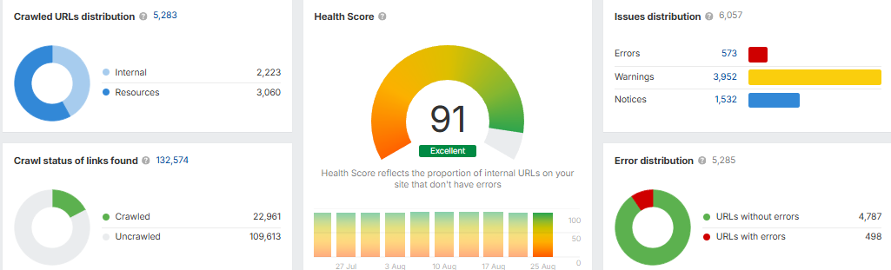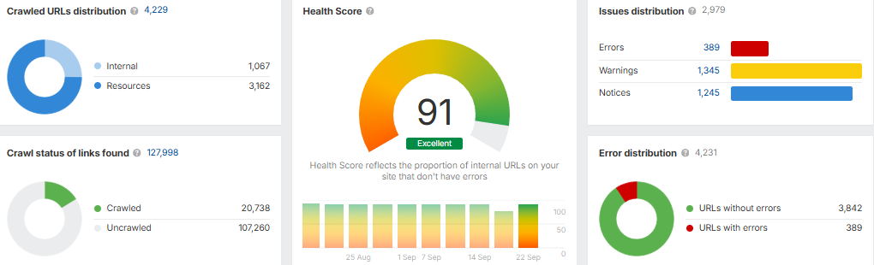

Pubrica
Date | Error | Warning | Notices
25/8/2026 | 351 | 10,030 | 2,306
25/9/2026 | 325 | 8,140 | 4,078

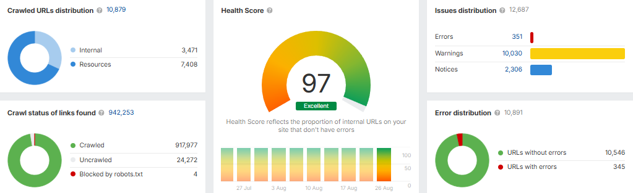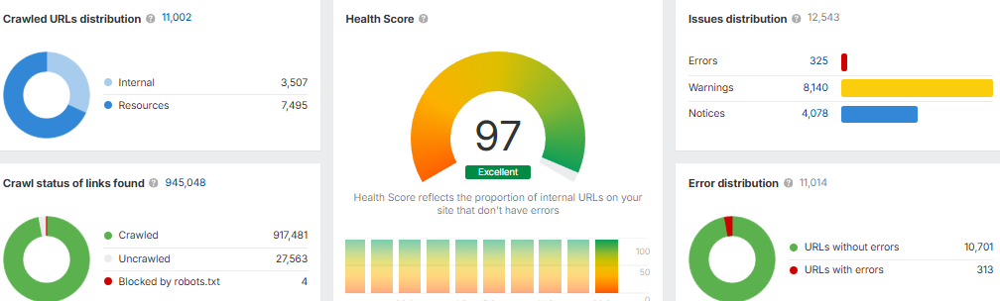
Service pages - PhD
S.No | Urls | Date | Progress
1 | https://www.phdassistance.uk/ | 6/8/2026 | Live

Service pages - pubrica
S.No | Urls | Date | Progress
1 | https://pubrica.com/scientific-research-poster-conference-support/ | 1/9/2026 | live

Statswork-Service and asset Pages- live
S.No | URLs | Date | Progress
1 | https://www.statswork.com/services/statistics-tutoring-training/in-house-tutoring/ | 4/9/2026 | live
2 | https://www.statswork.com/insights/sample-work/ | 26/8/2026

Employee Sign | TL Sign | HR Sign

