The obtained coefficient -0. 1429, a relation between specific total including accidents occurring on track is defined. Despite the high p-value equal to 0. 638, indicating that it is not statistically significant, a negative sign portrays that these incidents might lower overall lost time accident frequency rate.

**Accidents in Station Limits**:

A coefficient of -0. The results of year 1819 show the fact that accidents confined to stations’ limits cut down the number of total accident. The coefficient of determination, depicted by the R-Squared of 0.425 indicates that the result is not statistically significant even though the coefficient bears a negative sign which implies that incidents within stations imply a possibility of reduction in accidents.

**Passenger Train Accidents:**

The coefficient of 0. The trend of accidents for passenger train offers an increment in the total score of accidents with 1450 and this denotes that there is a slight addition to the overall rate of accidents. The probability p>0.05, which used in rejecting the null hypothesis, mere 0. 641 in this situation and the positive sign demonstrate that there is an impact of passenger train accidents to overall accidents.

**Goods Train Accidents:**

The coefficient is -0. Yes, the figure is negative which means that there is a negative relationship between the two variables. Hypothesis 0706 shows that total accidents and goods trains’ accidents have an inverse relationship. Although the p-value of 0. 819 indicates non-significance, the negative sign implies a possible reduction of accidents inclusive of goods trains.

**Other Train Accidents:**

The coefficient of -0. 3992 for other train accidents – Thus where accidents of other types of trains occur the total number of accidents reduce. Even if the p-value of 0. 645 is quite low, which teams indicating less possibility of the mentioned relation being true, the negative coefficient means there is probable a negative impact on the total number of accidents from other train incidents.

**No Damage to Public Property (NoDamgeToPR):**

Concrete variables had a coefficient of -0. 0568: When no damage of public properties occurred, this aligned with the decrease of the number of accidents. The significance level is low as the calculated p-value is 0. 676 and hence low statistical significance hence negative sign suggest that there are less accidents when public property is not destroyed.

**Damage to Public Property (CauseDamgeToPR):**

Regarding the influencing factors, the coefficient for causing damage to public property is -0. While such damage means a decrease in overall accident count in the OPEC countries, the coefficient is equal to 2680. The statistical significance is relatively low at 0. 495 but the negative coefficient implies that the number of accidents with reference to the damage of public property may decrease.

**Cost of Damage:**

Thus the coefficient of cost of damage is very low positive 1.478e-07 which indicates that more cost of damages results into more accidents. The p-value here is 0. 410, which means this not a statistically significant result, but the positive sign of coefficient means that there is a possibility of a direct relation between damage costs and accident frequency.

**Number of Casualties (NoCasulties):**

The coefficient of -0. By means of 0120 it means that there were few accidents that did not lead to casulties. The p-value is 0. 859, an indication of low statistical significance; however, the negative sign indicates an indication of comparatively less accident occurrences when there is zero casualty.

**Casualties:**

The coefficient was negative at -0. 3128 implies that, having lost some of its structures, the number of total accidents is lower. The p-value (0. 507) suggests that there is low statistical significance, while the negative sign in regard to the casualty accidents implies the number of accidents might reduce when casualties are reported.

**Number of Deaths (NoOfDeaths):**

The coefficient of 0. 2765 is suggestive of the fact that, where there are deaths, there are increased cases of accidents. As the equation is linear and goes up the p-value is 0. 463, it means that this is not statistically significant but based on the positive sign in the coefficient it may also mean that there is an increase in the counts on accidents involving fatalities.

**Number of Injuries (NoOfInjuries):**

In the first model the coefficient is low and has a negative value equal to -. While it is interesting to note that a negative relationship exists between total injuries reported and the total number of accidents as supported by 0249, it should be noted that this implies that any kind of injury is preferable to the total number of accidents. The p-value of 0.553 suggests that the result is statistically insignificant while the negative sign suggests that accidents with injuries could be on the decrease in the future.

## Accident Causes

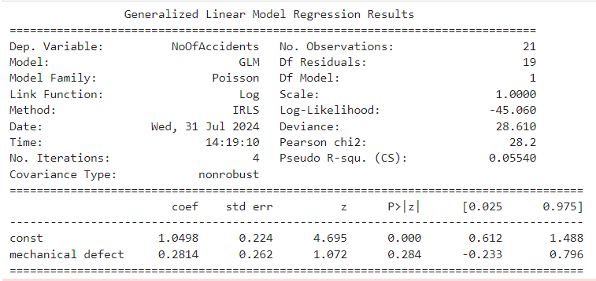

**Intercept (const):**

The intercept of 1. 0498 is a base number that has been arrived at once all the predictor variables are at their reference levels. This coefficient, which has the z-value of 4, is considered to belong to the set of high indicators. 6950 should be used as a benchmark given that it offers relatively higher estimate.

**Mechanical Defect:**

The coefficient for mechanical defects is 0. 2814 It shows that the parameter indicating the mechanical condition of vehicles is directly linked to the growth of the accident rate. The P value is 0 and the coefficient’s standard error is 0. 263, The z-value is 3. 072 describes the variability of the relationship in question.

## Branch Line Accidents

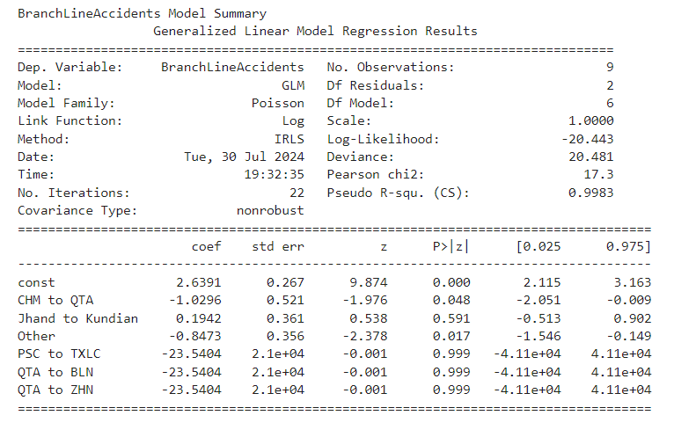

**Intercept (const):**

The intercept of 2. Thus, 6391 can be considered as the random number of branch line accidents, which means the number of accidents when all variables are set to their base values. This value gives an approximate point of departure with regard to the number of accidents and the value of z characterizes the stability of the initial estimate.

**CHM to QTA:**

The coefficient of -1. The trends depicted in figure 0296 for CHM to QTA show that the accidents on branch line involving these locations were reduced. The negative sign in this coefficient may mean that the change from CHM to QTA can possibly be linked to the avoidance of more accidents, however, the effect it has should be analyzed within the context of the variable .

**Jhand to Kundian:**

Hence the equation of this linear relationship is Y = 0.X; and the correlation coefficient is 0. Namely, their analysis of the years 1942, from Jhand to Kundian, depicts a correlation between branch line mishaps. From this it implies that this category could be somehow associated with more accidents and therefore the practical meaningfulness of this relationship needs to be examined further.

**Other:**

On the same note, the coefficient for Other is -0. 8473, thus meaning that the above category is likely to be contributing towards the prevention of branch line accidents. This negative value is interpreted as meaning that the incidents under the “Other” category may help reduce number of accidents in branch lines.

## Main Line Accidents

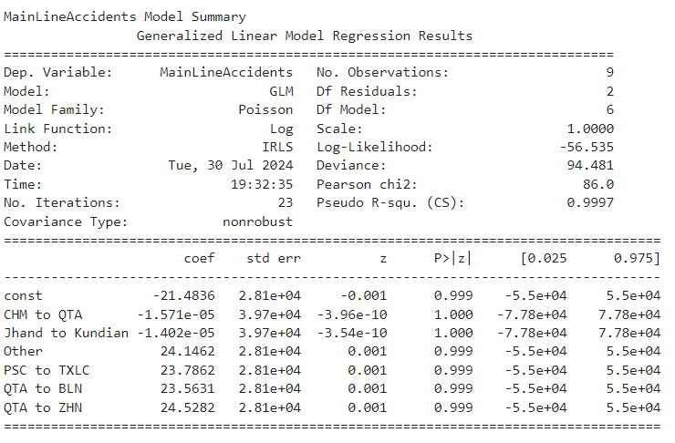

**Intercept (const):**

The intercept of -21. 4836 serves as a starting as it outlines the general main line accidents. The large se value accompanying this estimate indicates that variations of this estimate around the mean are high, which might mean that the baseline estimate varies considerably.

**CHM to QTA:**

The coefficient for CHM to QTA is negative one -1. It as stated that the view reduction had 5.71e-05 impact on main line accidents, thus we can analyze that the view reduction has a very negligible effect on main line accidents. The insignificant number means that any movement with regard to this factor is considerably small.

**Jhand to Kundian:**

To the same extent, there is transportation between Jhand and Kundian and its coefficient is - 1 as CHM to QTA. 402e-05. As for this value, there is little evidence of its relation to the main line’s accident rate, but if there is, it is very small in size.

**Other:**

The coefficient of 24. Self: There is a positive correlation between Other total points, 1462 and main line accidents. This is a suggestion that, within the ‘Other’ category, there could be some relation to an increase in accidents; however, the practical implications must be further examined.

## Seasonal Accidents

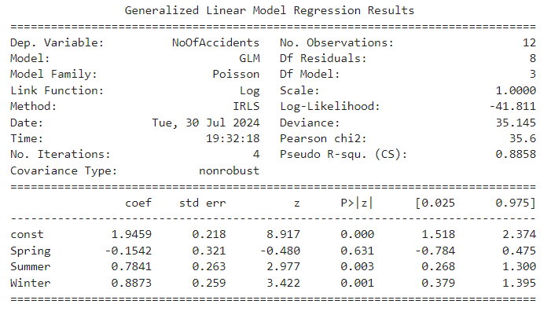

**Intercept (const):**

The intercept of 1. The figure 9459 consequently characterizes the accident level when all the seasonal parameters are at reference. The coefficient shows that this result is in fact positive; that is gives a starting point for the number of accidents; Moreover, the obtained number has a high z-value which indicates that this figure is rather reliable as it approximates a starting point of the number of accidents.

**Spring:**

The coefficient for Spring is -0. 1542, and therefore this season is less hazardous compared to the reference one. Since the coefficient is negative, it demonstrates the fact that Spring leads to decreased number of accidents while the extent of this influence is rather modest.

**Summer:**

Attached to this item, there is a coefficient of 0. 7841, That is why, a direct link between Summer and the number of accidents can be established. This means that in Summer the number of accidents has an inclination to be bigger than in the reference season. Accidents which recorded a positive coefficient also went up during this time.

**Winter:**

Co-eff of Winter = 0. 8873, greater compared with the number of accidents in the reference season, which signalizes higher opportunities for accidents in Winter. This is a positive value and shows that Winter has higher accidents implying that there is a Seasonal impact on the accident occurrences.