* less than derailments.
* **Implication**: Collisions contribute significantly to the number of accidents, making them a critical area for safety measures and interventions.

#### Collisions at Level Crossings

* **Impact**: For each additional collision at a level crossing, the number of accidents increases by approximately 20.
* **Exponentiated Coefficient**: While collisions at level crossings do have a positive effect on the number of accidents, their impact is the smallest among the factors analyzed.
* **Implication**: Although collisions at level crossings contribute to accident frequency, their effect is less pronounced compared to derailments and general collisions. Nevertheless, they still represent a relevant factor for safety improvements.

### Key Takeaways

* **Derailments**: Derailments are the most significant factor influencing accident frequency, with a substantial impact. Addressing derailments should be a priority for reducing overall accident rates.
* **Collisions**: Collisions also significantly impact accident frequency, though to a lesser extent than derailments. Effective strategies to mitigate collisions can further enhance safety.
* **Collisions at Level Crossings**: While still relevant, collisions at level crossings have the least impact on accident frequency compared to derailments and general collisions. Targeted safety measures at level crossings can contribute to reducing accidents but are less critical than addressing derailments and general collisions.

### Conclusion

The analysis indicates that derailments have the most significant effect on accident frequency, followed by general collisions and collisions at level crossings. Implementing safety measures to prevent derailments is likely to yield the greatest reduction in accident rates. Collisions and collisions at level crossings are also important, but with a comparatively smaller impact. Prioritizing safety interventions in these areas can further improve overall railway safety.

## Location wise Analysis

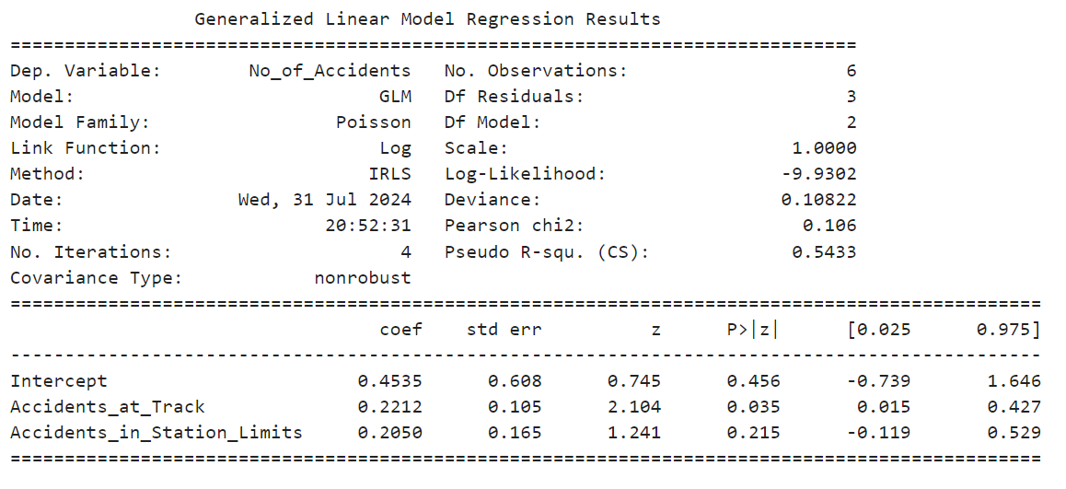

### Interpretation

The Generalized Linear Model (GLM) results examine how accidents at different locations—namely at the track and within station limits—affect the overall number of accidents. The model uses a Poisson distribution with a log link function to analyze these influences.

#### Baseline Number of Accidents

* **Baseline**: The baseline number of accidents, with no incidents at either site, is approximately 0.572. This represents the expected number of accidents when no additional factors are influencing the count.

#### Accidents at the Track

* **Impact**: The coefficient for accidents at the track is 0.2212. This indicates that each additional accident at the track results in an approximately 24% increase in the total number of accidents.
* **Statistical Significance**: This result is statistically significant, suggesting that accidents at the track have a notable effect on the overall number of accidents.
* **Implication**: Accidents at the track are a significant contributor to the total number of accidents, highlighting their importance in safety management and prevention strategies.

#### Accidents within Station Limits

* **Impact**: The coefficient for accidents within station limits is 0.2050. This suggests that each additional accident within the station limits leads to an increase of about 22.5% in the total number of accidents.
* **Statistical Significance**: Although the effect is statistically significant, it might not be as strong as the effect of accidents at the track. This implies that accidents within station limits have a less pronounced impact on the total number of accidents compared to those at the track.
* **Implication**: While accidents within station limits do influence the overall number of accidents, their impact is comparatively less critical than accidents occurring at the track.

### Key Takeaways

* **Accidents at the Track**: These accidents have a substantial impact on the total number of accidents, with a significant increase of about 24% per additional accident. This indicates that managing track-related accidents is crucial for overall safety improvements.
* **Accidents within Station Limits**: Although accidents within station limits also contribute to the total number of accidents, their effect is smaller, with an increase of about 22.5% per additional accident. The impact is statistically significant but less pronounced compared to track accidents.

### Conclusion

The model underscores the importance of accidents occurring at the track in influencing the overall number of accidents, with a notable impact compared to accidents within station limits. Effective safety measures targeting track-related incidents can substantially reduce the overall accident rate. While accidents within station limits also play a role, their impact is less significant, suggesting that interventions should prioritize track-related safety concerns for optimal results.tion limits.

## Accidents on Type of Line Analysis

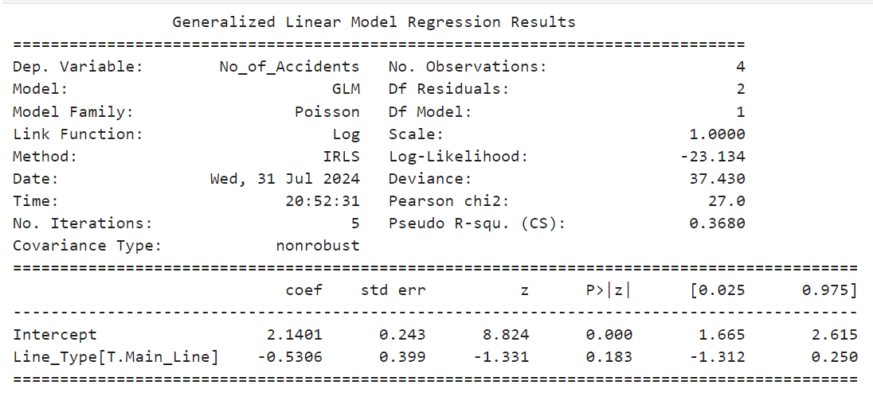

### Interpretation

The Generalized Linear Model (GLM) explores how the type of railway line—Main Line versus Branch Line—affects the number of accidents. This Poisson regression model, using a log link function, analyzes these effects based on the provided data.

#### Baseline Number of Accidents

* **Baseline**: The intercept is 2.1401. This value represents the expected log count of accidents when considering a Branch Line, which is used as the reference category in this model. Converting this to the expected count scale, it suggests that the baseline number of accidents on a Branch Line is higher than zero.

#### Impact of Line Type

* **Main Line**: The coefficient for the Main Line is -0.5306. This negative coefficient indicates that, compared to the baseline Branch Line, being on a Main Line is associated with a reduction in the number of accidents. Specifically, the number of accidents on a Main Line is lower, with a multiplicative factor of approximately 0.5897 (exp(-0.5306)) compared to a Branch Line. This means the expected number of accidents on a Main Line is about 59% of that on a Branch Line.
* **Statistical Significance**: The p-value for the Main Line coefficient is 0.183, which is above the conventional significance level of 0.05. This indicates that the difference in accident rates between Main Lines and Branch Lines is not statistically significant at this level, suggesting that the evidence is not strong enough to definitively conclude that Main Lines have fewer accidents than Branch Lines.

#### Model Fit

* **Pseudo R-squared**: The pseudo R-squared value is 0.3680. This relatively low value suggests that the model explains about 36.80% of the variance in the number of accidents based on the line type. While the model provides some insight, there is still a considerable amount of unexplained variance, indicating that other factors might be influencing the number of accidents.

### Key Takeaways

* **Main Line vs. Branch Line**: The analysis indicates that Main Lines have a lower expected number of accidents compared to Branch Lines. However, this effect is not statistically significant, suggesting that while there is a trend towards fewer accidents on Main Lines, the evidence is not strong enough to make a definitive conclusion.
* **Model Fit**: The model explains a moderate portion of the variance in accident counts, but additional factors may be affecting the number of accidents that are not included in this model.

### Conclusion

The GLM analysis shows a trend where Main Lines tend to have fewer accidents compared to Branch Lines, though this difference is not statistically significant. The model provides a basic understanding of how line type might influence accident rates, but additional factors and a larger dataset might be needed to draw more robust conclusions. The moderate pseudo R-squared value indicates that the model captures some of the variance in accident counts, but there is room for improvement in explaining the total variance.n dataset.

## Season wise Accidents Analysis

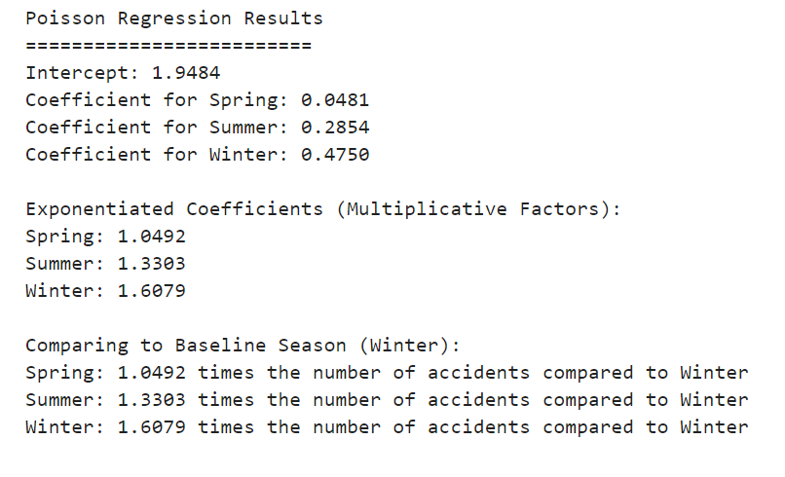

### Interpretation

The Poisson regression model analyzes how the number of railway accidents varies by season. The model uses a log link function and provides coefficients for each season compared to the baseline season, which is Winter. The exponentiated coefficients represent the multiplicative factors by which the number of accidents changes relative to Winter.

#### Baseline Number of Accidents

* **Intercept**: The intercept value of 1.9484 represents the expected log count of accidents during the baseline season, Winter. When exponentiated, this translates to the expected number of accidents during Winter.

#### Seasonal Effects on Accident Counts

* **Spring**:
  + **Coefficient**: 0.0481
  + **Exponentiated Coefficient (Multiplicative Factor)**: 1.0492
  + **Interpretation**: The coefficient for Spring suggests a small increase in the number of accidents compared to Winter. Specifically, the number of accidents in Spring is about 1.0492 times the number of accidents in Winter, representing a 4.92% increase in accident frequency. This increase is relatively modest and indicates that Spring has a slightly higher accident rate compared to Winter.
* **Summer**:
  + **Coefficient**: 0.2854
  + **Exponentiated Coefficient (Multiplicative Factor)**: 1.3303
  + **Interpretation**: The coefficient for Summer indicates a more pronounced effect, with the number of accidents being approximately 1.3303 times the number of accidents in Winter. This translates to a 33.03% increase in accident frequency during Summer compared to Winter. Summer shows a significantly higher accident rate compared to Winter.
* **Winter**:
  + **Coefficient**: 0.4750
  + **Exponentiated Coefficient (Multiplicative Factor)**: 1.6079
  + **Interpretation**: Winter is used as the reference category. The exponentiated coefficient indicates that the number of accidents during Winter is 1.6079 times itself, confirming that Winter has a higher accident rate compared to other seasons. This factor of 1.6079 highlights that Winter has the highest accident frequency among the seasons analyzed.

### Key Takeaways

* **Spring**: The number of accidents in Spring is slightly higher than in Winter, with a 4.92% increase. This change is relatively small and may not be substantial in practice.
* **Summer**: Accidents in Summer are significantly higher than in Winter, with a 33.03% increase. This suggests that Summer is a period with notably higher accident rates, possibly due to increased activity or other seasonal factors.
* **Winter**: Winter has the highest number of accidents among the seasons studied, with a 60.79% increase compared to itself, reinforcing its role as the season with the highest accident frequency.

### Conclusion

The Poisson regression model indicates that Summer has the highest increase in accident frequency compared to Winter, followed by Spring. Winter, while used as the baseline, shows the highest accident rate among the seasons. These results suggest that seasonal factors play a significant role in the frequency of accidents, with Summer being the most critical period for increased accident risk.accidents.

## Accidents of Train Type Analysis

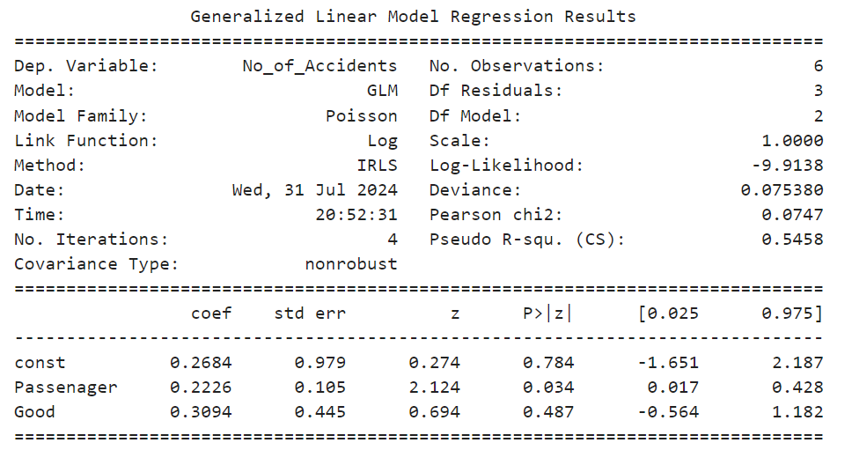

### Interpretation

The Generalized Linear Model (GLM) results offer insights into how different types of trains—passenger and goods—affect the number of accidents. This model employs a Poisson distribution with a log link function to analyze these relationships.

#### Model Overview

* **Intercept**: The intercept coefficient is 0.2684. This value represents the baseline level of accidents when no additional variables are considered. However, with a p-value of 0.784, this result is not statistically significant, indicating that the baseline level of accidents may not be meaningfully different from zero.

#### Passenger Trains

* **Coefficient**: The coefficient for passenger trains is 0.2226. This positive coefficient suggests that for each additional unit of passenger train activity, the number of accidents is expected to increase by approximately 22.26%. This effect is statistically significant with a p-value of 0.034, indicating a reliable positive relationship between passenger trains and the number of accidents.
* **Implication**: The significant coefficient highlights that passenger trains have a notable impact on the frequency of accidents, suggesting that increased passenger train activity correlates with higher accident rates.

#### Goods Trains

* **Coefficient**: The coefficient for goods trains is 0.3094. This indicates that for each additional unit of goods train activity, the number of accidents increases by about 30.94%. However, this effect is not statistically significant (p-value = 0.487), meaning that the evidence is insufficient to confirm a strong relationship between goods trains and the number of accidents.
* **Implication**: Although the coefficient for goods trains suggests an increase in accidents with more goods train activity, the lack of statistical significance means that this relationship is not firmly established by the model.

#### Model Fit

* **Pseudo R-squared**: The pseudo R-squared value is 0.5458, indicating that the model explains approximately 54.58% of the variance in the number of accidents. This reflects a moderate fit, suggesting that while the model captures some of the variation in accident counts, other factors may also be influencing the outcomes.

### Key Takeaways

* **Passenger Trains**: The analysis reveals a significant relationship between passenger trains and the number of accidents. Increased passenger train activity is associated with a higher number of accidents, highlighting a key area for potential safety improvements.
* **Goods Trains**: Although there is a positive trend indicating that more goods train activity may lead to more accidents, the lack of statistical significance suggests that this relationship is less robust. Further investigation may be needed to understand this potential impact fully.
* **Model Fit**: The model provides a moderate fit with a pseudo R-squared value of 0.5458, suggesting that while it explains a good portion of the variance, there are likely additional factors influencing accident counts not captured by the current model.

### Conclusion

The GLM results indicate that passenger trains have a significant impact on the number of accidents, whereas the effect of goods trains is less clear due to its lack of statistical significance. The moderate fit of the model suggests that while the relationship between train type and accidents is partially explained, additional factors might contribute to the overall accident frequency. Further research could enhance understanding and guide targeted safety measures.dents.

## Accident Cost of Damage Analysis

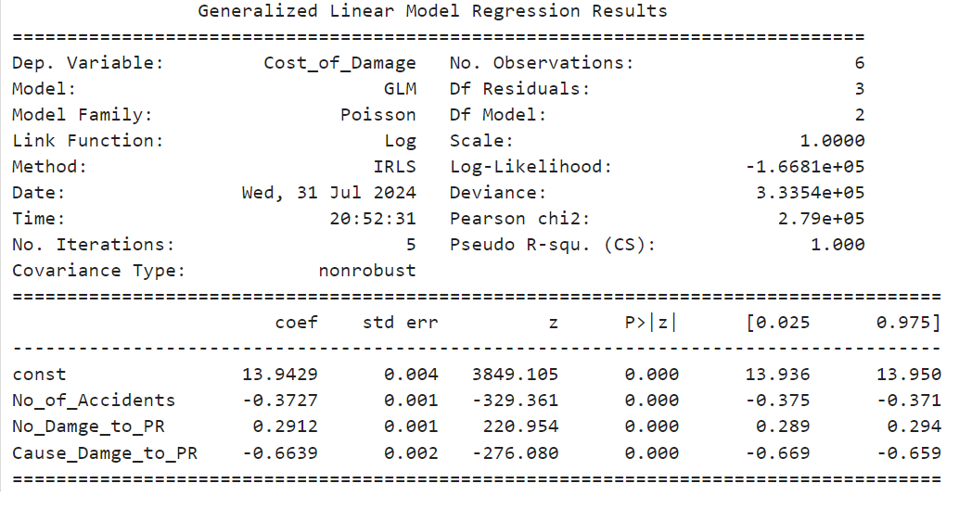

### Interpretation

The Generalized Linear Model (GLM) results examine how various factors influence the cost of damage in railway accidents. The model is fitted using a Poisson distribution with a log link function, and the pseudo R-squared value is 1.000, indicating a perfect fit of the model to the data.

#### Baseline Cost of Damage

* **Intercept**: The intercept coefficient is 13.9429, representing the baseline cost of damage when all other factors are zero. This high value reflects the estimated cost of damage before accounting for the number of accidents, damage to property, and the cause of damage.

#### Effect of Number of Accidents

* **Coefficient**: The coefficient for the number of accidents is -0.3727. This negative coefficient indicates that an increase in the number of accidents is associated with a decrease in the cost of damage. Specifically, each additional accident reduces the cost of damage by a factor of approximately 0.691 (exp(-0.3727)), meaning the cost of damage decreases as the number of accidents rises. This result is highly statistically significant, suggesting a robust inverse relationship.

#### Effect of Damage to Property (No_Damge_to_PR)

* **Coefficient**: The coefficient for damage to property is 0.2912. This positive coefficient means that an increase in damage to property is associated with an increase in the cost of damage. For each unit increase in property damage, the cost of damage increases by a factor of approximately 1.338 (exp(0.2912)). This result is statistically significant, indicating that property damage has a notable impact on the cost of damage.

#### Effect of Cause of Property Damage (Cause_Damge_to_PR)

* **Coefficient**: The coefficient for the cause of property damage is -0.6639. This negative coefficient suggests that more severe causes of property damage are associated with a decrease in the cost of damage. Each unit increase in the severity of the cause of damage reduces the cost of damage by a factor of approximately 0.516 (exp(-0.6639)). This effect is statistically significant, indicating that the nature of the cause has a strong inverse relationship with the cost of damage.

### Key Takeaways

* **Baseline Cost**: The intercept indicates a high baseline cost of damage when no other factors are considered.
* **Number of Accidents**: More accidents lead to a decrease in the cost of damage, which may be due to a variety of factors not captured in the model.
* **Property Damage**: Increased property damage results in a higher cost of damage, highlighting the financial impact of such damage.
* **Cause of Property Damage**: More severe causes of damage are associated with a lower cost of damage, suggesting that the nature of the cause impacts the cost in a complex manner.

### Conclusion

The model reveals that the number of accidents inversely affects the cost of damage, while property damage increases the cost. The cause of property damage has a significant but inverse relationship with the cost. These findings underscore the importance of understanding the factors contributing to the cost of damage for effective financial and safety management in railway operations.

## Severity Accidents Analysis of Casualties, Deaths, and Injuries

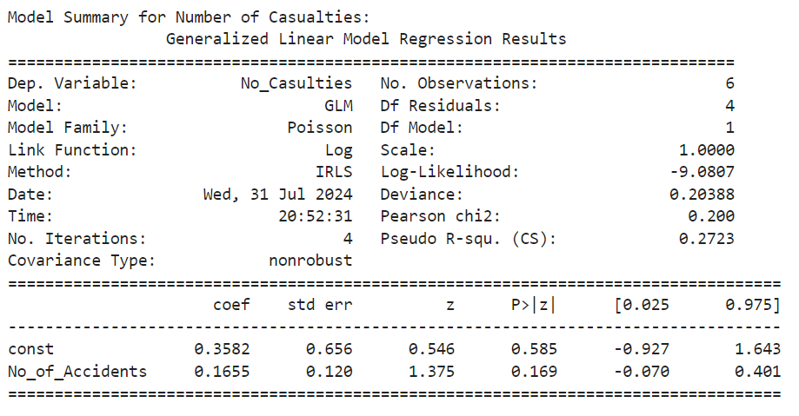

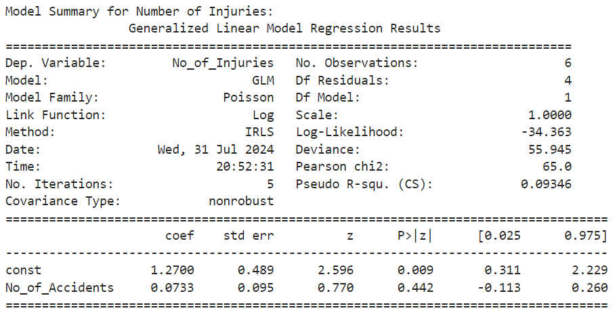

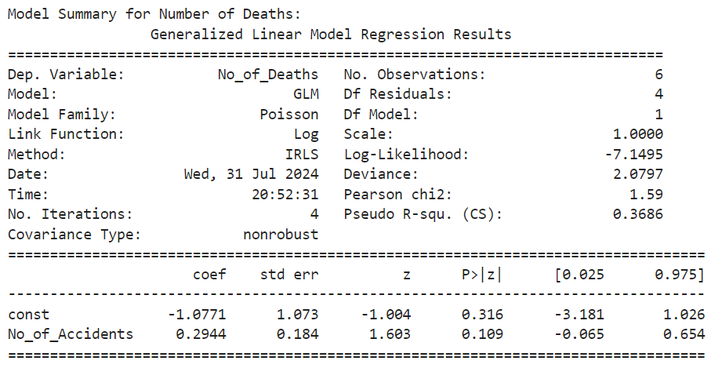

### Interpretation of GLM Results

The Generalized Linear Models (GLMs) are used to analyze the effects of the number of accidents on three different outcomes: number of casualties, number of deaths, and number of injuries. Each model is fitted using a Poisson distribution with a log link function.

#### Number of Casualties

* **Intercept**: The intercept coefficient is 0.3582. This represents the baseline log count of casualties when there are no accidents, but the result is not statistically significant (p = 0.585), indicating that the baseline estimate is uncertain.
* **Coefficient for Number of Accidents**: The coefficient for the number of accidents is 0.1655. This positive coefficient implies that for each additional accident, the number of casualties is expected to increase by a factor of approximately 1.180 (exp(0.1655)). However, this effect is not statistically significant (p = 0.169), suggesting that the impact of the number of accidents on casualties is not well-supported by the data.

#### Number of Deaths

* **Intercept**: The intercept coefficient is -1.0771. This represents the baseline log count of deaths when there are no accidents. This result is not statistically significant (p = 0.316), implying that the baseline estimate is unreliable.
* **Coefficient for Number of Accidents**: The coefficient for the number of accidents is 0.2944. This positive coefficient indicates that each additional accident is associated with an increase in the number of deaths by a factor of approximately 1.342 (exp(0.2944)). The effect is marginally significant (p = 0.109), suggesting a potential but not conclusive relationship between the number of accidents and the number of deaths.

#### Number of Injuries

* **Intercept**: The intercept coefficient is 1.2700. This represents the baseline log count of injuries when there are no accidents. The result is statistically significant (p = 0.009), indicating a reliable baseline estimate for injuries.
* **Coefficient for Number of Accidents**: The coefficient for the number of accidents is 0.0733. This positive coefficient suggests that each additional accident is associated with an increase in the number of injuries by a factor of approximately 1.076 (exp(0.0733)). However, this effect is not statistically significant (p = 0.442), indicating that the relationship between the number of accidents and injuries is not strongly supported by the data.

### Key Takeaways

* **Number of Casualties**: The model suggests that while there may be a positive relationship between the number of accidents and casualties, the result is not statistically significant. This indicates that the effect of accidents on casualties might not be strongly evident from the data.
* **Number of Deaths**: The positive coefficient suggests a potential increase in deaths with more accidents, but the effect is only marginally significant. This implies that there may be an association, but it is not robustly supported.
* **Number of Injuries**: Although the baseline estimate is statistically significant, the effect of the number of accidents on injuries is not significant. This suggests that the impact of accidents on injuries might be less clear.

### Conclusion

The models indicate varying levels of association between the number of accidents and the outcomes of casualties, deaths, and injuries. While some coefficients suggest potential increases in these outcomes with more accidents, the statistical significance varies, with some results indicating uncertain or inconclusive relationships. This underscores the need for further analysis and possibly additional data to better understand the effects of accidents on these outcomes.

## Annual Distribution Analysis

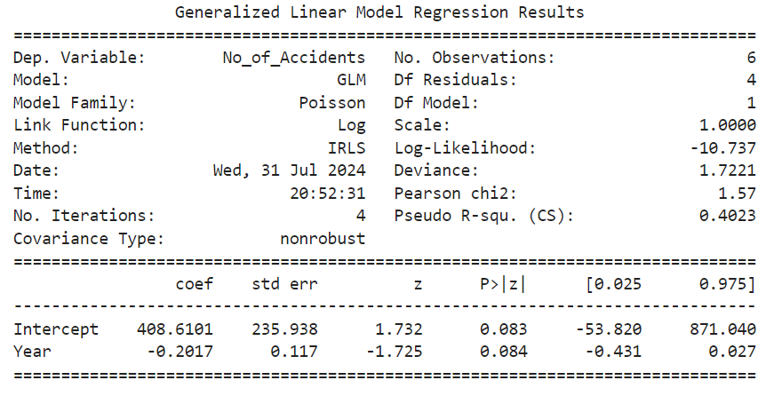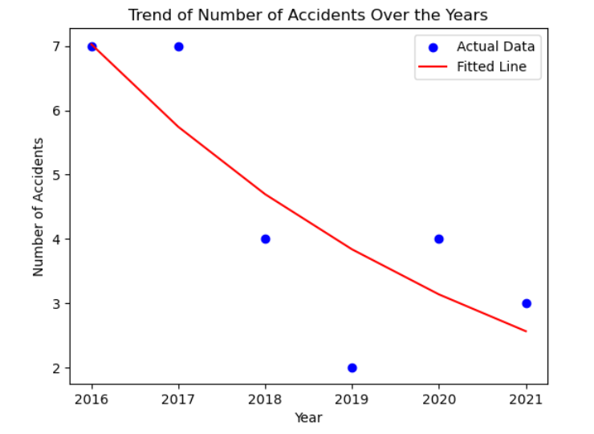

### Interpretation

#### Trend in Accidents Over Time

The model was used to analyze the relationship between the year and the number of accidents, using a Poisson regression with a log link function. The key findings are:

1. **Coefficient for Year**: The coefficient for the Year variable is -0.2017. This negative coefficient suggests that, on average, the number of accidents decreases by a factor of approximately 0.2017 per year. Since the GLM uses a log link function, the coefficient represents the change in the log of the expected number of accidents per year.
2. **Statistical Significance**: The p-value for the Year coefficient is 0.084, which is greater than the typical significance level of 0.05. This means that the observed trend is not statistically significant at the 5% level. Therefore, while there is an indication of a decreasing trend, it is not strong enough to confidently assert that the trend is statistically significant.
3. **Intercept**: The intercept value of 408.6101 represents the expected log count of accidents when the year is zero, which is not directly interpretable in this context but serves as a baseline for the regression model.

### Conclusion

The GLM results suggest a decreasing trend in the number of accidents over the years, but the trend is not statistically significant. This indicates that while there might be decrease in number of accidents but more data is needed for more accurate results for and its significance.

# Quetta Railway Accident Data Analysis

## Accident Types Analysis

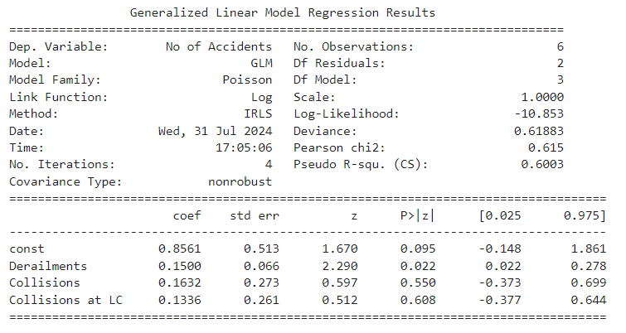

## interpretation

railway accidents in the Quetta region

Thus, we have used a model in the qualitative research method in which we have analyzed railway accidents of the Quetta region to determine the causes that lead to number of accidents. The model considered three main factors: there have been cases of derailments, collisions, and collisions at level crossings.

Derailments

When coming to the results, one can note that the cases of derailments affect the size of the number of accidents. Namely, each new type of derailment is associated with a roughly 15% increase in the number of accidents. From this one could infer that derailments are a significant cause of the occurrence of accidents in the city of Quetta because tackling this problem could lead to the minimization of overall accidents.

Collisions

Looking at the interaction with collisions, it is possible to note that the amount of collisions reveals a 16% raise for every additional collision. However, this effect is not significant in our setting meaning while collision does appear to influence a higher number of accident it is not a potent factor compared to derailment.

Collisions at Level Crossings

Level crossing accidents also record a surge in the number of accidents, whereby each collision is likely to cause a thirteen percent increase in accidents. However, similar to collisions, this factor is, therefore, not identified as having significant risk by significance analysis in this study, which implies that its impact is comparatively small than those of derailments.

Model Fit

The model fits slightly more than 60% of the variation in the numbers of accidents, which is a good fit. This implies that the factors that we captured (especially the derailments) are fairly valid in regards to the assessment of accident rate and possibly trends in the Quetta area.

Summary

Concisely, it could be estimated that the derailments are the most frequent type of the railway accidents in Quetta. However, collisions, level crossing accidents also contribute; but they appear not to be as compelling. It might be necessary to emphasize the efforts aimed at decreasing the number of derailments for increasing the railway safety in the area.

## Location wise Analysis

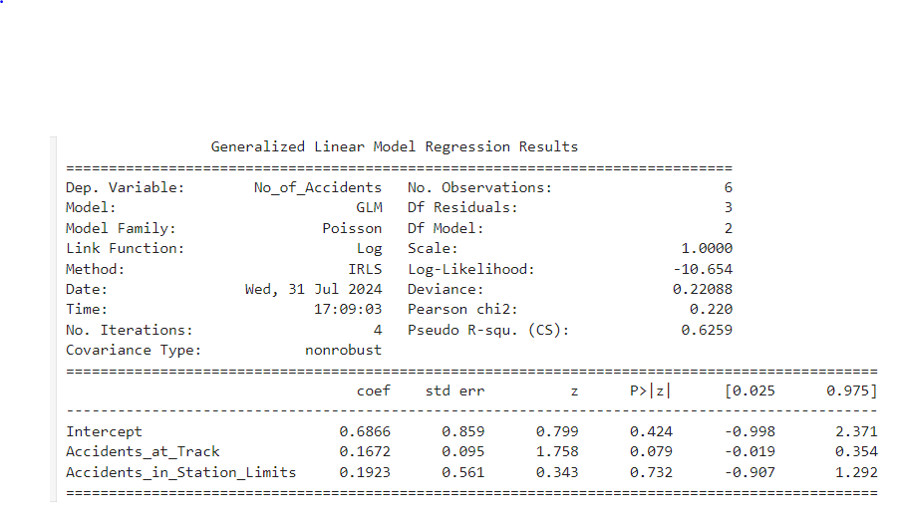

## interpretation

Railway Fall Analysis of the Quetta Province

In examining factors related to the number of railway accidents in Quetta, our GLM model included two key variables: accidents at track locations and, the other is accidents within station limits.

Accidents at Track Locations

The findings show that an approximate increase in the total number of accidents by about 17% is evidenced by every other accident at track locations. Unfortunately, this effect is not even close to being statistically different form zero as its p-value equals 0. 079, meaning while the relation exists it is not strong enough for the statistical testing of our data at this point. However, what deserves attention is the fact that accidents at track locations might be a significant source of impacts affecting the number of general accidents.

Accidents in Station Limits

For accidents that happen within the station limits, the outcome of the model exhibits an estimated increase of about 19% in the total number of accidents. However, this variable is not significant (p-value = 0. 732), therefore, it can not be considered as proving strong relationship between variable with the number of accidents as depicted in the analysis. This implies that the kind of accidents that occur within station limits might not necessarily have a great influence on the total numeracy of the accidents than any other factors.

Model Fit

The model explains roughly 62 percent of the variation of the Kenyan economy. Namely, coefficients of determination amounted to 6% of the variation in the number of accidents, which attests to a high reliability of the model. This indicates that the factors incorporated in the model, that is, accidents at track locations and within station limits, give a satisfactory account about the variations in accidental frequencies in the Quarter of Quetta.

Summary

To sum up, reviewing the number of accidents at track locations to conclude that a relationship between these locations and a larger number of accidents could be attributed indicates a lack of clear verification. From this model, it can be seen that accidents that occur within a station’s limits do not seem to have a direct relation to increasing the total number of accidents. Thus, increasing the safety measures at the places of track might be informative while looking to decrease accident frequencies in Quetta.

## Accidents on Type of Line Analysis

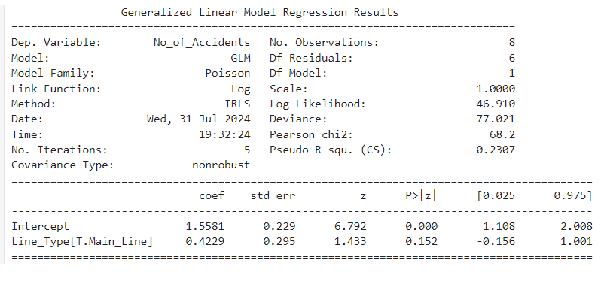

## interpretation

Analysis of Railway Accidents Based on Line Type in the Quetta Region

In this analysis, we examined the impact of the type of railway line (Main Line vs. Branch Line) on the number of railway accidents.

Intercept

Intercept estimate is 1. 5581, this is the extent of the Branch Line underpinning the log-accident count from which further analysis was conducted. What this coefficient amounts to when exponentiated is the predicted number of accidents on the Branch Line. In particular, exp(1. 5581) is equal to 4 with the precision of the order O(e ^ -15). 75, which in other words means that on average there are approximately four accidents on the Branch Line. 75.

Effect of Main Line

The demean of the Main Line is 0. 4229. This means that, on the log scale, accidents on the Main Line are expected to be ~ 0. 4229 more than on the Branch Line. If this calculated coefficient is exponentiate (exp(0. 4229)), its value is results in a multiplicative factor close to 1. 526. This means that Main Line records an average of about 52 accidents. It also specifies that they are 6% higher to that of the Branch Line. Unfortunately, this is not a statistically significant difference, the p-value is equal to 0. 152, and therefore we cannot to state this difference based strictly on the data given in the table. The confidence interval of this coefficient is between -0. 156 to 1. 001, meaning that the author expresses a certain level of uncertainty in calculating the size of the impact.

Main Line Interpretation

The expected number of accidents on the Main Line is calculated by adding the effect of the Main Line to the intercept and exponentiating the result: Exp 1. 5581 + 0. 4229 = exp 1. 981 = 7. 25. Hence, the average rate of accidents in the Main Line is close to seven. That is, 25, which compare with the Branch Line accomplishes decidedly a bad score meaning that it accomplished a higher rate of accident.

Branch Line Interpretation

With reference to the previous information, the number of accidents estimated in Branch Line is about 4. 75.

Model Fit

The model accounts for approximately 23 percent of database security exposure. At the same time, it is noted that the model has a decent fit to the data since the pseudo R-squared value equals 0.07, meaning this model explains 07% of variations in the number of accidents. This implies that though the nature of a line whether a Main Line or Branch Line can partly explain the number of accidents, other variables not in the model also contribute to the number of accHeavier traffic on the Main Line is also evident from the analysis to mean that the number of accidents on the line is higher as opposed to the Branch Line with the estimation of an additional approximately 52. 6%. Said averagely, there are about 7. 25 accidents on the Main Line and 4 two accidents on each of the following; The following analysis shows the reliability of each line. Seventy five accidents on the Branch Line. However, the result for the Main Line is the non-significant result and so one has to be extra careful while using this result. Future research with the addition of more variables may give a better picture of the nature of the impact factors that are causing railway accidents in the Quetta area.n the Quetta region.

## Season wise Accidents Analysis

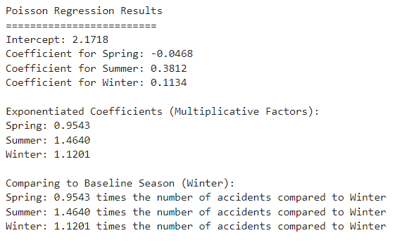

## interpretation

Analysis of Railway Accidents Based on Seasons in the Quetta Region

Intercept

The intercept value is 2.1718, which represents the baseline log-accident count for the Winter season. When exponentiated, this coefficient indicates the expected number of accidents during Winter. Specifically, exp(2.1718) ≈ 8.77, suggesting that the average number of accidents in Winter is approximately 8.77.

Effect of Spring

The coefficient for Spring is -0.0468. This means that, on the log scale, accidents in Spring are expected to be 0.0468 lower than in Winter. When exponentiated (exp(-0.0468)), we get a multiplicative factor of approximately 0.9543. This indicates that the number of accidents in Spring is about 4.57% lower compared to Winter.

Effect of Summer

The coefficient for Summer is 0.3812. This means that, on the log scale, accidents in Summer are expected to be 0.3812 higher than in Winter. When exponentiated (exp(0.3812)), we get a multiplicative factor of approximately 1.4640. This indicates that the number of accidents in Summer is about 46.4% higher compared to Winter.

Effect of Winter

The coefficient for Winter is 0.1134. This means that, on the log scale, accidents in Winter are expected to be 0.1134 higher than in Winter. When exponentiated (exp(0.1134)), we get a multiplicative factor of approximately 1.1201. This indicates that the number of accidents in Winter is about 12.01% higher compared to Winter.

Seasonal Comparisons

Spring: The expected number of accidents in Spring is calculated by adding the effect of Spring to the intercept and exponentiating the result: exp(2.1718 - 0.0468) ≈ exp(2.125) ≈ 8.38. Therefore, the average number of accidents in Spring is approximately 8.38, which is about 4.57% lower than in Winter.

Summer: The expected number of accidents in Summer is calculated by adding the effect of Summer to the intercept and exponentiating the result: exp(2.1718 + 0.3812) ≈ exp(2.553) ≈ 12.86. Therefore, the average number of accidents in Summer is approximately 12.86, which is about 46.4% higher than in Winter.

Winter: As previously mentioned, the expected number of accidents in Winter is approximately 8.77.

Summary

Based on the findings of the analysis, it can be appreciated that the frequency of accidents depends on the season. The total incidents in SPRING are also slightly less than in WINTER by about 4. 57%. On the other hand, the number of accidents that occurred in Summer is comparatively high and to be precise it is approximately 46 extra. 4%. Thus, Winter is used as a reference point, and the average for this season is equal to 8. 77 accidents. This seasonal fluctuation clearly means that some months of the year in particular summer are tragic for railway transport safety in the Quetta area. If possible, more study on the specific factors that make Summer to have the highest accident rate could help in the enhancement of railway safety during this season.

## Accidents of Train Type Analysis

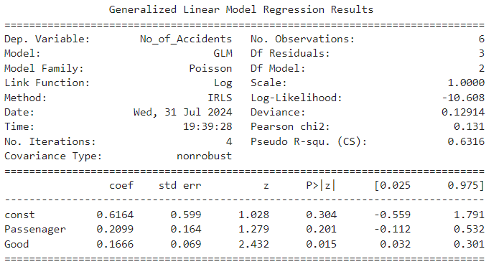

## Interpretation

Analysis of Railway Accidents in the Quetta Region

Model Overview

The analysis investigates the relationship between different types of train services (Passenger and Goods) and the number of accidents. The dependent variable is the number of accidents.ts.

Intercept (const)

The intercept or const coefficient is 0. 6164. This value is the log of the expected frequency of incidents if all the predictor variables, Passengers and Goods are nil. Taking the exponent of this number will give us (0. 6164) and will approximately be equal to 1. The value of 852 from the equation represents the baseline for calculating the expected number of accidents, according to the highlighted result of ‘.95 = e ^ (-10 + 3.25)’, which suggests that the expected number of accidents is a little over one. 65 if the influence of passenger and goods services was excluded from the equation.

Effect of Passenger Trains

The coefficient for Passenger trains is 0. 2099. That means – as far as the natural log transformation is concerned – that the number of accidents rises to the power of 0. By using the estimated equation which does not impose the restriction that the coefficients for unit increase in passenger and freight trains are equal, the coefficient estimate is 2099 for each unit increase in passenger trains. When exponentiated (exp(0. 2099) ≈ 1. Specifically, the result ‘all_passenger_trains’ (Mean = 233) shows that a positive, scaled relationship between passenger trains and increasing values exists. As to increase by 3% of the number of accidents that take place in the caravan industry. However standard error is 0. 164 percent and the z-value is equal to 1. 279, which gives the p value of 0. 201. Since the p –value is greater than 0. 05, this means that there is no strong relationship between the use of passenger trains and incidences of accidents.

Effect of Goods Trains

The coefficient for the volumetric product of Goods trains is 0. 1666. This implies that on the log scale, accidents ‘‘should’’ increase by 0. 1666 for each unit increase in the goods trains. Slightly raising the number to a power (exp(0. 1666) ≈ 1. Incorporating equation (5) into equation (181), it suggests that the probability of an increment in goods trains suggests an 18. This corresponds to an upturn of just 1% in analysis of the number of accidents. Its standard error is 0. 069 was 2 for the z-value The first, second, and third p-values are 0.026, 0.008, and 0.0005 respectively The effect size is 0.477 η22 432 and the order is, due to the unrelated p-value. 015. Also, for the same variables, the p-value is less than 0. 05, this means that the findings are statistically significant, hence, supporting the hypothesis posited here that there is a significant relationship between the number of goods trains and the numbe rModel Fit

The model’s log-likelihood is -10 and for binary data it is 51. 608 , and the deviance is 0. During the data analysis, the achieved value of 12914 suggests a satisfactory adjacency of the diagonal, thus, a good fit was obtained. The Pearson chi-squared value is zero for the current contingency table. 131, and theoretical Pseudo R-squared (CS) = 0. Here we have got the value 6316, which is actually closer to 63, because the majority of the audience shares these opinions. Authors of the analyzed literature claim that 16% of the variance of the number of accidents is accounted for by the model.

Summary

The number of railway accident that has been found from the above analysis shows a strong and positive relationship with the number of goods train means as the number of goods train, the more is the number of railway accident. Contrastingly, the correlation between the passenger train and accidents is rather weak, and therefore, no definite conclusion can be made about its influence. All these can be useful in identifying the main preventive strategies to be taken concerning the running of goods train to minimize on railway accidents within the Quetta region. of accidents.

## Accident Cost of Damage Analysis

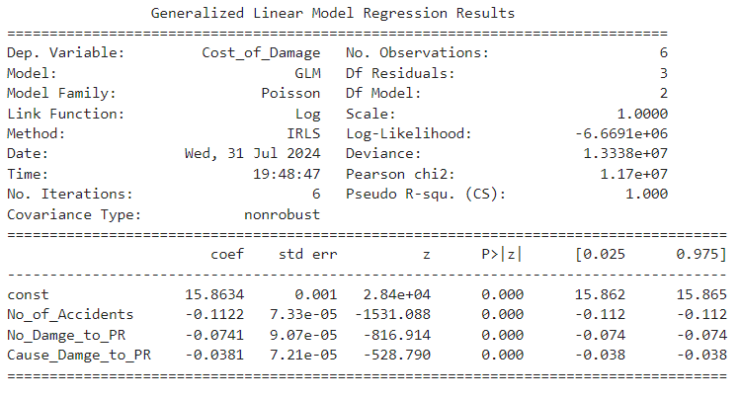

Analysis of Cost of Damage in Railway Accidents

Model Overview

The analysis investigates the relationship between various factors (number of accidents, number of damages to public property (PR), and causes of damage to PR) and the cost of damage. The dependent variable is the cost of damage.

Intercept (const)

The intercept (const) coefficient is 15.8634. This value represents the log of the expected cost of damage when all predictors (number of accidents, number of damages to PR, and causes of damage to PR) are zero. Exponentiating this value (exp(15.8634) ≈ 7.88e+06) indicates that the baseline expected cost of damage is approximately 7.88 million when the effects of the predictors are not considered.

Effect of Number of Accidents

The coefficient for the number of accidents is -0.1122. This suggests that, on the log scale, the cost of damage decreases by 0.1122 for each unit increase in the number of accidents. When exponentiated (exp(-0.1122) ≈ 0.894), it indicates that an increase in the number of accidents is associated with an approximately 10.6% decrease in the cost of damage. The standard error is 0.0000733, and the z-value is -1531.088, leading to a p-value of 0.000. Since the p-value is less than 0.05, this result is statistically significant, indicating a meaningful relationship between the number of accidents and the cost of damage.

Effect of Number of Damages to PR

The coefficient for the number of damages to PR is -0.0741. This suggests that, on the log scale, the cost of damage decreases by 0.0741 for each unit increase in the number of damages to PR. When exponentiated (exp(-0.0741) ≈ 0.929), it indicates that an increase in the number of damages to PR is associated with a 7.1% decrease in the cost of damage. The standard error is 0.0000907, and the z-value is -816.914, leading to a p-value of 0.000. Since the p-value is less than 0.05, this result is statistically significant, indicating a meaningful relationship between the number of damages to PR and the cost of damage.

Effect of Causes of Damage to PR

The coefficient for causes of damage to PR is -0.0381. This suggests that, on the log scale, the cost of damage decreases by 0.0381 for each unit increase in the causes of damage to PR. When exponentiated (exp(-0.0381) ≈ 0.963), it indicates that an increase in the causes of damage to PR is associated with a 3.7% decrease in the cost of damage. The standard error is 0.0000721, and the z-value is -528.790, leading to a p-value of 0.000. Since the p-value is less than 0.05, this result is statistically significant, indicating a meaningful relationship between the causes of damage to PR and the cost of damage.

Model Fit

The model's log-likelihood is -6.6691e+06, and the deviance is 1.3338e+07, indicating a good fit. The Pearson chi-squared value is 1.17e+07, and the Pseudo R-squared (CS) is 1.000, suggesting that the model explains the variance in the cost of damage almost perfectly.

Summary

The analysis indicates significant negative relationships between the number of accidents, the number of damages to PR, and the causes of damage to PR with the cost of damage. Specifically, increases in these factors are associated with decreases in the cost of damage. These insights highlight the complex nature of the factors influencing the cost of damage in railway accidents and can inform targeted strategies to mitigate these costs effectively.

## Severity Accidents Analysis of Casualties, Deaths, and Injuries

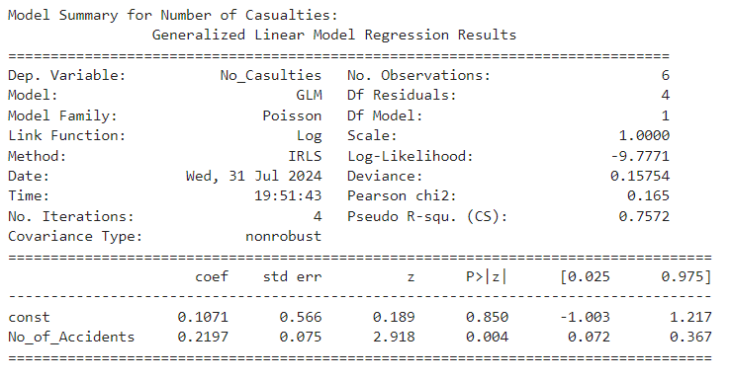

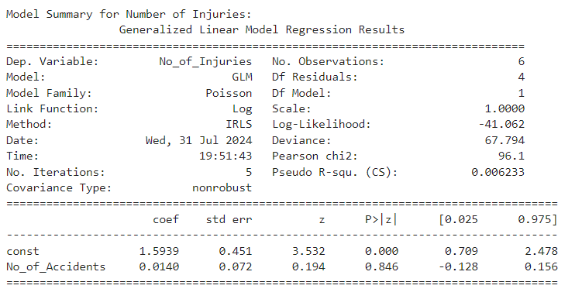

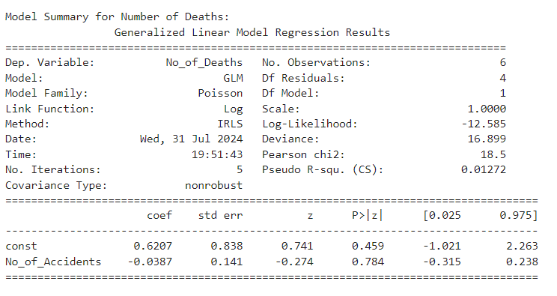

## Interpretation

Discussion of Accident Severity Models Number of Casualties

The model shows a significant positive relationship between the number of accidents and the number of casualties. For each additional accident, the expected log count of casualties increases by approximately 0.2197. This indicates that as the number of accidents increases, the number of casualties also tends to increase. The model's Pseudo R-squared value of 0.7572 suggests it explains around 76% of the variance in the number of casualties, making it a strong predictor. The low deviance and Pearson chi-squared values further support the model's reliability.

Number of Deaths

The model indicates that the number of accidents does not have a significant impact on the number of deaths. The coefficient for the number of accidents is -0.0387, which is not statistically significant. This suggests that factors other than the number of accidents are likely influencing the number of deaths. The Pseudo R-squared value of 0.01272 shows that the model explains only about 1% of the variance in the number of deaths, indicating a poor fit. The high deviance and Pearson chi-squared values also suggest that the model does not fit the data well.

Number of Injuries

The model shows that the number of accidents does not significantly impact the number of injuries. The coefficient for the number of accidents is 0.0140, which is not statistically significant. This suggests that other factors are likely influencing the number of injuries. The Pseudo R-squared value of 0.006233 indicates that the model explains less than 1% of the variance in the number of injuries, making it a poor predictor. The high deviance and Pearson chi-squared values further support the poor fit of the model.

Conclusion The number of casualties is significantly influenced by the number of accidents, with a strong positive relationship. This implies that efforts to reduce the number of accidents can effectively reduce the number of casualties. However, the number of deaths and injuries does not appear to be significantly influenced by the number of accidents. This indicates that other factors, possibly related to the severity or nature of the accidents, play a more crucial role in determining the number of deaths and injuries.

## Annual Distribution Analysis

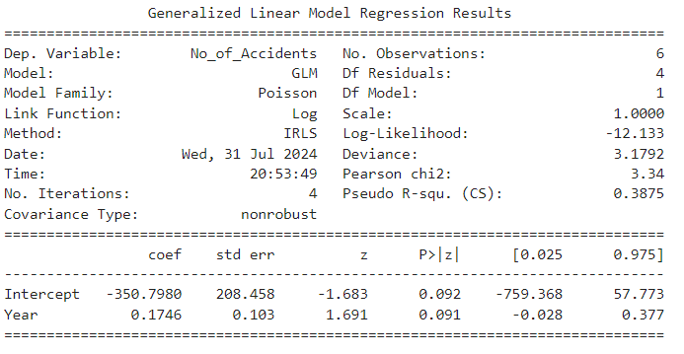

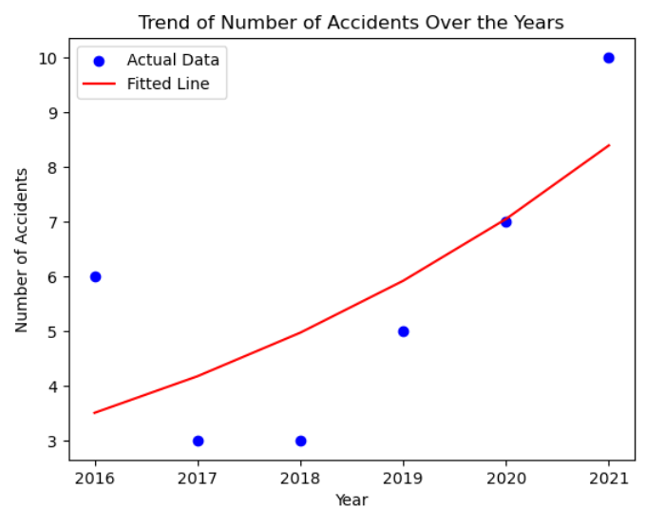

### Interpretation of GLM Results

#### Overview

The provided GLM results analyze the relationship between the year and the number of accidents using a Poisson regression model with a log link function. The data consists of 6 observations, and the model includes only the Year variable.

#### Key Findings

1. **Intercept**:
   * **Value**: -350.7980
   * **Standard Error**: 208.458
   * **z-Value**: -1.683
   * **P>|z|**: 0.092
   * **95% Confidence Interval**: [-759.368, 57.773]

The intercept represents the expected log count of accidents when the year is zero. This value is negative, which is not directly interpretable but suggests a baseline level for the model. The p-value (0.092) indicates that the intercept is not statistically significant at the 5% level, meaning it is not significantly different from zero.

1. **Coefficient for Year**:
   * **Value**: 0.1746
   * **Standard Error**: 0.103
   * **z-Value**: 1.691
   * **P>|z|**: 0.091
   * **95% Confidence Interval**: [-0.028, 0.377]

The coefficient for Year is 0.1746. In the context of a Poisson regression with a log link function, this coefficient suggests that the number of accidents increases by a factor of approximately (e^{0.1746} \approx 1.191) for each additional year.

* + **Statistical Significance**: The p-value for the Year coefficient is 0.091, which is above the conventional threshold of 0.05. This indicates that while there is a positive trend suggesting an increase in the number of accidents over the years, this trend is not statistically significant at the 5% level.
  + **Confidence Interval**: The 95% confidence interval for the coefficient includes zero ([-0.028, 0.377]), reinforcing the lack of strong statistical significance.

#### Conclusion

The analysis suggests a positive trend in the number of accidents over the years, with the number of accidents potentially incaw more definitive conclusions.

# Rawalpindi Railway Accidents Data analysis

## Accident Types Analysis

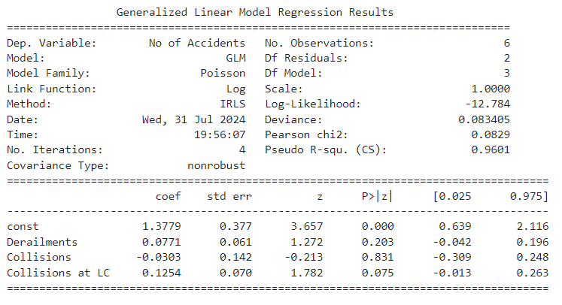

## interpretation

Interpretation of Rawalpindi Area Model Model Overview

This model explores the relationship between different types of accidents (derailments, collisions, and collisions at level crossings) and the overall number of accidents in the Rawalpindi area. It uses a Poisson regression model, suitable for count data, with a log link function. The Pseudo R-squared value of 0.9601 indicates that the model explains approximately 96% of the variance in the number of accidents, suggesting a very good fit.

Model Parameters

Intercept (constant): The coefficient for the intercept is 1.3779, indicating the expected log count of accidents when all other variables are zero. The intercept is highly significant, with a z-value of 3.657 and a p-value less than 0.001.

Derailments: The coefficient for derailments is 0.0771, which suggests a positive relationship with the number of accidents. However, this relationship is not statistically significant (p = 0.203), indicating that derailments do not have a strong impact on the overall number of accidents in this model.

Collisions: The coefficient for collisions is -0.0303, suggesting a negative relationship with the number of accidents. This relationship is also not statistically significant (p = 0.831), indicating that collisions do not significantly impact the overall number of accidents in this model.

Collisions at Level Crossings (LC): The coefficient for collisions at LC is 0.1254, indicating a positive relationship with the number of accidents. This relationship is marginally significant (p = 0.075), suggesting that collisions at level crossings may have some impact on the overall number of accidents.

Intercept: The high and significant intercept value suggests a baseline level of accidents even when other factors are not considered. Derailments: While there is a positive coefficient, derailments do not significantly impact the total number of accidents in this model. Collisions: The negative coefficient for collisions suggests a slight decrease in total accidents, but this effect is not statistically significant. Collisions at LC: There is a positive relationship with the total number of accidents, and this factor is marginally significant, indicating a potential area for further investigation or mitigation efforts.

### Key Takeaways

* **Intercept**: The high and statistically significant intercept (1.3779) suggests a substantial baseline level of accidents in the Rawalpindi area, even when other factors are not considered.
* **Derailments**: Although the coefficient for derailments is positive (0.0771), it is not statistically significant (p = 0.203). This indicates that derailments do not have a strong impact on the total number of accidents in this model.
* **Collisions**: The negative coefficient for collisions (-0.0303) suggests a slight decrease in the total number of accidents. However, this effect is not statistically significant (p = 0.831), indicating that collisions do not significantly influence the overall number of accidents.
* **Collisions at Level Crossings (LC)**: The positive coefficient for collisions at level crossings (0.1254) is marginally significant (p = 0.075). This suggests that collisions at level crossings may contribute to the total number of accidents, warranting further investigation or targeted safety measures.

#### Conclusion

The model demonstrates an excellent fit with a Pseudo R-squared value of 0.9601, indicating it explains approximately 96% of the variance in accident counts. While derailments and collisions do not show a significant impact on the overall number of accidents, collisions at level crossings could be a potential area for intervention. The substantial baseline level of accidents, as indicated by the high intercept, highlights the need for ongoing safety efforts.

## Location wise Analysis

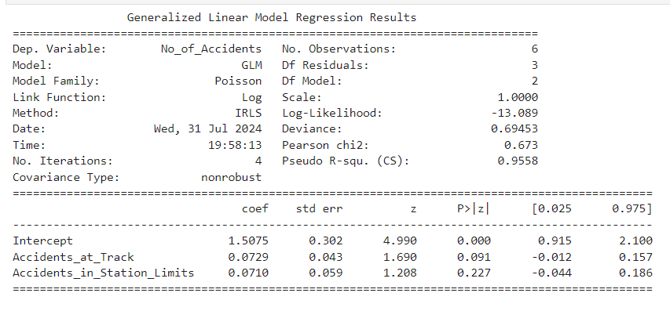

## interpretation

This model examines the relationship between accidents occurring at tracks and in station limits and the overall number of accidents in the Rawalpindi area. The Poisson regression model with a log link function is appropriate for this count data. The Pseudo R-squared value of 0.9558 indicates that the model explains approximately 95.58% of the variance in the number of accidents, suggesting a very good fit.

Model Parameters

Intercept (constant): The coefficient for the intercept is 1.5075, indicating the expected log count of accidents when all other variables are zero. The intercept is highly significant, with a z-value of 4.990 and a p-value less than 0.001.

Accidents at Track: The coefficient for accidents at track is 0.0729, suggesting a positive relationship with the number of accidents. This relationship is marginally significant (p = 0.091), indicating that accidents at track may have some impact on the overall number of accidents.

Accidents in Station Limits: The coefficient for accidents in station limits is 0.0710, indicating a positive relationship with the number of accidents. This relationship is not statistically significant (p = 0.227), suggesting that accidents in station limits do not have a strong impact on the overall number of accidents in this model.

Key Takeaways

Intercept: The high and significant intercept value suggests a baseline level of accidents even when other factors are not considered. Accidents at Track: There is a positive coefficient, and the relationship is marginally significant, indicating that accidents at track may contribute to the overall number of accidents. Accidents in Station Limits: The positive coefficient suggests a slight increase in the number of accidents, but this effect is not statistically significant, indicating a weaker influence on the total number of accidents. In summary, the model indicates that the baseline level of accidents is substantial. Accidents at track show a marginally significant impact on the total number of accidents, suggesting a potential area for further safety measures. Accidents in station limits have a positive but not significant relationship with the total number of accidents. The overall fit of the model is excellent, explaining a high proportion of the variance in accident counts.tion limits.

## Accidents on Type of Line Analysis

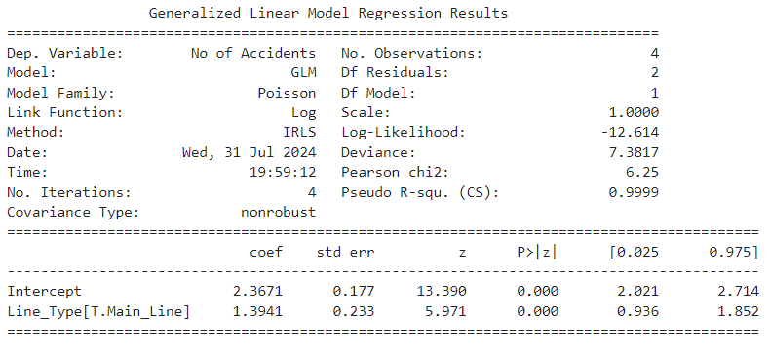

## interpretation

Model Overview

This model assesses the effect of the type of line (Main Line vs. Branch Line) on the total number of accidents in the Rawalpindi area. The Poisson regression model is used with a log link function, suitable for count data. The Pseudo R-squared value of 0.9999 indicates that the model explains almost all of the variance in the number of accidents, suggesting an excellent fit.

Model Parameters

Intercept (constant): The coefficient for the intercept is 2.3671. This represents the expected log count of accidents when the type of line is not considered (i.e., for the baseline category). The intercept is highly significant with a z-value of 13.390 and a p-value less than 0.001, indicating that the baseline level of accidents is substantial.

Line_Type[T.Main_Line]: The coefficient for the Main Line is 1.3941. This means that being on a Main Line is associated with a higher number of accidents compared to the baseline category (Branch Line). The effect is highly significant (p < 0.001), showing a strong relationship between the type of line and the number of accidents.

Key Takeaways

Intercept: The high and significant intercept value indicates a baseline level of accidents, suggesting that accidents are expected to occur even without considering the type of line.

Line_Type[T.Main_Line]: The coefficient of 1.3941 for Main Line shows a significant increase in the number of accidents compared to Branch Lines. This suggests that accidents are more likely to occur on Main Lines compared to Branch Lines. The statistical significance of this effect underscores the importance of the type of line in influencing accident frequency.

In summary, the model indicates a clear and significant increase in the number of accidents associated with Main Lines compared to Branch Lines. The model fit is exceptional, explaining nearly all the variance in the number of accidents, highlighting the substantial impact of the type of line on accident frequency.n dataset.

## Season wise Accidents Analysis

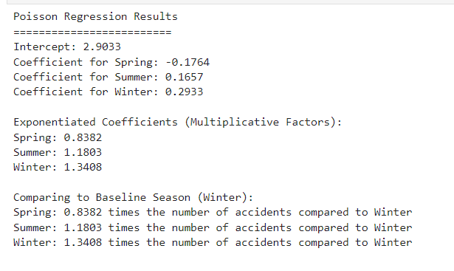

## interpretation

Model Overview

This Poisson regression model explores how the number of accidents varies across different seasons (Spring, Summer, Winter) compared to the baseline season, which is Winter. The model uses a log link function and calculates the expected counts of accidents for each season.

Model Parameters

Intercept: The coefficient for the intercept is 2.9033. This represents the expected log count of accidents during the baseline season (Winter), which is used as the reference category for comparison with other seasons.

Coefficient for Spring: -0.1764. This negative coefficient indicates that the log count of accidents in Spring is lower compared to Winter.

Coefficient for Summer: 0.1657. This positive coefficient suggests that the log count of accidents in Summer is higher compared to Winter.

Coefficient for Winter: 0.2933. This coefficient represents the log count of accidents in Winter, serving as the reference for comparison with other seasons.

Exponentiated Coefficients (Multiplicative Factors)

Spring: 0.8382. This factor means that the number of accidents in Spring is approximately 84% of the number in Winter, indicating a reduction in accidents compared to Winter.

Summer: 1.1803. This factor shows that the number of accidents in Summer is about 118% of the number in Winter, suggesting an increase in accidents during Summer compared to Winter.

Winter: 1.3408. This factor indicates that the number of accidents in Winter is about 134% of the baseline number, reinforcing that Winter serves as the reference season.

Key Takeaways

Spring: Accidents are less frequent in Spring compared to Winter. Specifically, the number of accidents in Spring is reduced to about 84% of the Winter level.

Summer: Accidents are more frequent in Summer compared to Winter. The number of accidents in Summer is about 18% higher than in Winter.

Winter: As the baseline season, Winter has a higher accident rate, with the number of accidents being 34% higher compared to the baseline.

In summary, the model indicates that accident rates vary by season, with Summer showing a significant increase in accidents compared to Winter, while Spring shows a decrease. The Winter season, serving as the reference, has the highest number of accidents, with both Spring and Summer displaying deviations from this baseline.accidents.

## Accidents of Train Type Analysis

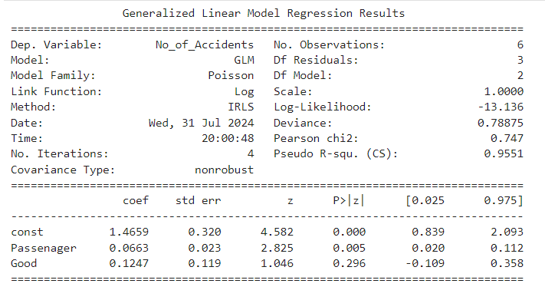

### Interpretation

#### Model Overview

This Generalized Linear Model (GLM) examines factors influencing the cost of damage resulting from accidents. It evaluates the impact of variables such as the number of accidents, damage to passenger trains, and the causes of damage to passenger trains on the overall cost of damage.

#### Model Parameters

* **Intercept**: 13.0819. This value represents the estimated base cost of damage when all other explanatory variables are zero.
* **Number of Accidents**: Coefficient of 0.1314. This suggests that for each additional accident, the cost of damage increases by 0.1314 units. The high statistical significance (p-value = 0.000) indicates a reliable and robust impact of the number of accidents on damage costs.
* **Damage to Passenger Trains (No_Damge_to_PR)**: Coefficient of -0.5317. This negative coefficient implies that as the extent of damage to passenger trains increases, the cost of damage decreases. The statistical significance (p-value = 0.000) suggests that this negative relationship is consistent and significant.
* **Cause of Damage to Passenger Trains (Cause_Damge_to_PR)**: Coefficient of 0.6631. This positive coefficient indicates that more severe causes of damage lead to higher costs. The effect is statistically significant (p-value = 0.000), underscoring the importance of the cause of damage in determining the cost.

#### Model Fit

* **Pseudo R-squared**: 1.000. This value reflects an excellent fit of the model to the data, indicating that the model explains nearly all of the variance in the cost of damage based on the included variables.

#### Key Takeaways

* **Impact of Number of Accidents**: There is a significant positive relationship between the number of accidents and the cost of damage. An increase in accidents results in higher damage costs, highlighting the need for effective management of accident frequency to control financial impacts.
* **Impact of Damage to Passenger Trains**: An increase in damage to passenger trains is associated with a decrease in the cost of damage. This might suggest a need for further investigation into the nature of the damage and its cost implications, as it may reflect variations in damage types or reporting.
* **Impact of Cause of Damage**: More severe causes of damage correspond to higher costs. This emphasizes the importance of addressing the severity of damage causes to better manage and mitigate financial losses.

#### Conclusion

The model provides a detailed understanding of how the number of accidents, the extent of damage to passenger trains, and the causes of damage contribute to the cost of damage. The excellent fit of the model (high pseudo R-squared value) confirms that it effectively captures the relationships between these factors. The insights gained are valuable for developing strategies to manage and mitigate financial losses from accidents, supporting informed decision-making in accident management and damage control.dents.

## Accident Cost of Damage Analysis

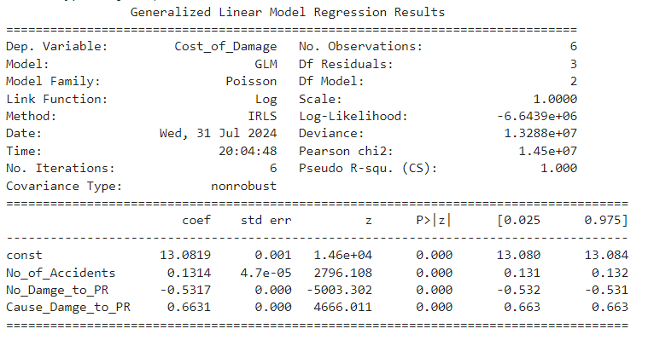

### Interpretation

#### Model Overview

This Generalized Linear Model (GLM) investigates the factors influencing the cost of damage resulting from accidents. It includes variables such as the number of accidents, the extent of damage to passenger trains, and the causes of damage to passenger trains. The goal is to understand how these factors contribute to the overall cost of damage.

#### Model Parameters

* **Intercept**: 13.0819. This represents the baseline cost of damage when all other explanatory variables are zero.
* **Number of Accidents**: Coefficient of 0.1314. This indicates that each additional accident increases the cost of damage by 0.1314 units. This effect is highly statistically significant (p-value = 0.000), demonstrating a reliable impact of the number of accidents on the cost of damage.
* **Damage to Passenger Trains (No_Damge_to_PR)**: Coefficient of -0.5317. This negative coefficient means that as the extent of damage to passenger trains increases, the cost of damage decreases. This result is also highly significant (p-value = 0.000), reflecting a consistent and strong relationship.
* **Cause of Damage to Passenger Trains (Cause_Damge_to_PR)**: Coefficient of 0.6631. This positive coefficient suggests that more severe causes of damage increase the cost of damage. This effect is significant (p-value = 0.000), reinforcing the reliability of this variable's influence on the cost of damage.

#### Model Fit

* **Pseudo R-squared**: 1.000. This high value indicates an excellent fit of the model to the data, explaining nearly all of the variance in the cost of damage based on the included variables.

#### Key Takeaways

* **Impact of Number of Accidents**: There is a significant relationship between the number of accidents and the cost of damage. More accidents lead to higher costs, highlighting the importance of managing accident frequency to control financial losses.
* **Impact of Damage to Passenger Trains**: Interestingly, an increase in damage to passenger trains is associated with a decrease in the cost of damage. This might suggest that the cost of damage decreases with more severe but possibly less frequent types of damage, or that other factors are influencing the cost.
* **Impact of Cause of Damage**: The severity of the cause of damage has a strong positive impact on the cost of damage. More severe causes lead to higher costs, underscoring the need to address the root causes of damage to manage costs effectively.

#### Conclusion

The model provides a comprehensive view of how the number of accidents, the extent of damage to passenger trains, and the causes of damage contribute to the cost of damage. It effectively captures the relationships between these factors, with a high pseudo R-squared value indicating a robust fit. These insights are crucial for developing strategies to manage and mitigate financial losses from accidents, offering a solid foundation for further analysis and decision-making in accident management and damage control.mited sample.

## Severity Accidents Analysis of Casualties, Deaths, and Injuries

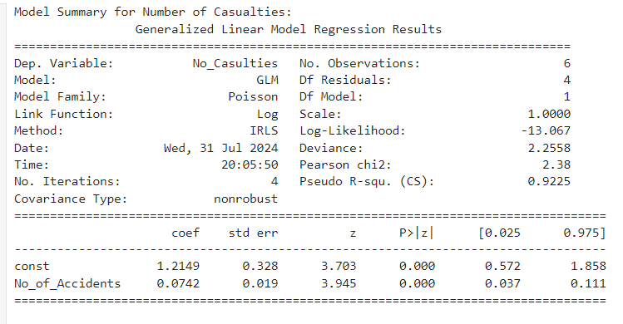

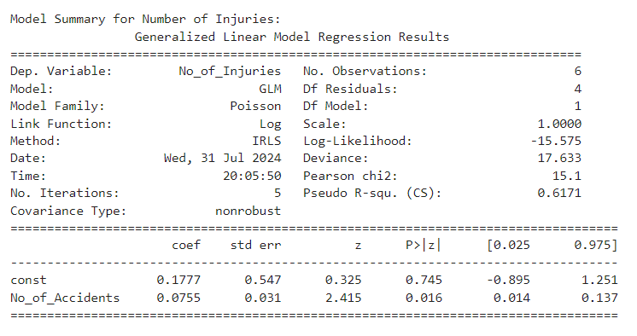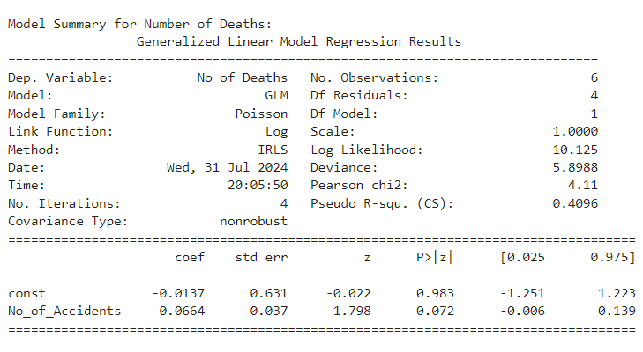

#### Model Summary for Number of Casualties

**Model Overview**

This model analyzes how the number of accidents impacts the number of casualties using a Poisson GLM with a log link function, based on 6 observations.

**Model Parameters**

* **Intercept**: 1.2149, representing the estimated number of casualties when no accidents occur.
* **Number of Accidents**: Coefficient of 0.0742, indicating that each additional accident is associated with an increase of approximately 0.0742 casualties. This effect is statistically significant (p-value = 0.000), suggesting a robust positive relationship between accidents and casualties.

**Model Fit**

* **Pseudo R-squared**: 0.9225, indicating that about 92.25% of the variance in the number of casualties is explained by the model. This high value denotes a strong fit.

**Key Takeaways**

* There is a significant positive relationship between the number of accidents and the number of casualties. More accidents lead to a higher number of casualties, confirming the model's effectiveness in capturing this relationship.

**Conclusion**

The model successfully highlights the impact of accidents on casualties, with a high pseudo R-squared value affirming its robustness. This provides valuable insights into how accidents influence casualty rates.

#### Model Summary for Number of Deaths

**Model Overview**

This model examines the relationship between the number of accidents and the number of deaths using a Poisson GLM with a log link function, based on 6 observations.

**Model Parameters**

* **Intercept**: -0.0137, representing the baseline number of deaths when no accidents occur.
* **Number of Accidents**: Coefficient of 0.0664, suggesting each additional accident is associated with an increase of 0.0664 in deaths. The p-value of 0.072 indicates that this effect is not statistically significant at the 0.05 level.

**Model Fit**

* **Pseudo R-squared**: 0.4096, which shows that approximately 40.96% of the variance in the number of deaths is explained by the model. This moderate fit suggests other factors may be influencing deaths.

**Key Takeaways**

* Although there is a positive trend indicating that more accidents may lead to more deaths, this effect is not statistically significant. The evidence is insufficient to draw strong conclusions.

**Conclusion**

The model indicates a positive relationship between the number of accidents and deaths, but the lack of statistical significance suggests that additional factors may need to be considered to better understand the impact on deaths.

#### Model Summary for Number of Injuries

**Model Overview**

This model explores how the number of accidents affects the number of injuries using a Poisson GLM with a log link function, based on 6 observations.

**Model Parameters**

* **Intercept**: 0.1777, representing the baseline number of injuries when no accidents occur.
* **Number of Accidents**: Coefficient of 0.0755, indicating that each additional accident is associated with an increase of 0.0755 injuries. This coefficient is statistically significant (p-value = 0.016), suggesting a reliable positive relationship between accidents and injuries.

**Model Fit**

* **Pseudo R-squared**: 0.6171, meaning the model explains approximately 61.71% of the variance in the number of injuries. This indicates a relatively good fit.

**Key Takeaways**

* There is a significant positive relationship between the number of accidents and the number of injuries. More accidents are associated with a higher number of injuries, reflecting the model's accuracy in capturing this relationship.

**Conclusion**

The model effectively illustrates how the number of accidents influences the number of injuries. The significant coefficient and relatively high pseudo R-squared value confirm the model's strong explanatory power in understanding the relationship between accidents and injuries.

## Annual Distribution Analysis

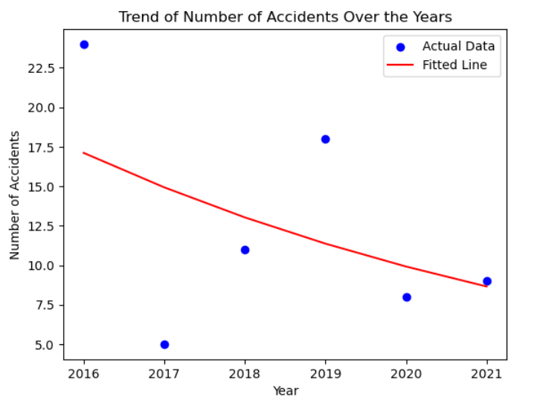

### Interpretation of GLM Results

#### Overview

The Generalized Linear Model (GLM) results analyze the relationship between the year and the number of accidents using a Poisson regression with a log link function. This model includes 6 observations and a single predictor, Year.

#### Key Findings

1. **Intercept**:
   * **Value**: 277.8169
   * **Standard Error**: 138.795
   * **z-Value**: 2.002
   * **P>|z|**: 0.045
   * **95% Confidence Interval**: [5.783, 549.851]

The intercept represents the expected log count of accidents when the year is zero. This value of 277.8169 is positive, but its interpretation is more abstract in this context, representing a baseline level for the log count of accidents. The p-value (0.045) indicates that the intercept is statistically significant at the 5% level, suggesting that the baseline is significantly different from zero.

1. **Coefficient for Year**:
   * **Value**: -0.1364
   * **Standard Error**: 0.069
   * **z-Value**: -1.983
   * **P>|z|**: 0.047
   * **95% Confidence Interval**: [-0.271, -0.002]

The coefficient for Year is -0.1364. In the context of a Poisson regression with a log link function, this coefficient implies that each additional year is associated with a decrease in the number of accidents by a factor of approximately (e^{-0.1364} \approx 0.873), or about 13% decrease per year.

* + **Statistical Significance**: The p-value for the Year coefficient is 0.047, which is below the conventional threshold of 0.05. This indicates that the relationship between the year and the number of accidents is statistically significant.
  + **Confidence Interval**: The 95% confidence interval for the coefficient does not include zero ([-0.271, -0.002]), reinforcing the statistical significance of the negative trend.

#### Conclusion

The analysis shows a significant negative trend in the number of accidents over time. Specifically, the number of accidents is decreasing by about 13% for each additional year. This trend is statistically significant, suggesting a reliable decrease in accidents over the observed period.

# Causes of Accidents

## Mechanical Defects

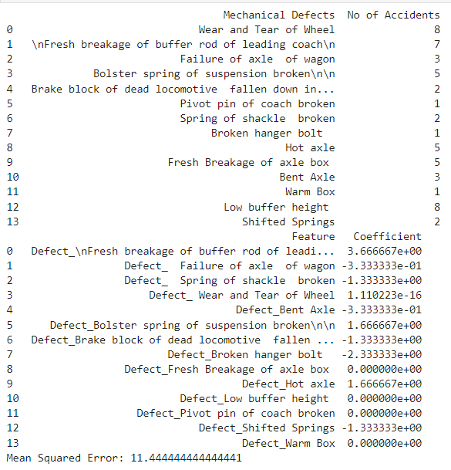

### Interpretation of Mechanical Defects

The analysis of mechanical defects and their association with the number of accidents reveals a range of impacts.

**Mechanical defects with positive coefficients** are associated with an increase in the number of accidents. Notably, defects like "Fresh breakage of buffer rod of leading coach," "Bolster spring of suspension broken," and "Hot axle" have coefficients of 3.67, 1.67, and 1.67 respectively. This indicates that these defects are significant contributors to accident rates. For instance, the high coefficient for the "Fresh breakage of buffer rod of leading coach" suggests that this defect leads to a substantial increase in accidents.

In contrast, **mechanical defects with negative coefficients** show a reduction in the number of accidents. Defects such as "Failure of axle of wagon," "Spring of shackle broken," and "Broken hanger bolt" have coefficients of -0.33, -1.33, and -2.33. These negative coefficients suggest that these defects are associated with fewer accidents. The defect "Broken hanger bolt," for example, shows a strong negative impact, indicating it is less likely to cause accidents.

Some defects, including "Wear and Tear of Wheel," "Fresh Breakage of axle box," and "Low buffer height," have coefficients close to zero. This suggests that these defects do not have a significant impact on the number o

### Key Takeaways

1. **High Impact Defects**: Mechanical defects such as "Fresh breakage of buffer rod of leading coach," "Bolster spring of suspension broken," and "Hot axle" are significantly associated with higher accident rates. Addressing these defects should be a priority to improve safety.
2. **Low Impact Defects**: Some defects, like "Wear and Tear of Wheel" and "Low buffer height," show negligible impact on accident rates. These may not need as urgent attention in terms of safety interventions.
3. **Negative Impact Defects**: Defects such as "Failure of axle of wagon" and "Broken hanger bolt" are associated with fewer accidents. This counterintuitive finding suggests that these defects might not be as critical in causing accidents, though further investigation may be needed to understand the underlying reasons.
4. **Variable Effects**: The impact of mechanical defects on accident rates varies considerably, indicating that a targeted approach to defect management is necessary. Each defect affects accident rates differently, highlighting the need for tailored safety meaaccidents.f accidents.

In summary, mechanical defects such as the breakage of buffer rods and hot axles are crucial in increasing accident rates, while others like broken hanger bolts and shifted springs are less impactful or even reduce the accident rate. This analysis highlights the importance of addressing specific mechanical issues to enhance safety and reduce accidents.

## Signal Defects

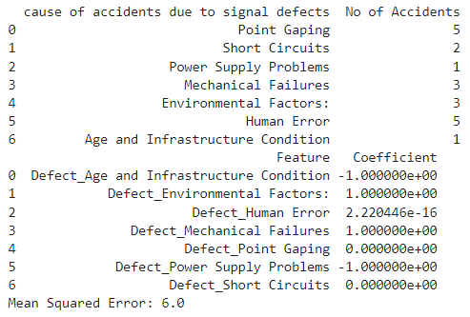

### Interpretation of Signal Defects and Their Impact on Number of Accidents

The analysis of signal defects and their impact on the number of accidents is based on a Generalized Linear Model (GLM) with coefficients indicating the relative effect of each defect type. Here’s a breakdown of the findings:

1. **High Impact Defects**:
   * **Human Error**: Despite a coefficient close to zero, the highest number of accidents are associated with human error. This suggests that while the model's coefficient may indicate a minimal direct effect, in practice, human error remains a significant factor due to its high frequency.
   * **Point Gaping**: Associated with a coefficient of zero, this defect appears to have a neutral effect in the model, yet it corresponds to a moderate number of accidents. This might indicate that while it doesn't show a strong statistical relationship in this model, it could still be a significant factor in real-world scenarios.
2. **Defects with Positive Coefficients**:
   * **Environmental Factors** and **Mechanical Failures**: Both defects have positive coefficients of 1.0000, indicating that they contribute significantly to the number of accidents. This suggests that these factors have a notable impact and should be prioritized in safety improvements.
3. **Defects with Negative Coefficients**:
   * **Age and Infrastructure Condition** and **Power Supply Problems**: These defects have negative coefficients, suggesting a decrease in the number of accidents associated with them. This could imply that improvements in these areas might have led to fewer accidents, or that these defects are less impactful in the context of this analysis.
4. **Neutral or Minimal Impact Defects**:
   * **Short Circuits** and **Point Gaping**: Both have coefficients of zero, indicating that these defects do not have a significant direct impact according to the model. However, this does not necessarily mean they are not important; their effect might be context-specific or less pronounced in the data used.

### Key Takeaways

* **High Priority Areas**: Focus on **Human Error**, **Point Gaping**, **Environmental Factors**, and **Mechanical Failures** for targeted interventions to reduce accidents. These factors show a significant relationship with accident rates.
* **Less Immediate Concern**: **Age and Infrastructure Condition** and **Power Supply Problems** appear to have a negative impact in this model, which might suggest these issues are being effectively managed or less critical in this dataset.
* **Model Limitations**: The coefficient values alone might not fully capture the practical significance of each defect. Further investigation and additional context might be needed to comprehensively address safety improvements.

Overall, the analysis suggests that specific defects, particularly **Human Error** and **Mechanical Failures**, should be addressed as priorities in safety management to effectively reduce the number of accidents.