Bookstore Application
Abdinasir Jama | Problem Solving & Programming | Assignment 2
In this document, I will be focusing on the design and development of a Bookstore Management System aimed at improving the efficiency and organisation of a paper-based bookstore. As bookstores or stores in general nowadays have to handle a large volume of books, transactions and customers data, managing these activities manually can be time consuming and error prone.
The project has been influenced by both client requirements, technical limitations and regulatory considerations throughout the development process and the project life cycle, these influences have streamlined and set the expectations of the final outcomes to effectively meet the clients’ functional demands.
At the heart of this bookstore are the several key components, including:
Component | Description
Dashboard | Overview Of System Activity
Customers | Management Of Customer Records
Authors | Stores & Maintains Author Information
Books | Handles Inventory & Stock Management
Orders | Supports Order Processing & Monitoring
Invoices | Manages Billing, Invoicing and Payment Records

Purpose
The purpose of this is system is to provide a digital solution in managing key records and invoice generation through a user-friendly graphical interface and in which meets client needs and requirements. For example, the separation of core business logic from presentation logic allowed me to reflect and adapt to the best programming practices in software architecture and development, therefore supporting scalability, reusability and ease of maintenance.

Aims & Objectives
An ‘aim is a long-term goal’ while an ‘objective is designed to help achieve that aim’.

Aims
The primary aim of the assessment and project is to design, implement and document a Python application in which separates the business logic from its graphical interface, whilst applying the concept taught between in the weeks 9-13 and the principles of object-oriented design and meeting the functional requirements specified in the assignment brief.

Objectives
The main objectives of this project include the following:
- Utilise the concept of OOD by building a system of interrelated classes and objects to demonstrate inheritance, encapsulation and abstraction.
- Implement core program flow logic in a standalone’s python program that managers the book-store core components.
- Design a Tkinter-based (graphical user-interface) that interacts with the core program with clear and structured execution logic.
- Follow python coding conventions, including meaningful docstrings and demonstrate software-engineering practices.
- Produce a clear documentation, including a design rationale, code explanations, reflections and a video demonstration for the digital solution.
Before we dive into the functional requirements of the project, it is necessary we understand the following concepts and programming pratices.
Concept | Description
Encapsulation | The bundling of data (attributes) and functions (methods) into a single unit called a class.
Abstraction | Involves the idea of simplifying a program logic by hiding low-level details and addressing the essential features
Inheritance | The ability to derive properties and behaviour from an existing class or objects (for legacy/old python code)
Polymorphism | The ability for different classes to be treated as objects of a common super class.
Composition | The ability of an class to be constructed from multiple objects

A pattern is a proven solutions to common problems that arise in software design, and in which provide structure for our code to be more efficient and maintainable.
Whilst such design patterns were not necessarily required for this project, I have aimed to follow and design the structure and execution flow to follow similar design principles for clear and defined class and object responsibilities, which includes the following:
- MVC-style Pattern
- Strategy
- Observer
- Factory

Functional Requirements
In this project, it was important to understand the functional requirements i.e. what the system must do as well as define the features and behaviour that must be implemented to meet the project objectives

Functional Requirements
BookStoreCore.py
The core management and the centralised program module that handles all business logic and class-records management.
ID | Functional Requirement | Description
1 | Customer Management | Allows customers to be added, edited and removed.
2 | Author Management | Allows authors to be added, edited and removed.
3 | Book Management | Allows books to be added, edited and removed.
4 | Order Management | Allows for orders to added by selecting customer and book
5 | Invoice Management | Generates invoices and receipts from orders

BookStoreApp.py
Provides a Tkinter-based graphical interface that communicates with the core management program and present core functions and behaviour.
ID | Functional Requirement | Description
1 | Customers Interface | Allows users to add, edit, and remove customers via the graphical interface.
2 | Authors Interface | Allows users to add, edit, and remove customers via the graphical interface.
3 | Books Interface | Allows users to add, edit, and remove customers via the graphical interface.
4 | Orders Interface | Allows users to create orders by selecting customers and books from the GUI.
5 | Invoices Interface | Allows users to generate and view invoices using the GUI.
6 | Shipping Control
  Allows users to enable or disable shipping through the interface.
7 | Errors / Validation
  Displays validation and error messages for invalid user input.
8 | Core Framework | Imports and uses BookStoreCore.py without duplicating logic and making it vital component.

Non-functional Requirements:
- Follow Python naming conventions
- Include docstrings and documentation
- Program runs reliably without errors
- Clear separation between core and GUI
- Code is readable, maintainable, and well structured
- Demonstration video is provided

System Architecture
The program follows a constructive class-based architecture and MVC-style architectural pattern where the core module acts as the model, The Tkinter-user interface acts as the view and the application and page classes act as the controller. So yeah, not a strict MVC Implementation but I have focused on the clear separation of logic and UI.
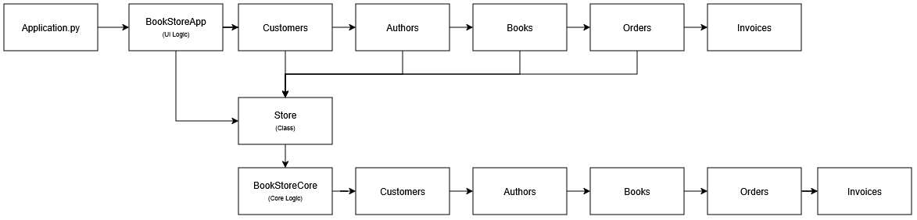

The executional logic starts with the file “Application.py” which is strategically located in the root directory for many reasons, mainly to act as the entry-point for the application and be responsible for starting the program and launch the graphical interface, whilst having little to no logic to improve run-time efficiency and error-handling.

Model
The ‘Model’ component of the MVC architecture is represented by the program file “BookStoreCore.py”. its primary class “Store” is responsible for manging the bookstore and application logic. It provides an internal data structure, unique identifier tables and public methods that encapsulate all core functionality, whilst being entirely independent of the graphical interface to ensure that its logic remains isolated and reusable.

View
The ‘View’ component consists of a collection of program files located within the Pages directory. The program files on this directory are classes dedicated to presenting information to the user and collecting input. These classes do not contain business logic, instead focus on layout, widgets and visual feedback to maintain this clear distinction between presentation and logic.

Controller
The ‘Controller’ and its responsibilities are handled by the “BookStoreApp.py” file and the individual page classes. These components manage application flow, navigation between pages, and user interactions such as button events. When user actions occur, the controller layer invokes appropriate methods on the Store class, acting as an intermediary between the ‘View’ and the ‘Model ‘component.

Object-Oriented Design
Now that we understand what object-oriented design is and its implications, I am going to discuss the next step in my project development which is System Planning. Keep in mind this message:
- ‘Aims will guide you to your vision’
- ‘Objectives will guide to your aims’
- ‘A plan will help you achieve those objectives’
The idea or concept of if I ‘planned in a volatile or complex environment, a rigid plan becomes obsolete’ meaning that I have to ensure that I kept a clear, maintainable and well-organised solution to project key constraints to avoid being prone to human mistakes.
My focus on building a scalable, reliable and maintainable system was eminent, the determination in early design prototyping and decision making helped me over-time come up with a clear architecture of the application and ensured that the final system meet the project objectives.
Planning the system in advance, allowed me to clearly separate the responsibilities between the different components in the project and apply object-oriented principles throughout the project life cycle. I have used UML class diagrams and wireframes to represent the planning process.

UML Class Diagrams
The following UML class diagrams were used to model the structure of the Bookstore Management System and define the key relationships between classes before implementation. It helped identify the key domain classes and characteristics or responsibilities in how they interact with one another, focusing on object-oriented concepts such as encapsulation, inheritance and abstraction.
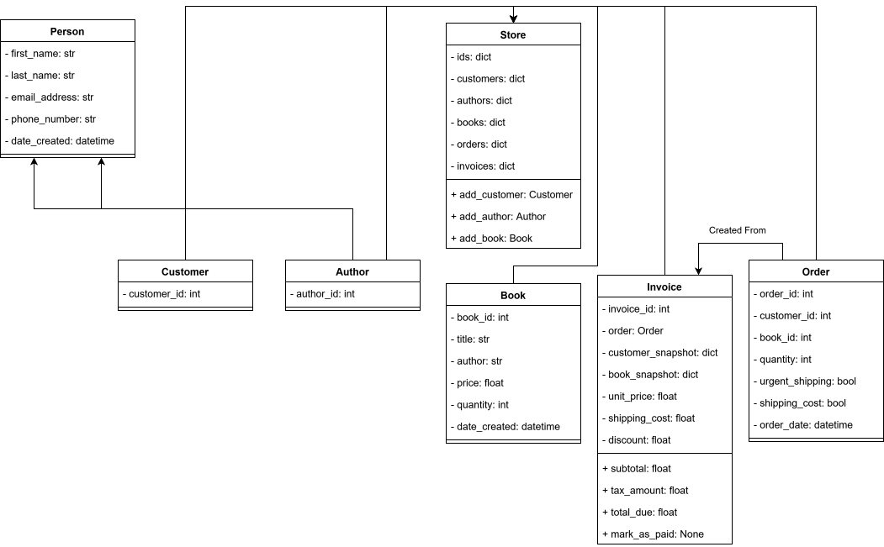
Okay remember that Store class in System Architecture section of the report, I am going to discuss its functionality here, you could think of it as the main coordinator of the system, responsible for managing core domain entities such as customers, authors, books, orders, and invoices.
The store class centralising this responsibility, loses the system tension of tight coupling between the individual domain classes and ensures that all business logic is accessed through a controlled interface.
Now, this approach I would say strongly supports encapsulation as internal data structures are kept private within the Store class and accessed only through public methods. It also promotes abstraction, allowing other parts of the system, including the graphical user interface, to interact with the core logic without knowledge of internal implementation details. Additionally, inheritance is used where appropriate to share common attributes between related classes, reducing duplication and improving code reuse.

Wireframes
Since UML Class Diagrams were used for the core logic, I need another way to plan the structure and navigation of the graphical user-interface prior to development. They provided a visual representation of how staff would interact with the system and how different screens would be connected. This planning helped ensure that the interface aligned with the underlying system logic and supported a clear separation between presentation and business logic.
It is important that you understand that wireframes focus on structure and functionality rather than visual styling, therefore wireframes contributed to the usability of the system and reinforced the object-oriented design by allowing the interface to act solely as a means of interaction, while all core functionality remained within the central Store class.
Layout Wireframe
This wireframe is used to demonstrate the layout of the application as well as the primary navigation structure. The navigation menu is positioned on the left-hand side of the interface. It is divided into six main components, including the following:
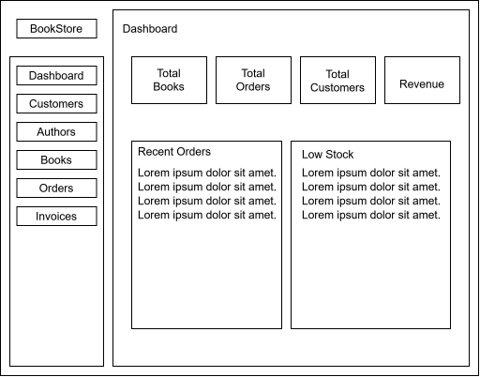
In the graphical side of the Bookstore Management System, each component includes a search feature that allows users to find records quickly within the current section, such as books, customers, or orders. This supports usability by reducing the time required to find specific information, particularly as the volume of data increases. The search functionality is integrated consistently across pages to maintain a predictable user experience.

Adding Item Wireframe
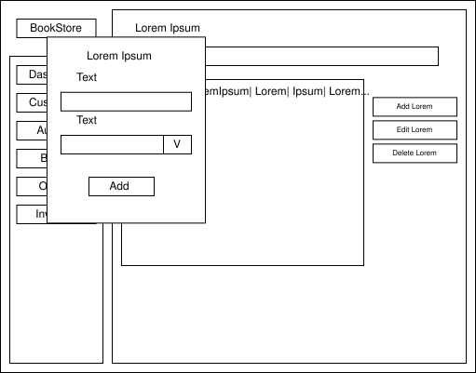
The wireframe is a template used to create new records within the application. The layout follows a consistent structure for a clear navigation and efficient data entry.
The main workspace is divided into two functional areas:
- An Add form panel (displayed as a foreground panel) containing labelled input fields. Labels indicate the required attributes, and input components include text entry fields and a dropdown selector where a controlled choice is needed.
- A content and action area behind/alongside the form that includes a data display region and a set of action buttons (e.g., Add / Edit / Delete), supporting management of existing records.
- The Add button is positioned within the form panel to submit the entered data and create the selected record.

Implementation
Now that we have a good understanding of the project architecture, I will be breaking down the key components and the code that makes up the Bookstore Management System, explaining its purpose, why I have designed in such a way and the decision-making process.
Before we get started, I need you to remember the following:
- The application is structured around the central store class which encapsulates all core data and business logic
- All domain entities are implemented as individual classes to reflect on the UML design and Object-oriented principles
- The graphical interfaces are implemented using a Tkinter class-based approach including the separation of the core components to represent the different areas of the application

BookStoreApp
The “BookStoreApp.py” class acts as the main application controller and entry point for the graphical user interface. It is responsible for initialising the application window, configuring global styles, creating the navigation structure, and managing page transitions. This class serves as the link between the user interface and the core business logic by holding a single instance of the Store class.
Snippet 1:
This snippet shows the execution logic and how “BookStoreApp.py” initialises it core dependencies such as the instantiation of the store instance allowing for all pages to share access to the same central, business logic and reinforces the encapsulation and consistency across the application.
import tkinter as TK
from tkinter import ttk as TTK
from Main.BookStoreCore import Store
from Pages.Dashboard import Dashboard
from Pages.Customers import Customers
from Pages.Authors import Authors
from Pages.Books import Books
from Pages.Orders import Orders
from Pages.Invoices import Invoices

class RMSApp(TK.Tk):
def __init__(self):
super().__init__()
# Configuration / Applying Settings
self.title("Bookstore App")
self.root = self.winfo_toplevel()
self.geometry("1380x720")
self.rowconfigure(0, weight=1)
self.columnconfigure(1, weight=1)
self.configure(bg="#F8FAFC")
self.store = Store()
Snippet 2:
This snippet shows how the application creates and manages the main interface pages, instantiation and referencing it memory. It also make sure the Dashboard is first page you see.
self.frames = {}

for Page in (Dashboard, Customers, Authors, Books, Orders, Invoices):
frame = Page(self.content_page, self.store)
self.frames[Page.__name__] = frame
frame.grid(row=0, column=0, sticky="nsew")
self.root.bind(f"<<{Page.__name__}>>", frame.refresh)
self.make_nav(Page.__name__)
frame.refresh()

# displays the Dashboard as the first page
self.show("Dashboard")

Snippet 3:
This snippet shows the key utility methods to control page navigation within the application to avoid duplication and ensure consistent behaviour when switching pages therefore achieving maintainability and clarity.
def make_nav(self, page_name):
TK.Button(
self.navigation_bar,
text=page_name.replace("Page", ""),
fg="white",
bg="#111827",
relief="flat",
command=lambda: self.show(page_name)
).grid(sticky="ew", padx=10, pady=2)

def show(self, page_name):
self.frames[page_name].tkraise()

def _refresh_all(self, event=None):
for frame in self.frames.values():
frame.refresh()

Functionality
BookStoreApp sets up the main application window, including layout configuration and styling. It creates a persistent navigation bar and dynamically loads each page of the application, such as the dashboard and management pages. The class controls which page is currently displayed and ensures that all pages share access to the same core data through the central Store instance.
Decisions & Justification
A key design decision was to centralise page management within a single application class. This avoids duplication of navigation logic and ensures consistent behaviour across all pages. Passing the Store instance into each page enforces separation of concerns, as the user interface does not manage data directly. This approach supports an MVC-style architecture, where the application controller coordinates interactions between the ‘View’ and the ‘Model’.
Suitability
This approach is well suited to the scale of the project, as it provides a clear structure without unnecessary complexity. The design allows new pages to be added easily while maintaining consistent navigation and access to shared data, making it appropriate for a modular desktop application.

BookStoreCore
The purpose of the ‘BookStoreCore.py’ module is to act as the central coordinator of the system’s core logic and data management. It provides a single access point for creating, storing, and managing all domain entities within the application, including customers, authors, books, orders, and invoices. This ensures that all business rules are enforced consistently and independently of the user interface.
Snippet 1:
Illustrates the store class acting as the central coordinator for all core domain components within the Bookstore Management System. It enforces encapsulation by keeping all core data structures private and exposing them through read-only properties therefore ensures that all business logic goes through it’s methods.
def __init__(self):
# Core storage
self.__books: dict[int, Book] = {}
self.__authors: dict[int, Author] = {}
self.__customers: dict[int, Customer] = {}
self.__orders: dict[int, Order] = {}
self.__invoices: dict[int, Invoice] = {}

# ID counters
self.__ids = {
"book": 1,
"author": 1,
"customer": 1,
"order": 1,
"invoice": 1,
}

# ---------- Properties ----------

@property
def books(self) -> dict[int, Book]:
return self.__books

@property
def authors(self) -> dict[int, Author]:
return self.__authors

@property
def customers(self) -> dict[int, Customer]:
return self.__customers

@property
def orders(self) -> dict[int, Order]:
return self.__orders

@property
def invoices(self) -> dict[int, Invoice]:
return self.__invoices

@property
def _ids(self):
return self.__ids

Snippet 2:
Demonstrates how the Store class provides controlled methods for creating, retrieving, and updating author records. By centralising these operations within the Store, the system enforces encapsulation and ensures that validation and data integrity rules are applied consistently
def add_author(self,first_name: str,last_name: str,email_address: str,phone_number: str) -> Author:
author_id = self._next_id("author")
author = Author(first_name, last_name, email_address, phone_number, author_id)
self.authors[author_id] = author
return author

def find_author(self, author_id: int) -> Author | None:
return self.authors.get(int(author_id))

def edit_author(self,author_id: int,first_name: str,last_name: str,email_address: str,phone_number: str):
if author_id not in self.authors:
raise ValueError("Author not found")

a = self.authors[author_id]
a.first_name = first_name
a.last_name = last_name
a.email_address = email_address
a.phone_number = phone_number

Snippet 3:
Shows how the Store class coordinates the creation of an invoice from an order, encapsulating a multi-step business process within a single method. Generating immutable snapshots of customer and book data and calculating costs centrally, allows the design to ensures consistency and prevents historical data from being affected by future changes
def _create_invoice_from_order(self, order: Order) -> Invoice:
customer = self.customers[order.customer_id]
book = self.books[order.book_id]

invoice_id = self._next_id("invoice")

customer_snapshot = {
"customer_id": customer.customer_id,
"name": f"{customer.first_name} {customer.last_name}",
"email": customer.email_address,
"phone": customer.phone_number,
}

book_snapshot = {
"book_id": book.book_id,
"title": book.title,
"author": book.author,
}

shipping_cost = self._calculate_shipping(order.urgent_shipping, order.shipping_cost, order.quantity)

invoice = Invoice(
invoice_id=invoice_id,
order=order,
customer_snapshot=customer_snapshot,
book_snapshot=book_snapshot,
unit_price=book.price, # price frozen here
shipping_cost=shipping_cost # shipping frozen here
)

self.invoices[invoice_id] = invoice
return invoice

Functionality
BookStoreCore manages a collection of domain objects and provides methods to add, edit, and delete records. It enforces validation rules, manages relationships between entities, and coordinates processes such as generating invoices automatically when orders are created. The component also handles perseverance by saving and loading data, allowing the system to be maintained across application.
Decisions & Justification
A key design decision was to centralise all business logic within a single Store class rather than distributing logic across multiple components. This reduces duplication and prevents tight coupling between the user interface and domain entities. Encapsulation is enforced by keeping internal data structures private and exposing functionality through well-defined methods. This approach supports abstraction, allowing other parts of the system to interact with the core logic without knowledge of its internal implementation.
Suitability
This implementation is well suited to the scope and objectives of the project. It provides a clear, maintainable structure while remaining simple enough for a small-scale program. Centralising logic in BookStoreCore makes the system easier to extend, test, and debug, and aligns closely with object-oriented best practices introduced in the module.

Dashboard
The purpose of the Dashboard component is to provide users with a high-level overview of the bookstore’s current state and recent activity. It acts as an informational page that summarises key data without allowing direct modification, helping staff quickly understand system status at a glance.
Snippet 1:
Illustrates the initialisation of the Dashboard interface, where layout and visual components are configured independently of any business logic. The Dashboard receives a reference to the Store class, allowing it to display summary information while maintaining a clear separation between presentation and core system logic
def __init__(self, parent, store):
super().__init__(parent, bg="#F8FAFC")
self.store = store
self.root = self.winfo_toplevel()

self.columnconfigure(0, weight=1)

pad = 5
title_text = self.__class__.__name__
description_text = "Here’s a quick overview of your bookstore’s performance and recent activity."

# ================= HEADER =================
tk.Label(self,text=title_text,font=("Arial", 20, "bold"),bg="#F8FAFC",fg="#0F172A",padx=pad).grid(row=0, column=0, sticky="w")

tk.Label(self,text=description_text,font=("Arial", 12),bg="#F8FAFC",fg="#0F172A", padx=pad,justify="left",anchor="w").grid(row=1, column=0, sticky="w")

# ================= STATS =================
stats_frame = tk.Frame(self, bg="#F8FAFC")
stats_frame.grid(row=2, column=0, sticky="w", padx=24, pady=16)

self.card_total_books = self.make_card(stats_frame, "0", "Total Books")
self.card_total_orders = self.make_card(stats_frame, "0", "Total Orders")
self.card_total_customers = self.make_card(stats_frame, "0", "Total Customers")
self.card_revenue = self.make_card(stats_frame, "£0.00", "Revenue")

Snippet 2:
Demonstrates the use of a helper method to encapsulate the creation of reusable user interface components within the Dashboard. By abstracting repeated layout logic into a single method, the design improves maintainability and ensures a consistent visual structure across summary cards
def make_card(self, parent, value, label):
frame = tk.Frame(parent,bg="#FFFFFF",width=220,height=110,highlightbackground="#E5E7EB",highlightthickness=1)
frame.pack(side="left", padx=8)
frame.pack_propagate(False)

value_label = tk.Label(frame,text=value,fg="#0F172A",bg="#FFFFFF",font=("Segoe UI", 22, "bold"))
value_label.pack(pady=(14, 0))

tk.Label(frame,text=label,fg="#6B7280",bg="#FFFFFF",font=("Segoe UI", 11)).pack(pady=(4, 10))

return value_label

Snippet 3:
Shows how the Dashboard dynamically refreshes its displayed information based on the current state of the Store. The method reads data in a read-only manner to update summary statistics, recent orders, and low-stock indicators, ensuring that the interface remains accurate while maintaining separation between presentation and business logic
def refresh(self):
# ----- CARDS -----
self.card_total_books.config(text=str(len(self.store.books)))
self.card_total_orders.config(text=str(len(self.store.orders)))
self.card_total_customers.config(text=str(len(self.store.customers)))

revenue = sum(
inv.total_due
for inv in self.store.invoices.values()
if inv.paid
)
self.card_revenue.config(text=f"£{revenue:,.2f}")

# ----- RECENT ORDERS -----
for w in self.recent_orders_list.winfo_children():
w.destroy()

recent = sorted(
self.store.orders.values(),
key=lambda o: o.order_date,
reverse=True
)[:5]

if not recent:
tk.Label(
self.recent_orders_list,
text="No orders yet.",
bg="#FFFFFF",
fg="#6B7280"
).pack(anchor="w")
else:
for o in recent:
c = self.store.customers[o.customer_id]
b = self.store.books[o.book_id]
tk.Label(
self.recent_orders_list,
text=f"#{o.order_id} • {c.first_name} {c.last_name} • {b.title}",
bg="#FFFFFF",
anchor="w"
).pack(anchor="w", pady=2)

# ----- LOW STOCK -----
for w in self.low_stock_list.winfo_children():
w.destroy()

low_stock = [b for b in self.store.books.values() if b.quantity <= 3]

if not low_stock:
tk.Label(
self.low_stock_list,
text="All books sufficiently stocked.",
bg="#FFFFFF",
fg="#6B7280"
).pack(anchor="w")
else:
for b in low_stock:
tk.Label(
self.low_stock_list,
text=f"{b.title} — {b.quantity} left",
bg="#FFFFFF",
fg="#DC2626",
anchor="w"
).pack(anchor="w", pady=2)

Functionality
The Dashboard displays a summary of statistics such as the total number of books, customers, and orders, as well as overall revenue from completed invoices. It also presents a list of recent orders and highlights of books with a low stock level. The Dashboard listens for application-wide update events and refreshes automatically when data changes, ensuring that all displayed information remains current.
Decisions & Justification
The decision to separate the Dashboard into its own class ensures that presentation logic is clearly isolated from business logic. The Dashboard accesses data in a read-only manner through the Store class, reinforcing encapsulation and separation of concerns. An event-driven refresh mechanism was chosen to avoid tight coupling between components and to ensure efficient updates across the interface.
Suitability
This design is suitable for the project as it enhances usability without adding unnecessary complexity. By providing clear summaries and visual feedback, the Dashboard supports user awareness while maintaining the integrity of the data structure and aligning with the overall object-oriented architecture.

Orders
The purpose of the Orders component is to allow users to create and view customer orders within the application. It provides a structured interface for managing order-related data while ensuring that all business rules are enforced through the core logic.
Snippet 1:
Illustrates the structure of the Orders page interface, including the tabular display of existing orders and the primary action used to create new records. The design separates data presentation from business logic by relying on the Store class for all order data and operations.
# ================= TABLE =================
table_container = TK.Frame(self, bg="#F8FAFC")
table_container.grid(row=3, column=0, sticky="nsew", padx=(24, 10), pady=10)
table_container.rowconfigure(0, weight=1)
table_container.columnconfigure(0, weight=1)

columns = ("Order ID", "Customer", "Book", "Quantity", "Urgent", "Order Date")

self.table = TTK.Treeview(table_container, columns=columns, show="headings", height=25, style="Borderless.Treeview")
self.table.grid(row=0, column=0, sticky="nsew", padx=12, pady=12)

for col in columns:
self.table.heading(col, text=col)
self.table.column(col, anchor="center", width=160)

# ================= BUTTONS =================
buttons = TK.Frame(self, bg="#F8FAFC", width=220)
buttons.grid(row=3, column=1, sticky="ns", padx=(0, 24), pady=10)

self.add_btn = TTK.Button(buttons, text="Add Order", style="Side.TButton", command=self.create_order_form)
self.add_btn.grid(sticky="ew", pady=6)

self.refresh()

Functionality
The Orders page displays existing orders in a searchable table, allowing users to quickly locate specific records. It provides a form-based interface for creating new orders, where users can select customers and books, specify quantities, and choose shipping options. When an order is created, the system automatically generates an associated invoice and updates relevant areas of the application.
Decisions & Justification
A key design decision was to delegate all order processing and validation to the Store class rather than handling it directly within the user interface. This reinforces encapsulation and ensures consistent enforcement of business rules. Input validation is also applied at the interface level to improve usability by preventing invalid submissions. The use of a separate form window helps focus user attention and reduces interface clutter.
Suitability
This implementation is suitable for the project’s requirements as it balances usability with data integrity. The clear separation between user interaction and business logic supports maintainability and makes the Orders component easy to extend in the future, for example by adding order editing or additional filtering features.
Snippet 2:
This snippet shows how the Orders page collects user input for creating a new order through a dedicated form window. Selection controls are populated dynamically from the Store, ensuring that only valid customers and books can be chosen while keeping business logic outside the user interface
form = TK.Toplevel(self, bg="#F8FAFC")
form.title("Create Order")
form.geometry("420x420")
form.grab_set()

# ----- CUSTOMER -----
TK.Label(form, text="Customer", bg="#F8FAFC").pack(anchor="w", padx=24, pady=(16, 0))

cust_var = TK.StringVar()
customers = {f"{c.first_name} {c.last_name} (ID {c.customer_id})": c.customer_id for c in self.store.customers.values()}

cust_box = TTK.Combobox(form, textvariable=cust_var, values=list(customers.keys()), state="readonly")
cust_box.pack(fill="x", padx=24)

# ----- BOOK -----
TK.Label(form, text="Book", bg="#F8FAFC").pack(anchor="w", padx=24, pady=(12, 0))

book_var = TK.StringVar()
books = {f"{b.title} (ID {b.book_id})": b.book_id for b in self.store.books.values()}

book_box = TTK.Combobox(form, textvariable=book_var, values=list(books.keys()),state="readonly")
book_box.pack(fill="x", padx=24)

Snippet 3:
Demonstrates how the Orders page delegates order creation to the Store class, ensuring that all validation and business rules are enforced centrally. User interface updates are triggered through application events, maintaining loose coupling between components and improving maintainability
def save():
try:
self.store.add_order(
customer_id=customers[cust_var.get()],
book_id=books[book_var.get()],
quantity=int(qty_entry.get()),
urgent_shipping=urgent_var.get(),
shipping_cost=shipping_var.get(),
)
self.root.event_generate("<<RefreshAll>>")
form.destroy()

except Exception as e:
messagebox.showerror("Error", str(e))

Testing & Error Handling

Bookstore Management System
TEST ID | Description | Expected Result | Actual Result
1 | Add a new customer | Customer is added and displayed in the customer list | Customer added successfully
2 | Add a new author | Author is stored and available for book creation | Author added successfully
3 | Add new book | Book is added and appears in the books list | Book added successfully
4 | Prevent invalid customer input | System disables displays record creation | Successfully disables record creation
5 | Create a valid order | Order is created and invoice generated automatically | Order and invoice created
6 | Prevent orders with insufficient stock | Order is rejected with error message | Error message displayed
7 | Automatic invoice generation | Invoice is created and linked to the order | Invoices created and displayed automatically
8 | Dashboard statics update | Dashboard updates totals and revenue | Dashboard updated correctly
9 | Low stock detection | Book appears in low stock section | Low stock displayed
10 | Search functionality | Table filters matching orders | Matching records shown in table view
11 | UI refreshes after data change | All relevant pages refresh automatically | UI refreshed correctly
12 | Error handling on invalid record inputs | Record creation is blocked | Error messages displayed

User Interface

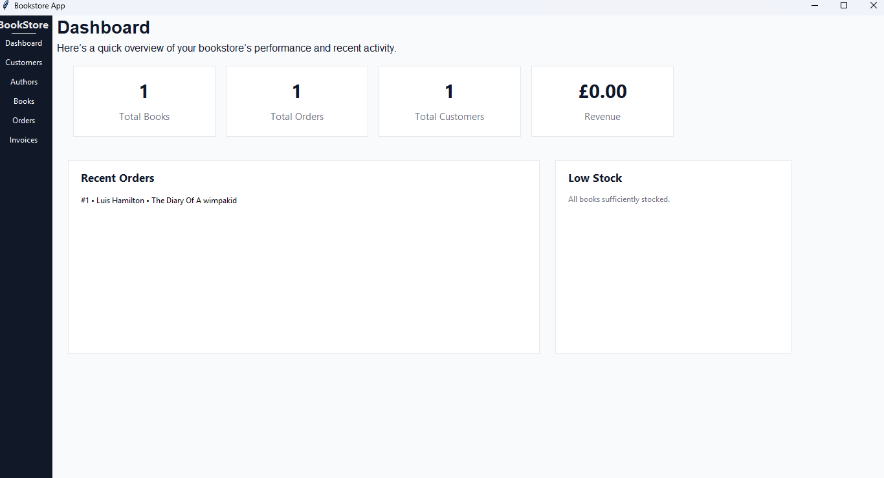
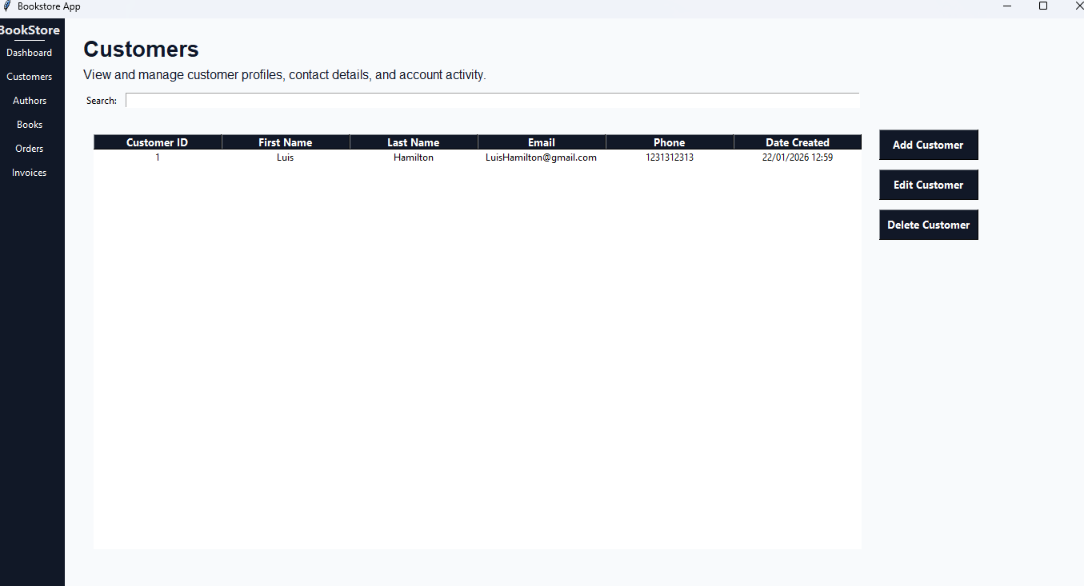
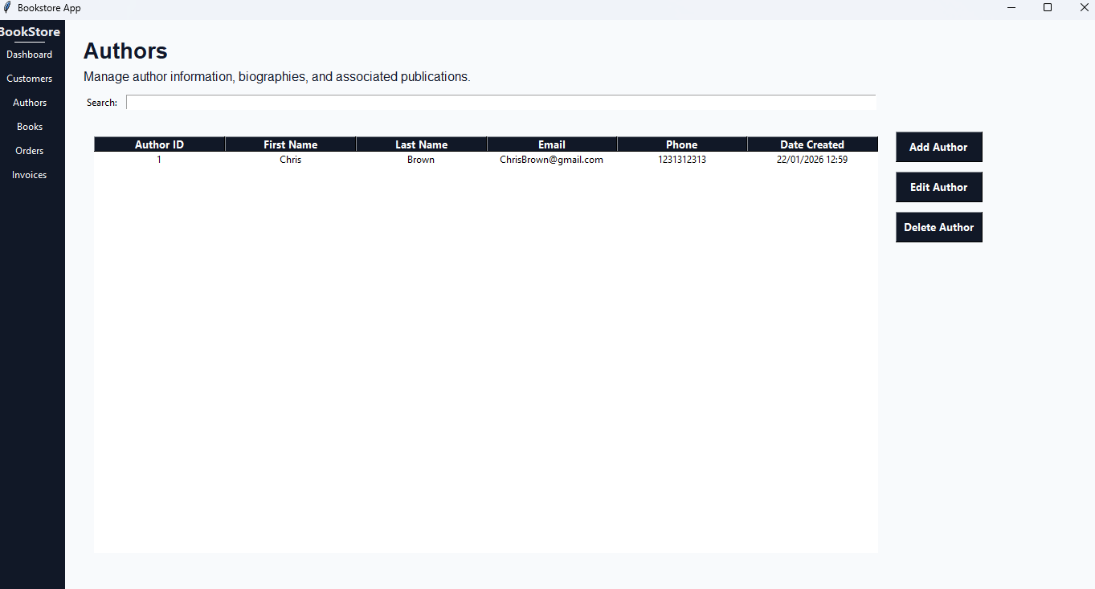
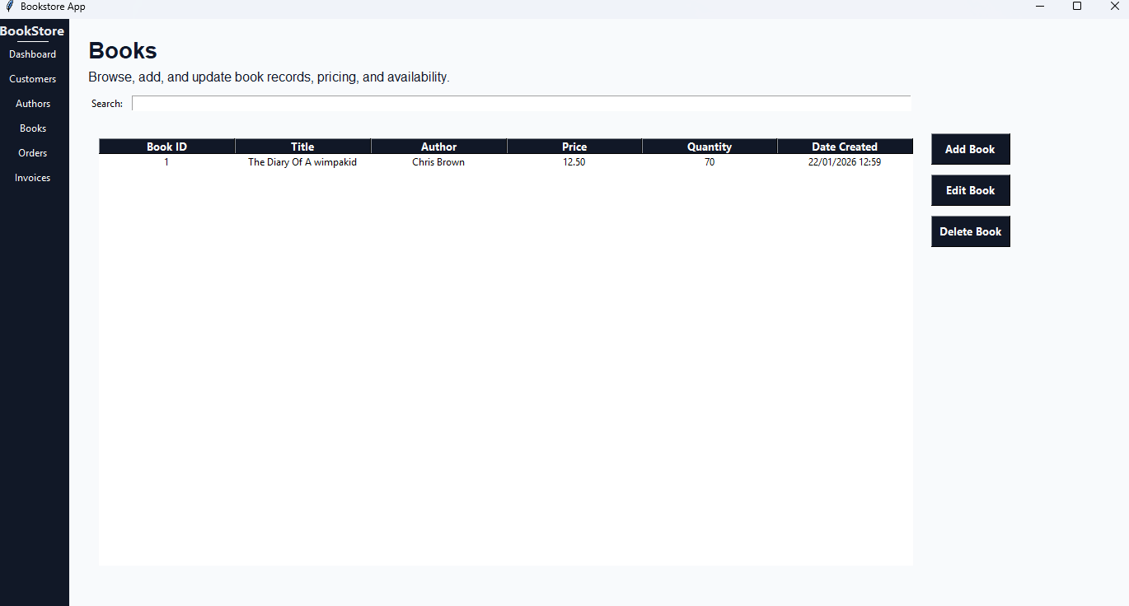
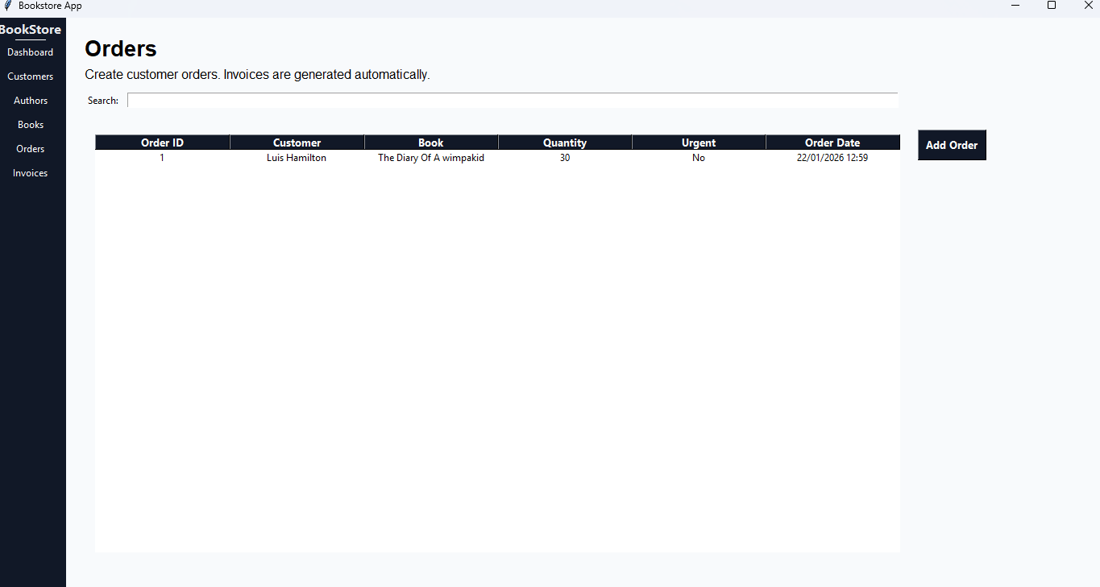
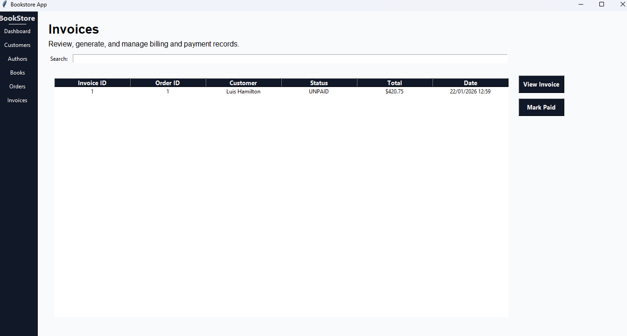

Conclusion
This section concludes the report by reflecting on the development process, summarising the final outcome of the project, and referencing the accompanying video demonstration and project checklist.

Reflection
Now that we are here, I going to reflect on the project as a whole.
I found that the development process was both challenging and highly rewarding.
At the start I struggled to understand how I can structure a large application, something I felt overwhelming at the time, particularly when I tried to separate the user interface code from business Logic.

However, as the project progressed, I became more confident in applying object-oriented principles such as encapsulation and abstraction, which helped me organise the system more effectively. Seeing the application function as a complete system, rather than isolated features, was particularly satisfying and reinforced my understanding of software architecture.
Although I am pleased with the final outcome, there are areas where I feel improvements could have been made.
With more time, I would have liked to refine the user interface further and implement additional features such as more advanced validation and reporting tools. I also recognise that expanding the testing phase earlier in development may have helped identify potential issues sooner.
Overall, I enjoyed working on this project and feel that it significantly improved my confidence and skills in object-oriented programming and application design. If you would like to see the video demonstration or checklist you can view it down below.

Video Demonstration
https://www.youtube.com/watch?v=VjZdsMqxRd4
https://mymedia.northampton.ac.uk/media/Project+1%3A+Bookstore+Application/0_nfv9gzaj

Checklist:
0% to 49% (D Grade)
Customer Records
- Add a new customer | ☒
- Display all customer records | ☒
Book Records
- Add a new book to stock | ☒
- Display all book records | ☒
Place an order by selecting a customer and book | ☒
Display a simple invoice showing customer, book, and total price | ☒
50% to 59% (C Grade)
Shipping
- Option to add shipping to order | ☒
- Calculate shipping costs along with total price | ☒
- Toggle for urgent shipping | ☒
Invoices/Receipts
- Display all invoices/receipts in the system | ☒
- Display individual invoices/receipts | ☒
60% to 69% (B Grade)
Search for invoices by a number (ID) | ☒
Validation
- Input validation when creating customer records | ☒
- Input validation when creating book records | ☒
- Input validation when creating order records | ☒
- Clear error messages using message boxes or labels | ☒
Prevent Invalid Operations
- Cannot place an order if no customers exist | ☒
- Cannot place an order if no books exist | ☒
70%+ (A Grade)
Classes
- Single inheritance (e.g. Person -> Customer) | ☒
- Multiple inheritance | ☒
- Encapsulation using getters | ☒
- Encapsulation using setters | ☒
Access modifiers
- Private attributes | ☒
- Protected attributes | ☒
- Private methods | ☒
- Protected methods | ☒
Use of the @property decorator | ☒
Tkinter Layout
- Multi page layout (week 12) | ☒
- Disable buttons until prerequisites are met, for example a book cannot be added until all required attributes have been entered | ☒

