

The University of Azad Jammu and Kashmir, Muzaffarabad
Department of software Engineering

Group Name | Nasir Abbas  Sheikh Abrar Mudassar Raza
 | 2022-SE-37
Roll No | 2022-SE-21
 | 2022-SE-40
Course code | SE-3210
Course Title | Deep Learning
Semester | 6th
Session | 2023-2027
Assignment No | 02
Submitted To | Engr. Ahmed Khawaja

BirdCLEF+ 2026
Bioacoustic Species Recognition

Project Documentation Report
Cornell Lab of Ornithology & Google | Kaggle Competition | 2025–2026

0.946
Public Leaderboard — Macro ROC-AUC
FINAL SCORE

Field | Details
Competition | BirdCLEF+ 2026
Organizer | Cornell Lab of Ornithology & Google
Platform | Kaggle
Task Type | Multi-label Audio Classification
Metric | Macro ROC-AUC
Final Score | 0.946
Environment | CPU-only, 9-hour Kaggle session
Year | 2025 – 2026

1. Project Overview

BirdCLEF+ 2026 is an international Kaggle competition organized by the Cornell Lab of Ornithology and Google, focused on automated identification of wildlife species from passive acoustic monitoring (PAM) recordings. The recordings are 60-second soundscape audio files captured across diverse global ecosystems, and the task requires predicting the presence or absence of over 200 species — including birds, amphibians, insects, and mammals — for each 5-second window within the file.
The challenge tests both the quality of machine learning models and their ability to run efficiently under strict computational constraints: inference must complete within Kaggle's 9-hour CPU-only session limit, with no internet access during submission.
Group Members
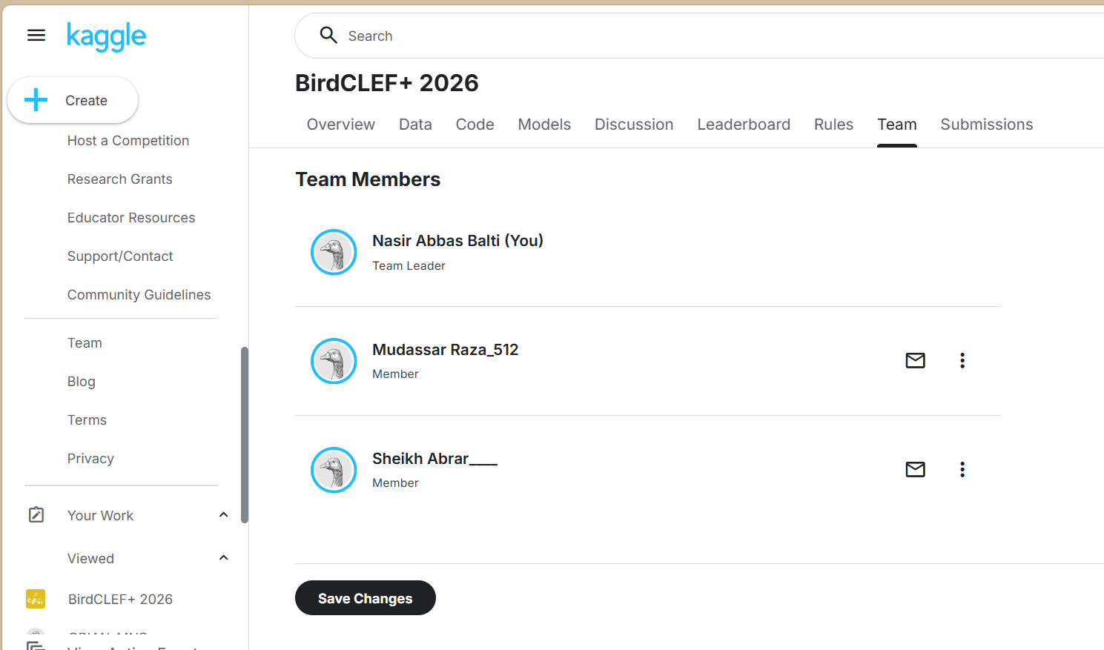

Score
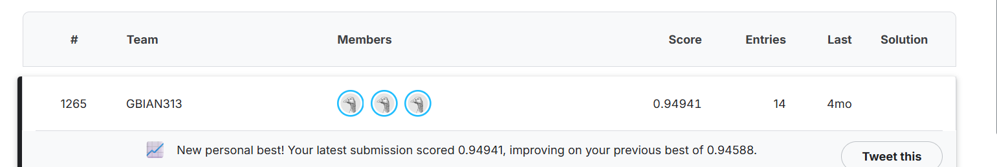

Objectives
- Identify 200+ wildlife species from raw audio recordings in near-real-time
- Handle heavy class imbalance — many species are acoustically rare in the dataset
- Generalize across multiple geographic sites and recording time zones
- Complete inference within 9 hours on CPU-only hardware (no GPU available)
- Submit per-window probability scores in the competition's required CSV format

2. Dataset Description

Component | Details
Training Data | Labeled soundscape recordings (train_soundscapes/*.ogg)
Test Data | Hidden soundscapes (test_soundscapes/*.ogg)
Audio Format | .ogg files, 60 seconds each, 32 kHz sampling rate
Window Size | 5 seconds per prediction window
Windows per File | 12 windows × 5s = 60 seconds total
Label Type | Multi-label binary — species present / absent per window
Species Count | 200+ species across Aves, Amphibia, Insecta, Mammalia
Taxonomy File | taxonomy.csv — scientific names, class, family, order
Metadata | Site ID, recording date, UTC hour embedded in filename

Filename Format
BC2026_Train_[RecordingID]_[SiteID]_[YYYYMMDD]_[HHMMSS].ogg

Example: BC2026_Train_001_S04_20260312_064500.ogg
--> Site: S04 | Date: 12 March 2026 | Hour UTC: 06
3. Technical Architecture

Overall Pipeline
Raw Audio (.ogg, 60s)
|
[Perch v2 ONNX Backbone] -- frozen, no fine-tuning
|
+----+ +
| |
1536-dim Embeddings Perch Logits (14795 species)
| |
+---[Species Mapping]------+ genus-level proxy for unmapped
|
[Bayesian Prior] <-- Site x Hour ecological statistics
|
[MLP Probes] -- per-class sklearn MLP on PCA embeddings
|
[ProtoSSM] -- Bidirectional SSM + Cross-Attention + Prototypes
|
[ResidualSSM] -- second-pass error correction
|
ProtoSSM Final Scores
|
+----+ +
| |
ProtoSSM SED Model (5-fold EfficientNet ONNX) (55%) (45%)
| |
[Rank-Percentile Blend]
|
[Post-Processing Gates 1-5]
| submission.csv

Google Perch v2 Backbone
The Google Bird Vocalization Classifier (Perch v2) is used as a frozen feature extractor. It was pretrained on a large-scale bioacoustic dataset and outputs a 1536-dimensional embedding and logits over 14,795 species for each 5-second audio chunk.

Property | Value
Model Type | TF SavedModel + ONNX no-DFT variant
Output | 1536-dim embedding + 14,795 species logits
Fine-tuning | None — fully frozen
ONNX Speedup | ~150x faster than TF SavedModel on CPU
Species Match | Direct match via scientific name; proxy via genus-level max

ProtoSSM — Core Custom Model
The ProtoSSM is the primary classifier. It combines Prototypical Networks (few-shot learning) with Bidirectional Selective State Space Models to capture temporal dependencies across the 12 audio windows of each recording.
Input: (batch, 12 windows, 1536 dims)
--> Linear Projection --> LayerNorm --> GELU --> Dropout
--> + Positional Encoding (learned)
--> + Site Embedding + Hour Embedding (meta conditioning)
--> BiSSM Layer 1 (Forward SSM || Backward SSM --> Merge)
--> Multi-Head Cross-Attention (2 heads)
--> BiSSM Layer 2 (Forward SSM || Backward SSM --> Merge)
--> Multi-Head Cross-Attention (2 heads)
--> Prototype Similarity (cosine) x Learned Temperature
--> Learned alpha fusion with Perch logits Output: (batch, 12 windows, N_classes)

Component | Design Choice | Reason
SSM Type | Selective SSM (Mamba-inspired) | Long-range temporal context
Directionality | Bidirectional (Fwd + Bwd) | Past and future window context
Prototypes | One per class, cosine similarity | Few-shot generalisation for rare species
Meta Conditioning | Site + Hour embeddings | Encodes ecological and time context
Fusion | Learned alpha blending with Perch | Preserves strong Perch signal

Sound Event Detection (SED) Model

Property | Value
Architecture | EfficientNet-based CNN (distilled)
Input | Log-mel spectrogram: 256 mels, 2048 FFT, 512 hop
Output | Clip-level logits + frame-level predictions
Inference | 50% clip-level sigmoid + 50% frame-level max pooling
Smoothing | Gaussian temporal smoothing across windows (sigma=0.65)
Format | ONNX, 5 separate fold models averaged (ensemble)

  - MLP Probes
Lightweight per-class classifiers trained on top of Perch embeddings to capture class-specific patterns not captured by the general backbone.
    - Embedding compression: PCA (1536 dims  64 dims)
    - Features: PCA components + current Perch score + prev/next window scores + file-level mean / max / std
    - Model: MLPClassifier with hidden layers (128  64 units)
    - Class balancing: positive sample oversampling (capped at 8x repetition)
    - Blend: 30% MLP probe output + 70% Perch logits per class

ResidualSSM — Second-Pass Error Correction
A lightweight second BiSSM model trained to predict the residual error of the first-pass ProtoSSM predictions and correct systematic over/under-prediction.

Property | Value
Input | Perch embeddings + first-pass ProtoSSM logits
Target | Residuals = ground truth - sigmoid(first pass)
Architecture | Single BiSSM layer with site/hour conditioning
Effect | Corrects systematic per-class bias, improves calibration

4. Feature Engineering

Bayesian Ecological Prior
Species prevalence is strongly influenced by recording site and time of day. A 3-tier shrinkage prior is computed from the training labels and applied as a logit offset during inference.
Prior Hierarchy (shrinkage toward global if n is small):

Level 1: Global base rate p_global(c) Level 2: Site-level p_site(c | site) k=8 Level 3: Hour-level p_hour(c | hour) k=8
Level 4: Joint site x hour p_sh(c | site,hour) k=4

Shrinkage: w = n / (n + k)
Prior applied as logit offset: score += lambda * log(p / (1-p)) Lambda = 0.4 (empirically tuned)

Species Mapping to Perch Logits

Type | Method | Coverage
Direct | Exact scientific name match to Perch label index | ~70% of species
Proxy | Genus-level max pooling over all genus matches | ~20% of remaining
No Signal | Left at zero — no proxy available | ~10% of remaining

  - Per-Taxon Temperature Scaling

Taxon Class | Temperature | Effect
Aves (Birds) | 1.10 | Slightly softer predictions (more species, more ambiguity)
Amphibia / Insecta | 0.95 | Sharper predictions (more distinctive calls)

5. Training Strategy

ProtoSSM Training Configuration

Parameter | Value
Optimizer | AdamW
Learning Rate | 8e-4
Weight Decay | 1e-3
Epochs | 50 (submit mode)

Loss Function | BCE with pos_weight (capped at 25.0) + 0.15 x MSE distillation
SWA | Stochastic Weight Averaging from epoch 65% onward
SWA LR | 3e-4
Multi-seed | 3 seeds: 42, 123, 777 — averaged for stability

  - Prototype Initialization
Before gradient training, class prototypes are initialized as the mean of all positive training embeddings for each class. This gives the model a strong starting point, especially for rare classes with few positive examples.

Class Imbalance Handling
pos_weight[c] = (total_windows - positive_count[c]) / (positive_count[c] + 1) pos_weight[c] = min(pos_weight[c], 25.0) # cap to avoid extreme gradients

Applied per-class in BCEWithLogitsLoss to upweight rare species.

6. Inference Strategy

Test Time Augmentation (TTA)
Five temporal shifts are applied to each 12-window sequence: [0, +1, -1, +2, -2] windows. For each shift, the sequence is rolled, predictions are generated, then unrolled back. All 5 outputs are averaged. This reduces boundary effects and improves robustness to recording start offset.

Multi-Seed Ensemble
Three independent ProtoSSM models are trained with different random seeds (42, 123, 777). Combined with 5 TTA shifts, each test sample receives 15 predictions that are averaged. This significantly reduces prediction variance without additional data.

Rank-Percentile Blending
# Convert raw scores to percentile ranks (removes scale mismatch) rank_proto = percentile_rank(proto_scores) # shape: (N, C) rank_sed = percentile_rank(sed_scores) # shape: (N, C)

# Weighted blend in rank space
final = 0.55 * rank_proto + 0.45 * rank_sed

# Rank normalization is critical: ProtoSSM and SED have very
# different score distributions. Blending raw scores degrades both.

7. Post-Processing Gates

Ga te | Name | Description | Effect
1 | Noise Suppression | ProtoSSM high-conf (>0.50) but SED very low (<0.05) | Downweights likely false positives
2 | Temporal Continuity | Fat-tailed t-kernel smoothing over 35s context window | Boosts species with sustained multi-window presence
3 | SED Spike Preservation | High SED rank (>0.95) that ProtoSSM missed (<0.80) | Recovers brief but confident SED-only detections
4 | Sonotype Mirroring | Max-pool across acoustically similar species groups | Prevents penalising near-duplicate species
5 | Rare-Class Thresholding | Suppresses sub-threshold Amphibia / Mammalia / Reptilia | Reduces false positives in rare non-bird taxa
0.946
Public Leaderboard — Macro ROC-AUC
FINAL SCORE
8. External Resources Used

Resource | Purpose
google/bird-vocalization-classifier | Perch v2 TF SavedModel + species label CSV
tuckerarrants/perch-v2-no-dft-onnx | Fast ONNX Perch (no DFT preprocessing)
tuckerarrants/bc2026-distilled-sed-public | 5-fold EfficientNet SED ONNX models
jaejohn/perch-meta | Pre-computed Perch embeddings cache
rishikeshjani/perch-onnx-for-birdclef-2026 | Custom ONNX Runtime wheel for Kaggle
ashok205/tf-wheels | TensorFlow 2.20 pre-built wheels
9. Results & Evaluation
Metric | Value
Public Leaderboard Score | 0.946 Macro ROC-AUC
Evaluation Metric | Macro-averaged ROC-AUC across all species
Prediction Type | Per-window probability scores (continuous, not binary)
Submission Format | CSV: row_id + 200+ species columns
Hardware | CPU-only (Kaggle, no GPU)
Total Inference Time | Within 9-hour Kaggle session limit

10. Key Learnings & Insights

Frozen Pretrained Backbones
Google Perch v2 provides exceptional bioacoustic features without any fine-tuning. The 1536-dim embeddings capture spectral, temporal, and species-level acoustic patterns far better than training a spectrogram CNN from scratch on limited competition data.

Ecological Metadata is Strong Signal
Site ID and UTC recording hour are highly predictive of species presence. Certain species are active only at dawn or dusk, and others are geographically restricted. Encoding this as a Bayesian prior gave consistent score improvements.

Rank-Percentile Blending is Critical
When ensembling two models with very different score distributions (SSM logits vs. sigmoid outputs from SED), blending raw scores degrades both. Converting to percentile ranks before blending is essential for a stable ensemble.

SSMs for Sequential Audio Windows
State Space Models are well-suited for 12-step sequences of audio windows. Their bidirectional variant allows the model to use both past and future windows when making per-window predictions, unlike causal models.

Prototypical Learning for Rare Classes
Prototype-based similarity scoring handles class imbalance naturally — rare classes with few positive examples still get a well-initialized class representative, which is more stable than learning a decision boundary from very few positives.

Overfitting Risk with Small Training Sets
The competition training set is relatively small. Adding complexity (more layers, aggressive loss functions) without careful validation leads to overfitting. The safest improvements were ensemble diversity (seeds, TTA) rather than model depth.

11. Tools & Technologies

Category | Tools / Libraries
Language | Python 3.12
Deep Learning | PyTorch, TensorFlow 2.20

Audio Processing | librosa, soundfile
Classical ML | scikit-learn (MLPClassifier, PCA, IsotonicRegression)
Data Handling | NumPy, Pandas
Parallel I/O | concurrent.futures ThreadPoolExecutor
Progress Tracking | tqdm
Platform | Kaggle Notebooks (CPU, 9h limit, no internet)
Hardware | CPU-only — no GPU acceleration

THE END…….

