**o3**

**COMSATS University Islamabad (CUI)**

**Project Proposal**

**(SCOPE DOCUMENT)**

**for**

**BrainBee**

Version 1.0

***By***

**Nasir Shahzad SP22-BCS-077**

**Sohail Faiz Rasool SP22-BCS-095**

***Supervisor*Mr. Tanveer Ahmad**

**Bachelor of Computer science (2022-2026)**

Application Evaluation History

|  |  |
| --- | --- |
| **Comments (by committee)**  **\*include the ones given at scope time both in doc and presentation** | **Action Taken** |
| Open Ai based Application doesn’t justify learning of students. | In the **Student App**, we are redefining education by introducing **personalization at its core**. Every student’s learning journey becomes unique as we generate quizzes, flashcards, topic summaries, and explanations tailored to their performance in assessments. This personalization enhances engagement and ensures that students focus on their areas of improvement, making learning more efficient and enjoyable.  To complement this, we are launching a **Teacher Portal** designed to empower educators like never before. At the heart of this portal lies an **advanced Machine Learning model** that analyzes each student’s performance and generates an optimized **learning path**. This cutting-edge feature ensures that teachers can easily guide students toward success with actionable insights.  Teachers can create and manage classes, seamlessly adding students to foster collaboration. They gain a comprehensive overview of student activities, track performance through detailed analytics, and assign quizzes and assignments to ensure consistent learning. Additionally, teachers can provide personalized feedback to guide students toward growth and excellence. |

Supervised by

Supervisor’s Name

Signature______________

**Table of Contents**

Contents

1. Abstract 3

2. Introduction 4

3. Problem Statement 4

4. Problem Solution/Objectives of the Proposed System. 5

5. Objectives 5

6. Related System Analysis/Literature Review 6

7. Vision Statement 7

8. Scope 7

9. Modules 7

9.1 Student App: 7

9.1.1 User Management: 7

9.1.2 Peer Competition Module: 8

9.1.3 Learning Module: 8

9.1.4 Quiz Module: 8

9.1.5 Achievement and Rewards Module: 8

9.1.6 Performance Analytics Module: 9

9.1.7 AI Powered Assistant Module: 9

9.2 Parent App: 9

9.2.1 User Management: 9

9.2.2 Monitor Children: 9

9.2.3 Goals Module: 9

10. System Limitations 10

11. Tools and Technologies 10

12. Project Stakeholders and Roles 10

13. Data Gathering Approach 11

13.1 Interviews: 11

13.2 Questionnaire Survey 11

13.3 Brainstorming 11

13.4 Analysis of Existing System Documentation 11

14. Module based Work Division 12

15. WBS Gantt Chart 12

16. Mockups 13

16.1 Student App Mockup 13

16.2 Parent App Mockup 15

17. References 16

18. Plagiarism Report 17

**Project Category: (**Select all the major domains of the proposed project**)**

□ **A-**Desktop Application/Information System □ **B-**Web Application/Web Application based Information System ■ **C-**Problem Solving and Artificial Intelligence □ **D-**Simulation and Modeling ■ **E-**Smartphone Application

□ **F-**Smartphone Game □ **G-**Networks □ **H-**Image Processing□ Other (specify category) ________________

# 1. Abstract

Students in urban and developing rural areas often lack access to quality educational opportunities, resources, and reputable academies, limiting their ability to receive the same academic support as their peers in more developed regions.

BrainBee is a mobile-based educational platform that tackles learning challenges in rural and developing urban areas. It offers AI-driven support, interactive tools, graded assessments, gamified learning, parental monitoring and teacher monitoring to bridge the educational gap. Features like personalized flashcards, personalized quizzes, and leaderboards create an engaging environment. Parents can monitor their child's progress through a dedicated dashboard, fostering collaboration and teachers can also do assessment and monitoring of students and create a personalized learning path for each student. The platform aims to make quality education affordable, accessible, and enjoyable for students in Grades 5-12.

# 2. Introduction

The motivation and purpose of this document are to provide a detailed and elaborative description of the final year project scope. It highlights the targeted problems, problem solutions, work, tools, and technologies required to complete a project. It provides the details of project deliverables and division of work between stakeholders for ensuring on-time completion of the project and understanding of the tasks. It also provides the limitations and constraints of the project.

There are approximately 303,446 schools in Pakistan, with around **56%** of children enrolled in formal education, leaving **44%** out of school. Among those studying, **64%** are in public schools, while **36%** attend private institutions. The latter includes notable schools like **The City School**, and **Roots**, which provide higher-quality education but are financially out of reach for many families.

Both public and private schools face significant challenges, including overcrowding, with an average of **66 students per class** in schools. As a result, teachers in these schools struggle to give individual attention to each student, leading to ineffective learning outcomes and a reliance on rote memorization. This situation is compounded by a lack of personalized feedback and progress tracking. Moreover the parents mostly does not know the progress of their children, it lacks early evaluation which results in bad results at the end. Furthermore, parents seeking better educational opportunities for their children often experience financial strain from enrolling them in costly after-school academies. Similarly, teachers struggle to manage classes, assignments and can’t able analyze each student's weaknesses efficiently.

In light of these challenges, we are proposing the **BrainBee** app, designed to offer comprehensive solutions to address educational disparities. The aim of this project is to bridge the gap between students in rural areas and those attending elite private schools by providing accessible, high-quality educational resources. Through this initiative, we seek to create equal learning opportunities for all students, regardless of their socioeconomic background or geographic location

# 3. Problem Statement

Children from elite families and those from urban and developing rural areas face significant educational disparities, driven by systemic challenges in affordability, access, and quality. Many families cannot afford the high fees required for quality education, forcing children from poorer households to sacrifice their studies and leaving them at a disadvantage. Public and private schools, where most of these children are enrolled, are often overcrowded, making it difficult for teachers to provide individual attention or personalized learning experiences. Teachers, burdened with managing large class sizes and lacking access to actionable insights, struggle to address the specific needs of each student effectively.

The quality of education in these schools is frequently subpar, with limited engaging content, poorly structured learning paths, and insufficient support for students and educators alike. Parents, aiming to improve their children’s education, often resort to enrolling them in private academies after school, adding financial strain to struggling families. Feedback from schools typically comes at the end of the term, offering generalized grade reports rather than identifying specific learning gaps, leaving both parents and teachers unable to actively address a child’s needs in real time. This lack of personalized education, timely feedback, and structured support for both students and teachers widens the educational gap between the wealthy and the underprivileged.

# 4. Problem Solution/Objectives of the Proposed System.

**BrainBee** is an interactive AI-based Android/iOS application designed to bridge the educational disparity faced by students. The app organizes lectures systematically, providing a clear roadmap for effective learning. Each topic is covered through engaging, interactive lectures that promote understanding over rote memorization, supported by an AI assistant for real-time doubt clarification. Students can evaluate their knowledge through graded quizzes for each chapter, enhancing their grasp of key concepts.

The application features an engaging "Peer Competition" mode that fosters friendly competition among peers, incorporating power-ups and rewards to make learning more enjoyable. Additionally, it offers various study tools, including flashcards for quick reviews and topical tests for in-depth practice. Progress tracking is facilitated through scores, report cards, and leaderboards, motivating students to excel. Achievements are recognized with rewards, badges, and certifications, fostering a sense of accomplishment.

Initially, BrainBee will serve three user types: students, parents and teachers. Parents can register their children in the app, assign topics, and monitor their progress through detailed report cards, ensuring active engagement in their child's learning journey. A dedicated teacher application can empower educators by providing tools to manage classes efficiently, track individual student performance, and create structured, personalized learning paths. Through features like automated assignment grading, AI-driven insights, and customizable content, teachers can identify and address learning gaps, tailor educational approaches, and focus more on student development. With detailed analytics, real-time feedback mechanisms, and streamlined class management, the app supports teachers in overcoming the challenges of large class sizes and limited resources, enabling them to deliver quality education to every student.

# 5. Objectives

BO-1: Bridge the educational gap for students in rural areas and developing urban areas through an interactive learning platform.

BO-2: Provide structured, engaging Ai powered lectures that promote understanding over rote memorization.

BO-3: Enable students to assess their knowledge through graded quizzes for each chapter and topic.

BO-4: Foster friendly competition and collaboration among peers through the "Battle" feature.

BO-6: Track student progress through scores, report cards, and leaderboards to maintain motivation.

BO-7: Recognize and reward student achievements with badges and certifications to foster a sense of accomplishment.

BO-8: Facilitate parental involvement by allowing them to register their children and monitor their academic performance.

BO-10: Ensure real-time support through the AI assistant to address student queries and doubts.

BO-11: Enable teachers to assess student understanding through customizable, automatically graded assignments and quizzes.

BO-12: Provide teachers with actionable insights and recommendations to personalize learning paths for students using AI-driven performance analysis.

BO-13: Simplify classroom management by enabling teachers to upload and manage class materials, assignments, and announcements efficiently.

BO-14: Ensure seamless communication between teachers, students, and parents through a built-in messaging and feedback system.

# 6. Related System Analysis/Literature Review

Table 1 Related System Analysis with proposed project solution

|  |  |  |
| --- | --- | --- |
| **Application Name** | **Weakness** | **Proposed Project Solution** |
| Edkasa App | * No AI-based learning support * Limited engagement, encourages rote memorization * No peer interaction or competition * No system for student motivation or rewards * No parent portal for tracking student progress * No AI-powered personalized learning path suggestions for students. * Lack of detailed analytics on student performance trends. * No integrated communication tools between teachers, students, and parents. | Our system features an AI tutor, fine-tuned on course materials, that helps students clear doubts and teaches in simple way  Our system will provide dynamically generated quizzes using AI based on selected topics to promote active learning instead of rote memorization  Enables students to challenge their friends in quizzes, encouraging healthy peer competition  Provides certificates, badges, and report cards to recognize achievements and motivate students.  There will be a Parent portal where they can monitor their children  Offers AI-driven insights and recommendations to help teachers personalize learning paths.  Lack of detailed analytics on student performance trends.  Includes an in-app messaging and announcement system for seamless communication. |
| Maqsad App | * No AI-based learning support * Limited engagement, encourages rote memorization * No peer interaction or competition * No parent portal for tracking student progress * No AI-powered personalized learning path suggestions for students. * Lack of detailed analytics on student performance trends. * No integrated communication tools between teachers, students, and parents. | Our system features an AI tutor, fine-tuned on course materials, that helps students clear doubts and teaches in simple way  Our system will provide dynamically generated quizzes using AI based on selected topics to promote active learning instead of rote memorization  Enables students to challenge their friends in quizzes, encouraging healthy peer competition  There will be a Parent portal where they can monitor their children  Offers AI-driven insights and recommendations to help teachers personalize learning paths.  Lack of detailed analytics on student performance trends.  Includes an in-app messaging and announcement system for seamless communication. |

# 

# 7. Vision Statement

**For** students from developing rural areas and urban areas in Pakistan, **Who** need affordable, high-quality education to improve academic performance and close the educational gap, **The** BrainBee app **Is** a comprehensive mobile learning platform **That** offers interactive quizzes, personalized learning tools along with parental support and teacher’s support by creating a personalized learning path for each student from Grade 5 to Grade 12. It also provides progress tracking ,teachers and parental insights through detailed report cards. **Unlike** traditional government schools or lesser known private academies and the old structured application on the internet with no AI support, **Our product** delivers structured, personalized learning at a fraction of the cost, offering an enjoyable and competitive environment with features like leaderboards, rewards, and AI-driven support to enhance students' learning experience and academic success.

# 8. Scope

The **BrainBee** project will develop a mobile learning app for Android and iOS aimed at providing affordable, quality education to students from developing rural areas and urban areas in Pakistan. The app will serve students in Grades 5 to 12, offering personalized learning tools, interactive quizzes. Key features include chapter-wise quizzes, leaderboard competitions, flashcards, topical tests. A gamified "Battle" mode will encourage friendly competition, while an AI-powered chatbot will offer instant academic support. Students' progress will be tracked through scores, report cards, badges, and a leaderboard system, with parents receiving detailed insights and progress reports to monitor their child’s development. The platform will offer a teacher portal designed to facilitate class creation, student management, material uploads, and assignment grading with customizable criteria. Additionally, teachers will benefit from AI-driven insights, detailed performance analytics, and communication tools to effectively engage with students and parents. A personalized learning path will be created for teachers to tailor their approach and support students effectively.

The project also includes building a secure backend infrastructure to handle user data, performance tracking, and personalized learning recommendations. The initial launch will focus on Punjab’s educational curriculum, with future expansions potentially covering additional subjects, grade levels, and geographical regions. Real-time tutoring services are excluded in the initial phase, but AI-driven support will be available 24/7. Privacy and data protection will be key priorities to ensure a safe learning environment for students and parents.

# 9. Modules

## Student App:

### 9.1.1 User Management:

FE-1: Maintains the types of users.

FE-2: Register and manage account details.

FE-3: User can update their profile details.

FE-4: User can delete their account.

FE-5: User can update the Grade.

FE-6: User can select/deselect the subjects.

FE-7: User can upgrade to premium.

FE-8: User can switch to other type of User.

FE-9: User can share the progress.

### 9.1.2 Peer Competition Module:

FE-1: Generate AI based **personalized** quiz with random multiple-choice questions from topics

FE-2: Allows the student to initiate a new battle by selecting the topics, chapters of the book.

FE-3: Allows the student to invite the student into his friend list.

FE-4: Allows the student to invite the friend or share code to join without adding them.

FE-5: keeps track of the correct answers to the questions and monitor response time to help determine the winner.

FE-6: keeps the record of battle history.

FE-7: Allows the student to view the profile of the competitor.

FE-8: Keeps the battle info(loses/wins).

FE-9: Allows the student to view his position in the Leaderboard.

### 9.1.3 Learning Module:

FE-1: Generate AI based **personalized** quick summary or in-depth explanation of the topics from book .

FE-2: Allow the student to select the specific text form the topic and to clear their doubts by interacting with chatbot

FE-3: Allows the students to view **personalized** flash cards of the specific chapter of specific book.

### 9.1.4 Assessment Module:

FE-1: Allows student to select a chapter or topic from a specific book to starting a quiz.

FE-2: Generate AI based **personalized** quiz with random multiple-choice questions from selected topics or chapters.

FE-3: User can take quiz uploaded by the teacher and receive feedback from the teachers.

FE-4: User can take assignments uploaded by the teacher and receive feedback from the teacher.

FE-5: Allows the student to receive immediate feedback on each answer as the system checks their responses, indicating whether each answer is correct or incorrect.

FE-6: Give AI based explanation on wrong attemption

FE-7: Allows the student to view a summary of their quiz results at the end, showing the number of correct and incorrect answers.

FE-8: Generate a report card. And maintains its record.

FE-9: Affects the user’s position on the leaderboard and maintains the streak score and daily lives

### 9.1.5 Achievement and Rewards Module:

FE-1: Allows the student to view badges.

FE-2: Allows the student to view, add or delete the certificates.

FE-3: Allows the student to redeem the coins in exchange for valuable items.

FE-4: Allows the student to take coin quests to earn coins.

### 9.1.6 Performance Analytics Module:

FE-1: Allows the student to check the overall/book wise score.

FE-2: Allows the student to check detailed report card of a specific book.

FE-3: Allows the student to check weekly/monthly/yearly standing in the leaderboard.

### 9.1.7 AI Powered Assistant Module:

FE-1: Ask help from finetuned AI model on books(on which AI is finetuned).

FE-2: Maintains Chat History.

## 9.2 Parent App:

### 9.2.1 User Management:

FE-1: Maintains the types of users.

FE-2: Register and manage account details.

FE-3: User can update their profile details.

FE-4: User can delete their account.

### 9.2.2 Monitor Children:

FE-1: Add/delete children.

FE-2: Monitor the report cards of the specific child of specific book.

FE-3: Can track child’s activity.

FE-4: Can view the position on leaderboard.

FE-5: Receive Weekly and Monthly reports of children.

FE-6: Receive Real Time notification on completion of quizzes, Goals(Assigned by parent)

### 9.2.3 Goals Module:

FE-1: user can add/delete/update the goal.

FE-2: goal progress monitoring.

FE-3: Allow parents to assign rewards for goal achievements such as coins.

### 9.2.4 Communication module:

FE-1: Parent can chat with the teachers after sending request and getting approval.

FE-2: Parent can share feedback about the teacher or school to the admin.

## Teacher:

### User Management:

FE-1: Register and manage account details.

FE-2: User can update their profile details.

FE-3: User can delete their account.

### Class Management:

FE-1: Allows the user to create/delete multiple classes.

FE-2: Allows the user to add/delete students.

FE-3: Allows the user to add/delete and update materials.

FE-4: Allows the user to upload assignments

FE-5: Allows the user to create from given templates to create and upload quizzes.

### Assessment Module:

FE-1: Teacher can monitor the performance of each student, including quizzes by the teacher or by the app and assignments.

FE-2: A **Machine Learning algorithm** will provide the teacher with detailed performance insights, helping create a personalized learning path for each student for every book.

FE-3: The submitted assignments will be processed and marked automatically by ML, and the teacher will receive the processed assignments for final review. After the review, the teacher can return the marked assignments to the students, and grades will be updated automatically.

# 10. System Limitations

**LI-1:** Initially our system will only target Physics, Chemistry and Biology books of 9th and 10th classes of only Punjab Boards.

**LI-2:**  Initially we will add video lectures from YouTube as we don’t have access to the teachers

**LI-3:** System’s AI bot will only work for the subjects it is trained on.

**LI-4:** Internet connectivity is required for system to operate.

**LI-5**: Content Accuracy may vary.

# 11. Tools and Technologies

Table 2 Tools and Technologies

|  |  |  |  |
| --- | --- | --- | --- |
| **Tools**  **And**  **Technologies** | **Tools** | **Version** | **Rationale** |
| Visual Studio Code | 17.2 | IDE |
| MongoDB | 6.0 | DBMS |
| Figma | Latest | Design Work |
| Docker | 27.3 | Containerization |
| Git | 2.47.0 | Version Control |
| Postman | 11.19 | API Testing |
| Jira | 9.16.0 | Project Management |
| Lucidchart | 1.29.3 | Flowcharts & schema designs |
| Jupyter Notebook | 7.2 | Testing & training of models |
| **Technology** | **Version** | **Rationale** |
| Flutter | 3.24.0 | Front-end Development |
| Node.js | 23.2.0 | Back-end Development |
| Express.js | 5.0.0 | Back-end Development |
|  | Python | 3.13 | Model training or fine-tuning |
|  | Dart | 3.5.4 | Front-end Development |
|  | Sk-learn | 0.20 | Libarary |

# 12. Project Stakeholders and Roles

Table 3 Project stakeholders and roles

|  |  |
| --- | --- |
| **Project Sponsor** | COMSATS University Islamabad, Islamabad Campus |
| **Stakeholder** | * Nasir Shazad and Sohail Faiz Rasool * Mr. Tanveer Ahmad * Final Year Project Committee: Evaluation of project |

# 13. Data Gathering Approach

## 13.1 Interviews:

Visiting and Interviewing parents/guardians and children is a technique used in our project for data gathering and to know their view and uncertainties about such educational applications. We will be analyzing their inputs and their expectations.

## 13.2 Questionnaire Survey

Our main approach to data collection will be through a questionnaire survey. We will design a survey with 7-10 questions to gather insights and opinions from both parents/guardians and children. This survey will include open-ended questions, encouraging respondents to provide detailed, unrestricted feedback. We will use Google Forms to develop a questionnaire that covers all the issues addressed by our project. Each response will be carefully analyzed to understand the needs and preferences of our target audience.

## 13.3 Brainstorming

We will use brainstorming techniques to generate creative ideas for our educational application. All team members will work together to gather requirements, analyze them, and organize them based on priority. This approach will encourage active participation from everyone, helping us quickly generate many ideas. These ideas will then be refined and combined to develop an optimal solution.

## 13.4 Analysis of Existing System Documentation

We will conduct an analysis of existing system documentation to identify, evaluate, and extract useful information from past solutions. This process will enable us to understand various approaches that have been implemented in previous systems. By examining user reviews and feedback, we can assess the limitations of current systems and explore ways to improve upon these shortcomings in our proposed application. This analysis will also guide us in predicting the user interface design, allowing us to enhance efficiency and effectiveness in our solution.

# 14. Module based Work Division

Table 4 Module based work division

|  |  |  |
| --- | --- | --- |
| **Student Name** | **Student Registration Number** | **Responsibility/ Module / Feature** |
| Nasir Shazad | SP22-BCS-077 | **Student App:**   * Module 2, 3, 5   **Parent App:**   * Module 1,3   **Teacher App:**   * Module 1,2 |
| Sohail Faiz Rasool | SP22-BCS-095 | **Student App:**   * Module 1, 4, 6, 7   **Parent App:**   * Module 2   **Teacher App:**   * Module 3 |

# 15. WBS Gantt Chart

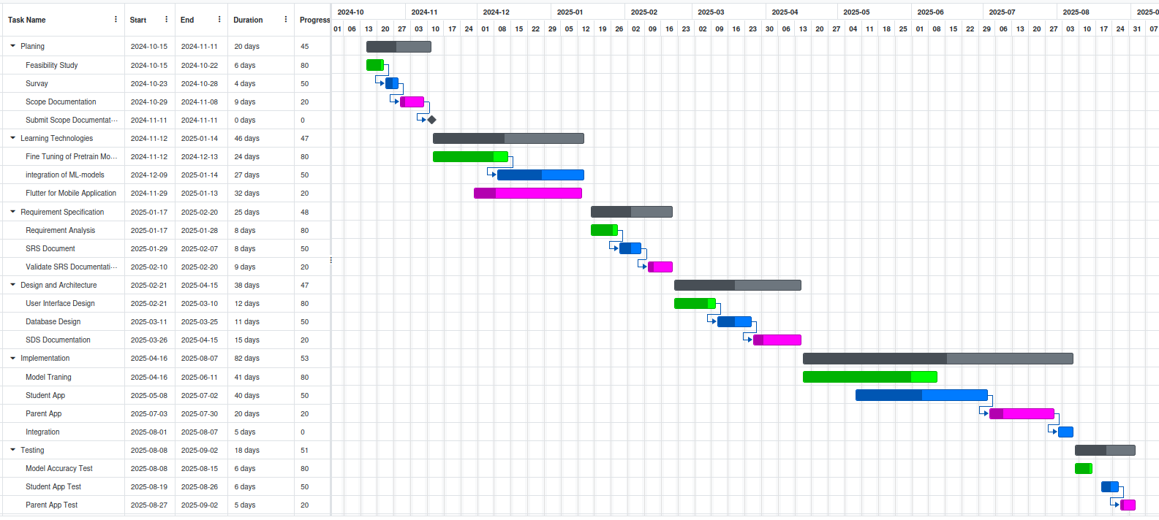

# 16. Mockups

## 16.1 Student App Mockup

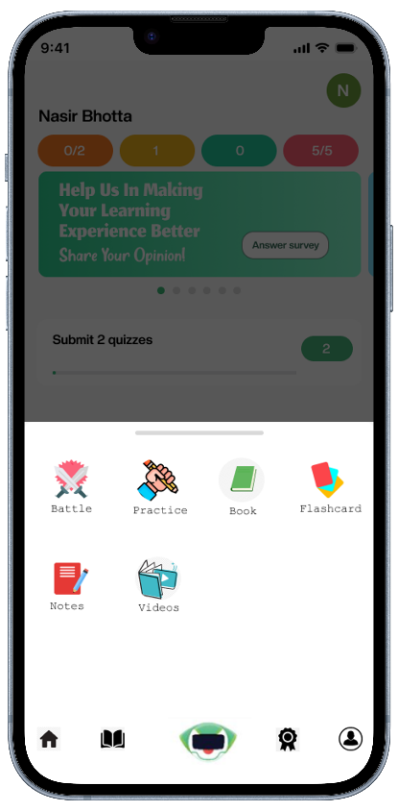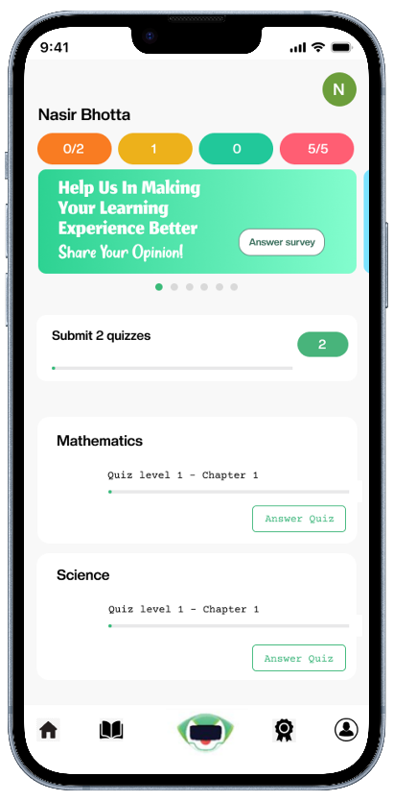

**Figure 1:** Student Dashboard screen **Figure 2:** Student learning interface

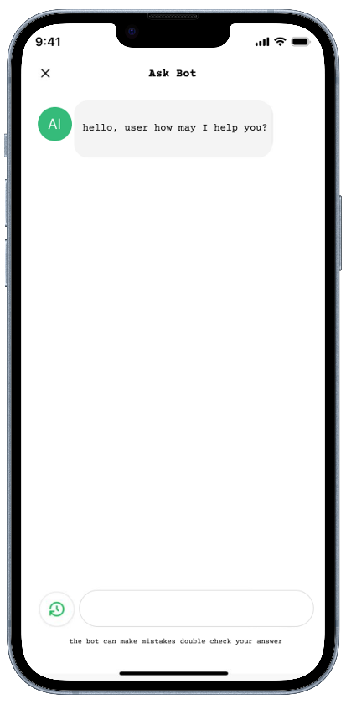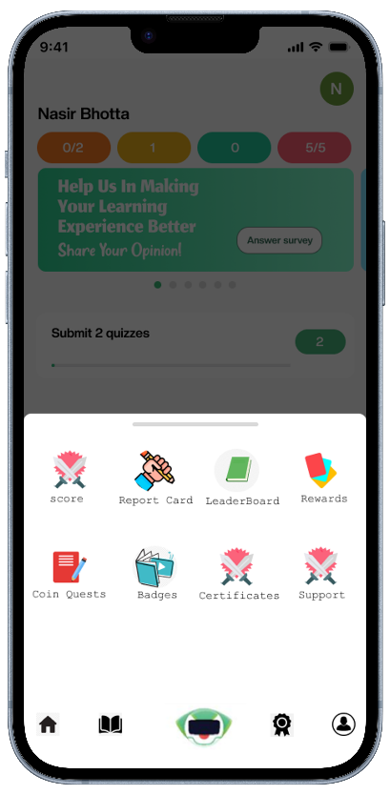

**Figure 3:** Student Achievements Center **Figure 4:** Ask PBOT interface

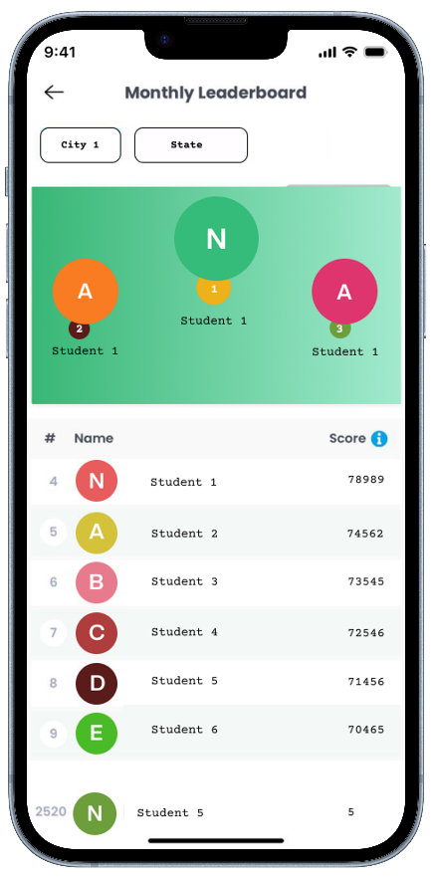

**Figure 5:** Student Battle Interface **Figure 6:** Student Leaderboard Interface

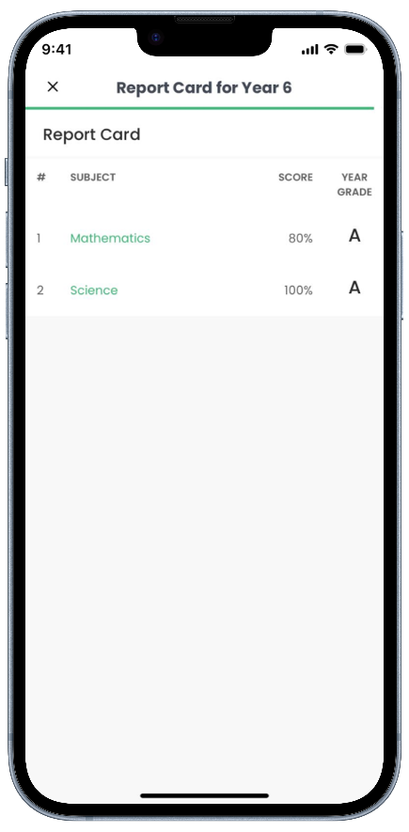

**Figure 7:** Student Report Card Interface

## 16.2 Parent App Mockup

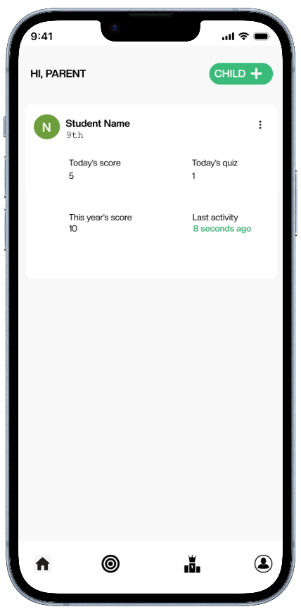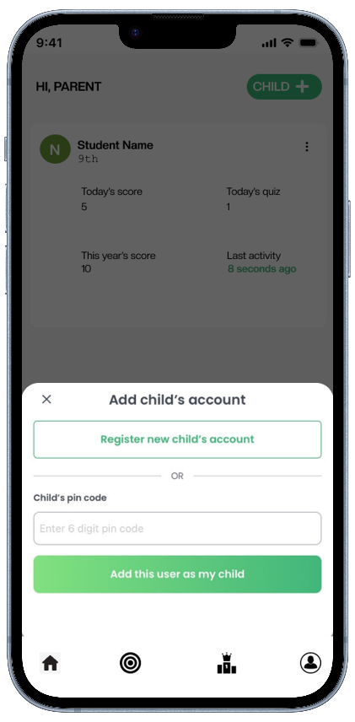

**Figure 8:** Parent Dashboard **Figure 9:** Add child Interface

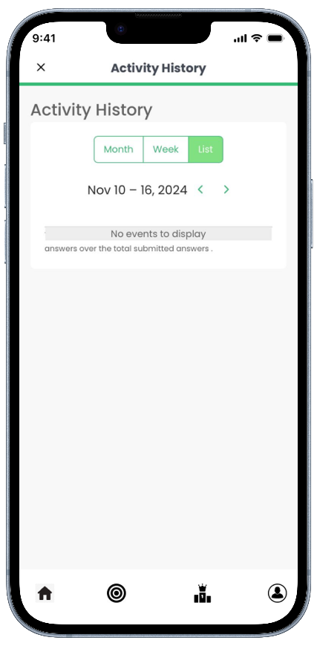

**Figure 10:** Child Activity History Interface

# 17. References

[1] M. Akhtar, Z. Andleeb, and S. Akhtar, “Problems of Education System in Pakistan: A Critical Analysis and Solution,” vol. 8, no. 2, Apr.–Jun. 2024.

[2] Pakistan Bureau of Statistics. “Pakistan Education Statistics 2021-22 Highlights.” Internet: <https://pie.gov.pk/SiteImage/Downloads/PES%20Highlights%202021-22%20New.pdf>, 2021 [Nov. 13, 2024].

[3] N. Tahir, “Education System in Pakistan: Lessons Learned and the Way Forward,” *The Pakistan Development Review*, vol. 48, no. 4, Part II, pp. 595–602, Winter 2009.

[4] International Journal of Academic Multidisciplinary Research. “The Use of Educational Applications on the Student’s Academic Performance.” IJAMR, vol. 5, no. 1, pp. 92-99, Jan. 2021.

[5] K. Demir and E. Akpinar. “The effect of mobile learning applications on students' academic achievement and attitudes toward mobile learning.” Malaysian Online Journal of Educational Technology, vol. 6, no. 2, 2018.

# 18. Plagiarism Report