
COMSATS University Islamabad (CUI)

Software Design Description
(SDS DOCUMENT)

for
BrainBee
Version 1.0
By
Nasir Shahzad CUI/SP22-BCS-077/ISB
Sohail Faiz Rasool CUI/SP22-BCS-095/ISB

Supervisor
Mr. Tanveer Ahmed

Bachelor of Science in Computer Science (2022-2026)

Table of Contents
1. Introduction 1
1.1 Modules 1
1.1.1 Student App 1
1.1.2 Parent App 2
1.1.3 Teacher App 2
2. Design Methodology and Software Process Model 2
2.1 Design Methodology 2
2.2 Software Process Model 3
3. System Overview 4
3.1 Functionality 4
3.2 Context 4
3.3 Design 4
3.4 Architectural Design 5
4. Design Models 8
4.1 Activity Diagrams 8
4.1.1 Activity Diagram for Module User Management 8
4.1.2 Activity Diagram for Module Peer Competition Module 9
4.1.3 Activity Diagram for Module Assessment Module 10
4.1.4 Activity Diagram for Module AI Powered Assistant Module 11
4.1.5 Activity Diagram for Module User Management 12
4.1.6 Activity Diagram for Module Monitor Children 12
4.1.7 Activity Diagram for Module Goals Module 14
4.1.8 Activity Diagram for Module User Management 15
4.1.9 Activity Diagram for Module Class Management 16
4.1.10 Activity Diagram for Module Assessment Module 17
4.2 Class Diagram 18
4.3 Sequence Diagrams 20
4.3.1 Module User Management 20
4.3.2 Module Peer Competition 21
4.3.3 Module Assessment 23
4.3.4 Module Performance Analytics 24
4.3.5 Module AI Powered Assistant 25
4.3.6 Module Monitor Children 26
4.3.7 Module Goal 27
4.3.8 Module User Management 28
4.3.9 Module Class Management 29
4.4 State Transition Diagrams 31
4.4.1 State Transition Diagram for Quiz Module 31
4.4.2 State Transition Diagram for Quiz Attempt 32
5. Data Design 33
5.1 Data Dictionary 33
5.2 Data Schema 42
5.2.1 User Schema (Base Schema) 42
5.2.2 Student Schema (Extends User) 42
5.2.3 Parent Schema (Extends User) 43
5.2.4 Teacher Schema (Extends User) 43
5.2.5 Quiz Schema 43
5.2.6 Battle Schema 44
5.2.7 FlashCard Schema 45
5.2.8 Assignment Schema 45
5.2.9 Reward Schema 45
5.2.10 Goal Schema 46
5.2.11 Report Card Schema 46
5.2.12 Chat History Schema 47
5.2.13 Class Schema 47
6. Human Interface Design 48
6.1 Screen Images 48
6.1.1 Student App 49
6.1.2 Parent and Teacher App: 67
6.2 Screen Objects and Actions 71
6.2.1 Login Screen: 71
6.2.2 Sign Up Screen: 71
6.2.3 Home/Dashboard Screen: 71
6.2.4 Battle Overview Screen: 71
6.2.5 Select Subject Screen (for Battle): 71
6.2.6 Select Chapters Screen: 71
6.2.7 Brain Battle Screen: 71
6.2.8 Battle Result Popup: 71
7. Implementation 73
7.1 Algorithms 73
7.1.1 Get Flashcards 73
7.1.2 Match Peer For Battle 74
7.1.3 Generate Quiz 74
7.1.4 Assign Goal 74
7.1.5 Enroll In Class 75
7.1.6 Calculate Progress 75
7.1.7 Check Rewards 76
7.1.8 Evaluate Quiz 76
7.1.9 Get Parent Dashboard 77
7.1.10 Generate AI Flashcards 77
7.1.11 Recommend Content 78
7.1.12 Match For Battle 78
7.1.13 Calculate Overall Score 79
7.1.14 Calculate Book-Wise Scores 79
7.1.15 Recommend Content (Hybrid) 80
7.1.16 Generate Explanation 80
7.1.17 Generate Summary 81
7.1.18 Check and Reward Goal 81
7.2 External APIs/SDKs 82
8. Testing and Evaluation 83
8.1 Unit testing: 83
8.2 Functional testing: 87
8.3 Business Rules Testing: 119
8.4 Integration Testing: 130

Revision History
Name | Date | Reason for changes | Version

Application Evaluation History

Comments (by committee)  *include the ones given at scope time both in doc and presentation | Action Taken
Animatios can be added to improve the learning process. | While we acknowledge that animations can enhance the learning experience, we have already defined a comprehensive and ambitious scope for our project, which includes multiple modules such as AI-generated flashcards, live classes, peer battles, performance tracking, and machine learning-based personalization. After thorough discussion with our supervisor, we collectively agreed to retain the current scope without additional features to ensure successful implementation, testing, and delivery within the available timeframe and resources. Expanding the scope at this stage may compromise the overall quality and stability of the system.

Supervised by
Supervisor’s Name
Signature____________

Introduction
The BrainBee project aims to develop a mobile-based, AI-powered learning platform tailored for Pakistani students in grades 5–12. The system is designed to address gaps in accessibility, engagement, and personalized support in the education sector by leveraging artificial intelligence and gamification. The goal is to make high-quality education affordable, engaging, and effective for students in urban and rural regions alike.

Modules
This subsection lists the modules of BrainBee, along with their functionalities.

Student App

User Management
Manages user registration, profile updates, account deletion, grade selection, subject preferences, and premium upgrades.

Peer Competition Module
Enables students to participate in AI-generated quiz battles, track performance, maintain battle history, and view leaderboard positions.

Learning Module
Provides AI-generated summaries and explanations, interactive chatbot support, and personalized flashcards.

Assessment Module
Generates personalized quizzes, enables quiz and assignment submission, provides instant feedback, and maintains report cards and leaderboard metrics.

Achievement and Rewards Module
Tracks and displays badges, certificates, redeemable coins, and coin quests to gamify the learning experience.

Performance Analytics Module
Offers detailed performance reports across books, report cards, and leaderboard standings over time.

AI Powered Assistant Module
Allows students to ask questions and receive AI-generated answers with chat history maintenance.

Parent App

User Management
Manages parent user accounts including registration, profile updates, and deletion.

Monitor Children
Allows parents to add/remove children, monitor performance, view leaderboard rankings, and receive reports and notifications.

Goals Module
Enables parents to set, track, and reward academic goals for their children.

Communication Module
Facilitates chat with teachers and feedback submission to admins.

Teacher App

User Management
Enables account management for teachers, including registration, profile updates, and deletion.

Class Management
Allows creation and management of classes, students, study material, assignments, and quizzes.

Assessment Module
Provides performance monitoring and insights through ML algorithms, auto-grading of assignments, and personalized learning path generation.

Design Methodology and Software Process Model
This section outlines the chosen design methodology and software process model for the BrainBee educational application.

Design Methodology
BrainBee employs Object-Oriented Programming (OOP) as its design methodology due to the modular and scalable nature of the application. OOP provides a structured way to represent complex real-world entities such as students, parents, teachers, quizzes, rewards, and performance analytics through classes and objects. This approach ensures high code reusability, maintainability, and extensibility, which is essential for a system that involves multiple interacting modules and diverse user types.
Encapsulation and abstraction enable developers to isolate features like assessments, goal tracking, and peer competition, making the application more manageable and easier to debug. OOP's use of inheritance and polymorphism also supports future feature expansions without major codebase refactoring. This design methodology aligns well with BrainBee’s goal of building a flexible and robust platform that supports continuous improvement and evolving educational needs.

Software Process Model
BrainBee follows the Agile Software Development process model due to its iterative, collaborative, and adaptive nature. Agile is particularly well-suited for BrainBee because the project involves AI integration, dynamic feedback from students, teachers, and parents, and frequent improvements based on user behavior and evolving academic needs.
Agile allows the development team to work in sprints, delivering incremental updates with fully functional modules such as the Student Quiz Module, AI Chatbot, or Parent Monitoring Dashboard. Regular feedback from stakeholders ensures that any required changes are identified early and implemented quickly. This reduces risk, enhances product quality, and improves alignment with end-user expectations. Agile’s emphasis on working software, adaptability, and close collaboration makes it ideal for an education-focused application aiming for continuous improvement and user engagement.
This figure illustrates the agile development process model and its stages.
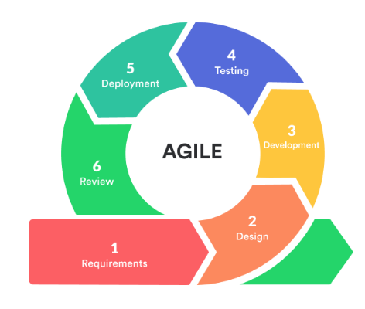
Figure 1 Agile Development Model

System Overview
This section provides a high-level summary of the overall system architecture and functionalities of BrainBee.

Functionality
BrainBee is an AI-powered mobile educational platform designed to enhance academic learning for students in grades 5 to 12 across Pakistan. It offers features such as user management for students, parents, and teachers; personalized learning content; AI-generated quizzes and explanations; gamified peer competition; performance analytics; and a reward system. The platform also provides tools for parental monitoring, goal setting, and teacher-based class and assignment management. Real-time feedback and AI tutoring ensure a customized, engaging, and efficient learning experience. The system promotes academic success through individualized learning paths, gamification, and collaborative support among users.

Context
Operating within the educational ecosystem of Pakistan, BrainBee addresses key challenges such as the lack of personalized instruction, rote learning, absence of student motivation, and limited parental and teacher engagement. The platform integrates artificial intelligence to personalize study material and assessments while encouraging healthy competition and progress tracking. By supporting students, parents, and teachers, BrainBee bridges the educational gap between urban elite and under-resourced communities, especially in Punjab. It aims to make quality education accessible, affordable, and interactive through AI and mobile technology.

Design
BrainBee utilizes a multi-tiered architecture that separates the system into distinct layers:
- Presentation Layer for user interfaces across mobile apps (Flutter-based)
- Business Logic Layer for managing core functionalities such as quizzes, performance tracking, and reward systems
- Data Access Layer for interacting with the MongoDB database securely
This design promotes modularity, reusability, and scalability, allowing different modules (e.g., student assessments, parent goals, teacher analytics) to work independently yet cohesively. RESTful APIs connect the layers to ensure seamless communication across different system components and user apps. The AI components are integrated through Python-based machine learning models that assist in generating personalized content, performance predictions, and quiz recommendations.

Architectural Design
BrainBee is designed with a modular architecture to support maintainability, extensibility, and integration of new features. The system is divided into key modules:
- User Management: Handles registration, profile management, and user type switching
- Assessment Module: Manages AI-generated quizzes, assignments, feedback, and report cards
- Learning Module: Provides summaries, flashcards, and AI chatbot explanations
- Peer Competition Module: Enables quiz battles, leaderboard tracking, and win/loss history
- Performance Analytics: Tracks detailed academic data and AI-based progress insights
- Parent & Teacher Modules: Allow monitoring, goal setting, and personalized teaching interventions
- Reward Module: Handles badges, coins, certificates, and redemption tracking
This modular approach ensures that updates or changes in one part of the system do not affect others. The multi-tiered architectural style supports separation of concerns and eases testing, deployment, and scaling.

This figure illustrates the architecture style diagram showing the multi-tiered pattern that is followed by the BrainBee system.

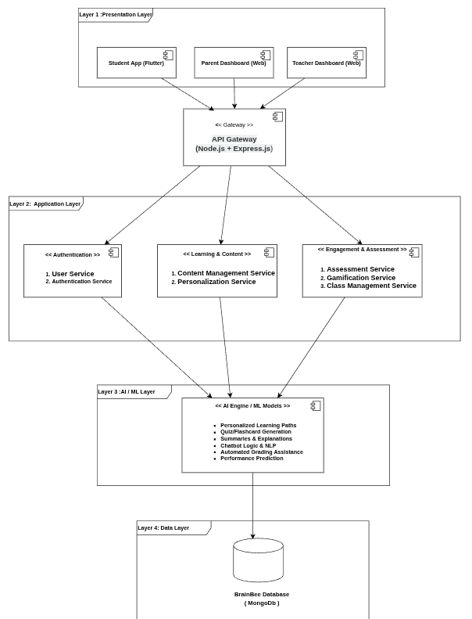

Figure 2 Architectural Style Diagram for BrainBee
This figure illustrates the box and line diagram to represent the BrainBee system.

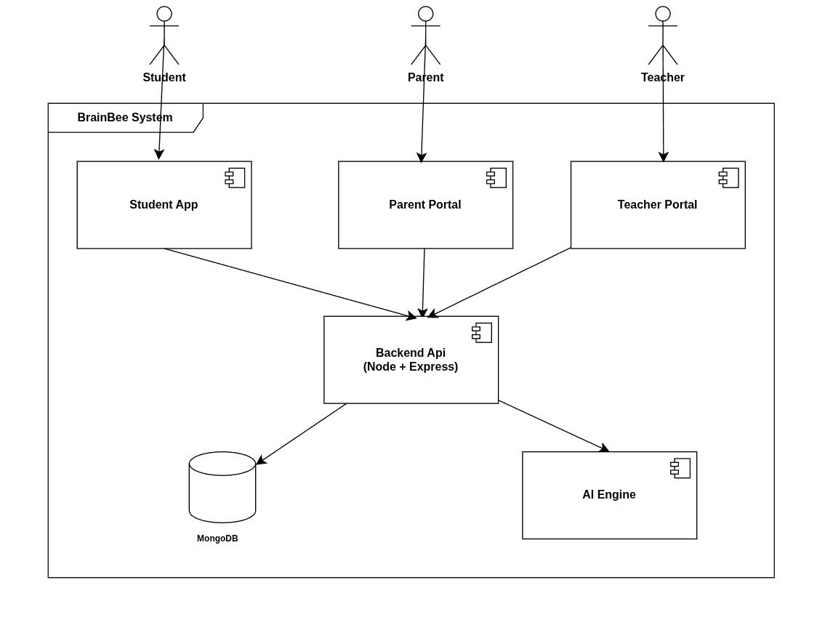
Figure 3 Box and Line Diagram for BrainBee

Design Models
This section details the design methodologies and models used to structure and implement the BrainBee system.

Activity Diagrams
This subsection presents activity diagrams illustrating the workflow of key processes within BrainBee

Activity Diagram for Module User Management

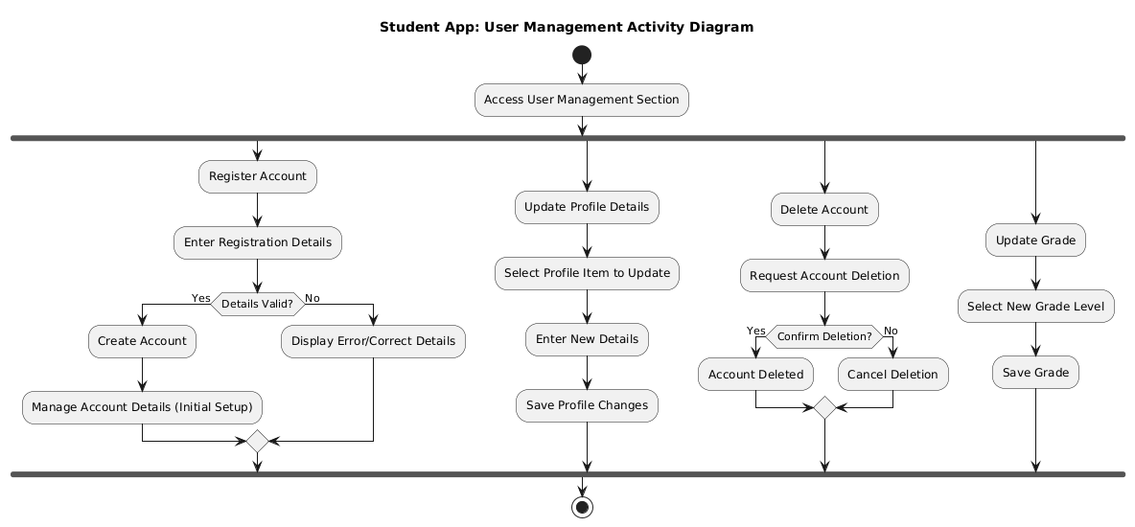
This figure illustrates the activity diagram detailing the flow of operations involved in the User Management module.

Figure 4 Activity Diagram for User Management

Activity Diagram for Module Peer Competition Module
This figure illustrates the activity diagram detailing the flow of operations involved in the Peer Competition Module
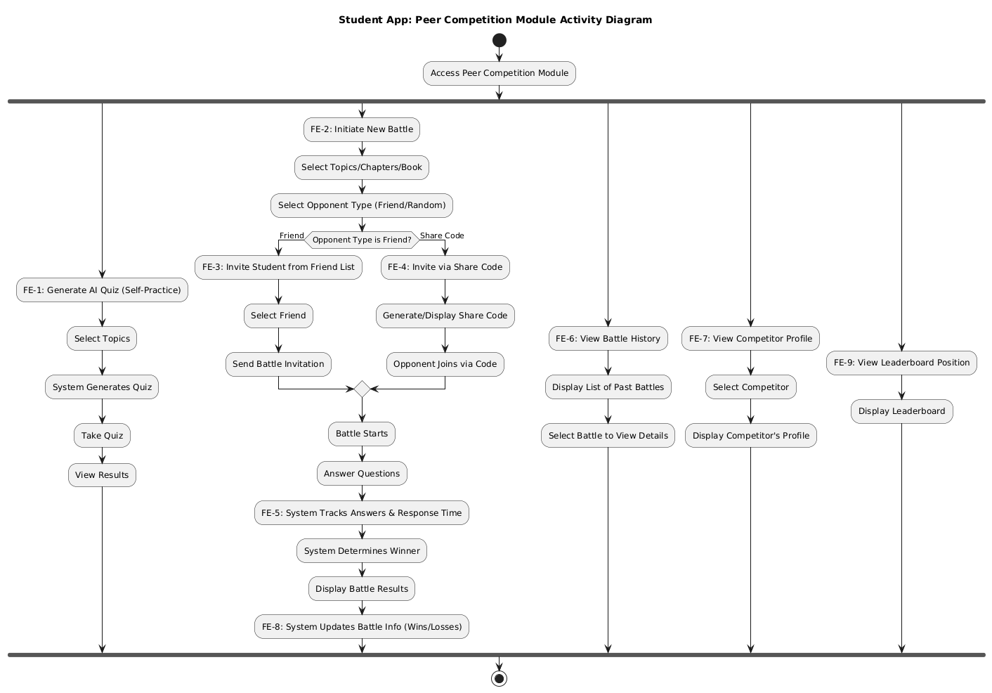
Figure 5 Activity Diagram for Peer Competition

Activity Diagram for Module Assessment Module

This figure illustrates the activity diagram detailing the flow of operations involved in the Assessment Module

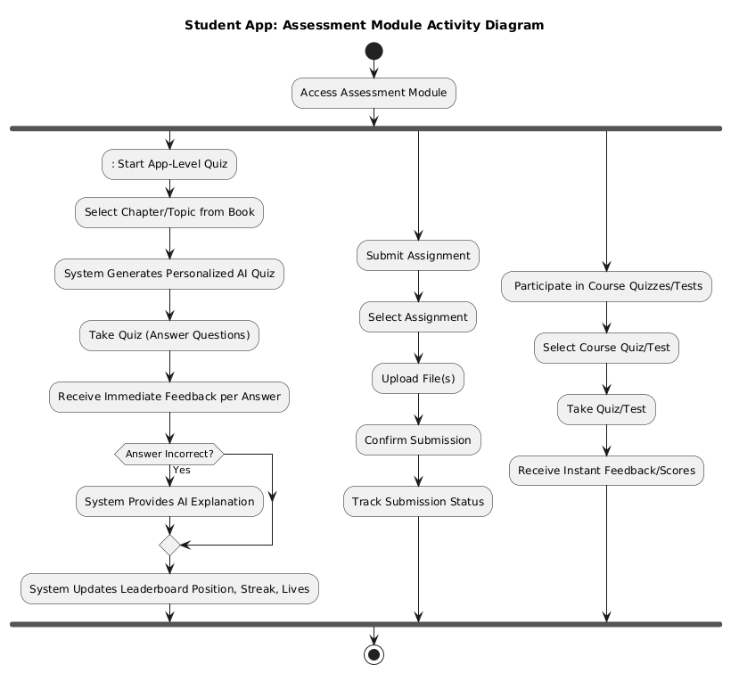
Figure 6 Activity Diagram for Assessment Module

Activity Diagram for Module AI Powered Assistant Module

This figure illustrates the activity diagram detailing the flow of operations involved in the AI Powered Assistant Module
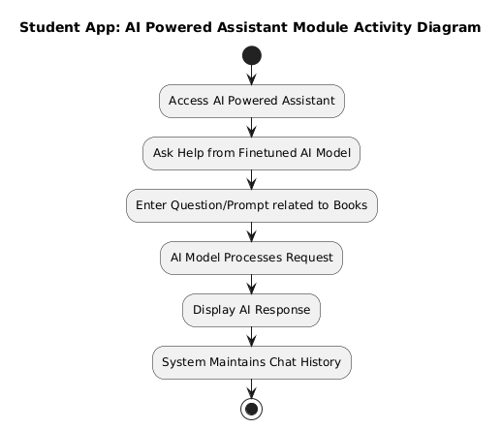
Figure 7 Activity Diagram for AI Powered Assistant Module

Activity Diagram for Module User Management
This figure illustrates the activity diagram detailing the flow of operations involved in the User Management module.

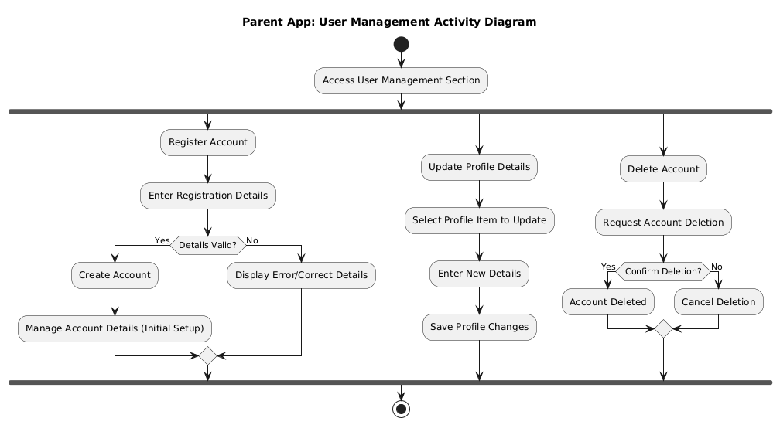

Figure 8 Activity Diagram for User Management

Activity Diagram for Module Monitor Children
This figure illustrates the activity diagram detailing the flow of operations involved in the Monitor Children

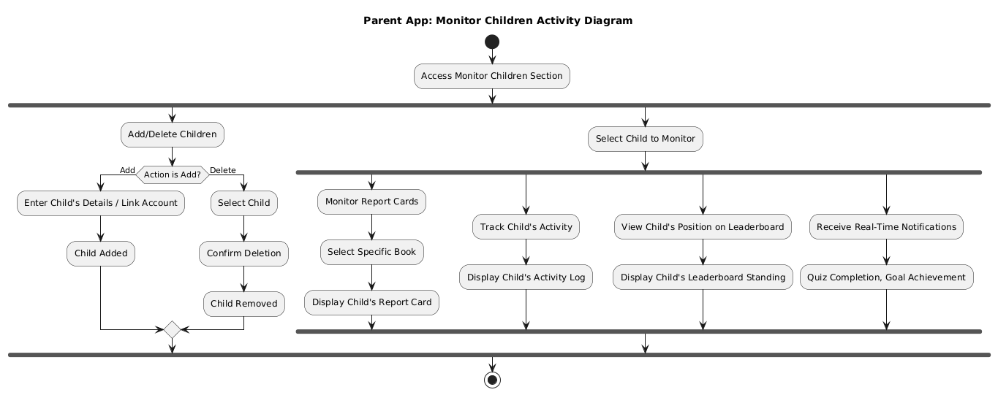

Figure 9 Activity Diagram for Monitor Children

Activity Diagram for Module Goals Module
This figure illustrates the activity diagram detailing the flow of operations involved in the Goals Module

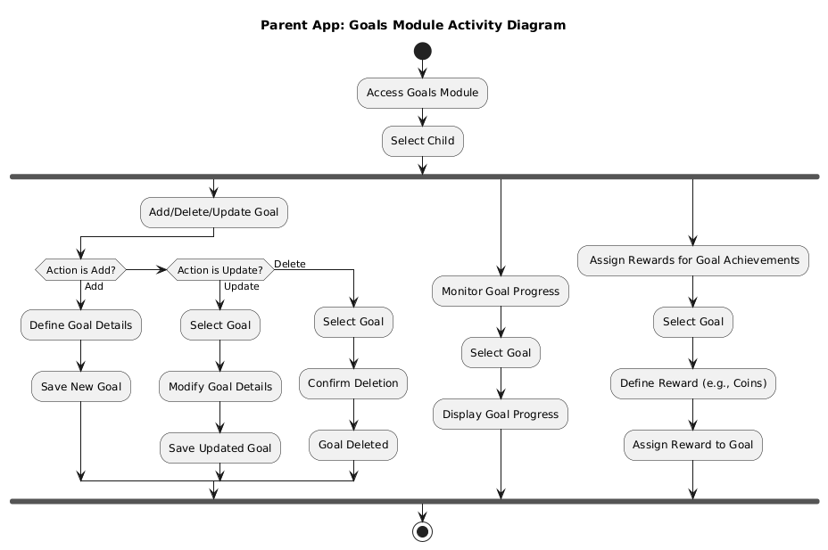

Figure 10 Activity Diagram for Goals Module

Activity Diagram for Module User Management

This figure illustrates the activity diagram detailing the flow of operations involved in the User Management module.
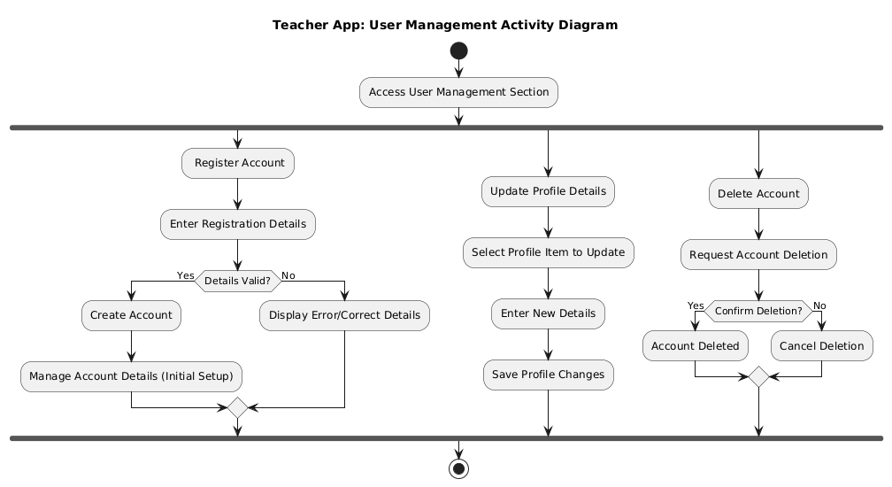
Figure 11 Activity Diagram for User Management

Activity Diagram for Module Class Management

This figure illustrates the activity diagram detailing the flow of operations involved in the Class Management

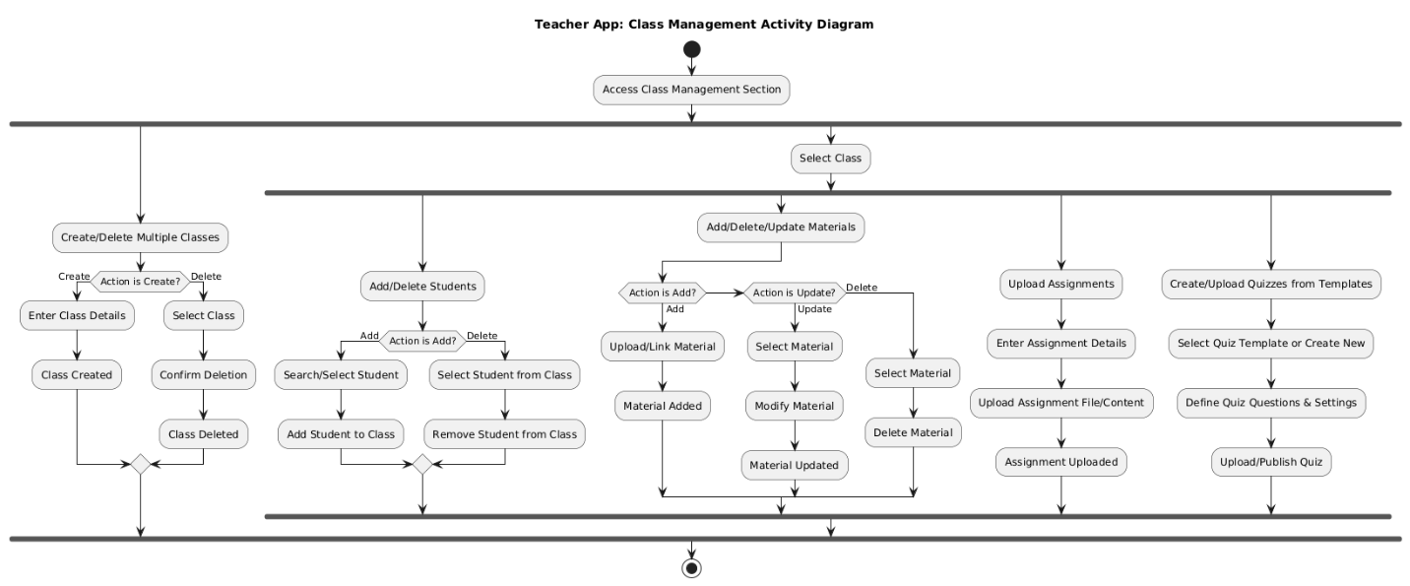
Figure 12 Activity Diagram for Class Management

Activity Diagram for Module Assessment Module

This figure illustrates the activity diagram detailing the flow of operations involved in the Assessment Module


Figure 13 Activity Diagram for Assessment Module

Class Diagram
This figure shows the class diagram representing the structure of the BrainBee system, illustrating the various classes, their attributes, methods, and relationships.
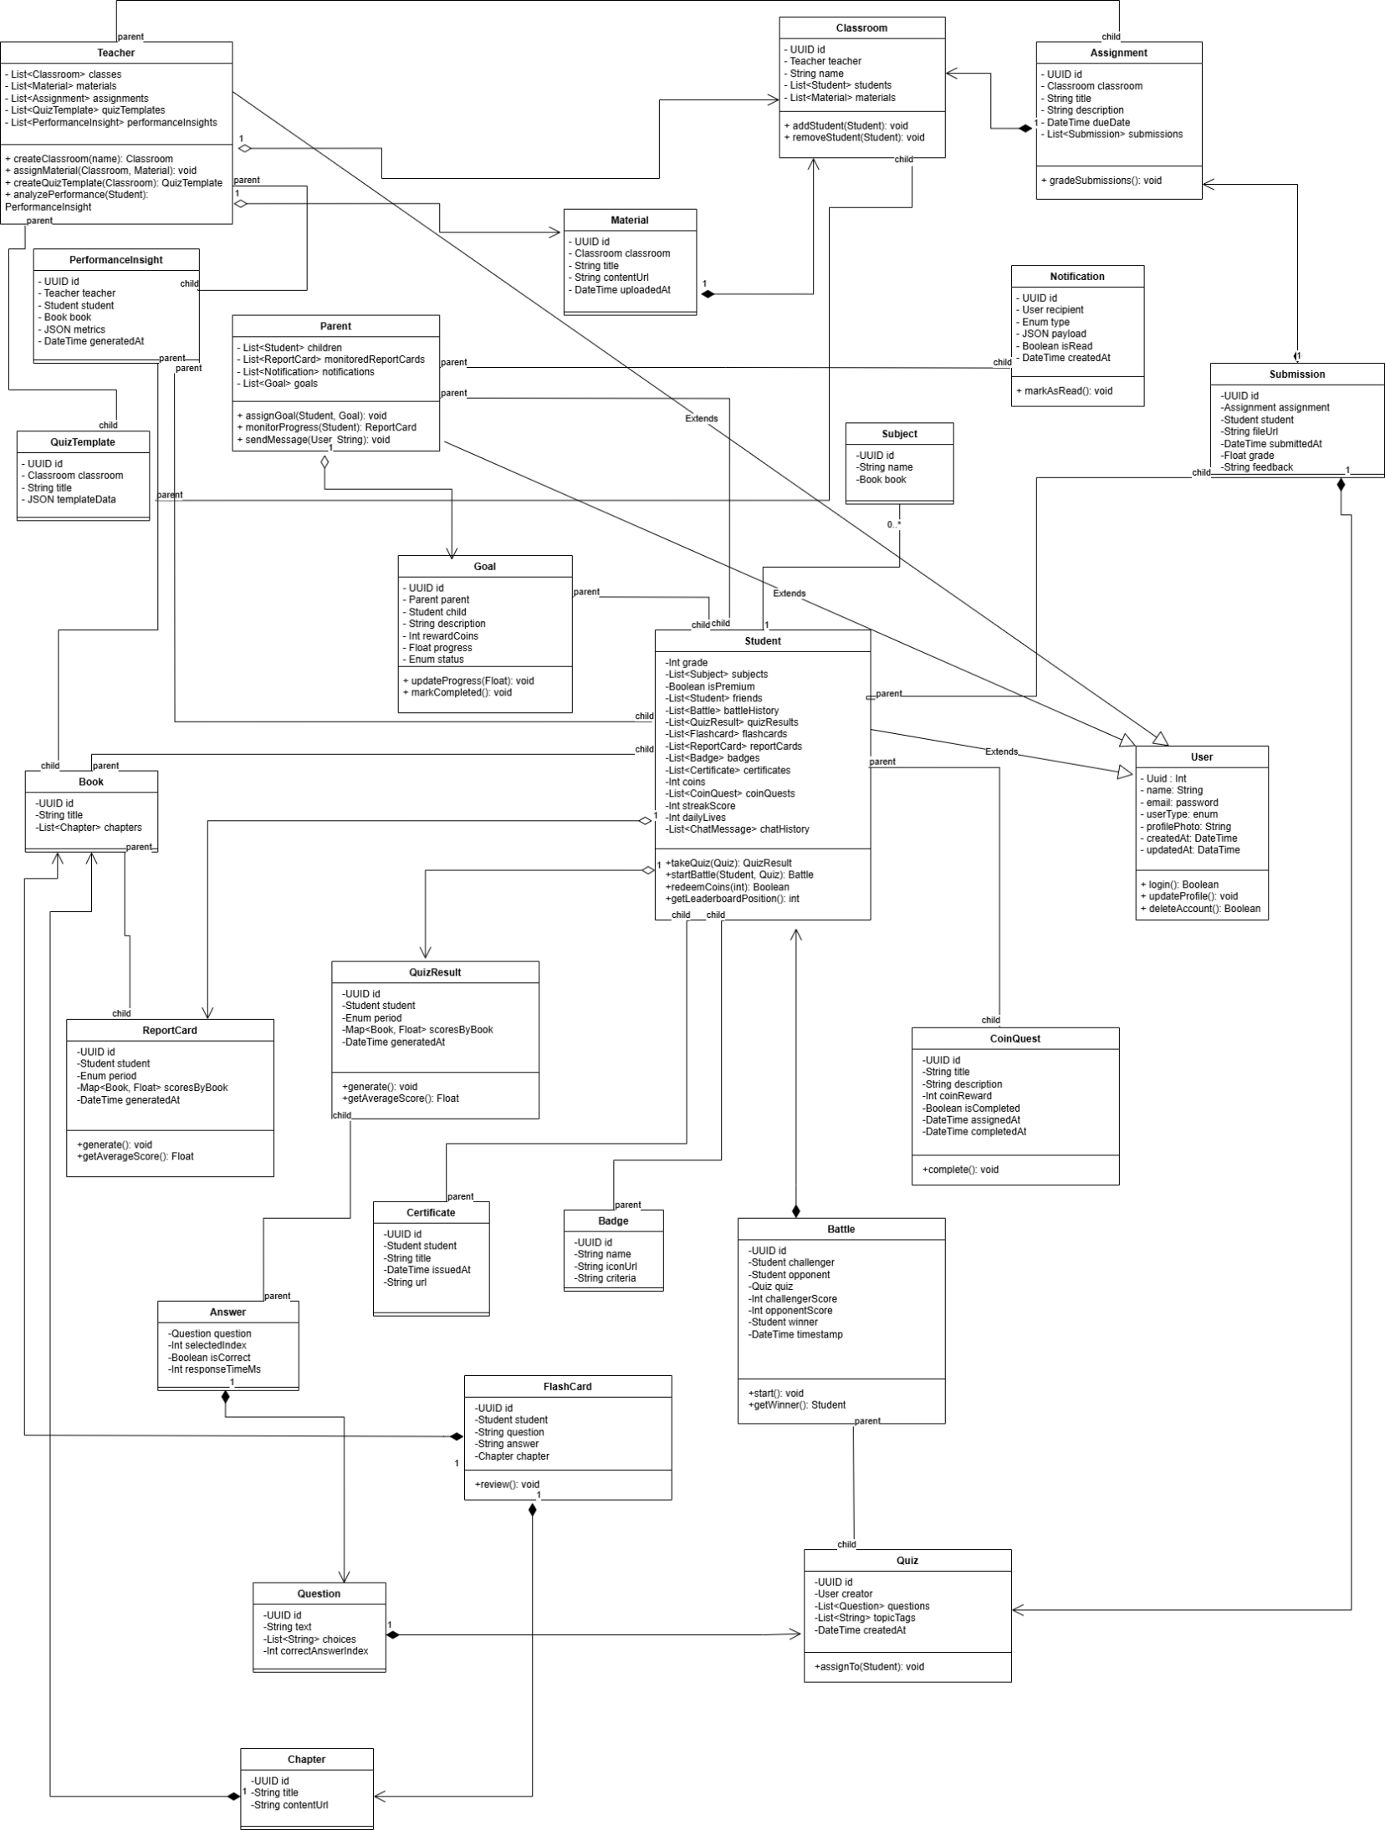

Sequence Diagrams
This subsection presents sequence diagrams depicting the sequence of interactions and messages exchanged between objects within BrainBee system during key processes.

Module User Management
This figure shows the sequence diagram for User Management module.

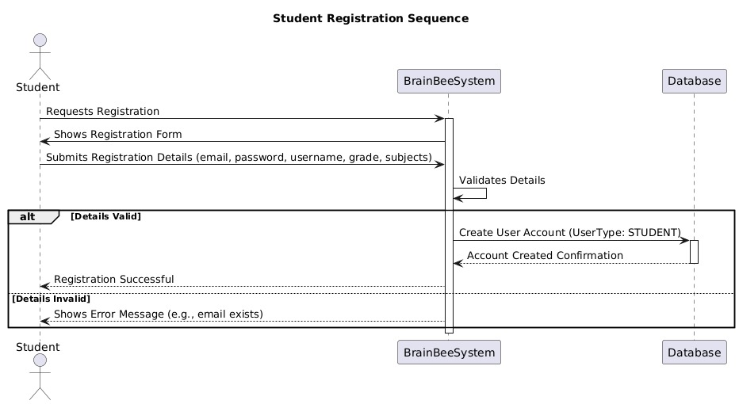
Figure 14 Sequence Diagram for User Management

Module Peer Competition
This figure shows the sequence diagram for Peer Competition Module

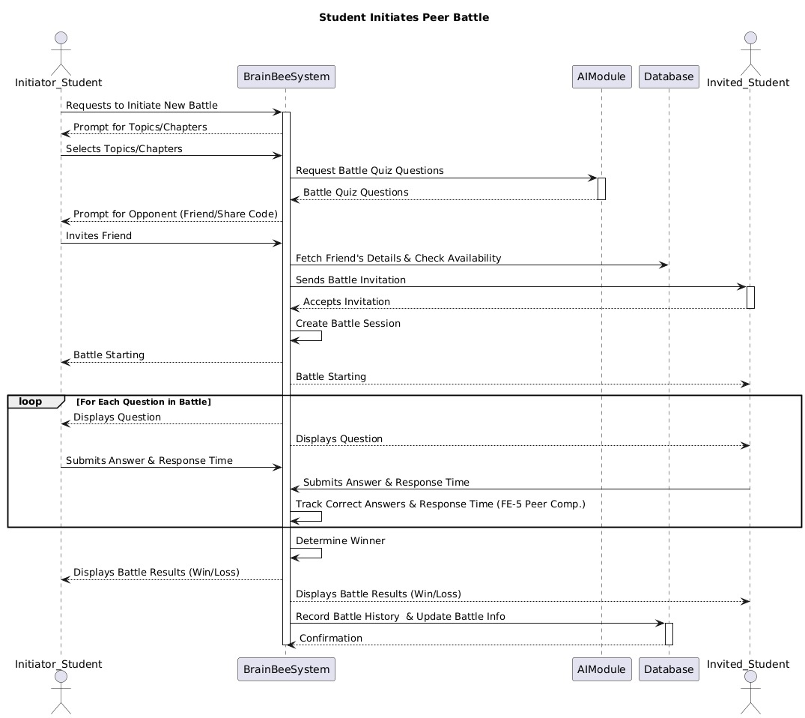
Figure 15 Sequence Diagram for Peer Competition Module

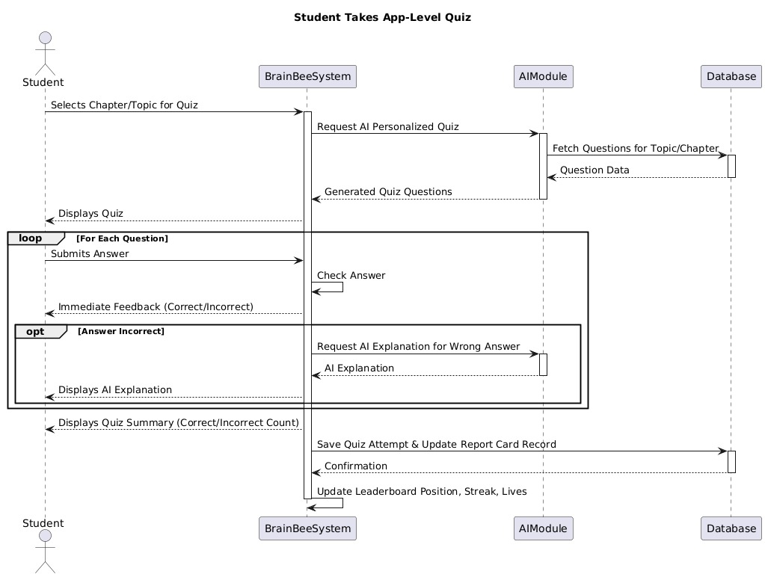
Figure 16 Sequence Diagram for Quiz

Module Assessment
This figure shows the sequence diagram for Assessment Module

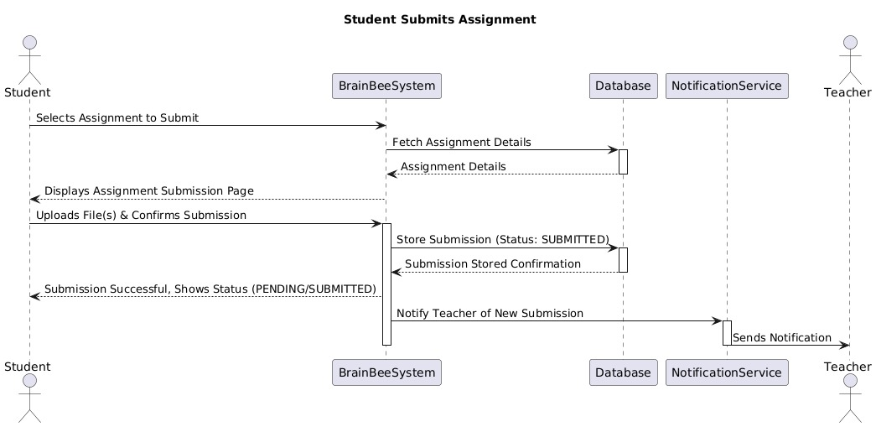
Figure 17 Sequence Diagram for Assessment Module

Module Performance Analytics
This figure shows the sequence diagram for erformance Analytics Module

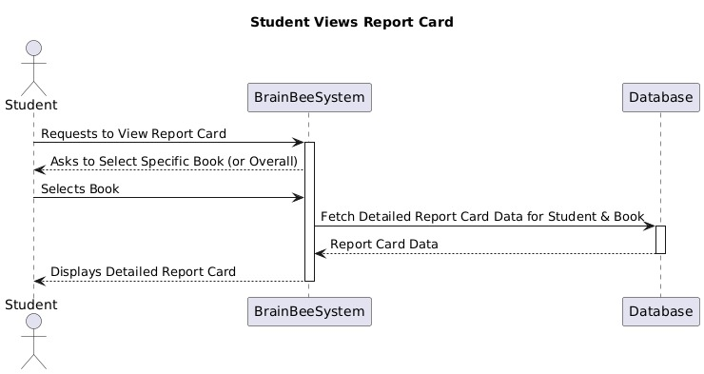
Figure 18 Sequence Diagram for Performance Analytics

Module AI Powered Assistant
This figure shows the sequence diagram for AI Powered Assistant Module

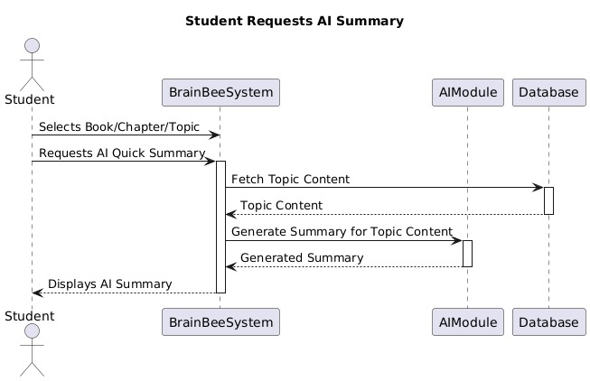
Figure 19 Sequence Diagram for AI Powered Assistant

Module Monitor Children
This figure shows the sequence diagram for Monitor Children

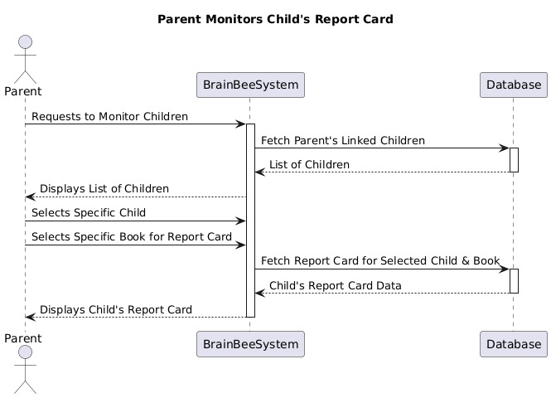
Figure 20 Sequence Diagram for Monitor Children

Module Goal
This figure shows the sequence diagram for Goals Module

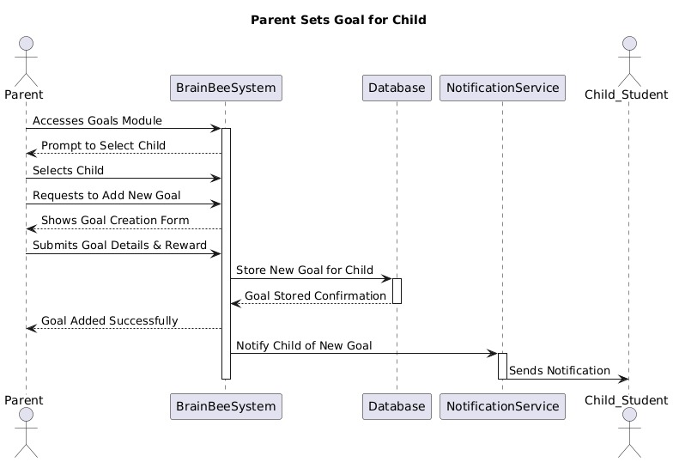
Figure 21 Sequence Diagram for Goals Module

Module User Management

This figure shows the sequence diagram for User Management module.

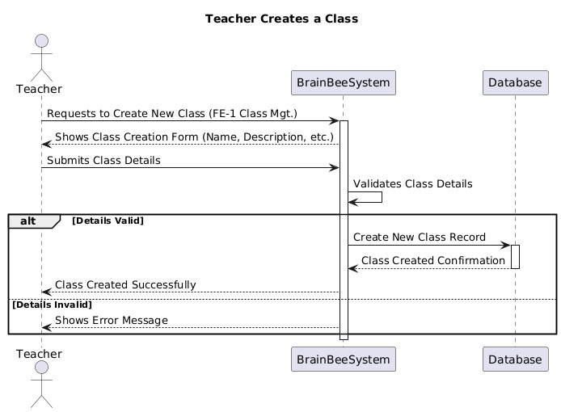
Figure 22 Sequence Diagram for User Management

Module Class Management
This figure shows the sequence diagram for Class Management

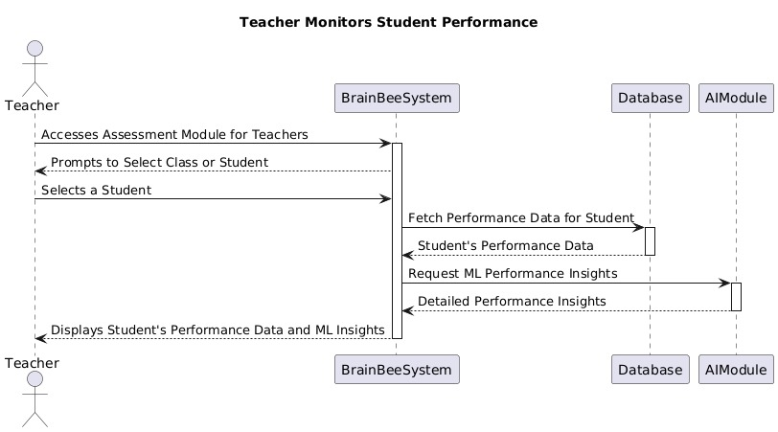
Figure 23 Sequence Diagram for Monitor Student Performance

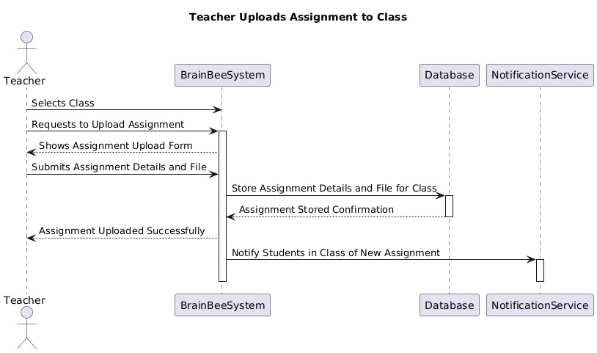
Figure 24 Sequence Diagram for Teacher Uploads assignment

State Transition Diagrams
The State Transition diagrams for our system BrainBee are described here.

State Transition Diagram for Quiz Module
This figure shows the state transition diagram for Quiz Module

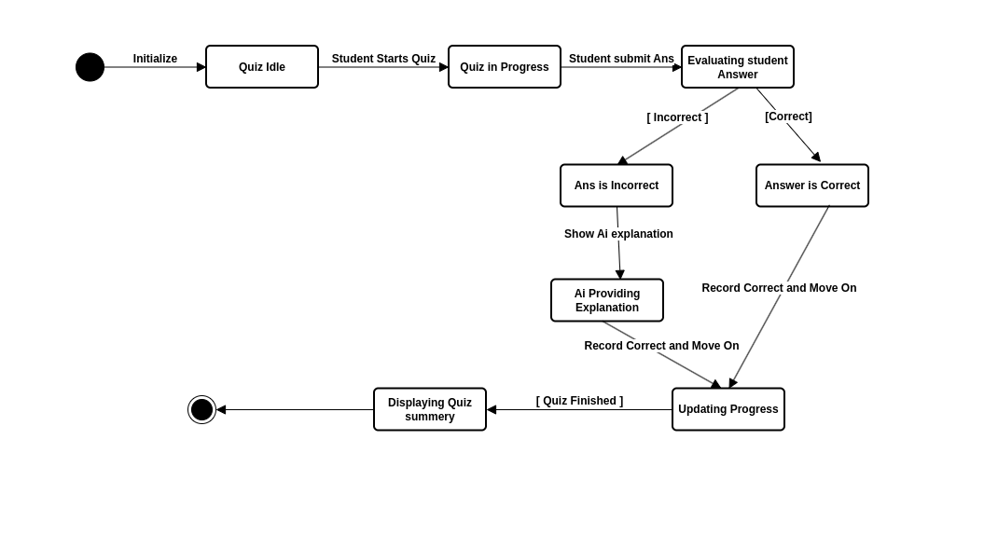
Figure 25 State Transition Diagram for Quiz

State Transition Diagram for Quiz Attempt
This figure shows the state transition diagram for Quiz Attempt

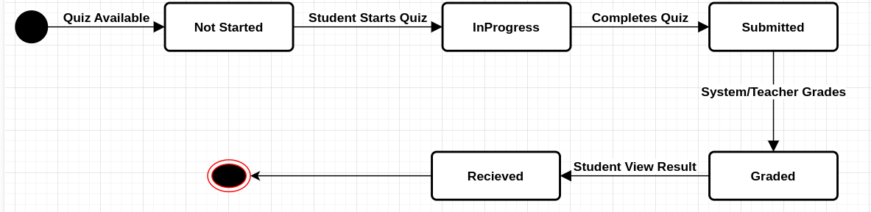
Figure 26 State Transition Diagram for Quiz Attempt

Data Design
This section outlines the structure and organization of the data used in BrainBee, detailing the schema, data models, and relationships essential for efficient data management and retrieval.

Data Dictionary
These tables show the data dictionary used in the BrainBee system.

User (Common Base for Student, Parent, Teacher):
Attribute | Type | Description
id | UUID | Unique user identifier
name | String | Full name of the user
email | String | Registered email address
passwordHash | String | Hashed password
userType | Enum | STUDENT, PARENT, or TEACHER
profilePhotoUrl | String? | URL to profile image
createdAt | DateTime | Account creation timestamp
updatedAt | DateTime | Last account update timestamp

Student (extends User):
Attribute | Type | Description
grade | Int | Grade level of the student
subjects | List | Subjects enrolled
isPremium | Boolean | Premium membership status
friends | List | Friends list
battleHistory | List | History of quiz battles
quizResults | List | Quiz attempt records
flashcards | List | Flashcards created by the student
reportCards | List | Academic report cards
badges | List | Earned badges
certificates | List | Awarded certificates
coins | Int | Current coin balance
coinQuests | List | Active and completed coin quests
streakScore | Int | Streak count for daily activity
dailyLives | Int | Remaining lives for daily quizzes
chatHistory | List | Chat history

Parent (extends User):
Attribute | Type | Description
children | List | Associated child accounts
Monitored  -ReportCards | List | Report cards being monitored
notifications | List | Received notifications
goals | List | Goals set for children

Teacher (extends User):
Attribute | Type | Description
classes | List | Assigned classes
materials | List | Teaching materials
assignments | List | Given assignments
quizTemplates | List | Quiz templates created
performanceInsights | List | Performance analytics

Subject:
Attribute | Type | Description
id | UUID | Unique subject ID
name | String | Name of the subject
book | Book | Associated book

Book:
Attribute | Type | Description
id | UUID | Unique book ID
title | String | Title of the book
chapters | List | Chapters in the book

Chapter:
Attribute | Type | Description
id | UUID | Unique chapter ID
title | String | Title of the chapter
contentUrl | String | URL to content

Quiz:
Attribute | Type | Description
id | UUID | Unique quiz ID
creator | User? | Creator of the quiz (or AI)
questions | List | List of questions
topicTags | List | Related topics
createdAt | DateTime | Quiz creation date

Question:
Attribute | Type | Description
id | UUID | Unique question ID
text | String | Question text
choices | List | Answer options
correctAnswerIndex | Int | Index of correct choice

QuizResult:
Attribute | Type | Description
id | UUID | Unique result ID
student | Student | Student who took the quiz
quiz | Quiz | Quiz taken
answers | List | Student answers
correctCount | Int | Number of correct answers
incorrectCount | Int | Number of incorrect answers
timestamp | DateTime | When the quiz was taken

Answer:
Attribute | Type | Description
question | Question | Associated question
selectedIndex | Int | Selected answer index
isCorrect | Boolean | Whether the answer was correct
responseTimeMs | Int | Time taken to answer (ms)

Battle:
Attribute | Type | Description
id | UUID | Unique battle ID
challenger | Student | Initiating student
opponent | Student | Opponent student
quiz | Quiz | Quiz used for battle
challengerScore | Int | Score of challenger
opponentScore | Int | Score of opponent
winner | Student? | Winner of the battle
timestamp | DateTime | Battle timestamp

ReportCard:
Attribute | Type | Description
id | UUID | Unique report card ID
student | Student | Associated student
period | Enum | WEEKLY, MONTHLY, or YEARLY
scoresByBook | Map<Book, Float> | Performance by book
generatedAt | DateTime | Date of report generation

Flashcard:
Attribute | Type | Description
id | UUID | Unique flashcard ID
student | Student | Owner of the flashcard
question | String | Flashcard question
answer | String | Flashcard answer
chapter | Chapter | Linked chapter

ChatMessage:
Attribute | Type | Description
id | UUID | Unique message ID
sender | User | Message sender
recipient | User | AIModel | Message recipient
content | String | Message content
timestamp | DateTime | Time of sending

CoinQuest:
Attribute | Type | Description
id | UUID | Unique quest ID
title | String | Quest title
description | String | Quest description
coinReward | Int | Coins awarded
isCompleted | Boolean | Completion status
assignedAt | DateTime | Assignment date
completedAt | DateTime? | Completion date

Badge:
Attribute | Type | Description
id | UUID | Unique badge ID
name | String | Name of the badge
iconUrl | String | Badge icon URL
criteria | String | Criteria to earn the badge

Certificate:
Attribute | Type | Description
id | UUID | Unique certificate ID
student | Student | Certificate holder
title | String | Certificate title
issuedAt | DateTime | Issue date
url | String? | Optional certificate link

Notification:
Attribute | Type | Description
id | UUID | Unique notification ID
recipient | User | Notification recipient
type | Enum | QUIZ_COMPLETED, GOAL_PROGRESS, etc.
payload | JSON | Additional data
isRead | Boolean | Read status
createdAt | DateTime | Notification timestamp

Goal:
Attribute | Type | Description
id | UUID | Unique goal ID
parent | Parent | Goal setter
child | Student | Goal target
description | String | Goal description
rewardCoins | Int | Reward coins
progress | Float | Progress (0.0–1.0)
status | Enum | PENDING or COMPLETED

Classroom:
Attribute | Type | Description
id | UUID | Unique classroom ID
teacher | Teacher | Class teacher
name | String | Class name
students | List | Enrolled students
materials | List | Teaching materials

Material:
Attribute | Type | Description
id | UUID | Unique material ID
classroom | Classroom | Related classroom
title | String | Material title
contentUrl | String | Content file URL
uploadedAt | DateTime | Upload time

Assignment:
Attribute | Type | Description
id | UUID | Unique assignment ID
classroom | Classroom | Related class
title | String | Assignment title
description | String | Details about the assignment
dueDate | DateTime | Submission deadline
submissions | List | Student submissions

Submission:
Attribute | Type | Description
id | UUID | Unique submission ID
assignment | Assignment | Related assignment
student | Student | Student who submitted
fileUrl | String | File link
submittedAt | DateTime | Time of submission
grade | Float? | Assigned grade
feedback | String? | Teacher's feedback

QuizTemplate:
Attribute | Type | Description
id | UUID | Unique template ID
classroom | Classroom | Linked classroom
title | String | Template name
templateData | JSON | Quiz blueprint

PerformanceInsight:
Attribute | Type | Description
id | UUID | Unique insight ID
teacher | Teacher | Associated teacher
student | Student | Student being analyzed
book | Book | Targeted book
metrics | JSON | Metrics like difficulty and timing
generatedAt | DateTime | Timestamp of generation

Data Schema

User Schema (Base Schema)
const UserSchema = new mongoose.Schema({
userID: { type: String, unique: true, required: true },
fullName: String,
email: { type: String, unique: true, required: true },
phoneNumber: String,
passwordHash: String,
role: { type: String, enum: ['Student', 'Parent', 'Teacher'], required: true },
accountType: { type: String, enum: ['Standard', 'Premium'], default: 'Standard' },
profilePicture: String,
registrationDate: { type: Date, default: Date.now },
isActive: { type: Boolean, default: true }
});

Student Schema (Extends User)
const StudentSchema = new mongoose.Schema({
userID: { type: String, ref: 'User' },
gradeLevel: String,
enrolledSubjects: [String],
quizHistory: [{ type: mongoose.Schema.Types.ObjectId, ref: 'Quiz' }],
leaderboardRank: Number,
streakScore: Number
});

Parent Schema (Extends User)
const ParentSchema = new mongoose.Schema({
userID: { type: String, ref: 'User' },
childrenIDs: [{ type: String, ref: 'Student' }],
notifications: [String]
});

Teacher Schema (Extends User)

const TeacherSchema = new mongoose.Schema({
userID: { type: String, ref: 'User' },
classIDs: [{ type: mongoose.Schema.Types.ObjectId, ref: 'Class' }],
assignedQuizzes: [{ type: mongoose.Schema.Types.ObjectId, ref: 'Quiz' }],
uploadedMaterials: [String]
});

Quiz Schema
const QuizSchema = new mongoose.Schema({
quizID: { type: String, unique: true },
createdBy: String,
subject: String,
topic: String,
questions: [
{
questionText: String,
options: [String],
correctAnswer: String
}
],
generatedByAI: { type: Boolean, default: true },
attemptHistory: [{ studentID: String, score: Number, attemptedAt: Date }],
dateCreated: { type: Date, default: Date.now }
});

Battle Schema
const BattleSchema = new mongoose.Schema({
battleID: { type: String, unique: true },
challengerID: String,
opponentID: String,
quizData: { type: Object }, // Could embed quiz structure
winnerID: String,
battleDate: Date,
durationSeconds: Number,
winLossRecord: {
[String]: { type: String, enum: ['Win', 'Loss', 'Draw'] }
}
});

FlashCard Schema
const FlashCardSchema = new mongoose.Schema({
cardID: { type: String, unique: true },
studentID: String,
subject: String,
topic: String,
content: String,
createdAt: { type: Date, default: Date.now }
});

Assignment Schema
const AssignmentSchema = new mongoose.Schema({
assignmentID: { type: String, unique: true },
classID: String,
uploadedBy: String,
description: String,
deadline: Date,
submissions: [{
studentID: String,
fileURL: String,
status: { type: String, enum: ['Pending', 'Submitted', 'Graded'] }
}]
});

Reward Schema
const RewardSchema = new mongoose.Schema({
rewardID: { type: String, unique: true },
type: { type: String, enum: ['Badge', 'Certificate', 'CoinQuest'] },
name: String,
awardedTo: String,
awardedBy: String,
dateAwarded: { type: Date, default: Date.now },
coinValue: Number
});

Goal Schema
const GoalSchema = new mongoose.Schema({
goalID: { type: String, unique: true },
parentID: String,
studentID: String,
description: String,
status: { type: String, enum: ['Pending', 'Completed', 'Failed'], default: 'Pending' },
rewardCoins: Number,
dueDate: Date
});

Report Card Schema
const ReportCardSchema = new mongoose.Schema({
reportCardID: { type: String, unique: true },
studentID: String,
bookName: String,
score: Number,
weakAreas: [String],
evaluationDate: { type: Date, default: Date.now }
});

Chat History Schema
const ChatHistorySchema = new mongoose.Schema({
chatID: { type: String, unique: true },
studentID: String,
topic: String,
messages: [{
sender: { type: String, enum: ['student', 'AI'] },
text: String,
timestamp: { type: Date, default: Date.now }
}],
createdAt: { type: Date, default: Date.now }
});

Class Schema
const ClassSchema = new mongoose.Schema({
classID: { type: String, unique: true },
teacherID: String,
className: String,
studentList: [{ type: String, ref: 'Student' }],
materials: [{
title: String,
fileURL: String,
uploadedAt: Date
}]
});

Human Interface Design
This section outlines the user interface design principles and components for BrainBee, ensuring an intuitive and seamless experience for both mobile app users and admin dashboard operators.

Screen Images
This subsection presents the screen images showing the user interface for the SafarRehnuma platform.

Student App

Login screen
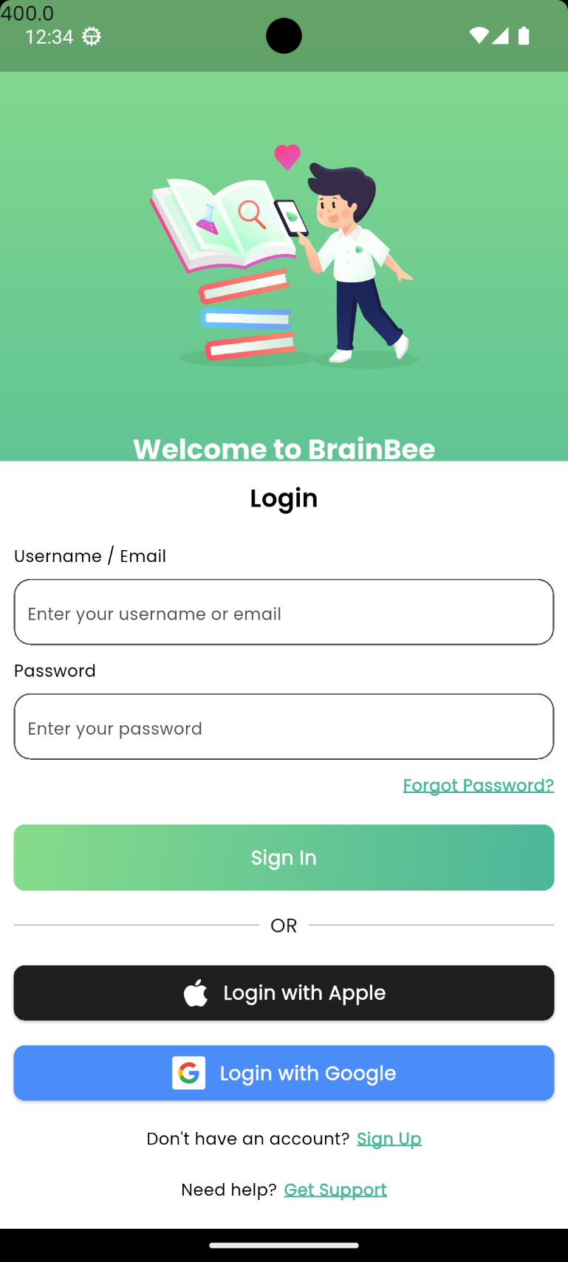

SignUp screen
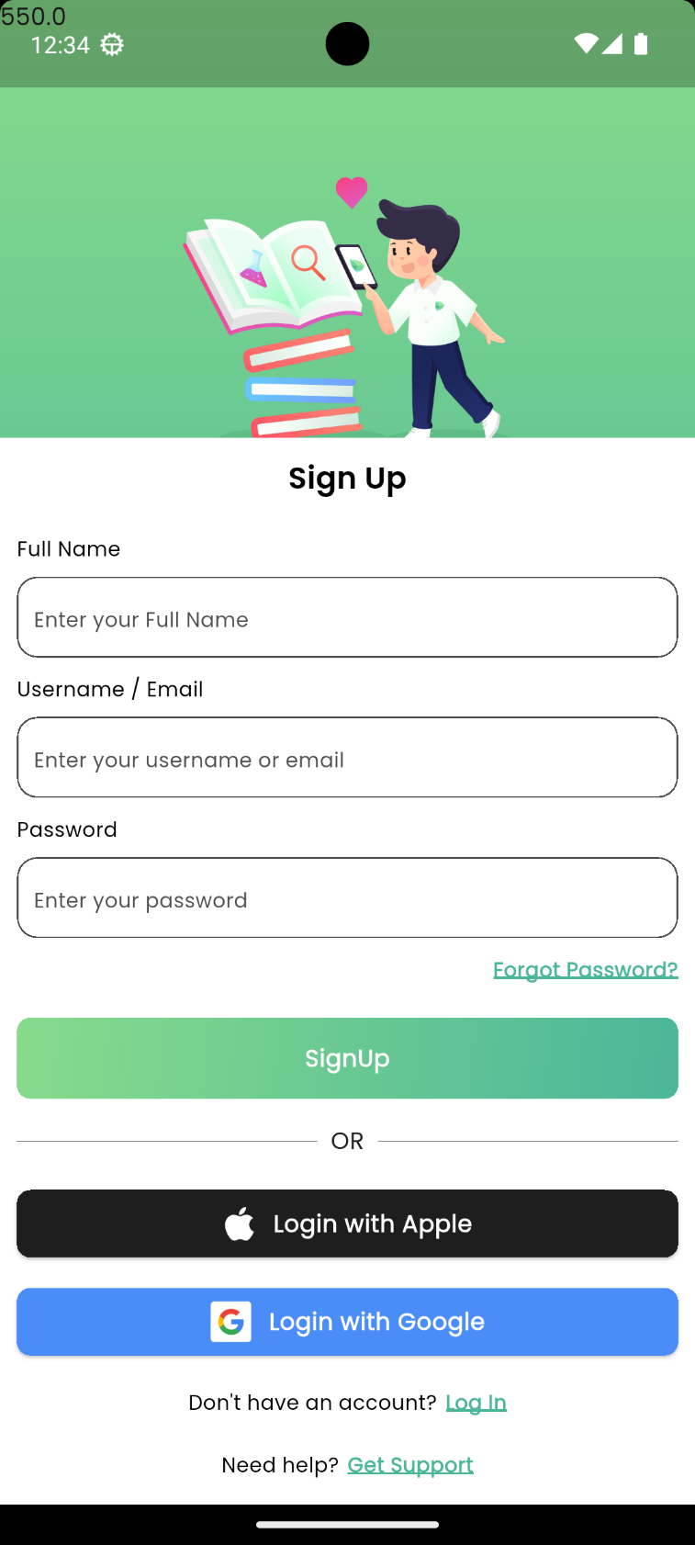

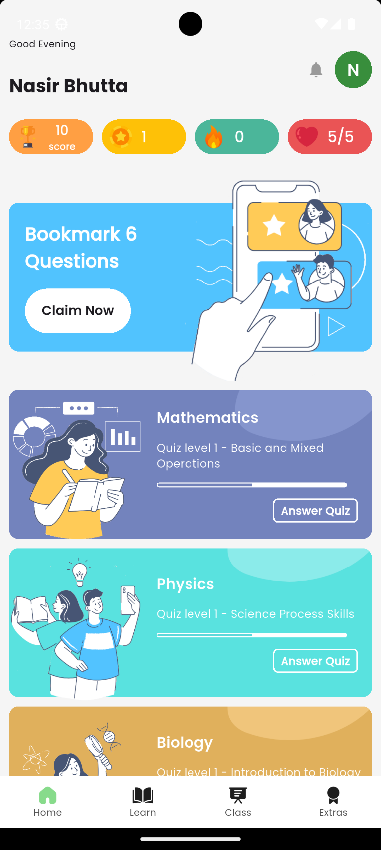
Dashboard

Goals Screen
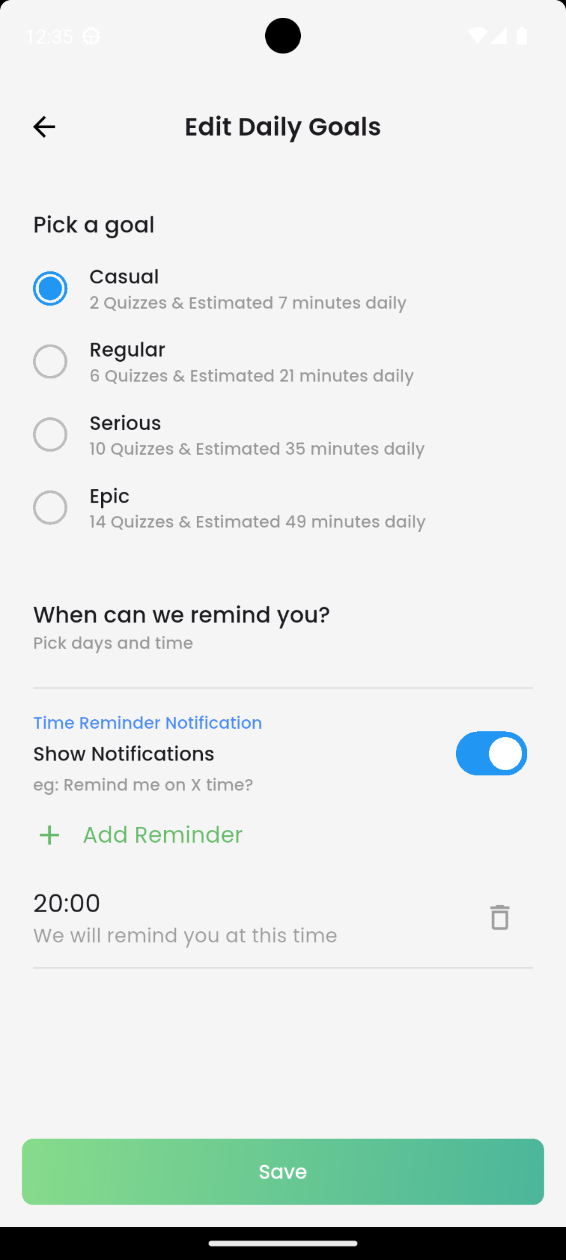

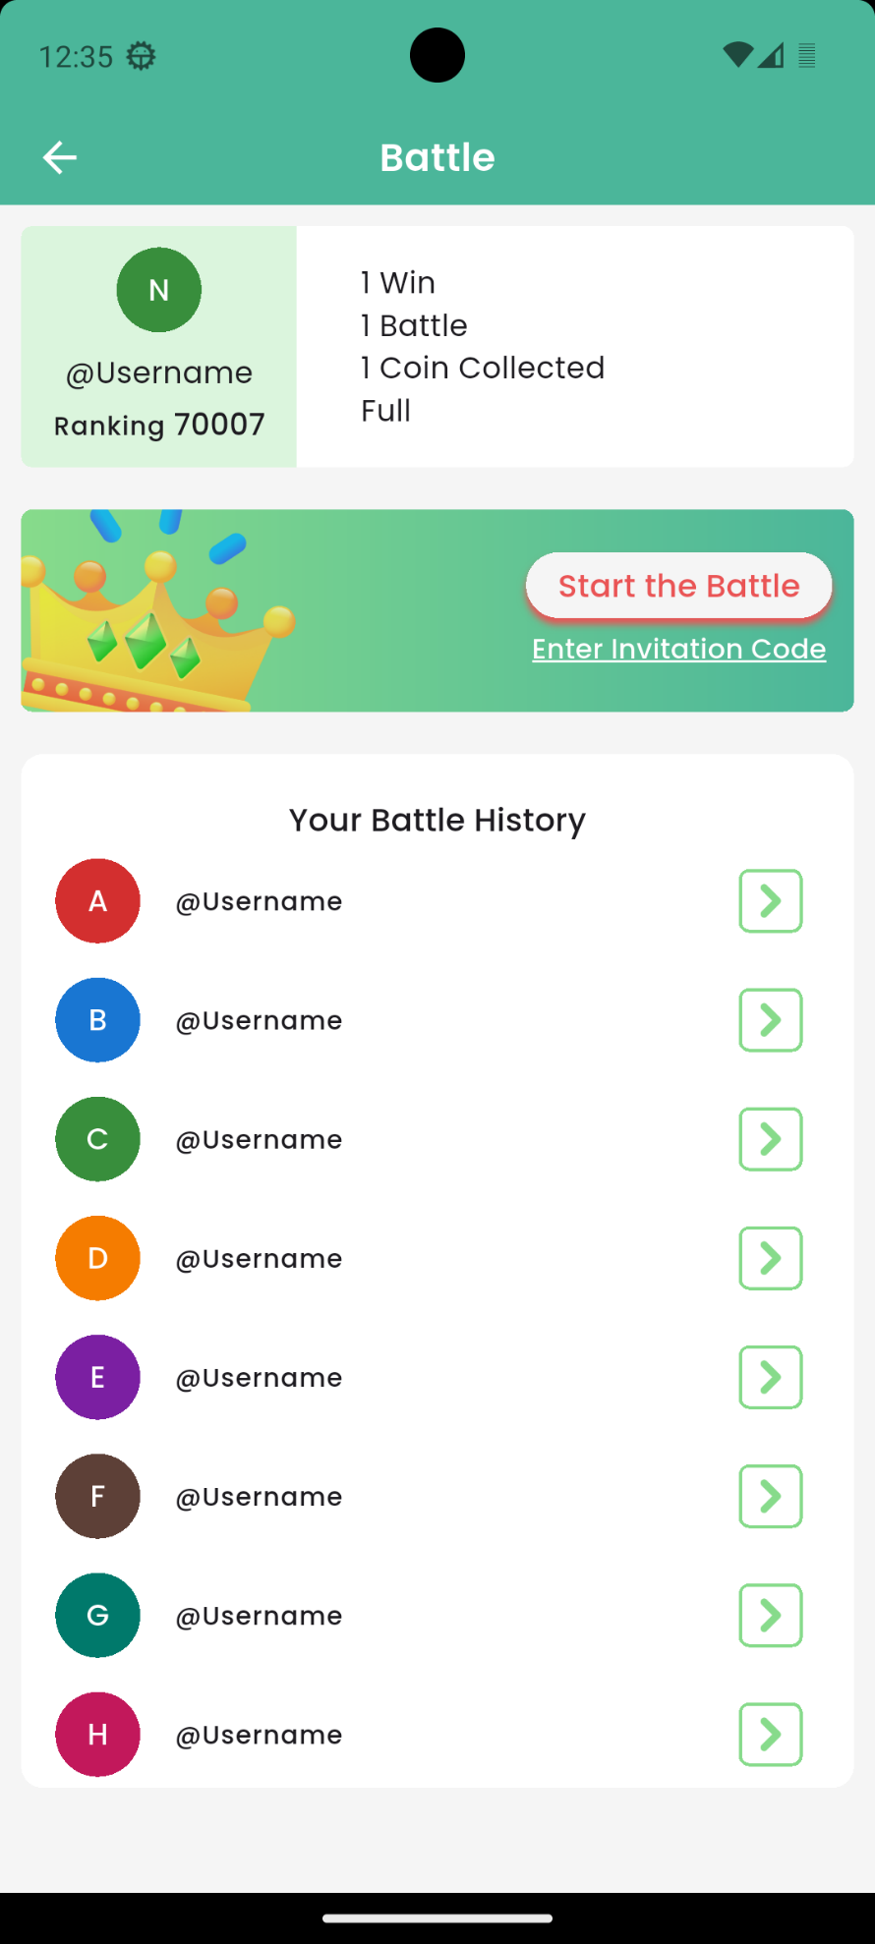
Battle Screen

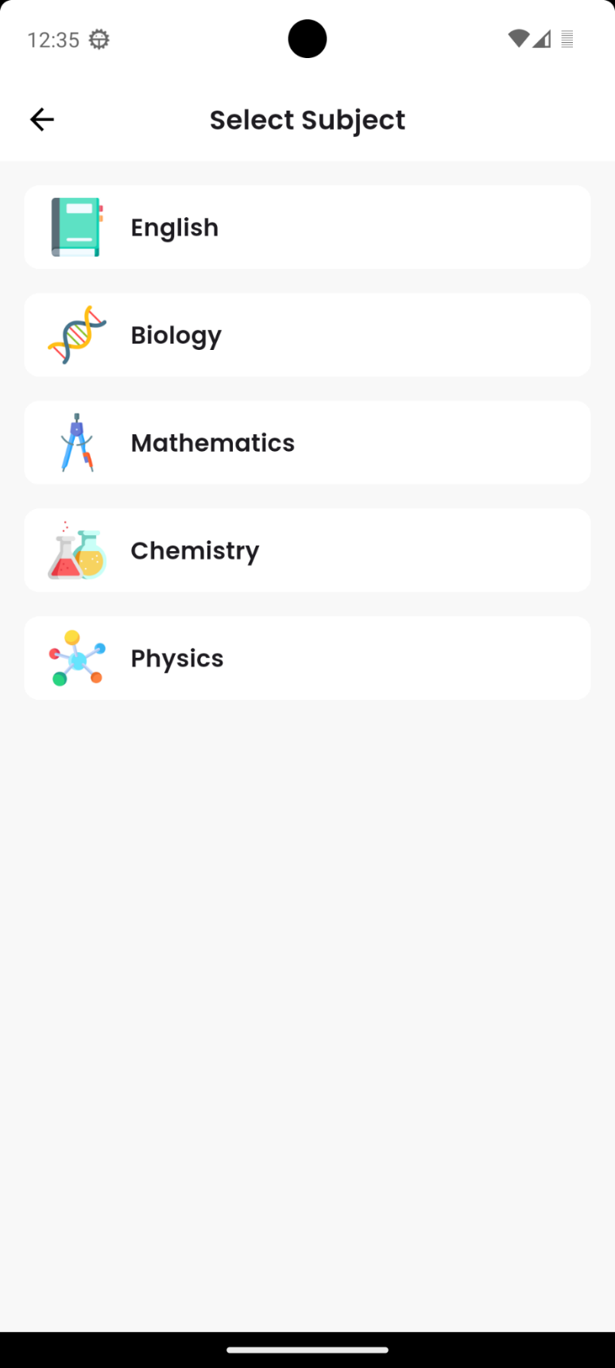
Select Subject for Battle:

Select Chapter For Battle:
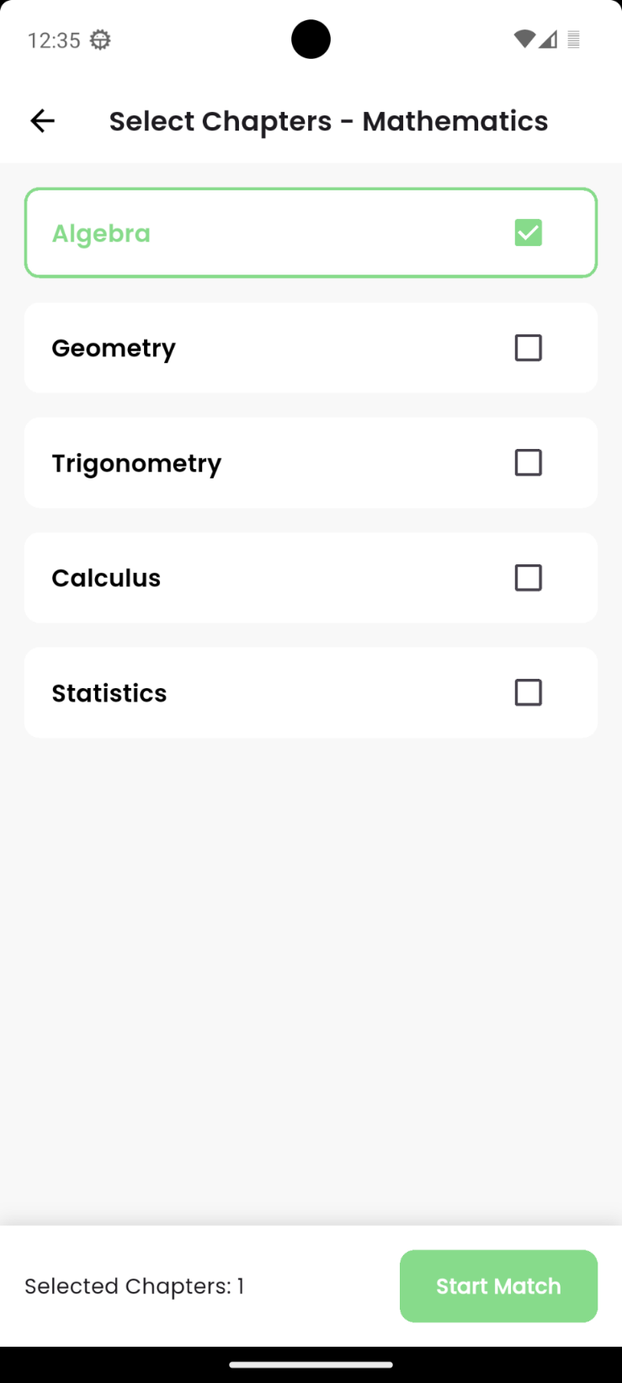

Quiz Battle Screen:
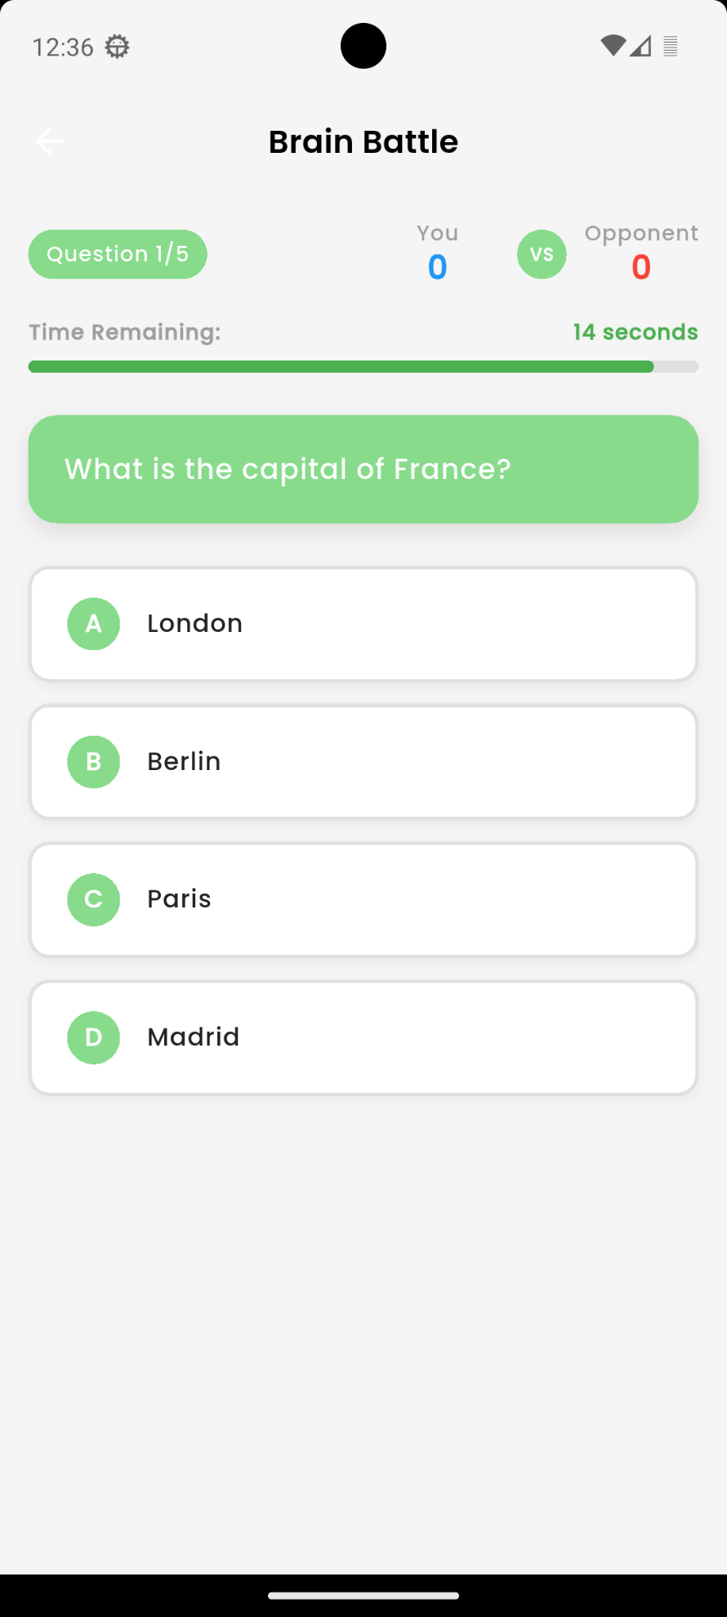

Result Screen:
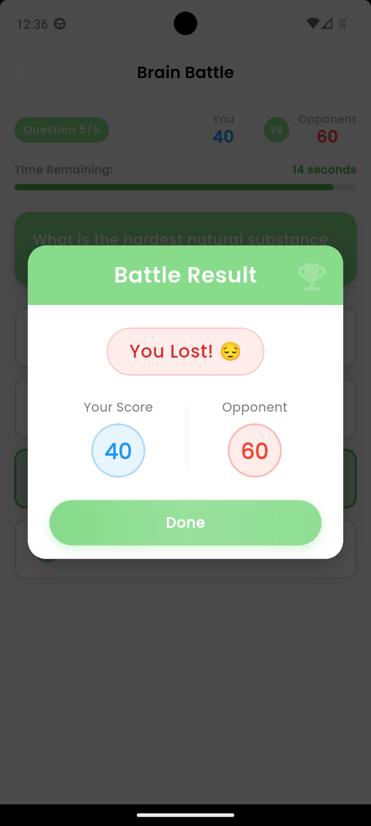

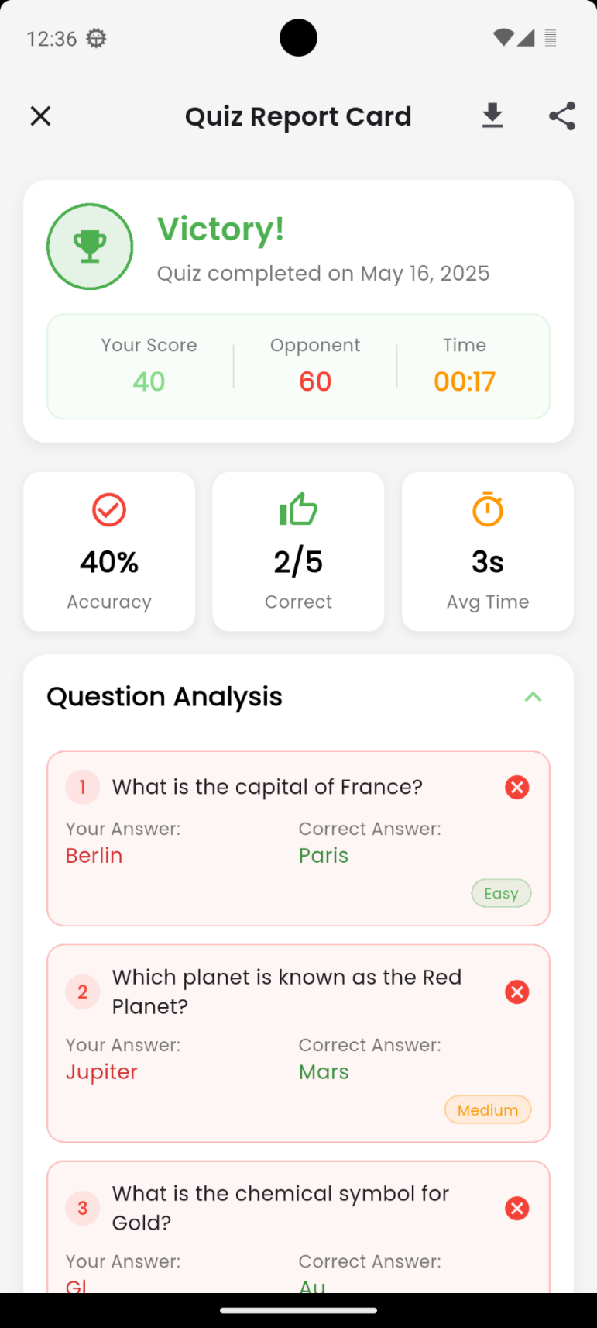
Battle Report Card:

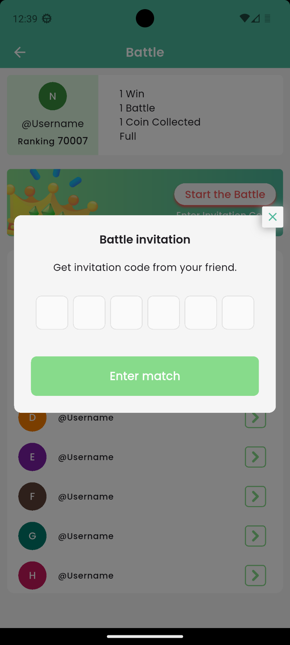
Battle invitation Screen:

Enrolled Classes:
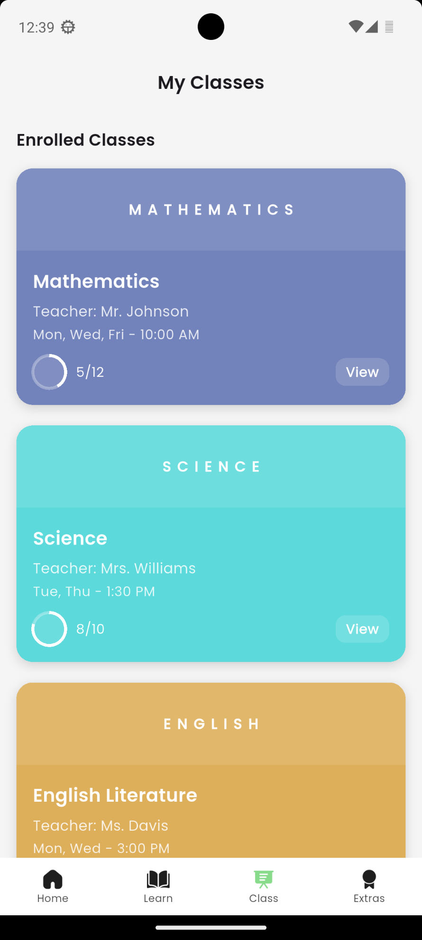

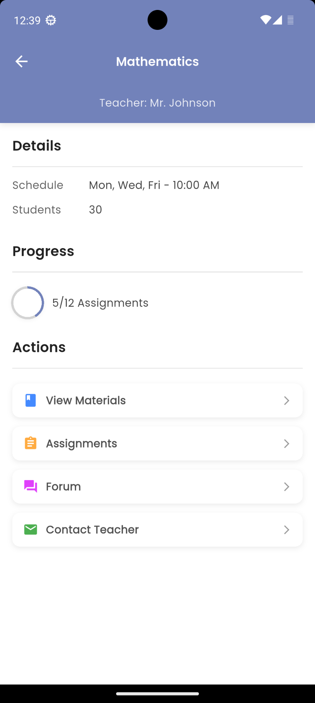
Class Detail Screen:

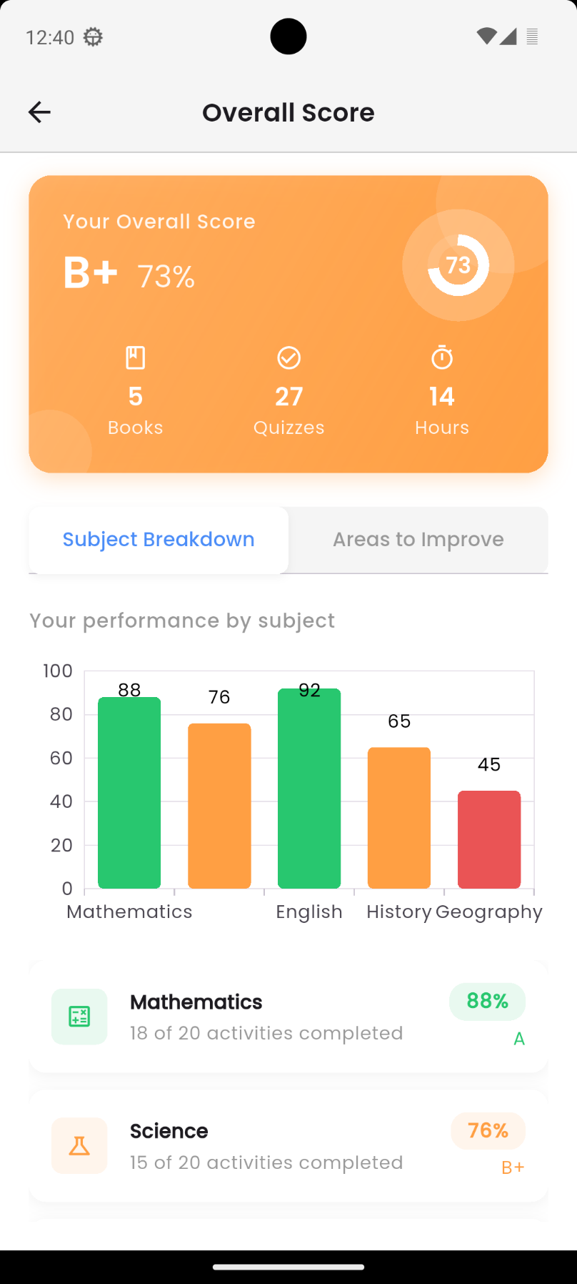
Overall Score screen of in app Quizzes:

Book wise Score:
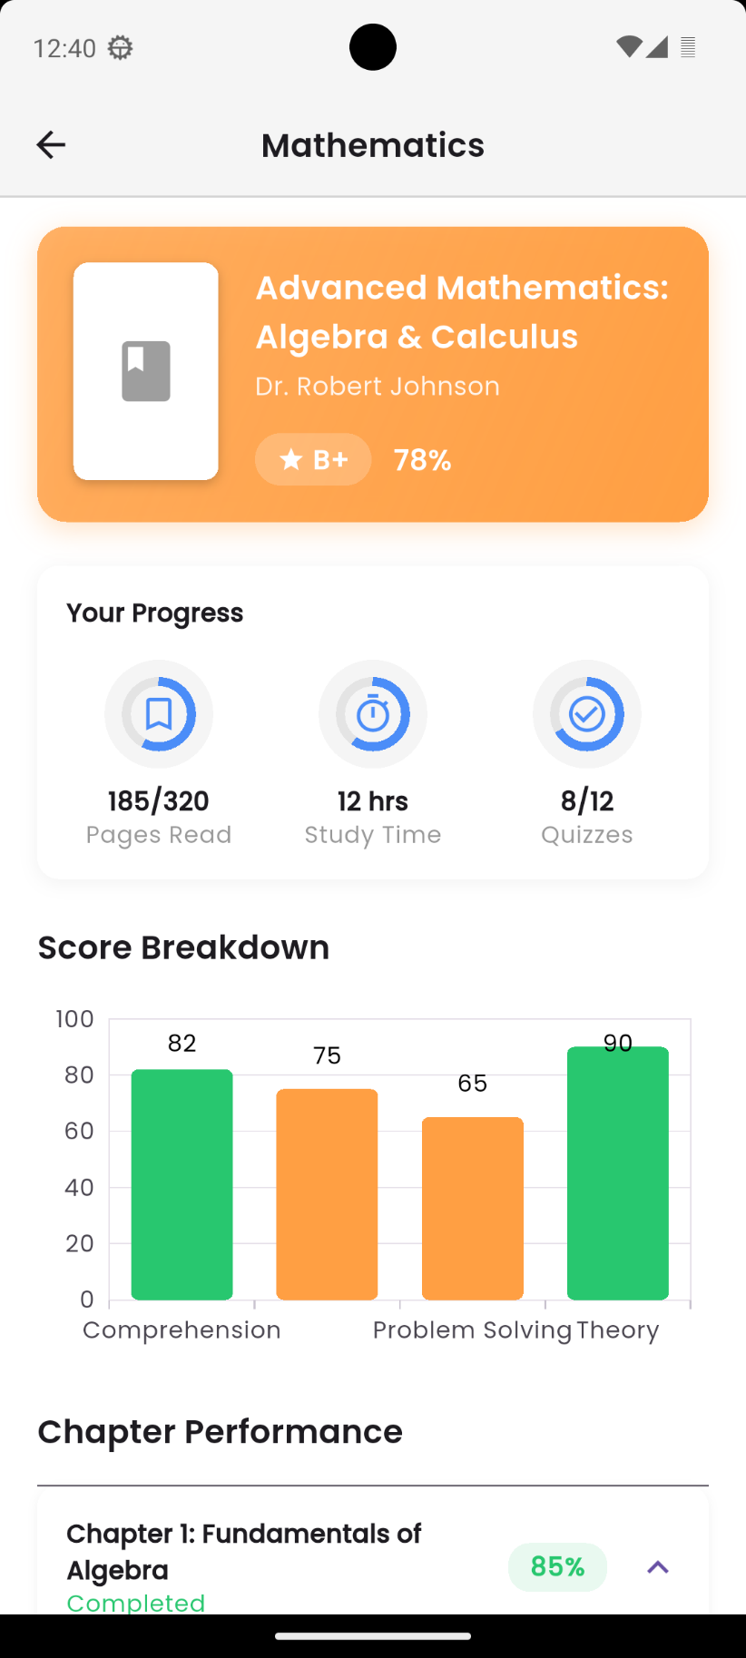

LeaderBoard:
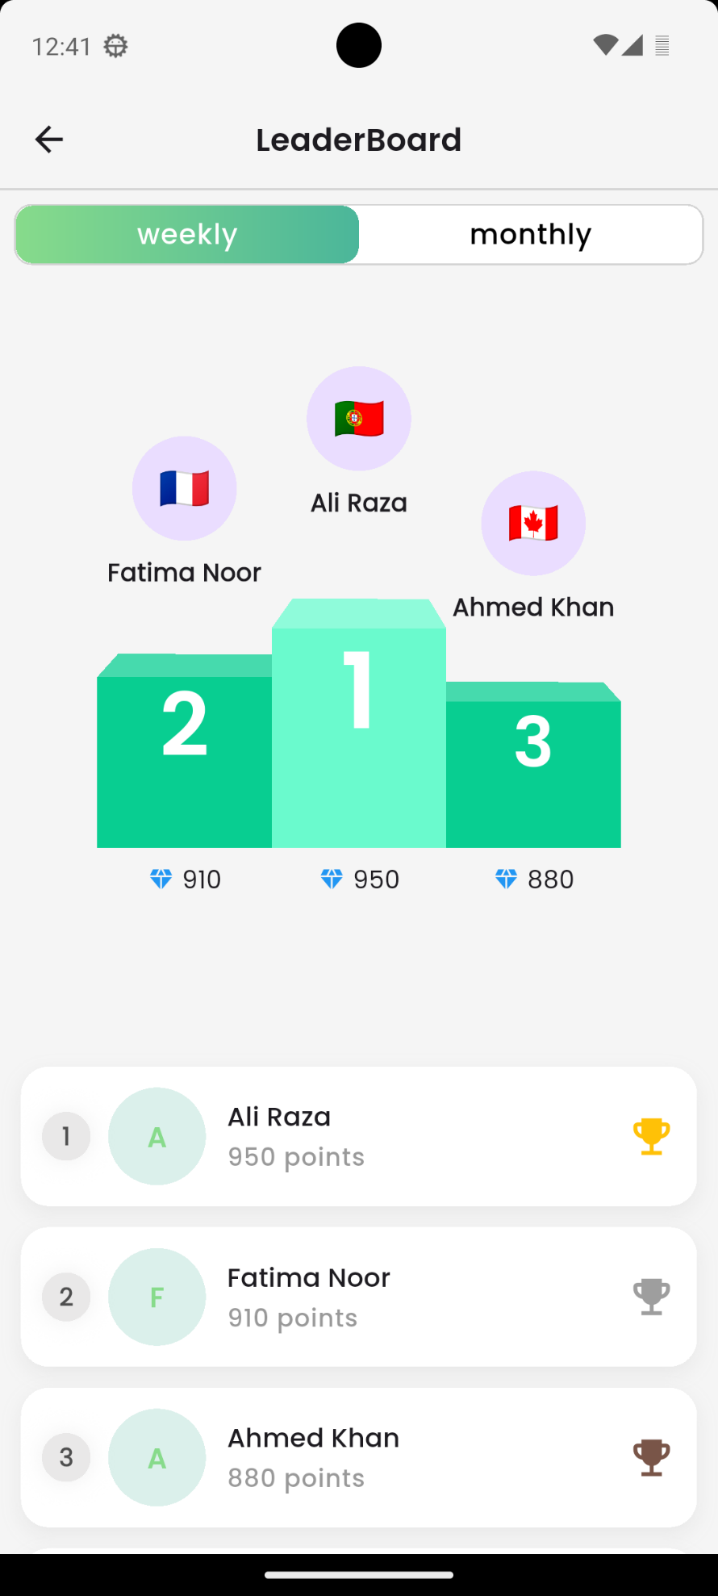

Menu
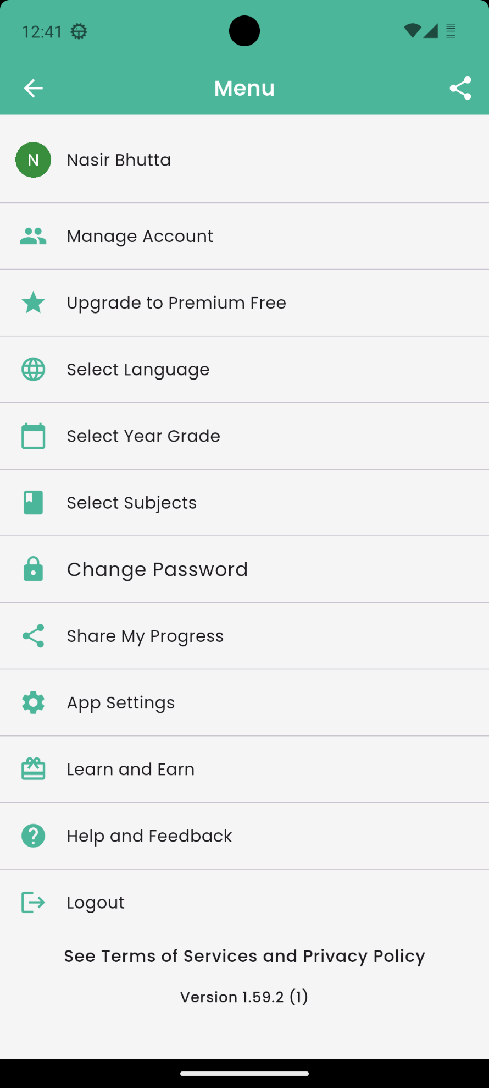

Notifications:
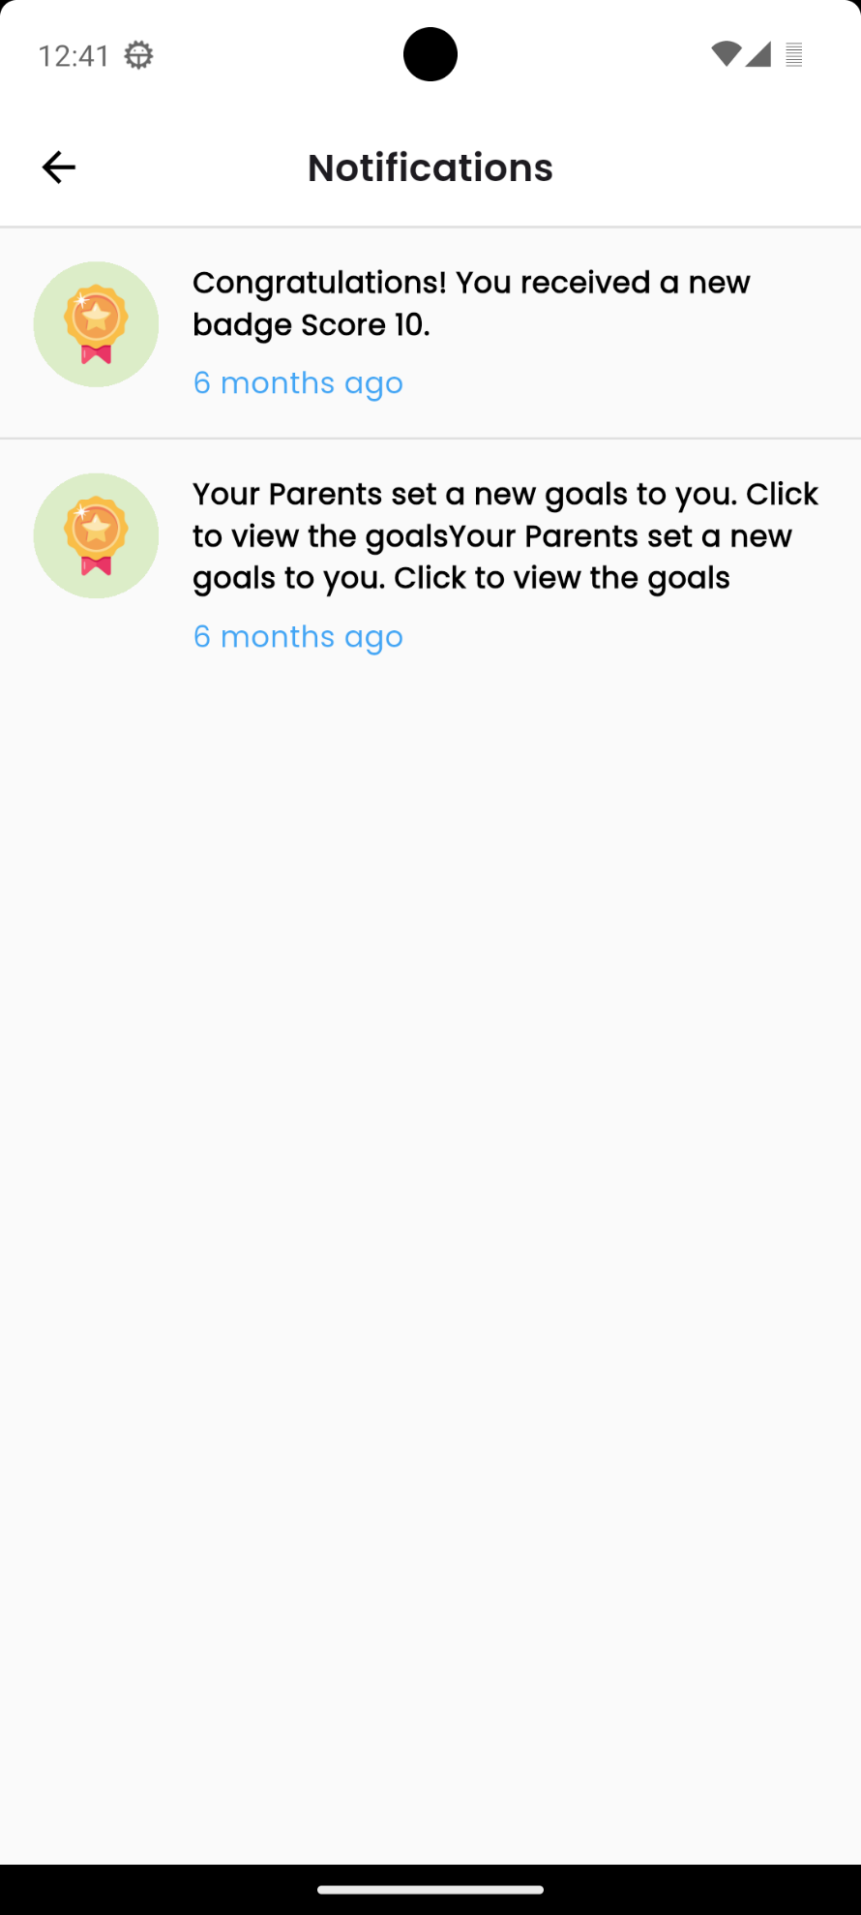

Parent and Teacher App:
This Section shows the screens of the parent and teacher application.

Login Page
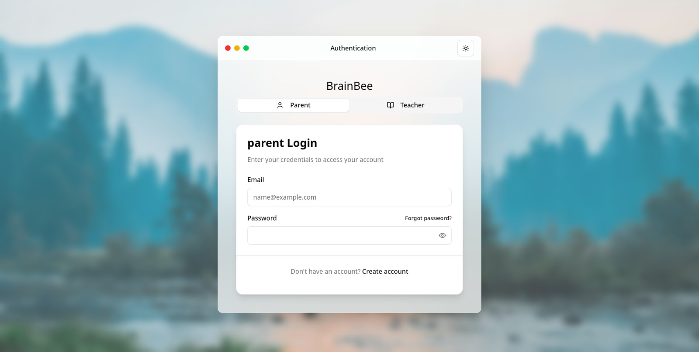

Signup
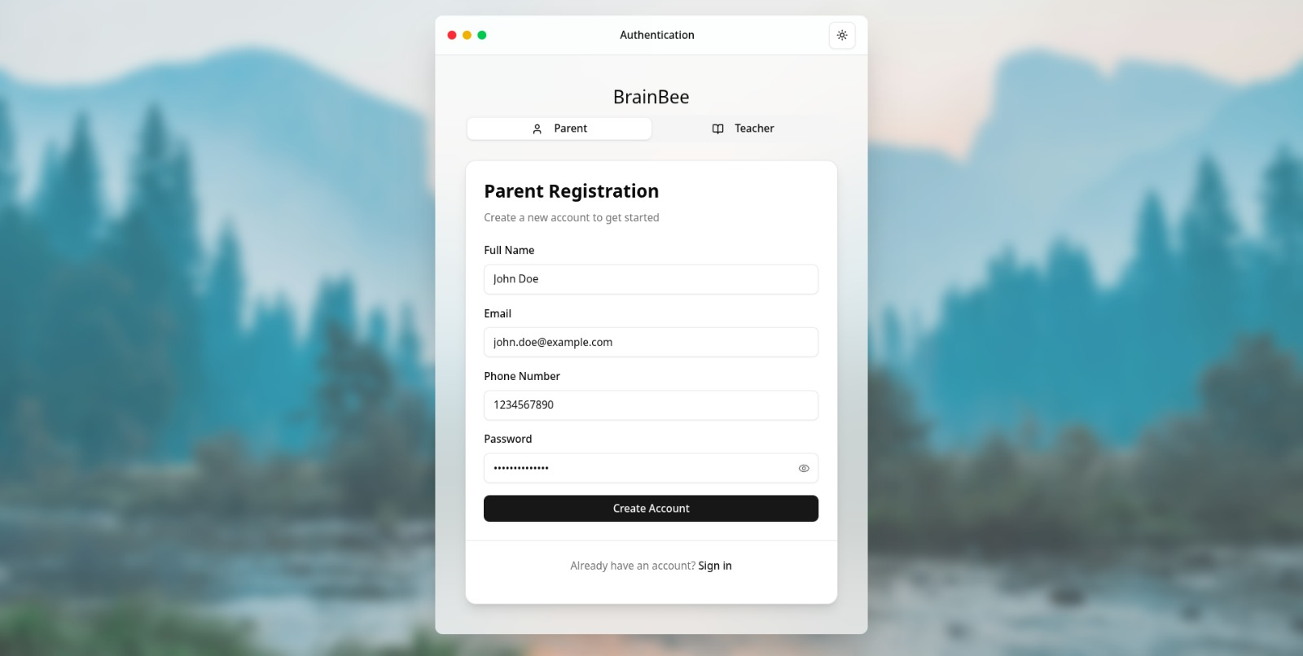

Dashboard
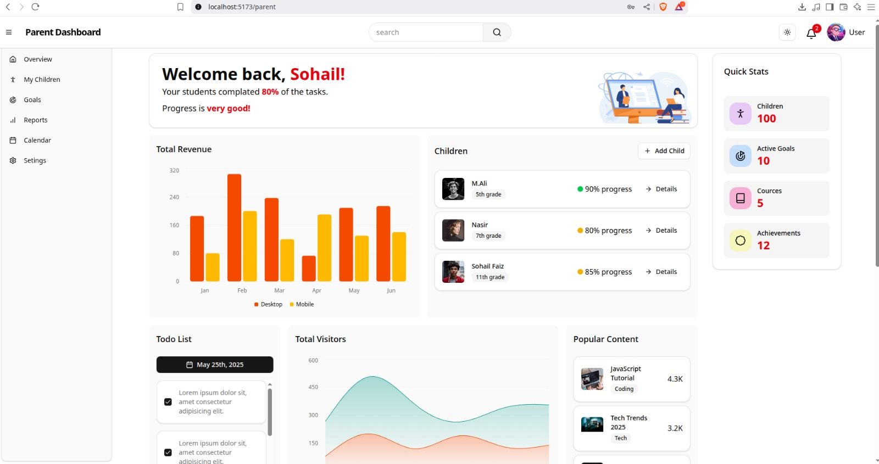

Monitor Children
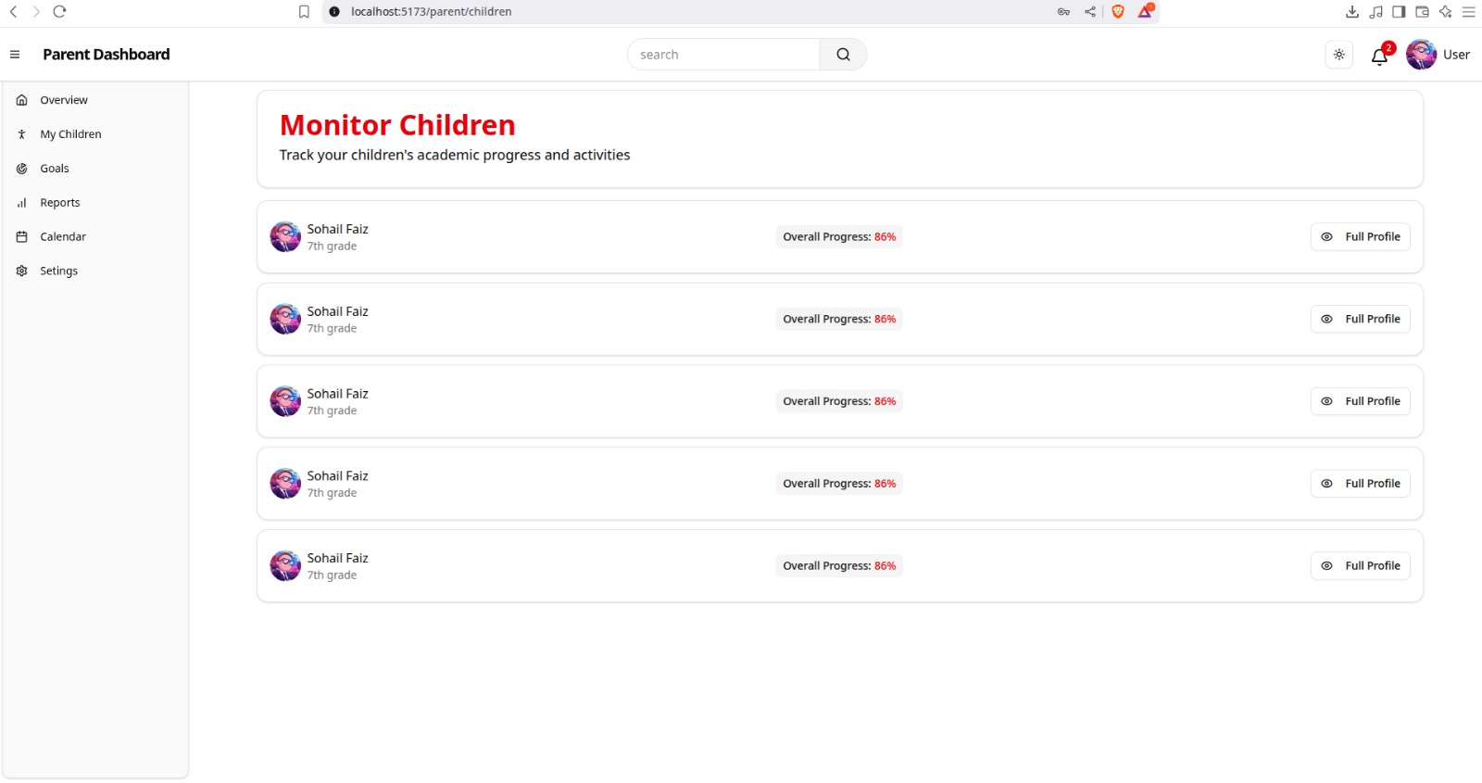

Screen Objects and Actions
This subsection outlines the different screens and user interactions present in the BrainBee application.
    - Login Screen: Allows existing users to access their account using their username/email and password or via social logins (Apple/Google). Provides options for password recovery and new user sign-up.

    - Sign Up Screen: Enables new users to create an account by providing their full name, username/email, and password, or by using social logins. Offers a link to log in for existing users.

    - Home/Dashboard Screen: Displays user's progress (score, achievements), features promotional banners like "Bookmark Questions," and lists available subjects (Mathematics, Physics, Biology) for quizzing. Provides main navigation via bottom tabs.

    - Battle Overview Screen: Shows the user's battle statistics (wins, rank) and a history of past battles. Allows users to start a new battle or join one using an invitation code.

    - Select Subject Screen (for Battle): Presents a list of academic subjects (English, Biology, Mathematics, etc.) for the user to choose from before starting a quiz or battle.

    - Select Chapters Screen: Allows the user to refine their quiz/battle by selecting specific chapters (e.g., Algebra, Geometry) within the previously chosen subject.

    - Brain Battle Screen: Displays the live quiz interface showing the current question, multiple-choice answers, user and opponent scores, question progress, and a countdown timer.

    - Battle Result Popup: A modal dialog that appears after a battle, indicating whether the user won or lost, and showing their score versus the opponent's score.
    - Quiz Report Card Screen: Provides a detailed summary of a completed quiz, including the overall result (Victory!), scores, time taken, accuracy, and a question-by-question analysis of answers.

    - Battle Invitation Popup: Allows a user to join a private battle by entering a 6-digit invitation code obtained from a friend.

    - Select Subject Screen (for Flashcards): Lists available subjects (English, Biology, etc.) and indicates the number of flashcards available for each, allowing users to choose a subject for flashcard study.

    - My Classes Screen: Displays a list of classes the user is enrolled in, showing the subject, teacher, schedule, and progress on assignments for each class.

    - Class Details Screen : Shows detailed information for a specific enrolled class, including schedule, student count, assignment progress, and actions like viewing materials or contacting the teacher.

    - Overall Score Screen : Presents the user's overall academic score and grade, along with statistics (books, quizzes, hours) and a bar chart breaking down performance by subject.

    - Subject Details Screen: Provides an in-depth look at the user's progress within a specific subject (e.g., Advanced Mathematics), including pages read, study time, quiz scores, and a skill-based score breakdown.

    - Leaderboard Screen: Displays rankings of users based on points, with options to view weekly or monthly leaderboards, showcasing top performers and their scores.

    - Menu Screen: Provides access to various account settings (manage account, change password, select grade/subjects), app preferences (language, settings), help, and logout options.

    - Notifications Screen: Lists important updates and alerts for the user, such as earned badges, new goals set by parents, or other app-related information.

Implementation
This section covers the practical implementation aspects of SafarRehnuma, encompassing algorithmic implementations, integration with external interfaces, and the development of user interfaces for seamless interaction.

Algorithms
This subsection explains the algorithms implemented within BrainBee, highlighting their roles in optimizing routes, calculating dynamic pricing, and managing ride requests efficiently.

Get Flashcards
Input: Book ID, Chapter ID
Output: List of dynamically generated flashcards
function GetFlashcards(bookID, chapterID)

db ← connect_to_MongoDB()
chaptersCollection ← db.getCollection("Chapters")
chapter ← chaptersCollection.findOne({ "bookID": bookID, "chapterID": chapterID })
if chapter is null or chapter.content is null then
throw "Chapter not found or content is missing"
end if
flashcards ← AI.GenerateFlashcards(chapter.content)
return flashcards

end function

Match Peer For Battle
Input: Student ID
Output: Matching result message
function MatchPeerForBattle(studentID)
waitingList ← GetWaitingPeers()
for each peer in waitingList do
if IsCompatible(peer, studentID) then
CreateBattleRoom(studentID, peer)
return "Matched with " + peer.name
return "No match found. Please wait."
end

Generate Quiz
Input: Chapter ID, Difficulty Level
Output: Quiz (list of questions)
function GenerateQuiz(chapterID, difficultyLevel)
allQuestions ← GetQuestions(chapterID)
suitable ← FilterByDifficulty(allQuestions, difficultyLevel)
quiz ← RandomSelect(suitable, 10)
return quiz
end

Assign Goal
Input: Child ID, Goal Text, Deadline
Output: Goal assignment confirmation
function AssignGoal(childID, goalText, deadline)
goal ← CreateGoal(goalText, deadline)
AssignToChild(childID, goal)
return "Goal assigned"
end

Enroll In Class
Input: Student ID, Class ID
Output: Enrollment status
function EnrollInClass(studentID, classID)
class ← GetClass(classID)
if class.capacity > class.enrolled then
Enroll(studentID, classID)
return "Enrolled"
return "Class Full"
end

Calculate Progress
Input: Student ID, Subject ID
Output: Progress percentage
function CalculateProgress(studentID, subjectID)
totalTasks ← GetAllTasks(subjectID)
completed ← GetStudentCompletions(studentID, subjectID)
progress ← (completed / totalTasks) * 100
return progress
end

Check Rewards
Input: Child ID
Output: Rewards issued (if any)
function CheckRewards(childID)
goals ← GetGoals(childID)
for goal in goals do
if goal.status == "Completed" and goal.rewardGiven == false then
GiveReward(childID, goal.reward)
MarkRewardGiven(goal)
end

Evaluate Quiz
Input: Quiz ID, Student Answers
Output: Score and feedback
function EvaluateQuiz(quizID, studentAnswers)
correctAnswers ← GetCorrectAnswers(quizID)
score ← 0
for i in range(len(correctAnswers)) do
if studentAnswers[i] == correctAnswers[i] then
score += 1
feedback ← GenerateFeedback(score)
return score, feedback
end

Get Parent Dashboard
Input: Parent ID
Output: Dashboard data
function GetParentDashboard(parentID)
children ← GetChildren(parentID)
dashboard ← []
for child in children do
stats ← GetChildStats(child.id)
dashboard.append(stats)
return dashboard
end

Generate AI Flashcards
Input: Chapter Text
Output: Flashcards (Q&A pairs)
function GenerateAIFlashcards(chapterText)
keyPoints ← ExtractKeyConcepts(chapterText)
flashcards ← []
for point in keyPoints do
question ← GenerateQuestion(point)
answer ← GenerateAnswer(point)
flashcards.append((question, answer))
return flashcards
end

Recommend Content
Input: User ID
Output: Recommended content list
function RecommendContent(userID)
history ← GetUserHistory(userID)
similarUsers ← FindSimilarUsers(userID)
preferredTopics ← AnalyzeWeakAreas(history)
recommended ← []
for topic in preferredTopics do
content ← FetchContent(topic)
recommended.append(content)
return recommended
end

Match For Battle
Input: Student ID
Output: Matched Peer or Waiting Message
function MatchForBattle(studentID)
userLevel ← GetUserSkillLevel(studentID)
availablePeers ← GetWaitingStudents()
matchedPeer ← null
for peer in availablePeers do
if abs(GetUserSkillLevel(peer) - userLevel) ≤ threshold then
matchedPeer ← peer
break
if matchedPeer ≠ null then
CreateBattleRoom(studentID, matchedPeer)
return matchedPeer
return "No suitable peer found. Waiting in queue."
end

Calculate Overall Score
Input: Student ID
Output: Overall score percentage
function CalculateOverallScore(studentID)
books ← GetAllBooksAttempted(studentID)
totalScore ← 0
totalQuestions ← 0
for book in books do
(score, questions) ← GetBookScore(studentID, book.id)
totalScore += score
totalQuestions += questions
if totalQuestions == 0 then
return 0
return (totalScore / totalQuestions) * 100
end

Calculate Book-Wise Scores
Input: Student ID
Output: Dictionary of book-wise percentages
function CalculateBookWiseScores(studentID)
books ← GetAllBooksAttempted(studentID)
scores ← {}
for book in books do
(score, questions) ← GetBookScore(studentID, book.id)
if questions > 0 then
percentage ← (score / questions) * 100
scores[book.title] ← percentage
return scores
end

Recommend Content (Hybrid)
Input: User ID
Output: Ranked list of recommended items
function RecommendContent(user_id)
user_profile ← GetUserPreferences(user_id)
similar_users ← FindSimilarUsersUsingCosineSimilarity(user_profile)
content_based_recs ← RecommendBasedOnUserProfile(user_profile)
collaborative_recs ← RecommendFromSimilarUsers(similar_users)
combined_recs ← MergeAndRank(content_based_recs, collaborative_recs)
return combined_recs
end

Generate Explanation
Input: Topic Text
Output: Detailed Explanation
function GenerateExplanation(topic_text)
keywords ← ExtractKeyConcepts(topic_text)
explanation ← []
for keyword in keywords do
step_explanation ← UseGPTOrT5ToExplain(keyword)
explanation.append(step_explanation)
return explanation
end

Generate Summary
Input: Content
Output: Summary
function GenerateSummary(content)
cleaned_text ← PreprocessText(content)
summary ← RunPegasusOrT5Summarizer(cleaned_text)
return summary
end

Check and Reward Goal
Input: User ID, Goal ID
Output: Reward given (Boolean)
function CheckAndRewardGoal(user_id, goal_id)
goal ← GetGoalDetails(goal_id)
progress ← GetUserProgress(user_id, goal.book, goal.chapter)
if progress ≥ goal.target then
reward ← AssignReward(user_id)
return true
else
return false
end

External APIs/SDKs
Describe the third-party APIs/SDKs used in the project implementation in the following table. Few examples of APIs are provided in the table.

Name of API/SDK or Library | Description | Purpose of Usage | API Endpoint/Function Used
Cloudinary | Image and video management solution | Uploading user-generated images (e.g., avatars, notes) to cloud storage | https://api.cloudinary.com/v1_1/demo/image/upload
Firebase Cloud Messaging (FCM) | Messaging and push notification service | Sending notifications to users (e.g., quiz results, live class reminders) | FirebaseMessaging.onMessage, FirebaseMessaging.send()
MongoDB Atlas Search | Full-text search engine integrated with MongoDB | Searching books, topics, and flashcards across user data | db.collection.aggregate([{ $search: {...} }])
scikit-learn (Decision Tree) | ML library for classification and regression | Classifying student performance and guiding personalized learning paths | DecisionTreeClassifier().fit(), .predict()
scikit-learn (TF-IDF) | Term Frequency–Inverse Document Frequency model | Identifying important keywords for AI flashcard and summary generation | TfidfVectorizer().fit_transform()
pyirt / IRT Model | Item Response Theory model | Adaptive quiz difficulty and estimating student ability levels | irt_model.fit(), irt_model.predict()
spaCy / Hugging Face Transformers | Natural Language Processing (NLP) libraries | Summarizing educational content, generating explanations and paraphrased notes | nlp_model(text), transformers.pipeline("summarization")
Reinforcement Learning (Q-learning / Custom) | Reward-based ML model | Used in dynamic battle matchmaking and progress optimization | env.step(), agent.learn()

Testing and Evaluation

Unit testing:
No. | Test Case/Test Script | Attribute and Value | Expected Result | Actual Result | Result
1 | Validate email format with valid email | `isValidEmail("test@example.com")` | Function returns `true` | `true` | Pass
2 | Validate email format with invalid email (no @) | `isValidEmail("testexample.com")` | Function returns `false` | `false` | Pass
3 | Validate email format with empty input | `isValidEmail("")` | Function returns `false` | `false` | Pass
7 | Check if user exists with existing email | `userExists("existing@email.com")` | Function returns `true` | `true` | Pass
9 | Check if user exists with non-existent email | `userExists("nonexistent@email.com")` | Function returns `false` | `false` | Pass
10 | Create a new user with valid unique data | `createUser(validUniqueData)` | Success status/ID | Success status/ID | Pass
11 | Create a user with duplicate email | `createUser(existingEmail)` | Error: duplicate email | Error: duplicate email | Pass
12 | Create a user with invalid email format | `createUser(invalidEmail)` | Error: invalid email | Error: invalid email | Pass
13 | Create a user with weak password | `createUser(weakPassword)` | Error: invalid password | Error: invalid password | Pass
17 | Validate password with length above minimum | Password validation (>= min length) | Logic returns `true` | `true` | Pass
18 | Validate password with length below minimum | Password validation (< min length) | Logic returns `false` | `false` | Pass
19 | Validate username with allowed characters | Username validation (allowed chars) | Logic returns `true` | `true` | Pass
20 | Validate username with disallowed characters | Username validation (disallowed chars) | Logic returns `false` | `false` | Pass
21 | Render input field with placeholder | Render `InputField` with placeholder "Enter username" | Input field with correct placeholder | Input field with "Enter username" | Pass
22 | Render password input with toggle functionality | Render `PasswordInput` with toggle | Text visibility toggles | Text visibility toggles | Pass
23 | Render button in enabled state | Render `Button` with "Sign In", `disabled=false` | Button is active/clickable | Button is active/clickable | Pass
24 | Render button in disabled state | Render `Button` with "Sign In", `disabled=true` | Button is greyed out/disabled | Button is greyed out/disabled | Pass
27 | Render onboarding page with dummy content | Render `OnboardingPage` with dummy content | Displays dummy content | Displays dummy content | Pass
28 | Render header with username and icons | Render `Header` with username "Nasir Bhutta" and icons | Displays username and icons | Displays "Nasir Bhutta" and icons | Pass
29 | Render score widget with score and icon | Render `ScoreWidget` with score (user.score) and icon | Displays score and icon | Displays 10 and icon | Pass
30 | Render subject card with dummy data | Render `SubjectCard` with (user.subject.name) data | Displays all dummy data | Displays "Mathematics" data | Pass
31 | Render bottom navigatio-n | Render `BottomNavBar` | Rendered Correctly | Rendered Correctly | Pass
32 | Render modal with title and content | Render `Modal` with title, content, `isVisible=true` | Modal with title, content, 'X' button | Modal with title, content, 'X' button | Pass
33 | Render battle history item with dummy data | Render `BattleHistoryItem` with dummy data | Displays initial, username, arrow | Displays initial, "@Username", arrow | Pass
34 | Render subject list item with subject and icon | Render `SubjectListItem` with (user.subject.name) and book icon | Displays subject and icon | Displays (user.subject.name) and book icon | Pass
35 | Render chapter item with checkbox states | Render `ChapterItem` with (subject.chapter) and `isChecked=true/false` | Correct checked/unchecked state | Correct checked/unchecked state | Pass
38 | Render report card question item with dummy data | Render `ReportCardQuestionItem` with dummy data | Displays all data with 'X' for incorrect | Displays all data with 'X' | Pass
39 | Render class card with dummy data | Render `ClassCard` with dummy data | Displays all Card of Classes | Displays all Card of Classes | Pass
40 | Render score summary widget with dummy data | Render `ScoreSummaryWidget` with dummy data | Displays all dummy data with icons | Displays all dummy data with icons | Pass
41 | Render podium item with rank 1 data | Render `PodiumItem` with rank 1 data | Displays rank, user, name, points | Displays rank 1, "Ali Raza", 950 | Pass

Functional testing:
No. | Test Case/Test Script | Attribute and Value | Expected Result | Actual Result | Result
1 | Verifying initial Onboarding screen display | Launch the application after a fresh install (or simulating first launch). | The first onboarding screen (Image 1 content) is displayed prominently. Dot indicators show 1/3 active. | The first onboarding screen (Image 1 content) is displayed prominently. Dot indicators show 1/3 active. | Pass
2 | Swiping left on 1st Onboarding screen | On the first onboarding screen, swipe left. | User is navigated to the second onboarding screen (Image 2 content). Dot indicators update to 2/3 active. | User is navigated to the second onboarding screen (Image 2 content). Dot indicators update to 2/3 active. | Pass
3 | Swiping left on 2nd Onboarding screen | On the second onboarding screen, swipe left. | User is navigated to the third (last) onboarding screen (Image 3 content). Dot indicators update to 3/3 active. | User is navigated to the third (last) onboarding screen (Image 3 content). Dot indicators update to 3/3 active. | Pass
4 | Swiping right on 2nd Onboarding screen | On the second onboarding screen, swipe right. | User is navigated back to the first onboarding screen (Image 1 content). Dot indicators update to 1/3 active. | User is navigated back to the first onboarding screen (Image 1 content). Dot indicators update to 1/3 active. | Pass
5 | Swiping right on 3rd Onboarding screen | On the third onboarding screen, swipe right. | User is navigated back to the second onboarding screen (Image 2 content). Dot indicators update to 2/3 active. | User is navigated back to the second onboarding screen (Image 2 content). Dot indicators update to 2/3 active. | Pass
6 | Attempting to swipe left on 3rd Onboarding screen | On the third onboarding screen, swipe left. | No navigation occurs. The user remains on the third screen. | No navigation occurs. The user remains on the third screen. | Pass
7 | Tapping a dot indicator to navigate | On any onboarding screen, tap one of the inactive dot indicators. | The user is directly navigated to the screen corresponding to the tapped dot. (Assumes dots are interactive, common UI pattern). | The user is directly navigated to the screen corresponding to the tapped dot. (Assumes dots are interactive, common UI pattern). | Pass
8 | Entering valid Username/Email in login field | On Login screen, tap the "Username / Email" field and type "test@example.com". | The text "test@example.com" appears in the input field. Keyboard appears. | The text "test@example.com" appears in the input field. Keyboard appears. | Pass
9 | Entering valid Password in login field | On Login screen, tap the "Password" field and type "password123". | The text "password123" appears in the input field, obscured by dots/asterisks. Keyboard appears. | The text "password123" appears in the input field, obscured by dots/asterisks. Keyboard appears. | Pass
10 | Toggling password visibility on login screen | On Login screen, tap the password field toggle icon (if present). | The password text becomes visible (or hidden) as the icon changes state. | The password text becomes visible (or hidden) as the icon changes state. | Pass
11 | Signing in with valid credentials | On Login screen, enter valid credentials. Click "Sign In". | User is successfully logged in and navigated to the Home screen (Image 4). | User is successfully logged in and navigated to the Home screen (Image 4). | Pass
12 | Signing in with invalid password | On Login screen, enter valid Username/Email and invalid Password. Click "Sign In". | An error message (e.g., "Invalid credentials") is displayed on the screen. User remains on the Login screen. | An error message (e.g., "Invalid credentials") is displayed on the screen. User remains on the Login screen. | Pass
13 | Signing in with non-existent user credentials | On Login screen, enter credentials for a non-existent user. Click "Sign In". | An error message (e.g., "User not found", "Invalid credentials") is displayed. User remains on the Login screen. | An error message (e.g., "User not found", "Invalid credentials") is displayed. User remains on the Login screen. | Pass
14 | Signing in with empty Username/Email | On Login screen, leave Username/Email empty, enter password. Click "Sign In". | Validation error message appears next to the empty field. Button click might be prevented if client-side validation active. User remains on screen. | Validation error message appears next to the empty field. Button click might be prevented if client-side validation active. User remains on screen. | Pass
15 | Signing in with empty Password | On Login screen, enter Username/Email, leave Password empty. Click "Sign In". | Validation error message appears next to the empty field. Button click might be prevented. User remains on screen. | Validation error message appears next to the empty field. Button click might be prevented. User remains on screen. | Pass
16 | Signing in with both fields empty | On Login screen, leave both fields empty. Click "Sign In". | Validation error messages appear for both fields. Button click might be prevented. User remains on screen. | Validation error messages appear for both fields. Button click might be prevented. User remains on screen. | Pass
17 | Clicking "Forgot Password?" link | On Login screen, click the "Forgot Password?" link. | User is navigated to a password recovery screen/flow. | User is navigated to a password recovery screen/flow. | Pass
18 | Clicking "Sign Up" link | On Login screen, click the "Sign Up" link. | User is navigated to the Sign Up screen (Image 3). | User is navigated to the Sign Up screen (Image 3). | Pass
20 | Clicking "Login with Google" button | On Login screen, click "Login with Google". | A system-level Google login dialog is presented, or a placeholder action occurs. | A system-level Google login dialog is presented, or a placeholder action occurs. | Pass
21 | Clicking "Get Support" link | On Login screen, click the "Need help? Get Support" link. | User is navigated to a support screen or contact form (even if placeholder). | User is navigated to a support screen or contact form (even if placeholder). | Pass
22 | Entering valid Full Name on Sign Up screen | On Sign Up screen, tap "Full Name" field and type "Test User". | Text appears correctly. Keyboard appears. | Text appears correctly. Keyboard appears. | Pass
23 | Entering valid Username/Email on Sign Up screen | On Sign Up screen, tap "Username / Email" field and type "testuser@example.com". | Text appears correctly. Keyboard appears. | Text appears correctly. Keyboard appears. | Pass
24 | Entering valid Password on Sign Up screen | On Sign Up screen, tap "Password" field and type "SecurePassword123". | Text appears correctly, obscured. Keyboard appears. | Text appears correctly, obscured. Keyboard appears. | Pass
25 | Toggling password visibility on Sign Up screen | On Sign Up screen, tap password field toggle icon (if present). | Password text becomes visible/hidden. Icon changes state. | Password text becomes visible/hidden. Icon changes state. | Pass
26 | Signing up with valid and unique data | On Sign Up screen, fill all fields with valid, unique data. Click "Signup". | User is successfully registered and navigated to Home screen or Login screen (as per design). | User is successfully registered and navigated to Home screen or Login screen (as per design). | Pass
27 | Signing up with existing email | On Sign Up screen, fill fields with valid data but an existing email. Click "Signup". | Error message (e.g., "Email already exists") is displayed. User remains on screen. | Error message (e.g., "Email already exists") is displayed. User remains on screen. | Pass
28 | Signing up with existing username | On Sign Up screen, fill fields with valid data but an existing username. Click "Signup". | Error message (e.g., "Username already exists") is displayed. User remains on screen. | Error message (e.g., "Username already exists") is displayed. User remains on screen. | Pass
29 | Signing up with invalid email format | On Sign Up screen, fill fields, enter invalid email format. Click "Signup". | Validation error message appears. User remains on screen. (Client-side or Backend validation feedback). | Validation error message appears. User remains on screen. (Client-side or Backend validation feedback). | Pass
30 | Signing up with password failing strength/length rules | On Sign Up screen, fill fields, enter a password failing rules. Click "Signup". | Validation error message appears. User remains on screen. (Client-side or Backend validation feedback). | Validation error message appears. User remains on screen. (Client-side or Backend validation feedback). | Pass
31 | Signing up with empty Full Name | On Sign Up screen, leave Full Name empty. Fill other fields. Click "Signup". | Validation error for Full Name appears. User remains on screen. | Validation error for Full Name appears. User remains on screen. | Pass
32 | Signing up with empty Username/Email | On Sign Up screen, leave Username/Email empty. Fill other fields. Click "Signup". | Validation error for Username/Email appears. User remains on screen. | Validation error for Username/Email appears. User remains on screen. | Pass
33 | Signing up with empty Password | On Sign Up screen, leave Password empty. Fill other fields. Click "Signup". | Validation error for Password appears. User remains on screen. | Validation error for Password appears. User remains on screen. | Pass
34 | Signing up with all fields empty | On Sign Up screen, leave all fields empty. Click "Signup". | Validation error for all required fields appears. User remains on screen. | Validation error for all required fields appears. User remains on screen. | Pass
35 | Clicking "Log In" link on Sign Up screen | On Sign Up screen, click the "Log In" link. | User is navigated to the Login screen (Image 1 or 2). | User is navigated to the Login screen (Image 1 or 2). | Pass
37 | Clicking "Login with Google" button on Sign Up screen | On Sign Up screen, click "Login with Google". | A system-level Google login dialog is presented, or a placeholder action occurs. | A system-level Google login dialog is presented, or a placeholder action occurs. | Pass
38 | Clicking "Get Support" link on Sign Up screen | On Sign Up screen, click the "Need help? Get Support" link. | User is navigated to a support screen or contact form (even if placeholder). | User is navigated to a support screen or contact form (even if placeholder). | Pass
39 | Verifying Welcome greeting and Username display on Home screen | On Home screen, observe the greeting and username in the header. | The greeting (e.g., "Good Evening") is displayed. The logged-in user's name ("Nasir Bhutta") is displayed below it. | The greeting (e.g., "Good Evening") is displayed. The logged-in user's name ("Nasir Bhutta") is displayed below it. | Pass
40 | Verifying Header Icons presence on Home screen | On Home screen, observe the top right of the header. | A notification bell icon and a user initial/profile icon ('N') are displayed. | A notification bell icon and a user initial/profile icon ('N') are displayed. | Pass
41 | Verifying Score widget display on Home screen | On Home screen, observe the Score widget. | The widget displays an icon (trophy), a number (10), and the text "score". | The widget displays an icon (trophy), a number (10), and the text "score". | Pass
42 | Verifying Coins widget display on Home screen | On Home screen, observe the Coins widget. | The widget displays an icon (star), a number (1), and the icon text. | The widget displays an icon (star), a number (1), and the icon text. | Pass
43 | Verifying Streak widget display on Home screen | On Home screen, observe the Streak widget. | The widget displays an icon (flame), a number (0), and the icon text. | The widget displays an icon (flame), a number (0), and the icon text. | Pass
44 | Verifying Lives widget display on Home screen | On Home screen, observe the Lives widget. | The widget displays an icon (heart), a number (5/5), and the icon text. | The widget displays an icon (heart), a number (5/5), and the icon text. | Pass
45 | Clicking Score widget on Home screen | On Home screen, click the Score widget (trophy). | The Score & Goals modal (Image 5) is displayed on top of the Home screen. | The Score & Goals modal (Image 5) is displayed on top of the Home screen. | Pass
46 | Clicking Coins widget on Home screen | On Home screen, click the Coins widget (star). | The Coins modal (Image 7) is displayed. | The Coins modal (Image 7) is displayed. | Pass
47 | Clicking Streak widget on Home screen | On Home screen, click the Streak widget (flame). | The Streak modal (Image 8) is displayed. | The Streak modal (Image 8) is displayed. | Pass
48 | Clicking Lives widget on Home screen | On Home screen, click the Lives widget (heart). | The Lives modal (Image 9) is displayed. | The Lives modal (Image 9) is displayed. | Pass
49 | Verifying Bookmark card display on Home screen | On Home screen, observe the Bookmark card. | A card titled "Bookmark 6 Questions" with a "Claim Now" button is displayed. An illustration is present. | A card titled "Bookmark 6 Questions" with a "Claim Now" button is displayed. An illustration is present. | Pass
50 | Clicking "Claim Now" on Bookmark card on Home screen | On Home screen, click the "Claim Now" button on the Bookmark card. | A placeholder action occurs (e.g., a toast message "Claimed!" or navigation to a bookmarks screen). The button might become disabled or change text. | A placeholder action occurs (e.g., a toast message "Claimed!" or navigation to a bookmarks screen). The button might become disabled or change text. | Pass
51 | Verifying Subject cards display on Home screen | On Home screen, scroll down and observe the subject cards. | Subject cards for Mathematics, Physics, and Biology (and potentially others if scrollable) are displayed, showing subject name, level, description, progress bar, and "Answer Quiz" button. Illustrations are present. | Subject cards for Mathematics, Physics, and Biology (and potentially others if scrollable) are displayed, showing subject name, level, description, progress bar, and "Answer Quiz" button. Illustrations are present. | Pass
52 | Clicking "Answer Quiz" on Mathematics card on Home screen | On Home screen, click the "Answer Quiz" button on the Mathematics card. | User is navigated to a quiz screen related to Mathematics (e.g., Brain Battle screen or a specific quiz entry point). Context (subject: Mathematics) should be passed. | User is navigated to a quiz screen related to Mathematics (e.g., Brain Battle screen or a specific quiz entry point). Context (subject: Mathematics) should be passed. | Pass
53 | Clicking "Answer Quiz" on Physics card on Home screen | On Home screen, click the "Answer Quiz" button on the Physics card. | User is navigated to a quiz screen related to Physics. Context (subject: Physics) should be passed. | User is navigated to a quiz screen related to Physics. Context (subject: Physics) should be passed. | Pass
54 | Clicking "Answer Quiz" on Biology card on Home screen | On Home screen, click the "Answer Quiz" button on the Biology card. | User is navigated to a quiz screen related to Biology. Context (subject: Biology) should be passed. | User is navigated to a quiz screen related to Biology. Context (subject: Biology) should be passed. | Pass
55 | Clicking notification icon in header on Home screen | On Home screen, click the notification bell icon. | User is navigated to the Notifications screen (Image 31). | User is navigated to the Notifications screen (Image 31). | Pass
56 | Clicking user initial/profile icon in header on Home screen | On Home screen, click the 'N' icon. | User is navigated to the Menu screen (Image 30). | User is navigated to the Menu screen (Image 30). | Pass
57 | Clicking "Home" when on Home screen | On Home screen, tap "Home" in the bottom nav. | No navigation occurs. The Home screen remains active. (Unless designed to refresh). | No navigation occurs. The Home screen remains active. (Unless designed to refresh). | Pass
58 | Clicking "Learn" from Home screen | On Home screen, tap "Learn" in the bottom nav. | The "Learn" icon becomes active. User is navigated to a Learn-related screen (likely subject selection, similar to Image 12 or 22). | The "Learn" icon becomes active. User is navigated to a Learn-related screen (likely subject selection, similar to Image 12 or 22). | Pass
59 | Clicking "Class" from Home screen | On Home screen, tap "Class" in the bottom nav. | The "Class" icon becomes active. User is navigated to the My Classes screen (Image 23). | The "Class" icon becomes active. User is navigated to the My Classes screen (Image 23). | Pass
60 | Clicking "Extras" from Home screen | On Home screen, tap "Extras" in the bottom nav. | The "Extras" icon becomes active. The Extras menu modal (Image 10) is displayed on top of the Home screen. | The "Extras" icon becomes active. The Extras menu modal (Image 10) is displayed on top of the Home screen. | Pass
61 | Clicking "Home" from Class screen | Navigate to Class screen (FT_BottomNav_059). Tap "Home" in the bottom nav. | The "Home" icon becomes active. User is navigated back to the Home screen (Image 4). | The "Home" icon becomes active. User is navigated back to the Home screen (Image 4). | Pass
62 | Clicking "Learn" from Class screen | Navigate to Class screen. Tap "Learn" in the bottom nav. | The "Learn" icon becomes active. User is navigated to the Learn screen. | The "Learn" icon becomes active. User is navigated to the Learn screen. | Pass
63 | Clicking "Extras" from Class screen | Navigate to Class screen. Tap "Extras" in the bottom nav. | The "Extras" icon becomes active. The Extras modal appears over the Class screen. | The "Extras" icon becomes active. The Extras modal appears over the Class screen. | Pass
64 | Verifying Extras modal content | Trigger Extras modal | The modal displays icons and text for "Battle", "Practice", "FlashCards", and "Books". An 'X' close button is in the corner. | The modal displays icons and text for "Battle", "Practice", "FlashCards", and "Books". An 'X' close button is in the corner. | Pass
65 | Clicking "Battle" in Extras modal | Open Extras modal. Click "Battle". | Modal closes. User is navigated to the Battle Lobby screen (Image 11). | Modal closes. User is navigated to the Battle Lobby screen (Image 11). | Pass
66 | Clicking "Practice" in Extras modal | Open Extras modal. Click "Practice". | Modal closes. User is navigated to a Practice subject selection screen (similar to Image 12). | Modal closes. User is navigated to a Practice subject selection screen (similar to Image 12). | Pass
67 | Clicking "FlashCards" in Extras modal | Open Extras modal. Click "FlashCards". | Modal closes. User is navigated to the Flashcard subject selection screen (Image 22). | Modal closes. User is navigated to the Flashcard subject selection screen (Image 22). | Pass
68 | Clicking "Books" in Extras modal | Open Extras modal. Click "Books". | Modal closes. User is navigated to a Books/Study Materials screen (even if dummy). | Modal closes. User is navigated to a Books/Study Materials screen (even if dummy). | Pass
69 | Clicking 'X' to close Extras modal | Open Extras modal. Click the 'X' button. | Modal is dismissed. User returns to the screen from which the modal was opened. | Modal is dismissed. User returns to the screen from which the modal was opened. | Pass
70 | Tapping outside Extras modal to close (if applicable) | Open Extras modal. Tap on the dimmed background outside the modal area. | If implemented, modal is dismissed. User returns to the screen below. | If implemented, modal is dismissed. User returns to the screen below. | Pass
71 | Verifying Battle Lobby screen layout and content | Navigate to Battle Lobby (FT_Extras_65). | Screen displays header with back button ("<") and title "Battle". User info area (initial, username, stats). Banner. "Start the Battle", "Enter Invitation Code" buttons. "Your Battle History" section title and dummy list. | Screen displays header with back button ("<") and title "Battle". User info area (initial, username, stats). Banner. "Start the Battle", "Enter Invitation Code" buttons. "Your Battle History" section title and dummy list. | Pass
72 | Clicking "Start the Battle" button on Battle Lobby | On Battle Lobby, click "Start the Battle". | User is navigated to the Select Subject screen (Image 12). | User is navigated to the Select Subject screen (Image 12). | Pass
73 | Clicking "Enter Invitation Code" button on Battle Lobby | On Battle Lobby, click "Enter Invitation Code". | The "Battle invitation" modal (Image 21) is displayed on top. | The "Battle invitation" modal (Image 21) is displayed on top. | Pass
74 | Clicking a Battle History list item on Battle Lobby | On Battle Lobby, click one of the dummy items in "Your Battle History". | User is navigated to a Battle Report Card or history details screen (Image 19/20 equivalent) related to that history item. | User is navigated to a Battle Report Card or history details screen (Image 19/20 equivalent) related to that history item. | Pass
75 | Clicking back button on Battle Lobby | On Battle Lobby, click the "<" back button. | User is navigated back to the previous screen (likely Home). | User is navigated back to the previous screen (likely Home). | Pass
76 | Verifying Battle Invitation modal content | Open Battle Invitation modal (FT_BattleLobby_73). | Modal displays title "Battle invitation", instruction text, input fields for code, and "Enter match" button. 'X' close button is present. | Modal displays title "Battle invitation", instruction text, input fields for code, and "Enter match" button. 'X' close button is present. | Pass
77 | Entering code in Invitation modal fields | Open Invitation modal. Tap fields and type text. | Text appears in the fields. Keyboard appears. | Text appears in the fields. Keyboard appears. | Pass
78 | Clicking "Enter match" in Invitation modal (dummy action) | Open Invitation modal. Enter text (valid/invalid format) in fields. Click "Enter match". | A placeholder action occurs (e.g., message "Attempting to join match with code..."). Navigation might be attempted to a dummy battle screen or error message displayed based on dummy logic. | A placeholder action occurs (e.g., message "Attempting to join match with code..."). Navigation might be attempted to a dummy battle screen or error message displayed based on dummy logic. | Pass
79 | Clicking 'X' to close Battle Invitation modal | Open Invitation modal. Click the 'X' button. | Modal is dismissed. User returns to the Battle Lobby screen. | Modal is dismissed. User returns to the Battle Lobby screen. | Pass
80 | Verifying Select Subject screen content (from Battle) | Navigate to Select Subject from Battle (FT_BattleLobby_72). | Screen displays header ("Select Subject") and list of subjects (English, Biology, etc.) with icons. | Screen displays header ("Select Subject") and list of subjects (English, Biology, etc.) with icons. | Pass
81 | Clicking a subject on Select Subject (from Battle) | On Select Subject screen, click "Mathematics". | The "Battle Mode" dialog (Image 13) is displayed, mentioning the selected subject "Mathematics". | The "Battle Mode" dialog (Image 13) is displayed, mentioning the selected subject "Mathematics". | Pass
82 | Clicking back button on Select Subject | On Select Subject, click "<". | User is navigated back to the Battle Lobby screen. | User is navigated back to the Battle Lobby screen. | Pass
83 | Verifying Battle Mode dialog content | Open Battle Mode dialog (FT_SelectSubjectBattle_81). | Dialog displays title "Battle Mode", question "How would you like to compete...", and buttons "By Chapter", "Whole Book". 'X' close button is present. | Dialog displays title "Battle Mode", question "How would you like to compete...", and buttons "By Chapter", "Whole Book". 'X' close button is present. | Pass
84 | Clicking "By Chapter" in Battle Mode dialog | Open Battle Mode dialog. Click "By Chapter". | Modal closes. User is navigated to the "Select Chapters - Mathematics" screen (Image 15). | Modal closes. User is navigated to the "Select Chapters - Mathematics" screen (Image 15). | Pass
85 | Clicking "Whole Book" in Battle Mode dialog | Open Battle Mode dialog. Click "Whole Book". | Modal closes. The "Invite Friends" dialog (Image 14) is displayed. | Modal closes. The "Invite Friends" dialog (Image 14) is displayed. | Pass
86 | Clicking 'X' to close Battle Mode dialog | Open Battle Mode dialog. Click the 'X'. | Modal is dismissed. User returns to the Select Subject screen. | Modal is dismissed. User returns to the Select Subject screen. | Pass
87 | Verifying Invite Friends dialog content | Open Invite Friends dialog (FT_BattleModeDialog_85). | Dialog displays title "Invite Friends", question "Are you ready?", and buttons "Share invitation code", "Random Match". 'X' close button is present. | Dialog displays title "Invite Friends", question "Are you ready?", and buttons "Share invitation code", "Random Match". 'X' close button is present. | Pass
88 | Clicking "Share invitation code" in dialog (dummy action) | Open Invite Friends dialog. Click "Share invitation code". | A system-level share sheet or placeholder appears (e.g., message "Sharing code..."). | A system-level share sheet or placeholder appears (e.g., message "Sharing code..."). | Pass
89 | Clicking "Random Match" in dialog (dummy action) | Open Invite Friends dialog. Click "Random Match". | Modal closes. User is navigated to the Brain Battle screen (Image 16), simulating a random match start. | Modal closes. User is navigated to the Brain Battle screen (Image 16), simulating a random match start. | Pass
90 | Clicking 'X' to close Invite Friends dialog | Open Invite Friends dialog. Click the 'X'. | Modal is dismissed. User returns to the Select Subject screen (where Battle Mode dialog originated). | Modal is dismissed. User returns to the Select Subject screen (where Battle Mode dialog originated). | Pass
91 | Verifying Select Chapters screen layout and content | Navigate to Select Chapters (FT_BattleModeDialog_84). | Screen displays header ("Select Chapters - Mathematics") with back button. A list of chapters with checkboxes is shown (Algebra, Geometry, etc.). Below, "Selected Chapters: X" count. "Start Match" button below, initially disabled. | Screen displays header ("Select Chapters - Mathematics") with back button. A list of chapters with checkboxes is shown (Algebra, Geometry, etc.). Below, "Selected Chapters: X" count. "Start Match" button below, initially disabled. | Pass
92 | Clicking a chapter checkbox (select) on Select Chapters | On Select Chapters, click the "Algebra" checkbox. | The checkbox becomes checked. The "Selected Chapters" count increases by 1. The "Start Match" button becomes enabled. | The checkbox becomes checked. The "Selected Chapters" count increases by 1. The "Start Match" button becomes enabled. | Pass
93 | Clicking a chapter checkbox (deselect) on Select Chapters | On Select Chapters, click the "Algebra" checkbox which is currently checked. | The checkbox becomes unchecked. The "Selected Chapters" count decreases by 1. The "Start Match" button might become disabled if count is 0. | The checkbox becomes unchecked. The "Selected Chapters" count decreases by 1. The "Start Match" button might become disabled if count is 0. | Pass
94 | Selecting multiple chapters on Select Chapters | On Select Chapters, select "Algebra", then "Geometry". | Both checkboxes are checked. "Selected Chapters" count is 2. "Start Match" button remains enabled. | Both checkboxes are checked. "Selected Chapters" count is 2. "Start Match" button remains enabled. | Pass
95 | Clicking "Start Match" with chapters selected on Select Chapters | On Select Chapters, ensure at least one chapter is selected. Click "Start Match". | User is navigated to the Brain Battle screen (Image 16), simulating a match starting with questions from selected chapters. | User is navigated to the Brain Battle screen (Image 16), simulating a match starting with questions from selected chapters. | Pass
96 | Attempting to click "Start Match" with no chapters selected on Select Chapters | On Select Chapters, ensure no chapters are selected. Attempt to click the "Start Match" button. | The button does not respond to clicks (it's disabled). | The button does not respond to clicks (it's disabled). | Pass
97 | Clicking back button on Select Chapters | On Select Chapters, click "<". | User is navigated back to the Select Subject screen. | User is navigated back to the Select Subject screen. | Pass
98 | Verifying Brain Battle screen initial state | Navigate to Brain Battle | Screen displays header ("Brain Battle", back button), question number ("Question 1/5"), scores ("You 0 vs Opponent 0"), Time Remaining bar (full) and text (e.g., "15 seconds"), question text, and 4 answer options (A, B, C, D). | Screen displays header ("Brain Battle", back button), question number ("Question 1/5"), scores ("You 0 vs Opponent 0"), Time Remaining bar (full) and text (e.g., "15 seconds"), question text, and 4 answer options (A, B, C, D). | Pass
99 | Selecting an Answer Option on Brain Battle | On Brain Battle, click one of the answer options (e.g., Option C). | The clicked option is highlighted. The screen progresses to the next question after a brief delay. Your score and opponent score may update (dummy). Question number increments. Timer resets. | The clicked option is highlighted. The screen progresses to the next question after a brief delay. Your score and opponent score may update (dummy). Question number increments. Timer resets. | Pass
100 | Observing Time Remaining decrement on Brain Battle | On Brain Battle, watch the Time Remaining bar and text. | The bar visually decreases and the text counts down towards 0. | The bar visually decreases and the text counts down towards 0. | Pass
101 | Letting timer run out on a question on Brain Battle | On Brain Battle, wait for the timer to reach 0 without selecting an answer. | The UI indicates time is up (e.g., bar empty, text 0s). The screen progresses to the next question after a brief delay. Your score does not increase for this question. | The UI indicates time is up (e.g., bar empty, text 0s). The screen progresses to the next question after a brief delay. Your score does not increase for this question. | Pass
102 | Completing the Battle (answering all 5 questions) on Brain Battle | Proceed through the Brain Battle, answering all 5 questions or letting the timer expire. | After the 5th question, the Brain Battle screen transitions to the Battle Result modal (Image 18). | After the 5th question, the Brain Battle screen transitions to the Battle Result modal (Image 18). | Pass
103 | Clicking back button during Battle on Brain Battle | On Brain Battle screen, click the "<" back button. | A confirmation dialog (e.g., "Are you sure you want to leave? Your progress will be lost.") is displayed. (Common pattern for ongoing activities). | A confirmation dialog (e.g., "Are you sure you want to leave? Your progress will be lost.") is displayed. (Common pattern for ongoing activities). | Pass
104 | Confirming leaving Battle in dialog on Brain Battle | If leaving dialog appears (FT_BrainBattle_103), click "Yes" or "Leave". | The user is navigated back to the previous screen (e.g., Battle Lobby). The battle state is abandoned. | The user is navigated back to the previous screen (e.g., Battle Lobby). The battle state is abandoned. | Pass
105 | Canceling leaving Battle in dialog on Brain Battle | If leaving dialog appears (FT_BrainBattle_103), click "No" or "Cancel". | The dialog is dismissed. User remains on the Brain Battle screen. | The dialog is dismissed. User remains on the Brain Battle screen. | Pass
106 | Verifying Battle Result modal content | Complete a battle (FT_BrainBattle_102). | Modal displays title "Battle Result", a result trophy icon, a win/loss/draw status ("You Lost!"). It shows "Your Score" and "Opponent Score" with numerical values. A "Done" button is present. | Modal displays title "Battle Result", a result trophy icon, a win/loss/draw status ("You Lost!"). It shows "Your Score" and "Opponent Score" with numerical values. A "Done" button is present. | Pass
107 | Clicking "Done" button in Battle Result modal | On Battle Result modal, click "Done". | Modal is dismissed. User is navigated to the Quiz Report Card screen (Image 19). | Modal is dismissed. User is navigated to the Quiz Report Card screen (Image 19). | Pass
108 | Verifying Report Card header and summary section | Navigate to Quiz Report Card (FT_BattleResult_107 or FT_BattleLobby_74). | Screen displays header ("Quiz Report Card", back button, download, share icons). A summary section shows result status (Victory/Loss), completion date/time, Your Score, Opponent Score, and Time Taken (dummy data). | Screen displays header ("Quiz Report Card", back button, download, share icons). A summary section shows result status (Victory/Loss), completion date/time, Your Score, Opponent Score, and Time Taken (dummy data). | Pass
109 | Verifying Performance Summary section on Report Card | On Report Card, observe Performance Summary section. | Section displays "Accuracy" (%), "Correct" (count), and "Avg Time" (seconds) (dummy data). | Section displays "Accuracy" (%), "Correct" (count), and "Avg Time" (seconds) (dummy data). | Pass
110 | Verifying Question Analysis section layout on Report Card | On Report Card, observe Question Analysis section. | Section is titled "Question Analysis" and shows a list of questions. Each item has a number, question text, "Your Answer", "Correct Answer", and difficulty. | Section is titled "Question Analysis" and shows a list of questions. Each item has a number, question text, "Your Answer", "Correct Answer", and difficulty. | Pass
111 | Verifying Question Analysis item (Incorrect answer) on Report Card | On Report Card, find an item for an incorrectly answered question (e.g., Question 1 in Image 19). | The question text, "Your Answer" (e.g., "Berlin"), and "Correct Answer" (e.g., "Paris") are displayed. An 'X' icon or red indicator is shown next to the question. Difficulty is shown. | The question text, "Your Answer" (e.g., "Berlin"), and "Correct Answer" (e.g., "Paris") are displayed. An 'X' icon or red indicator is shown next to the question. Difficulty is shown. | Pass
112 | Verifying Question Analysis item (Correct answer) on Report Card | On Report Card, find an item for a correctly answered question (if dummy data includes one). | The question text, "Your Answer", and "Correct Answer" are displayed (they should be the same). A checkmark icon or green indicator is shown. Difficulty is shown. | The question text, "Your Answer", and "Correct Answer" are displayed (they should be the same). A checkmark icon or green indicator is shown. Difficulty is shown. | Pass
113 | Verifying Performance Metrics section on Report Card | On Report Card, scroll to Performance Metrics section (Image 20). | Section titled "Performance Metrics". Bar graphs for Accuracy, Speed, and Score are displayed with dummy percentages/values and change indicators. | Section titled "Performance Metrics". Bar graphs for Accuracy, Speed, and Score are displayed with dummy percentages/values and change indicators. | Pass
114 | Verifying Comparison with Past Quizzes section on Report Card | On Report Card, scroll to Comparison with Past Quizzes section (Image 20). | Section titled "Comparison with Past Quizzes". A chart (bar graph) compares current vs past quizzes (dummy data). A table below shows quiz details (Date, Score, Accuracy, Time/Q) for current and past quizzes (dummy data). | Section titled "Comparison with Past Quizzes". A chart (bar graph) compares current vs past quizzes (dummy data). A table below shows quiz details (Date, Score, Accuracy, Time/Q) for current and past quizzes (dummy data). | Pass
115 | Clicking back button on Report Card | On Report Card, click "<". | User is navigated back to the screen from which the report card was accessed (likely Battle Lobby or Home). | User is navigated back to the screen from which the report card was accessed (likely Battle Lobby or Home). | Pass
116 | Clicking Download icon on Report Card | On Report Card, click the download icon in the header. | A placeholder action related to downloading the report occurs (e.g., a toast, a modal, or initiating download - dummy logic). | A placeholder action related to downloading the report occurs (e.g., a toast, a modal, or initiating download - dummy logic). | Pass
117 | Clicking Share icon on Report Card | On Report Card, click the share icon in the header. | A system-level share sheet or placeholder appears to share the report (dummy logic). | A system-level share sheet or placeholder appears to share the report (dummy logic). | Pass
118 | Navigating to Learn subject selection | Tap "Learn" in bottom nav (FT_BottomNav_58). | User is navigated to a Select Subject screen (similar to Image 12), titled "Select Subject", listing subjects with icons. | User is navigated to a Select Subject screen (similar to Image 12), titled "Select Subject", listing subjects with icons. | Pass
119 | Clicking a subject on Learn selection screen | On Learn subject selection, click "Physics". | User is navigated to a Physics-specific learning screen (e.g., chapter list, learning materials, quiz list) (even if dummy). Context (subject: Physics) passed. | User is navigated to a Physics-specific learning screen (e.g., chapter list, learning materials, quiz list) (even if dummy). Context (subject: Physics) passed. | Pass
120 | Clicking back button on Learn subject selection | On Learn subject selection, click "<". | User is navigated back to the Home screen. | User is navigated back to the Home screen. | Pass
121 | Navigating to Flashcard subject selection | Tap "FlashCards" in Extras modal (FT_Extras_67). | User is navigated to the Select Subject screen for Flashcards (Image 22), titled "Select Subject". List of subjects with icons and flashcard counts (dummy). | User is navigated to the Select Subject screen for Flashcards (Image 22), titled "Select Subject". List of subjects with icons and flashcard counts (dummy). | Pass
122 | Clicking a subject on Flashcard selection screen | On Flashcard selection (Image 22), click "English". | User is navigated to the Flashcards screen for English (even if dummy flashcards). Context (subject: English) passed. | User is navigated to the Flashcards screen for English (even if dummy flashcards). Context (subject: English) passed. | Pass
123 | Clicking back button on Flashcard subject selection | On Flashcard selection (Image 22), click "<". | User is navigated back to the screen from which the Flashcards screen was opened (likely Home or Battle Lobby if accessed via Home->Extras->Flashcards). | User is navigated back to the screen from which the Flashcards screen was opened (likely Home or Battle Lobby if accessed via Home->Extras->Flashcards). | Pass
124 | Navigating to My Classes screen | Tap "Class" in bottom nav (FT_BottomNav_59). | User is navigated to the My Classes screen (Image 23), titled "My Classes". "Enrolled Classes" title and a list of class cards are displayed. | User is navigated to the My Classes screen (Image 23), titled "My Classes". "Enrolled Classes" title and a list of class cards are displayed. | Pass
125 | Verifying My Classes list content on My Classes screen | On My Classes screen, observe the list of class cards. | Cards for Mathematics, Science, and English Literature are shown, each with dummy teacher, schedule, and progress (e.g., 5/12). | Cards for Mathematics, Science, and English Literature are shown, each with dummy teacher, schedule, and progress (e.g., 5/12). | Pass
126 | Clicking a class card on My Classes screen | On My Classes screen, click the "Mathematics" class card. | User is navigated to the Class Details screen for Mathematics (Image 24). Context (class: Mathematics) passed. | User is navigated to the Class Details screen for Mathematics (Image 24). Context (class: Mathematics) passed. | Pass
127 | Clicking back button on My Classes screen | On My Classes screen, click "<". | User is navigated back to the Home screen. | User is navigated back to the Home screen. | Pass
128 | Verifying Class Details screen layout and content | Navigate to Class Details (FT_Classes_126). | Screen displays header ("Mathematics", back button), Teacher name ("Mr. Johnson"). "Details" section (Schedule, Students - dummy). "Progress" section (Assignments completion - dummy). "Actions" section with buttons "View Materials", "Assignments", "Forum", "Contact Teacher". | Screen displays header ("Mathematics", back button), Teacher name ("Mr. Johnson"). "Details" section (Schedule, Students - dummy). "Progress" section (Assignments completion - dummy). "Actions" section with buttons "View Materials", "Assignments", "Forum", "Contact Teacher". | Pass
129 | Clicking "View Materials" button on Class Details | On Class Details, click "View Materials". | User is navigated to a Class Materials screen (even if dummy content). | User is navigated to a Class Materials screen (even if dummy content). | Pass
130 | Clicking "Assignments" button on Class Details | On Class Details, click "Assignments". | User is navigated to a Class Assignments screen (even if dummy content). | User is navigated to a Class Assignments screen (even if dummy content). | Pass
131 | Clicking "Forum" button on Class Details | On Class Details, click "Forum". | User is navigated to a Class Forum screen (even if dummy content). | User is navigated to a Class Forum screen (even if dummy content). | Pass
132 | Clicking "Contact Teacher" button on Class Details | On Class Details, click "Contact Teacher". | A contact interface (e.g., email composer pre-filled, message form modal/screen - dummy) appears, targeting the teacher. | A contact interface (e.g., email composer pre-filled, message form modal/screen - dummy) appears, targeting the teacher. | Pass
133 | Clicking back button on Class Details | On Class Details, click "<". | User is navigated back to the My Classes screen. | User is navigated back to the My Classes screen. | Pass
134 | Navigating to Overall Score screen | Navigate via Menu (FT_Menu_162). | User is navigated to Overall Score screen (Image 25), titled "Overall Score". Header back button present. Overall Score section, Subject Breakdown/Areas to Improve tabs (Subject Breakdown active), Subject Breakdown content (chart, list). | User is navigated to Overall Score screen (Image 25), titled "Overall Score". Header back button present. Overall Score section, Subject Breakdown/Areas to Improve tabs (Subject Breakdown active), Subject Breakdown content (chart, list). | Pass
135 | Verifying Overall Score section content on Overall Score | On Overall Score, observe top section. | Displays "Your Overall Score" (Grade, Percentage, Score Ring) and summary metrics (Books, Quizzes, Hours) with icons (dummy data). | Displays "Your Overall Score" (Grade, Percentage, Score Ring) and summary metrics (Books, Quizzes, Hours) with icons (dummy data). | Pass
136 | Verifying Subject Breakdown tab content on Overall Score | On Overall Score, ensure "Subject Breakdown" tab is active. | Displays performance bar chart by subject (Mathematics, English, History Geography - dummy data). List of subjects below with completion stats and grade (dummy data). | Displays performance bar chart by subject (Mathematics, English, History Geography - dummy data). List of subjects below with completion stats and grade (dummy data). | Pass
137 | Switching to "Areas to Improve" tab on Overall Score | On Overall Score, click the "Areas to Improve" tab. | The "Areas to Improve" tab becomes active. The content below the tabs updates to display areas needing improvement (Image 26). | The "Areas to Improve" tab becomes active. The content below the tabs updates to display areas needing improvement (Image 26). | Pass
138 | Verifying "Areas to Improve" tab content on Overall Score | On Overall Score, ensure "Areas to Improve" tab is active. | Section titled "Areas that need improvement". Lists specific areas (Geography - Map Reading, Mathematics - Algebra) with percentages (dummy), improvement suggestions, and "Practice Now" buttons. | Section titled "Areas that need improvement". Lists specific areas (Geography - Map Reading, Mathematics - Algebra) with percentages (dummy), improvement suggestions, and "Practice Now" buttons. | Pass
139 | Clicking "Practice Now" button on Areas to Improve on Overall Score | On Overall Score ("Areas to Improve" tab), click "Practice Now" for "Geography - Map Reading". | User is navigated to a practice screen/quiz specifically for Geography Map Reading (even if dummy). Context passed. | User is navigated to a practice screen/quiz specifically for Geography Map Reading (even if dummy). Context passed. | Pass
140 | Clicking a subject item in "Subject Breakdown" on Overall Score | On Overall Score ("Subject Breakdown" tab), click the "Mathematics" list item. | User is navigated to the Subject Performance screen for Mathematics (Image 27). Context passed. | User is navigated to the Subject Performance screen for Mathematics (Image 27). Context passed. | Pass
141 | Clicking back button on Overall Score | On Overall Score, click "<". | User is navigated back to the screen from which the Overall Score was accessed (likely Menu). | User is navigated back to the screen from which the Overall Score was accessed (likely Menu). | Pass
142 | Verifying Subject Performance screen layout and content | Navigate to Subject Performance (FT_OverallScore_140 or FT_Home_52 etc. if subjects on Home navigate here). | Screen displays header (Subject Title, back button). Course card (title, instructor, grade, percentage - dummy). Progress metrics (Pages Read, Study Time, Quizzes - dummy). Score Breakdown chart (dummy). Chapter Performance list (collapsed, dummy data). Personalized Recommendations (dummy). | Screen displays header (Subject Title, back button). Course card (title, instructor, grade, percentage - dummy). Progress metrics (Pages Read, Study Time, Quizzes - dummy). Score Breakdown chart (dummy). Chapter Performance list (collapsed, dummy data). Personalized Recommendations (dummy). | Pass
143 | Verifying Course card details on Subject Performance | On Subject Performance screen, observe the card below the header. | Displays course title ("Advanced Mathematics: Algebra & Calculus"), instructor ("Dr. Robert Johnson"), grade ("B+"), and percentage ("78%") (dummy data). | Displays course title ("Advanced Mathematics: Algebra & Calculus"), instructor ("Dr. Robert Johnson"), grade ("B+"), and percentage ("78%") (dummy data). | Pass
144 | Verifying Progress metrics display on Subject Performance | On Subject Performance screen, observe the progress metrics section. | Displays circles with counts/values and labels ("Pages Read", "Study Time", "Quizzes") (dummy data). | Displays circles with counts/values and labels ("Pages Read", "Study Time", "Quizzes") (dummy data). | Pass
145 | Verifying Score Breakdown chart on Subject Performance | On Subject Performance screen, observe the Score Breakdown chart. | Displays a bar chart with categories ("Comprehension", "Problem Solving Theory") and scores (dummy data). | Displays a bar chart with categories ("Comprehension", "Problem Solving Theory") and scores (dummy data). | Pass
146 | Verifying Chapter Performance list (collapsed state) on Subject Performance | On Subject Performance screen, observe the "Chapter Performance" list. | List items for chapters are displayed (e.g., Chapter 1, Chapter 2, etc.), showing name, status (Completed, In Progress), percentage, and down arrow. | List items for chapters are displayed (e.g., Chapter 1, Chapter 2, etc.), showing name, status (Completed, In Progress), percentage, and down arrow. | Pass
147 | Expanding a Chapter Performance item on Subject Performance | On Subject Performance screen, click a chapter item with a down arrow (e.g., "Chapter 1: Fundamentals of Algebra"). | The section expands below the chapter item. Sub-topics with percentages and checkmarks appear (Basic Equations 90%, Polynomials 85%, Word Problems 80% - dummy data). The arrow icon changes to point up. A "Practice This Chapter" button appears. | The section expands below the chapter item. Sub-topics with percentages and checkmarks appear (Basic Equations 90%, Polynomials 85%, Word Problems 80% - dummy data). The arrow icon changes to point up. A "Practice This Chapter" button appears. | Pass
148 | Collapsing an expanded Chapter Performance item on Subject Performance | On Subject Performance screen, click an expanded chapter item (with an up arrow). | The section collapses, hiding the sub-topic details and "Practice This Chapter" button. The arrow icon changes to point down. | The section collapses, hiding the sub-topic details and "Practice This Chapter" button. The arrow icon changes to point down. | Pass
149 | Clicking "Practice This Chapter" button on Subject Performance | On Subject Performance screen, expand a chapter. Click the "Practice This Chapter" button. | User is navigated to a practice screen/quiz specifically for that chapter (e.g., Algebra Fundamentals) (even if dummy). Context passed. | User is navigated to a practice screen/quiz specifically for that chapter (e.g., Algebra Fundamentals) (even if dummy). Context passed. | Pass
150 | Verifying Personalized Recommendations section on Subject Performance | On Subject Performance screen, scroll to the bottom. | Section titled "Personalized Recommendations" is displayed. A list of numbered recommendations with text is shown (dummy data). | Section titled "Personalized Recommendations" is displayed. A list of numbered recommendations with text is shown (dummy data). | Pass
151 | Clicking back button on Subject Performance | On Subject Performance screen, click "<". | User is navigated back to the previous screen (e.g., Overall Score or Home). | User is navigated back to the previous screen (e.g., Overall Score or Home). | Pass
152 | Navigating to Leaderboard screen | Navigate via Menu (FT_Menu_163). | User is navigated to Leaderboard screen (Image 29), titled "LeaderBoard". Header back button present. "weekly" and "monthly" tabs visible ("weekly" active). Top 3 podium display and list below. | User is navigated to Leaderboard screen (Image 29), titled "LeaderBoard". Header back button present. "weekly" and "monthly" tabs visible ("weekly" active). Top 3 podium display and list below. | Pass
153 | Verifying "weekly" tab content on Leaderboard | On Leaderboard, ensure "weekly" tab is active. | Top 3 podium shows users ranked 1, 2, 3 with names, flags/images, and scores (dummy data). List below shows users ranked 1+ with rank, initial, name, points, and trophy icons (dummy data). | Top 3 podium shows users ranked 1, 2, 3 with names, flags/images, and scores (dummy data). List below shows users ranked 1+ with rank, initial, name, points, and trophy icons (dummy data). | Pass
154 | Switching to "monthly" tab on Leaderboard | On Leaderboard, click the "monthly" tab. | The "monthly" tab becomes active. The podium and list content update to show monthly rankings (dummy data). | The "monthly" tab becomes active. The podium and list content update to show monthly rankings (dummy data). | Pass
155 | Verifying "monthly" tab content on Leaderboard | On Leaderboard, ensure "monthly" tab is active. | Top 3 podium shows users ranked 1, 2, 3 with names, flags/images, and scores (dummy data). List below shows users ranked 1+ with rank, initial, name, points, and trophy icons (dummy data). (Differs from weekly data). | Top 3 podium shows users ranked 1, 2, 3 with names, flags/images, and scores (dummy data). List below shows users ranked 1+ with rank, initial, name, points, and trophy icons (dummy data). (Differs from weekly data). | Pass
156 | Clicking back button on Leaderboard | On Leaderboard, click "<". | User is navigated back to the screen from which the Leaderboard was accessed (likely Menu). | User is navigated back to the screen from which the Leaderboard was accessed (likely Menu). | Pass
157 | Navigating to Menu screen | Click user initial on Home (FT_Home_56). | User is navigated to Menu screen (Image 30), titled "Menu". Header back button and share icon present. User name ("Nasir Bhutta") and initial ('N'). List of menu items. Terms/Privacy link and version info. | User is navigated to Menu screen (Image 30), titled "Menu". Header back button and share icon present. User name ("Nasir Bhutta") and initial ('N'). List of menu items. Terms/Privacy link and version info. | Pass
158 | Verifying Menu items list on Menu screen | On Menu screen, observe the list of items. | Items for "Manage Account", "Upgrade to Premium Free", "Select Language", "Select Year Grade", "Select Subjects", "Change Password", "Share My Progress", "App Settings", "Learn and Earn", "Help and Feedback", and "Logout" are displayed with icons and forward arrows. | Items for "Manage Account", "Upgrade to Premium Free", "Select Language", "Select Year Grade", "Select Subjects", "Change Password", "Share My Progress", "App Settings", "Learn and Earn", "Help and Feedback", and "Logout" are displayed with icons and forward arrows. | Pass
159 | Clicking "Manage Account" menu item on Menu screen | On Menu screen, click "Manage Account". | User is navigated to an Account Management screen (even if dummy). | User is navigated to an Account Management screen (even if dummy). | Pass
160 | Clicking "Upgrade to Premium Free" menu item on Menu screen | On Menu screen, click "Upgrade to Premium Free". | User is navigated to a premium/upgrade screen (even if dummy). | User is navigated to a premium/upgrade screen (even if dummy). | Pass
161 | Clicking "Select Language" menu item on Menu screen | On Menu screen, click "Select Language". | User is navigated to a Language selection screen/modal (even if dummy). | User is navigated to a Language selection screen/modal (even if dummy). | Pass
162 | Clicking "Select Year Grade" menu item on Menu screen | On Menu screen, click "Select Year Grade". | User is navigated to a Year Grade selection screen/modal (even if dummy). | User is navigated to a Year Grade selection screen/modal (even if dummy). | Pass
163 | Clicking "Select Subjects" menu item on Menu screen | On Menu screen, click "Select Subjects". | User is navigated to a Subject selection screen (similar to Image 12/22, possibly for customizing interests) (even if dummy). | User is navigated to a Subject selection screen (similar to Image 12/22, possibly for customizing interests) (even if dummy). | Pass
164 | Clicking "Change Password" menu item on Menu screen | On Menu screen, click "Change Password". | User is navigated to a Change Password screen (even if dummy input fields). | User is navigated to a Change Password screen (even if dummy input fields). | Pass
165 | Clicking "Share My Progress" menu item on Menu screen | On Menu screen, click "Share My Progress". | A system-level share sheet or placeholder appears to share user progress (dummy logic). | A system-level share sheet or placeholder appears to share user progress (dummy logic). | Pass
166 | Clicking "App Settings" menu item on Menu screen | On Menu screen, click "App Settings". | User is navigated to an App Settings screen (even if dummy toggles/options). | User is navigated to an App Settings screen (even if dummy toggles/options). | Pass
167 | Clicking "Learn and Earn" menu item on Menu screen | On Menu screen, click "Learn and Earn". | User is navigated to a Learn and Earn explanation/feature screen (even if dummy). | User is navigated to a Learn and Earn explanation/feature screen (even if dummy). | Pass
168 | Clicking "Help and Feedback" menu item on Menu screen | On Menu screen, click "Help and Feedback". | User is navigated to a Help/Feedback screen or support contact options (even if dummy). | User is navigated to a Help/Feedback screen or support contact options (even if dummy). | Pass
169 | Clicking "Logout" menu item on Menu screen | On Menu screen, click "Logout". | User is logged out (frontend state reset, potentially backend call). User is navigated back to the Welcome/Login screen. Session data (if any) is cleared. | User is logged out (frontend state reset, potentially backend call). User is navigated back to the Welcome/Login screen. Session data (if any) is cleared. | Pass
170 | Clicking "See Terms of Services and Privacy Policy" link on Menu screen | On Menu screen, click the "See Terms of Services and Privacy Policy" link. | A screen displaying the Terms and Privacy Policy is shown, or an external link is opened in a browser (even if dummy content/URL). | A screen displaying the Terms and Privacy Policy is shown, or an external link is opened in a browser (even if dummy content/URL). | Pass
171 | Verifying App Version display on Menu screen | On Menu screen, observe the bottom. | The app version number ("Version 1.59.2 (1)") is displayed. | The app version number ("Version 1.59.2 (1)") is displayed. | Pass
172 | Clicking Share icon in Menu header on Menu screen | On Menu screen, click the share icon. | A system-level share sheet or placeholder appears to share the app (dummy logic). | A system-level share sheet or placeholder appears to share the app (dummy logic). | Pass
173 | Clicking back button on Menu screen | On Menu screen, click "<". | User is navigated back to the Home screen. | User is navigated back to the Home screen. | Pass
174 | Navigating to Notifications screen | Click notification icon on Home (FT_Home_55). | User is navigated to Notifications screen (Image 31), titled "Notifications". Header back button present. A list of notifications is displayed. | User is navigated to Notifications screen (Image 31), titled "Notifications". Header back button present. A list of notifications is displayed. | Pass
175 | Verifying Notification list content on Notifications screen | On Notifications screen, observe the list. | List items are displayed, each showing an icon, title ("Congratulations!", "Your Parents set..."), description text, and timestamp ("6 months ago") (dummy data). | List items are displayed, each showing an icon, title ("Congratulations!", "Your Parents set..."), description text, and timestamp ("6 months ago") (dummy data). | Pass
176 | Clicking a notification item on Notifications screen | On Notifications screen, click a notification item. | An action related to the notification occurs (e.g., navigating to a relevant screen like Report Card or Goals screen, displaying more details - even if dummy). The UI reacts to the click. | An action related to the notification occurs (e.g., navigating to a relevant screen like Report Card or Goals screen, displaying more details - even if dummy). The UI reacts to the click. | Pass
177 | Clicking back button on Notifications screen | On Notifications screen, click "<". | User is navigated back to the Home screen. | User is navigated back to the Home screen. | Pass
178 | Testing scrolling functionality on scrollable lists/screens | On any screen with lists or content longer than the viewport (e.g., Battle History, Subject Lists, Class list, Menu, Report Card, Notifications), swipe up/down. | The content scrolls smoothly, allowing all list items or content to be visible. Scrolling reaches the top and bottom boundaries. | The content scrolls smoothly, allowing all list items or content to be visible. Scrolling reaches the top and bottom boundaries. | Pass
179 | Testing keyboard dismissal after input on input screens | On a screen with an input field (Login, Signup, Invitation modal), tap a field, type, then tap outside the field or use system key to dismiss keyboard. | The on-screen keyboard is dismissed, returning the full screen view. | The on-screen keyboard is dismissed, returning the full screen view. | Pass
180 | Testing back button consistency (Header) | Navigate through a sequence using header back buttons (e.g., Home -> Extras -> Battle -> Select Subject -> Select Chapters -> Battle Result -> Report Card). Press back repeatedly. | Clicking the header back button consistently navigates to the immediately preceding screen in the stack. The sequence is reversed. | Clicking the header back button consistently navigates to the immediately preceding screen in the stack. The sequence is reversed. | Pass
181 | Testing back button consistency (System/Gesture) | Use the system-level back gesture or button from various screens (e.g., Home, My Classes, Menu). | From screens that are top-level in a flow (like Home or My Classes if accessed directly), the back action should typically exit the app or go to the background. From screens deeper in a flow, it should navigate back within the app. | From screens that are top-level in a flow (like Home or My Classes if accessed directly), the back action should typically exit the app or go to the background. From screens deeper in a flow, it should navigate back within the app. | Pass
182 | Testing modal overlay behavior (cannot interact with background) | Open any modal (e.g., Score & Goals). Attempt to tap on elements on the screen visible *behind* the modal. | Taps on the background elements do not register or trigger actions on the screen behind the modal. Only interactions with the modal itself or its close mechanism are possible. | Taps on the background elements do not register or trigger actions on the screen behind the modal. Only interactions with the modal itself or its close mechanism are possible. | Pass

Business Rules Testing:
No. | Test Case/Test Script | Attribute and Value | Expected Result | Actual Result | Result
1 | Testing username uniqueness during registration | Username: "testuser" for user A and user B | Registration attempt for user B fails with an error message indicating the username is already taken. | Registration attempt for user B fails with an error message indicating the username is already taken. | Pass
2 | Testing email uniqueness during registration | Email: "test@example.com" for user A and user B | Registration attempt for user B fails with an error message indicating the email is already in use. | Registration attempt for user B fails with an error message indicating the email is already in use. | Pass
3 | Testing login restrictions for unregistered users | Credentials: Non-existent user; Valid user with incorrect password | Login attempts fail with an error message indicating invalid credentials or user not found. The user remains on the login screen. | Login attempts fail with an error message indicating invalid credentials or user not found. The user remains on the login screen. | Pass
4 | Testing password reset email delivery for registered users | Email: Registered address; Unregistered address | For a registered email, a confirmation message is displayed, and a password reset email is sent (verified via mock email service or logs). For an unregistered email, an error message is displayed indicating the email is not found, and no email is sent. | For a registered email, a confirmation message is displayed, and a password reset email is sent (verified via mock email service or logs). For an unregistered email, an error message is displayed indicating the email is not found, and no email is sent. | Pass
5 | Testing direct login with a linked Google account | User: Previously linked Google account | The user is logged in directly without being prompted to grant permissions via the Google authorization dialog. | The user is logged in directly without being prompted to grant permissions via the Google authorization dialog. | Pass
6 | Testing recovery restrictions for a deleted account | Account: Deleted user credentials | Attempts to recover the account fail with a message indicating the account does not exist or cannot be recovered, unless within a defined temporary deactivation window where recovery is possible (test this edge case if applicable). | Attempts to recover the account fail with a message indicating the account does not exist or cannot be recovered, unless within a defined temporary deactivation window where recovery is possible (test this edge case if applicable). | Pass
7 | Testing role switching to authorized roles only | User: Student; Teacher authorized for Student role | Attempts to switch to unauthorized roles (e.g., Teacher/Parent) fail or are not presented as options. Switching to the authorized Student role succeeds, with only authorized roles displayed as options. | Attempts to switch to unauthorized roles (e.g., Teacher/Parent) fail or are not presented as options. Switching to the authorized Student role succeeds, with only authorized roles displayed as options. | Pass
8 | Testing re-authentication requirement during role switching | Credentials: Invalid; Valid | The UI prompts for authentication (e.g., password entry) during role switching. With invalid credentials, authentication fails, and the role switch is aborted or shows an error. With valid credentials, authentication succeeds, and the role switch proceeds. | The UI prompts for authentication (e.g., password entry) during role switching. With invalid credentials, authentication fails, and the role switch is aborted or shows an error. With valid credentials, authentication succeeds, and the role switch proceeds. | Pass
9 | Testing new role creation option for users with a single role | User: Single role (Student), eligible for other roles | The UI displays the current role and an option to "Create New Role" or similar, provided the user meets eligibility criteria for creating another role type. | The UI displays the current role and an option to "Create New Role" or similar, provided the user meets eligibility criteria for creating another role type. | Pass
10 | Testing admin notification for role creation requiring approval | Role: New role requiring admin approval | The user sees a message indicating the request is pending approval. A notification is sent to the administrator (verified via mock notification service or admin dashboard/logs). The new role is not immediately active for the user. | The user sees a message indicating the request is pending approval. A notification is sent to the administrator (verified via mock notification service or admin dashboard/logs). The new role is not immediately active for the user. | Pass
11 | Testing quality of AI-generated summaries for students | Content: Selected chapter | The generated text is reasonably short, logically organized, and uses simple language appropriate for a student. (Qualitative test requiring manual review). | The generated text is reasonably short, logically organized, and uses simple language appropriate for a student. (Qualitative test requiring manual review). | Pass
12 | Testing usage limits for AI-generated summaries | Summary Requests: Exceed configured daily limit | Requests succeed up to the configured daily limit. Additional requests beyond the limit fail with an error message indicating the usage limit has been reached. | Requests succeed up to the configured daily limit. Additional requests beyond the limit fail with an error message indicating the usage limit has been reached. | Pass
13 | Testing accuracy and readability of AI-generated explanations | Concept: Specific curriculum topic | The explanation is factually correct according to the subject matter and is written in a way that is easy for a student to understand. (Qualitative test requiring manual review and subject matter expertise). | The explanation is factually correct according to the subject matter and is written in a way that is easy for a student to understand. (Qualitative test requiring manual review and subject matter expertise). | Pass
14 | Testing single question presentation in quizzes | Quiz: Any quiz from Home screen | The quiz UI displays only the current question and its answer options. Subsequent questions are not visible until the current one is answered or skipped (if skipping is allowed). | The quiz UI displays only the current question and its answer options. Subsequent questions are not visible until the current one is answered or skipped (if skipping is allowed). | Pass
15 | Testing prohibition of skipping questions in quizzes | Quiz: Any quiz, no answer selected | No "Skip" button is present. Any "Next" or progression mechanism is disabled or non-responsive until an answer option is selected. The quiz does not automatically advance unless a timer runs out (per simulated FT_BrainBattle_101). | No "Skip" button is present. Any "Next" or progression mechanism is disabled or non-responsive until an answer option is selected. The quiz does not automatically advance unless a timer runs out (per simulated FT_BrainBattle_101). | Pass
16 | Testing relevance of AI-generated flashcards to selected content | Content: Specific chapter/topic | The content (terms, definitions, concepts, questions) on the flashcards corresponds to the key information within the selected chapter or topic. (Qualitative test requiring manual review and content knowledge). | The content (terms, definitions, concepts, questions) on the flashcards corresponds to the key information within the selected chapter or topic. (Qualitative test requiring manual review and content knowledge). | Pass
17 | Testing personalization of AI-generated flashcards based on user performance | User A: Weak in definitions; User B: Weak in formulas | Flashcards for User A include terms/definitions they struggle with. Flashcards for User B include formulas they struggle with. Content differs based on user performance profiles. (Requires mock user data and AI logic). | Flashcards for User A include terms/definitions they struggle with. Flashcards for User B include formulas they struggle with. Content differs based on user performance profiles. (Requires mock user data and AI logic). | Pass
18 | Testing battle invitations for online and available friends only | Friend Status: Offline; In another battle; Online and available | Invitations to offline friends or friends in another battle fail, with an error message or unavailable friends greyed out/hidden in the UI. Invitations to online and available friends succeed, and the invitation is sent or the match starts. (Requires presence/status tracking). | Invitations to offline friends or friends in another battle fail, with an error message or unavailable friends greyed out/hidden in the UI. Invitations to online and available friends succeed, and the invitation is sent or the match starts. (Requires presence/status tracking). | Pass
19 | Testing display of battle history details | Battles: Multiple completed battles | Each battle history item shows the opponent’s username/identifier, outcome (Win, Loss, Draw), and likely scores. (Uses dummy data in the UI). | Each battle history item shows the opponent’s username/identifier, outcome (Win, Loss, Draw), and likely scores. (Uses dummy data in the UI). | Pass
20 | Testing report card metrics and opponent comparison | Battle: Completed battle | The Report Card displays metrics like Accuracy, Correct count, Avg Time, with a question-by-question breakdown including correct answers. It includes visual or tabular comparison data against the opponent(s) and/or past quizzes. (Uses dummy data). | The Report Card displays metrics like Accuracy, Correct count, Avg Time, with a question-by-question breakdown including correct answers. It includes visual or tabular comparison data against the opponent(s) and/or past quizzes. (Uses dummy data). | Pass
21 | Testing competitor profile details visibility | Profile: Competitor from Leaderboard or Battle History | The competitor’s profile screen displays information beyond username, such as performance metrics (score, accuracy) and possibly a subset of battle history, adhering to privacy considerations. (Requires mock profile data). | The competitor’s profile screen displays information beyond username, such as performance metrics (score, accuracy) and possibly a subset of battle history, adhering to privacy considerations. (Requires mock profile data). | Pass
22 | Testing display of enrolled classes for a student | Classes: Enrolled in Math, Science; Not enrolled in History | The list of enrolled classes shows only Math and Science. History is not displayed. (Requires mock user and class enrollment data). | The list of enrolled classes shows only Math and Science. History is not displayed. (Requires mock user and class enrollment data). | Pass
23 | Testing class discussion access for enrolled students only | Users: Student enrolled in class; Student not enrolled in class | Enrolled students can access the class forum and post messages. Non-enrolled students cannot access the forum or are prevented from posting if they gain access. (Requires backend permission checks). | Enrolled students can access the class forum and post messages. Non-enrolled students cannot access the forum or are prevented from posting if they gain access. (Requires backend permission checks). | Pass
24 | Testing access to teacher-uploaded class materials | Student: Enrolled in class | The list of materials contains only items uploaded or linked by the teacher(s) of that class. Materials from other classes or general system materials are not present. (Requires mock class materials data). | The list of materials contains only items uploaded or linked by the teacher(s) of that class. Materials from other classes or general system materials are not present. (Requires mock class materials data). | Pass
25 | Testing access to teacher-created class quizzes | Student: Enrolled in class | The list of quizzes for the class contains only quizzes created by the teacher(s) of that class, excluding quizzes from other classes or general subject quizzes. (Requires mock class quiz data). | The list of quizzes for the class contains only quizzes created by the teacher(s) of that class, excluding quizzes from other classes or general subject quizzes. (Requires mock class quiz data). | Pass
26 | Testing submission of teacher-assigned class assignments | Assignment: Teacher-created; Non-teacher-created | The list of assignments contains only those created by the teacher(s) of the class. Attempts to submit non-teacher-created assignments fail (e.g., no interface or validation error). (Requires mock class assignment data). | The list of assignments contains only those created by the teacher(s) of the class. Attempts to submit non-teacher-created assignments fail (e.g., no interface or validation error). (Requires mock class assignment data). | Pass
27 | Testing streak increment for specific activities | Activities: Streak-contributing (e.g., daily quiz); Non-contributing (e.g., view profile) | Streak-contributing activities (e.g., daily quiz) increase or maintain the streak counter. Non-contributing activities (e.g., viewing profile) do not change the streak counter. (Requires mock/real streak tracking). | Streak-contributing activities (e.g., daily quiz) increase or maintain the streak counter. Non-contributing activities (e.g., viewing profile) do not change the streak counter. (Requires mock/real streak tracking). | Pass
28 | Testing display of earned badges for a student | Badges: Earned and unearned | Earned badges are displayed as unlocked/colored. Unearned badges are displayed as locked/greyed out or not shown, depending on UI design. | Earned badges are displayed as unlocked/colored. Unearned badges are displayed as locked/greyed out or not shown, depending on UI design. | Pass
29 | Testing coin awards for completed quests | Quest: Coin Quest, abandoned then completed | Abandoning a quest does not change the coin balance. Completing a quest increases the coin balance by the awarded amount. (Requires mock/real coin quest tracking and award system). | Abandoning a quest does not change the coin balance. Completing a quest increases the coin balance by the awarded amount. (Requires mock/real coin quest tracking and award system). | Pass
30 | Testing accuracy and relevance of AI responses to student queries | Query: Related to curriculum or app features | The AI response is factually correct based on the curriculum/app functionality and directly addresses the query. (Qualitative test requiring manual review and subject matter expertise). | The AI response is factually correct based on the curriculum/app functionality and directly addresses the query. (Qualitative test requiring manual review and subject matter expertise). | Pass
31 | Testing overall score calculation from completed activities | User: History of completed activities | The displayed score, grade, and percentage accurately reflect a weighted or summed calculation of all completed activities tracked for the user. (Requires backend calculation logic and frontend display). | The displayed score, grade, and percentage accurately reflect a weighted or summed calculation of all completed activities tracked for the user. (Requires backend calculation logic and frontend display). | Pass
32 | Testing highlighting of overall weak performance areas | User: Low scores in Algebra topics | The "Areas to Improve" section lists topics or subjects where the user performed poorly, based on system analysis. (Requires backend performance analysis and frontend display). | The "Areas to Improve" section lists topics or subjects where the user performed poorly, based on system analysis. (Requires backend performance analysis and frontend display). | Pass
33 | Testing score calculation for a specific book | User: Completed quizzes for Mathematics | The displayed score and percentage on the Mathematics course card reflect only quizzes/activities completed for Mathematics, excluding other subjects like Physics or Biology. (Requires backend calculation logic and frontend display). | The displayed score and percentage on the Mathematics course card reflect only quizzes/activities completed for Mathematics, excluding other subjects like Physics or Biology. (Requires backend calculation logic and frontend display). | Pass
34 | Testing highlighting of weak areas within a specific book | User: Weak in Algebra, strong in Calculus within Mathematics | The Chapter Performance list highlights or shows lower percentages for areas within Mathematics (e.g., Algebra fundamentals) where the user performed poorly. (Requires backend performance analysis and frontend display). | The Chapter Performance list highlights or shows lower percentages for areas within Mathematics (e.g., Algebra fundamentals) where the user performed poorly. (Requires backend performance analysis and frontend display). | Pass
35 | Testing timing of teacher registration confirmation email | Registration: Teacher account | The confirmation email is sent to the provided email address within 2 minutes of successful registration completion. (Requires backend email service integration and timing check). | The confirmation email is sent to the provided email address within 2 minutes of successful registration completion. (Requires backend email service integration and timing check). | Pass
36 | Testing class name uniqueness for a teacher | Class Name: "Math 101" for two classes | The second attempt to create a class named "Math 101" fails with an error message indicating the class name is already used by this teacher. | The second attempt to create a class named "Math 101" fails with an error message indicating the class name is already used by this teacher. | Pass
37 | Testing auto-generation of class codes | Class: Newly created | The system generates a 6-character alphanumeric code for the class. (Requires backend generation logic). | The system generates a 6-character alphanumeric code for the class. (Requires backend generation logic). | Pass
38 | Testing email format validation when adding students | Email: Invalid format (e.g., "student@domain", "student.com") | The system rejects invalid email formats with a validation error message displayed next to the email input field or upon attempting to send the invitation. | The system rejects invalid email formats with a validation error message displayed next to the email input field or upon attempting to send the invitation. | Pass
39 | Testing expiration of student invitations after 7 days | Invitation: Sent, 7 days elapsed (simulated) | Attempting to accept the invitation after 7 days fails with a message indicating the invitation has expired. | Attempting to accept the invitation after 7 days fails with a message indicating the invitation has expired. | Pass
40 | Testing real-time updates of student performance for teachers | Quiz: Submitted by student | The student’s quiz submission data (e.g., score, completion status) updates on the Teacher’s monitoring dashboard without requiring a page refresh. (Requires real-time communication like websockets or polling). | The student’s quiz submission data (e.g., score, completion status) updates on the Teacher’s monitoring dashboard without requiring a page refresh. (Requires real-time communication like websockets or polling). | Pass
41 | Testing AI insights generation threshold for teacher monitoring | Assessments: Fewer than 3 completed; 3 or more completed | No AI insights are displayed for students with fewer than 3 completed assessments. AI insights (e.g., suggested areas for focus) are displayed for students with 3 or more completed assessments. (Requires backend logic to count assessments and trigger AI analysis). | No AI insights are displayed for students with fewer than 3 completed assessments. AI insights (e.g., suggested areas for focus) are displayed for students with 3 or more completed assessments. (Requires backend logic to count assessments and trigger AI analysis). | Pass
42 | Testing mandatory fields for teacher assignment creation | Assignment Fields: No title; No deadline | Attempts to create or save an assignment without a Title or Deadline fail with validation errors indicating these fields are mandatory. | Attempts to create or save an assignment without a Title or Deadline fail with validation errors indicating these fields are mandatory. | Pass

Integration Testing:
No. | Test Case/Test Script | Attribute and Value | Expected Result | Actual Result | Result
1 | Testing successful registration flow from UI to backend | User Data: Valid, unique Full Name, Username/Email, Password | Registration succeeds, user navigates to Home screen. | Registration succeeds, user navigates to Home screen. | Pass
2 | Testing duplicate email error during registration | Email: Already in DB | Error message displays: "Email already in use". | Error message displays: "Email already in use". | Pass
3 | Testing invalid data error during registration | Email: Invalid format (e.g., " test@ ") | Error message displays: "Invalid email format". | Error message displays: "Invalid email format". | Pass
4 | Testing successful login flow from UI to backend | Credentials: Valid for existing user | Login succeeds, user navigates to Home screen. | Login succeeds, user navigates to Home screen. | Pass
5 | Testing invalid credentials error during login | Credentials: Valid Username/Email, incorrect Password | Error message displays: "Invalid credentials". | Error message displays: "Invalid credentials". | Pass
6 | Testing user not found error during login | Credentials: Non-existent user | Error message displays: "User not found". | Error message displays: "User not found". | Pass
7 | Testing logout flow from UI to backend | Action: Click "Logout" on Menu screen | Logout succeeds, user navigates to Welcome/Login screen. | Logout succeeds, user navigates to Welcome/Login screen. | Pass
8 | Testing forgot password flow for registered email | Email: Registered address | Success message displays: "Reset email sent". | Success message displays: "Reset email sent". | Pass
9 | Testing forgot password flow for unregistered email | Email: Unregistered address | Error message displays: "Email not found". | Error message displays: "Email not found". | Pass
10 | Testing social login flow for new user | Social Account: Not yet registered | Social login succeeds, new user navigates to Home screen. | Social login succeeds, new user navigates to Home screen. | Pass
11 | Testing social login flow for existing linked user | Social Account: Already linked | Social login succeeds, user navigates to Home screen. | Social login succeeds, user navigates to Home screen. | Pass
12 | Testing account deletion flow from UI to backend | Action: Click "Delete Account" on Menu screen | Account deletion succeeds, user navigates to Welcome/Login screen. | Account deletion succeeds, user navigates to Welcome/Login screen. | Pass
13 | Testing home screen dummy data loading | Data: Dummy user details, scores, subjects, promotions | Home screen displays dummy user details, scores, subjects, and promotions. | Home screen displays dummy user details, scores, subjects, and promotions. | Pass
14 | Testing overall score screen dummy data loading | Data: Dummy overall score, subject breakdowns, areas to improve | Overall Score screen displays dummy score, breakdowns, and areas to improve. | Overall Score screen displays dummy score, breakdowns, and areas to improve. | Pass
15 | Testing subject performance screen dummy data loading | Data: Dummy subject metrics, chapter performance, recommendations | Subject Performance screen displays dummy metrics, chapter performance, and recommendations. | Subject Performance screen displays dummy metrics, chapter performance, and recommendations. | Pass
16 | Testing leaderboard screen dummy data loading | Data: Dummy weekly and monthly rankings | Leaderboard screen displays dummy weekly and monthly rankings with tab switching. | Leaderboard screen displays dummy weekly and monthly rankings with tab switching. | Pass
17 | Testing my classes screen dummy data loading | Data: Dummy list of classes | My Classes screen displays dummy list of class cards. | My Classes screen displays dummy list of class cards. | Pass
18 | Testing class details screen dummy data loading | Data: Dummy class details, materials, assignments, forum | Class Details screen displays dummy class details, materials, assignments, and forum data. | Class Details screen displays dummy class details, materials, assignments, and forum data. | Pass
19 | Testing battle history screen dummy data loading | Data: Dummy user info, banner, battle history items | Battle Lobby screen displays dummy user info, banner, and battle history items. | Battle Lobby screen displays dummy user info, banner, and battle history items. | Pass
20 | Testing quiz report card screen dummy data loading | Data: Dummy quiz results, performance metrics, question analysis | Quiz Report Card screen displays dummy results, metrics, and question analysis. | Quiz Report Card screen displays dummy results, metrics, and question analysis. | Pass
21 | Testing notifications screen dummy data loading | Data: Dummy list of notifications | Notifications screen displays dummy list of notifications. | Notifications screen displays dummy list of notifications. | Pass
22 | Testing battle initiation flow with UI navigation | Action: Select "Whole Book" and "Random Match" | Navigation proceeds to Brain Battle screen, simulating quiz flow. | Navigation proceeds to Brain Battle screen, simulating quiz flow. | Pass
23 | Testing chapter battle initiation flow with UI navigation | Action: Select "By Chapter" and specific chapters | Navigation proceeds to Brain Battle screen, simulating chapter-specific quiz flow. | Navigation proceeds to Brain Battle screen, simulating chapter-specific quiz flow. | Pass
24 | Testing practice initiation flow with UI navigation | Action: Click "Practice Now" or "Practice This Chapter" | Navigation proceeds to Practice screen with dummy chapter context. | Navigation proceeds to Practice screen with dummy chapter context. | Pass
25 | Testing class action navigation flow | Action: Click "View Materials" on Class Details screen | Navigation proceeds to Materials screen with dummy class data. | Navigation proceeds to Materials screen with dummy class data. | Pass
26 | Testing menu item navigation flow | Action: Click "Select Language" on Menu screen | Navigation proceeds to Language Selection screen with dummy content. | Navigation proceeds to Language Selection screen with dummy content. | Pass
27 | Testing navigation stack management after login | Action: Use system back action on Home screen after login | System back action exits app or moves it to background. | System back action exits app or moves it to background. | Pass
28 | Testing bottom navigation switching | Action: Tap "Class" then "Home" in bottom nav | Bottom nav switches to Class, then back to Home with active state updates. | Bottom nav switches to Class, then back to Home with active state updates. | Pass
29 | Testing header back button navigation consistency | Action: Click header back button in navigation sequence | Header back button navigates to the previous screen in the stack. | Header back button navigates to the previous screen in the stack. | Pass
30 | Testing chapter selection impact on button state | Action: Select a chapter checkbox on Select Chapters screen | "Start Match" button becomes enabled after chapter selection. | "Start Match" button becomes enabled after chapter selection. | Pass
31 | Testing tab selection impact on content display | Action: Switch to "Areas to Improve" tab on Overall Score screen | "Areas to Improve" content displays, hiding "Subject Breakdown". | "Areas to Improve" content displays, hiding "Subject Breakdown". | Pass
32 | Testing list component rendering with dummy data | Data: Dummy list for Battle Lobby or My Classes | List component renders dummy list items correctly. | List component renders dummy list items correctly. | Pass
33 | Testing item component state rendering with dummy data | Data: Dummy question results for Report Card | Question items display dummy results with correct visual indicators. | Question items display dummy results with correct visual indicators. | Pass
34 | Testing modal interaction for display and closure | Action: Click Score widget, then close modal | Score & Goals modal displays, then closes on 'X' button click. | Score & Goals modal displays, then closes on 'X' button click. | Pass

