Cross-Platform Bluetooth Communication Bridge between Android and iOS

1. Project Overview
This project builds a cross-platform communication bridge between an Android and an iOS device using Bluetooth. The Android device acts as a communication hub containing a SIM card, allowing the iOS device to make and receive calls or SMS messages through it remotely. The iOS app (built with Flutter) connects to the Android app (built in Kotlin/Java) via Bluetooth GATT for telephony and SMS control.

2. Objectives
- Enable iOS users to call and message using Android’s SIM card.
- Establish Bluetooth-based communication between Android and iOS.
- Use a modular structure separating UI, logic, and hardware functionalities.
- Demonstrate interoperability using Flutter, Bluetooth, and Android APIs.

3. Scope
In-Scope:
- Bluetooth connection between Android and iOS
- Call and SMS control
- Cross-platform Flutter app
Out of Scope:
- Cloud-based calling
- VoIP or Internet calls
- Third-party messaging integration

4. System Architecture
The system consists of an Android device acting as a BLE GATT server handling calls and SMS, and a Flutter app acting as a BLE client. Audio during calls is routed through Bluetooth SCO.

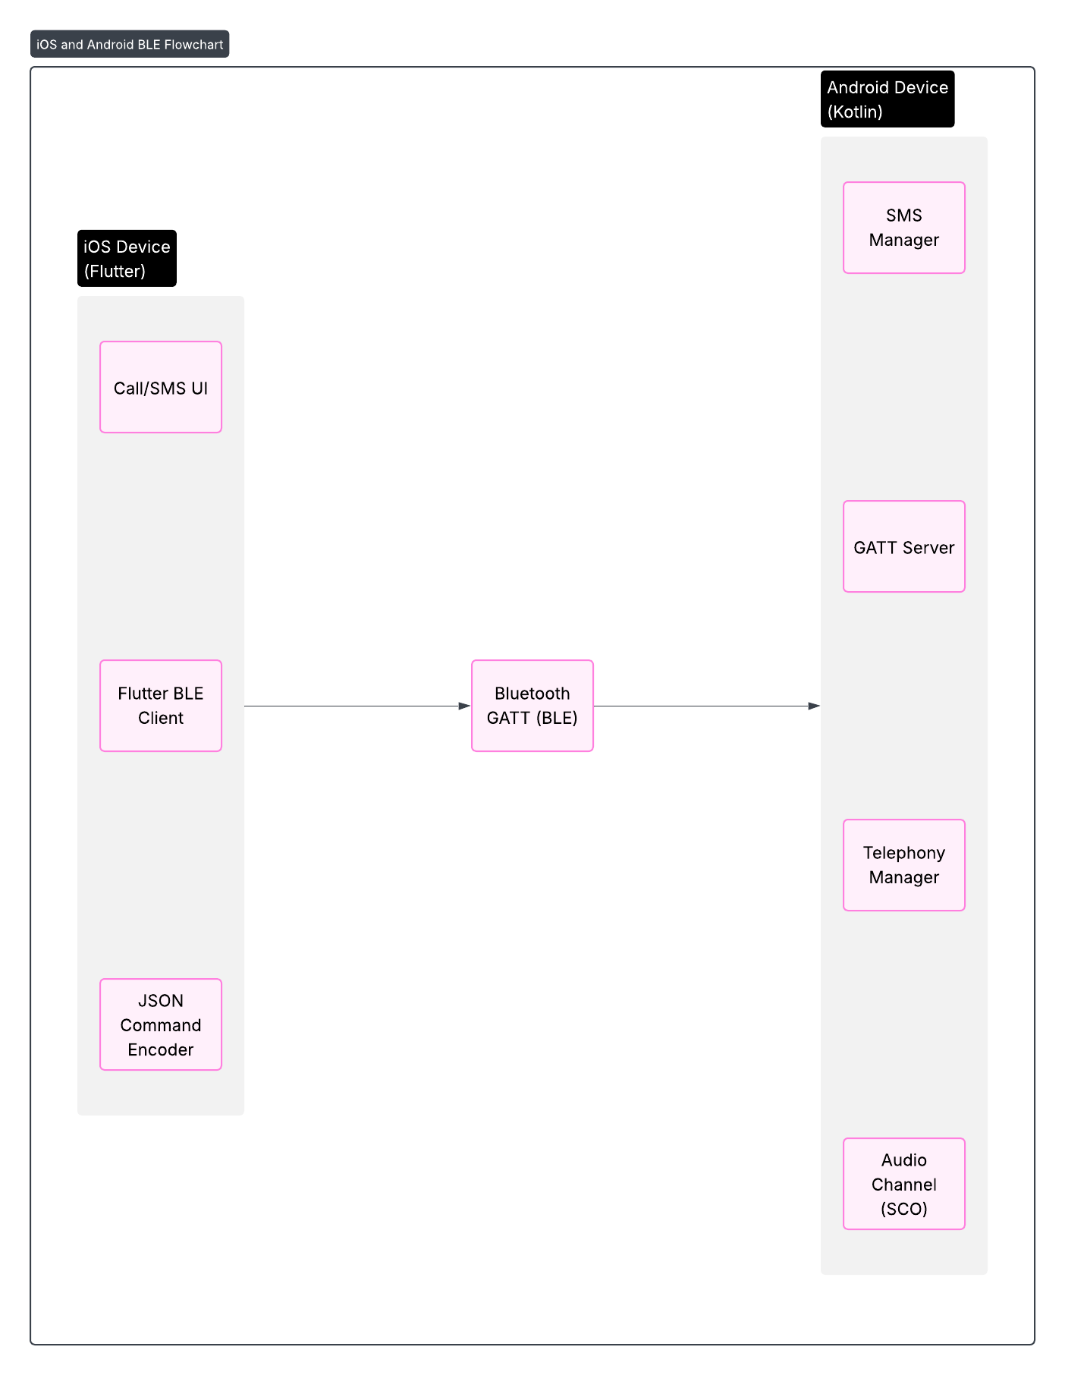

5. Technology Stack
Cross-Platform UI: Flutter (Dart)
Android Native: Kotlin / Java
Communication: Bluetooth Low Energy (BLE)
Audio Channel: Bluetooth SCO (Classic)
Build Tools: Android Studio, Flutter SDK, Gradle
Data Format: JSON

6. Functional Requirements
- FR-1: BLE Connection — iOS app connects to Android via Bluetooth GATT.
- FR-2: Dial Call — iOS app sends a command to Android to dial a number.
- FR-3: Receive Call — Android notifies iOS of incoming calls.
- FR-4: Send SMS — iOS app sends SMS via Android’s SIM.
- FR-5: Receive SMS — Android forwards SMS to iOS.
- FR-6: Bluetooth Data Exchange — Commands exchanged in JSON format.
- FR-7: Audio Routing — Audio transferred bidirectionally using Bluetooth SCO during calls.

7. Development Phases
Phase 1 — Bluetooth Bridge: Setup BLE communication between devices using JSON commands.
Phase 2 — Telephony Integration: Use TelephonyManager to make and receive calls via Android.
Phase 3 — SMS Integration: Implement SMS send/receive using SmsManager.
Phase 4 — Audio Routing: Enable bidirectional audio using Bluetooth SCO.
Phase 5 — iOS Integration: Build Flutter iOS app and test full functionality.

8. Challenges and Solutions
iOS BLE Limitations: Keep iOS as BLE client, Android as server.
Bluetooth Stability: Implement auto-reconnect logic in Flutter.
Audio Transfer: Use Bluetooth SCO for real-time audio streaming.
Permissions: Handle CALL, SMS, and BLUETOOTH permissions properly.

9. Conclusion
This project demonstrates a successful integration between iOS and Android using Bluetooth. It enables call and SMS operations through Android’s SIM, with audio routing over Bluetooth SCO. The modular architecture ensures scalability and cross-platform support for future enhancements.

