

Creative Technology Solutions

# **CS 230 Project Software Design Template**

Version 1.0

## Table of Contents

**CS 230 Project Software Design Template** 1

**Table of Contents** 2

**Document Revision History** 2

**Executive Summary** 3

**Design Constraints** 3

**System Architecture View** 3

**Domain Model** 3

**Evaluation** 3

**Recommendations** 5

## Document Revision History

| Version | Date | Author | Comments |
| --- | --- | --- | --- |
| 1.0 | 11/15/2020 | Nasir Wright | Implementation of a new web-based game environment. |

## Executive Summary

Creative Technology Solutions is looking to implement a multi-player gaming app for their client, The Gaming Room. The issue is that the staff at The Gaming Room does not know how to set up the web environment and they need help to streamline the game. The main priority would be to make the game compatible with all mobile devices. Then, dictation of the number of players and teams that can exist in one game session. Lastly, the security components need to go into place as far as saving data and protecting data with the use of unique passwords and user names.

## Design Constraints

Constraints of the application are as follows:Disrupted stream time in regards to data connectivity. Hardware not compatible with software. These issues would cause game play to not be fluent and connectivity issues among players and game servers.

## System Architecture View

Player>Team>Game Session>Puzzle Selection>Number of Rounds>Time Limit>

## Domain Model

**The program runs on a Singletontester. It starts off by identifying the user’s name. Next, the game lets you pick your team, player and game. In sequence, You choose the player id first, then the team/size of team, and then the game type.**

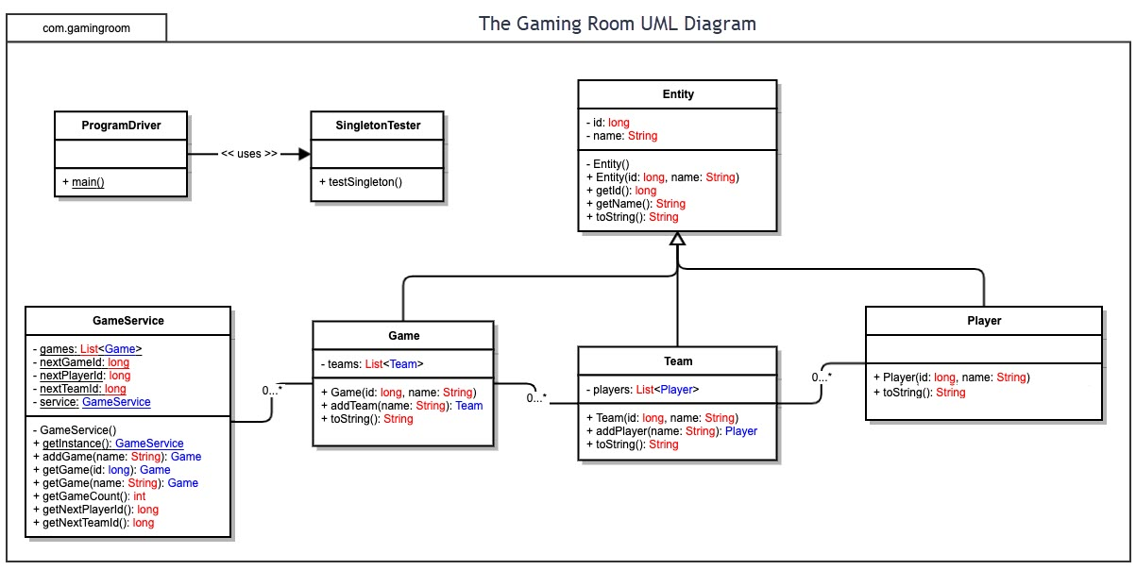

## Evaluation

Using your experience to evaluate the characteristics, advantages, and weaknesses of each operating platform (Linux, Mac, and Windows) as well as mobile devices, consider the requirements outlined below and articulate your findings for each. As you complete the table, keep in mind your client’s requirements and look at the situation holistically, as it all has to work together.

In each cell, remove the bracketed prompt and write your own paragraph response covering the indicated information.

| **Development Requirements** | **Mac** | **Linux** | **Windows** | **Mobile Devices** |
| --- | --- | --- | --- | --- |
| **Server Side** | Mac is compatible with mainly Apple products, so it is better ran with those products. Overall, Mac has superior processors and gaming technologies to aid with efficient game play. | The Linux operating system is mainly used in storage and memory aspects. In particular, I don’t think it has servers that can run a web-based video game as the primary operating system. | Windows is an operating system that is responsible for gaming on mobile devices as well as computers. Although windows is efficient, there are many loop holes and tricks that allow hackers to infiltrate its systems. | Mobile Devices nowadays are designed to mirror and basically take the place of CPUs.. The only downside is that the graphics and game play may be altered because of screen size and memory capabilities. |
| **Client Side** | The cost of the development with Mac will increase by a lot. Granted, the technology will be fast and efficient. The technology that Mac provides is very accessible and easy to understand and operate. | Linux is a system that will be very affordable and easy to use. In regards, the operating may slow and not efficient enough to support multiple players and game sessions. | Windows is very affordable and efficient when it comes to operating systems. In regards to running a web based game environment, I think it will work efficiently. | Mobile Devices in general can vary from price to price. Along with different operating systems involved, prices can vary. I think this would be the best tool to create and use a web based mobile game. |
| **Development Tools** | The relevant programming languages that are used to develop Mac software is called Swift. This program is used in most IOS devices | The programming languages used in Linux applications are Java and Python | Windows main programming language is C or C++. This language is key in Windows based applications. | The main programming languages used while developing mobile devices are JavaScript, C++, and Python. These systems are initialized in most mobile devices. |

## Recommendations

Analyze the characteristics of and techniques specific to various systems architectures and make a recommendation to The Gaming Room. Specifically, address the following:

1. **Operating Platform**: I believe Mac would be the best option to develop the web based mobile application for The Gaming Room.
2. **Operating Systems Architectures**: Mac operating system is efficient, responsive, and faster than the other platforms in regards to gaming.
3. **Storage Management**: An appropriate storage system would be to have multiple storage spots within the app and also cloud auto saving via Mac operating platform. This ensures safety of data and storage capabilities.
4. **Memory Management**: The system is able to save past data and current data during sessions and after.
5. **Distributed Systems and Networks**: Draw it or Lose it would have to be a downloaded application among mobile devices and different consoles. Connectivity is an issue with any application or game so that’s the least with an application powered by Mac. The application should provide and offline feature as well to be able to operate the application without internet connection to make it more accessible.
6. **Security**: Mac offers facial recognition and finger print touch, so i believe those features should be incorporated into the gaming application. Those feature would be used to access the game and save data within the application.