**To Run the Solution locally**:

1. Clone the Repository(https://github.com/Nasirali-Kovvuru/Tools\_and\_Technologies\_Learning.git) to your working directory.
2. Move to the project “[nodejs\_task\_mentime](https://github.com/Nasirali-Kovvuru/Tools_and_Technologies_Learning/tree/main/nodejs_task_mentime" \o "nodejs_task_mentime)” by using “cd” utility.

*# cd* [*nodejs\_task\_mentime*](https://github.com/Nasirali-Kovvuru/Tools_and_Technologies_Learning/tree/main/nodejs_task_mentime)

1. If “nodejs” application not installed in your system, please install it from the official website: <https://nodejs.org/en/download/>
2. Install the dependencies by using npm package manager:

*# npm install cors*

*# npm install express*

1. Then, run *#npm run start*
2. The above command would start a web service for you with Restful APIs exposed.
3. Another way to do the steps 1 to 6, is by using docker image from the docker hub registry: <https://hub.docker.com/r/nasirali568/mentimet-node-server>
4. Download the above docker image from docker registry.
5. Build the image and run the image with appropriate port binding from port 8081 of the container.

Building image from local directory:

*# docker build -t mentimet-node-server .*

Run image

# docker run -d -p 8081:8081 mentimet-node-server

1. To ensure API endpoints are working fine, check the following Example Urls correctly exposed:

<http://localhost:8081/questions>

<http://localhost:8081/results>

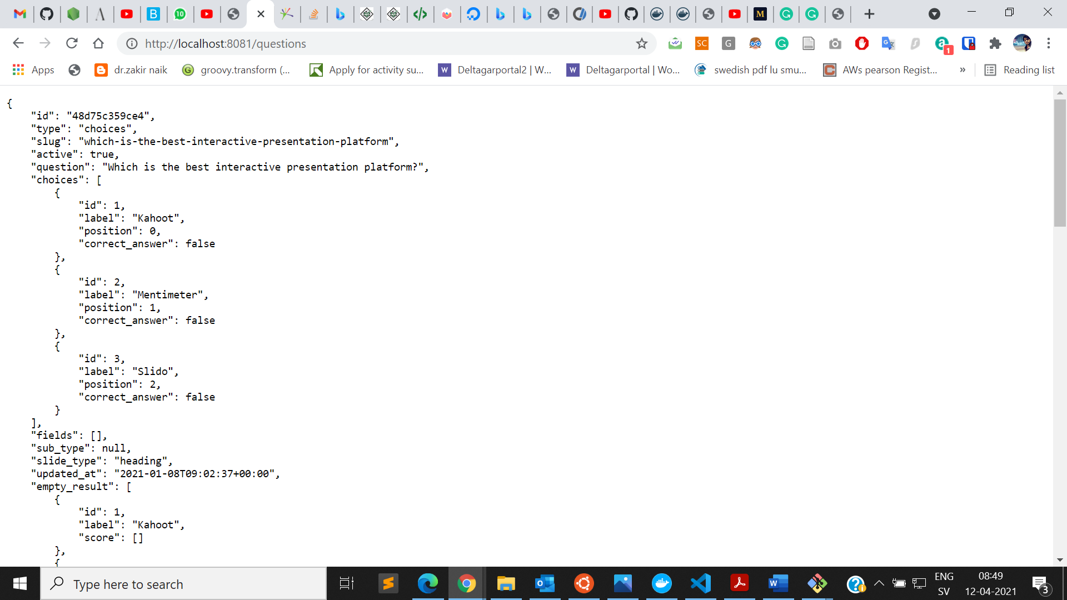

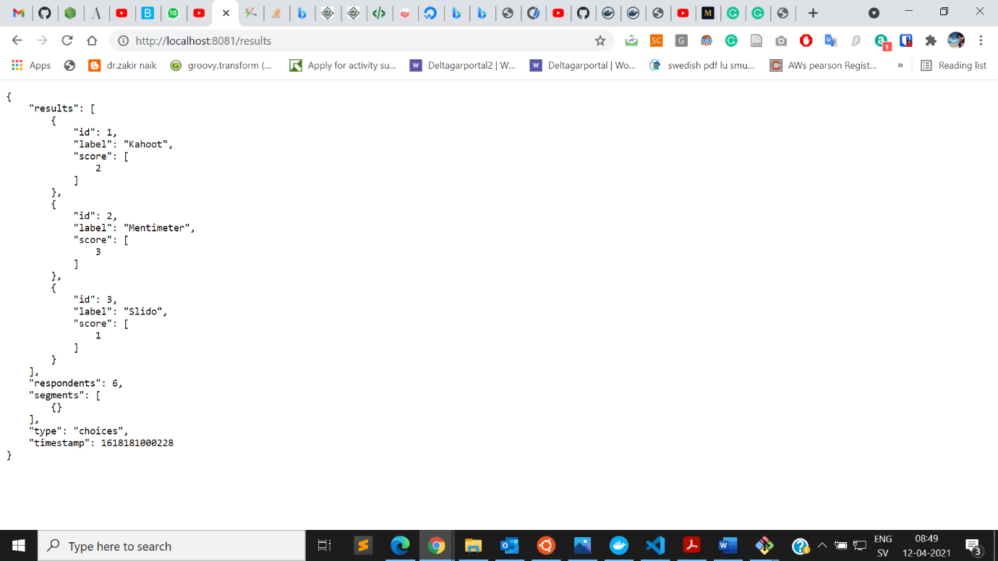

1. Now, change directory to “frotend\_service” directory and run “index.html” file. It would return following output.

