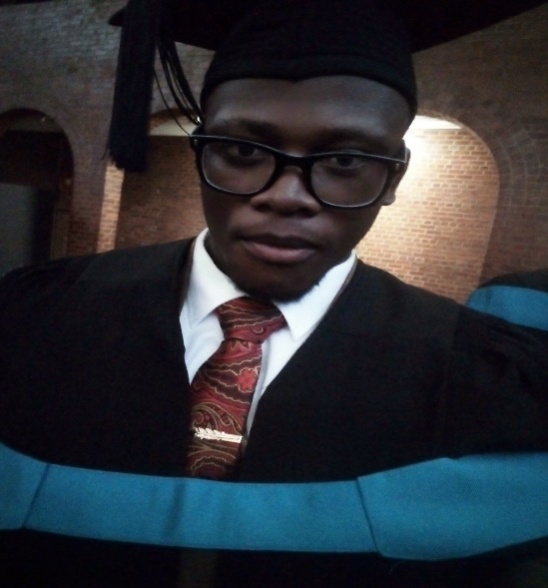

I am a highly driven individual who likes the thrill of a challenge. I am very ambitious about life and enjoy acquire knowledge, whether it being from reading, research or an insightful conversation with a person. A team-player is my star quality and communicate well with others. I am a goal-orientated person and prefer busy schedules as I can cope well under-pressure.

PROFILE

Information Technology Graduate

**NEO KOBUOE**

✆0742933364🖂newkobuoe@gmail.com🕿0562121228

EDUCATION

SKILLS

**Higher Certificate in IT**

**Pearson Institute of Higher Education**

**East London**

EDUCATION

2013-2014

This was an introduction to my dream career which is Information Technology and the first exposure to real-life situations. This experience moulded and taught me a great deal and really learned a lot in my higher certificate first year.

**PROFESSIONAL**

* Deadline Driven
* Direct customer relationships
* Time Management
* Management skills
* Computer Literate
* Communication skills
* Problem solving skills
* Research & Presentation skill
* Good analytical skills
* Able to delegate

**PERSONAL**

* Able to work well under pressure, prioritise workload and work on deadlines
* Take own initiative
* Excellent written and verbal skills
* Highly motivated with a positive attitude
* Reliable and punctual
* Responsible and trustworthy
* Planning and organisational skills

**Pearson Institute of Higher Education**

**Bloemfontein**

**Bachelor of Science in IT**

This came to being a great challenge in my life and taught me immense life skills and lessons. Creating systems was my favourite experience, from design to implementation and constantly strive to improve on that aspect of the degree.

2015-2018

CAREER HISTORY

**Royal Elegant Homeware – Store Manager**

Although this is a family business, it demands a lot of attention-to-detail traits as well as a business spirit.

* Regular Stock-taking
* Record customer orders and tracking
* Managing Lay-byes an daily operations using POS software
* Keeping track of financials (monthly)
* Interacting with a variety of customers
* Researching new products
* Networking with catering and event companies

November 2016 - Current

CAREER HISTORY



CAREER HISTORY

My roles at Shell Ultra City were to pack products, manage fridges, clean, and ensure quality of products of the Select store. I would also occasionally work as a petrol jockey and enjoyed the responsibility of doing stock count and this part-time job helped me manage time and accountability.

**CTI Education Group-Bloemfontein**

**Owner**

**Tewie Wessels**

0824478932

**Shell Ultra City- Kroonstad**

**Owner of Royal Elegant Homeware/Mother**

**Eunice Kobuoe**

0846203213/0562164204

**Department of Correctional Services**

**Campus Coordinator**

**Grizelda Goosen**

+27 51 430 2701

November 2014 - January 2015

**Shell Ultra City - Kroonstad**

REFERENCES





















