**Paperless Ticketing Using Face Recognition for Metro Rail**

A Mini Project report

Submitted in the partial fulfillment of the requirements for

the award of the degree of

Bachelor of Technology

in

Computer Science and Engineering

By

DUDEKULA NASREEN

19761A0581

Under the guidance of

Mr.A.Sree Rama Chandra Murthy

Sr. Assistant Professor



**Department of Computer Science and Engineering**

**Lakireddy Bali Reddy College of Engineering (Autonomous)**

**Accredited by NAAC & NBA (Under Tier - I)**

**Affiliated to JNTUK, Kakinada; ISO 9001:2015 Certified**

**2020-2021**



**Certificate**

This is to certify that the project entitled “**Paperless Ticketing Using Face Recognition for Metro Rail**” is being submitted by **Dudekula Nasreen** in partial fulfillment for the award of B.Tech in Computer Science & Engineering to the Jawaharlal Nehru Technological University Kakinada is a record of bonafide work carried out by her under our guidance.

The results embodied in this project report have not been submitted to any other University or Institute for the award of any degree or diploma.

**Project guide Head of the department**

Mr.A.Sree Rama Chandra Murthy Dr.D.Veeraiah

Sr. Assistant Professor Professor

**External Examiner**

**ACKNOWLEDGEMENT**

I would like to thank **Mr.A.Sree Rama Chandra Murthy,** Sr.Assistant Professor**,** CSE department for the encouraging and support in carrying out this project.

I would like to thank Mini-Project In-charge **Mr. A. Raja Gopal**, Sr. Assistant Professor**, CSE department** for the encouraging and support in carrying out this project.

I also take the privilege to record my thanks to **Dr. D.Veeraiah,** Head of the Department of CSE whose encouragement, cooperation and valuable support crown our success.

I express my thanks to the support given by management in completing my thesis. I also express my sincere gratitude & deep sense of respect to the Principal, **Dr.K.Appa Rao** for making us available all the required assistance and his support and inspiration to carry out this project in the Institute.

I am thankful to the teaching and non-teaching staff of CSE department for their direct as well as indirect help in my project.

I am elated to avail my selves to this opportunity to express my deep sense of gratitude to my parents.

**Paperless Ticketing Using Face Recognition for Metro Rail**

**ABSTRACT**

Paperless Ticketing Using Face Recognition for Metro Rail is to improve the metro rail ticketing system which is more efficient without paper. Now a days traffic is increasing which leads to increase the fuel cost and pollution. The solution to eradicate this problem is public transport system. This is safe and it can transport many persons at a time. Metro is one of the public transport system which is safe and which runs with high speed. To use the metro trains passengers need some metro cards, paper tickets with barcodes etc. The main aim of this project is to improve the metro rail ticketing system is more efficient without paper. As face is one of the easiest ways to distinguish the individual identity of a person, we are planning to use Face recognition to implement a Paperless ticketing system. So if we use this ticketing method then passengers can easily enter in to the metro, they can overcome problem of forgetting metro cards etc.. which are required to enter into the metro.

**Table of Contents**

1.Introduction

2.Objective

3.Face Recognition

4.System Analysis

5.System Configuration

6.System Architecture

7.Modules

* Administrator
* Station master
* Entrance verification
* Exit validation

8.Conclusion

**INTRODUCTION**

Time and convenience have great importance in human life. We are trying to make metro rail ticketing system more efficient without paper. As face is one of the easiest ways to distinguish the individual identity of a person, we are planning to use Face recognition to implement a Paperless ticketing system.

**OBJECTIVE**

To make Metro rail ticketing system more efficient and convenient without paper.

**FACE RECOGNITION**

A biometric is a biometric software application capable of uniquely identifying or verifying a person by comparing and analyzing pattern based on the persons facial contours.

**SYSTEM ANALYSIS**

**Existing System**

Paper tickets with barcodes are used as entry

And exit pass for metro rail transport.

**Drawbacks**

* Inconvenience for safe keeping of paper tickets
* Wastage of paper
* Time consuming

**Proposed System**

A paperless ticketing system using face recognition by identifying and analyzing the shape of a person’s face. Each face has approximately 80 unique nodal points which distinguishes one from another.

**Advantages**

* Convenient
* Eco-friendly
* Time saving

**SYSTEM CONFIGURATION**

**Software Specification**

* OS : MS Windows7 or higher versions/ Ubuntu 14.04
* Opencv
* Python 3.7
* Mysql

**Hardware Specification**

* Intel Core 2 Duo/Quad or higher and 64bit processor
* Hard Disk capacity of 1- 4TB, 4 GB RAM or more
* Input devices: keyboard, digital camera
* Output device : computer monitor

**SYSTEM ARCHITECTURE**

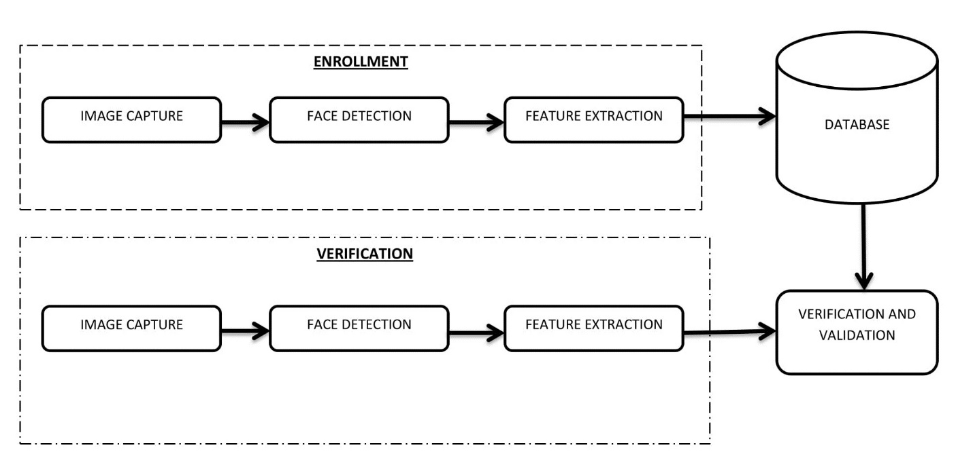

**MODULES**

**Administrator**

* Station master management
* Database management
* Rules and regulations
* Fare rate calculation

**Station master**

* Ticket reservation
  + - Face capturing
    - Details collection
      * + Name
        + Contact details - phone number
        + From station
        + Destination
* Ticket cancellation
  + - Database update

**Entrance Verification**

* Face recognition
* Verification
* Time stamp allocation
* Ticket activation

**Exit Validation**

* Face recognition
* Verification
* Time stamp checking
* Ticket deactivation

**STATION MASTER MODULE**

**Station Master Functions**

* Station Validation
  + Station Username
  + Password
* Ticketing
  + Name
  + Destination
  + Fare calculation
  + Face Detection, Capture & Storing

**Station Table**

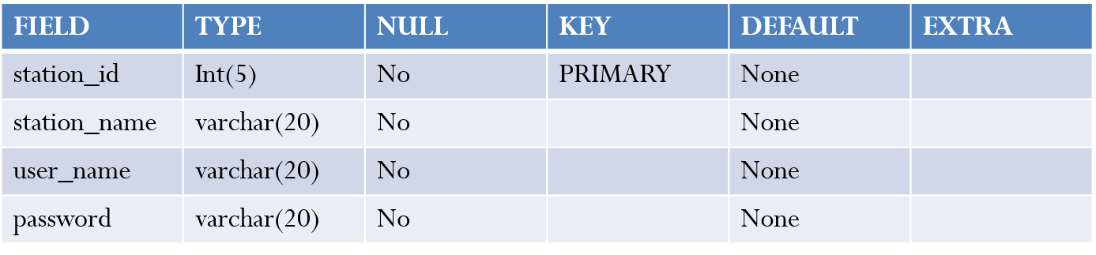

**Passenger Table**

**Use-Case Diagram**

**SCREENSHOTS**

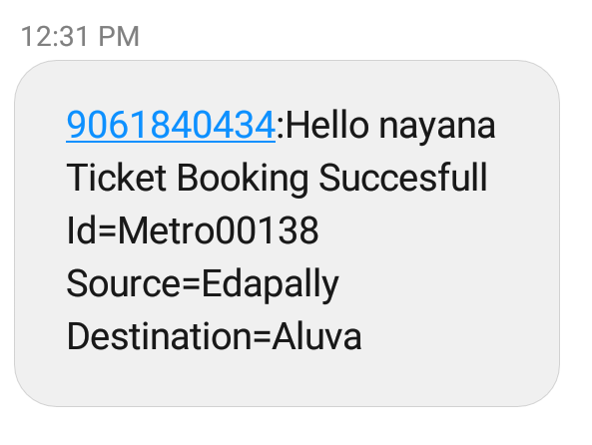

**CONCLUSION**

We are trying to create a convenient and time saving ticketing model for metro rail ticketing with the help of face recognition technique.