**PROBLEM ASSISTED LEARNING (17PD01)**

COUNSELLOR’S DAIRY

**Report Submitted**

**in partial fulfillment of the requirements for the award of the Degree of**

**BACHELOR OF TECHNOLOGY**

**In**

**COMPUTER SCIENCE & ENGINEERING**

**By**

**DUDEKULA NASREEN 19761A0581**

## Under the guidance of

## J. NAGESWARA RAO

## Sr. Assistant Professor



**DEPARTMENT OF COMPUTER SCIENCE & ENGINEERING**

**LAKIREDDY BALI REDDY COLLEGE OF ENGINEERING (AUTONOMOUS)**

Accredited by NAAC & NBA (Under Tier I) and ISO 9001:2015 Certified Institution

Approved by AICTE, New Delhi & Affiliated to JNTUK, Kakinada

L.B.Reddy Nagar, Mylavaram, Krishna Dt, A.P-521230

**2019 – 2023**

**LAKIREDDY BALI REDDY COLLEGE OF ENGINEERING (AUTONOMOUS)**

Accredited by NAAC & NBA (Under Tier I) and ISO 9001:2015 Certified Institution

Approved by AICTE, New Delhi & Affiliated to JNTUK, Kakinada

L.B.Reddy Nagar, Mylavaram, Krishna Dt, A.P-521230

**Department Of**

**COMPUTER SCIENCE & ENGINEERING**



**CERTIFICATE**

This is to certify that the a report entitled “Counsellor’s Dairy**”** for Problem Assisted Learning(PAL) is being submitted by  **DUDEKULA NASREEN, 19761A0581** in partial fulfillment of the requirements for the award of degree of B**.Tech** in **Computer Science & Engineering** from **Jawaharlal Nehru Technological University Kakinada** is a record of bonafide work carried out by them at **Lakireddy Bali Reddy College of Engineering.**

**PAL GUIDE HEAD OF THE DEPARTMENT**

**J. Nageswara Rao Dr. D. Veeraiah**

**Sr. Assistant Professor Professor**

**DECLARATION**

I here by declaring that the report entitled **“Counsellor’s Dairy”**  for Problem Assisted Learning(PAL) work done by me. I certify that the work contained in the report is original and has been done by me under the guidance of supervisor. The work has not been submitted to any other institute in preparing for any degree or diploma. I have followed the guidelines provided by the institute in preparing the report. I have conformed to the norms and guidelines given in the ethical code of conduct of the institute. Whenever I have used materials (data, theoretical analysis, figures and text) from other sources, I have given due credit to them by citing them in the text of the report and giving their details in the references. Further, I have taken permission from the copyrights owner of the sources, whenever necessary**.**

**Signature of the student**

**DUDEKULA NASREEN**

**19761A0581**

***COUNSELLOR’S DAIRY***

**ABSTRACT**

*In this project, I am developing Android based application which is useful for counsellor’s to keep track for their students details. By using this application counsellors can get information in mobile(small, portable)which is available everytime. Whenever the counsellors need information regarding their students. They can easily get by their mobile. In this app, I am providing information like Name, Roll No., Mobile No., Parent Details, CGPA, Attendance, Backlogs, Category(Management/BC-Scholar),Hostel/Bus, Fees Due. If there is any change in student details, Counsellor can modify this information using edit screen. We are providing one touch call and message options in this application. So, Counsellors can feel comfort and easy to use.*

***COUNSELLOR’S DAIRY***

**INTRODUCTION / BACKGROUND / LITERATURE STUDY**

*In present Scenario, Counsellor’s are facing problems to get information about their students. There is no dedicated app available for this process for counsellors. Everyone has mobile with them. So, If an app is created for this then it will be easy for the counsellors. In this project, I am developing Android based application which is useful for counsellor’s to keep track for their students details. By using this application counsellors can get information in mobile(small, portable)which is available everytime. Whenever the counsellors need information regarding their students. They can easily get by their mobile. In this app, I am providing information like Name, Roll No., Mobile No., Parent Details, CGPA, Attendance, Backlogs, Category(Management/BC-Scholar),Hostel/Bus, Fees Due. If there is any change in student details, Counsellor can modify this information using edit screen. We are providing one touch call and message options in this application. So, Counsellors can feel comfort and easy to use.*

***Requirements:***

*Hardware Requirements:*

*Processor : Intel@ Dual Core 2.0 GHz minimum*

*Hard Disk: 250GB or more*

*RAM : 2GB or more*

*Software Requirements:*

*MIT App Inventor*

*The smartphone is an information nexus in today’s digital age, with access to a nearly infinite supply of content on the web, coupled with rich sensors and personal data. However, people have difficulty harnessing the full power of these ubiquitous devices for themselves and their communities. Most smartphone users consume technology without being able to produce it, even though local problems can often be solved with mobile devices. How then might they learn to leverage smartphone capabilities to solve real-world, everyday problems? MIT App Inventor is designed to democratize this technology and is used as a tool for learning computational thinking in a variety of educational contexts, teaching people to build apps to solve problems in their communities.*

*MIT App Inventor is an online development platform that anyone can leverage to solve real-world problems. It provides a web-based “What you see is what you get” (WYSIWYG) editor for building mobile phone applications targeting the Android and iOS operating systems. It uses a block-based programming language built on Google Blockly (Fraser,* [*2013*](https://link.springer.com/chapter/10.1007/978-981-13-6528-7_3#CR7)*) and inspired by languages such as StarLogo TNG (Begel & Klopfer,* [*2007*](https://link.springer.com/chapter/10.1007/978-981-13-6528-7_3#CR2)*) and Scratch (Resnick et al.,* [*2009*](https://link.springer.com/chapter/10.1007/978-981-13-6528-7_3#CR26)*; Maloney, Resnick, Rusk, Silverman, & Eastmond,* [*2010*](https://link.springer.com/chapter/10.1007/978-981-13-6528-7_3#CR14)*), empowering anyone to build a mobile phone app to meet a need. To date, 6.8 million people in over 190 countries have used App Inventor to build over 24 million apps. We offer the interface in more than a dozen languages. People around the world use App Inventor to provide mobile solutions to real problems in their families, communities, and the world. The platform has also been adapted to serve requirements of more specific populations, such as building apps for emergency/first responders (Jain et al.,* [*2015*](https://link.springer.com/chapter/10.1007/978-981-13-6528-7_3#CR10)*) and robotics (Papadakis & Orfanakis,* [*2016*](https://link.springer.com/chapter/10.1007/978-981-13-6528-7_3#CR20)*).*

**PROBLEM STATEMENT**

*In present Scenario, Counsellor’s are facing problems to get information about their students. There is no dedicated app available for this process for counsellors. In this project, I am developing Android based application which is useful for counsellor’s to keep track for their students details. By using this application counsellors can get information in mobile(small, portable)which is available everytime. Whenever the counsellors need information regarding their students. They can easily get by their mobile. In this app, I am providing information like Name, Roll No., Mobile No., Parent Details, CGPA,Attendance,Backlogs,Category(Management/BC-Scholar),Hostel/Bus, Fees Due. If there is any change in student details, Counsellor can modify this information using edit screen. We are providing one touch call and message options in this application. So, Counsellors can feel comfort and easy to use.*

*VIEW SCREEN DESIGNER*

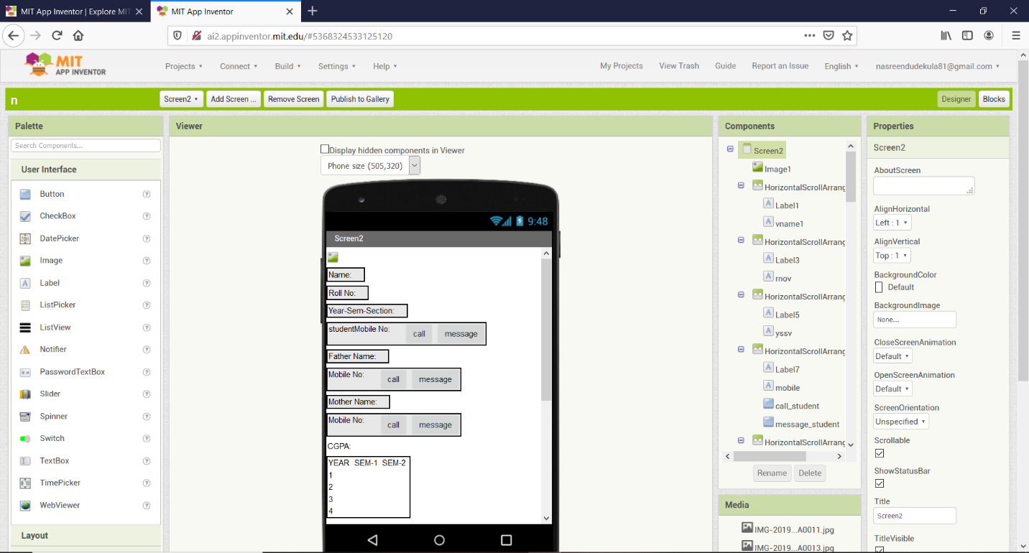

*EDIT SCREEN DESIGNER*

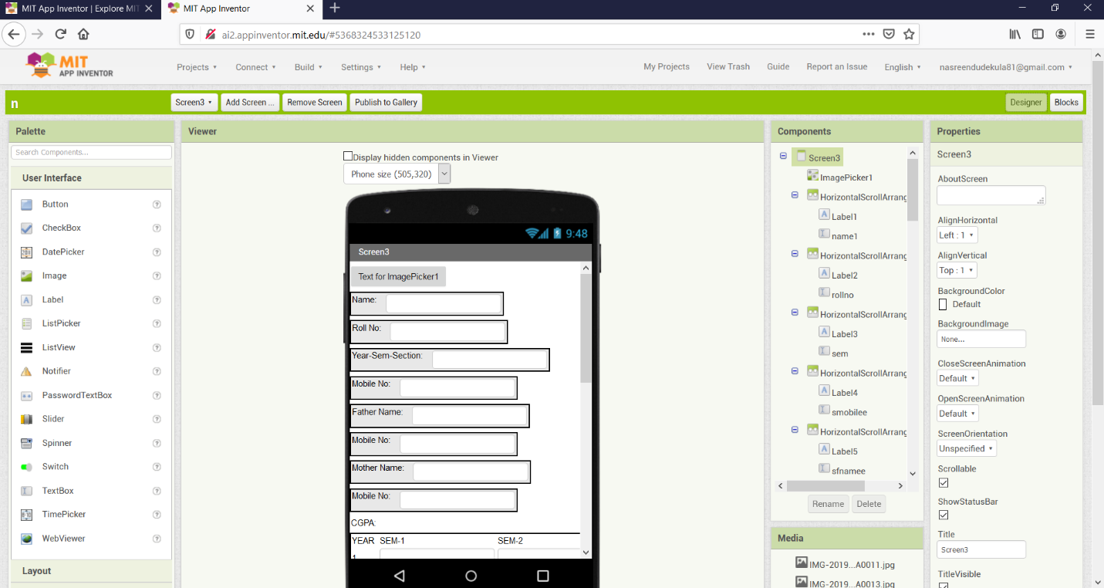

*VIEW SCREEN BLOCK*

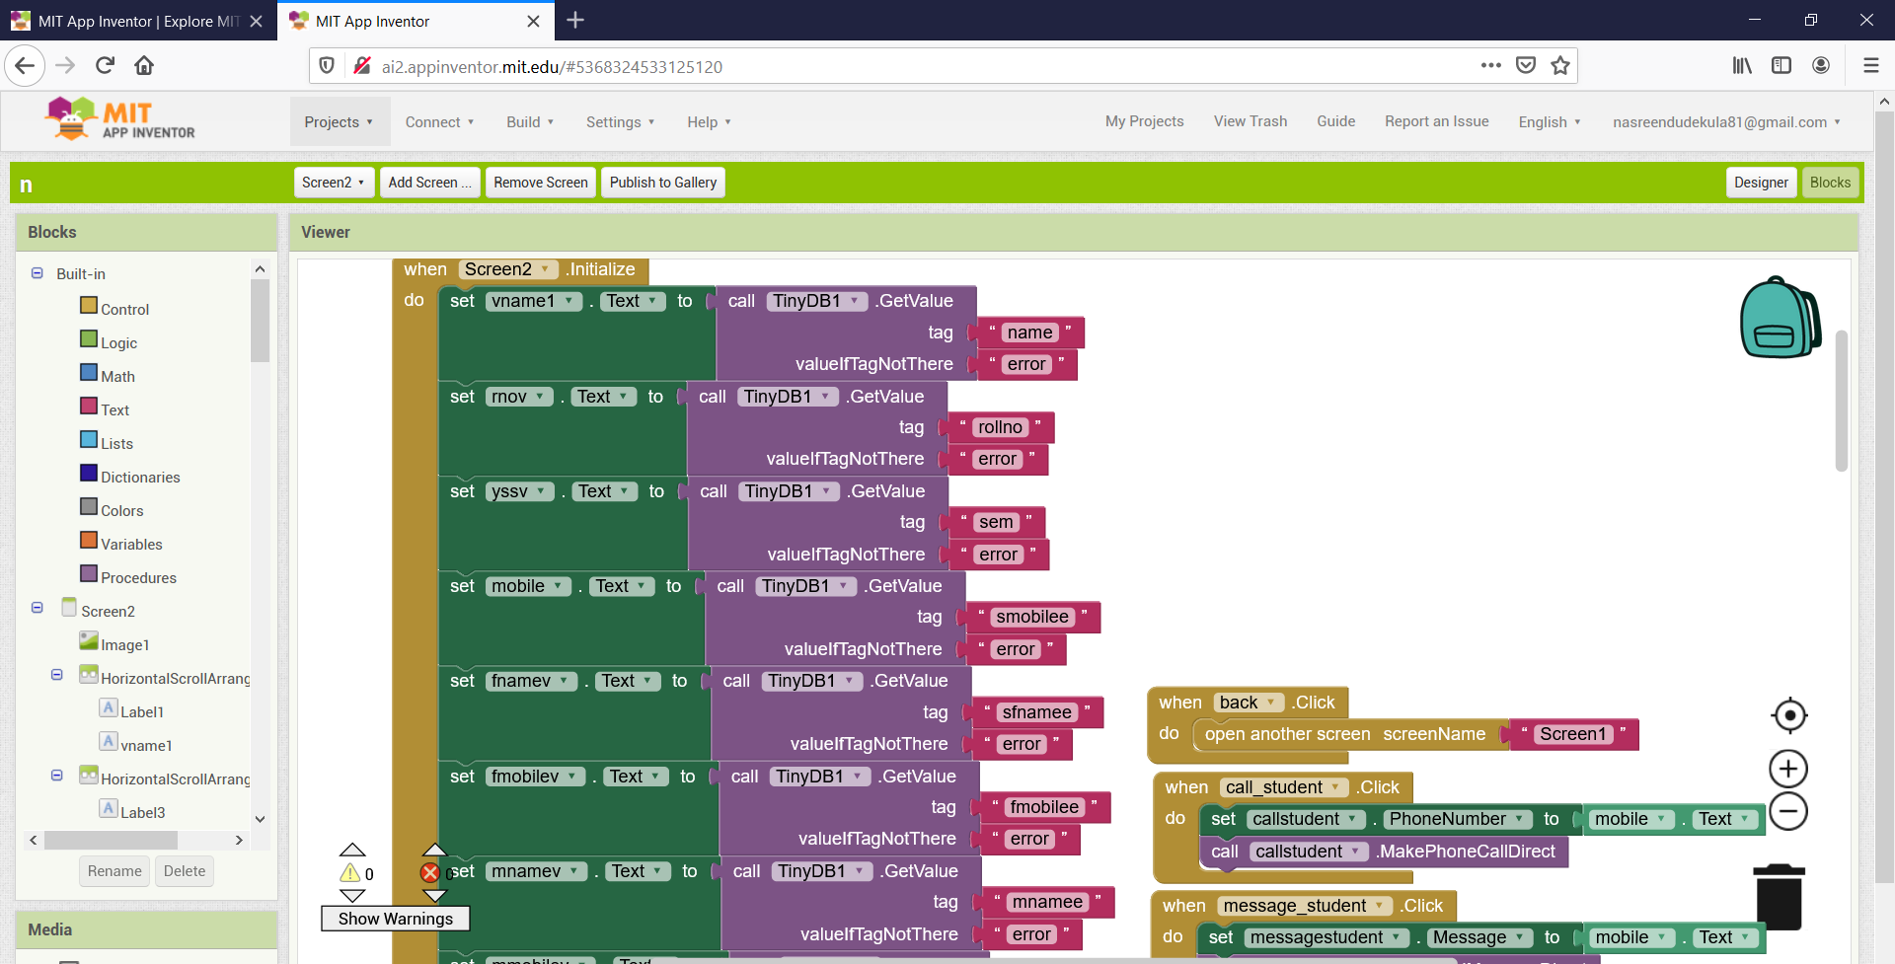

*EDIT SCREEN BLOCK*

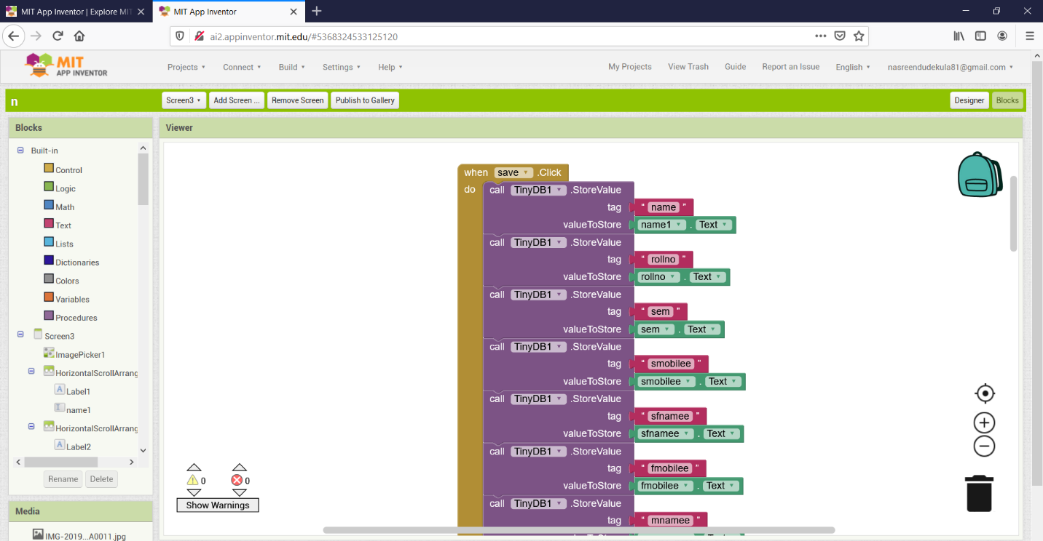

**DOMAIN / APPLICATION / BENEFICIARIES**

*In present Scenario, Counsellor’s are facing problems to get information about their students. There is no dedicated app available for this process for counsellors. Everyone has mobile with them. So, If an app is created for this then it will be easy for the counsellors. In this project, I am developing Android based application which is useful for counsellor’s to keep track for their students details. By using this application counsellors can get information in mobile(small, portable)which is available everytime. Whenever the counsellors need information regarding their students. They can easily get by their mobile. In this app, I am providing information like Name, Roll No., Mobile No., Parent Details, CGPA, Attendance, Backlogs, Category(Management/BC-Scholar),Hostel/Bus, Fees Due. If there is any change in student details, Counsellor can modify this information using edit screen. We are providing one touch call and message options in this application. So, Counsellors can feel comfort and easy to use.*

*VIEW SCREEN:*

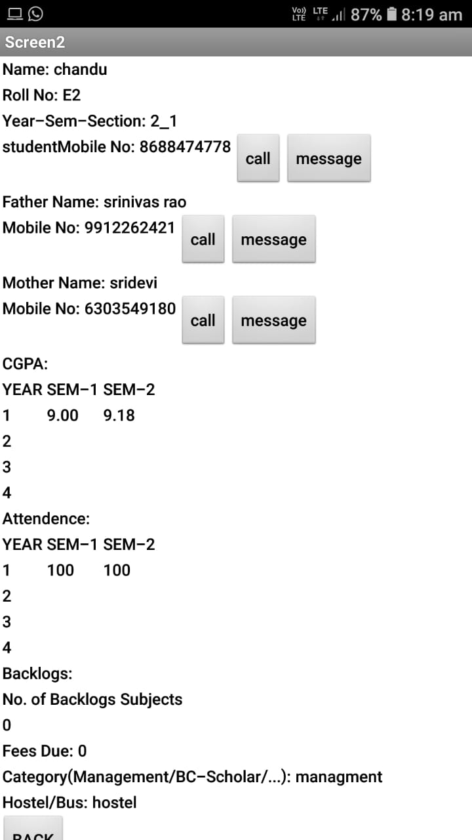

*EDIT SCREEN:*

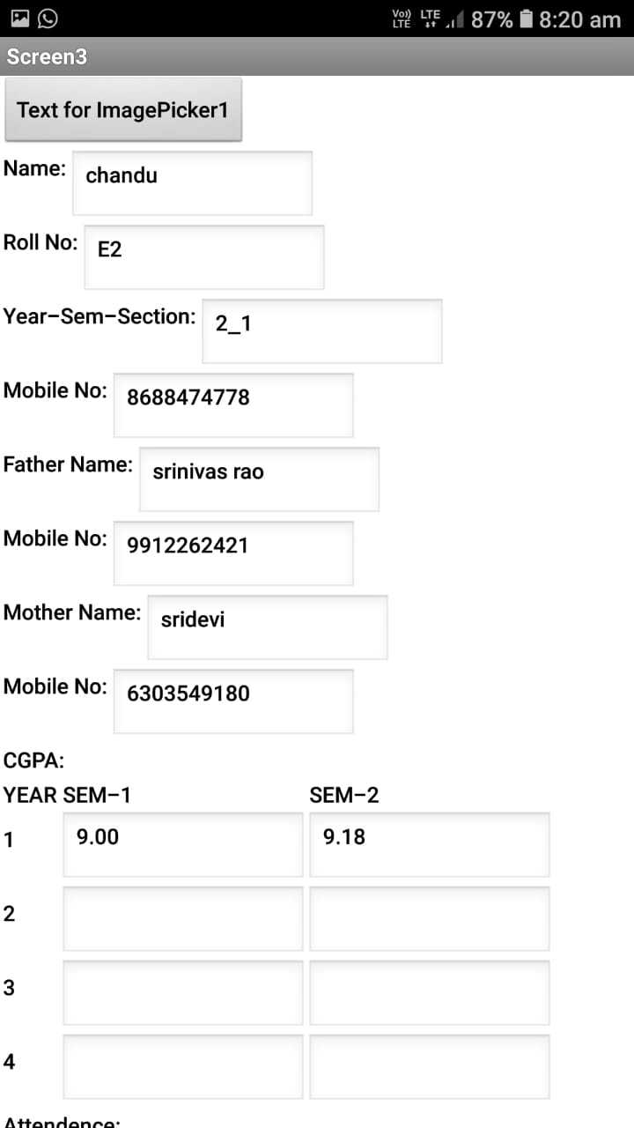

**SOURCES / WEBLINKS/ REFERENCES**

**[ 1 ] http://appinventor.mit.edu/explore/ai2/beginner-videos**

**[ 2 ]** **http://appinventor.mit.edu/explore**

**[ 3 ] http://ai2.appinventor.mit.edu/#5368324533125120**

**[ 4 ] https://www.youtube.com/watch?v=BT4YihNXiYw**

**[ 5 ]** [**https://www.youtube.com/watch?v=BT4YihNXiYw&list=**](https://www.youtube.com/watch?v=BT4YihNXiYw&list=)

**PL7sbjUYIdF3Ux_UrRiBaC73OrJLvLza4u**

**….**