Assignment 2
Technical Analysis Using R
Student Name - .Nasreen Malik
Student ID – 664429257
Course – Data Science Tools and Techniques (BDA400)

GitHub Link: https://github.com/NasreenMalik29257/TechnicalAnalysis.git
1. Objective and Approach
This project establishes a reproducible R workflow to import historical stock prices, summarize price behavior, and visualize short-term trends. Five technology-related stocks were selected: NVIDIA (NVDA), Meta (META), Netflix (NFLX), AMD (AMD), and Intel (INTC). The analysis uses Yahoo Finance price data retrieved with quantmod beginning January 1, 2025. It compares daily closing prices with a 30-trading-day simple moving average.
2. Setup and Files
A Posit Cloud RStudio project, BDA400_StockMarket_Nasreen, was used to develop and run the code. The portfolio.txt file contains one ticker per line. The R script nasreen_stock_analysis.R reads this list, retrieves prices, calculates descriptive statistics, and exports five PNG charts. The project uses quantmod, TTR, ggplot2 and dplyr in its R environment.
The script uses a custom import_portfolio_data() function, tryCatch() to handle unsuccessful downloads, and a summarize_stock_prices() function for calculations. The resulting files were uploaded to the Assignment2 directory in the TechnicalAnalysis GitHub repository.
Initial Posit Cloud project setup before analysis.
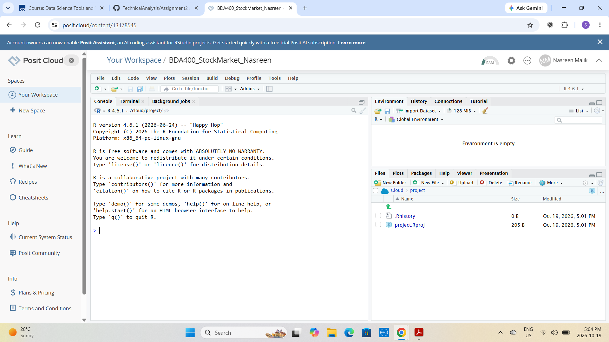

R package installation and successful loading during initial setup.
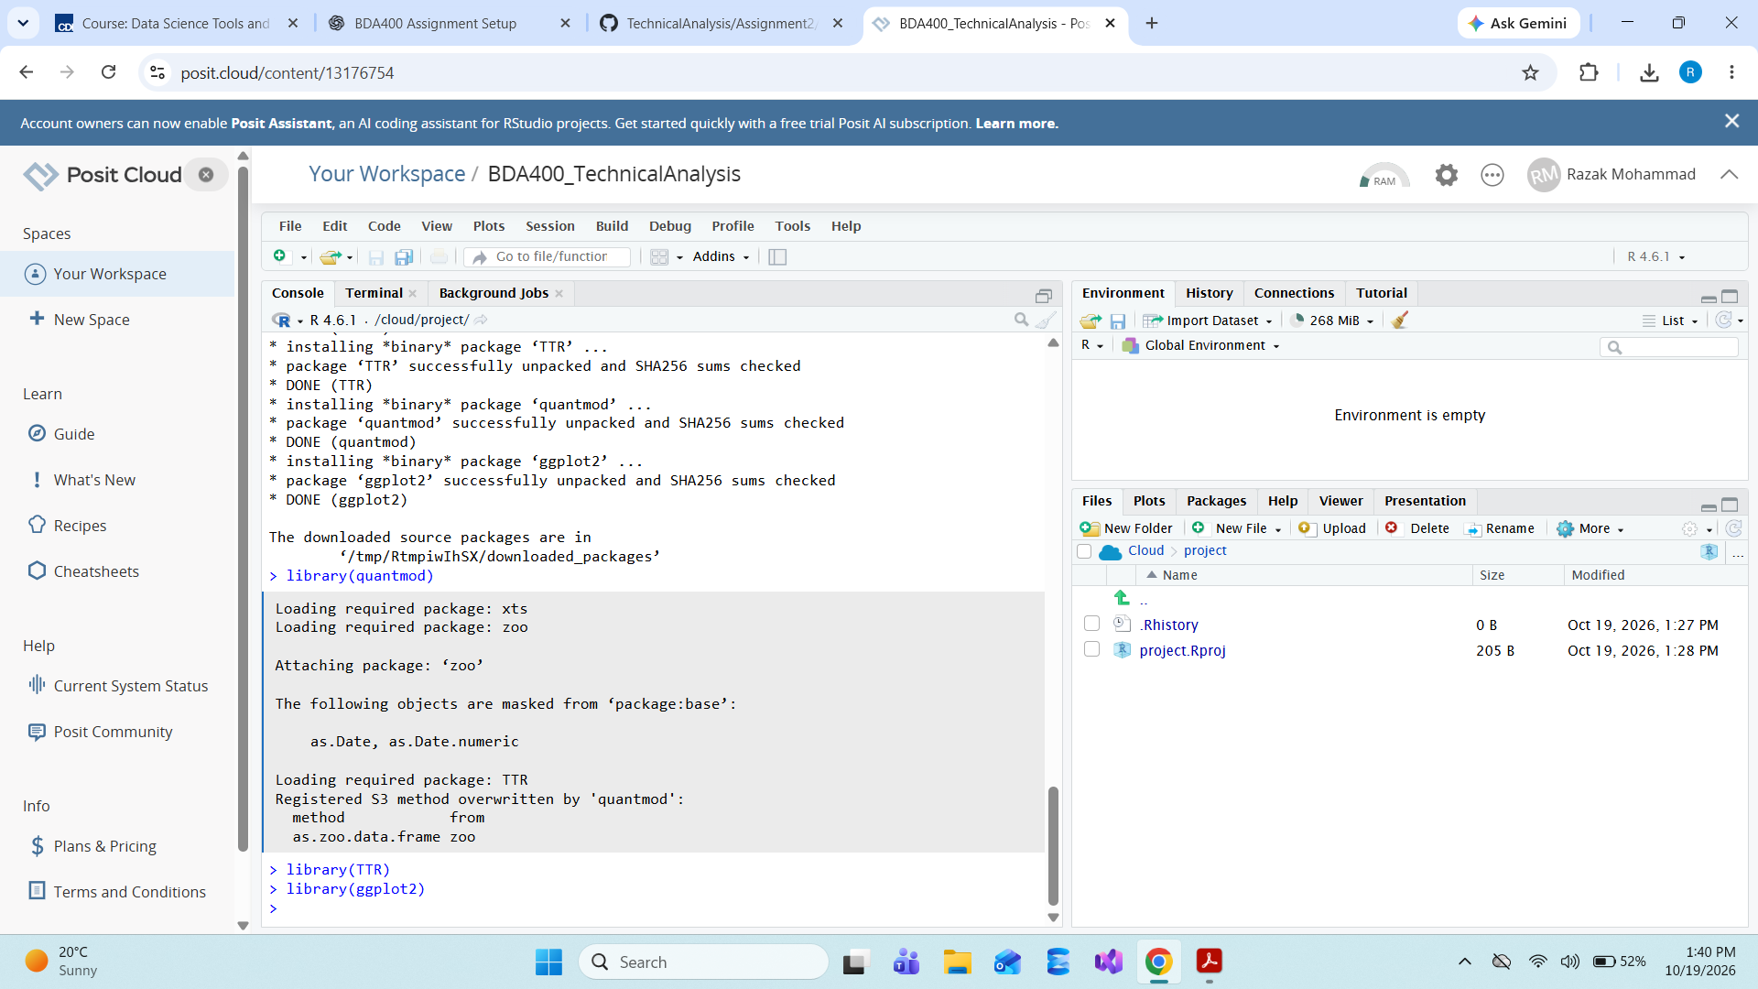
3. Descriptive Statistics
The following output was recorded in Posit Cloud on October 19, 2026. Figures are rounded to two decimal places; they describe the retrieved sample, not expected future returns.
Ticker | Mean ($) | Median ($) | Mode ($) | SD ($) | Latest MA30 ($)
NVDA | 175.69 | 182.02 | 177.82 | 35.02 | 225.29
META | 652.85 | 648.18 | 586.00 | 64.72 | 708.30
NFLX | 97.79 | 95.19 | 76.02 | 17.68 | 72.42
AMD | 260.04 | 205.37 | 96.65 | 160.54 | 578.24
INTC | 52.20 | 37.81 | 20.68 | 35.99 | 109.13
Mean is the average closing price; median is the midpoint; standard deviation summarizes price variability. The reported mode is the first most-frequent observed price, which may be of limited interpretive value for continuously varying market prices. MA30 is the most recent 30-observation simple moving average.
In this sample, AMD has the largest price standard deviation (about $160.54), while NFLX has the smallest (about $17.68). These are dollar-scale comparisons, not percentage-volatility rankings. The latest MA30 values are sample end-point summaries and should not be interpreted as price forecasts.

4. Charts and Interpretation
Five charts were exported at 300 dpi, one per ticker. Each plots the daily closing price alongside a 30-day moving average. The moving average smooths short-term fluctuations but reacts to price changes with a lag. For INTC, the chart shows a pronounced price rise followed by substantial fluctuations, while the moving-average line follows the overall direction more smoothly. This visual pattern alone does not establish the cause of the changes.
Generated files: NVDA_market_trend.png, META_market_trend.png, NFLX_market_trend.png, AMD_market_trend.png and INTC_market_trend.png.
Figure evidence: The chart screenshot supplied from GitHub shows INTC with a title, axes and a two-series legend.
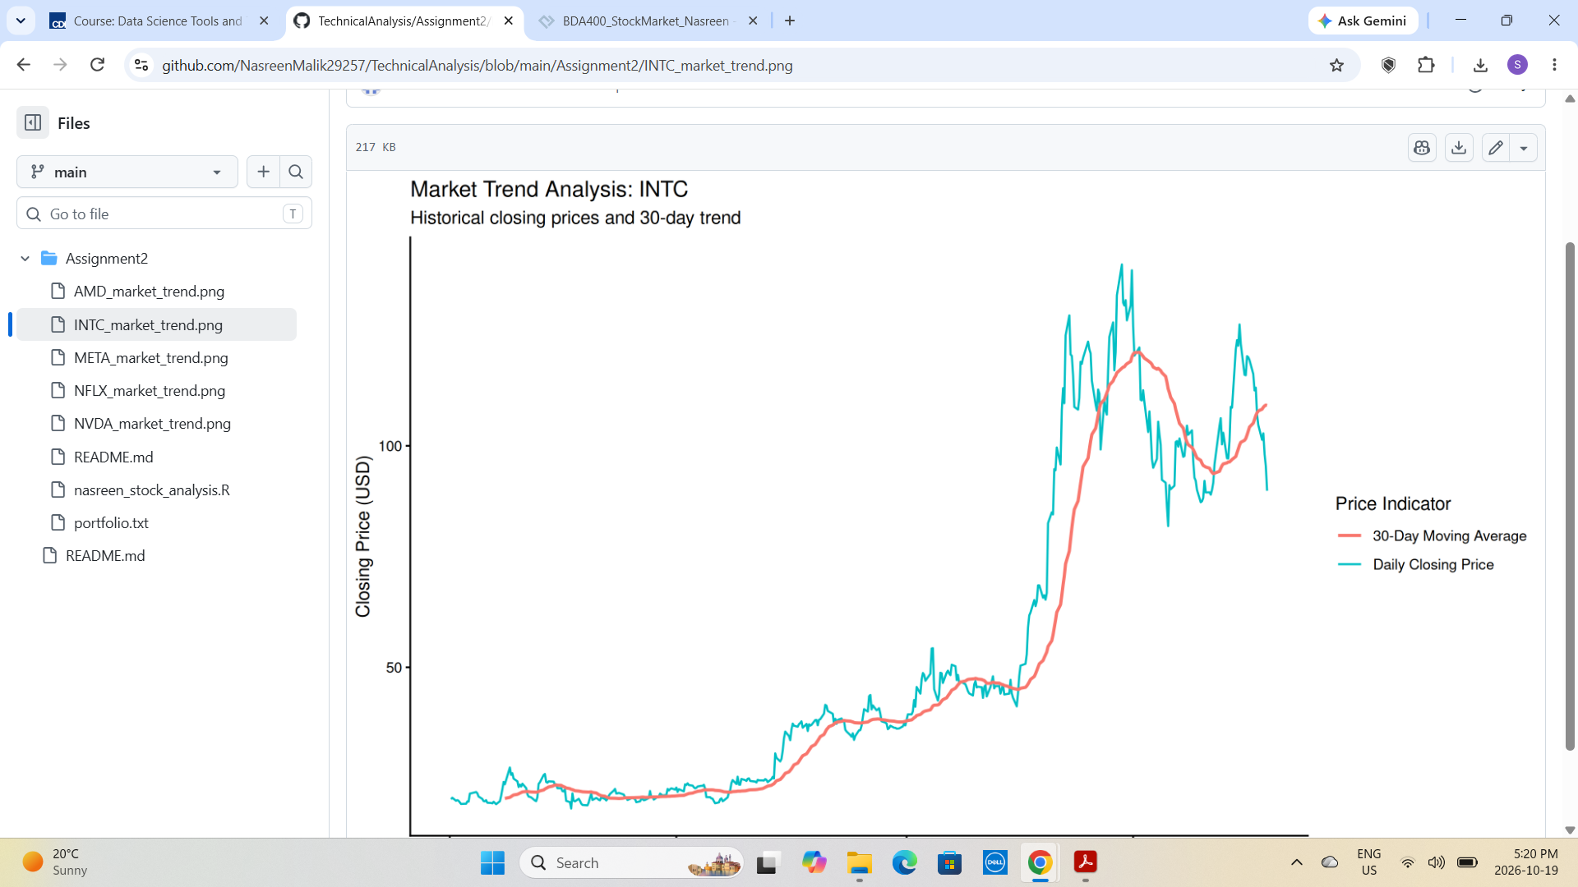
INTC stock trend chart displayed on GitHub.
5. Verification and Reproducibility
The RStudio Environment showed nasreen_market_data as a list of five datasets. Console output displayed stock price observations and statistical summaries. The saved R script and all five PNGs were visible in the GitHub Assignment2 folder. The screenshots document successful execution and upload; they do not independently audit the underlying Yahoo Finance data.
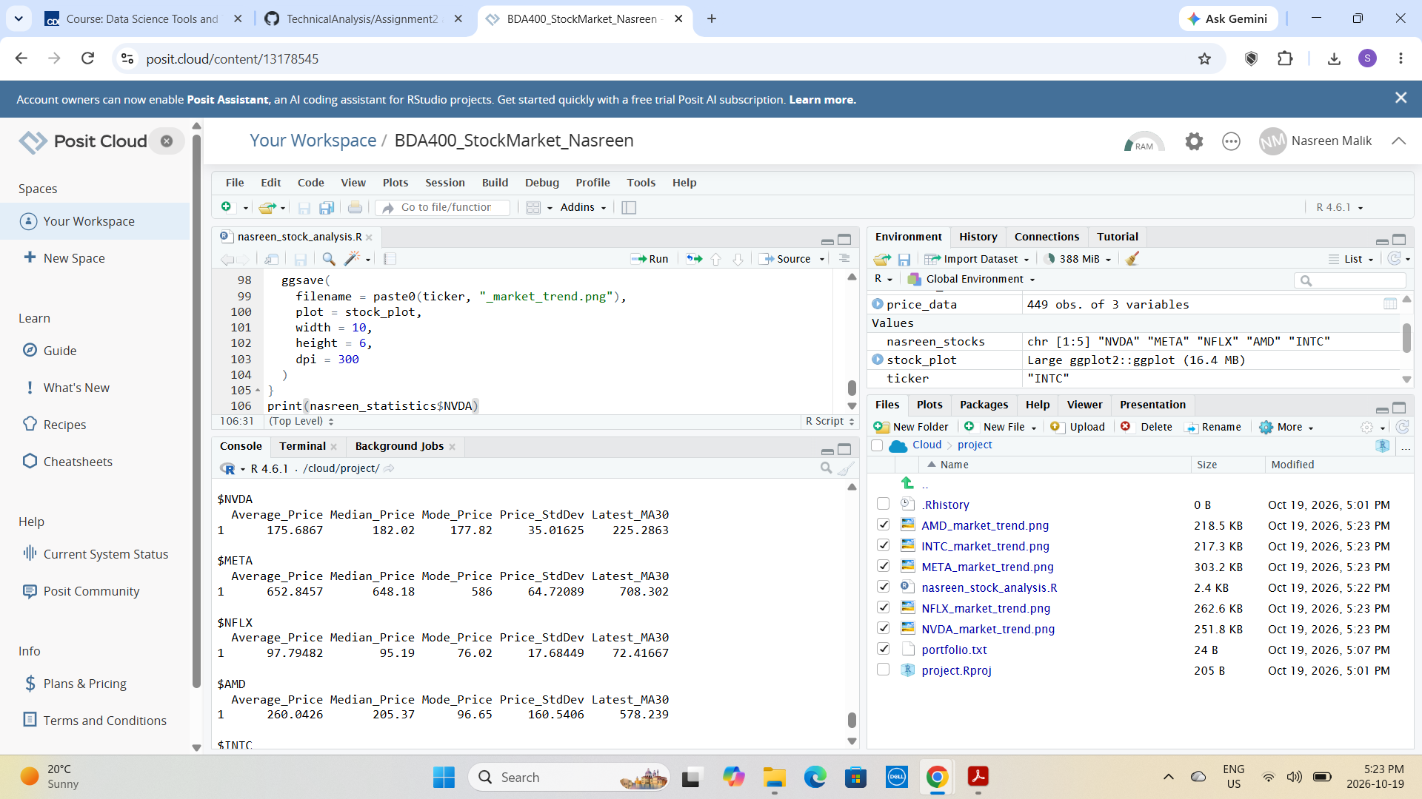
RStudio output including NVDA statistics and saved chart files.
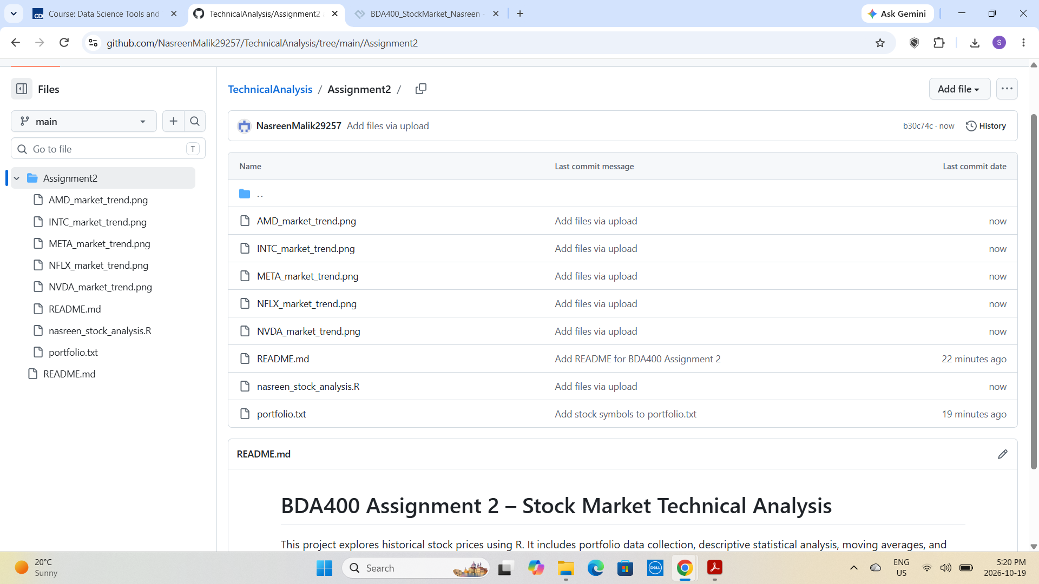
GitHub Assignment2 folder with README, portfolio, script and charts.
6. Ethical Considerations and Limitations
Historical market data may be revised or affected by stock splits, corporate actions and differences between raw closing and adjusted prices. The script uses closing prices and does not calculate investment returns or account for transaction costs. Comparing standard deviations in dollars across differently priced stocks is not equivalent to comparing percentage risk. The analysis is educational, not personalized financial advice.
The data source and analytical methods should be disclosed, outputs should be verified before submission, and generated code should be reviewed rather than assumed correct. Missing data and failed downloads should be investigated. The selected period and the 30-day window may materially affect the conclusions.
7. AI Assistance Disclosure
AI assistance (ChatGPT) was used to help structure the R workflow, draft and explain code, suggest debugging and verification steps, and organize the report. The stock list, code execution, Console outputs, exported charts, and GitHub uploads were checked in the student’s Posit Cloud and GitHub workspace. AI-generated suggestions were not treated as authoritative without testing. The student is responsible for reviewing the analysis and confirming that the submission reflects work actually completed.

