Internet of things

# Traffic signal control

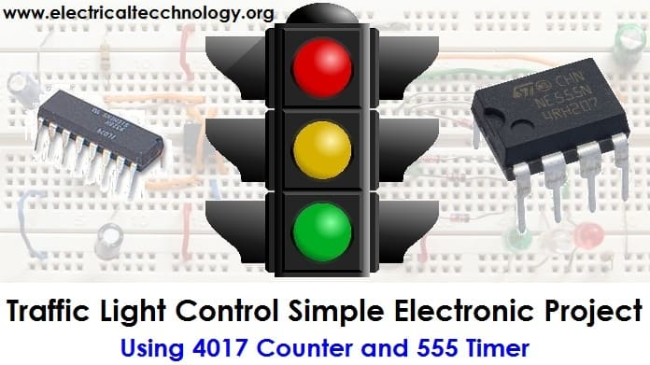

# TEAM MEMBERS:

D.Milwin Antany(821021104030)

A.Vishal(821021104701)

R.Lokesh Raj(821021104029)

R.Nasren Cruze(821021104033)

K.Vasanth(821021104306)

problem statement:

"Design and implement an IoT-based smart traffic signal system that optimizes traffic flow and minimizes congestion at intersections while considering factors such as real-time traffic conditions, pedestrian safety, and emergency vehicle prioritization. The system should also provide remote monitoring and control capabilities to traffic management authorities for efficient traffic management and should be cost-effective to deploy and maintain."

Design thinking

1. User-Centered Design : Start by identifying the needs of the users (pedestrians, cyclists, drivers, and traffic authorities). Consider their pain points and how IoT technology can address them.

2. Traffic Data Collection: Implement sensors (such as cameras, inductive loop sensors, or radar) to collect real-time traffic data, including vehicle and pedestrian counts, speed, and congestion levels.

3. Connectivity: Ensure reliable internet connectivity for data transmission. Consider using 5G or dedicated IoT networks for low latency and high bandwidth.

4. Data Processing and Analysis: Use cloud-based platforms or edge computing to process and analyze the collected data. Implement machine learning algorithms to predict traffic patterns and optimize signal timing.

5. Adaptive Signal Control: Design the traffic signal control system to adapt in real-time based on the analyzed data. Prioritize traffic flow on congested routes and adjust signal timing accordingly

6. Interoperability: Ensure compatibility with other smart city systems, such as public transportation, emergency services, and environmental monitoring.

7. Energy Efficiency: Optimize power usage with low-energy sensors and LED lights. Consider renewable energy sources like solar panels.

8. User Interface: Develop a user-friendly interface for both traffic authorities and the public. Mobile apps or web dashboards can provide real-time traffic information.

9. Safety and Redundancy: Implement fail-safes and redundancies to prevent accidents in case of system failures. Include backup power sources and signal overrides.

10. Scalability and Future-Proofing: Design the system to be easily expandable as the city grows and as new technologies emerge.

11. Data Privacy and Security: Implement robust security measures to protect the data and prevent unauthorized access or cyberattacks.

12. Feedback Loop: Establish a feedback mechanism for users to report issues or suggest improvements. Continuous user feedback can help refine the system.

13. Regulatory Compliance: Ensure compliance with local traffic regulations and obtain necessary permits for deploying the smart traffic signal.

14. Cost Analysis: Evaluate the cost of implementation versus the expected benefits, including reduced congestion, improved safety, and environmental impact.

15. Community Engagement: Involve the local community in the design process and inform them about the benefits of the smart traffic signal system.

16. Testing and Pilots: Conduct thorough testing and pilot programs in a controlled environment before deploying the system citywide.

Conclusion :

Remember that designing an IoT smart traffic signal system is a complex endeavor that requires collaboration among engineers, urban planners, data scientists, and community stakeholders. It's essential to keep the focus on improving traffic efficiency, safety, and the overall quality of life in the city.