# SMART SIGNAL TRAFFIC CONTROL

TEAM MEMBERS…

D.Milwin Antany(821021104030)

A.Vishal(821021104701)

R.Logesh Raj(821021104029)

R.Nasren Cruze(821021104033)

K.Vasanth(821021104306)

# CONTENTS

* INTRODUCTION
* BLOCK DIAGRAM
* CIRCUIT DIAGRAM
* WORKING
* COMPONENT
* CCTV CAMERA
* TRAFFIC SIGNAL OPERATIONS
* ADVANTAGES
* APPLICATION
* CONCLUSION

# INTRODUCTION :

* Our intelligent expert solution for road traffic control system offers the ability to acquire real-time traffic information.
* Traffic management measures are aimed at improving the safety and flow of traffic Our intelligent expert solution for road traffic control system offers the ability to acquire real-time traffic information.
* Traffic expert enables operators to perform real-time data analysis on the information gathered.
* Traffic management measures are aimed at improving the safety and flow of traffic utilizing traffic capacity more effectively.
* Our intelligent expert solution for road traffic control system offers the ability to acquire real-time traffic information.Our intelligent expert solution for road traffic control system offers the ability to acquire real-time traffic information.
* Traffic expert enables operators to perform real-time data analysis on the information gathered.

# BLOCK DIAGRAM :

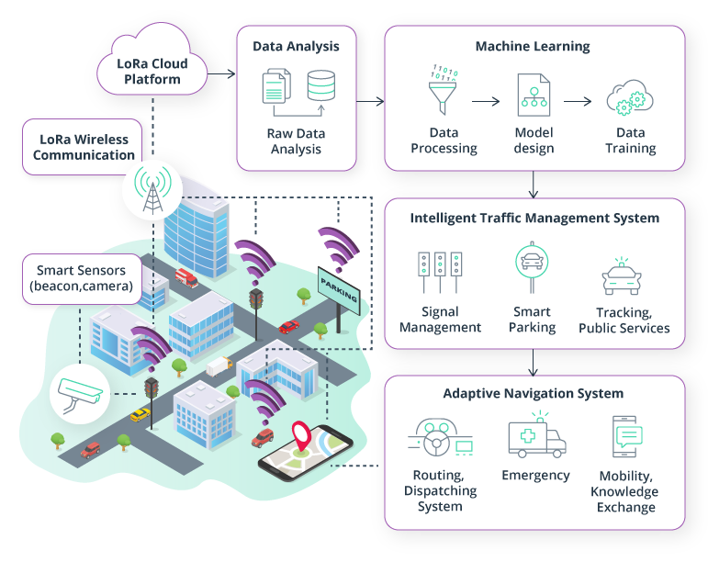

# CIRCUIT DIAGRAM :

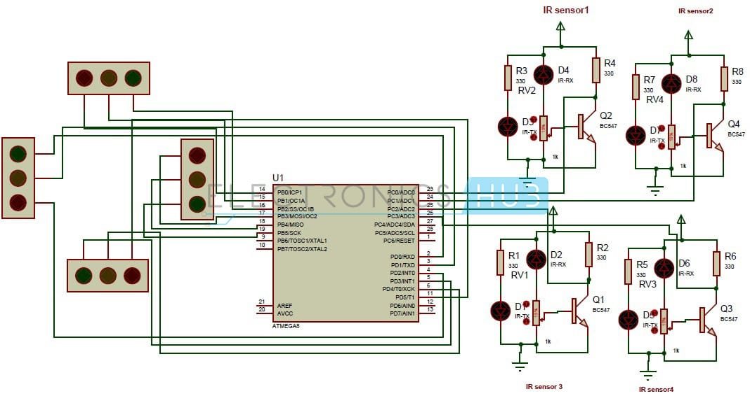

## Working :

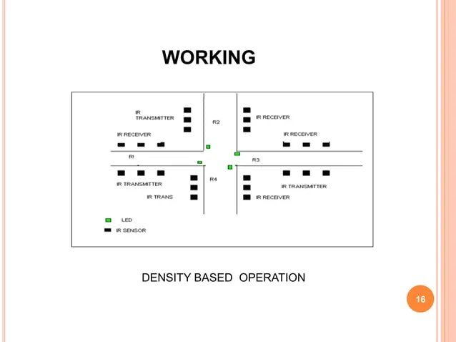

o Consider a junction where three lights (green, amber and red) are arranged on all four sides.

o Three sensors placed at each road, marks low, medium and high density zones respectively

o High density traffic there will be more allotment of time and for low density low time respectively.

o In other side it is continously monitors the RF receiver information.

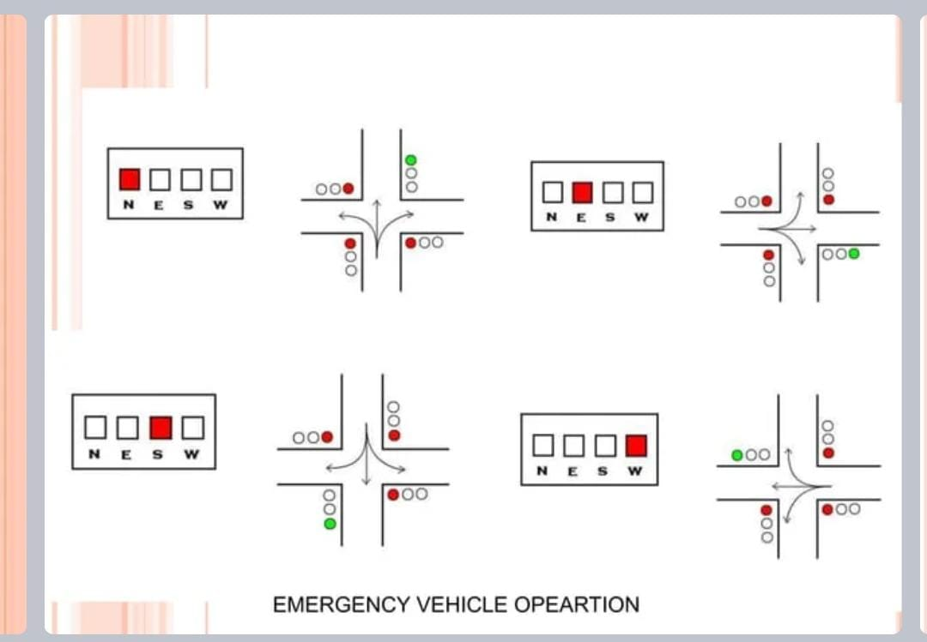

## COMPONENT :

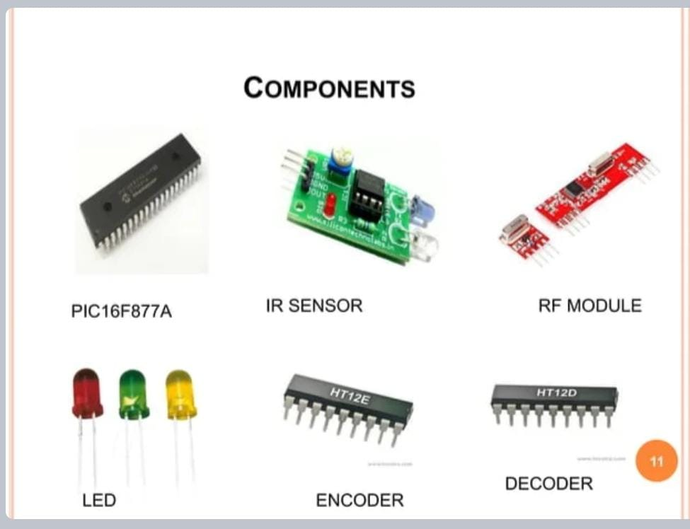

## CCTV CAMERA STATEMENT :

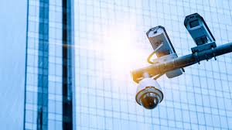

DEVELOPMENT IN CCTV TECHNOLOGY

Advancements in surveillance technologies came at such a fast pace. Before, only black and white images were available for the authorities to review. Today, very clear and colored videos can be obtained, and this helps in expediting the investigations related to crime and terrorism.

Further developments were also seen in the past years, including weather-resistant and wide-angle units, infrared night vision, and remote access via a smartphone or tablet. All these technologies are available from Casa Security’s range of CCTV options, and the user can also select the storage capacity for HDD video recorders. Aside from these options, the quality of images can also be determined by selecting from the range of full high-definition cameras (from 1080P to 8MP).

SECURITY VS PRIVACY :

One of the most pressing dilemmas in the surveillance age is where to draw the line between security and privacy. The intention of security cameras is good, but what if these clips fall in the wrong hands? How about those cameras capable of facial recognition? What if the supplier puts a hidden monitoring device in your unit?

The best way to address the above questions is to get your surveillance system from a trusted supplier. There are vendors that are certified BOSCH partners. This will put the user at peace, knowing that they are in good hands.

After-sales service is also as important as the product itself. Getting a CCTV camera from a supplier that knows what they do and is quick to respond is a major plus. Do obtain your security camera needs from a provider with decades of experience in this stuff to ensure that you get the best possible solution.

Even if you can remotely access your CCTV cameras, this is not a guarantee that you can act quickly if any untoward incident occurs. Look for a vendor of security cameras that can do this for you any time of the day, seven days a week

# TRAFFIC SIGNAL OPERATIONS

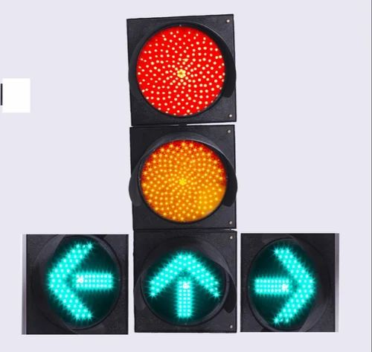

OPERATIONS

Steady red arrow

• No left turns are allowed during red. STOP

and wait for flashing yellow arrow or green

arrow.

Steady yellow arrow

• Signal is about to turn red. Be prepared to

STOP.

Flashing yellow arrow

• Left turns are permitted but not protected.

Proceed with caution after YIELDING to

oncoming traffic.

Steady green arrow

• Left turns are protected from oncoming

traffic. The green arrow can come at the

beginning or end of the signal sequence.

Left-turn lane

WYDOT Quick Facts

SOLID RED

• A red signal means “STOP.” You can make

a right turn after you stop and yield to all

other traffic. Do not turn if a “NO TURN ON

RED” sign is posted.

Solid Yellow

• A yellow signal light means “CAUTION,” the

red signal is about to appear.

Solid Green

• A green light means “GO,” after first yielding

to vehicles and pedestrians already lawfully

in the intersection.

Through Lane

# ADVANTAGES :

Reducing traffic jams and accidents on the streets

Ensuring immediate clearance for emergency vehicles

Facilitating safer and shorter commute times

Reducing congestion & energy consumption at intersections

Offering significant productivity benefits with real-time monitoring of crucial infrastructures

Reducing operating costs with efficient traffic management processes

Ensuring compliance with the regulations for reducing the carbon footprint

Saving billions of gallons of fuel wasted every year

Accurate tracking & quick recovery of lost and stolen vehicles

# APPLICATIONS :

Detection and Management of traffic Congestion :

In addition to the earlier method of traffic congestion detection, one more method can be used. A server can be maintained which can receive certain crucial data calculated by the Controller of the signals. The main aim is to implement a system that would trace the travel time of individual cars as they pass the roadside controllers and compute an average trip time using a rule-based system to decide whether the area is congested or uncongested. If congestion is sensed then system would control traffic signals / generate automatic re-routing messages to selected approaching vehicles.

Automatic detection of speed limit violation :

violates the rule, a warning

We can use this technique to calculate the speed of a motorist and to detect if he violates the prescribed/set speed limit. If the motorist message will be sent to the motorist via audio and/or video interface and penalty will be calculated in the server and billed monthly to the vehicle owner

Automatic Billing of Core Area / Toll Charge :

Automatic toll collection and automatic ―core area charge‖ collections are also done using the same framework. Controller unit will be placed at toll-booth and along the motor able roads around the core area which will detect each individual vehicle uniquely within its zone by capturing their device ids and will keep records of the time during which the vehicle was seen by those Controllers within its reading zone. This information will be sent to a main server. Accordingly the main server will calculate the charges and raise bills against the vehicle ids

# CONCLUSION :

The proposed work focuses on Smart Traffic management System using RFID which will eliminate the drawbacks of the existing system such as high implementation cost, dependency on the environmental conditions, etc. The proposed system aims at effective management of traffic congestion. It is also cost effective than the existing system. Furthermore, the study presents the problems in metropolitan areas all over the world caused by congestions and the related sources. Congestions developed to a problem, which affects economies worldwide. Particularly metropolitan areas are worst hit under these conditions. Congestions have a negative impact on the financial situation of a country, on the environment and hence the overall quality of life. The proposed system can be enhanced by using any other powerful communication network other than GSM.

