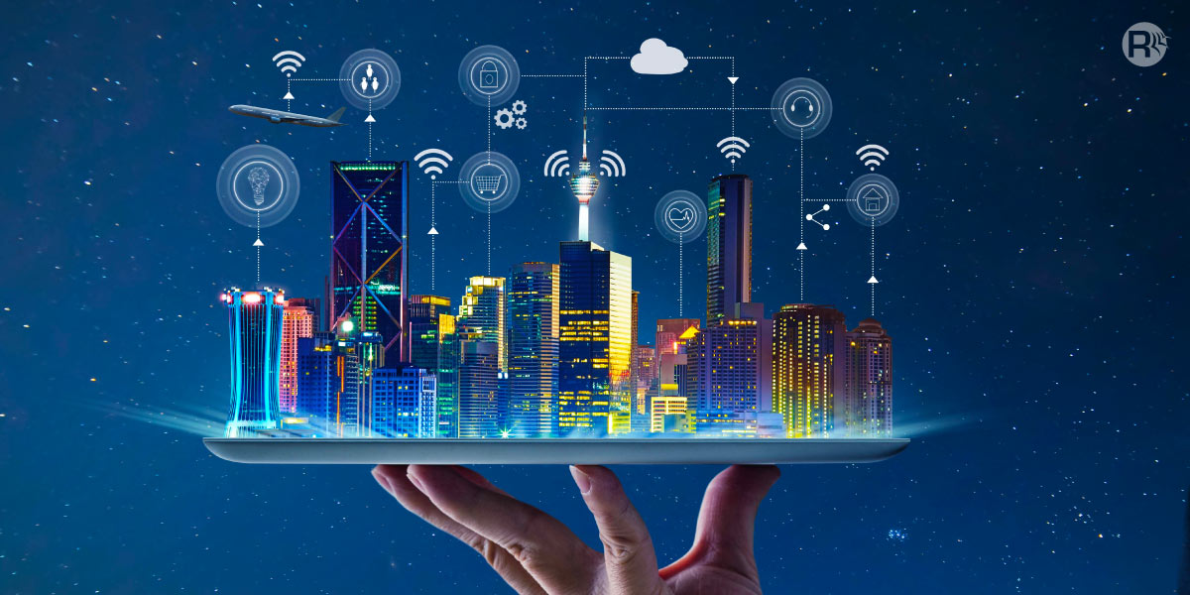

TEAM MEMBERS…

D.Milwin Antany(821021104030)

A.Vishal(821021104701)

R.Logesh Raj(821021104029)

R.Nasren Cruze(821021104033)

K.Vasanth(821021104306)

# CONTENTS

* Introduction
* Block diagram
* Block diagram description
* Circuit diagram
* Main circuit diagram
* Ambulance reciver circuit
* Ambulance transmitter circuit
* Flow chart
* Conclusion

# INTRODUCTION :

Smart signal traffic control refers to the use of advanced technologies and data-driven approaches to efficiently manage and optimize traffic flow at intersections and along roadways. Traditional traffic signal systems rely on fixed timing plans, which can lead to inefficiencies, congestion, and increased travel times. Smart signal traffic control, on the other hand, leverages real-time data, sensors, and communication networks to make traffic management more adaptive, responsive, and effective

Smart signal traffic control is a critical component of smart cities and urban mobility initiatives, as it can significantly improve the quality of life for residents, reduce traffic accidents, and enhance the overall efficiency of transportation systems. By harnessing technology and data, these systems help create safer, more sustainable, and more livable cities

# BLOCK DIAGRAM :

A block diagram for a smart signal traffic control system would illustrate the main components and their interactions. Here's a simplified block diagram for such a system

+--------------------------------+

| Smart Signal Traffic Control |

+--------------------------------+

| |

+----------------+| |+----------------+

| Traffic Sensors || Communication || Traffic Data |

| and Detectors || Infrastructure || Processing |

| (e.g., cameras, || (e.g., 5G, || and Analytics |

| loop detectors) || fiber optics) || (Data Center) |

+----------------+| |+----------------+

| |

+-----------------| |-----------------+

| v v |

| Traffic Management Control and Optimization |

| Algorithms and Logic |

+-----------------| |-----------------+

| |

+-----------------| |-----------------+

| v v |

| Traffic Signal Timing and Coordination System |

+-----------------| |-----------------+

| |

+-----------------| |-----------------+

| v v |

| Connected Vehicle Integration |

| (if applicable, for vehicle-to-infrastructure |

| and vehicle-to-vehicle communication) |

+-----------------| |-----------------+

| |

+-----------------| |-----------------+

| v v |

| Pedestrian and Cyclist Management |

| (Crosswalks, Bike Lanes, etc.) |

+-----------------| |-----------------+

| |

+-----------------| |-----------------+

| v v |

| Emergency Vehicle Priority System |

+-----------------| |-----------------+

| |

+-----------------| |-----------------+

| v v |

| User Interface and Monitoring |

| (for traffic operators and public) |

|  |
| --- |
|  |

This block diagram represents the main components of a smart signal traffic control system, and it may vary depending on the specific features and technologies implemented in a particular system.

# BLOCK DIAGRAM DESCRIPTION :

Certainly, let's provide a detailed description of each component in the smart signal traffic control block diagram:

Traffic Sensors and Detectors: These are physical devices installed at intersections and along roadways to collect real-time data about traffic conditions. This data includes information about the number of vehicles, vehicle types, speeds, and often includes cameras for visual monitoring. Loop detectors, radar sensors, and cameras are examples of such sensors.

Communication Infrastructure: This component represents the communication network that enables data transfer between the various system elements. It includes high-speed data connections like 5G, fiber optics, and wireless communication protocols. This infrastructure ensures that data collected by sensors can be transmitted to the central processing unit for analysis and control.

Traffic Data Processing and Analytics: This is where the collected data is processed and analyzed. It typically involves a data center or server infrastructure where complex algorithms and data analytics tools are used to make sense of the incoming traffic data. The results of this analysis are used to inform traffic management decisions.

Traffic Management Control and Optimization Algorithms: These are the core algorithms that determine how traffic signals should be timed and coordinated based on the data collected from the sensors and detectors. They continuously assess the current traffic situation and adjust signal timings to optimize traffic flow, reduce congestion, and minimize delays.

Traffic Signal Timing and Coordination System: This component directly controls the traffic signals at intersections. It takes the input from the optimization algorithms and adjusts the timing of red, green, and yellow lights as needed to ensure the smooth and safe flow of traffic. It may also manage the coordination of signals along a corridor to maintain a green wave for traffic.

Connected Vehicle Integration: In cases where it's implemented, this component allows the system to communicate with connected vehicles. It can provide data to drivers about upcoming signal changes and, in return, receive data from connected vehicles to further enhance traffic management.

Pedestrian and Cyclist Management: This component ensures the safety and efficiency of pedestrian and cyclist crossings. It controls crosswalk signals and may also consider bike lanes in signal timing to accommodate different modes of transportation.

Emergency Vehicle Priority System: This system ensures that emergency vehicles have a fast and safe route through traffic by providing them with priority at intersections. It can preempt normal signal timing to allow these vehicles to pass quickly.

User Interface and Monitoring: This interface provides a means for traffic operators to monitor the system and make manual adjustments if necessary. It also often includes information displays for the public, showing estimated wait times, signal changes, and other traffic-related information.

Overall, the smart signal traffic control system is a complex network of components that work together to optimize traffic flow, reduce congestion, improve safety, and enhance the efficiency of transportation systems. It relies on real-time data, communication, and advanced algorithms to adapt to changing traffic conditions and make intelligent decisions for managing traffic at intersections and along roadways.

# CIRCUIT DIAGRAM :

Creating a complete circuit diagram for a smart signal traffic control system is a complex task that would typically involve numerous components, including microcontrollers, sensors, communication devices, power supplies, and more. It would also involve software elements and connections to a larger infrastructure. Below is a highly simplified representation of some key components that could be involved in a smart signal traffic control system.

+-------------------+

| Smart Traffic |

| Control System |

+--------+----------+

|

|

+------------------------+ | +------------------------+

| Traffic | | | Communication |

| Sensors |---|---| Infrastructure |

| (e.g., | | | (e.g., 5G, |

| Cameras, | | | Fiber Optics) |

| Detectors) | | | |

+------------------------+ | +------------------------+

|

|

+------------------------+ | +------------------------+

| Data Processing | | | Traffic Management |

| and Analytics |---|---| Control Algorithms |

| (Data Center) | | | and Logic |

+------------------------+ | +------------------------+

|

|

+------------------------+ | +------------------------+

| Traffic Signal |---|---| Traffic Signal Timing |

| Control and | | | and Coordination |

| Optimization | | | System |

| Hardware | | | |

+------------------------+ | +------------------------+

|

|

+------------------------+ | +------------------------+

| Connected Vehicle | | | Pedestrian and |

| Integration | | | Cyclist Management |

| |---|---| (Crosswalks, Bike |

| | | | Lanes, etc.) |

+------------------------+ | +------------------------+

|

|

+------------------------+ | +------------------------+

| Emergency Vehicle | | | User Interface and |

| Priority System |---|---| Monitoring |

| | | | (for traffic |

| | | | operators and public)|

+------------------------+ | +------------------------+

... (Other Components may be present in a real system)

Please note that this is a highly abstract and simplified representation for illustrative.

# MAIN CIRCUIT DIAGRAM :

In a real-world smart signal traffic control system, each of these components would involve intricate circuitry, microcontrollers, and various sensors and devices to carry out their functions. Moreover, communication between components would likely be facilitated through complex network infrastructure. The diagram above serves as a high-level abstraction to provide a conceptual overview of the key components involved in such a system.

Creating a comprehensive circuit diagram for a smart traffic signal control system involves numerous components, microcontrollers, sensors, communication devices, and intricate connections. Below is a highly simplified and abstract representation for a basic traffic signal control circuit. Note that real-world systems are far more complex.

+--------------------------------+

| Smart Traffic Signal Control |

+--------------------------------+

|

+---------------|---------------+

| v |

| +--------[ Microcontroller ]--------+

| | | | |

| | +-----+ +-----+ |

| | | | |

| | v v |

| | | | |

| | | | |

| | v v |

| | | | |

| | | | |

| | v v |

| | | | |

| | | | |

| | v v |

| | | | |

| | | | |

| | | | |

| | | | |

| | | | |

| | | | |

| | | | |

| | v v |

| | | | |

| | | | |

| | v v |

| | | | |

| | | | |

| | | | |

| | v v |

| | | | |

| | | | |

| | v v |

| | | | |

| | | | |

| | v v |

| | | | |

| | | | |

| +---|-------------------|----------+

| | |

| v v

| | |

| | |

| v v

| | |

| | |

| | |

| v v

| | |

| | |

| +---[ Traffic Light ]

|

+--------[ Sensors and Detectors ]

In a real-world traffic signal control circuit:

The "Microcontroller" is responsible for processing data from sensors, determining optimal signal timings, and controlling the traffic lights accordingly.

The "Sensors and Detectors" represent various sensors like cameras, inductive loop detectors, and vehicle presence sensors that provide real-time data to the microcontroller.

The "Traffic Light" is the output device that displays the traffic signals, including red, yellow, and green lights

# AMBULANCE RECIVER CIRCUIT :

Ambulance Unit :

This unit is further divided into 2 systems- RFID system and Strobe detection system. These systems can work both separately as well as in combination. If used separately the combination of these systems will not only be more efficient but will be more secure as it will be very difficult to hack or violate the conditions.

RFID system :

This system consists of a RFID tag installed in the ambulance. It will be used as a sensor in a case of emergency. This means that whenever there will be an emergency, driver of the ambulance will activate the RFID tag which will be then detected by the RFID readers present few meters before or on the junction semaphores. These readers will then continuously pass on the signals to the junction unit where the controlling ofsemaphores will take place. As soon the ambulance having the active tag cross the junction, the reader will stop sending the signals and conditions will turn back to normal. Also since every road will have a separate semaphore, therefore number of RFID readers present will be same as that of semaphores.

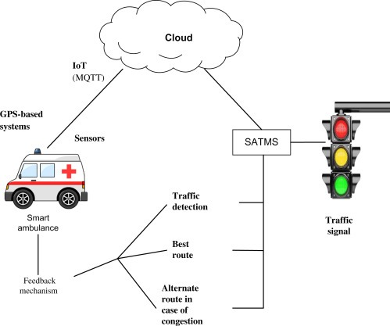

# AMBULANCE TRANSMITTER CIRCUIT :

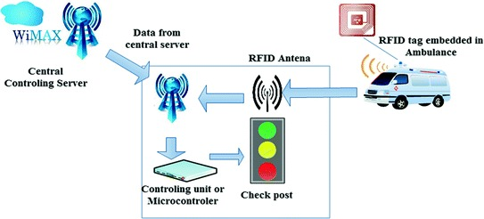

# FLOW CHART :

+-------------------------+

| Smart Traffic Signal |

| Control System |

+-------------------------+

|

| Initialization

v

+--------------------------------+

| Monitor Traffic Data |

| (e.g., from sensors) |

+--------------------------------+

|

| Analyze

v

+--------------------------------+

| Is Traffic Data Abnormal? |

+--------------------------------+

|

| Yes

|------------------------+

v |

+--------------------------------+ |

| Activate Emergency Protocol | |

| (e.g., for emergency vehicle)| |

+--------------------------------+ |

| |

| No |

v |

+--------------------------------+ |

| Apply Traffic Optimization | |

| Algorithms | |

| (e.g., adaptive timing) | |

+--------------------------------+ |

| |

| |

v |

+--------------------------------+ |

| Update Signal Timing | |

| Based on Analysis | |

+--------------------------------+ |

| |

| |

v |

+--------------------------------+ |

| Control Traffic Signals | |

+--------------------------------+ |

| |

| |

v |

+--------------------------------+ |

| Monitor Emergency Signals | |

| (e.g., from emergency vehicle)| |

+--------------------------------+ |

| |

| |

v |

+--------------------------------+ |

| Is Emergency Active? | |

+--------------------------------+ |

| |

| Yes |

|------------------------+

v

+--------------------------------+

| Give Priority to Emergency |

| Vehicle (e.g., green light) |

+--------------------------------+

|

| No

v

+--------------------------------+

| Continue Normal Traffic Flow |

+--------------------------------+

|

v

+--------------------------------+

| Loop (Continuously) |

+--------------------------------+

Initialization: The system initializes and prepares for monitoring traffic data.

Monitor Traffic Data: The system continuously collects data from various sensors, such as cameras and detectors.

Analyze Traffic Data: The system analyzes the traffic data to determine if any abnormal conditions exist.

Activate Emergency Protocol: If abnormal conditions are detected (e.g., an emergency vehicle approaching), the emergency protocol is activated.

Apply Traffic Optimization Algorithms: The system uses traffic optimization algorithms to improve traffic flow.

Update Signal Timing: The signal timings are adjusted based on the analysis and optimization.

Control Traffic Signals: The system controls the traffic signals to implement the adjusted timings.

Monitor Emergency Signals: The system monitors for signals from emergency vehicles.

Give Priority to Emergency Vehicle: If an emergency vehicle is detected, the system gives it priority (e.g., a green light).

Continue Normal Traffic Flow: If no emergency is detected, the system continues normal traffic flow.

Loop (Continuously): The system continuously loops through these processes to manage traffic effectively.

# TRAFFIC LIGHT :

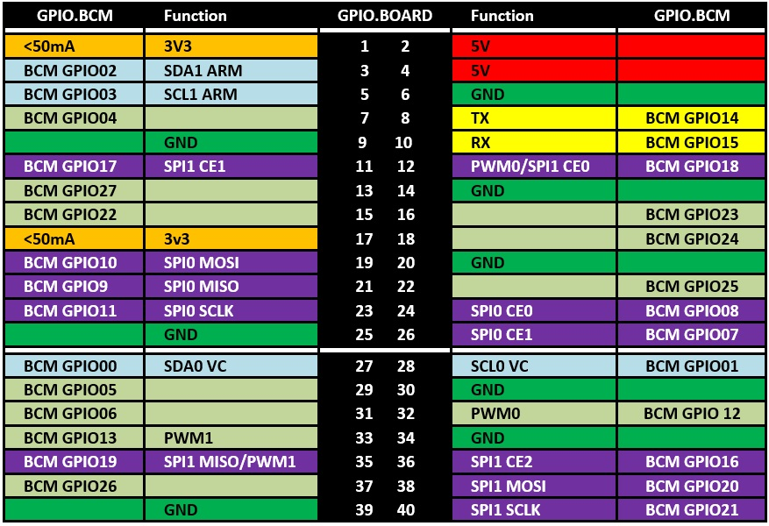

Prerequisite

Hardware

As well as a Raspberry Pi with an SD card and the usual peripherals, you'll also need:

1x Solderless breadboard

All king of jumper leads

1x Tactile button

3x LEDs (Red, Green, and Yellow)

3x 330 ohm Register

Buzzer

Button

Software

Raspberry Pi needs NOOBS OS. NOOBS is a way of making setting up a Raspberry Pi for the first time much, much easier. You won't need network access, and you won't need to download imaging software. Just head to the download page, grab a copy of the NOOBS zip file and unpack it onto a freshly formatted 4GB (or larger) SD card. Once you have installed an operating system, your Pi will boot as normaGPIO pins

One powerful feature of the Raspberry Pi is the row of GPIO pins along the top edge of the board. GPIO stands for General-Purpose Input/Output. These pins are a physical interface between the Raspberry Pi and the outside world.

If you don't have a pin label, then this can help you to identify the pin numbers

Making Traffic Light

We need a breadboard, three LEDs, a button, a buzzer, and the necessary jumper cables and registers.

Wiring

First, you need to understand how each component is connected.

A push-button requires 1 ground pin and 1 GPIO pin

An LED requires 1 ground pin and 1 GPIO pin, with a current limiting register

A buzzer requires 1 ground pin and 1 GPIO pin

Component GPIO pin

Button 21

Red LED 25

Yellow LED 8

Green LED 7

Buzzer 15

This is the same as the Switching and LED on and off step

Open Python 3 from the main menu

Create a new file just save with the project name.py

TRAFFIC LIGHT USING PYTHON CODING :

Add TrafficLight, Button and Buzzer Code

from gpiozero import Button, TrafficLights, Buzzer

from time import sleep

buzzer = Buzzer(15)

button = Button(21)

lights = TrafficLights(25, 8, 7)

while True:

button.wait_for_press()

buzzer.on()

light.green.on()

sleep(1)

lights.amber.on()

sleep(1)

lights.red.on()

sleep(1)

lights.off()

buzzer.off()

OUTPUT

Run your Powershell coding (F5)

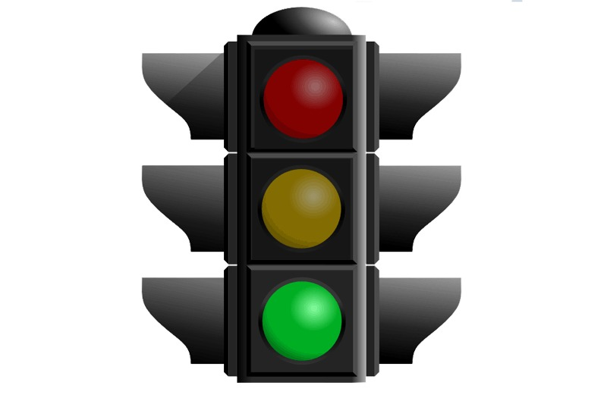

# CAMERA CONTROL :

Camera control in traffic signals typically involves using cameras for various purposes, such as monitoring traffic conditions, enforcing traffic laws, and optimizing signal timings. Here's an overview of how cameras are used in traffic signal control:

Traffic Monitoring Cameras:

Purpose: Traffic monitoring cameras are placed at intersections and along roadways to capture real-time traffic data.

Function: These cameras continuously monitor traffic flow, congestion, and other conditions. The data collected is used for traffic analysis and management.

Red Light Cameras:

Purpose: Red light cameras are used to enforce traffic laws by capturing images or video footage of vehicles running red lights.

Function: When a vehicle enters an intersection after the traffic signal has turned red, the camera captures evidence, which can be used for issuing traffic citations.

Speed Cameras:

Purpose: Speed cameras are employed to monitor and enforce speed limits on roads.

Function: These cameras capture images or video of vehicles exceeding the speed limit, and fines or citations can be issued to violators.

Pedestrian Detection Cameras:

Purpose: Pedestrian detection cameras are used to enhance pedestrian safety at crosswalks and intersections.

Function: These cameras monitor crosswalks and detect pedestrians waiting to cross. They can trigger the traffic signal to change in favor of pedestrians.

License Plate Recognition (LPR) Cameras:

Purpose: LPR cameras are used to recognize and record license plate numbers for various purposes, such as law enforcement and toll collection.

Function: These cameras capture license plate information from passing vehicles, which can be used for identifying vehicles, tracking traffic patterns, and enforcing regulations.

Traffic Signal Optimization Cameras:

Purpose: Some advanced traffic control systems use cameras for optimization.

Function: Cameras capture real-time traffic conditions, and the data is processed to adjust traffic signal timings. This helps in reducing congestion and improving traffic flow.

Traffic Data Analysis:

Purpose: The data collected from cameras is used for detailed traffic analysis.

Function: Traffic engineers and authorities can analyze the data to identify traffic patterns, congestion hotspots, and make informed decisions about signal timings and infrastructure improvements.

Remote Monitoring and Control:

Purpose: Cameras can be part of a remote monitoring and control system.

Function: Operators can use camera feeds to monitor traffic conditions in real-time and make adjustments to traffic signals, especially during special events, emergencies, or traffic incidents.

# Coding :

import cv2

import os

# Define the directory where captured images will be saved

image_directory = 'captured_images'

# Create the directory if it doesn't exist

os.makedirs(image_directory, exist_ok=True)

# Initialize the camera (0 represents the default camera)

camera = cv2.VideoCapture(0)

# Set the resolution (you can adjust this as needed)

camera.set(3, 1920) # Width

camera.set(4, 1080) # Height

try:

while True:

# Capture a frame from the camera

ret, frame = camera.read()

if ret:

# Display the captured frame (optional)

cv2.imshow('Traffic Camera', frame)

# Save the captured frame as an image

image_file = os.path.join(image_directory, 'captured_image.jpg')

cv2.imwrite(image_file, frame)

# Break the loop if the 'q' key is pressed

if cv2.waitKey(1) & 0xFF == ord('q'):

break

finally:

# Release the camera and close any open windows

camera.release()

cv2.destroyAllWindows()

# CAMERA SCANNING :

1. **Camera Installation:** Cameras are strategically installed at key locations, such as intersections, highways, or road segments. The type of camera can vary, including fixed, pan-tilt-zoom (PTZ) cameras, and specialized cameras for specific purposes (e.g., license plate recognition or vehicle counting).
2. **Data Capture:** Cameras continuously capture images or video footage of the traffic in their field of view. The frequency of data capture can vary depending on the system's requirements and capabilities.
3. **Real-Time Image Processing:** The captured images or video frames are processed in real-time by software or hardware components. This processing can involve various tasks:
   * **Vehicle Detection:** Software analyzes the images to identify vehicles, their positions, and movements. This is often done using object detection algorithms or machine learning models.
   * **License Plate Recognition (LPR):** For law enforcement or parking management, LPR systems can be used to read and recognize license plates on vehicles.
   * **Traffic Flow Analysis:** By tracking the speed and movement of vehicles, the system can assess traffic congestion, traffic flow patterns, and irregularities.
   * **Pedestrian Detection:** Some systems also include features to detect and monitor pedestrians at crosswalks or busy intersections.
4. **Data Storage and Management:** The captured data is typically stored for analysis and historical reference. This data can include images, video recordings, and metadata related to each frame, such as timestamps and vehicle counts.
5. **Traffic Management and Decision-Making:** The processed data is used to make real-time decisions related to traffic management. This can include:
   * **Traffic Signal Control:** Adjusting traffic signal timings at intersections to optimize traffic flow, reduce congestion, and improve safety.
   * **Incident Detection:** Identifying and responding to traffic incidents, such as accidents or breakdowns, by notifying relevant authorities and providing alternate routes to drivers.
   * **Vehicle Counting:** Monitoring the number of vehicles passing through an area to assess traffic volume and congestion levels.
   * **Data Analysis:** Analyzing historical traffic data to identify trends, plan road infrastructure improvements, and make informed decisions for future traffic management.

Top of Form

# CODING :

import cv2

# Initialize the camera (0 represents the default camera)

camera = cv2.VideoCapture(0)

# Set the resolution (you can adjust this as needed)

camera.set(3, 1920) # Width

camera.set(4, 1080) # Height

# Create a background subtractor for motion analysis

fgbg = cv2.createBackgroundSubtractorMOG2()

try:

while True:

# Capture a frame from the camera

ret, frame = camera.read()

if ret:

# Apply background subtraction to detect motion

fgmask = fgbg.apply(frame)

# Process the foreground mask (optional)

# You can apply further image processing techniques for better object detection

# Find and draw contours around moving objects

contours, _ = cv2.findContours(fgmask, cv2.RETR_EXTERNAL, cv2.CHAIN_APPROX_SIMPLE)

for contour in contours:

if cv2.contourArea(contour) > 1000: # You can adjust the area threshold

x, y, w, h = cv2.boundingRect(contour)

cv2.rectangle(frame, (x, y), (x + w, y + h), (0, 255, 0), 2)

# Display the processed frame

cv2.imshow('Traffic Camera', frame)

# Break the loop if the 'q' key is pressed

if cv2.waitKey(1) & 0xFF == ord('q'):

break

finally:

# Release the camera and close any open windows

camera.release()

cv2.destroyAllWindows()

# CONCLUSION :

Improving transportation efficiency is still an active and challenging research area due to the criticality of the transportation infrastructure being monitored by such systems. This article has provided a comprehensive study of the TMSs, emphasizing the main challenges and shortcomings of the existing systems and suggesting some directions to improve the TMS efficiency. First, we have presented a comprehensive overview of the state of the art in TMS, where the three main TMS phases were described: information gathering, information process, and service delivery. We have also proposed an in-depth classification and review of TMS services organized by their architecture and goals. Furthermore, a qualitative analysis was done based on TMS described. Finally, we presented our vision on improving TMS efficiency and robustness to achieve the desired level of accuracy and traffic control, where this improvement relies on targeting the open challenges. In addition, we have identified and discussed some potential efforts to solve it.

