# INTRODUCTION

# This is an era of computer and information technology. In this era, if you want to exist in the market, you have to use computers and information to provide the best services to the customer. Real Estate is the business of buying, selling, and renting land, buildings, and office. We using salesforce we manage the property .

1. **Problem Definition & Design Thinking**
   1. Empathy Map

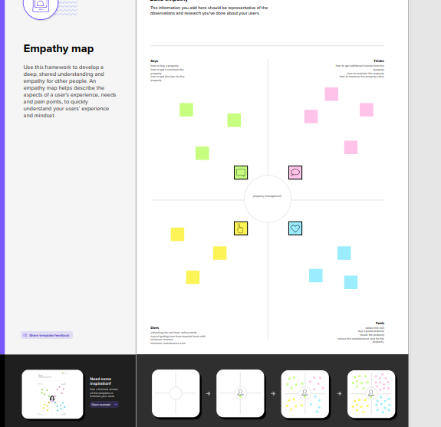

* 1. Ideation & Brainstorming Map

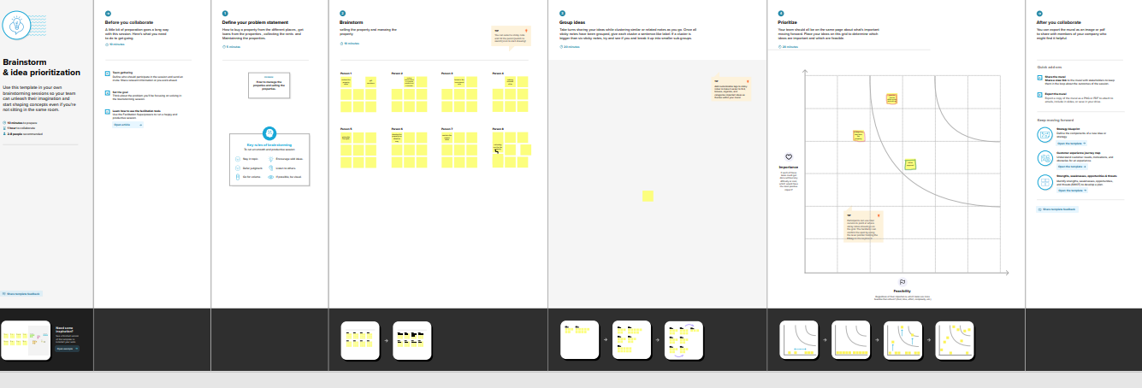

# RESULT

* 1. Data Model:

|  |  |
| --- | --- |
| **Object name** | **Fields in the Object** |
| Buy | |  |  | | --- | --- | | Field label | Data type | | Property | text | | Discount | Percentage | |
| Rent  Loan | |  |  | | --- | --- | | Field label | Data type | | Rental city | Text | | Interest Rate | Currency | |

# Activity & Screenshot

Attach the screenshots of your project activity along with the description.

# Trailhead Profile Public URL

# Team Lead- https://trailblazer.me/id/nasrin24

# Team Member 1 -https://trailblazer.me/id/naveen7065

# Team Member 2 -https://trailblazer.me/id/saroo10

# Team Member 3 -https://trailblazer.me/id/rinthiya25

# Team Member 4 -https://trailblazer.me/id/kowsalya24

# Team Member 5-https://trailblazer.me/id/punitha22

# Team Member 6 -https://trailblazer.me/id/meganaprakash15

1. **ADVANTAGES**

Whether it’s a multi-story hotel in a busy market or a small property in a beautiful rural town, using a property management system has many advantages. You’ll be able to streamline your operations, offer comprehensive training to your staff and ensure guests have a positive, stress-free experience

. **DISADVANTAGES**

While a property management system may ultimately help your business run more smoothly, it’s important to consider the disadvantages to determine if it’s right for your property before investing.

# APPLICATIONS

A property management system (PMS) is a software application for the operations of hospitality accommodations and commercial residential rental properties. PMS is also used in manufacturing industries, local government and manufacturing.

# CONCLUSION

Conclusion summarizing the Entire work and findings.

# FUTURE SCOPE

# Seeing how valuable property management is has made clients seek additional services from their property managers. Owners realized how tough collecting rent and leasing rental properties became during the pandemic, not to mention the ongoing changes to tenant-landlord legislation at a state and local level to remain in compliance with for their occupied properties.