

**PREMIER UNIVERSITY, CHITTAGONG**

|  |
| --- |
| Department of Computer Science & Engineering |

Course Title **:** Computational Methods For Engineering

Problems Laboratory.

Course Code  **:** CSE-302.

Experiment No. **:** 02

Experiment Name **:** Find the root of non-linear equation using False Position

Method in C++.

Date of Performance **:** 13-08-2022

Date of Submission **:** 02-09-2022

**Submitted To Submitted By**

Tanni Dhoom **Name:** Nasrin Jahan Ripa

Lecturer ,  **ID:** 1903710201936

Department of CSE **Section:** B1

Premier University, Chittagong **Semester:** 5th

**Remarks:**

**Experiment No** : 04

**Report No** **:** 02

**Title** **:** Find the root of non-linear equation using False Position Method in C++.

**Tools** **:** PC and codeblocks Software.

**Objective :** To find the root of non-linear equation using False Position Method in C++.

**Algorithm** :

1. Start

2. Read values of x0, x1 and e.

3. Computer function values f(x0) and f(x1)

4. Check whether the product of f(x0) and f(x1) is negative or not.

If it is positive take another initial guesses. If it is negative then goto step 5.

5. Determine: x = [x0*f(x1) – x1*f(x0)] / (f(x1) – f(x0))

6. Check whether the product of f(x1) and f(x) is negative or not.  
 If it is negative, then assign x0 = x; If it is positive, assign x1 = x;

7. Check whether the value of f(x) is greater than 0.00001 or not.  
 If yes, goto step 5.  
 If no, goto step 8.

8.Display the root as x.

9.Stop

**Program :**

#include <bits/stdc++.h>

#define ll long long

using namespace std;

double func(double x){

return (x*x*x)-(x*x)+x-7;

}

void fasleposition (double a,double b,double e){

double fa = func(a);

double fb = func(b);

double fc;

while(fa*fb>=0){

a++;

b++;

fa = func(a);

fb = func(b);

}

if(fa*fb>0){

cout << "Given initial value do not bracket the root\n";

}

else{

double c = ((b*fa)-(a*fb))/(fa-fb);

fc = func(c);

printf("\n\n a \t\t b \t\t c \t\t f(c) \n");

while(abs(fc)>e){

printf("%lf \t %lf \t %lf \t %lf\n",a,b,c,fc);

if(fc*fa<0){

b = c;

fb = func(b);

}

else{

a = c;

fa = func(a);

}

c = ((b*fa)-(a*fb))/(fa-fb);

fc = func(c);

}

cout << "root is : " << c << endl;

}

}

int main()

{

double a,b,e;

cout << "strat range : ";

cin >> a ;

cout << endl;

cout << "end range : ";

cin >> b ;

cout << endl;

cout << "tolarable error : ";

cin >> e ;

cout << endl;

fasleposition(a,b,e);

}

**Output :**

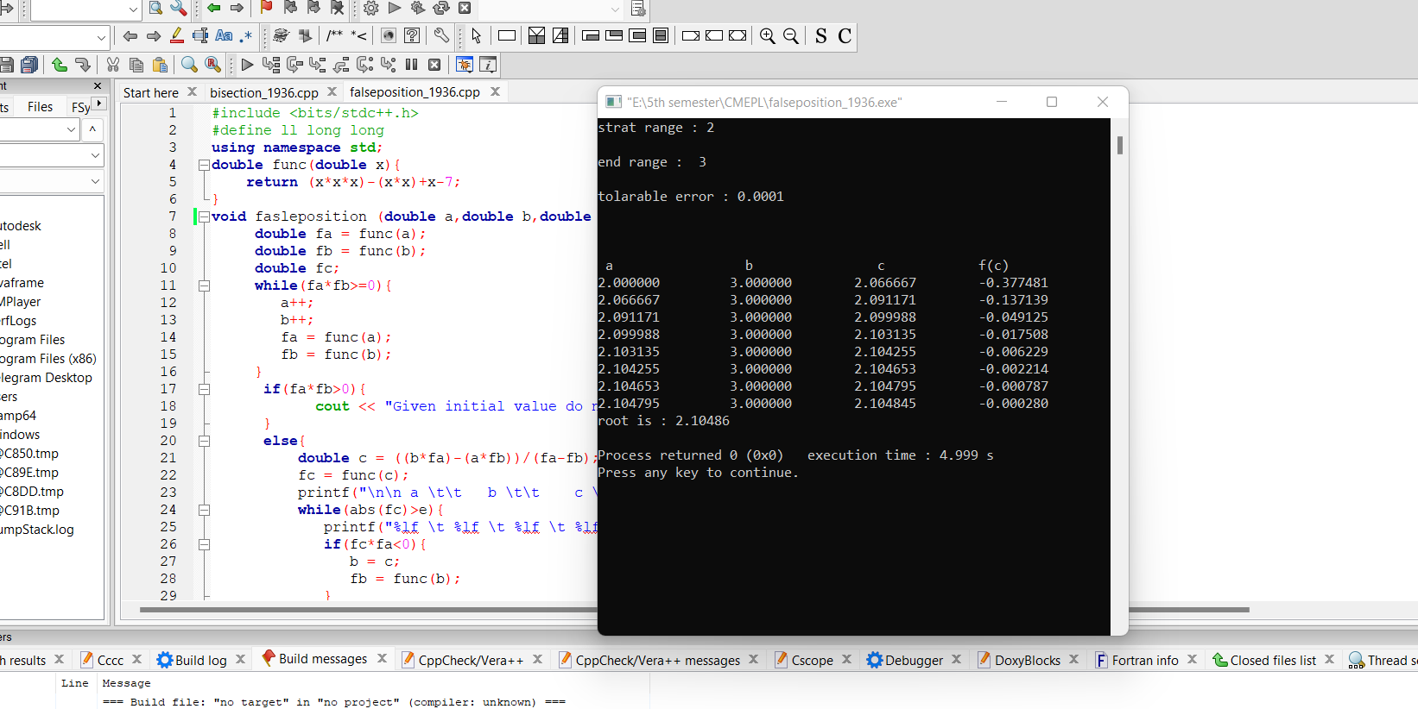

**Discussion :**

The false position method is one of the iterative methods of finding the roots of a non-linear equation of the form f(x) = 0. This method provides us with a better approximation of the roots of the equation.

Although convergence of Regula Falsi method is guaranteed, it is generally slow. Can not find root of some equations. For example: f(x) = x2 as there are no bracketing values..

While doing this program we have face some problem like variable declaration error, typing mistake, not use end line statement (;) and many other logical error .For logical error we can not find proper output result. Therefore, to deny this problem we have to write code sincerely and carefully.