From Forecast Accuracy to Operational Value: Public Signal Augmentation for NYC 311 Service Demand
arXiv-style / workshop-style research artifact. The study is predictive and correlational; it makes no causal, production-readiness, real-dispatch, or full-paper-readiness claim. All empirical values are read from committed repository artifacts under reports/ and data/metadata/.
Abstract
Day-ahead forecasts of municipal service-request volume are a natural input to staffing and dispatch planning, yet a reduction in average forecast error does not automatically translate into better operational decisions. We ask, on real data, two questions: do public external signals improve next-day forecasts of NYC 311 service-request volume, and does any improvement carry through to a stylized staffing-allocation simulation? Using real NYC 311 Service Requests for 2022-2024 (9,851,452 raw records aggregated to 43,240 date x borough x complaint_group observations) and real NOAA Central Park daily weather, we compare four feature sets - internal_historical, calendar_augmented, weather_augmented, and calendar_weather_augmented - across four model families under a strictly chronological protocol with five-fold rolling-origin validation. Calendar features deliver the largest accuracy gain; real weather adds a smaller but consistent further gain. The best model, a random forest on calendar_weather_augmented, attains a held-out test mean absolute error (MAE) of 55.325 versus 71.848 for a naive seasonal baseline, a 23.0% reduction. A stylized proportional staffing simulation shows the augmented policy reduces weighted unmet demand at every crew budget tested and closes 26.381% of the gap to an oracle at the baseline budget, but the magnitude of the decision benefit is budget-dependent. The central finding is that the forecast gains are real and robust, while the decision gains are smaller and conditional on capacity. The work is a reproducible baseline; no synthetic data or synthetic weather is used.
1. Introduction
Municipal service operations plan finite crews against demand that varies by day of week, season, and location. Short-horizon (next-day) volume forecasts are a standard planning input. Two questions follow. First, a predictive question: does augmenting an internal-history forecasting model with public external signals reduce next-day forecast error? Second, a decision question: does any such forecast improvement actually improve the quality of a capacity allocation built on top of the forecast?
These questions are related but distinct. Mean absolute error weights all errors equally across cells and days. A capacity allocation does not: under a fixed, scarce budget, an error on a high-volume or high-priority cell is more consequential than an error on a quiet one, and a proportional allocation maps forecasts to capacity non-linearly. A study reporting only forecast metrics can therefore misstate operational relevance.
We make three contributions. (i) A reproducible, real-data baseline on NYC 311 augmented with real NOAA weather, with a leakage-controlled chronological protocol. (ii) An honest four-way feature-set comparison isolating the marginal value of calendar features and of real weather. (iii) A transparent forecast-to-decision simulation that measures whether forecast gains transfer to a stylized allocation, with the result reported as it is: directionally positive but budget-dependent. The study is predictive and correlational and is positioned as an arXiv/workshop artifact, not a full paper; gating items for a stronger paper are stated in Section 8.
2. Related Work
The methodological template is the demonstration that publicly available signals can improve operational forecasts. Cui et al. (2018) show, in a retail setting, that public social-media information improves daily sales forecasts across multiple machine-learning methods, with tree-based methods extracting more value from heterogeneous public signals than linear methods, and they frame the contribution as feature value rather than method novelty. Our work is in this lineage but moves from retail to municipal service operations, uses public weather rather than social media, and adds an explicit forecast-to-decision layer rather than stopping at forecast accuracy.
Prediction-driven prioritization in service and scheduling settings has been studied from an equity and efficiency angle (Samorani et al., 2022). We make no equity or causal claim; we cite this line only to situate the general point that the objective placed on top of a predictive model, not the model alone, shapes outcomes - which motivates our separate evaluation of the decision layer.
3. Data
Two real public sources are used; no synthetic data and no synthetic weather are used anywhere. Table 1 summarizes both.
NYC 311 Service Requests (NYC Open Data, Socrata dataset erm2-nwe9, “311 Service Requests from 2010 to Present”; City of New York, 2026), restricted to 2022-2024. From 9,851,452 raw records the pipeline produces a 43,240-row date x borough x complaint_group panel spanning observed dates 2022-01-15 to 2024-12-30 (after lag and rolling warmup). Records are mapped to eight complaint groups (Housing, Noise, Other, Public Safety, Sanitation, Street Condition, Traffic, Water) by a deterministic substring rule and aggregated to daily counts over the five NYC boroughs. The forecasting target is request_volume_next_day, the observed next-day request count per cell, defined only when consecutive calendar days are present.
NOAA NCEI Daily Summaries (GHCN-Daily) (NOAA NCEI, 2026), station USW00094728 (NY City Central Park), 2022-2024, 1,096 daily rows. Variables used: precipitation, daily maximum and minimum temperature, average temperature, snowfall, snow depth, and wind speed. The source average-temperature field was empty for this station, so average temperature is derived as the mean of observed daily maximum and minimum; five missing wind-speed days are filled by time interpolation of neighbouring real observations. A single Central Park station is used as a city-level proxy, a documented spatial-resolution limitation.
Table 1. Dataset summary.
Property | Value
Service data | NYC 311 Service Requests (NYC Open Data, erm2-nwe9)
Study window | 2022-01-01 to 2024-12-31
Raw records | 9,851,452
Processed rows | 43,240 (date x borough x complaint_group)
Observed range (processed) | 2022-01-15 to 2024-12-30
Boroughs / complaint groups | 5 / 8
Target | request_volume_next_day (observed next-day count)
Weather source | NOAA NCEI Daily Summaries (GHCN-Daily)
Weather station | USW00094728 (NY City Central Park); single-station proxy
Weather rows / variables | 1,096 / 7
Synthetic data or weather | none

4. Methods
We compare four feature sets: internal_historical (lag and rolling statistics of the per-cell series), calendar_augmented (internal plus deterministic calendar features), weather_augmented (internal plus the seven real weather variables), and calendar_weather_augmented (internal plus calendar plus weather). Full feature definitions are in Appendix A.
Four model families are evaluated: a naive seasonal baseline (trailing 7-day mean), Ridge regression, a random forest, and gradient boosting. Categorical features (borough, complaint_group) are one-hot encoded; numeric features pass through. Lag and rolling features use only past observations, with rolling statistics shifted by one day to avoid same-day or future leakage.
Validation uses a strictly chronological split by date: the earliest 70% of dates for training (30,240 rows), the next 15% for validation (6,480 rows), and the latest 15% for test (6,520 rows). The primary metric is MAE; RMSE, MAPE (with safe handling of near-zero actuals), and R-squared are also reported. The best configuration by validation MAE is refit on train+validation before the final test evaluation. Separately, five expanding-window rolling-origin folds assess stability.
The decision layer is a stylized staffing-allocation simulation. Each day a fixed crew budget is distributed across cells in proportion to the forecast using a largest-remainder rule. Each crew handles a fixed number of requests; unmet demand in a cell is the positive part of actual demand minus allocated capacity; weighted unmet demand assigns higher weight to Public Safety, Water, and Traffic. Policies driven by each feature set are compared against an oracle that allocates on true next-day demand (an upper bound only). Full assumptions are in Appendix D.
5. Forecasting Results
Calendar augmentation improves test MAE for every model, and real weather adds a smaller consistent gain on top of it. For the random forest, MAE falls from 65.282 (internal_historical) to 58.082 (calendar_augmented); weather alone improves the internal model (64.104 versus 65.282), and calendar+weather is best (56.224 on the train-only fit). Ridge does not benefit from weather (internal 69.219, weather 69.283, calendar+weather 68.915). Figure 2 shows the best test MAE per feature set; the full per-model results are in Table 3 (trimmed below; complete table in Appendix G).
Table 3 (selected rows). Held-out test MAE by model and feature set; lower is better. Full 13-row table in Appendix G.
Model | Feature set | Test MAE
naive_seasonal | naive_seasonal | 71.848
random_forest | internal_historical | 65.282
random_forest | calendar_augmented | 58.082
random_forest | weather_augmented | 64.104
random_forest | calendar_weather_augmented | 56.224
gradient_boosting | calendar_weather_augmented | 61.878
ridge | calendar_weather_augmented | 68.915

The selected model (by validation MAE, refit on train+validation) is the random forest on calendar_weather_augmented, with held-out test MAE 55.325, RMSE 177.476, MAPE 27.469%, and R-squared 0.648 - a 23.0% MAE reduction over the naive seasonal baseline (71.848). Figure 7 shows observed versus predicted city-wide next-day totals over the test period, which track the overall level and weekly pattern of demand.
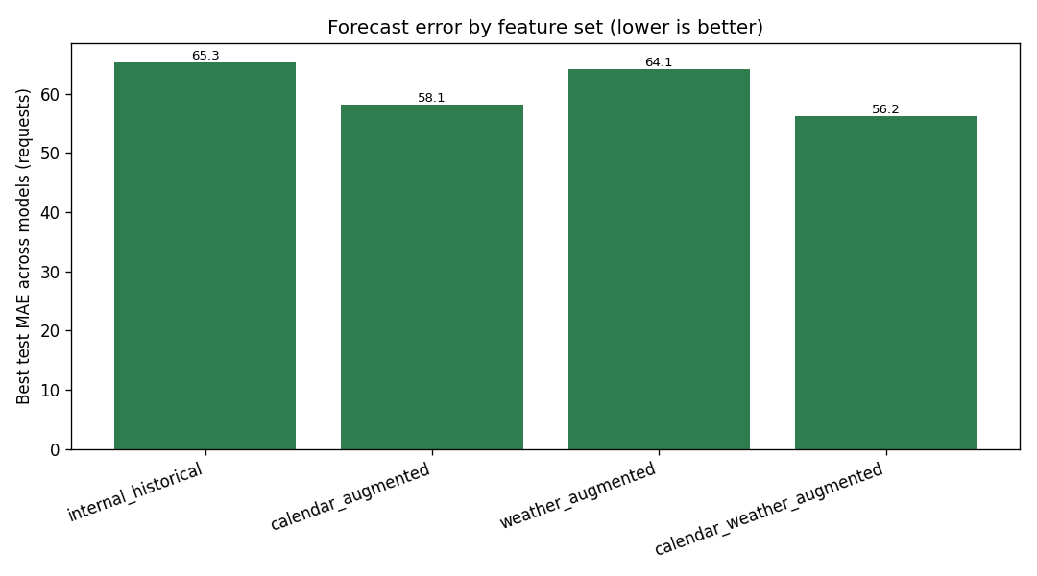
Figure 2. Best test MAE achieved per feature set across models.
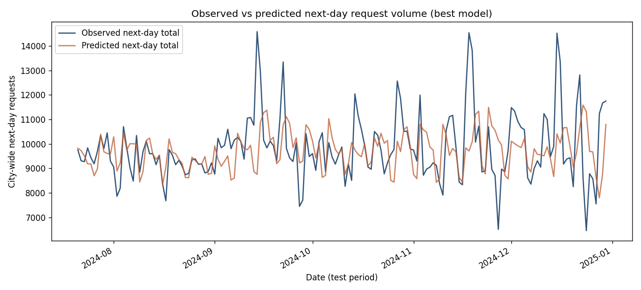
Figure 7. Observed vs predicted city-wide next-day request totals over the test period for the best model.
6. Forecast-to-Decision Simulation
At the baseline budget (135 crews, 50 requests per crew, 163 test days), total weighted unmet demand is 643,324 under the internal-historical policy and 631,191 under calendar+weather, versus an oracle of 597,332: the augmented policy reduces weighted unmet demand by 1.886% and closes 26.381% of the baseline-to-oracle gap.
Across crew budgets (Table 7, Figure 6) the calendar+weather policy is better than the baseline in all three settings, but the magnitude grows with capacity: the weighted-unmet reduction is 0.38% (scarce, 100 crews), 4.32% (moderate, 160), and 14.53% (generous, 220). The headline contrast - an approximately 11-15% forecast-accuracy gain versus a roughly 1.9% decision-quality gain at the baseline budget - is the central observation: average accuracy and operational value are not the same, and a scarce budget with demand concentrated in a few large cells limits how much any forecast can help.
Table 7. Decision sensitivity by crew budget. Stylized simulation; total weighted unmet demand (lower is better); calendar+weather versus internal-historical.
Setting | Crews | Internal | Calendar+Weather | Oracle | Reduction | Gap to oracle closed
scarce | 100 | 941,817 | 938,211 | 928,491 | 0.38% | 27.06%
moderate | 160 | 454,073 | 434,469 | 367,553 | 4.32% | 22.66%
generous | 220 | 164,197 | 140,346 | 50,865 | 14.53% | 21.05%

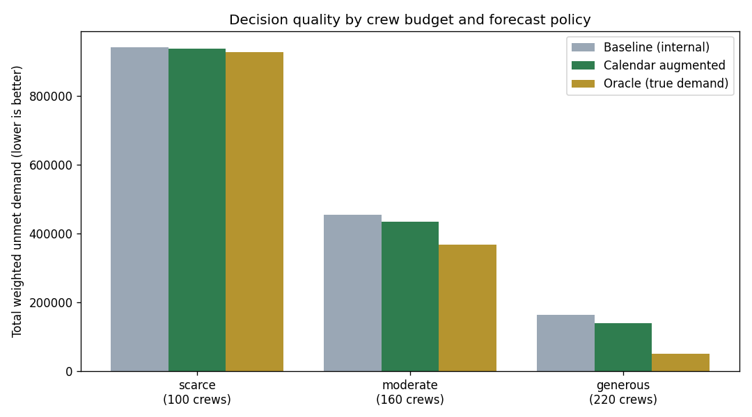
Figure 6. Total weighted unmet demand by policy under scarce, moderate, and generous crew budgets.
7. Robustness Checks
Five-fold expanding-window rolling-origin validation (Figure 3; full table in Appendix C) shows calendar augmentation lowering MAE in every fold for every model: mean improvement 15.13% for the random forest, 9.94% for gradient boosting, and 0.94% for Ridge, each in all 5 of 5 folds. The calendar_weather_augmented random forest has the lowest mean fold MAE (47.497). Segmented analysis (random forest, internal vs calendar; Appendix G) shows the improvement holds for all five boroughs (about 8.8% to 18.8%) and all eight complaint groups (about 8.9% to 25.8%); absolute error concentrates in the highest-volume segments (Noise, Housing; the Bronx). The forecast improvement is therefore consistent across folds and segments, not an artifact of one split.
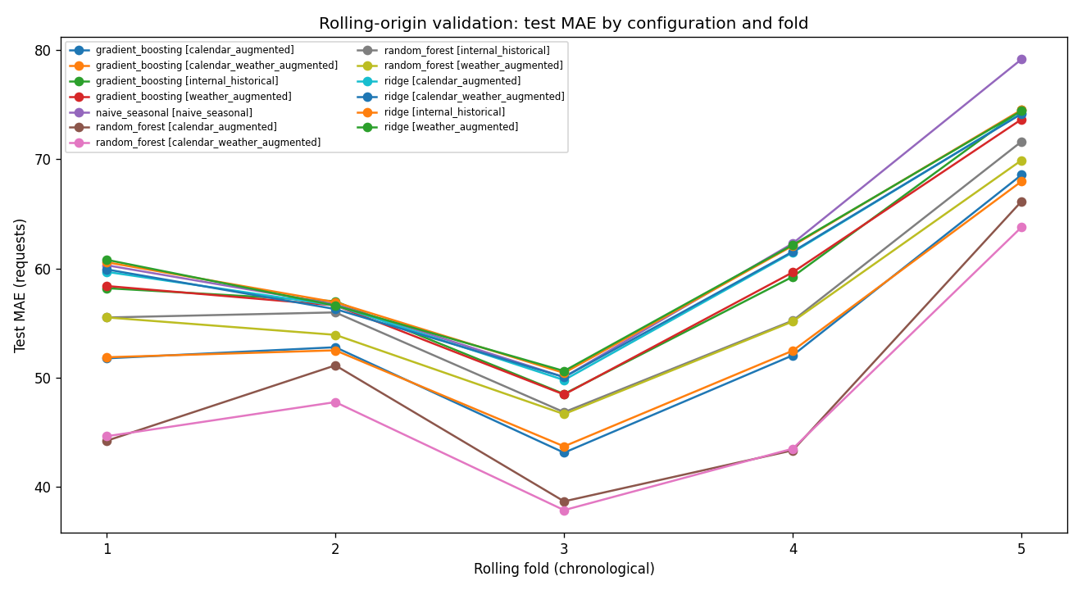
Figure 3. Per-fold test MAE by configuration across five expanding-window chronological folds.
8. Limitations
The study is predictive and correlational and makes no causal claim. NYC 311 reflects reporting behaviour, not true incidence (reporting bias), so forecasts predict reported volume. Weather is a single Central Park station used as a city-level proxy. Borough-level aggregation hides within-borough variation; the complaint-group mapping is a deterministic approximation with a residual Other group. No transit or event data is included. The staffing simulation is a stylized proportional heuristic - not real dispatch, not staffing optimization, not validated against any real policy - and omits crew travel, shifts, backlog, intra-day timing, and substitution; it uses no observed dispatch decisions. Results apply to NYC and 2022-2024 only.
Gating items for a stronger (full) paper: a non-stylized, agency-grounded decision model with an empirical service-level realism check; formal forecast-difference testing (for example a Diebold-Mariano test) with uncertainty intervals; and broader external signals beyond a single weather station, or cross-city replication.
9. Conclusion
On real NYC 311 data augmented with real NOAA weather, public-signal augmentation consistently improves next-day service-demand forecasts - calendar most, weather a smaller consistent increment - across rolling folds, boroughs, and complaint groups. The improvement transfers in direction to a stylized staffing allocation but with attenuated, budget-dependent magnitude. The forecast gains are real and robust; the decision gains are smaller and conditional on capacity. The artifact is a reproducible baseline suitable as a workshop / short-paper / arXiv-style contribution.
Reproducibility Statement
All values are read from committed artifacts under reports/ and data/metadata/. The pipeline is run with python -m src.weather, python -m src.build_dataset, python -m src.train, python -m src.evaluate, python -m src.decision_simulation, python -m src.monitor, python -m src.rolling_validation, python -m src.robustness_analysis, python -m src.decision_sensitivity, and python -m src.practical_significance, on Python 3.11. The quality gate is ruff check . and pytest, run offline on a committed real-schema sample; continuous integration runs the pipeline in that sample mode. No API keys or secrets are required. The committed inputs are the aggregated real daily counts and the real NOAA weather export; the large raw monthly exports and the trained model binary are not committed.
Data Availability Statement
NYC 311 Service Requests are public via NYC Open Data (Socrata dataset erm2-nwe9; City of New York, 2026). NOAA NCEI Daily Summaries (GHCN-Daily) for station USW00094728 are public (NOAA NCEI, 2026). The study window is 2022-2024. The aggregated daily counts and the NOAA export used here are committed; the large raw monthly 311 exports and the processed modelling dataset are regenerable and not committed; small real-schema samples are committed for continuous integration. No synthetic data and no synthetic weather are used.
Ethics Statement
The study uses public data only, at an aggregate date x borough x complaint_group level; no individual-level records and no personal data are used or produced. It makes no individual-level decisions, is not deployed, and is not public-safety software. It makes no causal claim and no real dispatch or staffing optimization claim. NYC 311 reflects reporting behaviour, not true incidence; reporting propensity varies across communities and time, so forecasts of 311 volume are forecasts of reporting, not of need, and must not be read as measures of true demand or used in ways that could compound existing inequities.

Appendix
A. Feature and feature-set definitions
Lag features (request_lag_1, request_lag_7) and rolling statistics (rolling_mean_7/14, rolling_std_7/14) per (borough, complaint_group) cell, using only past observations with a one-day shift. Calendar features: is_weekend, is_holiday, day_of_week, month, quarter, year, day_of_year, week_of_year, is_month_start, is_month_end. Weather features: precipitation_mm, temp_max_c, temp_min_c, temp_avg_c, snowfall_mm, snow_depth_mm, wind_speed_ms. Feature sets: internal_historical; calendar_augmented (internal + calendar); weather_augmented (internal + weather); calendar_weather_augmented (internal + calendar + weather). Table 2 lists the feature sets.
Table 2. Feature sets.
Feature set | Features
internal_historical | borough, complaint_group, request_lag_1, request_lag_7, rolling_mean_7, rolling_mean_14, rolling_std_7, rolling_std_14
calendar_augmented | internal_historical + is_weekend, is_holiday, day_of_week, month, quarter, year, day_of_year, week_of_year, is_month_start, is_month_end
weather_augmented | internal_historical + precipitation_mm, temp_max_c, temp_min_c, temp_avg_c, snowfall_mm, snow_depth_mm, wind_speed_ms
calendar_weather_augmented | internal_historical + calendar features + weather features

B. Complaint-group mapping
Raw complaint types are mapped by a deterministic, order-sensitive substring rule into eight groups (Housing, Noise, Sanitation, Street Condition, Water, Traffic, Public Safety, and a residual Other).
C. Chronological split and rolling-origin setup
Chronological 70/15/15 split by date (30,240 / 6,480 / 6,520 rows). Five expanding-window rolling-origin folds; each fold trains on all dates up to a cut point and tests on the next block, with no future information in training. Per-fold metrics are in reports/rolling_validation_report.csv; the summary (Figure 3 source) is in reports/rolling_validation_summary.json. Table 4 reports the mean fold MAE.
Table 4. Rolling-origin validation: random-forest mean fold test MAE by feature set.
Configuration | Mean MAE | Std
naive_seasonal | 61.701 | 9.673
random_forest internal_historical | 57.027 | 8.046
random_forest weather_augmented | 56.222 | 7.561
random_forest calendar_augmented | 48.690 | 9.590
random_forest calendar_weather_augmented | 47.497 | 8.746

D. Decision-simulation assumptions
Stylized proportional allocation via a largest-remainder rule; baseline-budget configuration 135 crews x 50 requests per crew over 163 test days; weighted unmet demand up-weights Public Safety, Water, and Traffic; an oracle allocates on true next-day demand. Not real dispatch; uses no observed dispatch decisions.
E. Crew-budget sensitivity
Three budgets - scarce (100 crews, 5,000 daily capacity), moderate (160 / 8,000), generous (220 / 11,000); per-policy results in reports/decision_sensitivity_report.csv and ..._summary.json (Table 7).
F. Weather-data treatment
Single NOAA station (USW00094728) joined to all boroughs by date; temp_avg_c derived from observed TMAX/TMIN (source TAVG empty); five missing wind-speed days time-interpolated from real neighbours; no synthetic weather (data/metadata/weather_source_report.json). Figure 8 shows the series.
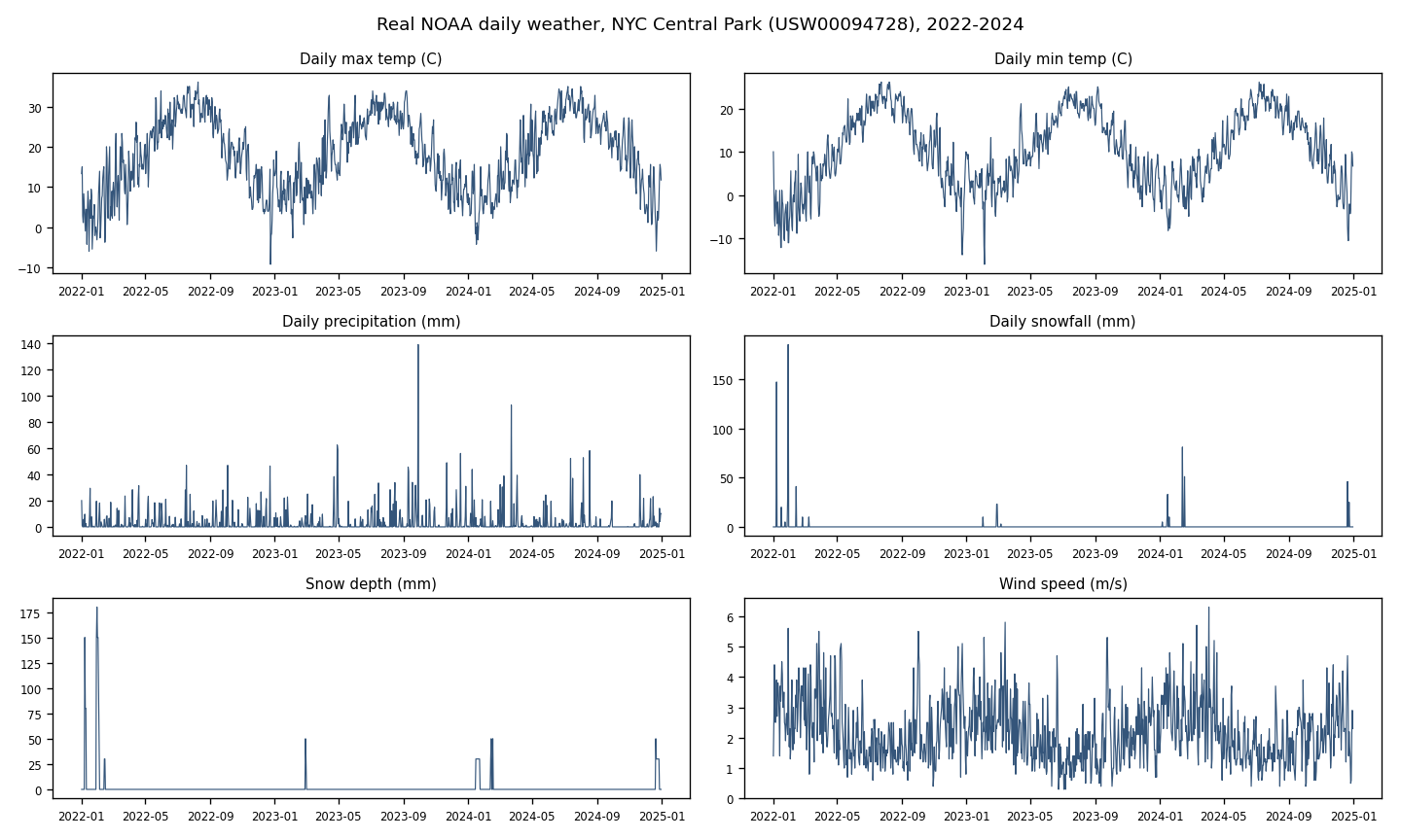
Figure 8. Real NOAA daily weather series for the Central Park station over 2022-2024.
G. Full results tables
Table G1 is the complete 13-row model comparison (reports/model_comparison.csv; Figure 1). Table G2 reports per-borough robustness (reports/borough_performance.csv; Figure 4) and Table G3 per-complaint-group robustness (reports/complaint_group_performance.csv; Figure 5), each comparing internal-historical vs calendar-augmented for the random forest. Figure 10 shows internal vs calendar-augmented per model; Figure 9 shows a baseline-budget policy comparison with the oracle.
Table G1. Full model comparison (held-out test).
Model | Feature set | Test MAE | Test RMSE | Test MAPE (%) | Test R2
naive_seasonal | naive_seasonal | 71.848 | 197.743 | 34.689 | 0.563
ridge | internal_historical | 69.219 | 187.753 | 36.073 | 0.606
ridge | calendar_augmented | 68.758 | 187.757 | 35.729 | 0.606
ridge | weather_augmented | 69.283 | 187.784 | 36.009 | 0.606
ridge | calendar_weather_augmented | 68.915 | 187.762 | 36.140 | 0.606
random_forest | internal_historical | 65.282 | 184.787 | 34.259 | 0.618
random_forest | calendar_augmented | 58.082 | 181.135 | 29.026 | 0.633
random_forest | weather_augmented | 64.104 | 181.379 | 33.614 | 0.632
random_forest | calendar_weather_augmented | 56.224 | 178.150 | 28.173 | 0.645
gradient_boosting | internal_historical | 67.493 | 187.734 | 38.378 | 0.606
gradient_boosting | calendar_augmented | 61.710 | 183.886 | 34.152 | 0.622
gradient_boosting | weather_augmented | 67.553 | 188.046 | 38.236 | 0.605
gradient_boosting | calendar_weather_augmented | 61.878 | 181.778 | 33.822 | 0.631

Table G2. Borough robustness (random forest; internal vs calendar).
Borough | Internal MAE | Calendar MAE | Improvement (%)
Bronx | 120.194 | 109.567 | 8.84
Brooklyn | 76.991 | 64.175 | 16.65
Manhattan | 58.178 | 48.078 | 17.36
Queens | 53.771 | 43.675 | 18.78
Staten Island | 12.766 | 11.129 | 12.82

Table G3. Complaint-group robustness (random forest; internal vs calendar).
Complaint group | Internal MAE | Calendar MAE | Improvement (%)
Noise | 194.882 | 168.272 | 13.65
Housing | 121.762 | 106.839 | 12.26
Other | 54.794 | 44.474 | 18.83
Traffic | 45.000 | 40.990 | 8.91
Sanitation | 24.957 | 22.078 | 11.54
Public Safety | 24.449 | 21.496 | 12.08
Water | 25.111 | 20.585 | 18.02
Street Condition | 24.084 | 17.865 | 25.82

Table 8. Limitations and mitigations.
Limitation | Mitigation / honest framing
311 reporting bias | Documented; target framed as reported volume; no need-based or causal claim
Borough-level aggregation | Granularity stated; within-borough variation not captured
Complaint-group mapping coarseness | Deterministic, documented; residual Other group reported
Single-station weather proxy | Documented spatial-resolution limitation; city-level proxy
Derived average temperature | Mean of observed TMAX/TMIN; source TAVG empty; documented
No transit or event data | Scope stated; future work
Stylized decision simulation | Labelled stylized; not real dispatch; oracle bound included
No observed dispatch decisions | Counterfactual only; no real-dispatch or optimization claim
Forecast-versus-decision gap | Decision metrics reported; transfer honestly attenuated/budget-dependent
No causal inference | No causal claim anywhere
NYC-only, 2022-2024 | External-validity limitation stated explicitly

H. Reproducibility commands
See the Reproducibility Statement.
Appendix Figures
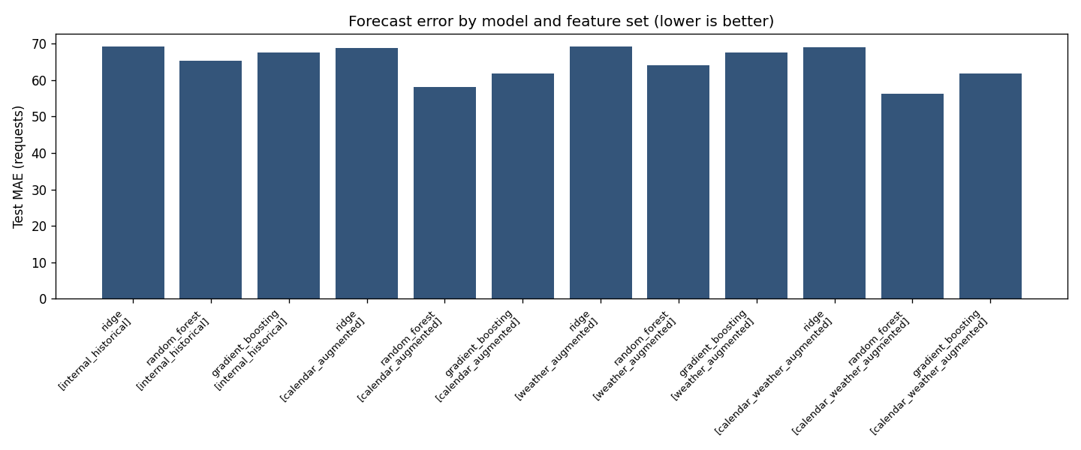
Figure 1. Held-out test MAE for the naive baseline and every model x feature-set combination across the four feature sets.
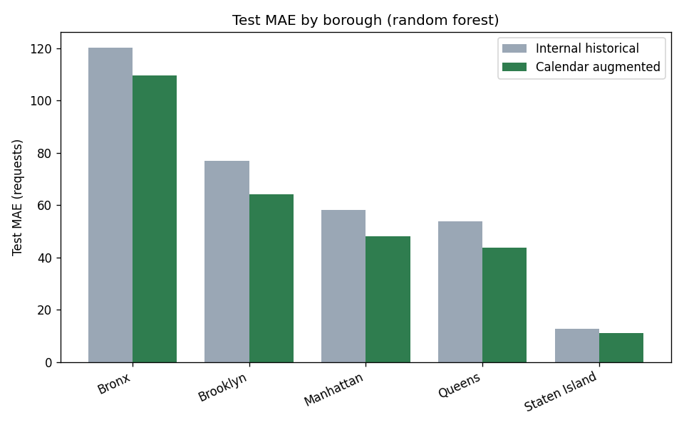
Figure 4. Internal-historical vs calendar-augmented test MAE by borough (random forest).
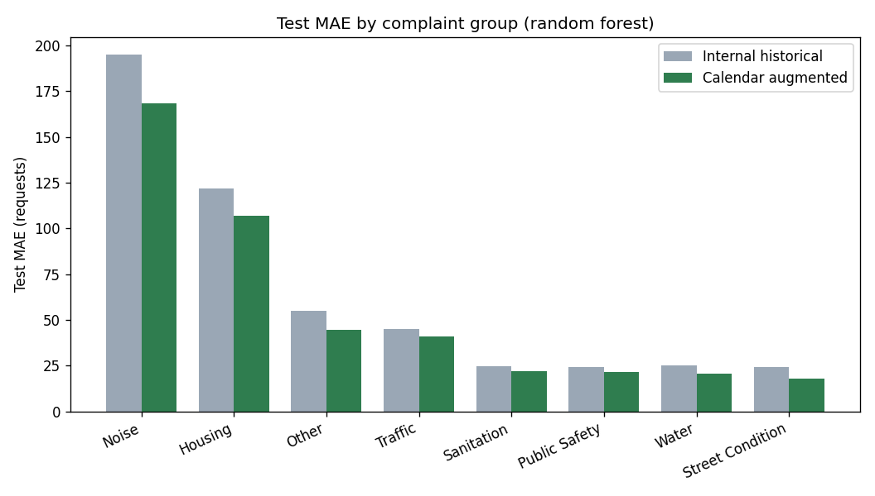
Figure 5. Internal-historical vs calendar-augmented test MAE by complaint group (random forest).
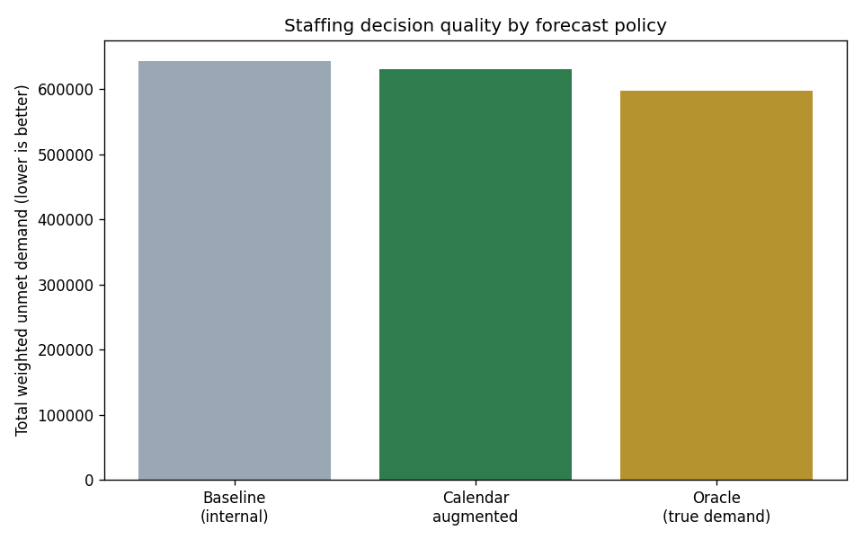
Figure 9. Total weighted unmet demand by policy at the baseline crew budget, with the oracle benchmark.
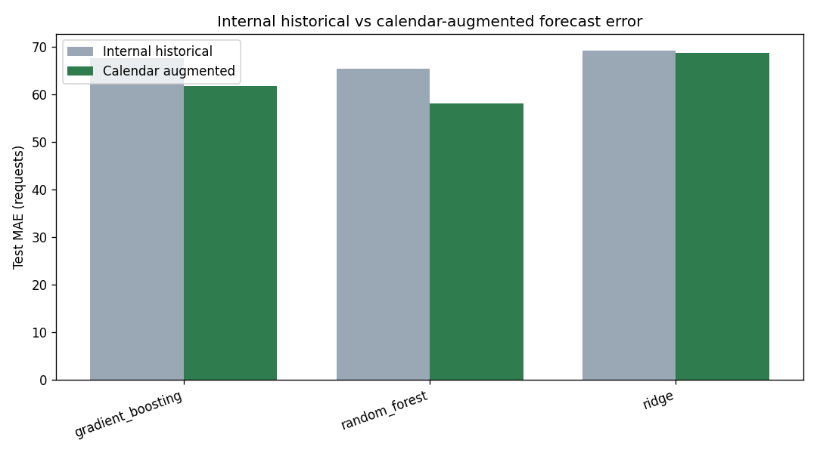
Figure 10. Internal-historical vs calendar-augmented test MAE per non-naive model.

References
City of New York. (2026). 311 Service Requests from 2010 to Present. NYC Open Data, Socrata dataset erm2-nwe9. https://data.cityofnewyork.us/Social-Services/311-Service-Requests-from-2010-to-Present/erm2-nwe9. Accessed 2026-06-03.
Cui, R., Gallino, S., Moreno, A., & Zhang, D. J. (2018). The Operational Value of Social Media Information. Production and Operations Management, 27(10), 1749-1769. https://doi.org/10.1111/poms.12707.
National Oceanic and Atmospheric Administration, National Centers for Environmental Information. (2026). Global Historical Climatology Network Daily (GHCNd). NOAA NCEI Daily Summaries; station USW00094728, NY City Central Park. https://www.ncei.noaa.gov/products/land-based-station/global-historical-climatology-network-daily. Accessed 2026-06-03.
Samorani, M., Harris, S. L., Blount, L. G., Lu, H., & Santoro, M. A. (2022). Overbooked and Overlooked: Machine Learning and Racial Bias in Medical Appointment Scheduling. Manufacturing & Service Operations Management, 24(6), 2825-2842. https://doi.org/10.1287/msom.2021.0999.

