First: Project Input Parameters
Parameter | Value | Unit
Capacity_KG | 480 | kg
Car_Weight_KG | 500 | kg
CW_Weight_KG | 740 | kg
Rope_Diameter_MM | 11 | mm
Number_of_Ropes | 4 | count
Suspension_Ratio | 2 | :1
Car_Width_M | 1.1 | m
Car_Depth_M | 2.1 | m
Guide_Shoe_Distance_M | 1.2 | m
Machine_Weight_KG | 250 | kg
Compens_Weight_KG | 600 | kg
W_Factor_1 | 950
W_Factor_2 | 850
W_Divisor | 1800
P_Factor_1 | 400
P_Factor_2 | 200
P_Divisor | 600
Parachute_Deceleration_M_S2 | 1.962 | m/s²
Parachute_Load_Multiplier | 10 | N/kg
Brake_Ratio | 1
Gravity_G | 9.81 | m/s²
Buffer_Factor | 4

Second: Ropes Static Tension Calculations
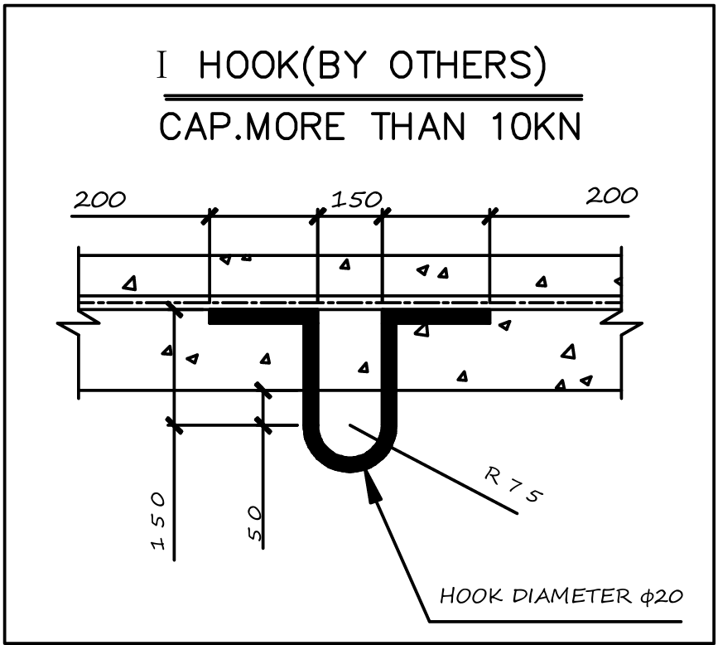
A) Static tension in each car suspension rope
T1 = (Capacity + Car + Compens) × g / 8
= (480 + 500 + 600) × 9.81 / (2 × 4) = 1937.475 N
B) Static tension in each C.W. suspension rope
Tcw = CW × g / 8 = 740 × 9.81 / 8 = 907.425 N
Third: Calculating the forces of irregular load distribution inside the car
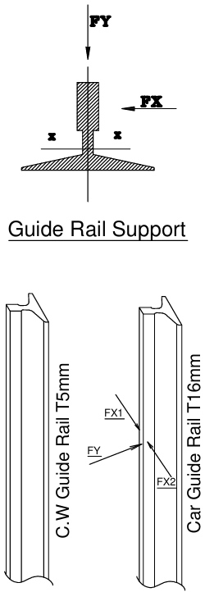
A) The Force FF1 (In the direction of the car guide rail axis)
FF1 = Capacity x 10 x Car Width / (4 x Vertical Guide Shoe Distance).
FF1 = 480 X 10 X 1.10 / (4 X 1.2) = 1100 N.
FF1 (design) = 1100 × 2 = 2200 N.
FF1 ≈ 224.34 kgf
B) The Force FF2 (Perpendicular to the car guide rail axis).
FF2 = Capacity x 10 x Car Depth / (8 x Vertical Guide Shoe Distance).
FF2 = 480 X 10 X 2.10 / ( 8 X 1.20 ) = 1050 N.
FF2 (design) = 1050 × 2 = 2100 N.
FF2 ≈ 214.14 kgf.

Fourth: Bedplate Load Distribution Calculations
W_Total = (480 + 500 + 740 + 600 + 250) × 9.81 = 25211.70 N
W1 = W_Total × 950/1800 = 13306.175 N; W2 = W_Total × 850/1800 = 11905.525 N
ΣP = W_Total
P1 = W1×400/600 ≈ 8870.78 N ≈ 904.57 kgf | P2 = W2×400/600 ≈ 7937.02 N ≈ 809.35 kgf | P3 = W2×200/600 ≈ 3968.51 N ≈ 404.68 kgf | P4 = W1×200/600 ≈ 4435.39 N ≈ 452.28 kgf

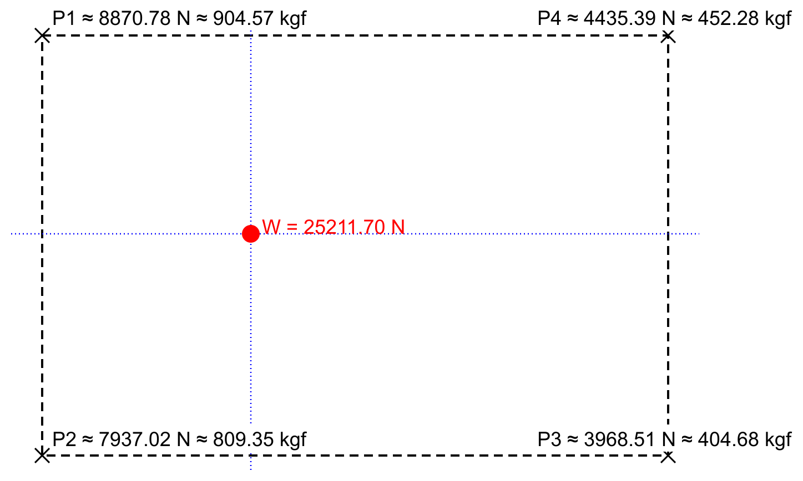

Fifth: Calculating the safety gear braking load on each car guide rail (Progressive Safety Gear).
P5 = (Capacity + Car + Compens) × 10 N/kg
= (480 + 500 + 600) × 10 = 15800 N ≈ 1611.15 kgf [Per Guide Rail]

Sixth: Loads on the pit supports below the car buffer | P6 (BUFFERS)
P6 = (Capacity + Car + Compens) × max(40, Buffer × g) N/kg
= (480 + 500 + 600) × max(40, 4 × 9.81) = 63200 N ≈ 6444.61 kgf [One Buffer]

Seventh: Pit support loads below the C.W. buffer | P7 (BUFFERS)
P7 = CW × max(40, Buffer × g) N/kg
= 740 × max(40, 4 × 9.81) = 29600 N ≈ 3018.36 kgf [One Buffer]

CODE - STANDARDS :

Diameter of ropes: The nominal diameter of ropes must not be less than 8 mm.
Tensile strength of rope wires: The tensile strength must be at least 1300 N/mm² and not more than 1800 N/mm².
Safety factor for ropes: Minimum breaking load divided by maximum rope tension must be at least 12 and not less than the value calculated under EN 81-50.
Number of ropes: At least 3 independent suspension ropes are required.
Rope data: Rope characteristics (construction, extension, ovality and flexibility) must comply with EN 12385-5.
The pitch diameter of traction sheaves and pulleys must be at least 40 times the nominal suspension rope diameter.
Rope terminations must withstand at least 80% of the minimum breaking load of the rope.
Rope traction: The car must not be raised by the machine when the counterweight rests on its buffers.

