Flower classification

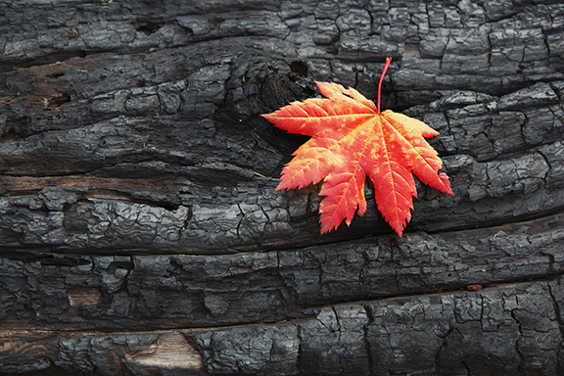

Authors : 1- Abdel-Nasser Heshamt

2- Mohamed Essam Bahgat

3- Norhan abd-Allah

TAble of  
Contents

Abstract 1

Problem 1

Datasets 1

Method 2

Results 3

* **Abstract**

In general, there are many different types of flowers. Nowadays, new flower are being discovered, even though they are very similar in color, shape and features. Ordinary persons with limited Botanical knowledge would not know the exact type of a flower just by looking at it.

* **Problem Definition**

living in the city. Sometimes we walk in a nearby park and encounter a flower that we have never noticed before. We may wonder how we would gain knowledge or details of that specific flower. Given an image of a flower, an ordinary people with limited Botanical knowledge would not be able to tell which species that flower belongs to

* **DataSets**

We used a data of ten kind of flowers from <https://www.kaggle.com/olgabelitskaya/flower-color-images> The data consists of 100 image with 128*128 size of 5 classes of flowers (Bellflower – Calendula – Goldquelle - Leucanthemum maximum – Phlox )

* **Methods**

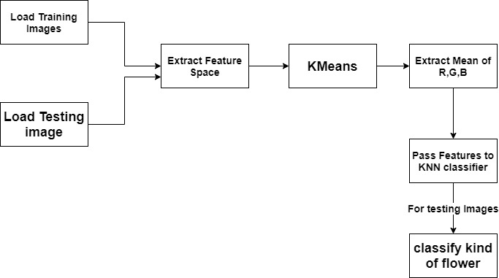

* We divided the Datasets into 70% Training and 30% testing data.
* Then we Extracted feature space for each color (R,G,B)
* We Applied Kmeans algorithm
* The Algorithm segment the image in two clusters
* We calculated the mean of each color as a feature
* We passed the features to KNN classifier
* We showed the results
* **Result**

**Accuracy of the classifier is 77.42%**