FedKG-Maint: Federated, Privacy-Preserving Predictive Maintenance with Knowledge-Graph-Grounded Explanations
Nasser Hossam Hamed - ID:320230051

Abstract
Predictive maintenance suffers from two practical problems: a single factory has few failure examples, and factories cannot share raw sensor data. We build FedKG-Maint, a framework in which several simulated factories train a shared failure-prediction model with federated learning, optionally protect the updates with differential privacy, and receive explanations grounded in a maintenance knowledge graph (KG). We evaluate on NASA C-MAPSS (remaining useful life, four factories FD001–FD004) and the Microsoft Azure Predictive Maintenance dataset (24-hour failure prediction, factories = machine models), always keeping one factory entirely unseen during training. On C-MAPSS, FedAvg reaches an RMSE of 32.9 cycles on the unseen factory FD004, against 48.8 and 54.6 for local models trained on single-operating-condition factories and 30.3 for centralized training on pooled data. Client-level differential privacy with only three clients shows no usable privacy/accuracy trade-off: noise levels giving a meaningful epsilon destroy the model. On Azure, federated models reach a held-out PR-AUC of 0.917, but an ablation shows this is driven by error-count features; with sensors alone the score is about 0.26. KG-grounded explanations mention 7.6 grounded entities per case versus 4.0 without the KG, with no unsupported claims, although this result is partly by construction (see Limitations). A subset study shows that which factories take part matters more than how many: every training subset containing the six-condition factory FD002 reached 30.1 to 35.4 RMSE on FD004, versus 48.9 to 56.0 without it.

1. Introduction and Objectives
This project investigates whether (i) factories with scarce or narrow data can benefit from federated learning without sharing raw data, (ii) a federated model generalizes to a factory that never took part in training, (iii) differential privacy can be added at an acceptable accuracy cost, and (iv) a knowledge graph can ground explanations so that they refer only to facts supported by the model output and the factory’s data. All experiments use a held-out factory for generalization testing, and every model-selection decision uses validation data from the training clients only.

2. Data and Experimental Setup

2.1 NASA C-MAPSS (remaining useful life)
C-MAPSS contains four turbofan sub-datasets that differ in operating conditions and fault modes: FD001 (1 condition, 1 fault mode), FD002 (6 conditions, 1 fault mode), FD003 (1 condition, 2 fault modes) and FD004 (6 conditions, 2 fault modes). Each sub-dataset is one factory. FD001–FD003 are federated clients and FD004 is the held-out factory.
- Features. 3 operating settings and 14 sensors (7 constant or uninformative sensors removed: s1, s5, s6, s10, s16, s18, s19), giving 17 features shared by all factories.
- Target. Remaining useful life (RUL) = last cycle minus current cycle, capped at 125 cycles (the usual piecewise-linear target).
- Windows. Sliding windows of 30 cycles with stride 1; the label is the RUL at the last cycle. Training windows: FD001 14,459, FD002 36,971, FD003 17,472, FD004 43,713 (after holding out 20% of the engines of each factory for validation, which gave 3,272, 9,248, 4,348 and 10,315 validation windows respectively; the split is by engine, so no engine appears in both).
- Test. One window per test engine (its last 30 cycles), scored against the official RUL files.
- Local normalization. Mean and standard deviation are computed inside each factory from its own training engines only; the held-out factory uses its own statistics.

2.2 Microsoft Azure Predictive Maintenance (failure prediction)
The Azure data contain hourly telemetry (voltage, rotation, pressure, vibration), error logs, maintenance records, failure records and machine metadata for 100 simulated machines during 2015. Factories are the machine models: model1, model2 and model3 are clients, model4 is held out.
- Target. One row per machine-hour; positive if any component fails within the next 24 hours, strictly after the current hour.
- Features (30). 4 raw sensors; 3-hour and 24-hour rolling mean and standard deviation of each sensor (16); 24-hour rolling counts of error1–error5 (5); days since the last maintenance of comp1–comp4, using only records strictly before the current hour (4); machine age (1).
- Splits. Per client, a time split: train before September, validation in September–October, test in November–December. The held-out factory is evaluated on all of its data. In training sets only, 10% of negative rows are kept (all positives kept); evaluation sets are untouched.
- Metrics. PR-AUC and F1, with the F1 threshold chosen on validation data only. Normalization is local to each factory.

3. Methods

3.1 Predictive models
C-MAPSS uses a 2-layer LSTM (64 hidden units) with a small fully connected head (about 56.6 thousand parameters), trained with Adam (learning rate 1e-3), MSE loss on RUL scaled to [0, 1], batch size 256 and gradient clipping at 1.0. Azure uses an MLP (30-64-32-1) with binary cross-entropy. In every setting the checkpoint with the best validation score is kept.

3.2 Training setups
- Local-only. Each client trains on its own data alone (reference).
- Centralized. One model trained on the pooled data of the three clients (reference; violates privacy).
- FedAvg. All three clients train locally each round and the server averages the weights, weighted by client data size. C-MAPSS: 40 rounds, 2 local epochs, learning rate decayed by 5% per round. Azure: 25 rounds, 1 local epoch.
- FedProx. As FedAvg, plus a proximal term (mu/2)·||w − w_global||² in the local loss, with mu = 0.01 (not tuned).
The best round is selected on the clients’ pooled validation data; the held-out factory is never used for selection (its per-round error is logged only for plotting).

3.3 Privacy: client-level differential privacy
Each client’s update (local weights minus global weights) is clipped to L2 norm C, the clipped updates are averaged uniformly, and Gaussian noise with standard deviation sigma·C/n (n = 3 clients) is added to every weight. A noise multiplier of 0 gives a control that still clips and averages, isolating the effect of the noise. Privacy is accounted with the Rényi-DP composition of the Gaussian mechanism over all 40 rounds (full participation), converted to (epsilon, delta)-DP with delta = 1e-5 under an add/remove-one-client neighbouring relation.

3.4 Maintenance knowledge graph
All factories agree on one schema: Factory –EXPERIENCES→ FailureMode –AFFECTS→ Component –MONITORED_BY→ Sensor, FailureMode –RECOMMENDS→ Action, and Sensor –WEAR_TREND_AT→ Factory (with direction and strength). Each factory builds its own local graph from its own data: the wear-trend edge records whether a sensor tends to rise or fall as RUL decreases, from the correlation between the sensor’s latest value and RUL in that factory’s training data. Sensor and component meanings come from the public C-MAPSS documentation; the failure modes per factory come from the dataset readme. The links from failure modes to components and the recommended maintenance actions are illustrative domain knowledge written for this project and have not been reviewed by a maintenance expert. The local graphs have 25 nodes and 33 edges (FD001, FD002) and 28 nodes and 37 edges (FD003, FD004).

3.5 Grounded explanations and checks
For each held-out engine the model predicts RUL; each sensor is then zeroed out in turn (occlusion) and the three sensors that change the prediction most are the cited evidence. Two explanations are produced: without KG (prediction, risk level, cited sensor codes, generic recommendation) and with KG (retrieved facts: sensor meaning, component, wear trend at this factory, most likely failure mode, recommended action). Two checks follow. A grounding check counts every mentioned sensor, component or failure mode that the case’s evidence does not support, and every “N cycles” claim that differs from the model’s prediction by more than 1.5 cycles. A deletion test compares the prediction change when the cited sensors are removed against the change for random sensors. Prompts and code for testing a real LLM with and without KG grounding are included, but that comparison was not run (see Limitations).

4. Results

4.1 C-MAPSS: reference setups versus federated learning
Own-test RMSE is measured on the test sets of the factories a model was trained on (for centralized and federated models, the average over the three clients). FD004 columns are for the unseen factory. The NASA score penalizes late predictions more and is lower-is-better. These are single-seed results.
Setup | Own-test RMSE | FD004 RMSE | FD004 NASA score | Communication (MB)
Local-only FD001 | 14.20 | 48.77 | 1,018,184 | 0
Local-only FD002 | 16.38 | 31.22 | 12,114 | 0
Local-only FD003 | 17.13 | 54.61 | 1,936,184 | 0
Centralized (pooled) | 15.92 | 30.32 | 12,232 | n/a (raw data shared)
FedAvg | 23.02 | 32.90 | 15,715 | 54.4
FedProx (mu = 0.01) | 31.03 | 39.38 | 197,140 | 54.4
- Local models trained on the single-condition factories FD001 and FD003 generalize poorly to the six-condition factory FD004 (RMSE 48.8 and 54.6). FedAvg reduces this error by about 33% and 40% without sharing raw data.
- FedAvg is within about 2.6 RMSE of centralized training (32.9 versus 30.3) on the unseen factory.
- Local FD002 (31.2) is as good as FedAvg on FD004 and has a lower NASA score. FD002 already covers six operating conditions like FD004, so it is a strong local reference.
- On the clients’ own test sets the federated models are clearly worse than local or centralized models (FedAvg 23.0 versus 14–17): one shared model is a compromise across heterogeneous factories.
- FedProx with mu = 0.01 was worse than FedAvg (39.4 versus 32.9). Its validation error was still decreasing at round 40, so the proximal term slowed convergence; mu was not tuned, so this does not show FedProx is generally inferior.
- Communication cost: 40 rounds × 3 clients × 2 directions × 56.6 thousand float32 weights ≈ 54.4 MB in total.
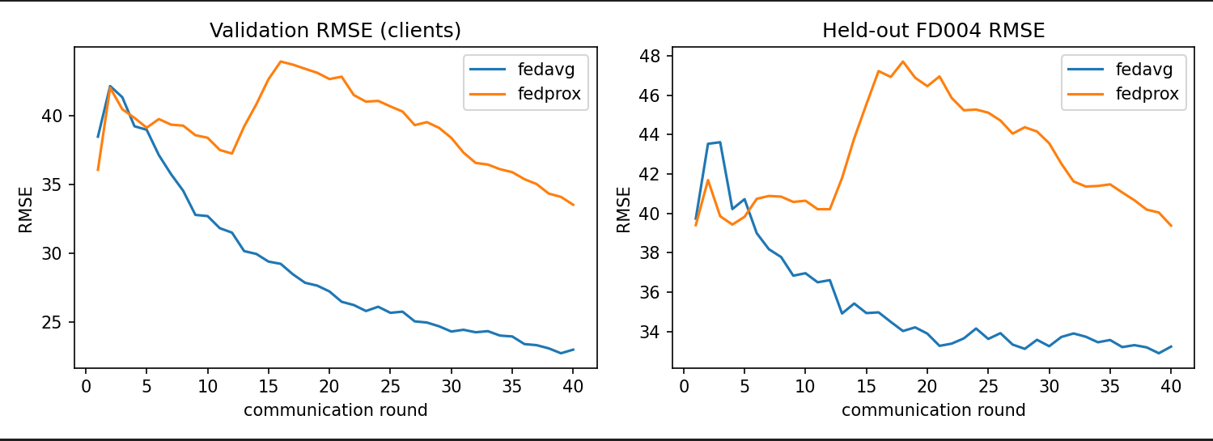

4.2 Azure: failure prediction
Results are means over 3 seeds. The held-out factory is model4.
All features
Setup | Own PR-AUC | Own F1 | Held-out PR-AUC | Held-out F1
Local-only model1 | 0.940 | 0.933 | 0.859 | 0.833
Local-only model2 | 0.930 | 0.902 | 0.878 | 0.854
Local-only model3 | 0.929 | 0.929 | 0.919 | 0.922
Centralized | 0.930 | 0.934 | 0.904 | 0.912
FedAvg | 0.927 | 0.908 | 0.917 | 0.900
FedProx (mu = 0.01) | 0.929 | 0.915 | 0.917 | 0.906
Sensors and age only (error counts and days-since-maintenance removed)
Setup | Own PR-AUC | Own F1 | Held-out PR-AUC | Held-out F1
Local-only model1 | 0.394 | 0.437 | 0.146 | 0.246
Local-only model2 | 0.288 | 0.409 | 0.151 | 0.281
Local-only model3 | 0.267 | 0.347 | 0.290 | 0.373
Centralized | 0.299 | 0.361 | 0.264 | 0.316
FedAvg | 0.299 | 0.348 | 0.265 | 0.360
FedProx (mu = 0.01) | 0.298 | 0.344 | 0.263 | 0.357
A single-seed run that removed only the days-since-maintenance features left the results almost unchanged (FedAvg held-out PR-AUC 0.914, FedProx 0.913, centralized 0.900), so the large drop comes from the error-count features. Total communication was about 2.5 MB (all features) and 2.1 MB (sensors only).
- With all features, federated models match centralized training on the unseen factory (0.917 versus 0.904) and clearly beat the local models of the two small factories (0.859 and 0.878); they tie with the local model of the largest client (model3, 0.919).
- With sensors only, the task is much harder (PR-AUC about 0.26). Federated learning lifts the small factories from about 0.15 to 0.265 on the unseen factory, but local model3 is slightly better (0.290).
- On each client’s own test period, local models are better than federated ones in the sensor-only setting (for example model1: 0.394 versus 0.299), which points to personalized federated learning as a natural extension.
- Paired t-tests over the three seeds are in results/report_tables.md. With only three seeds statistical power is low, so differences such as FedAvg versus FedProx (at most 0.003 PR-AUC) should not be treated as real.
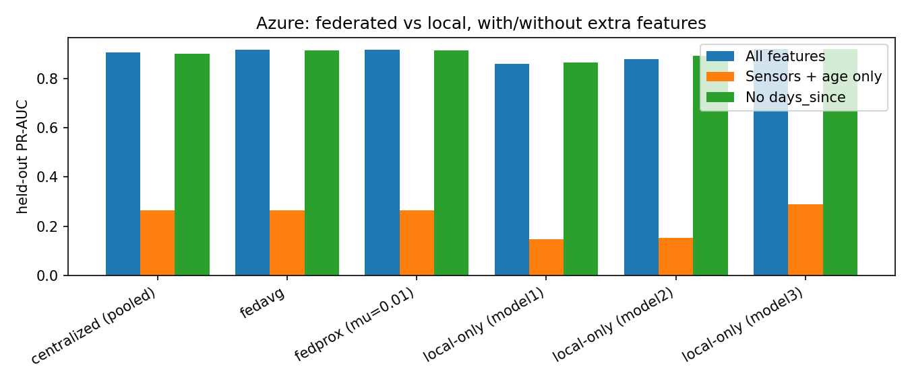

4.3 Privacy–performance trade-off (C-MAPSS)
DP-FedAvg with clip C = 3.0 (mean client update norm was about 3–5 in early rounds); epsilon is for 40 rounds at delta = 1e-5.
Noise multiplier sigma | Effective noise (sigma·C) | Epsilon | Own-test RMSE | FD004 RMSE
0 (clip only) | 0 | infinite | 22.77 | 33.61
0.05 | 0.15 | 8,618 | 28.85 | 36.75
0.2 | 0.6 | 652 | 84.52 | 77.99
0.5 | 1.5 | 141 | 331.35 | 332.05
- The no-noise control (33.6) is close to plain FedAvg (32.9), so clipping itself costs little when C is well chosen. An earlier run with C = 1.0 clipped every update and gave a no-noise RMSE of 40.5, showing that the clipping bound must be matched to the update scale.
- Light noise (sigma = 0.05) costs about 3 RMSE but its epsilon of about 8,600 gives no meaningful guarantee.
- Accuracy collapses once the effective noise (sigma·C) reaches about 0.6. In the C = 1.0 run, sigma = 5 was the only setting with a meaningful epsilon (6.87), and it destroyed the model (RMSE about 3,941).
- With only three clients, averaging provides little noise reduction, so strong client-level guarantees and usable accuracy cannot be obtained together in this setup.
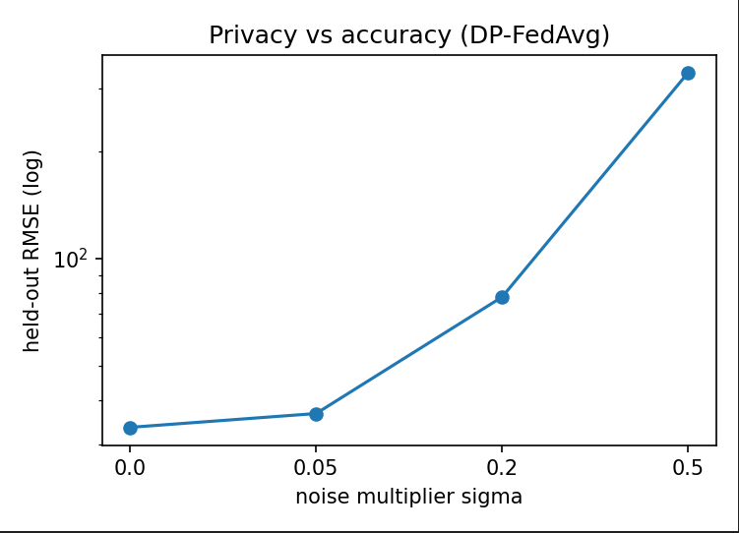

4.4 Explanations
Evaluated on the first 30 held-out FD004 engines with template explainers.
Explanation type | Entities mentioned (mean) | Unsupported mentions (mean) | Explanations with a hallucination | Grounded
Without KG | 4.00 | 0.00 | 0% | 100%
With KG | 7.57 | 0.00 | 0% | 100%
Removing the cited sensors changed the predicted RUL by 68.4 cycles on average, versus 28.7 cycles for random sensors (2.4 times larger), supporting the faithfulness of the cited evidence. Example (case 0, predicted RUL about 83 cycles):
- Without KG: “Predicted remaining useful life: about 83 cycles (normal). The prediction is most influenced by sensors s11, s4, s15. Recommendation: schedule a maintenance inspection.”
- With KG: the same prediction, plus for each cited sensor its meaning (for example s11, Ps30, HPC outlet static pressure), its deviation from the FD004 average and whether its trend agrees with the wear trend learned at FD004, then “Most likely failure mode: HPC degradation, affecting the High-Pressure Compressor. Action: continue routine monitoring and watch for HPC degradation.”

4.5 Ablations
- Without the knowledge graph: explanations contain about half as many facts (4.0 versus 7.6 entities) and give no component, failure mode or specific action.
- Without privacy: the sigma = 0 control (33.6) versus sigma = 0.05 (36.8) and larger noise (Section 4.3).
- Without the LLM: all explanations here are template-based; the LLM variant was not evaluated.
- Without maintenance and error features (Azure): held-out PR-AUC falls from about 0.92 to about 0.26 (Section 4.2).

4.6 Effect of the number of factories and of client heterogeneity
FedAvg was trained on every subset of the three training factories (the seven combinations of one, two and three factories) and tested on the unseen factory FD004. To keep the subsets comparable, all runs use the same lighter budget (20 rounds, 1 local epoch, single seed), so the three-factory result (34.98) differs from the 32.90 of Section 4.1, which used 40 rounds and 2 local epochs. A pooled (centralized) model trained on the same subset is the reference, and the gap is the FedAvg RMSE minus the pooled RMSE. Because FD004 has six operating conditions and two fault modes, the table also marks whether a subset contains a multi-condition client (FD002) and a fan-fault client (FD003). RMSE values are in cycles; own-test RMSE is the average over the subset’s own test sets.
Training factories | k | Multi-condition client | Fan fault | Own-test RMSE | FD004 RMSE (FedAvg) | FD004 RMSE (pooled) | Gap
FD001 | 1 | no | no | 14.54 | 48.90 | 48.77 | 0.13
FD002 | 1 | yes | no | 16.67 | 31.05 | 31.22 | -0.17
FD003 | 1 | no | yes | 15.65 | 56.00 | 54.61 | 1.40
FD001+FD002 | 2 | yes | no | 24.69 | 30.07 | 30.29 | -0.22
FD001+FD003 | 2 | no | yes | 15.27 | 51.74 | 50.46 | 1.28
FD002+FD003 | 2 | yes | yes | 30.09 | 35.43 | 29.39 | 6.04
FD001+FD002+FD003 | 3 | yes | yes | 28.54 | 34.98 | 30.32 | 4.66

- Number of factories. The mean FD004 RMSE across subsets falls from 45.3 (one factory) to 39.1 (two) to 35.0 (three), but the number alone does not explain this: the best two-factory model (FD001+FD002, 30.1) is better than the three-factory model (35.0), and the single factory FD002 (31.1) is already close.
- Composition matters most. Every subset containing FD002 reaches 30.1 to 35.4 on FD004, while every subset without it reaches 48.9 to 56.0. FD004 has six operating conditions, so this is consistent with operating-condition coverage being the key factor. Adding the fan-fault factory FD003 did not help (FD001+FD003: 51.7 versus 48.9 for FD001 alone). However, FD002 is also by far the largest client (36,971 training windows against 14,459 and 17,472), so data volume and condition coverage are confounded and this experiment cannot separate them.
- The cost of federating grows with heterogeneity. The gap between FedAvg and pooled training is small (at most 1.4) for single factories and for the pairs FD001+FD002 and FD001+FD003, and largest (6.0 and 4.7) for the two subsets that combine a multi-condition factory with the fan-fault factory FD003. FedAvg and the pooled models were trained with different budgets (20 rounds of one local epoch versus 15 pooled epochs), so gaps of about 1 RMSE or less are not meaningful.
- A shared model is a compromise on each client’s own data. Own-test RMSE is 14.5 to 16.7 for single factories and 15.3 for the similar pair FD001+FD003, but 24.7 to 30.1 once FD002 is combined with another factory.
- Communication. The total cost grows linearly with the number of factories: 9.1 MB for one, 18.1 MB for two and 27.2 MB for three (20 rounds).
- Caveats. These are single-seed results and heterogeneity here is the natural difference between factories, not a controlled parameter; only the large differences (the roughly 20-point gap with and without FD002 and the 4.7 to 6.0 gaps to pooled training) should be interpreted.

5. Discussion
Does federated learning help? For generalization to an unseen factory, yes when local data are narrow: FedAvg removes about a third to two fifths of the error of the single-condition local models on C-MAPSS, and lifts the small Azure factories to the level of the large one. It does not beat a local model trained on a factory that already covers the target conditions (FD002 on C-MAPSS, model3 on Azure), and it trails centralized training slightly. On the clients’ own data a shared model is worse than a specialized one, so personalized federated learning is a promising direction.
Heterogeneity. The big difference between FD001/FD003 (one operating condition) and FD002/FD004 (six) dominates the C-MAPSS results. We normalize per factory but not per operating condition, which likely makes the six-condition factories harder for every method. The subset experiment (Section 4.6) shows that which factories take part matters more than how many: all subsets containing the six-condition factory FD002 generalized to FD004 far better than those without it, although FD002 is also the largest client, so condition coverage and data volume cannot be separated here. The cost of federating, measured as the gap to pooled training, was largest when clients differed in both operating conditions and fault modes.
FedAvg versus FedProx. Both reached similar performance on Azure; on C-MAPSS FedProx with mu = 0.01 converged more slowly. A smaller mu or more rounds would be needed for a fair comparison.
Privacy. The formal guarantee depends on noise that is large relative to a three-client average. What could still leak: model updates can reveal information about local training windows through gradient inversion or membership inference attacks, even though raw data are never sent; DP bounds this for whole factories but only at the cost shown in Section 4.3. The shared schema is public domain knowledge, but the learned wear-trend edges (direction and correlation strength per sensor) are statistics of a factory’s own data, so sharing local graphs would leak those statistics; in our design graphs stay local. Secure aggregation would hide individual updates from the server without adding noise, but it was not implemented.
Explanations. Conditioning on KG facts produced richer explanations that cite the component, failure mode and action and check trend consistency with the factory’s own wear pattern. Because the templates are built only from retrieved facts, 100% grounding is expected; the informative test is a free-text LLM with and without KG grounding, which this work prepared but did not run.

6. Limitations
- Seeds and significance. The C-MAPSS experiments are single-seed, so no significance test was possible; Azure used three seeds, which gives low statistical power.
- Few clients. Three clients limit both federated variety and what differential privacy can guarantee. Accounting assumes full participation and does not include the effect of validation-based model selection or hyperparameter tuning.
- Heterogeneity study. Heterogeneity was studied through which factories participate (Section 4.6), not through a controlled heterogeneity parameter. It uses a single seed, a lighter training budget than Section 4.1 and at most three clients, and FD002 is confounded with data volume.
- Under-training and tuning. The federated C-MAPSS models are clearly worse than centralized ones on the clients’ own test sets and FedProx was still improving at round 40. Hyperparameters, including mu and the clipping bound, were not systematically tuned.
- Normalization. No per-operating-condition normalization, which is known to matter for FD002 and FD004.
- Azure data. The dataset is simulated and the error-count features carry most of the signal, so the 0.92 PR-AUC will not transfer to real factories. Negatives were subsampled for training, and only one machine model was held out. Privacy, the knowledge graph and explanations were applied to C-MAPSS only; Azure error and maintenance logs were not used to enrich the graph.
- Knowledge graph. The failure-mode-to-component links and the maintenance actions are illustrative and unreviewed by a domain expert.
- Explanations. The explanation experiments used a separately trained pooled LSTM rather than the federated model (the explanation method is model-agnostic). Evidence is chosen by zeroing a sensor, a crude perturbation. Template explanations are grounded by construction; no LLM comparison, hallucination study of free text or human evaluation was performed.

7. Conclusion
Federated learning let factories with narrow data build models that generalize much better to an unseen factory than their local models, approaching centralized accuracy without sharing raw data. Client-level differential privacy is practical only at very low noise levels with three clients, so strong guarantees would need more participants or complementary mechanisms such as secure aggregation. The Azure ablation shows how strongly results depend on the dataset’s error-count features. A knowledge graph built locally by each factory under a shared schema made explanations richer and checkable against facts; testing them against a real LLM remains the key next step, along with more seeds, tuned FedProx and personalized federated learning.

Appendix: Reproducibility
Run in order: step1_cmapss_prep.py (preprocessing), step2_baselines.py (local-only and centralized), step3_federated.py (FedAvg and FedProx), step4_privacy.py (DP; used --clip 3.0 --sigmas 0 0.05 0.2 0.5), step5_explain.py (knowledge graphs and explanations; kg_explain.py holds the graph code), azure_prep.py and step6_azure.py (Azure; --seeds 3, and --drop days_since error for the sensor-only ablation), step8_scaling.py (number of factories and client composition; run with --central), and step7_report_tables.py (tables, significance tests and the figures fig_fl_convergence.png, fig_privacy_tradeoff.png and fig_azure_ablation.png in results/). Shared code is in common.py. Random seeds start at 0.

