Software Design Document
  - AI Assisted Child Development Platform
Team: Group 11 Version: First version (Week 6) Updated: 2026-11-08
Repository: child-development-app-group11
This document describes how Group 11 will build a shared schedule, task list and development record for parents, specialists and children.
Implemented in main. At commit 362dd13, the Express server reads tasks from SQLite and returns them as JSON through GET /api/tasks. The seed script creates three example tasks. The GitHub Actions workflow sets up Node.js 22 and prints a placeholder message.
Target design. The architecture diagram, technology stack and wireframes below specify the intended M1–M8 system. Planned work includes the React interface, JWT and child access checks, task updates, specialist records, AI summaries and automated tests.
Revision marks. An asterisk (*) identifies a choice made for this design. On a wireframe title it covers the layout, example data and interactions.

1 Architecture Overview
The React client sends requests to a local Express API. The API reads and writes synthetic records in SQLite and enforces the permissions in the access matrix. Its AI module calls the Gemini API* for weekly summaries and uses a deterministic mock for automated tests.
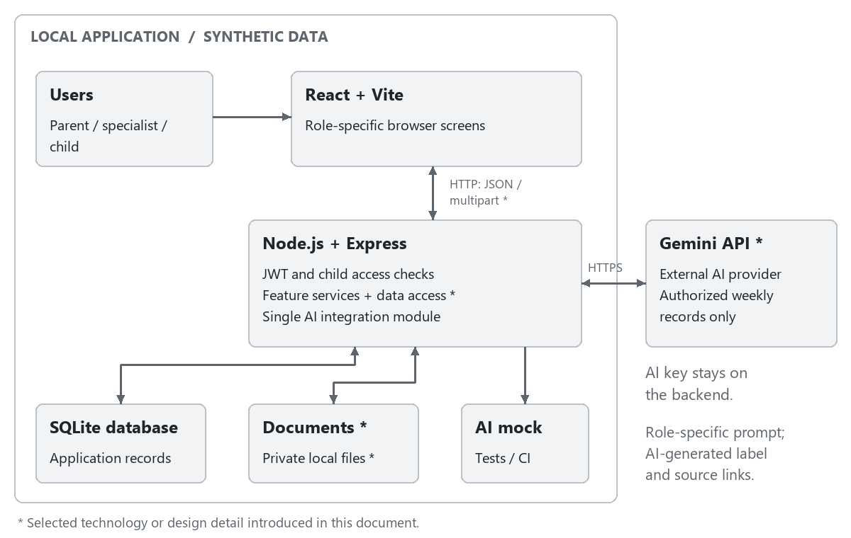
Figure 1 Architecture overview

Responsibilities and Trust Boundaries*
The browser collects input, displays authorized results and manages loading and validation states*. React components share an authenticated session and selected-child context*, so navigation preserves the user's current workspace. Frontend route guards* select the correct screens, while the API remains the authority for every data operation.
Express route handlers parse requests. Middleware checks identity and child access before feature services apply business rules and issue parameterized queries*. Each successful write returns the saved record* so the browser can display the stored result.
Express keeps uploaded files in a private local directory* and serves them through protected download routes*. The AI provider key stays on the server.

Access Control
Operation | Parent | Linked specialist | Child
View a child's weekly schedule | Own child | Linked child | Self only
Add events and assign tasks | Own child | Linked child | No
Mark a task done | No | No | Own task
Link or unlink specialists | Own child | No | No
Read specialist observations | Own child | Linked child | No
Add specialist observations | No | Linked child | No
Upload, view and download documents | Own child | Linked child | No
View weekly statistics | Own child | Linked child | No
Request a role-specific AI summary | Own child | Linked child | No

For each request, the API verifies the JWT and checks the requested action against the matrix. It matches a parent to an owned child, a specialist to an active link, or a child account to its own profile. This check also protects downloads and AI source links. Once a parent removes a specialist link, the next request for that child is denied even if the token is still valid.

Persistence and Consistency*
SQLite stores the application's structured records, and a seed script supplies synthetic users and feature data. Related writes use database transactions*, and stored relationships use foreign-key constraints*. New tasks begin as Pending*; when the child marks one Done, the server stores the update before the UI confirms completion*. The assigner's next retrieval reads that same saved state*. Observation edits retain the original entry date and set an edited flag* so that the required Edited label remains reliable.
For weekly statistics, the selected week runs from Monday through Sunday in the Europe/Istanbul application time zone*. The denominator is the number of tasks whose due date falls in that week*, and the numerator is the number of those tasks currently marked Done*. The same calculation is applied separately to each development area*. Three completed tasks out of five therefore produce 60%. A week or area with no tasks displays No tasks rather than dividing by zero*. These selection rules are shared by the dashboard and AI input builder*.
Documents use generated storage names*, while SQLite records their original name, verified type, uploader, child and upload date*. File size and content are validated before the upload is accepted*. If saving the metadata fails, the new file is removed*; a failed upload must not appear as a successful document row*. This prevents a visible record from referring to a missing or rejected file.

Technology Stack
Layer | Selected technology | Purpose
Frontend | React, Vite; JavaScript*, React Router*, CSS* | Build the browser interface, role-specific navigation and reusable screen components.
API communication | HTTP REST with JSON; browser Fetch API* | Exchange application data with Express; use multipart requests for document uploads*.
Backend | Node.js 22, Express; JavaScript with CommonJS | Provide the local API. Node.js 22 matches the repository's CI configuration; CommonJS matches the existing backend.
Database | SQLite using the existing sqlite3 package | Persist users, child profiles, specialist links and feature records; initialize synthetic data with a seed script.
Authentication | JWT; jsonwebtoken* and bcryptjs* | Sign and verify access tokens and hash passwords. Keep access tokens in frontend memory* and send them as Bearer tokens*.
Documents | Multer*; private local file storage* | Accept PDF and image uploads, validate file content and serve authorized downloads.
AI integration | Gemini API* using the Google Gen AI JavaScript SDK (@google/genai)* | Generate role-specific weekly summaries through the backend. A configurable model identifier* keeps model changes inside the integration module.
Testing | Jest, Supertest, Vitest, Playwright | Test backend logic, API permissions, frontend behavior and complete user journeys. Use the mandatory AI mock in automated tests.
CI | GitHub Actions | Run checks for pull requests and changes to main; extend the existing workflow with the required test suites.

The server reads the JWT signing secret and AI key from environment variables*. Token expiry opens sign-in*, and signing out clears the in-memory token*.
Technology references: Google Gen AI SDK, React Router, jsonwebtoken, bcryptjs, Multer.

Selection Rationale*
React components share forms, tables and feedback controls* across the three workspaces. Using the browser Fetch API* keeps network requests within the standard browser runtime.
The existing sqlite3 driver and local database let the team extend the task endpoint without provisioning another service. bcryptjs* keeps password hashing in JavaScript.
The live adapter and the AI mock share one interface*. Tests can supply a known response, then check the displayed summary and its source links. Reviewing a live summary against the records it cites also checks factual accuracy.

AI Integration and Operational Behavior
The API selects the authorized records for the requested week, applies the parent or specialist prompt and attaches stable source identifiers*. It returns the AI-generated summary with a server-maintained list of links to those records*. The provider summarizes recorded activity. Diagnosis, treatment and decisions about a child remain outside its scope.
The UI shows the selected child, week and AI-generated label beside the summary*. Changing the child or week clears the previous summary until the matching result is available*. An empty set of source records produces a No records for this week message*. Provider failures display a retry action* while the rest of the workspace remains available. An in-flight result is discarded if the user's child selection has changed*.
Condition | API and screen behavior
Missing or invalid input | Reject the write and show field-specific validation feedback*.
Expired or invalid login token | Return HTTP 401* and open sign-in*; do not expose protected records.
User lacks permission for the child or action | Return HTTP 403* and an access message*; clear protected content from that workspace*.
Authorized record no longer exists | Return HTTP 404* and refresh the affected list*.
Database write or document upload fails | Show failure* and keep valid form input*; do not display a success confirmation.
AI provider is unavailable | Return HTTP 503* for the summary request and offer retry*; core features continue to work.

