**Cairo University  
Faculty of Computers and Information** 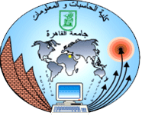

**CS251**

**Software Engineering I**

**Contents**

Instructions [To be removed]

Team

Document Purpose and Audience

System Models

I. Class diagrams

Important Algorithm

II. Sequence diagrams

Class - Sequence Usage Table

Ownership Report

Policy Regarding Plagiarism:

References

Authors

# 

# Document Purpose and Audience

# This document contains all of the information needed to develop the system and the target audience of this document is the implementation and testing team.

# Team

|  |  |  |  |
| --- | --- | --- | --- |
| **ID** | **Name** | **Email** | **Mobile** |
| 20140330 | Abeer Abdulraheem Abdulrahman | abeer.ah12.7@gmail.com | 01060481362 |
| 20140325 | Amal Osama Ibrahim Youssef | amal.Amer96@gmail.com | 01151613234 |
| 20140328 | Mohamed Abd AL Nasser Mohamed | mhmeeaad@gmail.com | 01064268468 |
| 20140370 | Hanaa Yassien Abdulkader | brightrooose@hotmail.com | 01016377811 |
| 20140353 | Yassmin Alamin Ahmedin | yaso0o_90@hotmail.com | 01154647622 |

# 

# System Models

## Class diagrams

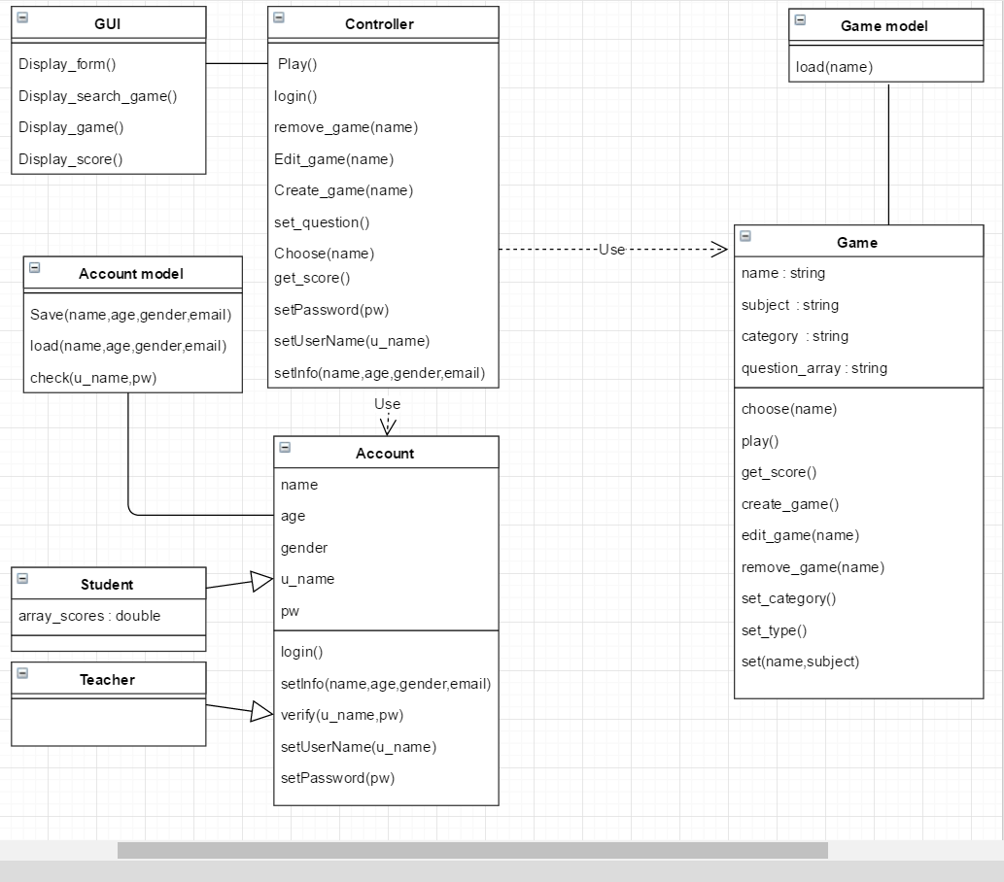

|  |  |  |
| --- | --- | --- |
| **Class ID** | **Class Name** | **Description & Responsibility** |
| CD1 | GUI | This is the user interface that displays games on the website |
| CD2 | Controller | This is the class responsible for creating objects and limiting access of users |
| CD3 | Game Model | This class saves the data of games and everything related to them |
| CD4 | Account | This class temporarily stores the users’ data in memory |
| CD5 | Account Model | This class stores the users’ data in the database |
| CD6 | Game | This class controls all the game operations like create, edit and remove |
| CD7 | True/False [Game] | A child of Game class that handles the T/F kind of games |
| CD8 | MCQ [Game] | A child of Game class that handles the MCQ kind of games |
| CD9 | Student [Account] | A child of Account class used by students to save their game scores and it allows access to games through the controller |
| CD10 | Teacher [Account] | A child of Account class used by teachers to allow them to create/edit their own games through the controller |

## 

## II. Sequence diagrams

ID: SD1

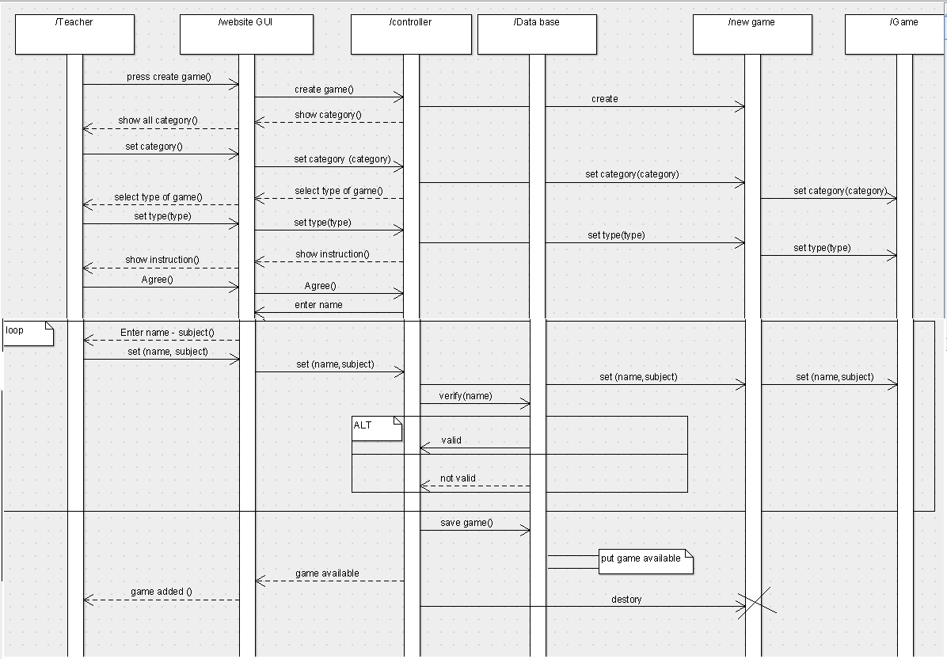

**ID: SD2**

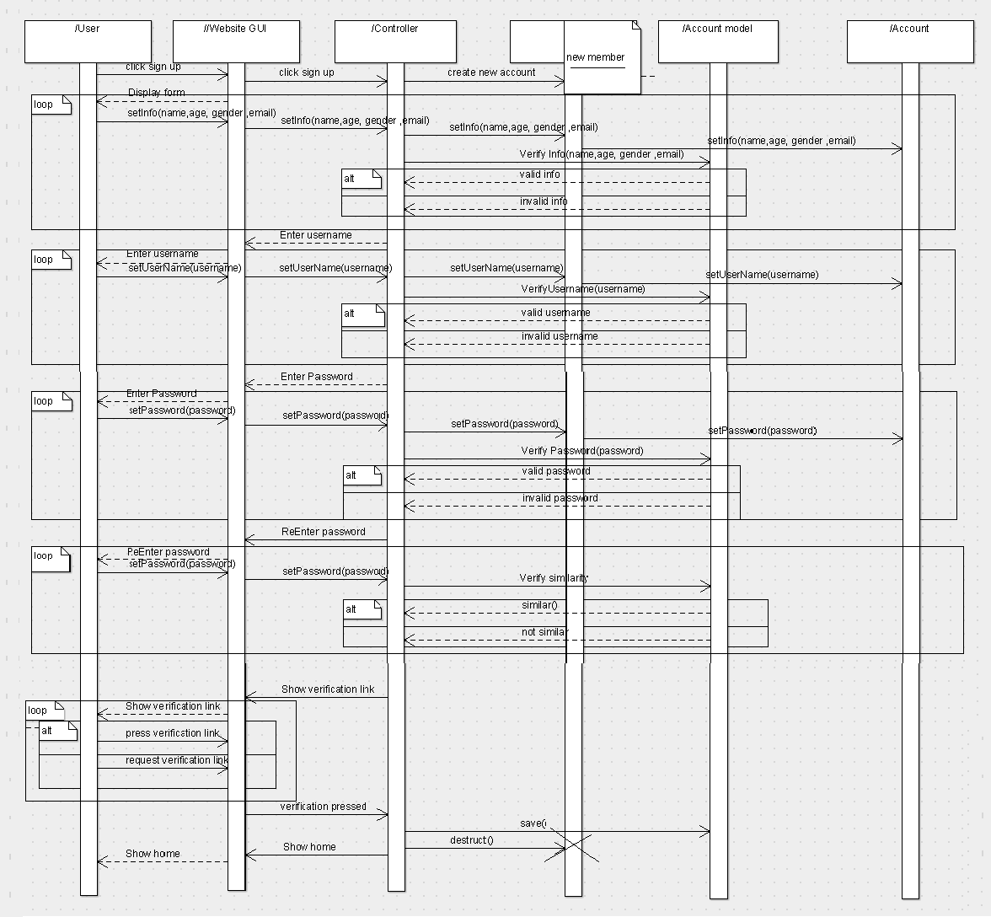

**ID: SD3**



### 

### Class - Sequence Usage Table

|  |  |  |
| --- | --- | --- |
| **Class Name** | **Sequence Diagrams** | **Overall used methods** |
| GUI | ALL | Display |
| Controller | ALL | Api for ( game , account ) |
| Teacher | SD1 | - |
| Student | SD2,SD3 | - |
| Account | SD2 , SD 3 | Controlling login , verify and set users data . |
| Game | SD1 ,SD3 | save , Handel the game operations |
| Account model | SD2,SD3 | Save and load Accounts data from Database |
| Game model | SD1 | Save and load game data from Database |

# Ownership Report

|  |  |
| --- | --- |
| **Item** | **Owners** |
| Integration | *Abeer* |
| Tables , documentation | *Abeer , Mohamed* |
| Class Diagram | *Mohamed* |
| SD1 | *Yassmen* |
| SD2 | *Hanna* |
| SD3 | *Amal , Mohamed* |