### **Installation and configuration of Jenkins container**

1. Open cmd 🡪**podman pull jenkins/jenkins:latest**

2. Create folder and Dockefile for building the image and run the container will be executed:

C:\Windows\System32>**mkdir C:\Users\Nastassia_Lahoiskaya\Jenkins**

C:\Windows\System32>**move Dockerfile C:\Users\Nastassia_Lahoiskaya\Jenkins**

3. Add information into Dockerfile:

*FROM jenkins/jenkins:latest*

*USER root*

*RUN apt-get update && apt-get install -y python3 python3-pip*

*USER Jenkins*

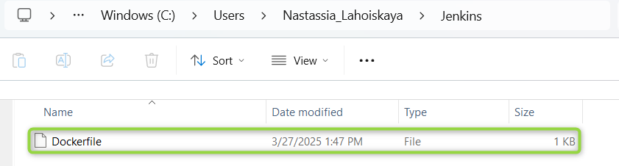

4. Run **podman build -t custom-jenkins .** for creating a custom Docker/Podman Jenkins image based on the Dockerfile:



5. Run the container🡪 **podman run -d --name jenkins -p 8080:8081 -p 50000:50000 -v jenkins_data:/var/jenkins_home custom-jenkins**

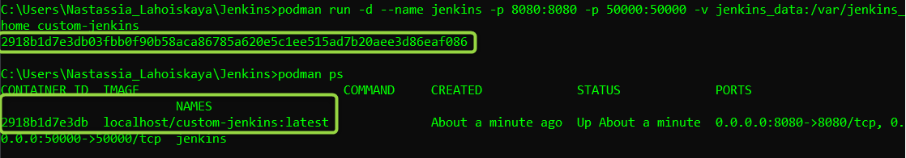

6. <http://localhost:8081>:

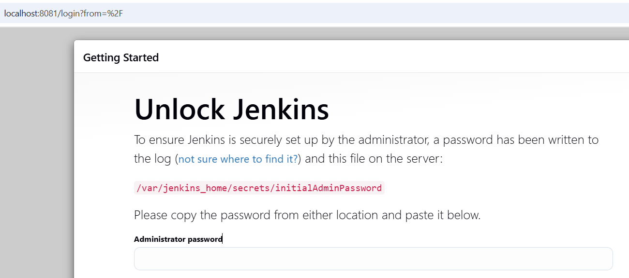

7. Jenkins setup: paste the password from the terminal 🡪 **podman logs jenkins-container**

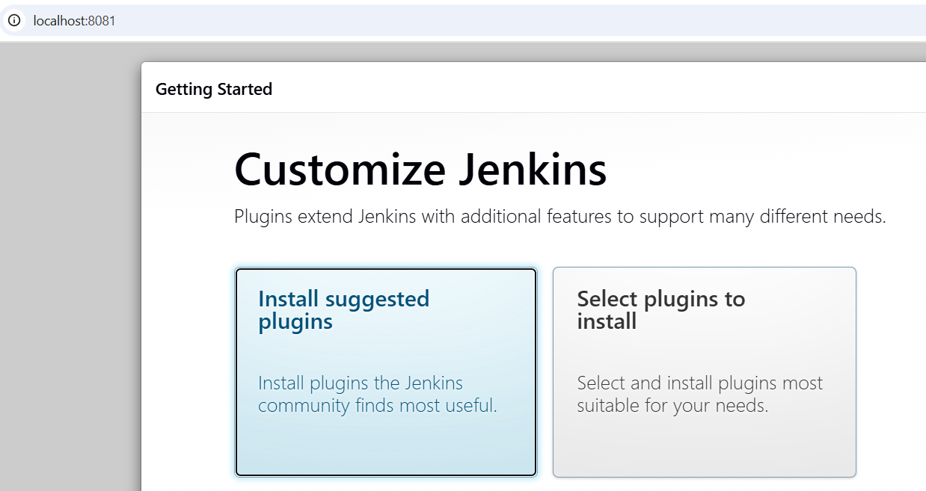

8. Create new repository in GitHub 🡪 [jenkins-python-project](https://github.com/NastassiaLahoiskaya/jenkins-python-project)

9. Clone with desktop Github and move .py file:

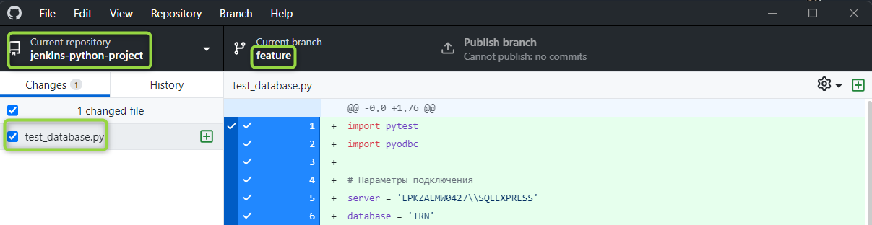

10. Push the file into repository:

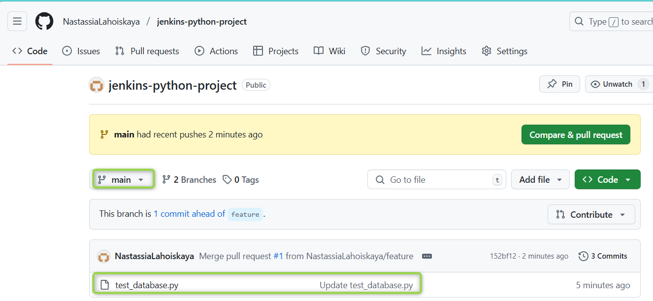

11. Install the GIT plugin to access the GitHub repository

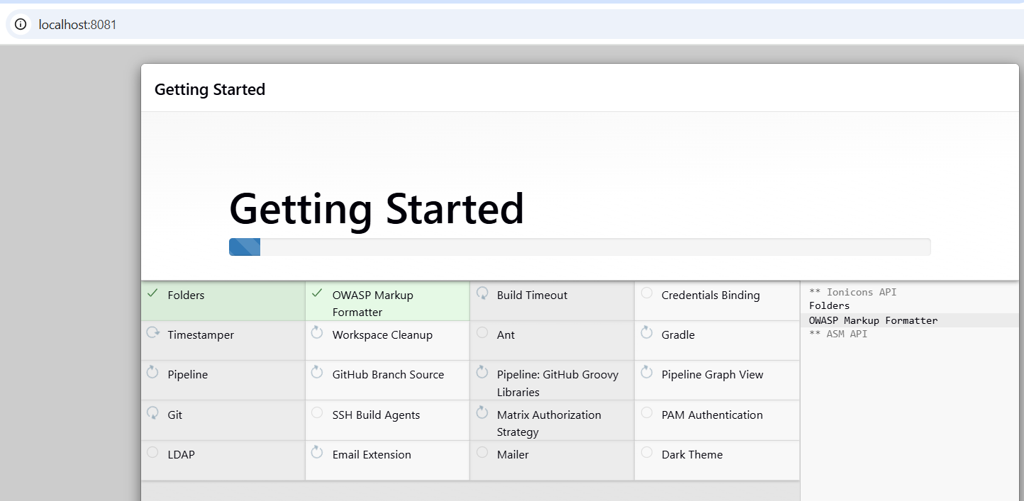

12. Create a new user.

13. Merging strategy is chosen: test before merging:

- Description:

The "test before merging" strategy is selected to ensure that code from the feature branch passes all tests before being integrated into the main branch.

- Justification:

This helps minimize risks by guaranteeing that only successfully tested code is merged into the main branch.

- Implementation:

- The pipeline fetches the code from the feature branch.

- Jenkins tests and validates the changes.

- If all tests pass, the pipeline automatically pushes the changes from the feature branch to the main branch via GIT commands.

14. [GitHub Branch Source Plugin](https://plugins.jenkins.io/github-branch-source) exists: 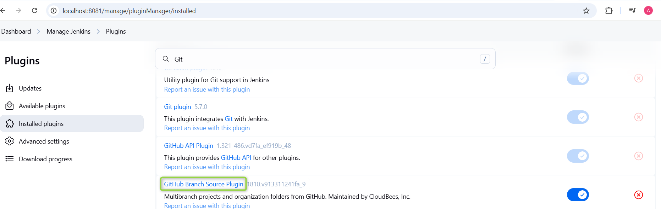

15. Click on ‘New Item’ -> CI-CD

16. General->check checkbox ‘GitHub hook trigger for GITScm polling’

17. Pipeline->Definition – Pipeline script from SCM

18. SCM – Git

19. Repository URL – your GIT link with .git extension in the end

20. Script Path – Jenkins file name from the GIT repo and in section for GIT set https://plenty-boxes-tell.loca.lt/github-webhook/

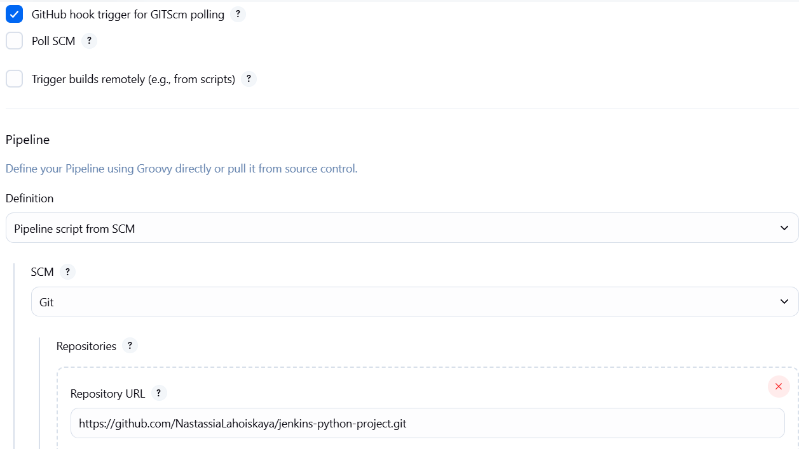

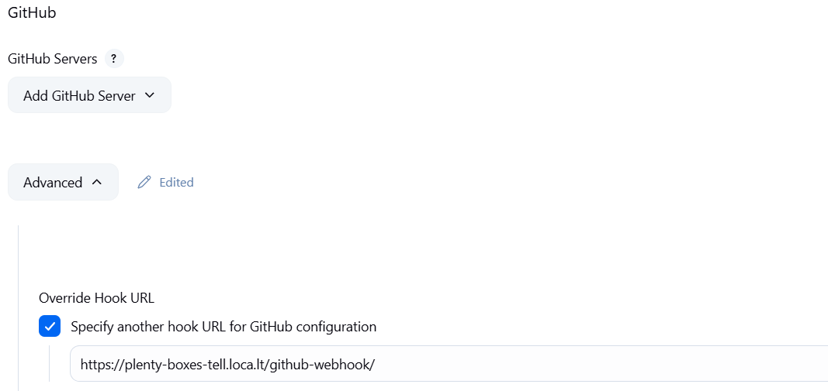

21. Create webhook in repository (Project->Webhooks-> Add webhook) - *I am writing in advance to inform you that this step could not be completed as LocalTunnel is unstable, and I kept losing the connection. Upon reconnecting, a new path is generated, which complicates the overall setup*

22. Payload URL – https://plenty-boxes-tell.loca.lt/github-webhook/

(before this step used LocalTunnel from cmd 🡪 **npx localtunnel --port 8081**)

23. Content type – application/json

24. Which events would you like to trigger this webhook? - Let me select individual events. (Pull requests;pushes)

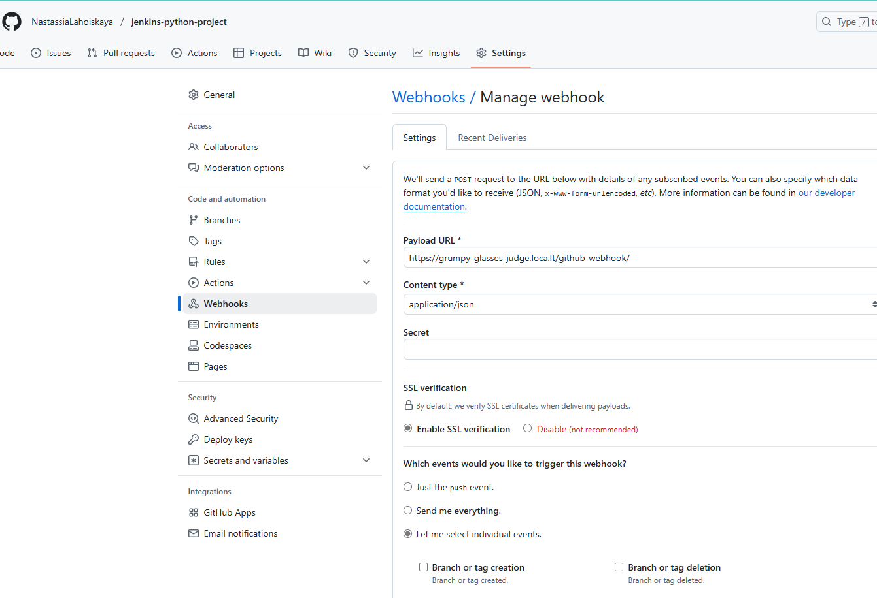

25.Generate Personal access tokens (Your account->Settings-> Developed Settings->Personal access tokens->Tokens (classic)).

26. Add GIT token as a variable in Jenkins

- In Jenkins, open Dashboard->Manage Jenkins->System-> Global properties

- Check “Environment variables” checkbox

- Add new pair. Name – TOKEN, Value – your generated token

**SQL Server**

1. **In SQL Server** allow remote connections

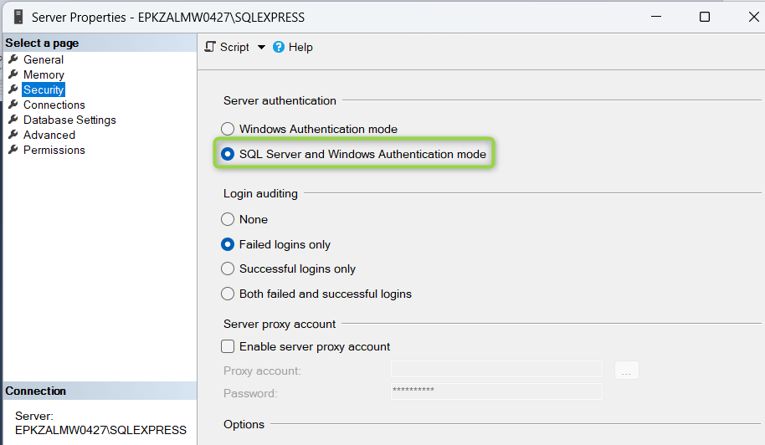

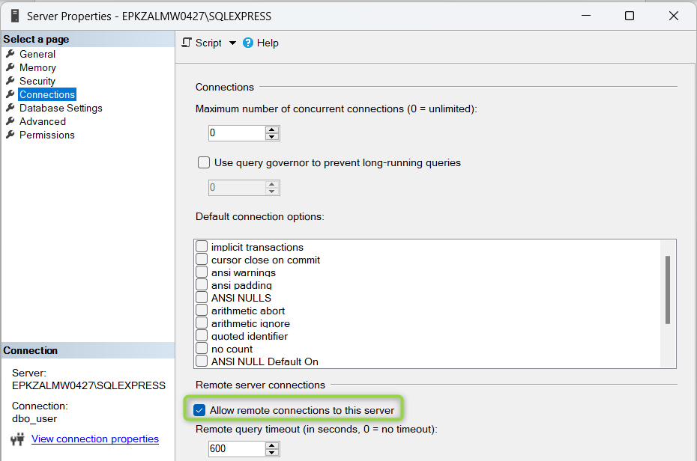

1. In **SQL Server Configuration Manager** enable TCP/ID and add port

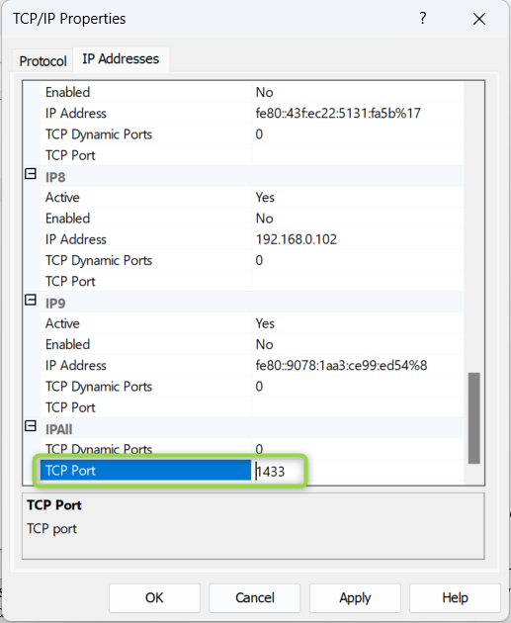

**Restart** SQL Server

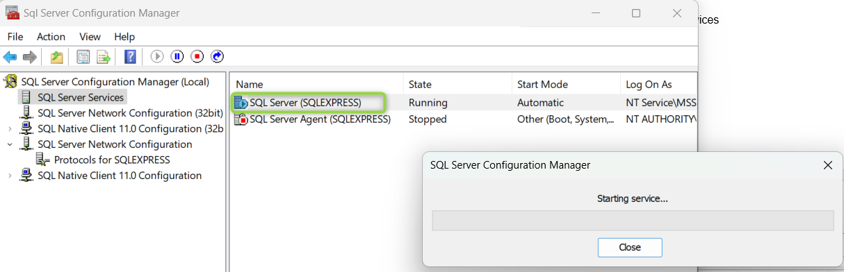

Overall, I would like to note that I was unable to set up the entire process due to a database connection error. I tried various approaches to resolve it, but none of them worked.

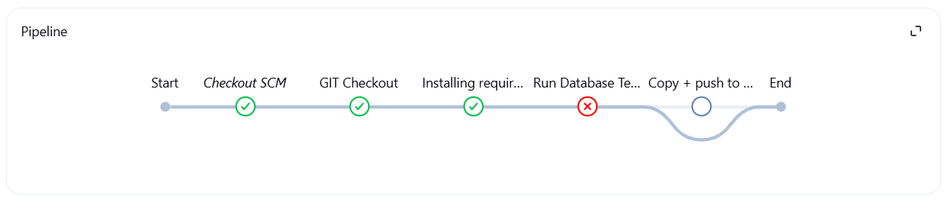

Link on my repository:

<https://github.com/NastassiaLahoiskaya/jenkins-python-project>