Loading with tJavaRow:

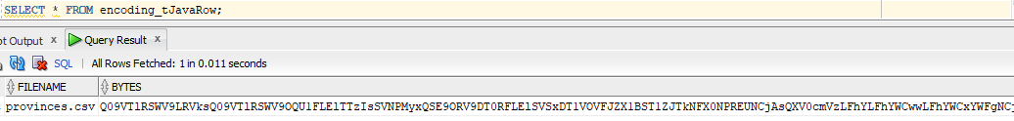

Loading with Routines:

