***Завдання 13.1*** *(№13)*

*#include <stdio.h>*

*#include <string.h>*

*#define N 255*

*main() {*

*FILE *f;*

*char s[N],a[N]; int k,n;*

*unsigned short line, flag, i;*

*f = fopen("text.txt", "r");*

*printf("Array: ");*

*while (fgets(s, N, f) != NULL) {*

*flag = 0;*

*if (s[i] == ' ') flag = 0;*

*a[i]=strlen(s);*

*printf("%ld ",a[i]);*

*}*

*fclose(f);*

*}*

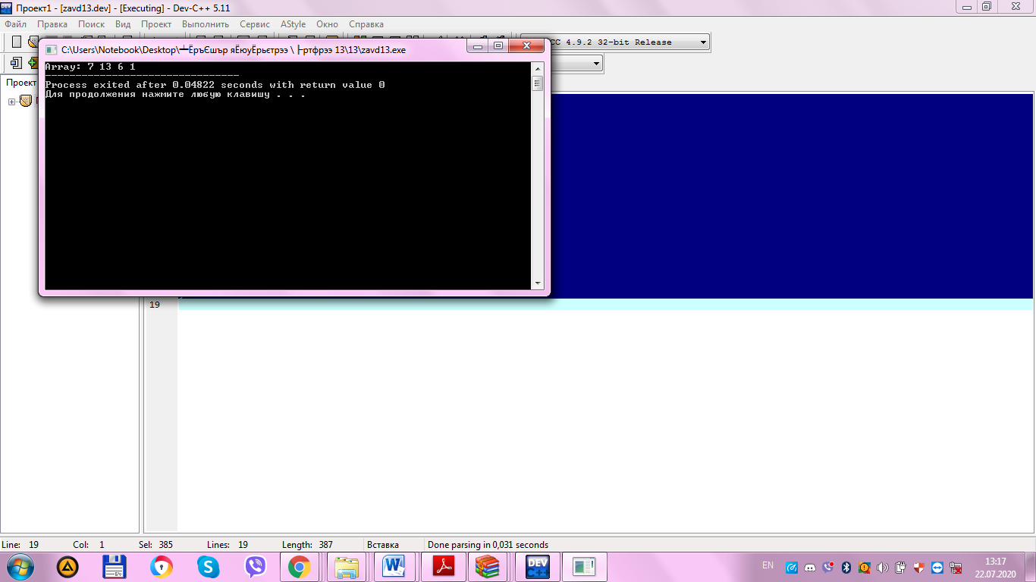

***Завдання 13.2*** *(№13)*

*#include <stdio.h>*

*#include <string.h>*

*#include <stdlib.h>*

*#define MAXCHAR 1000*

*typedef struct Character {*

*char value;*

*Character *next;*

*};*

*typedef struct Node {*

*struct Character *value;*

*struct Node *next;*

*int size = 0;*

*int hashCode = 0;*

*};*

*int getHashcode(Character *character, int size) {*

*int hash = 0; // added for clarity*

*int i = 0;*

*while (character != NULL) {*

*hash = 31 * hash + character->value;*

*character = character->next;*

*}*

*return hash;*

*}*

*Node* composeWord(Character *characterHead) {*

*Character *iterator = characterHead;*

*int wordSize = 0;*

*while (iterator != NULL) {*

*wordSize++;*

*iterator = iterator->next;*

*}*

*Node *node = (Node*) malloc(sizeof(Node));*

*node->value = characterHead;*

*node->size = wordSize;*

*node->hashCode = getHashcode(characterHead, wordSize);*

*node->next = NULL;*

*return node;*

*}*

*void printWord(Node *node, FILE *fp) {*

*Character *iterator = node->value;*

*char chars[node->size];*

*int i = 0;*

*while (iterator != NULL) {*

*chars[i++] = iterator->value;*

*iterator = iterator->next;*

*}*

*fprintf(fp, chars);*

*fprintf(fp, " ");*

*}*

*Node* readFile(char* filename) {*

*FILE *fp;*

*Node *head = NULL, *iterator = NULL, *tmpPtr = NULL;*

*char ch;*

*int a = 97, A = 65, z = 122, Z = 90;*

*fp = fopen(filename, "r");*

*if (fp == NULL) {*

*printf("Could not open file %s", filename);*

*return NULL;*

*}*

*Character *character = NULL, *characterHead = NULL;*

*Node *wordHead = NULL, *word = NULL;*

*Character *nextCharacter = (Character*) malloc(sizeof(Character));*

*while ((nextCharacter->value = fgetc(fp)) != EOF) {*

*if ((nextCharacter->value >= A && nextCharacter->value <= Z) || (nextCharacter->value >= a && nextCharacter->value <= z)) {*

*if (characterHead == NULL) {*

*characterHead = nextCharacter;*

*character = characterHead;*

*character->next = NULL;*

*nextCharacter = (Character*) malloc(sizeof(Character));*

*} else {*

*character->next = nextCharacter;*

*character->next->next = NULL;*

*character = character->next;*

*nextCharacter = (Character*) malloc(sizeof(Character));*

*}*

*} else if (characterHead != NULL) {*

*if (wordHead == NULL) {*

*wordHead = composeWord(characterHead);*

*word = wordHead;*

*} else {*

*word->next = composeWord(characterHead);*

*word = word->next;*

*}*

*characterHead = NULL;*

*}*

*}*

*if (characterHead != NULL) {*

*if (wordHead == NULL) {*

*wordHead = composeWord(characterHead);*

*word = wordHead;*

*} else {*

*word->next = composeWord(characterHead);*

*word = word->next;*

*}*

*characterHead = NULL;*

*}*

*return wordHead;*

*}*

*bool equals(Node *a, Node *b) {*

*return a->hashCode == b->hashCode;*

*}*

*int main()*

*{*

*Node *source = readFile("input1.txt");*

*Node *stopWords = readFile("input2.txt");*

*Node *differentHead = NULL, *differentWord = NULL;*

*Node *sourceIterator = source, *stopIterator = stopWords;*

*bool equal = false;*

*FILE *fp = fopen("output.txt", "w");*

*while (sourceIterator != NULL) {*

*while (stopIterator != NULL) {*

*if (equals(sourceIterator, stopIterator)) {*

*equal = true;*

*break;*

*}*

*stopIterator = stopIterator->next;*

*}*

*stopIterator = stopWords;*

*if (!equal) {*

*printWord(sourceIterator, fp);*

*} else {*

*equal = false;*

*}*

*sourceIterator = sourceIterator->next;*

*}*

*fclose(fp);*

*return 0;*

*}*