A little more information about The DanceSynergy Institute
The DanceSynergy Institute stands as the most extensive dance community, where the fusion of originality, contemporary innovation, instructor expertise, and a diverse array of dance styles creates a unique experience.

Our network of studios is not limited to the English language; we also cater to students in German and French. Since 2010, our organization has nurtured the talents of over 10,000 students throughout Europe, conducting numerous Master Classes.

With more than 15 branches already established in the UK, Germany, and France, we continue our expansion, forging new paths and opportunities to immerse you in the captivating realm of dance, regardless of your age, skill level, social standing, or place of origin.

Our main office
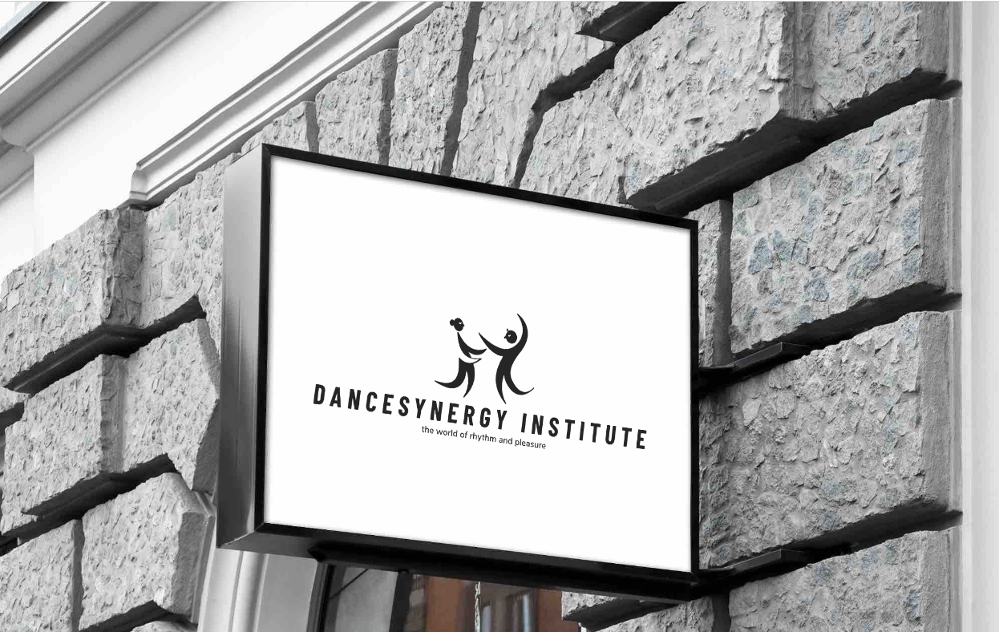

Our logo
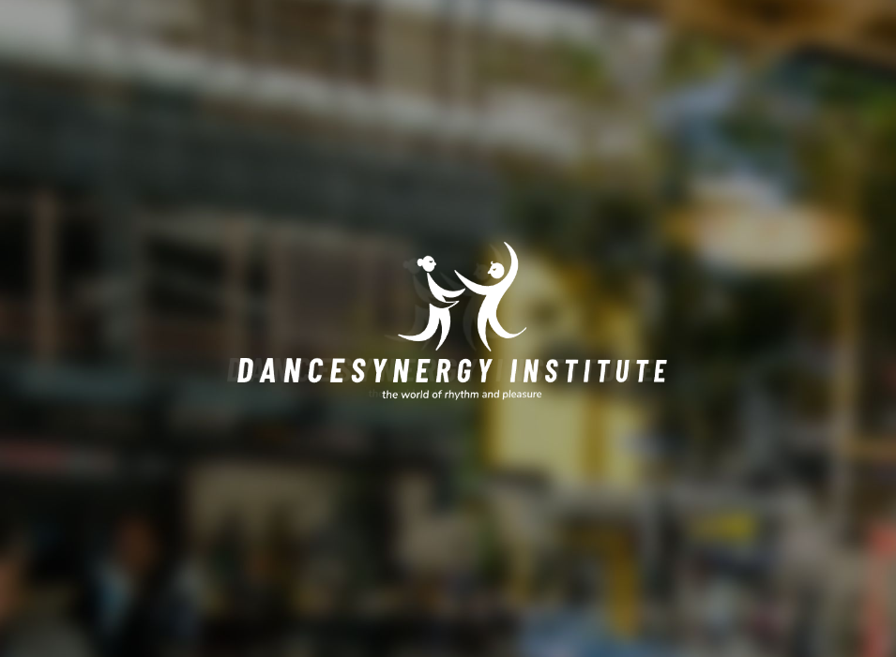
Our merch


