**28 Работа с графикой. Трехмерная графика**

Задание №1. Нарисовать 3 кнопки: Треугольную, круглую, в форме пирамиды.

Листинг программы:

using System;

using System.Drawing;

using System.Windows.Forms;

namespace CustomButtonsApp

{

public partial class MainForm : Form

{

public MainForm()

{

InitializeComponent();

this.Text = "Custom Buttons";

this.Size = new Size(400, 400);

this.StartPosition = FormStartPosition.CenterScreen;

Button triangleButton = new Button();

triangleButton.Size = new Size(100, 100);

triangleButton.Location = new Point(50, 50);

triangleButton.Paint += new PaintEventHandler(DrawTriangleButton);

triangleButton.FlatStyle = FlatStyle.Flat;

triangleButton.FlatAppearance.BorderSize = 0;

Button circleButton = new Button();

circleButton.Size = new Size(100, 100);

circleButton.Location = new Point(200, 50);

circleButton.Paint += new PaintEventHandler(DrawCircleButton);

circleButton.FlatStyle = FlatStyle.Flat;

circleButton.FlatAppearance.BorderSize = 0;

Button pyramidButton = new Button();

pyramidButton.Size = new Size(100, 100);

pyramidButton.Location = new Point(125, 200);

pyramidButton.Paint += new PaintEventHandler(DrawPyramidButton);

pyramidButton.FlatStyle = FlatStyle.Flat;

pyramidButton.FlatAppearance.BorderSize = 0;

this.Controls.Add(triangleButton);

this.Controls.Add(circleButton);

this.Controls.Add(pyramidButton);

}

private void DrawTriangleButton(object sender, PaintEventArgs e)

{

Button btn = sender as Button;

Graphics g = e.Graphics;

Point[] points = new Point[]

{

new Point(btn.Width / 2, 0),

new Point(btn.Width, btn.Height),

new Point(0, btn.Height)

};

g.FillPolygon(Brushes.LightBlue, points);

g.DrawPolygon(Pens.Black, points);

}

private void DrawCircleButton(object sender, PaintEventArgs e)

{

Button btn = sender as Button;

Graphics g = e.Graphics;

g.FillEllipse(Brushes.LightGreen, 0, 0, btn.Width, btn.Height);

g.DrawEllipse(Pens.Black, 0, 0, btn.Width, btn.Height);

}

private void DrawPyramidButton(object sender, PaintEventArgs e)

{

Button btn = sender as Button;

Graphics g = e.Graphics;

Point[] points = new Point[]

{

new Point(btn.Width / 2, 0),

new Point(btn.Width, btn.Height),

new Point(0, btn.Height)

};

g.FillPolygon(Brushes.LightCoral, points);

g.DrawPolygon(Pens.Black, points);

}

}

}

Анализ результатов:

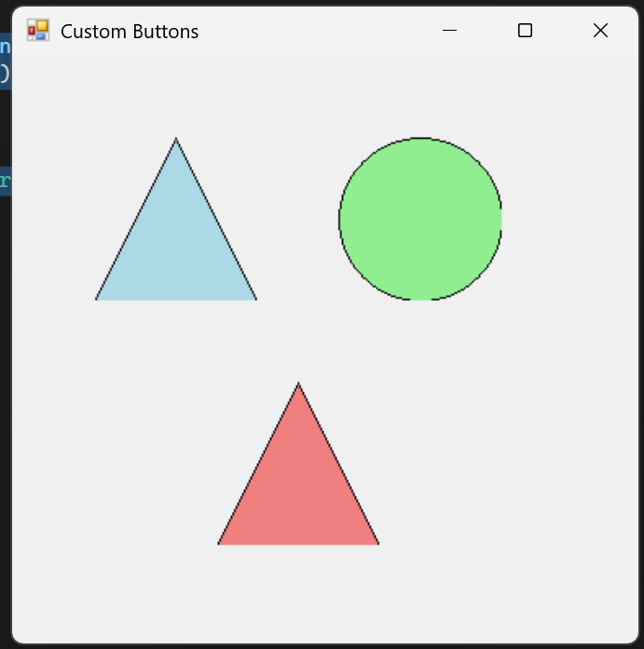

Рисунок 28.1 – Результаты работы программы