**29 Анимация**

Задание №1. Работа с таймером

Листинг программы:

namespace Task1

{

public partial class Form1 : Form

{

private double x1, y1, x2, y2;

private int alpha = 90;

private readonly Pen pen = new Pen(Color.DarkRed, 2);

private System.Windows.Forms.Timer timer1 = new System.Windows.Forms.Timer();

public Form1()

{

InitializeComponent();

timer1.Interval = 1000;

timer1.Start();

this.Paint += new PaintEventHandler(Form1_Paint);

timer1.Tick += new EventHandler(timer1_Tick);

}

private void timer1_Tick(object sender, EventArgs e)

{

alpha += -6;

if (alpha >= 360) alpha -= 360;

double radian = alpha * Math.PI / 180;

x1 = ClientSize.Width / 2;

y1 = ClientSize.Height / 2;

x2 = x1 + (int)(100 * Math.Cos(radian));

y2 = y1 - (int)(100 * Math.Sin(radian));

Invalidate();

}

private void Form1_Paint(object sender, PaintEventArgs e)

{

Graphics g = e.Graphics;

g.DrawLine(pen, (float)x1, (float)y1, (float)x2, (float)y2);

}

}

}

namespace Task1

{

partial class Form1

{

/// <summary>

/// Required designer variable.

/// </summary>

private System.ComponentModel.IContainer components = null;

/// <summary>

/// Clean up any resources being used.

/// </summary>

/// <param name="disposing">true if managed resources should be disposed; otherwise, false.</param>

protected override void Dispose(bool disposing)

{

if (disposing && (components != null))

{

components.Dispose();

}

base.Dispose(disposing);

}

/// </summary>

private void InitializeComponent()

{

this.components = new System.ComponentModel.Container();

this.AutoScaleMode = System.Windows.Forms.AutoScaleMode.Font;

this.ClientSize = new System.Drawing.Size(800, 450);

this.Text = "Form1";

}

#endregion

}

}

Анализ результатов:

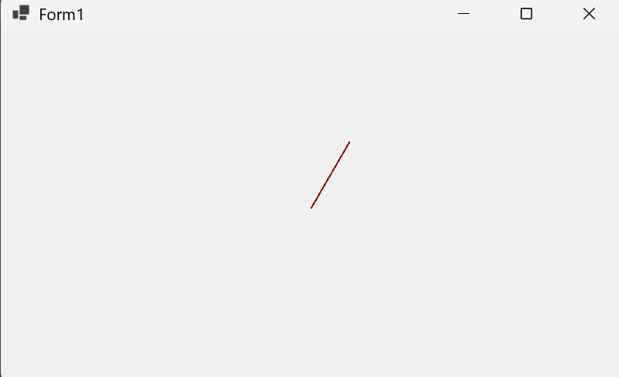

Рисунок 29.1 – Результаты работы программы