GENERATIVE DESIGN FOR AN ONLINE STUDING SYSTEM

1. **The Description of the Application Architecture with all the Details**

**Author:** Oleg Fominsky ()

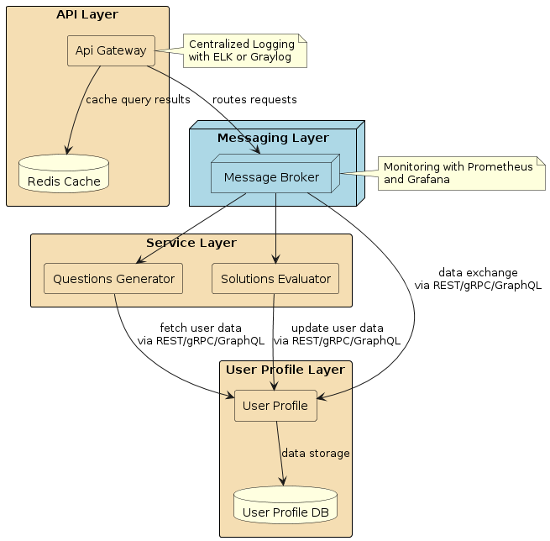

Picture 1. This structure describes the whole architecture of the application

* 1. **The Details of the Architecture**

**API Layer**

**Api Gateway**: It is the entry point for all incoming requests. It routes them through the Message Broker to the required services.

**Redis Cache**: It is used to cache the query results to speed up response amount and reduce the load on backend systems.

**Messaging Layer**

**Message Broker:** It provides asynchronous message processing between services, allowing it to distribute the load and improve the fault tolerance of the system.

**Service Layer**

**Questions Generator:** generates questions based on user data received from the UserProfile through established protocols (REST, gRPC, GraphQL).

**Solutions Evaluator:** accepts user responses, estimates them, and updates user data in the UserProfile.

**User Profile Layer**

**User Profile:** manages user data, processes requests to create, update, and retrieve user profile data. Interacts with other services via REST, gRPC or GraphQL.

**User Profile DB:** keeps the information about users.

* 1. **Service connection work**

All the Services and an API Gateway: All service requests go through Api Gateway, which uses Message Broker for the asynchronous routing of the requests to the required services.

Interaction protocols: UserProfile, Questions Generator and Solutions Evaluator are connected through REST, gRPC or GraphQL. This provides flexible management of requests and optimization of the data traffic.

**Data Exchange**

Questions Generator gets user data from the UserProfile to generate personalized questions.

Solutions Evaluator sends results back to the UserProfile to update the user’s data, thus maintaining the relevance of the information in the profiles.

* 1. **Monitoring and Logging**

Centralized Logging with LK Stack or Graylog for analysis and quick diagnostics of the problem.

For the Monitoring we use Prometheus and Grafana. It helps to real-time track system performance, it’s status.

Alerting is for rapid response to incidents and maintaining the continuity of business processes.

1. **Description of the connection service structure Question Generator – User**

**Author:** Ilyas Varshavsky

**Members of the task solving:** Oleg Fominsky, Anastasiya

GPT - Based Questions Generator

Users Profile DB

Context Database

Filter

User

Answer Validation System

To LMS

Questions DB

Transformer of confidential information

Picture 2. The structure of the service connection between the Question Generator and a User.

The context database contains information about the courses available for users to train. It is intended to form the context of the question generator. Based on the context of education, the generator forms questions of various types and complexity.

Once a request is received from a user for testing, the user receives questions through the filter that correspond to his data history (grades, educational preferences, personal assessment of the questions posed, and others) and educational needs. The filter can be adaptive, that is, to select questions with a threshold of complexity based on group profiling, not just personal.

The database of user profiles can be updated, among other things, with the results of the client response validator

Depersonalized user information may later be sent to the LMS.

**Project Realization**

Question generator is based on LLM GPT 4.

A filter with the use of personal and generalized clustering of user information. The complexity of the questions can be assessed by comparing the graph of the client's progress with the graph of the contextual complexity of the course.

The structuring of a confidential user database can be carried out using transformers.

1. **Data available for modeling**

**Author:** Shylnikova Dariya

<http://moocdata.cn/data/MOOCCube>

This data resource also contains a large-scale conceptual diagram and some connected with it scientific articles as a bonus resource for the further use.

The Information about our conceptual graph we found in Baidubaike and Wikipeida. The data about courses and student practices is taken from the real environment of XuetangX, one of the largest МООК web-sites in China. Academic resources are used from Aminer — academic project, which provides comprehensive data search and analysis services for research social networks.

<https://www.kaggle.com/datasets/desalegngeb/students-exam-scores>

The resalts of the student exams:

1. **ID**: A unique identifier assigned to each student.
2. **First Name**: The first name of the student.
3. **Last Name**: The last name of the student.
4. **Email**: The email address of the student.
5. **Gender**: The gender of the student.
6. **Math Score**: The score obtained by the student in mathematics (ranging from 0 to 100).
7. **History Score**: The score in history (0 to 100).
8. **Physics Score**: The score in physics (0 to 100).
9. **Chemistry Score**: The score in chemistry (0 to 100).
10. **Biology Score**: The score in biology (0 to 100).
11. **English Score**: The score in English (0 to 100).
12. **Geography Score**: The score in geography (0 to 100).
13. **Part-Time Job**: Indicates whether a student is engaged in a part-time job.
14. **Absence Days**: The total count of days the student was absent from class.
15. **Extracurricular Activities**: Captures whether a student participates in extracurricular activities.
16. **Weekly Self-Study Hours**: The number of hours a student spends on self-study each week.
17. **Career Aspiration**: Records the student’s career aspirations or goals for the future.

Reaction of the students on the online learning:

<https://www.kaggle.com/datasets/marlonferrari/elearning-student-reactions/data?select=online_classroom_data.csv>

The main various unique models of learning behaviors that can be found in any group of students in the e-learning systems/educational systems:

<https://ieee-dataport.org/open-access/learning-behavior-analytics-dataset>

Student performance data set: 66 columns:

<https://www.kaggle.com/datasets/impapan/student-performance-data-set/data>

**Design and language support:** Anastasia Shylnikova.