Лабораторная работа №21.

**Создание и вывод графических изображений на форму. MDI приложения.**

Задание1. Разработать многооконный пользовательский интерфейс.

Листинг программы:

public partial class Form1 : Form

{

public string fullPath;

public Form1()

{

InitializeComponent();

DriveTreeInit();

}

public void DriveTreeInit()

{

string[] drivesArray = Directory.GetLogicalDrives();

treeView1.BeginUpdate();

treeView1.Nodes.Clear();

foreach (string s in drivesArray)

{

TreeNode drive=new TreeNode(s,0,0);

treeView1.Nodes.Add(drive);

GetDirts(drive);

}

treeView1.EndUpdate();

}

public void GetDirts(TreeNode node)

{

DirectoryInfo[] diArray;

node.Nodes.Clear();

string fullPath = node.FullPath;

DirectoryInfo di = new DirectoryInfo(fullPath);

try

{

diArray = di.GetDirectories();

}

catch

{

return;

}

foreach (DirectoryInfo dirinfo in diArray)

{

TreeNode dir = new TreeNode(dirinfo.Name, 0, 0);

node.Nodes.Add(dir);

}

}

private void treeView1_BeforeExpand(object sender, TreeViewCancelEventArgs e)

{

treeView1.BeginUpdate();

foreach (TreeNode node in e.Node.Nodes)

{

GetDirts(node);

treeView1.EndUpdate();

}

}

private void treeView1_AfterSelect(object sender, TreeViewEventArgs e)

{

TreeNode selectedNode = e.Node;

fullPath = selectedNode.FullPath;

DirectoryInfo di = new DirectoryInfo(fullPath);

FileInfo[] fiArray;

DirectoryInfo[] diArray;

try

{

fiArray = di.GetFiles();

diArray = di.GetDirectories();

}

catch

{

return;

}

listView1.Items.Clear();

foreach (DirectoryInfo dirInfo in diArray)

{

ListViewItem lvi = new ListViewItem(dirInfo.Name);

lvi.SubItems.Add("0");

lvi.SubItems.Add(dirInfo.LastWriteTime.ToString());

lvi.ImageIndex = 0;

listView1.Items.Add(lvi);

}

foreach (FileInfo fileInfo in fiArray)

{

ListViewItem lvi = new ListViewItem(fileInfo.Name);

lvi.SubItems.Add(fileInfo.Length.ToString());

lvi.SubItems.Add(fileInfo.LastWriteTime.ToString());

string filenameExtension =

Path.GetExtension(fileInfo.Name).ToLower();

switch (filenameExtension)

{

case ".com":

{

lvi.ImageIndex = 2;

break;

}

case ".exe":

{

lvi.ImageIndex = 2;

break;

}

case ".hlp":

{

lvi.ImageIndex = 3;

break;

}

case ".txt":

{

lvi.ImageIndex = 4;

break;

}

case ".doc":

{

lvi.ImageIndex = 5;

break;

}

default:

{

lvi.ImageIndex = 1;

break;

}

}

listView1.Items.Add(lvi);

}

}

private void listView1_ItemActivate(object sender, EventArgs e)

{

foreach (ListViewItem lvi in listView1.SelectedItems)

{

string ext = Path.GetExtension(lvi.Text).ToLower();

if (ext == ".txt" || ext == ".htm" || ext == ".html")

{

try

{

richTextBox1.LoadFile(Path.Combine(fullPath, lvi.Text), RichTextBoxStreamType.PlainText);

statusStrip1.Text = lvi.Text;

}

catch

{

return;

}

}

else if (ext == ".rtf")

{

try

{

richTextBox1.LoadFile(Path.Combine(fullPath, lvi.Text), RichTextBoxStreamType.RichText);

statusStrip1.Text = lvi.Text;

}

catch

{

return;

}

}

}

}

}

Анализ результатов:

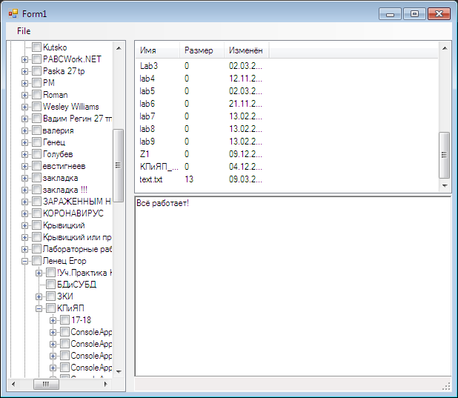

Задание 2. Создать MDI-приложение

Листинг программы:

public partial class Form1 : Form

{

public Form1()

{

InitializeComponent();

}

private void newToolStripMenuItem_Click(object sender, EventArgs e)

{

Form2 mdiChild = new Form2();

mdiChild.MdiParent = this;

mdiChild.Show();

}

private void menuItem11_Click(object sender, System.EventArgs e)

{

this.LayoutMdi(MdiLayout.Cascade);

}

private void menuItem10_Click(object sender, System.EventArgs e)

{

this.LayoutMdi(MdiLayout.TileHorizontal);

}

private void menuItem12_Click(object sender, System.EventArgs e)

{

this.LayoutMdi(MdiLayout.TileVertical);

}

private void copyToolStripMenuItem_Click(object sender, EventArgs e)

{

Form activeChild = this.ActiveMdiChild;

if (activeChild != null)

{

RichTextBox editBox = (RichTextBox)activeChild.ActiveControl;

if (editBox != null)

{

Clipboard.SetDataObject(editBox.SelectedText);

}

}

}

private void pastToolStripMenuItem_Click(object sender, EventArgs e)

{

Form activeChild = this.ActiveMdiChild;

if (activeChild != null)

{

RichTextBox editBox = (RichTextBox)activeChild.ActiveControl;

if (editBox != null)

{

IDataObject data = Clipboard.GetDataObject();

if (data.GetDataPresent(DataFormats.Text))

{

editBox.SelectedText =

data.GetData(DataFormats.Text).ToString();

}

}

}

}

}

Анализ результатов:

