Учебная практика, 2 курс, 2018

Неделя 1
Java

Изучаем UML!!!

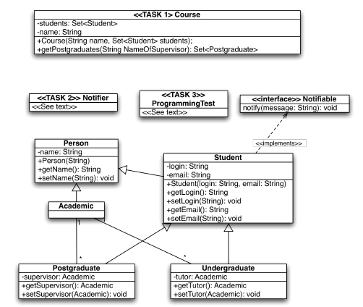

Решить следующие задачи.
Task 1. Write the Java source code file Course.java. A course has a name and a set of students associated to it. The class must provide a method getPostgraduates which takes as its only parameter the name of an Academic staff member. The method returns the set of postgraduate students who help with the course. These are postgraduate students who have as their supervisor the Academic staff member given as the parameter. You must also write the constructor for the class as depicted in the class diagram.
Task 2. Write the Java source code file Notifier.java. Class Notifier should be constructed with a set of notifiable objects which is stored in the attribute notifiables. The class provides a doNotifyAll method which calls notify on all objects in the notifiables set.
Task 3. Write the Java source code file ProgrammingTest.java with a main method that
a. Creates a course with 2 undergraduate students and 3 postgraduate students;
b. Extracts from the course all postgraduate students with <InputName> as their supervisor using method getPostgraduates;
c. Uses Notifier to notify them of the <InputMessage> message.
Task 4. Create UML diagram in IDE.

