1.

#include <iostream>

using namespace std;

const int m = 5;

int a[m][m];

int main()

{

for (int i = 0; i < m; ++i)

{

for (int j = 0; j < m; ++j)

{

if (j <= i)

a[i][j] = i - j + 1;

else

a[i][j] = 0;

}

}

for (int i = 0; i < m; ++i)

{

for (int j = 0; j < m; ++j)

{

cout << a[i][j] << " ";

}

cout << endl;

}

return 0;

}

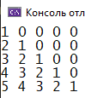

2. #include<iostream>

using namespace std;

int main()

{

const int m = 10;

int s = 1;

int a[m][m];

for (int i = 0; i < m; i++)

{

for (int j = 0; j < m; j++)

{

if ((i + j) % 2 == 1)

a[i][j] = 0;

else

{

a[i][j] = s;

s++;

if (s == 10)

s = 1;

}

}

}

for (int i = 0; i < m; i++)

{

for (int j = 0; j < m; j++)

{

cout << a[i][j] << " ";

}

cout << endl;

}

return 0;

}

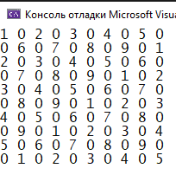

3. #include<iostream>

using namespace std;

int main()

{

const int n = 5;

int mas[n][n] = {0};

int mid = n / 2;

mas[0][mid] = 1;

int x1 = mid;

int x2 = mid;

for (int i = 1; i < n; i++)

{

if (i <= mid)

{

x1--;

x2++;

}

else

{

x1++;

x2--;

}

mas[i][x1] = 1;

mas[i][x2] = 1;

}

for (int i = 0; i < n; i++)

{

for (int j = 0; j < n; j++)

{

cout << mas[i][j] << " ";

}

cout << endl;

}

return 0;

}

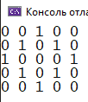

4. #include<iostream>

using namespace std;

int main()

{

const int m = 6;

int mas[m][m];

for (int i = 0; i < m; i++)

{

for (int j = 0; j < m; j++)

{

mas[i][j] = 1;

}

}

for (int i = 0; i < m; i++)

{

for (int j = i + 1; j < m - i - 1; j++)

{

mas[i][j] = 0;

}

}

for (int i = 0; i < m; i++)

{

for (int j = 0; j < m; j++)

{

cout << mas[i][j] << " ";

}

cout << endl;

}

}

