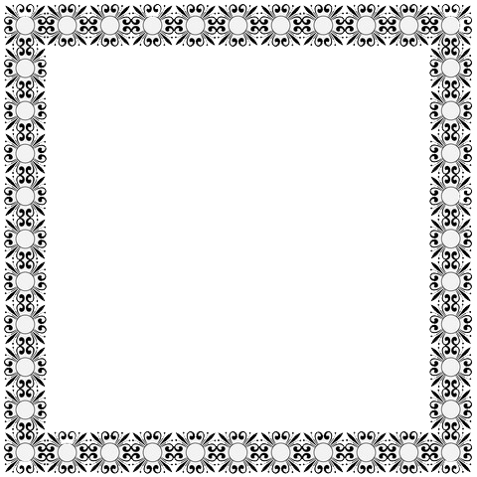

This is to certify that

_______________________________________________________________

Weighing _________________________ lbs. _______________ oz. Was born on the ______________ Day of ____________________________________ to ______________________________ and __________________________

In the year of ____________________.

____________________________ ___________________________

Father Mother

_____________________________ ___________________________

GODPPARENTS

***Birth Certificate***

Birth Certificate