Natalie Smith Wells
Professor Young
ITEC 2380
May 6, 2026

Final Project Report
(Recap of Progress report #1)
The website will be called:
Tech Clean & Repair
Hardware Cleaning & Repair for PCs, Consoles & Tablets
The website’s purpose will be to inform local customers about the services the business offers and connect customers with the business while explaining why regular hardware maintenance and cleaning is important. The website is intended to represent a small local hardware repair and maintenance service online for customer accessibility and information to services it offers.
The intended audience would be the average person or family, small business owner, or work -from-home user who owns a PC, gaming console, tablet, or other related hardware and accessories. These devices could be dropped off for service or serviced by a home or office visit thus addressing any repair issues or maintenance needed.
The site and service will address the problem of hardware devices such as PC’s, laptops, gaming consoles, tablets, and sometimes phones that need repair or routine maintenance as regular cleaning and maintenance can help devices run better and last longer.
The content of the website will include six pages. The site will have a Home page with the links to the following pages: a page describing Hardware Cleaning & Repair Services, a page explaining Why Hardware Cleaning & Regular Maintenance Matter, a page listing Service Packages & Pricing, a page listing Qualifications of Technicians & Devices We Service, and a final page for Contact and Service Requests.
Two websites that offer similar services would be (updated to include URLs):
- Geek Squad and the URL for them is: https://stores.bestbuy.com/pa/whitehall/1504-macarthur-rd-587/geeksquad.html?ref=NS&loc=ns100
- uBreakiFix and the URL for them is:
https://www.ubreakifix.com/locations/centervalley?utm_source=google&utm_medium=gmb&utm_campaign=centervalley

(Recap of Progress Repot #2)
Link to project:
https://naswinns.github.io/ITEC2380FinalProject/

Wireframe:
This wireframe is the outline for each page. The plan is to build a simple, clean, responsive, accessible, and minimal site. What changes for each page are the images and text that match the title of each page on the menu in the same minimal way each page.
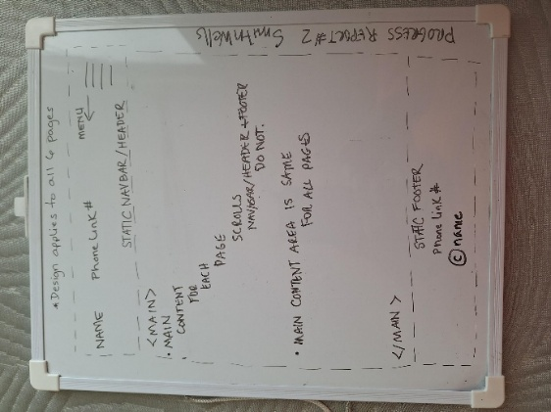
Color Swatch:
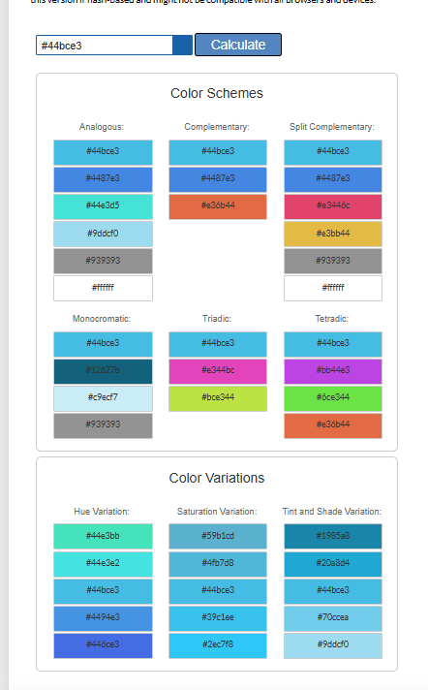

Added for Final Report:
WAVE result: WAVE result was great except for a possible redundancy, but I have the button there for a reason so did change it.
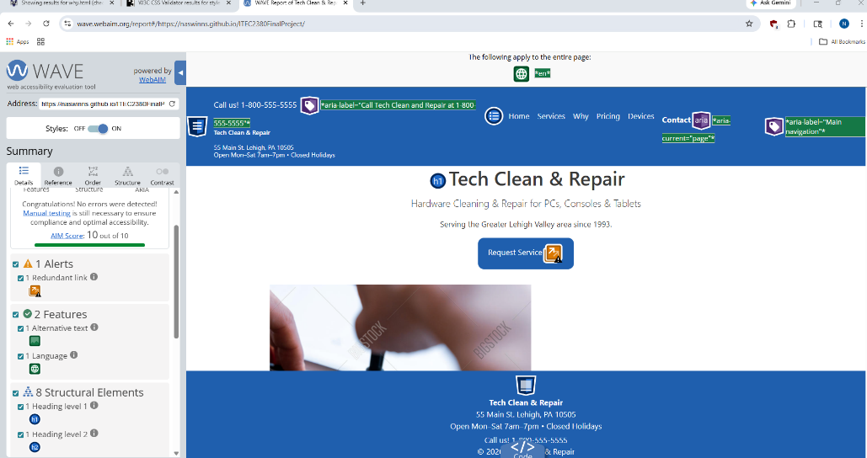
WebFx readability result: Readability test was mid-to-fair but was classified as informative, which is what I wanted so I did not change it.
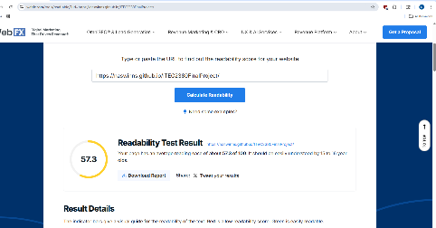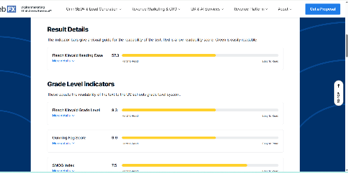
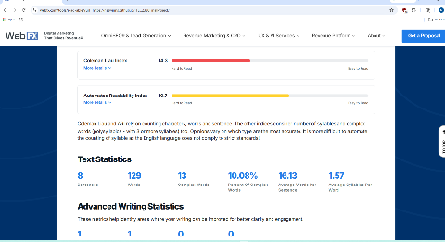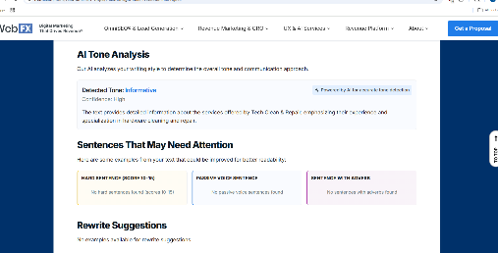

Page Speed Insight result: For Desktop was a good result.
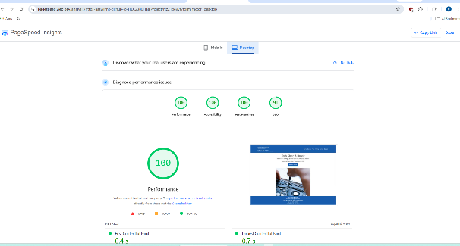
For mobile was a good result as well.
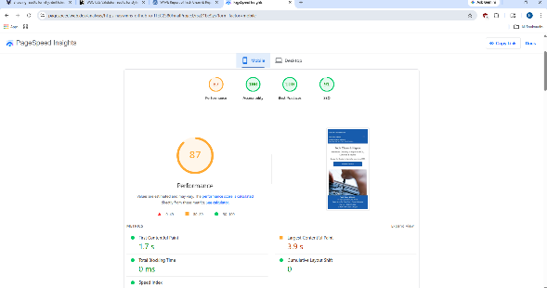

HTML and CSS results: All my HTML and CSS came out green in their checks.
User test results:
I had the site tested by 3 adults and 2 teenagers. All testers reported ease of use, understood site purpose immediately, found all the information they wanted easily, and all testers reported no changes they could think of.
Future Planned Activities:
For now, I do not have any future planned activities for this site unless a company would like me to change some of the info so they could use it.
Link to video walk-through: https://youtu.be/YLxgjhxdDQI

