Report Title

By

Your Name

Course Title

Teacher’s Name

# Network Topology of Designed System

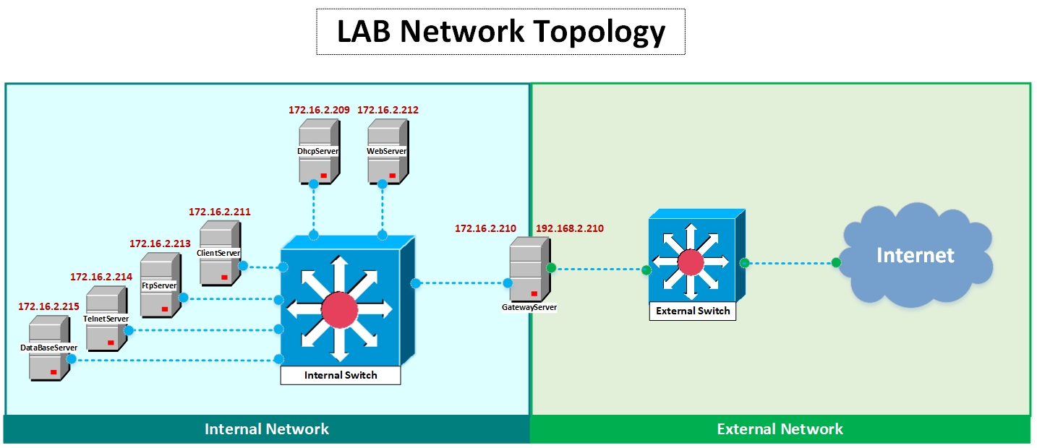

I have designed a network of 7 servers including:

* Gateway Server
* DHCP Server
* Client Server
* WEB Server
* FTP Server
* Telnet Server
* Database Server

The internal network has an IP Subnet of 172.16.2.0/24. The Gateway Server has two Network Interface Cards. Ethernet0 on Gateway Server is used to connect External Network i.e. Internet whereas Ethernet1 on Gateway Server is used to connect Internal Network hosting Core Servers for my company.

# Implementation of Designed System

To implement the designed system I have used VMware ESXi hypervisor and deployed all 7 Servers as Virtual Machines on ESXi Server.

Below IP Addresses have been assigned to the Designed Core Servers:

|  |  |
| --- | --- |
| Core Server | IP Address |
| Gateway Server | eth0:192.168.2.210, eth1: 172.16.2.210 |
| DHCP Server | eth0: 172.16.2.209 |
| Client Server | eth0: DHCP |
| WEB Server | eth0: 172.16.2.212 |
| FTP Server | eth0: 172.16.2.213 |
| Telnet Server | eth0: 172.16.2.214 |
| Database Server | eth0: 172.16.2.215 |

## Gateway Server

Alpine Linux 3.14.2 has been used to work as Gateway Server. Iptables have been installed on Gateway Server for IPv4 packet forwarding.

All the traffic from Internal Core Servers is being NAT on Gateway Server Ethernet0 interface to allow Internet access to these servers.

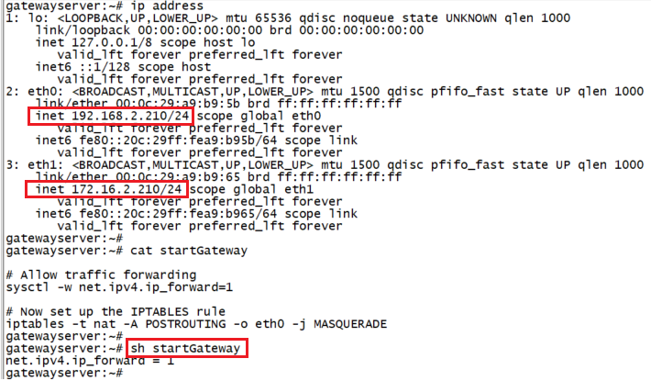

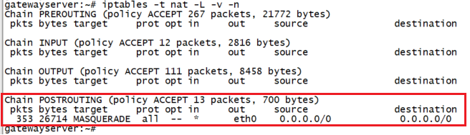

## DHCP Server

Alpine Linux 3.14.2 has been used to work as DHCP Server. DHCP (Dynamic Host Configuration Protocol) is a client/server protocol that enables a server to automatically assign an IP address and other related configuration parameters (such as the subnet mask and default gateway) to a client on a network.

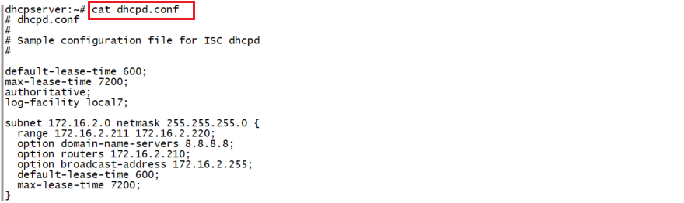

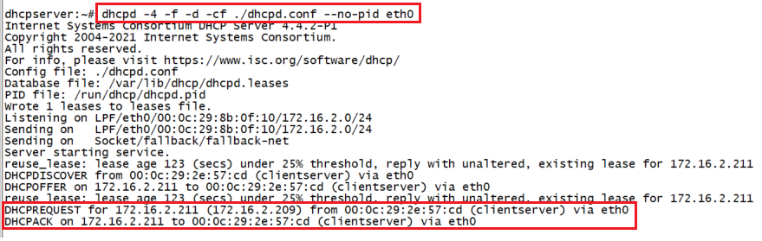

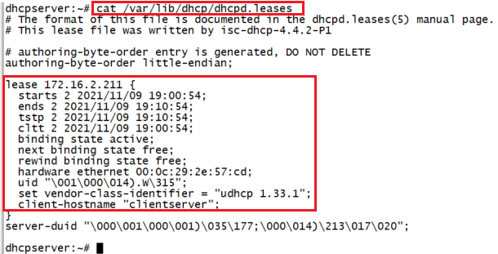

## Client Server

Alpine Linux 3.14.2 has been used to work as Client Server. Ethernet0 interface of Client Server is configured to acquire IP Address from DHCP Server.

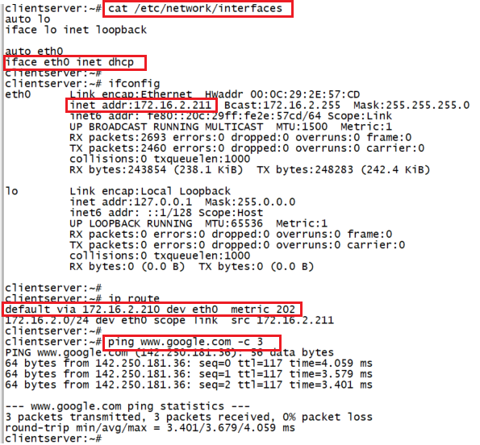

## Web Server

Alpine Linux 3.14.2 has been used to work as Web Server. Nginx is one of the most popular web servers in the world and is responsible for hosting some of the largest and highest-traffic sites on the internet. It is very resource-friendly and can also be used as a reverse proxy, load balancer, mail proxy and HTTP cache.

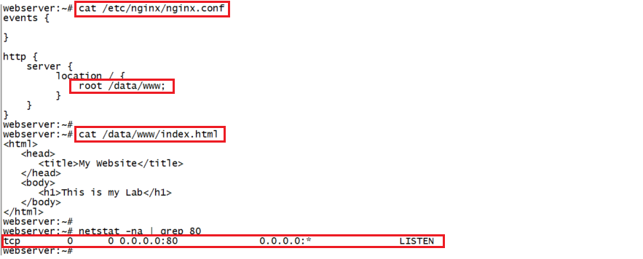

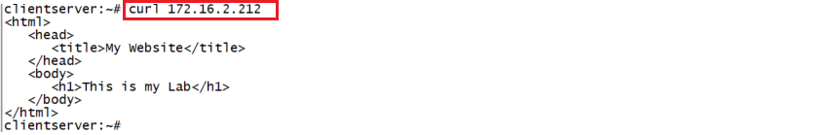



## FTP Server

Debian Linux 11.1 has been used to work as FTP Server. Vsftpd (Very Secure FTP Daemon), is an FTP protocol used to transfer files to and from a remote network. It is a secure, stable, and fast FTP server that is supported on Linux/UNIX operating systems.

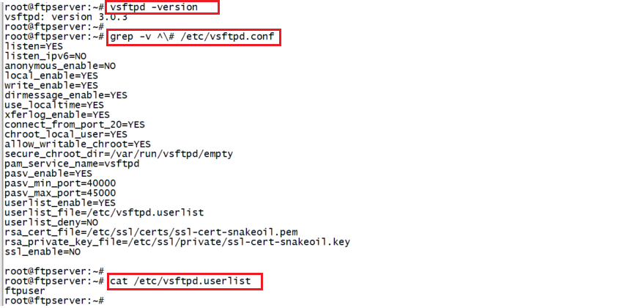

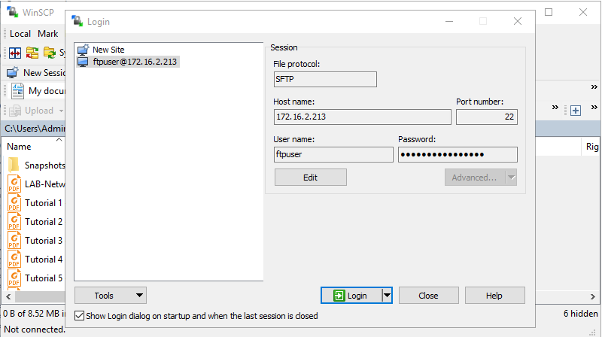

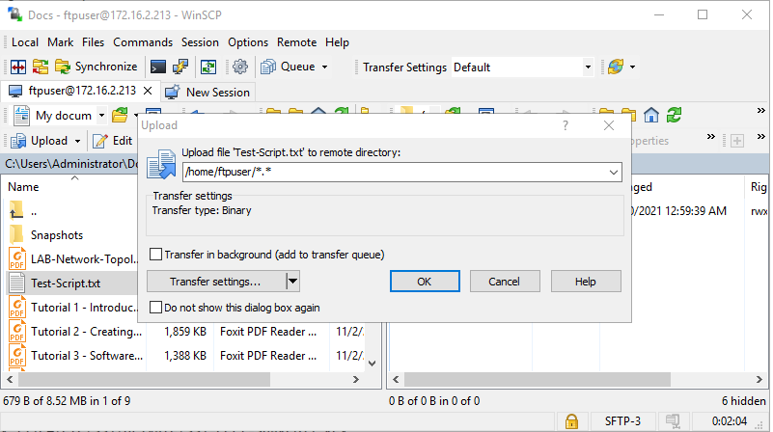

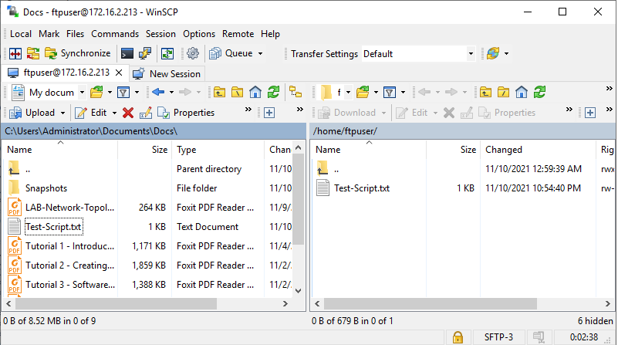

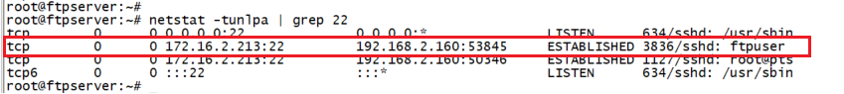

## Telnet Server

Debian Linux 11.1 has been used to work as Telnet Server. Telnet is a terminal emulation program for TCP/IP networks that allows you to access another computer on the Internet or local area network by logging in to the remote system. Telnet is a client-server protocol used to establish a connection to Transmission Control Protocol port number 23. You can also check open ports on a remote system using Telnet.

Telnet is an unencrypted and therefore insecure protocol. It is not recommended to use Telnet Server on Production system.

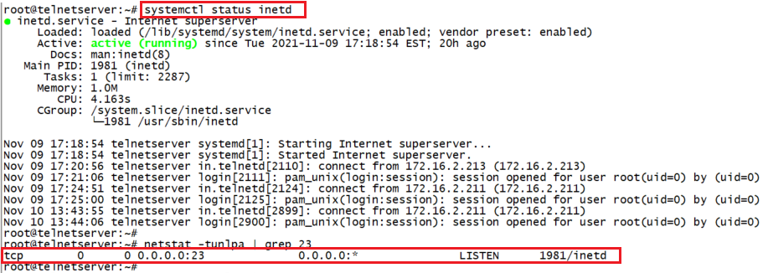

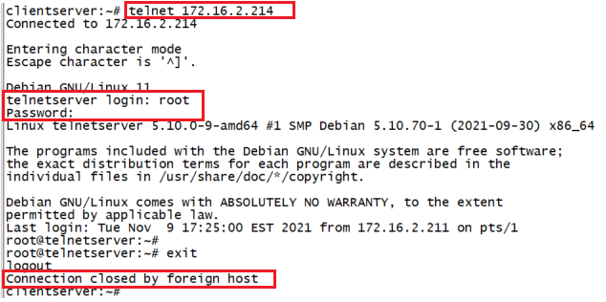



## Database Server

Alpine Linux 3.14.2 has been used to work as MariaDB Database Server. MariaDB is an open-source relational database management system, commonly used as an alternative for MySQL as the database portion of the popular LAMP (Linux, Apache, MySQL, PHP/Python/Perl) stack. It is intended to be a drop-in replacement for MySQL.

